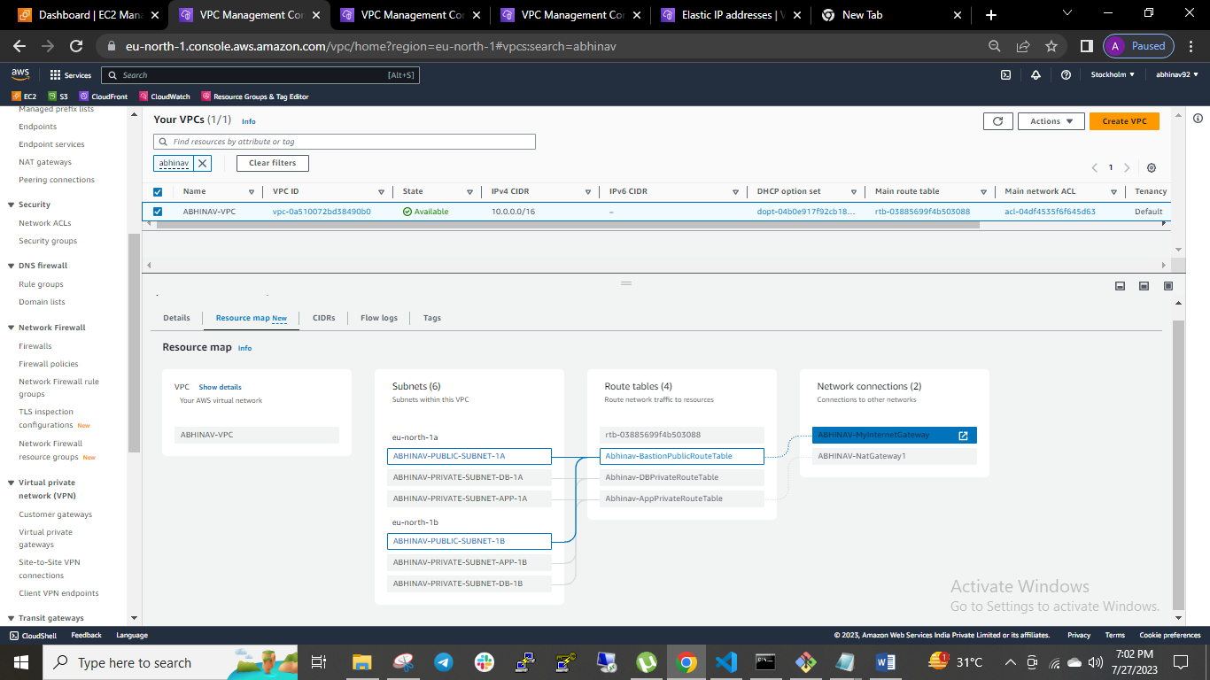

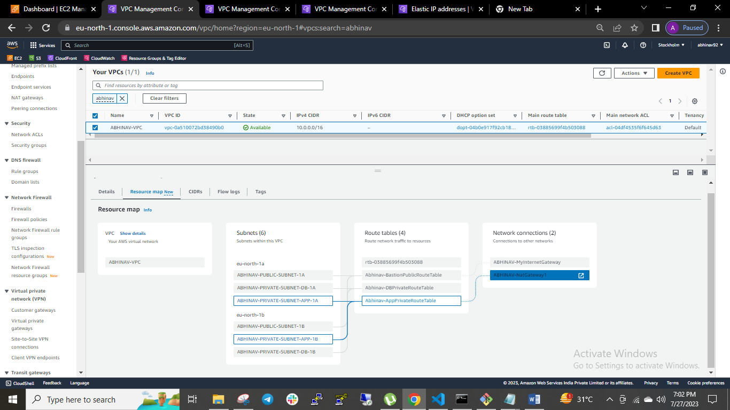

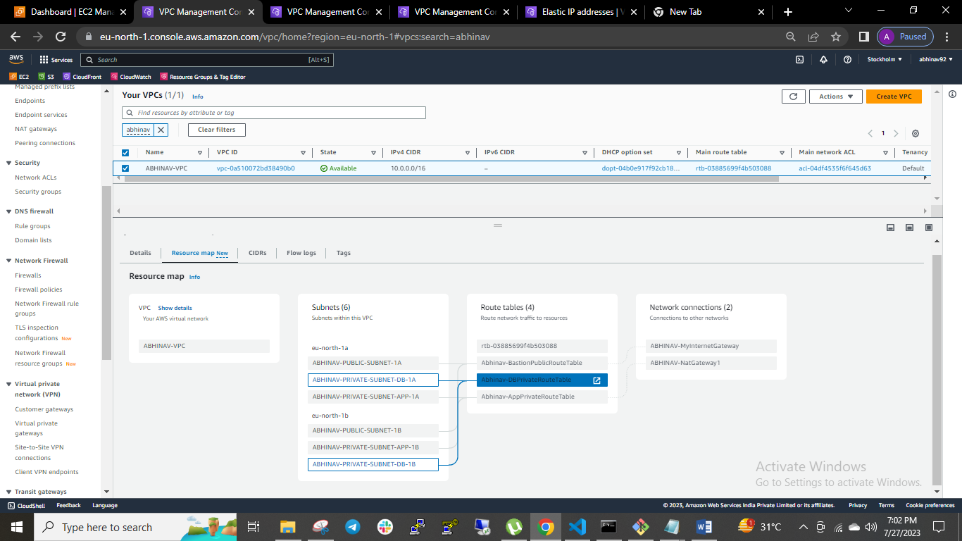

**VPC Details:**

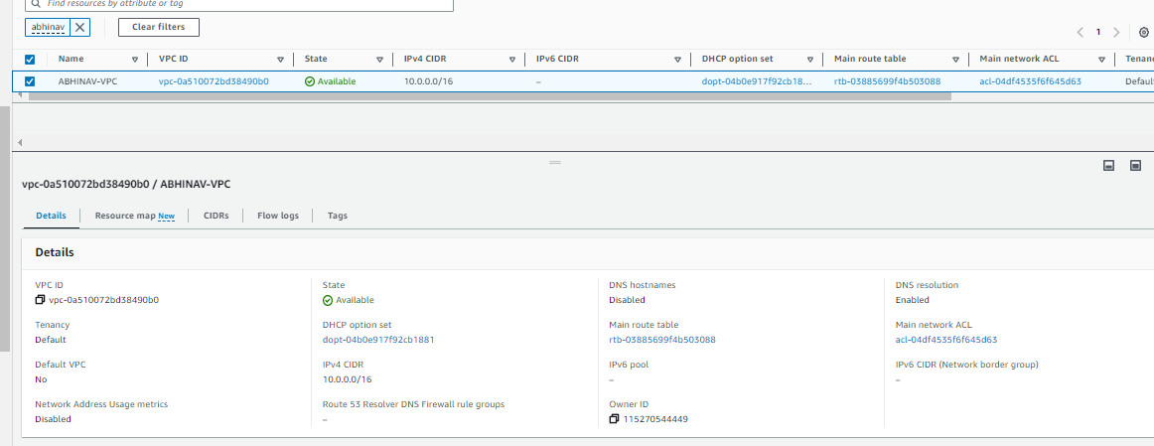

**SUBNET details:**

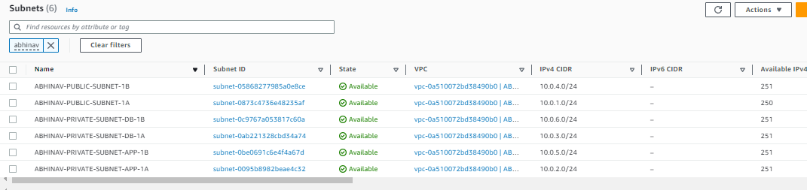

**ROUTE TABLE details:**

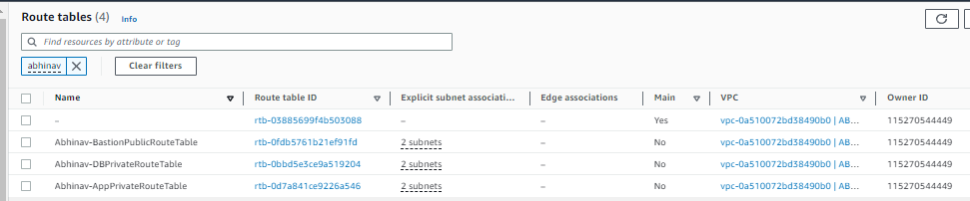

**For DB subnet I have intentionally kept routing locally if required we can make the route through NAT gateway:**

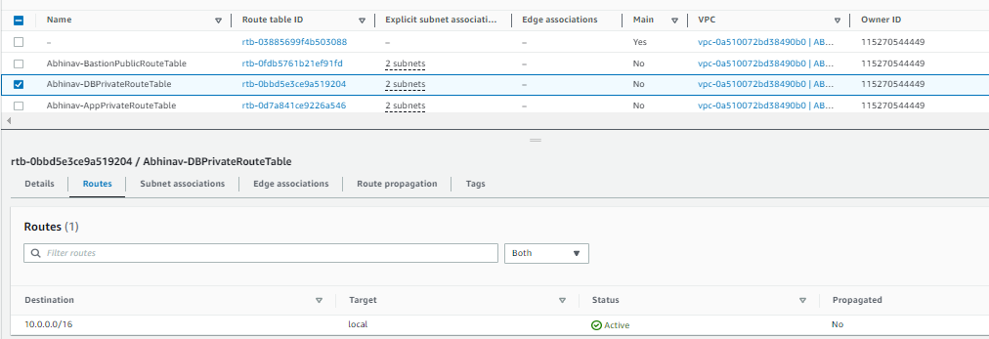

**EIP Address:**

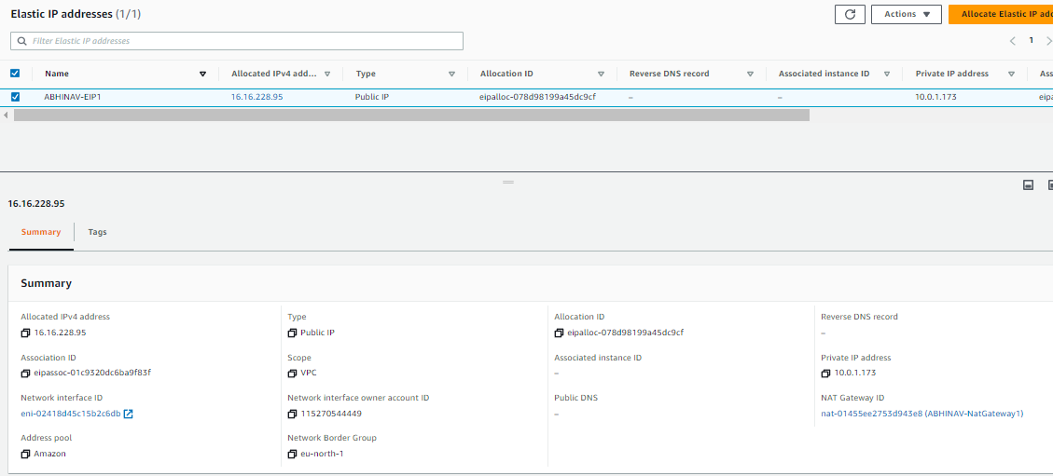

**NAT GATEWAY details:**

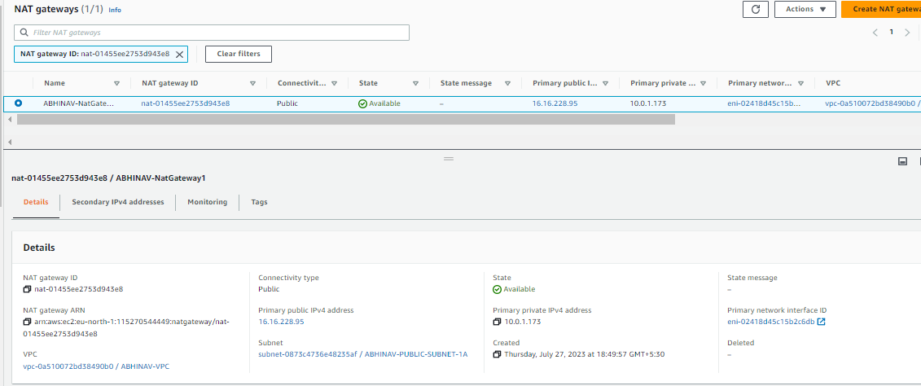

**IGW DETAILS:**

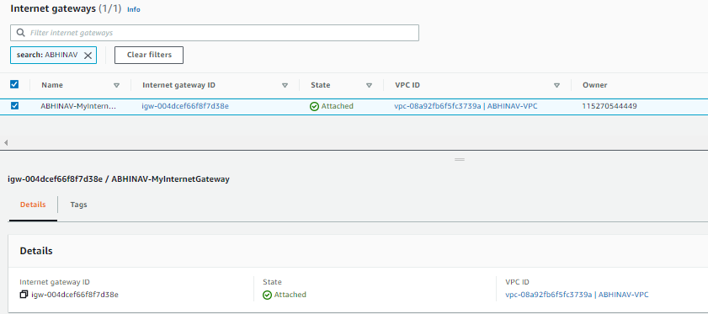

**DEPLOYED 3 EC2 INSTANCES IN 3 DIFFERENT SUBNETS:**

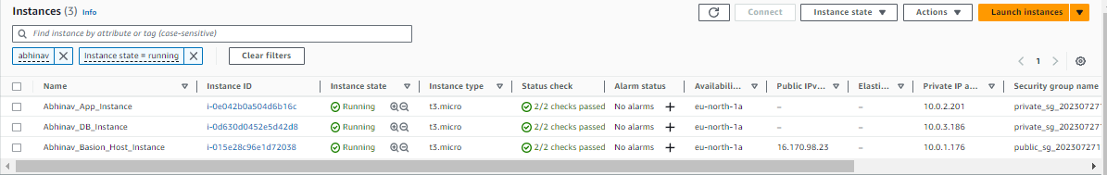

**DEPLOYED 2 SECURITY GROUPS IN PUBLIC & PRIVATE:**

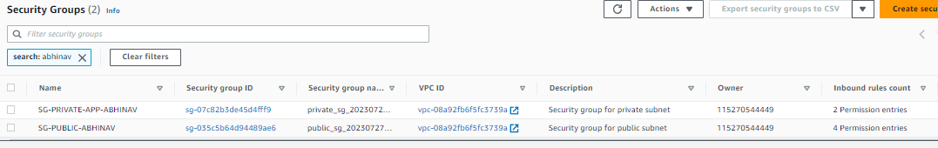

**PUBLIC SG RULES:**

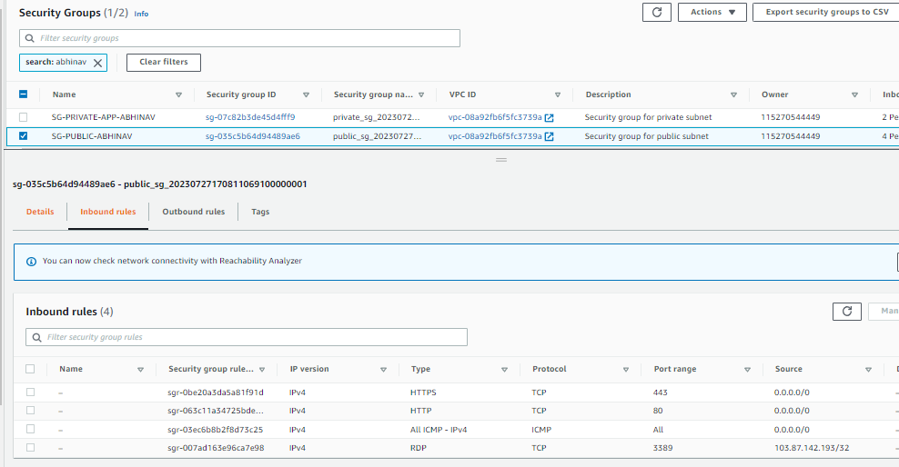

**PRIVATE SG RULES:**

