1. What are escape characters, and how do you use them?

**To insert characters that are illegal in a string, use an escape character.**

**An escape character is a backslash \ followed by the character you want to insert.**

**An example of an illegal character is a double quote inside a string that is surrounded by double quotes:**

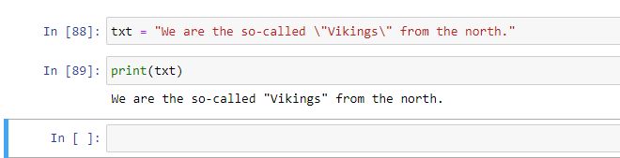

2. What do the escape characters n and t stand for?

**n stands for new line character and t stands for tab character**

3. What is the way to include backslash characters in a string?

**If we have a string that has a single quote inside a single-quoted string like the following string, We need to use the backslash to escape the single quote character:**

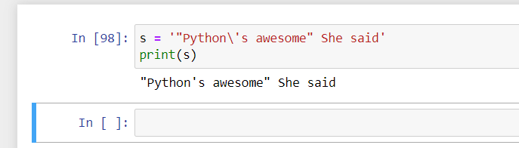

4. The string "Howl's Moving Castle" is a correct value. Why isn't the single quote character in the word Howl's not escaped a problem?

**The single quote in Howl's is fine because we have used double quotes to mark the beginning and end of the string.**

5. How do you write a string of newlines if you don't want to use the n character?

**Multiline strings allow you to use newlines in strings without the \n escape character.**

6. What are the values of the given expressions?

'Hello, world!'[1] – **‘e’**

'Hello, world!'[0:5] – **‘Hello’**

'Hello, world!'[:5] -- **‘Hello’**

'Hello, world!'[3:] – **‘lo, world!'**

7. What are the values of the following expressions?

'Hello'.upper() – **‘HELLO’**

'Hello'.upper().isupper() – **True**

'Hello'.upper().lower() -- **‘hello’**

8. What are the values of the following expressions?

'Remember, remember, the fifth of July.'.split()

'-'.join('There can only one.'.split())

9. What are the methods for right-justifying, left-justifying, and centering a string?

**rjust(), ljust(), Center()**

10. What is the best way to remove whitespace characters from the start or end?

**lstrip() or rstrip()**