1注册、登录、找回密码流程图
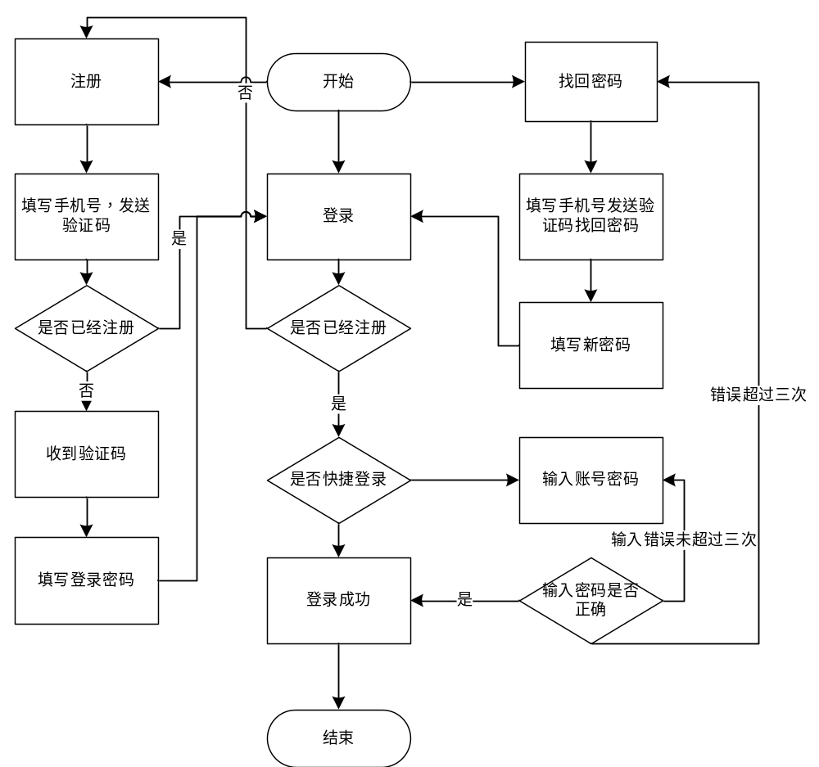

上图是用户在进入一个系统的登录页面后进行的操作主流程。
分支有进入后选择登录、注册、找回密码 。 是否快捷登录
异常流程的就是输入手机号已经注册 密码输错，输入账号没注册。

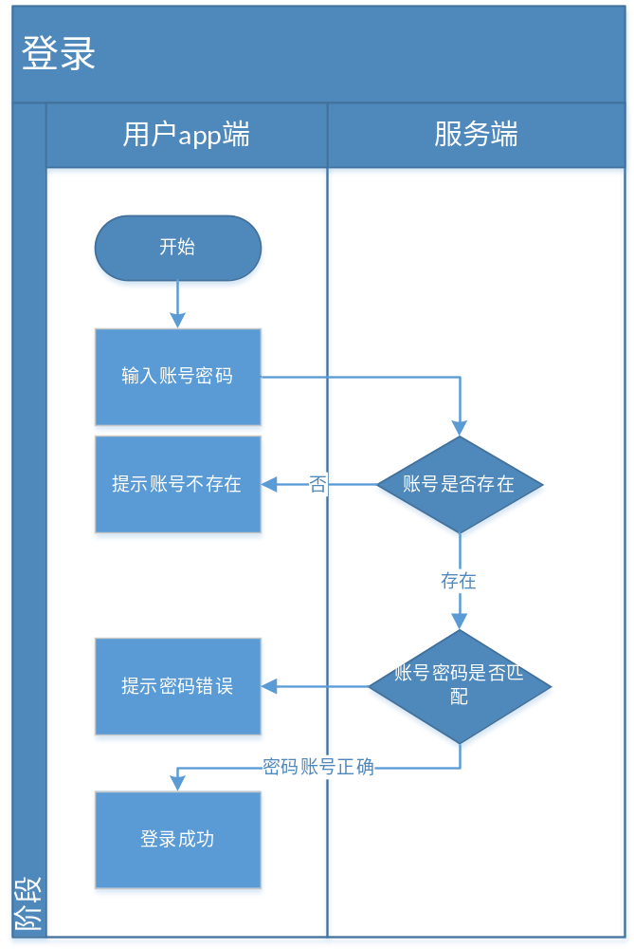

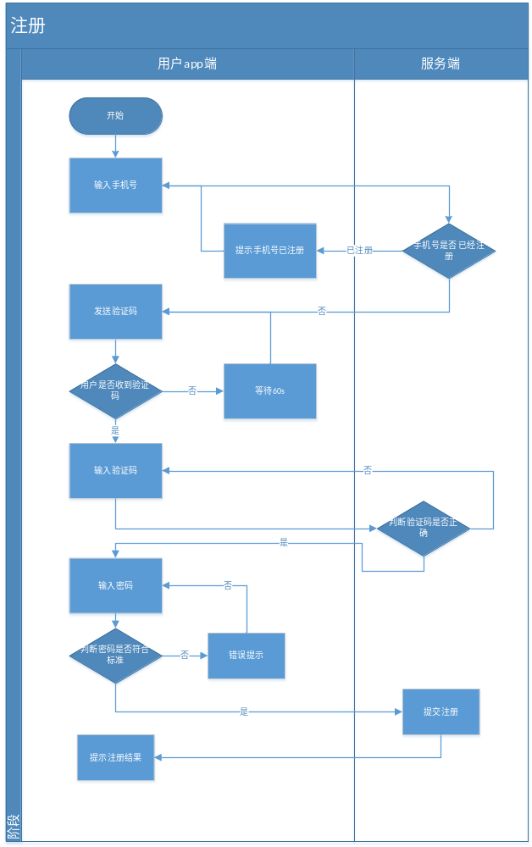

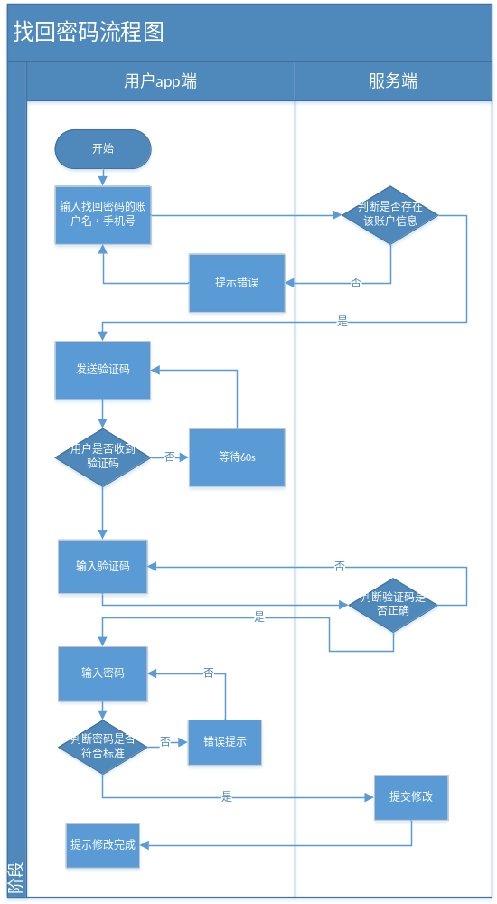

2数据表结构
上面流程图比较简单，没有显示用户后面会补充的一些基本信息，用户的实名信息，一个用户可能有多个账户情况。

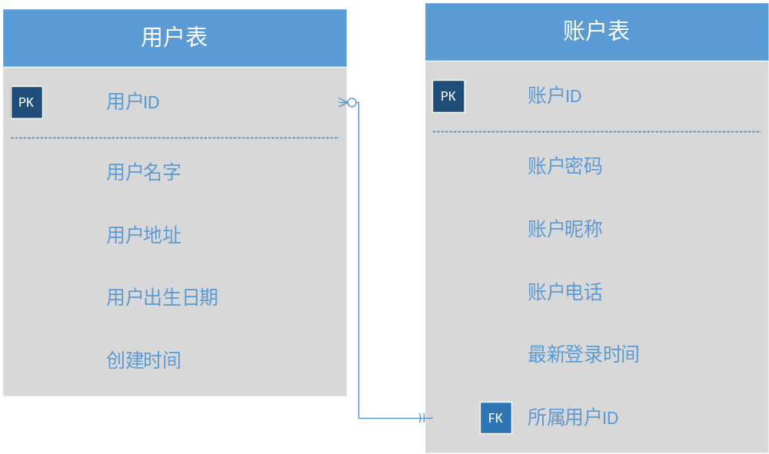

3编程实现
，
下面代码只写了代表性的部分

Sql语句创建数据库
create table Users(
UserID varchar(10) NOT NULL, --用户id
Username Varchar(10) ,--用户名字
Useraddress varChar(10),--用户地址
birthDate Date,--用户出生日期

CONSTRAINT UserPK PRIMARY KEY(UserID)
);

create table Acconts(
AccontsID varchar(10) NOT NULL, --账户ID
Accontspassword varchar(10) NOT NULL, --用户密码
Accontsname varchar(10),--账户昵称
Accontsphone Varchar(10) ,--用户电话
UserID varchar(10) NOT NULL, --用户id

CONSTRAINT AccontsPK PRIMARY KEY(AccontsID)
CONSTRAINT AcuserFK FOREIGN KEY(UserID) REFERENCRS Users(UsersID)
）

数据类
package com.test.Data;

public class Users {//用户
String UserID;//用户id
String Username;//用户名称
String Useraddress;//用户地址
String Userphone;//用户电话
java.sql.Date birthDate;//用户出生日期.数据库date型
public String getUserID() {
return UserID;
}

public void setUserID(String userID) {
UserID = userID;
}

public String getUsername() {
return Username;
}

public void setUsername(String username) {
Username = username;
}

public String getUseraddress() {
return Useraddress;
}

public void setUseraddress(String useraddress) {
Useraddress = useraddress;
}

public String getUserphone() {
return Userphone;
}

public void setUserphone(String userphone) {
Userphone = userphone;
}

public java.sql.Date getBirthDate() {
return birthDate;
}

public void setBirthDate(java.sql.Date birthDate) {
this.birthDate = birthDate;
}
}

数据库相关操作
package com.test.Data;

import java.sql.Connection;
import java.sql.Date;
import java.sql.DriverManager;
import java.sql.PreparedStatement;
import java.sql.ResultSet;
import java.sql.SQLException;
import java.sql.Time;
import java.sql.Timestamp;
import java.text.ParseException;
import java.text.SimpleDateFormat;
import java.util.ArrayList;

public class DataUtli {
static long WAITTIME = 2000L;
public static void main(String[] args) {
Users users = new Users();
users.setUserID("123");
users.setUserpassword("1334");
getConnection();
long future = System.currentTimeMillis() + WAITTIME;
String url = "jdbc:mysql://39.105.171.169:3306/shenghuowuyu?&user=root&password=Mishiweilai123&useSSL=true&serverTimezone=UTC";
try {
Class.forName("com.mysql.jdbc.Driver");
conn = DriverManager.getConnection(url);
} catch (Exception e) {
e.printStackTrace();
}
while (System.currentTimeMillis() - future < 0) { }
try {
pstmt = conn.prepareStatement("insert into Users values(?,?,?,?,?,?)");
pstmt.setString(1, users.getUserID());
pstmt.setString(2, users.getUsername());
pstmt.setString(3, users.getUserpassword());
pstmt.setString(4, users.getUseraddress());
pstmt.setString(5, users.getUserphone());
pstmt.setDate(6, users.getBirthDate());
pstmt.execute();
} catch (SQLException e) {
e.printStackTrace();
}

}
static Connection conn = null;
static PreparedStatement pstmt = null;
static ResultSet rs = null;

public static void getConnection() {
new Thread()
{
@Override
public void run() {
String url = "jdbc:mysql://lovelywhite.cn:3306/shenghuowuyu?&user=root&password=Mishiweilai123&useSSL=false&serverTimezone=UTC";
try {
Class.forName("com.mysql.jdbc.Driver");
conn = DriverManager.getConnection(url);
} catch (Exception e) {
e.printStackTrace();
}
super.run();
}
}.start();

}
public static void addUsers(final Users users) {//增加用户项
long future = System.currentTimeMillis() + WAITTIME;
if(conn==null)
getConnection();
while (System.currentTimeMillis() - future < 0) { }

new Thread(){
@Override
public void run() {
try {
pstmt = conn.prepareStatement("insert into Users values(?,?,?,?,?,?)");
pstmt.setString(1, users.getUserID());
pstmt.setString(2, users.getUsername());
pstmt.setString(3, users.getUserpassword());
pstmt.setString(4, users.getUseraddress());
pstmt.setString(5, users.getUserphone());
pstmt.setDate(6, users.getBirthDate());
pstmt.execute();
} catch (SQLException e) {
e.printStackTrace();
}
super.run();
}
}.start();
}
public static void updateUsers(Users users) throws SQLException {//修改用户信息项
if(conn==null)
getConnection();
pstmt = conn.prepareStatement("update Users set Userpassword =?,Username=?,Useraddress=?,Userphone=?,birthDate=? where UserID =?");

pstmt.setString(1, users.getUserpassword());
pstmt.setString(2, users.getUsername());
pstmt.setString(3, users.getUseraddress());
pstmt.setString(4, users.getUserphone());
pstmt.setDate(5, users.getBirthDate());
pstmt.setString(6, users.getUserID());
pstmt.execute();
}
public static void deleteUsers(Users users) throws SQLException {//删除用户信息项
if(conn==null)
getConnection();
pstmt = conn.prepareStatement("delete from Users where UserID =?");

pstmt.setString(1, users.getUserID());
pstmt.execute();
}

public static ArrayList<Users> selectUsers(final Users users) {//查询用户项
long future = System.currentTimeMillis() + WAITTIME;
if (conn == null)
getConnection();
while (System.currentTimeMillis() - future < 0) { }

final ArrayList<Users> arrayList = new ArrayList<>();
future = System.currentTimeMillis() + WAITTIME;
new Thread()
{
@Override
public void run() {
try {
pstmt = conn.prepareStatement("SELECT * FROM Users where UserID= '" + users.getUserID() + "'");
rs = pstmt.executeQuery();
while (rs.next()) {
Users user = new Users();
user.setUserpassword(rs.getString("UserID"));
System.out.println(rs.getString("UserID"));
user.setUsername(rs.getString("Username"));
user.setUseraddress(rs.getString("Useraddress"));
user.setUserphone(rs.getString("Userphone"));
user.setBirthDate(rs.getDate("birthDate"));
arrayList.add(user);
}
} catch (SQLException e) {
e.printStackTrace();
}
super.run();
}
}.start();
while (System.currentTimeMillis() - future < 0) { }
return arrayList;
}
public static Date sctdate(String str) {//标准年-月-日字符串转sql.date
SimpleDateFormat sdf = new SimpleDateFormat("yyyy-MM-dd");
java.util.Date d = null;
Date date = null;
try {
d = sdf.parse(str);
} catch (ParseException e) {
e.printStackTrace();
}
date = new java.sql.Date(d.getTime());
return date;
}
}
登录操作

import android.content.Intent;
import android.support.v7.app.AppCompatActivity;
import android.os.Bundle;
import android.view.View;
import android.widget.EditText;
import android.widget.Toast;

import com.test.Data.*;
import java.util.ArrayList;

public class LoginActivity extends AppCompatActivity {
private EditText account;
private EditText password;
@Override
protected void onCreate(Bundle savedInstanceState) {
super.onCreate(savedInstanceState);
setContentView(R.layout.activity_login);
account = findViewById(R.id.account);
password = findViewById(R.id.password);

}

public void log(View view) {
String ac = account.getText().toString();
String pw = password.getText().toString();
ArrayList<Users> user = DataUtli.getUsers(new Tuple("UserID ",ac));
if (user.isEmpty()) {
Toast.makeText(LoginActivity.this, "登陆失败", Toast.LENGTH_SHORT).show();
} else {
if (user.get(0).getUserpassword().equals(pw)) {
StaticData.setIsLogin(true);
StaticData.setUsers(user.get(0));
Toast.makeText(LoginActivity.this, "登陆成功", Toast.LENGTH_SHORT).show();
Intent intent = new Intent();
intent.putExtra("ac",ac);
setResult(1,intent);
finish();
} else {
Toast.makeText(LoginActivity.this, "登陆失败", Toast.LENGTH_SHORT).show();
}
}
}
public void reg(View view) {
}
}

