**PROJECT REPORT**

**ON**

**REALTORS.COM:**

**A REAL ESTATE WEB PORTAL**



**(Spring – 2016)**

**Submitted By:**

* Nipun Agarwal (nxa150830)
* Febin Steve Jose (fxs150330)
* Sunny Anand (sxa151231)

**INTRODUCTION**

Name of the website is Realtors.com, a web portal providing easy solution to the people looking to rent, buy or mortgage a property.

**REALTORS.com** is a web portal that provides listing of the properties for the users who wish to buy or rent a property. Additionally, one can search for mortgage options which are provided on a separate page. User can add property to a favorite page to be referenced later.

It provides separate page for the admin who can manage the website by adding, updating or deleting a property from the portal.

**ASSUMPTIONS:**

* We have assumed that only valid users are allowed access to the website. Thus, all the functionalities are provided to the users only once the user is logged in.
* Only admin can add or delete property listings from the web portal.

**ER/EER Diagrams**

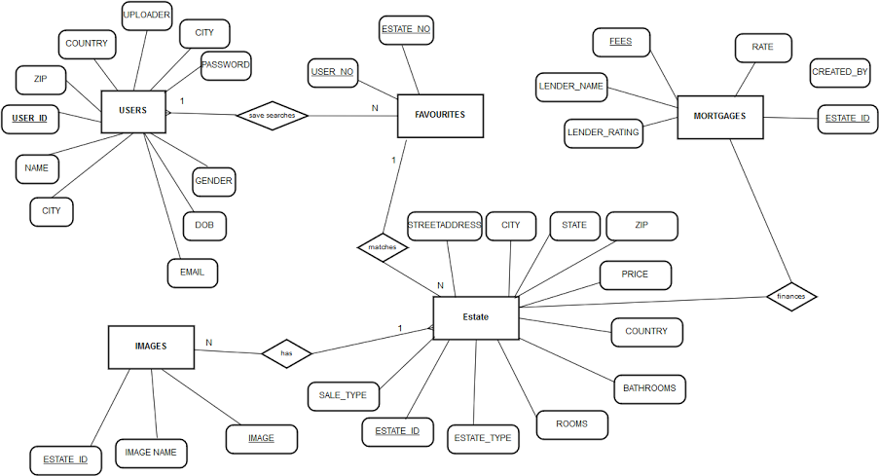

**Entities:**

* Users
* Favorites
* Estates
* Images
* Mortgages

**Relationships and foreign keys:**

* Every user search for an estate can be stored as a favorite. The user table and favorite table are related to each via a foreign key relationship on user_id which is 1:M relationship.
* The estate table and favorite table are related to each other via a foreign key relationship on estate_id which is a 1:1 relationship.
* Every property will have images which will be linked to each property via a foreign key relationship on estate_id which is a 1:M relationship.
* Every estate is related to a financing company via a M:N foreign key relationship on estate_id.

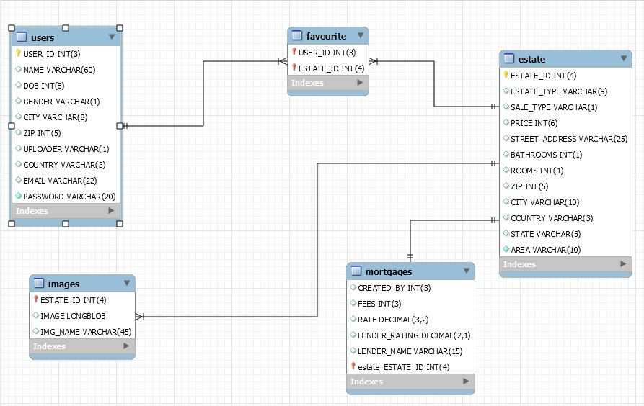

**Technologies used and code overview**

* The application is built using PHP, JavaScript, Jquery, AJAX, HTML and CSS technologies.
* Database used is MySQL.
* All pages in the application are protected using Sessions. Only logged in users are allowed access and there are checks in each and every page. If the credentials don’t match, we force them to the login page.
* AJAX is used to check the new email address if it’s already registered to the system.
* PHP is used for server side scripting.
* Javascript, Jquery is used for client side scripting.

**Major use cases / user flows:**

There are mainly 2 actors in the system and we explain below the major use cases for each of the actors:

**1) User:**

A user can log into the application and search the properties depending on if he is buying or renting. User can filter results based on city, type of property, number of bed rooms or bathrooms. He can add property to favorites which he can reference later or can remove them from favorites. User can also use the mortgage functionality provided on the portal to see mortgage info regarding numerous banks. At any page user can log off from the portal.

**2) Admin:**

A manager also plays on the role of the system admin. The manager can view the listing of all the properties and can filter results based on city, type of property, number of bed rooms or bathrooms. Admin can add new property, update a property or even delete existing property from the system.

**USER:**

**Register**

A new user can register to the portal by entering correct credentials. On registering the application checks if the username already exists or not, correctness of email and strength of password based on predefined rules.

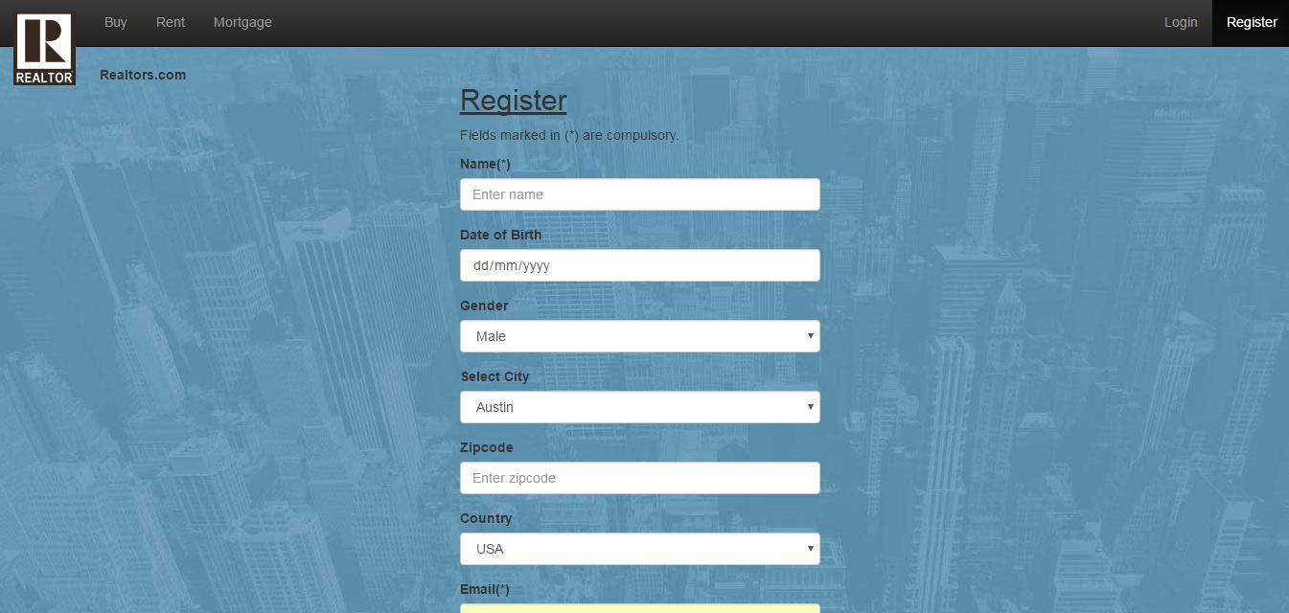

**Login/Logout**

All users can login or logout with their valid account. The application use sessions to keep track of authenticated users and to prevent unauthorized usage. It redirects all unauthenticated requests to the login page. Also, form validation is used to check if user enters a correct email or password that matches specified rules.

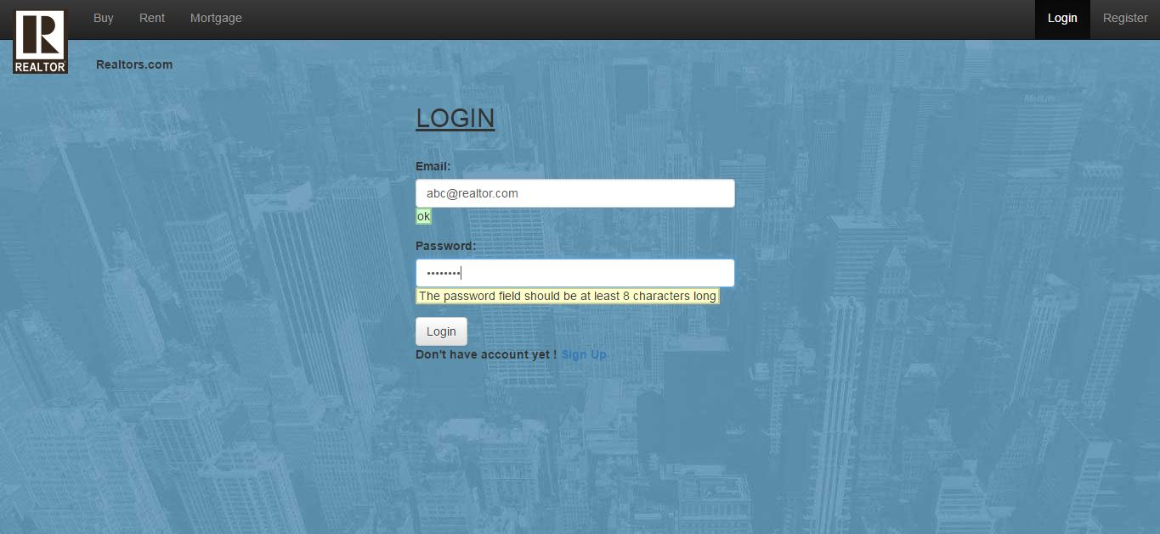

**Overview of properties**

After a user logs in, he is redirected to a page where he can have an overview of what the website do, some featured properties, can get to know more about the website etc. We have implemented image slider on this page. Also, user can choose from buy or rent, enter city and will be redirected to corresponding page with properties listing.

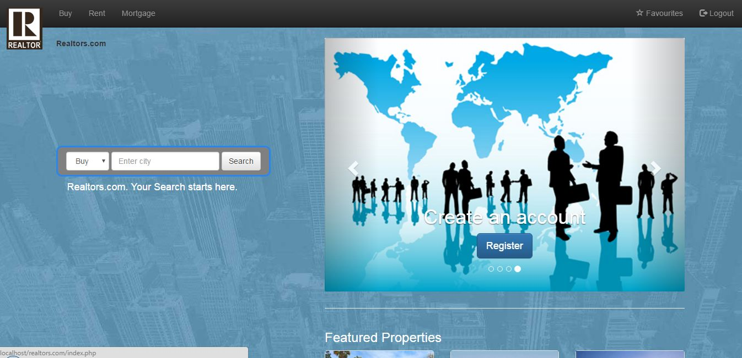

**Buy property**

User can see a listing of the properties and can filter results according to city, type of property, number of bedrooms or bathrooms. As the list is populated, user can click on add button associated with each property to add to his favorites which can be referenced in future.

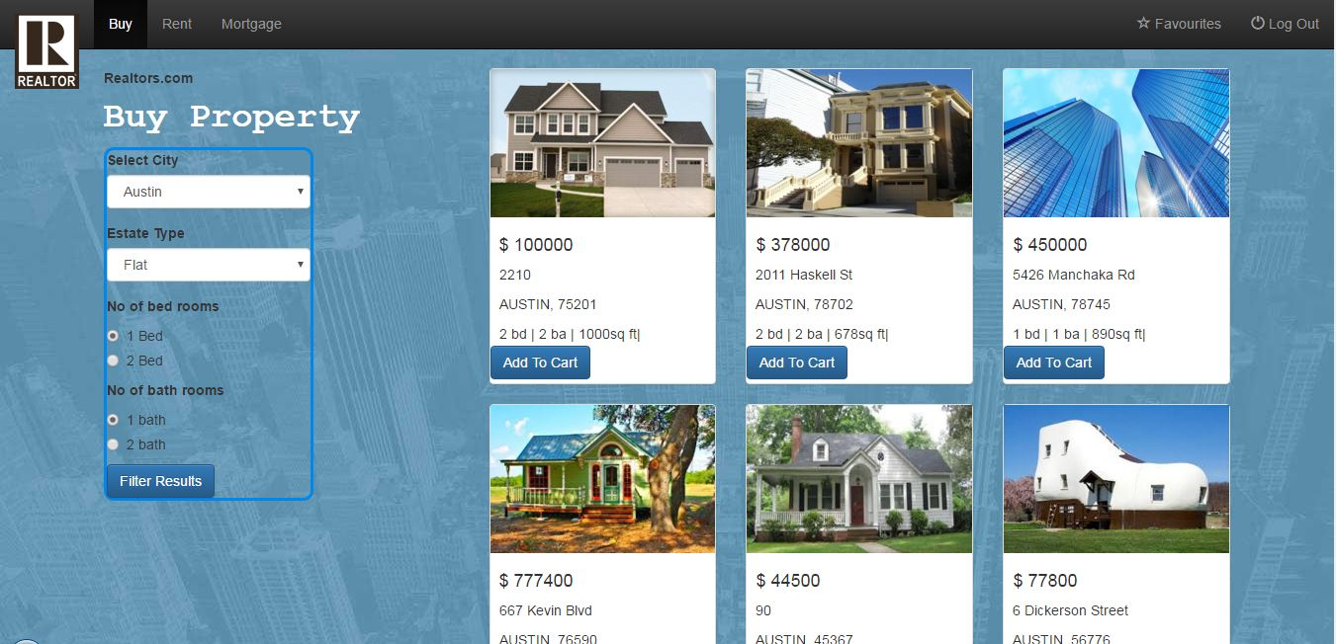

**Rent property**

User can see a listing of the properties and can filter results according to city, type of property, number of bedrooms or bathrooms. As the list is populated, user can click on add button associated with each property to add to his favorites which can be referenced in future.

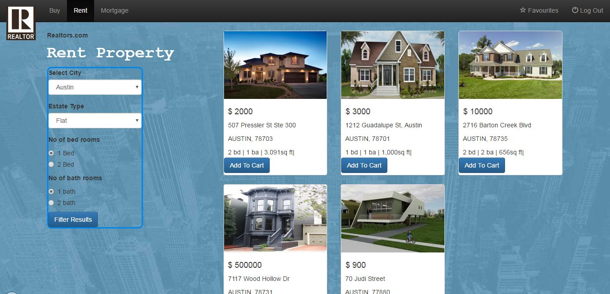

**Mortgage Property**

User can see a listing of number of providers with their details. Also, a link provided on each result redirects to the webpage of corresponding provider.

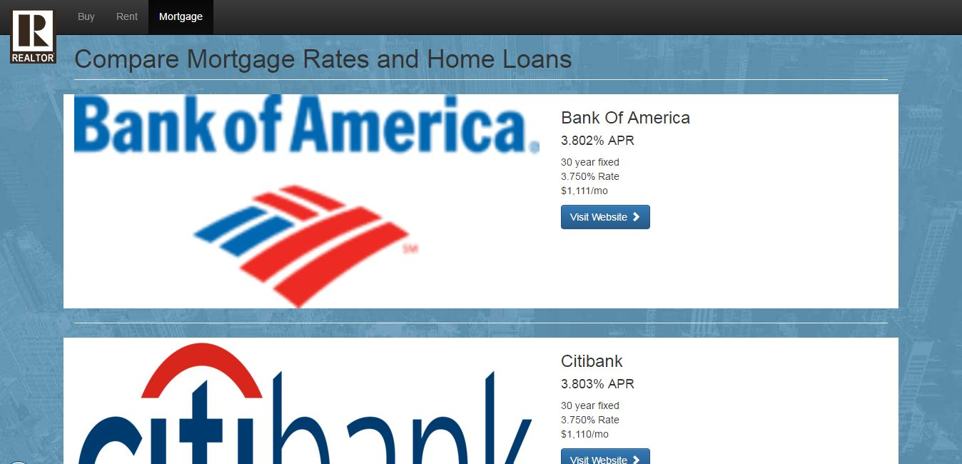

**Favorites**

This page provides a listing of the properties added to the favorites by the user previously. The listing for buy and rent is provided separately. User can remove individual items from favorites as well.

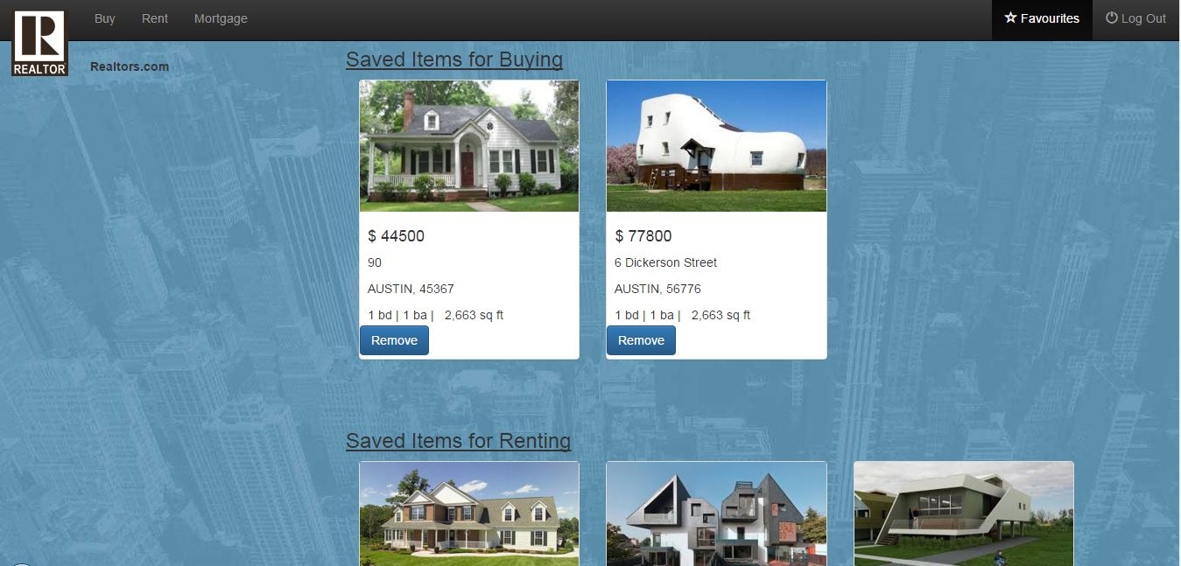

**ADMIN**

After the admin login with the credentials specific to an admin, he is redirected to admin console where he can see the listing of properties and filter results as well. Admin can delete individual properties by clicking the delete button. At any time the admin can log out from the portal.

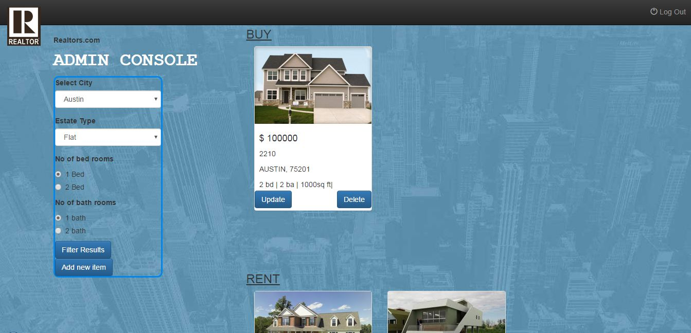

* **Add new property**

Admin has the functionality of adding a new property to the portal using this page.

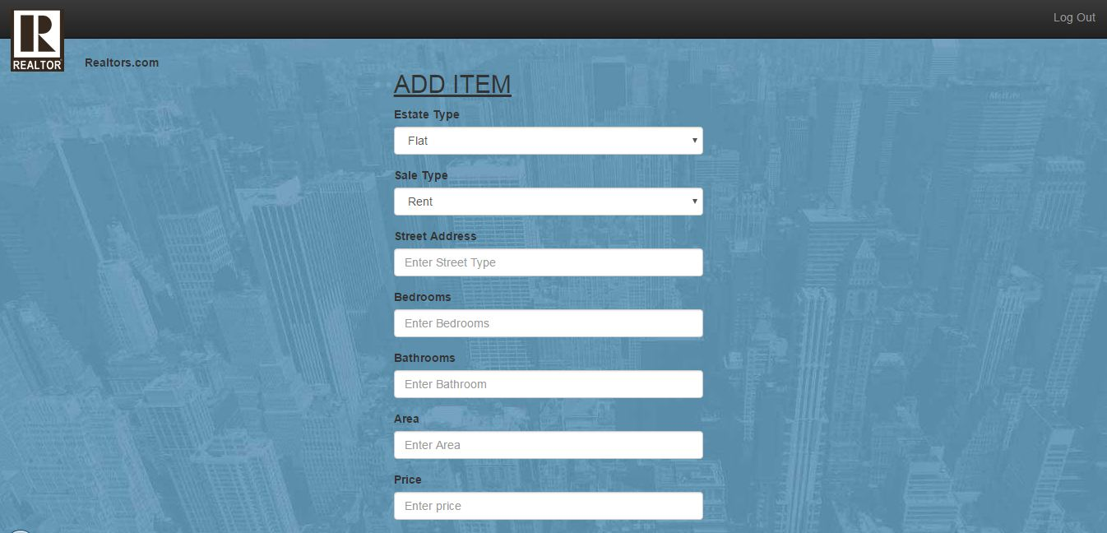

* **Update property**

Admin can click update button correspond to each property to update various attributes attached with the property.

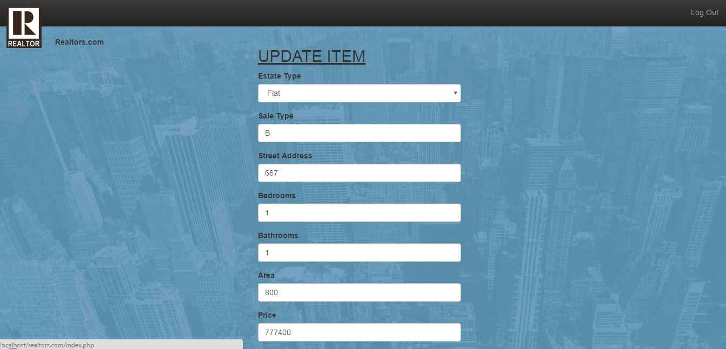

**Work Division:**

The project was completed in 3 phases. Firstly, the database was designed with mutual consent and rigorous discussions between all the members. Although all the members worked on every technology, however Sunny worked mainly on pages like index.php, register.php, login.php etc. Febin worked on pages like buy.php, admin.php, mortgage page etc. Nipun worked on pages like rent.php, register.php, favourite.php etc. There are some pages where the work was done mutually by multiple members. The styling and scripting for the web pages was handled by each individual for their respective pages.

**Concluding remarks :**

The Realtors.com furnished in this report thus integrates several technologies, implements all the provided functionalities and can serve as a scalable solution capable of being hosted online on a server to provide service to users and administrator related to buying, selling or mortgaging properties.

Members of the team:

* Nipun Agarwal (nxa150830)
* Febin Steve Jose (fxs150330)
* Sunny Anand (sxa151231)