#### Figure 1. Kernal Density of Household Income by Survey

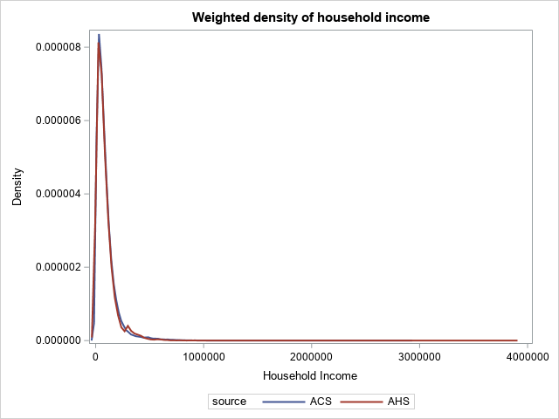

#### Figure 2. Normal Density of Household Income by Survey

