NEHISHLENS
Open Queries v1.1
Queries from Collatten, answered in place · Nehish → Collatten

About this document
This is Collatten's Open Queries v1.1 returned with a response under each item. Their queries and screenshots are reproduced unchanged; everything in a bordered block is the Nehish answer.
Three notes before the detail. Four of the answers are product rules rather than preferences and will not change — the reasoning is given each time so the constraint is usable. Three endpoint groups asked for here are now live on the mock — authentication, evidence packs and the DB console: twelve endpoints, 50 operations in the published spec, all covered by the service's own verification script. One query we cannot answer — the audit pivot view — because we have no such view in the specification and would be guessing.
# | Query | Answer
A1 | Evidence-pack builder, no action button | Own route, Assurance only. API now live
A2 | Audit rows clickable | Yes — endpoint already live
A3 | Records filtered by logged-in user | No, by design
A4 | Pivot view | Not specified — please send a sketch
A5 | Search on the screen | Yes — parameters now live
B1 | EOD rows clickable | No in Phase 1 — render inline
B2 | EOD summary tiles clickable | No in Phase 1
C1 | Write/update redirects to third party | Confirmed — hard rule
C2 | Observe-incident function | Dev affordance, not a shipped screen
D1 | Authentication API | Live — see A/D below

Audit & Evidence
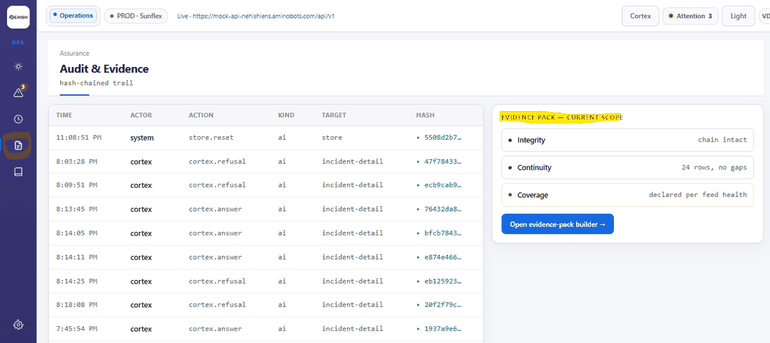
1. Open evidence-pack builder needs clarity. Currently we do not have action button.
Nehish. It is not a control on the Audit screen. The builder is its own surface at route #/audit/packs/new, restricted to the Assurance lens; the Audit screen carries only the entry point into it. It is a four-step workflow — scope, review checks, inspect gaps, export — and is deliberately separate from the trail, because building a pack is an action with a named person behind it and the trail is a record.
The endpoints are live now:
POST /api/v1/packs/preview · POST /api/v1/packs · GET /api/v1/packs/{id} · GET /api/v1/packs
Three behaviours to build for. preview returns gaps[] — coverage the pack cannot claim; it is content, not a warning to dismiss. A create whose scope has a gap not listed in acknowledgedGaps is refused 422 gaps_not_declared, and in the current seed one feed is silent, so the default scope always has a gap. A new pack is building and turns ready a few seconds later, so the loading state is real. The export writes pack.exported into the trail; link the confirmation to it.
For a lens without Assurance the entry point stays visible and states the rule in writing. It is not hidden.
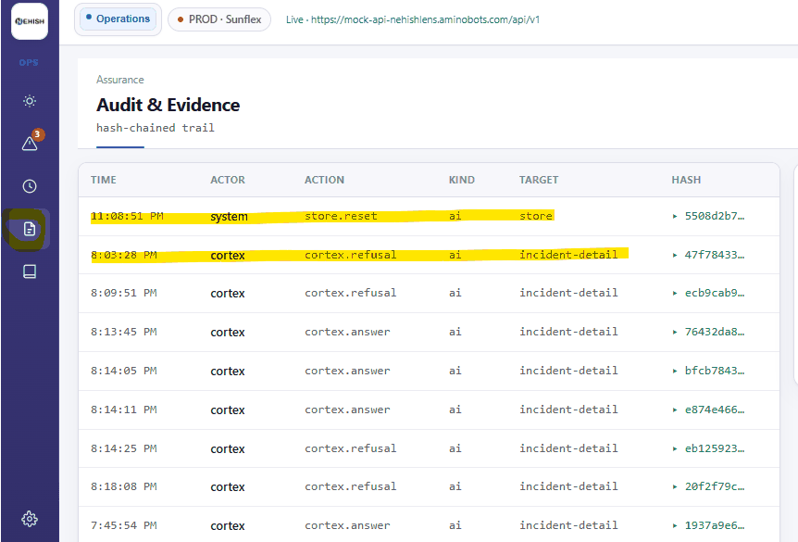
2. Do we need rows to be clickable? We would need API information for details to be shown.
Nehish. Yes, and the endpoint is already live — no new work on our side.
GET /api/v1/audit/{entry_hash} accepts a hash prefix, e.g. 5508d2b7. It returns the full entry: seq, at, actor, actorKind, verb, object, payload, prevHash, hash. Render it as a detail panel and make it deep-linkable at #/audit/{hash}, so a row can be sent to someone in a link.
While you are on this screen, please also call GET /api/v1/audit/verify, which returns {intact, length} or {intact: false, brokenAtSeq}. "Chain intact" is currently asserted in the page markup; it is a claim about the server's data and should come from the server.
3. API should return all records according to logged in User? Please confirm?
Nehish. No — and this one is deliberate, so the reasoning matters.
Two reasons, both load-bearing. The trail is hash-chained: each entry's hash covers the previous one. A filtered trail cannot be verified, so a per-user view would quietly destroy the property that makes it evidence. And our access rule is that permissions are never enforced by hiding — someone who cannot act on a thing still sees that it exists, and is told why.
What is role-scoped is different: whether a lens can reach a destination at all, and whether a particular resource returns its contents. The pattern to copy is GET /api/v1/sources/{id}, which returns 403 not_granted with a written reason for a lens without that grant. The row stays in the list; the detail is refused in words. Please render the server's message rather than removing the row.
Refusals by the AI appear in this trail as ordinary rows with actorKind: "ai". Please do not filter those out either — they are among the most important rows in the product.
4. User audit log trail — pivot view details required for us to be shown. Please provide.
Nehish. We cannot answer this one without guessing, so we would rather ask.
There is no pivot view in the specification. The Audit screen is a flat chronological chain on purpose: the order is the evidence, and a pivot that reorders or aggregates rows breaks the reading of it.
If what you mean is grouping or filtering by actor, kind or date, that is reasonable and is already covered by the parameters in A5 below. If you mean something else, please send a sketch and we will specify it properly.
5. Do we need to provide Search function on the screen?
Nehish. Yes — and it is live. GET /api/v1/audit now accepts, alongside the existing limit:
q (free text over actor, verb and object) · actor · kind (ai | human) · from and to (ISO timestamps) · cursor (opaque — pass back what the last response returned).
Two notes. A search returning nothing is a different state from an empty trail, and both need their own copy — the precedent is GET /api/v1/sources?q=. And filtering narrows what is shown, never what is recorded: the returned slice is therefore not independently chain-verifiable, which is why /audit/verify always walks the whole chain.

EOD run
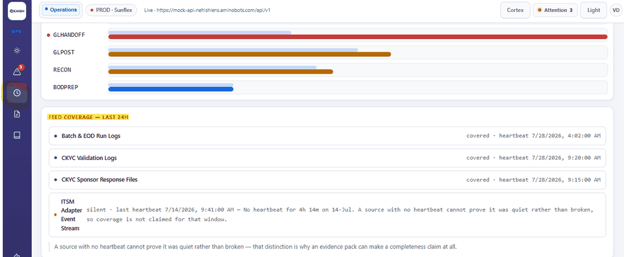
1. Do we need above rows clickable. If yes, please provide API details.
Nehish. Not in Phase 1, for either the stage rows or the feed-coverage rows.
There is no stage-detail endpoint and we do not plan one, because the row already carries everything a detail panel would show. GET /api/v1/runs/{run_id} returns per stage: name, expectedMin, actualMin, deviation, state, plus bodBreached on the run. Render those inline rather than behind a click.
Two things on this screen matter more than clickability. When the response carries a gap field, render the gap — a run showing four of six stages with no explanation reads as a completed run. And GET /api/v1/feeds/health returns a silent state with the reason: a silent source and a quiet night must never look the same, which is the whole point of that panel.
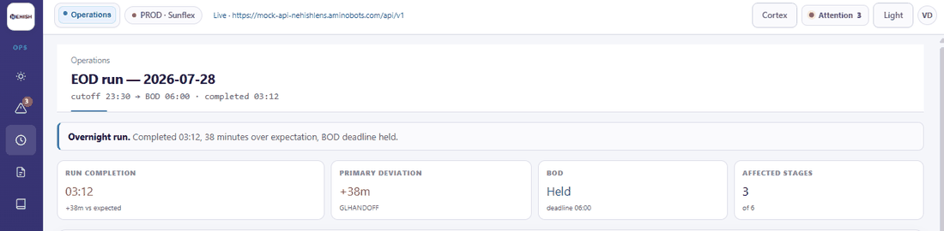
2. Do we need above section clickable? If yes, please provide API details.
Nehish. Not in Phase 1. Run completion, primary deviation, BOD and affected stages are read-outs of the run you have already fetched.
The one pattern that exists for inspecting a derived number is GET /api/v1/derivations/{id}, which backs the Today tiles. We are not extending it to EOD in this phase.

Incidents
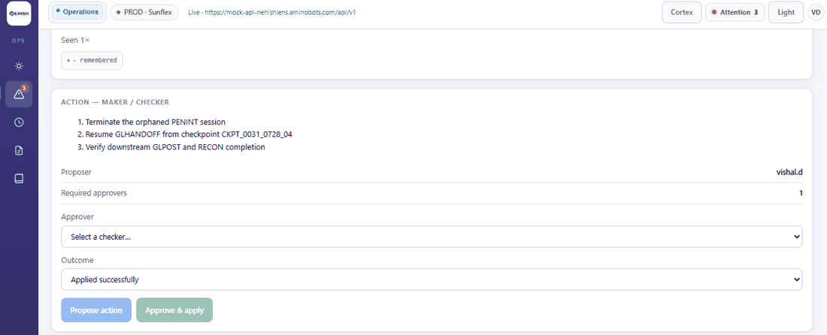
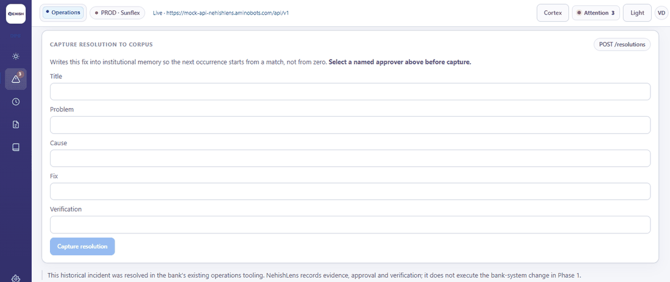
1. Do we need write/update function? As discussed we need to redirect to third party for Write/Update function.
Nehish. Confirmed — and this is a hard product rule, not a preference.
No role in NehishLens can execute a change in a bank system, and there is no execute path to build. The product records a proposal, the named approver, the outcome and a receipt; a person performs the change in FLEXCUBE or the ITSM tool, and the action is recorded as recorded_externally. If a design discussion ever appears to require an execute button, please treat it as a misunderstanding and raise it rather than building it.
The POST endpoints that do exist write to NehishLens's own record, never to the bank: POST /api/v1/actions (propose) and POST /api/v1/actions/{id}/approve.
Three points on the screens above, because they are easy to get wrong. The approver must be named before the action, so GET /api/v1/policy/approvers?lens=&incidentId= has to resolve before "Propose action" is enabled. Maker-checker is enforced on the server — 422 maker_is_checker when proposer and approver are the same person, 403 when the approver is not the named one; do not pre-filter the dropdown and treat that as the control. And a failed outcome still returns a receipt and regresses the incident to understood: show both, because a missing failure receipt is a hole in the chain and is exactly what an inspector looks for.
On the second screen — capture to corpus — approvedBy is required. The AI drafts; a named person approves. Please do not default that field to the logged-in user without an explicit action.
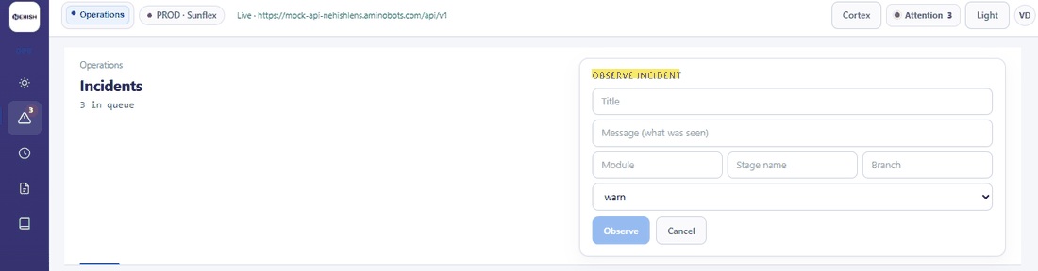
2. Do we need to Observe incident function?
Nehish. Not as a shipped screen.
POST /api/v1/incidents exists so the loop can be exercised end to end, and it is how you prove the product's central claim: fire it twice with the same problem text from different branches, and the second arrives already understood with the past fix attached. It is worth a throwaway button during development.
It should not ship as a user-facing action in Phase 1. Incidents arrive from observation — collectors, feeds, monitoring — not from a person filling a form. Please keep this behind a dev flag or remove it from the build.

Authentication
1. User Authentication API details are pending.
Nehish. Live now. Nehish-issued tokens; no bank IdP in Phase 1.
POST /api/v1/auth/login {username, password} → {accessToken, refreshToken, expiresIn, user:{id, name, lens, permissions[], tenant}}, 401 invalid_credentials · POST /api/v1/auth/refresh {refreshToken} · POST /api/v1/auth/logout → 204 · GET /api/v1/auth/me
Every other call carries Authorization: Bearer <accessToken>.
The lens is derived server-side from the token. X-Lens is a development affordance and will be rejected in production. The lens switcher in the prototype is a demonstration control, not a product feature. Please do not build the application around a client-chosen lens, and do not treat the lens as something the frontend asserts.
Nothing you have already wired breaks. Auth is optional on the mock: every endpoint built before it existed still works with X-Lens alone, so you can adopt auth screen by screen. When a bearer token is present, the lens comes from the token and X-Lens is ignored. One deliberate exception — a token that is present but expired or invalid is a 401, never a silent fall back to X-Lens. Failing open on a stale token is how an audit trail ends up attributing an action to the wrong person.
Signing in to the mock. It does not verify passwords — it checks the username is one of five seeded users, so no credential sits in the repository. The ids are vishal.d (Operations, proposer), r.edwards (Operations, approver), a.menon (Engineering), compliance.head (Assurance) and s.iyer (Executive); each carries the permissions its lens should have. Send the literal password wrong to drive the 401. The real service replaces this check wholesale — please do not mirror it.
The refresh token is single-use: refreshing returns a new pair and the old one stops working. Please build for that now rather than discovering it under a race.
Two points still open on our side, and we will confirm them: session lifetime and idle timeout, and whether concurrent sessions per user are permitted. Our recommendation for token storage is the refresh token in an httpOnly, Secure, SameSite=Strict cookie with the access token held in memory only — please raise it now if that conflicts with your deployment model, rather than at the security review.

DB console
Not raised in your queries, but specified here because it is in scope and had no contract. Engineering lens only.
GET /api/v1/db/schema?q= · GET /api/v1/db/objects/{name} · POST /api/v1/db/query · POST /api/v1/db/investigations
Nehish. Three behaviours worth knowing before you build the screen.
Read-only is enforced on the server, which refuses anything that is not a SELECT with 422 not_read_only. Implement a client-side check only as a courtesy message, never as the control.
maskedColumns[] names the columns policy masked. Show which ones — a redaction the reader cannot see is indistinguishable from missing data.
notConfirmed[] on the object view states what the dependency walk could not establish. It is the same principle as the EOD gap: said out loud, not swallowed. The journey ends with a signed investigation attached to a change record, not with the query itself.

What we need back from Collatten
- A sketch of the pivot view, or confirmation that filtering by actor, kind and date is sufficient (A4).
- Confirmation that the token-storage model above suits your deployment.
- Confirmation that the observe-incident form will sit behind a dev flag rather than ship (C2).
Pull the updated openapi.yaml and Postman collection — the service now publishes 50 operations. services/nehishlens-mock-api/scripts/check-api.sh covers the new groups, so you can confirm the behaviour yourself against whichever host you point it at.
These contracts are ours to keep stable. If any of them changes, the change is ours and is not chargeable to you.

