Comprehensive Data Science Project Report
Using tumour measurements to support breast cancer screening decisions
Virtual Data Science with Python Apprentice Intern – Week 5 Final Report
Integrates Week 1 (data cleaning and EDA), Week 2 (visual storytelling), Week 3 (hypothesis testing) and Week 4 (machine learning)

Executive Summary
This project asked a practical question: can simple measurements of cell nuclei, taken from a breast tissue sample, reliably tell a malignant tumour from a benign one, and how could a hospital use that? The Breast Cancer Wisconsin (Diagnostic) dataset (569 patients, 30 measurements, 37% malignant) was cleaned, explored, statistically tested and used to train a classification model.
Question | Answer | Evidence
Is the data usable? | Yes. No missing values or duplicates; 171 rows had outliers, which were handled by capping. | Week 1
Do the two groups differ? | Yes, strongly. Mean radius is 17.5 for malignant and 12.2 for benign tumours (difference 5.3, 95% CI 4.9 to 5.8, p < 0.001). | Week 3
Is size linked to risk? | Yes. The share of malignant tumours rises from 2% in the smallest quarter to 96% in the largest. | Weeks 2 and 3
Can a model predict it? | Yes. A logistic regression reached 96.5% accuracy, 97.5% precision, 92.9% recall and ROC-AUC 0.996 on 114 unseen patients. | Week 4
What is the main weakness? | 3 of 42 malignant tumours in the test set were missed, and the test set is small, so the estimates are uncertain. | Week 4

Headline recommendations: (1) use the model as a second reader that supports clinicians, not as an automatic diagnosis; (2) send borderline cases to human review, since in the test set 3 of the 4 errors fell in a narrow uncertain band holding only 3.5% of patients; (3) choose the alert threshold according to the cost of a missed cancer, using validation data; (4) validate on data from other hospitals before any real use. These conclusions describe patterns in one dataset and are not clinical advice.

1. Introduction and Objectives
Early and accurate classification of breast tumours matters because a missed malignancy delays treatment, while an unnecessary alarm causes anxiety and extra cost. The objective of the project was to move from raw data to a decision-ready recommendation in five steps, each building on the last: understand and clean the data, explain it visually, test the findings statistically, build a predictive model, and finally translate everything into recommendations for stakeholders. The intended readers are hospital managers and clinical leads (who decide whether to adopt a tool) and the data team (who build and maintain it).

2. Data
The dataset comes from the UCI Machine Learning Repository and is loaded through scikit-learn. Each of the 569 patients has 30 numeric features computed from a digitised image of a fine needle aspirate: the mean, standard error and worst value of ten nucleus properties (radius, texture, perimeter, area, smoothness, compactness, concavity, concave points, symmetry and fractal dimension). The label is the diagnosis: 357 benign (62.7%) and 212 malignant (37.3%).

3. Methodology
Week | Goal | Methods | Main output
1 | Prepare and explore the data | Pandas inspection, duplicate and missing-value checks, IQR outlier capping, summary statistics | Clean dataset, 5 EDA charts
2 | Communicate patterns visually | Violin plots, clustered heatmap, PCA, ranked correlations, chart-type experiment | 7 annotated visualizations
3 | Test the findings | Welch t-test, Mann-Whitney, chi-square, ANOVA with Tukey, Bonferroni and FDR corrections | Evidence with p-values, confidence intervals and effect sizes
4 | Predict the diagnosis | Pipeline with scaling, logistic regression, decision tree, random forest, cross-validation, error analysis | Tested classifier and its weaknesses
5 | Synthesise and recommend | Combining weeks 1 to 4 into one narrative | This report

Tools: Python with Pandas, NumPy, Matplotlib, Seaborn, SciPy and scikit-learn. Every step is reproducible from the scripts and notebooks in the GitHub repositories (see the appendix).

Key code excerpts
Cleaning (Week 1): outliers are capped at the IQR limits rather than deleted, so no patients are lost.
q1, q3 = df[num].quantile(.25), df[num].quantile(.75); iqr = q3 - q1
clean = df.copy()
clean[num] = clean[num].clip(q1 - 1.5*iqr, q3 + 1.5*iqr, axis=1)
Hypothesis test (Week 3): Welch t-test, which does not assume equal variances, with a 95% confidence interval for the difference.
t, p = stats.ttest_ind(malignant.mean_radius, benign.mean_radius, equal_var=False)
diff, lo, hi = welch_ci(malignant.mean_radius, benign.mean_radius)
Model (Week 4): scaling inside a pipeline so that test data never influences training.
pipe = Pipeline([('sc', StandardScaler()), ('m', LogisticRegression(max_iter=5000))])
grid = GridSearchCV(pipe, {'m__C': [0.001, 0.01, 0.1, 1, 10, 100]}, cv=cv, scoring='recall')
grid.fit(X_train, y_train)

4. Results

4.1 Data quality (Week 1)
The data had no missing values and no duplicates. The IQR rule flagged 171 of the 569 rows as containing at least one outlier, most often in area error, radius error, perimeter error and worst area. Deleting 30% of the patients would have thrown away a lot of information, so values were capped instead.
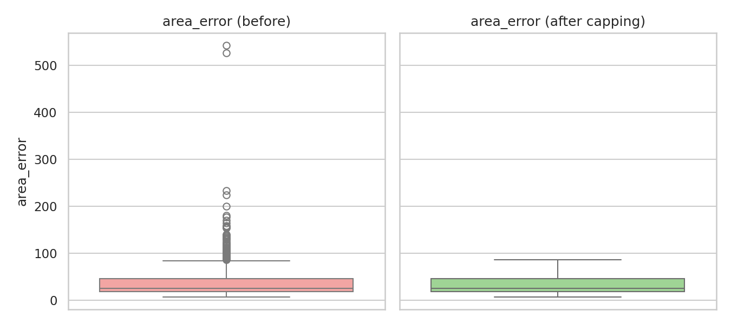
Figure 1: An error feature before and after outlier capping

4.2 What the data show (Weeks 1 and 2)
Malignant tumours are larger and more irregular. In the cleaned data the average mean radius was 17.3 against 12.2, and the average mean concavity was 0.16 against 0.05. Radius, perimeter and area are almost the same measurement (correlations above 0.99), so the 30 features contain much less independent information than their number suggests.
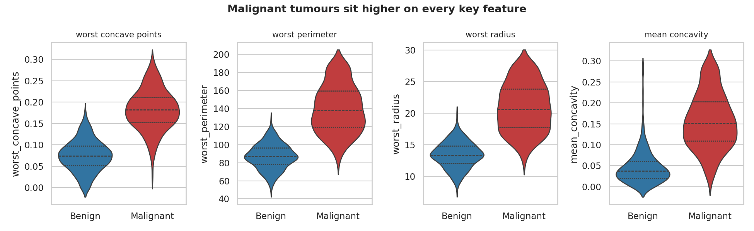
Figure 2: Malignant tumours sit higher on every key feature
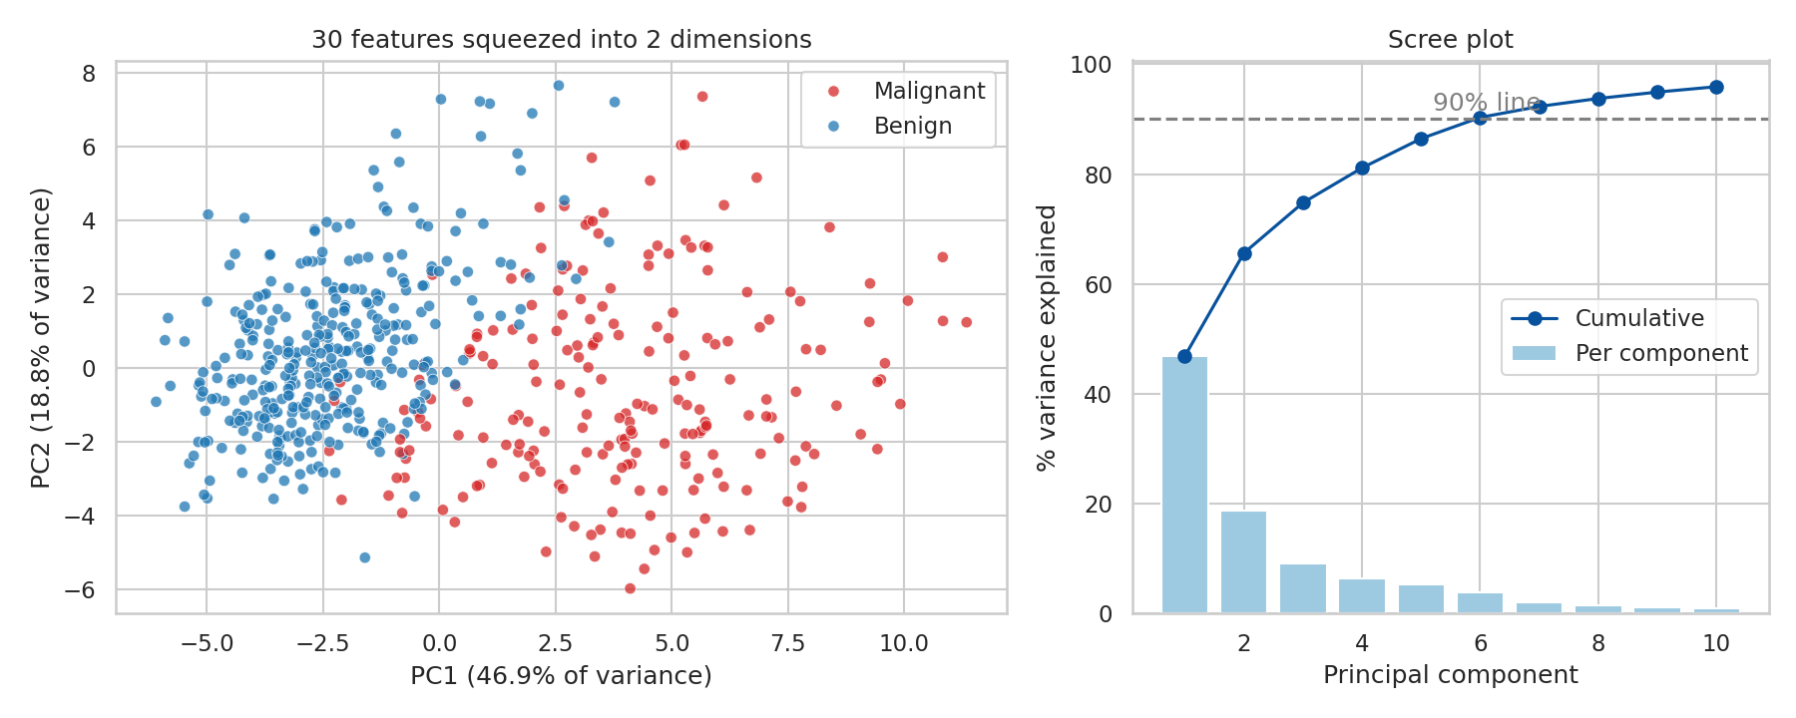
Figure 3: PCA compresses 30 features into two dimensions (65.6% of variance) and still shows two largely separate groups
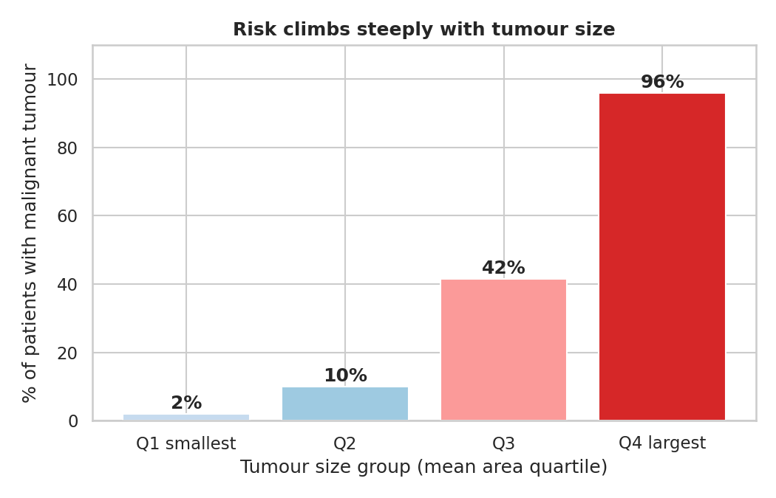
Figure 4: The share of malignant tumours climbs steeply with tumour size

4.3 Statistical evidence (Week 3)
On the raw data, the mean radius of malignant tumours was 17.46 and of benign tumours 12.15. The difference of 5.32 (95% CI 4.85 to 5.79) is highly significant (Welch t = 22.2, p < 0.001) and very large (Cohen's d = 2.21). The null hypothesis of equal means is rejected, and the non-parametric Mann-Whitney test agrees.
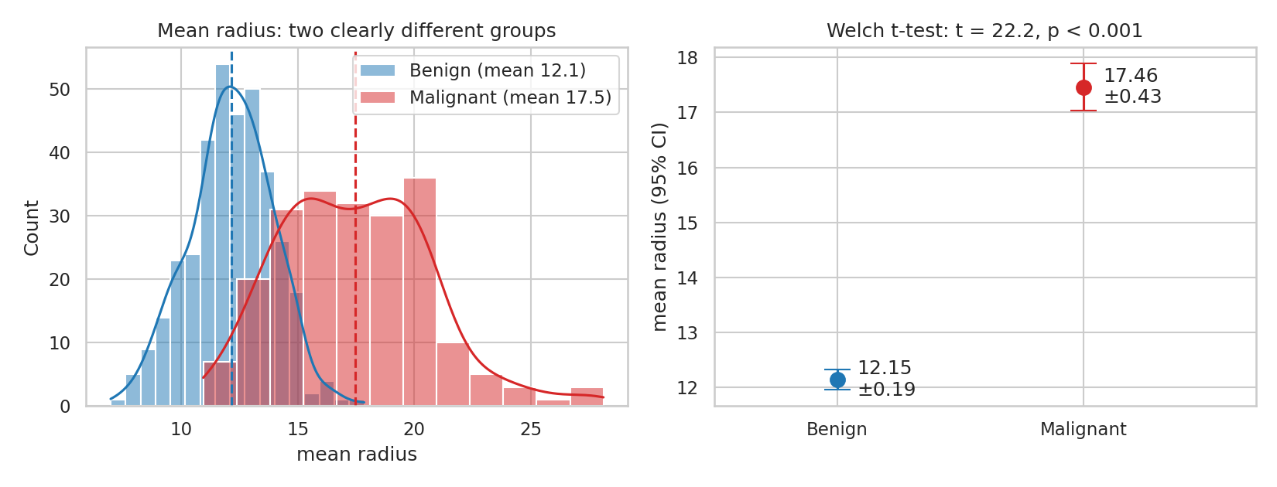
Figure 5: Distribution of mean radius and group means with 95% confidence intervals
Size group and diagnosis are strongly associated (chi-square 330.4, Cramér's V = 0.76), and concave points rise steadily across size groups (ANOVA F = 245.9, eta-squared 0.57). Screening all 30 features with multiple-testing correction showed that 26 differ significantly between the groups; mean fractal dimension, texture error, smoothness error and symmetry error do not. Fractal dimension, for example, has p = 0.767 and an effect size near zero.
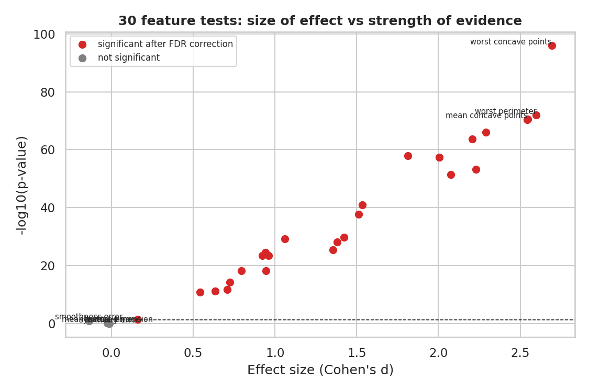
Figure 6: Effect size against strength of evidence for all 30 features (red = significant after correction)

4.4 Predictive model (Week 4)
Three models were compared with stratified train/test splitting and 5-fold cross-validation. Logistic regression was chosen: it had the best cross-validated accuracy (97.4%), is easy to explain, and shows a small gap between training and validation scores. The decision tree over-fitted (100% training against about 92% validation accuracy).
Model (test set, 114 patients) | Accuracy | Precision | Recall | ROC-AUC
Logistic Regression (chosen) | 96.5% | 97.5% | 92.9% | 0.996
Decision Tree | 93.0% | 90.5% | 90.5% | 0.925
Random Forest | 97.4% | 100% | 92.9% | 0.994

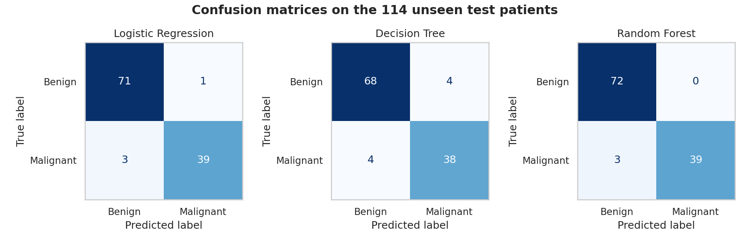
Figure 7: Confusion matrices on the test set
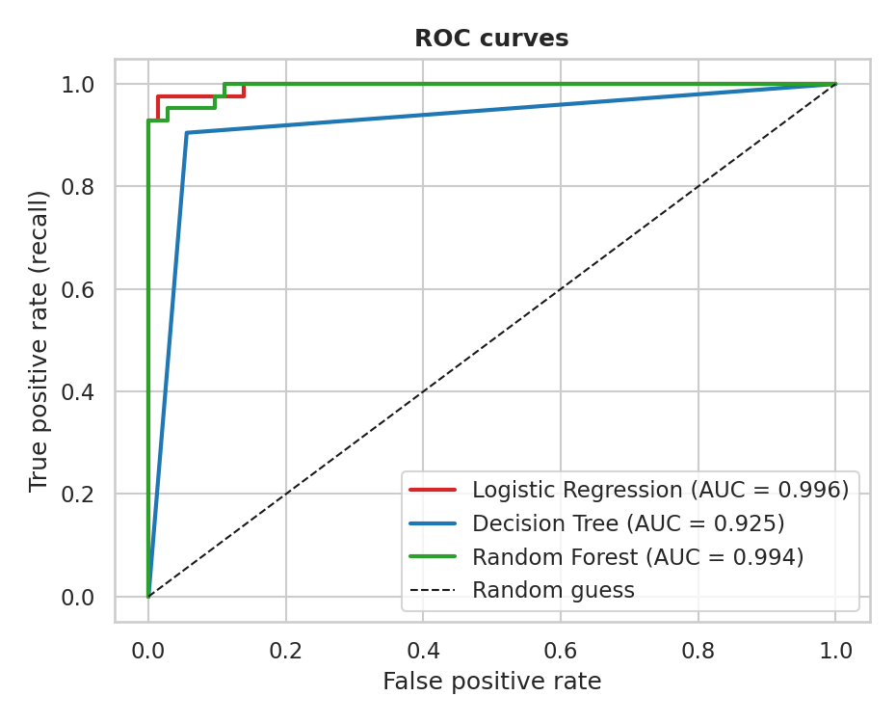
Figure 8: ROC curves for the three models
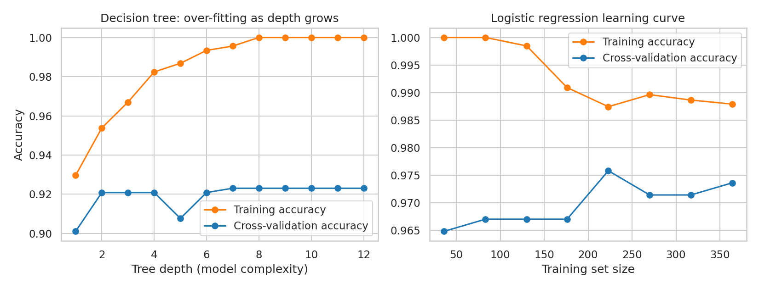
Figure 9: Over-fitting of the decision tree (left) and the healthy learning curve of logistic regression (right)
The logistic regression made 4 errors out of 114: one false alarm and three missed malignant tumours (recall 92.9%). A bootstrap 95% confidence interval for its accuracy is 93.0% to 99.1% and for recall 84.1% to 100%, so with only 42 malignant cases in the test set the true performance could be noticeably lower or higher. The differences between logistic regression and random forest are within this noise.
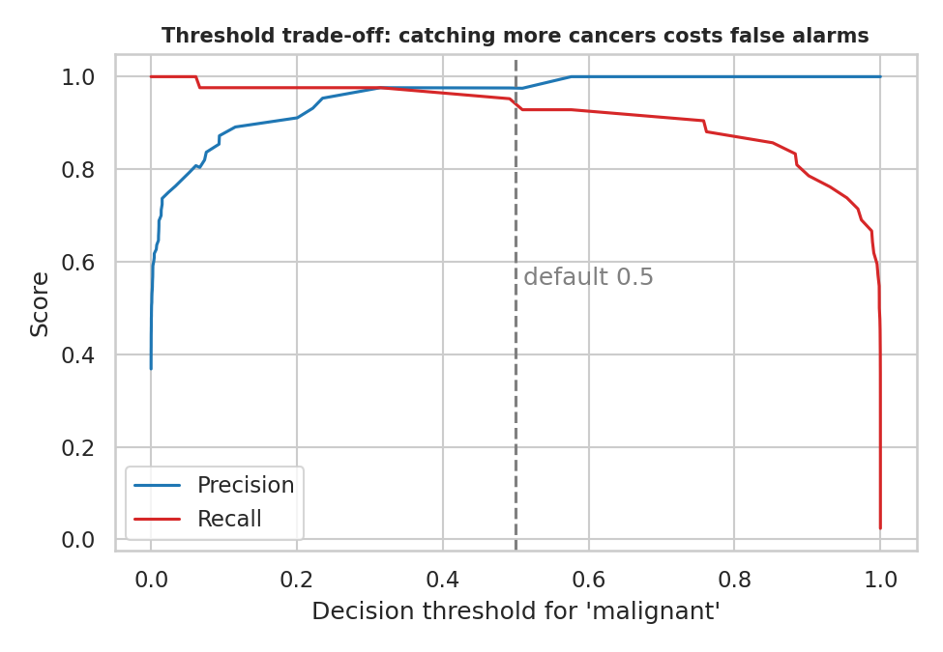
Figure 10: Lowering the decision threshold raises recall at the cost of precision

5. Discussion: How the Pieces Fit Together
Step | What it showed | What it enabled
Week 1 | Clean, complete data with a manageable outlier problem | A reliable base for analysis
Week 2 | Size and shape features separate the classes visually; many features are redundant | The idea that a simple model would work, and that fewer inputs may suffice
Week 3 | The differences are statistically real and large, not chance; four features carry no signal | Confidence that the model is learning real structure
Week 4 | A simple model uses this structure to predict well, but still misses a few cancers | A concrete tool and a list of its weaknesses

The evidence is consistent across approaches: charts, hypothesis tests and a predictive model all say that size and boundary-irregularity measurements are the main signal. One note on rigour: the quick accuracy checks in Week 2 were done before the pipeline was set up and are slightly optimistic, because scaling and PCA used all the data. The Week 4 pipeline results, where preprocessing is learned only from training data, are the figures to rely on.

6. Strategic Recommendations
# | Recommendation | Supporting evidence | Priority
1 | Use the model as a second reader that supports clinicians, never as an automatic diagnosis. Start with a pilot. | 96.5% test accuracy and AUC 0.996, but 3 of 42 cancers missed and a small test set | High
2 | Send borderline predictions (probability of malignancy between 0.3 and 0.7) to mandatory human review. | In the test set only 4 of 114 patients (3.5%) fell in this band, yet it held 3 of the 4 errors. This band was set after seeing the errors, so it must be confirmed on new data. | High
3 | Set the alert threshold by the cost of a missed cancer versus a false alarm, using validation data and not the test set. | Moving the threshold from 0.5 to 0.3 cut missed cancers from 3 to 1 in the test set (illustration only) | High
4 | Prioritise review of large tumours and high concave-points readings in the screening workflow. | 96% of tumours in the largest size quarter were malignant against 2% in the smallest; strong chi-square and ANOVA results | Medium
5 | Test whether fewer measurements are enough, and stop collecting features that add nothing. | Radius, perimeter and area are nearly identical; 6 components hold 90% of the variance; four features show no significant difference | Medium
6 | Validate on data from other hospitals and devices before any wider use, and monitor recall and precision over time. | Single-source data of 569 patients; wide confidence intervals | High
7 | Report recall and precision for the malignant class, not only accuracy. | 37% malignant share means accuracy alone hides the cost of missed cancers | Medium

How the recommendations drive decisions: recommendations 1 to 3 decide whether and how a pilot is run and how alerts are configured; recommendations 4 and 5 shape the workflow and the data collection cost; recommendations 6 and 7 protect the organisation against over-trusting the tool.

7. Potential Business and Research Impact

For hospitals and managers
- Faster triage: a model that gives an immediate risk score can help prioritise which cases specialists look at first.
- Fewer missed cancers when combined with human review of uncertain cases and a threshold tuned for recall.
- Lower data collection effort if the redundant measurements can be dropped after validation.
- Clear accountability: a simple, explainable model is easier to audit and to explain to patients and regulators than a black box.

For research
- The project gives a reproducible baseline (statistical tests plus three models) that more complex methods must beat.
- It identifies which measurements carry signal and which do not, guiding the design of future studies.
- Actual cost savings, time savings and clinical outcomes were not measured here and would have to be estimated in a pilot.

8. Limitations and Future Improvements

Limitations
- One dataset of 569 patients from a single study, so the results may not carry over to other populations, imaging equipment or measurement protocols.
- The Week 4 test set has only 114 patients (42 malignant), so every performance number is uncertain, as the bootstrap intervals show.
- The 0.3 to 0.7 review band and the 0.3 threshold were observed on the test set, so they are suggestions to verify and not tuned settings.
- The analysis shows statistical association and prediction, not cause, and has not undergone any clinical validation. It is a learning project and not a medical device.
- Many features are strongly correlated, which makes individual model coefficients unstable and the 30 feature tests not independent.

Future improvements
- Collect external validation data and use nested or repeated cross-validation for more stable estimates.
- Reduce redundant features with PCA or feature selection and compare L1 regularisation.
- Try gradient boosting and support vector machines, calibrate the probabilities, and choose the threshold on validation data.
- Review confident mistakes with a clinical expert and build an interface that shows each prediction with its uncertainty.
- Run a prospective pilot measuring workload, time to decision and missed or false cases.

9. Conclusion
Across five weeks the project moved from raw data to a tested, explainable model and a set of recommendations. Malignant tumours differ clearly and measurably from benign ones (mean radius difference 5.3, p < 0.001, risk rising from 2% to 96% across size groups), and a simple logistic regression turns this into 96.5% accuracy and 0.996 ROC-AUC on unseen patients. The honest caveat is that the evidence comes from one small dataset and that a few cancers were still missed. The recommended next step is therefore a supervised pilot with human review of borderline cases and external validation, not immediate deployment.

Appendix: Project Files and Reproducibility
Week | Report | Code and figures
1 | Week1_Data_Science_Report.docx | analysis.py, week1_eda.ipynb, 1_class.png to 5_heat.png
2 | Week2_Data_Visualization_Report.docx | week2_analysis.py, week2_viz.ipynb, v1 to v7 PNG files
3 | Week3_Hypothesis_Testing_Report.docx | week3_analysis.py, week3_hypothesis_testing.ipynb, s1 to s6 PNG files
4 | Week4_ML_Model_Report.docx | week4_model.py, week4_ml_model.ipynb, m1 to m6 PNG files
5 | This report | Combines the figures above

pip install pandas numpy matplotlib seaborn scikit-learn scipy
python analysis.py
python week2_analysis.py
python week3_analysis.py
python week4_model.py

