Data Acquisition, Cleaning and Exploratory Data Analysis
Virtual Data Science with Python Apprentice Intern – Week 1 Task

1. Introduction
The goal of this task is to simulate the data preparation workflow that every data science project starts with: acquiring a public dataset, cleaning and preprocessing it with Python, and exploring it with summary statistics and visualizations. All work was done in Python using Pandas, NumPy, Matplotlib, Seaborn and scikit-learn.

2. Data Acquisition
Domain chosen: healthcare. Dataset: Breast Cancer Wisconsin (Diagnostic), a public dataset from the UCI Machine Learning Repository, which is distributed with scikit-learn and loaded with load_breast_cancer(). It was chosen because it is well documented, widely used, and relevant to a real-world problem (early diagnosis of tumours).
Property | Value
Rows (patients) | 569
Columns | 31 (30 numeric features + diagnosis label)
Target | diagnosis: Benign (357) or Malignant (212)
Feature types | Mean, standard error and worst value of 10 cell-nucleus measurements (radius, texture, perimeter, area, smoothness, compactness, concavity, concave points, symmetry, fractal dimension)

from sklearn.datasets import load_breast_cancer
data = load_breast_cancer(as_frame=True)
df = data.frame.copy()
df['diagnosis'] = df['target'].map({0:'Malignant', 1:'Benign'})
df = df.drop(columns='target')

3. Data Cleaning and Preprocessing
Every step below was applied and its rationale is given.

3.1 Initial inspection
df.shape, df.dtypes, df.isnull().sum() and df.duplicated().sum() were checked first. Result: 569 rows, 30 float columns and one text column; 0 missing values; 0 duplicate rows. Because the dataset is already curated, no imputation was needed. If there had been missing numeric values, the plan was median imputation (robust to skew), and mode imputation for categorical columns.

3.2 Duplicates and column names
drop_duplicates() was still run as a safeguard (0 rows removed). Spaces in column names were replaced with underscores (for example "mean radius" became mean_radius) so columns can be used easily in code.

3.3 Validity checks
78 values were found to be zero or negative. All of them are in concavity and concave-points columns, where 0 is a valid value (it means the cell outline has no concave portions), so they were kept. This check avoided wrongly deleting genuine data.

3.4 Outlier handling
Outliers were detected using the IQR rule (values below Q1 − 1.5·IQR or above Q3 + 1.5·IQR). 171 of 569 rows had at least one outlier, mostly in area_error (65), radius_error (38), perimeter_error (38) and worst_area (35). Deleting 30% of the rows would lose a lot of information and bias the data, so the values were capped (winsorised) at the IQR limits instead. The number of rows stayed 569.
df = df.drop_duplicates().reset_index(drop=True)
df.columns = [c.replace(' ', '_') for c in df.columns]
num = df.select_dtypes('number').columns
q1, q3 = df[num].quantile(.25), df[num].quantile(.75)
iqr = q3 - q1
mask = (df[num] < q1-1.5*iqr) | (df[num] > q3+1.5*iqr)
clean = df.copy()
clean[num] = clean[num].clip(q1-1.5*iqr, q3+1.5*iqr, axis=1)

4. Exploratory Data Analysis

4.1 Summary statistics
Feature | Mean | Std | Min | Max
mean_radius | 14.06 | 3.34 | 6.98 | 21.90
mean_texture | 19.25 | 4.19 | 9.71 | 30.24
mean_area | 639.77 | 305.34 | 143.50 | 1326.30
mean_concavity | 0.09 | 0.07 | 0.00 | 0.28

Group average | mean_radius | mean_area | mean_concavity
Benign | 12.15 | 462.79 | 0.05
Malignant | 17.29 | 937.78 | 0.16

4.2 Visualizations
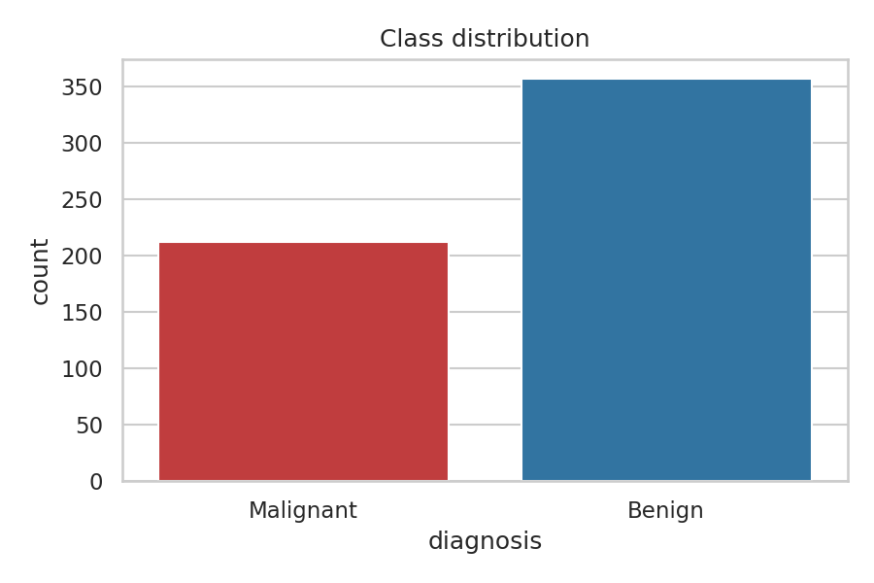
Figure 1: Class distribution (357 benign, 212 malignant)
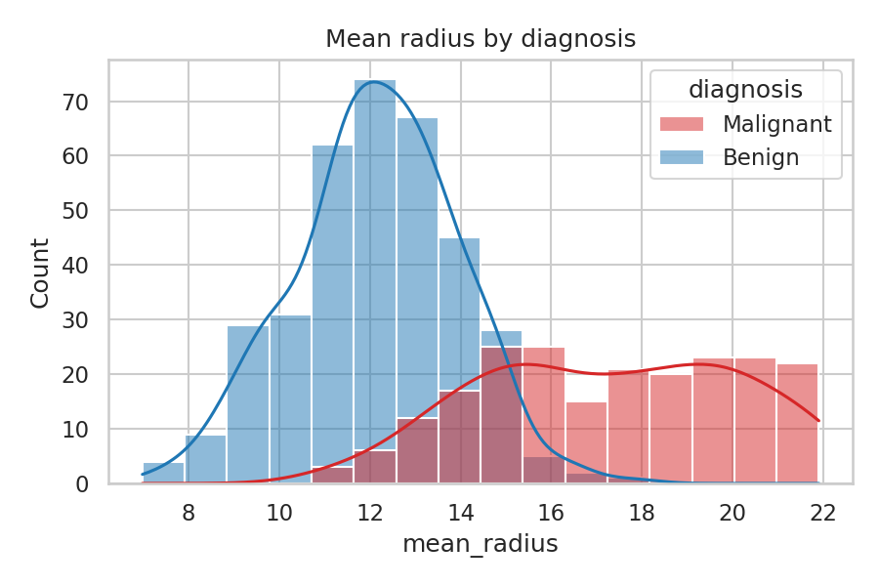
Figure 2: Distribution of mean radius by diagnosis
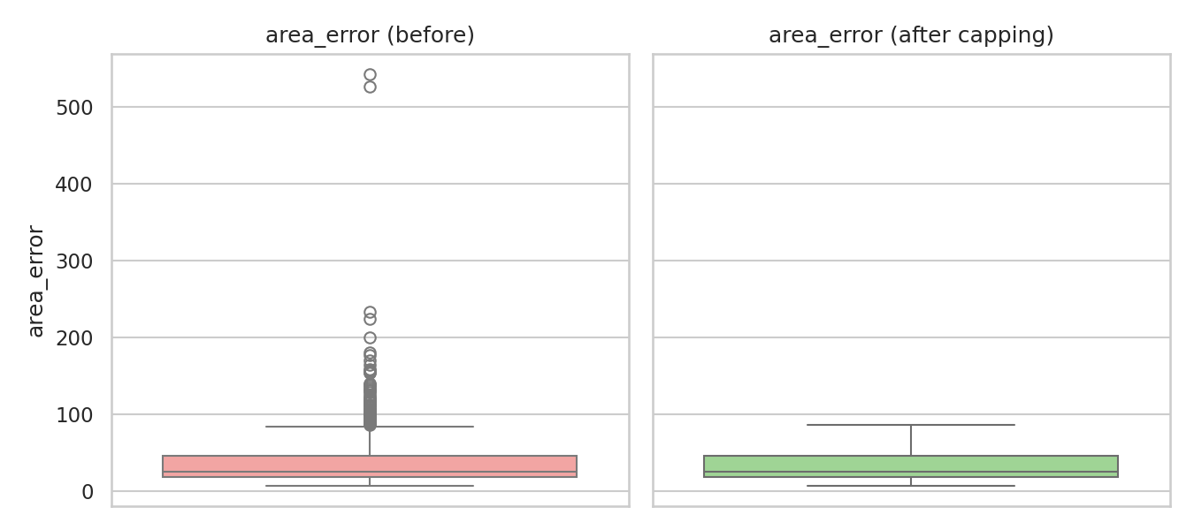
Figure 3: area_error before and after outlier capping
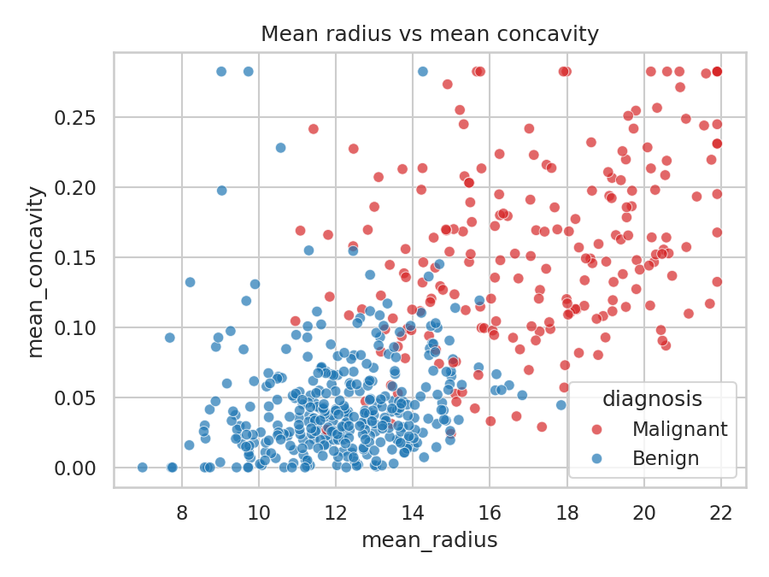
Figure 4: Mean radius vs mean concavity
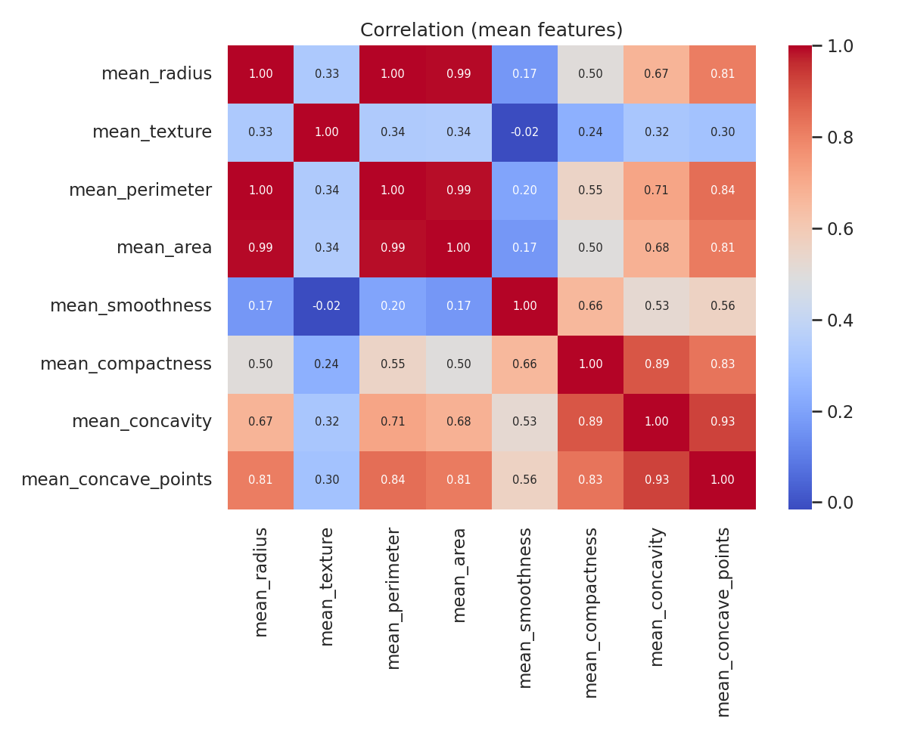
Figure 5: Correlation heatmap of mean features
The code used for all visualizations and statistics is included in the complete script below.

5. Insights
- The classes are moderately imbalanced: about 63% benign and 37% malignant. Accuracy alone would be a misleading metric for any later model.
- Malignant tumours are clearly larger: average mean radius 17.29 vs 12.15 and average mean area 937.78 vs 462.79. The histogram shows only a small overlap between the two groups.
- Malignant tumours also have more irregular outlines: average mean concavity is 0.16 vs 0.05, about three times higher. The scatter plot shows the two classes forming two fairly separate clusters.
- Strong multicollinearity exists: mean_radius is almost perfectly correlated with mean_perimeter (0.998) and mean_area (0.994). Keeping all of them adds little new information, so feature selection or PCA is recommended before modelling.
- The features most correlated with malignancy are worst_perimeter, worst_radius, worst_area, worst_concave_points and mean_concave_points (all about 0.79 to 0.80). Fractal dimension and texture error have almost no relationship with the diagnosis.

Areas for further analysis
- Train a classifier (logistic regression, random forest) and evaluate with recall, precision and ROC-AUC.
- Apply PCA to reduce the correlated size features.
- Compare results with and without outlier capping.

6. Conclusion
The dataset was acquired from a public source, checked for missing values, duplicates, invalid values and outliers, cleaned with justified choices, and explored with five visualizations. The analysis shows that size and shape features separate malignant from benign tumours very well, which makes this dataset a strong candidate for classification work in the following weeks.

Appendix: Complete Python Code
import pandas as pd, numpy as np, matplotlib
matplotlib.use("Agg")
import matplotlib.pyplot as plt, seaborn as sns
from sklearn.datasets import load_breast_cancer
sns.set_theme(style="whitegrid")

# 1. Data acquisition
data = load_breast_cancer(as_frame=True)
df = data.frame.copy()
df["diagnosis"] = df["target"].map({0: "Malignant", 1: "Benign"})
df = df.drop(columns="target")
print("Shape:", df.shape)
print(df.dtypes.value_counts())
print("Missing total:", int(df.isnull().sum().sum()))
print("Duplicates:", int(df.duplicated().sum()))
print(df["diagnosis"].value_counts())

# 2. Cleaning
raw_rows = len(df)
df = df.drop_duplicates().reset_index(drop=True)
df.columns = [c.replace(" ", "_") for c in df.columns]
num = df.select_dtypes("number").columns
# simulate-check: any impossible values (<=0 for size features)
print("Non-positive values:", int((df[num] <= 0).sum().sum()))
# outliers by IQR
q1, q3 = df[num].quantile(.25), df[num].quantile(.75)
iqr = q3 - q1
mask = (df[num] < q1 - 1.5*iqr) | (df[num] > q3 + 1.5*iqr)
out_counts = mask.sum().sort_values(ascending=False)
print("Rows with >=1 outlier:", int(mask.any(axis=1).sum()))
print(out_counts.head(5))
# winsorise (cap) instead of dropping
clean = df.copy()
clean[num] = clean[num].clip(q1 - 1.5*iqr, q3 + 1.5*iqr, axis=1)
print("Rows before/after:", raw_rows, len(clean))

# 3. EDA
print(clean[["mean_radius","mean_area","mean_texture","mean_concavity"]].describe().round(2))
print(clean.groupby("diagnosis")[["mean_radius","mean_area","mean_concavity"]].mean().round(2))
corr = clean[num].corr()
tgt = clean.assign(y=(clean.diagnosis=="Malignant").astype(int))[list(num)+["y"]].corr()["y"].drop("y").sort_values()
print(tgt.head(5).round(2)); print(tgt.tail(5).round(2))
hi = corr.where(np.triu(np.ones(corr.shape),1).astype(bool)).stack().sort_values(ascending=False)
print(hi.head(3).round(3))

pal = {"Malignant":"#d62728","Benign":"#1f77b4"}
plt.figure(figsize=(6,4)); sns.countplot(x="diagnosis", data=clean, palette=pal, hue="diagnosis", legend=False)
plt.title("Class distribution"); plt.tight_layout(); plt.savefig("figs/1_class.png", dpi=150); plt.close()

plt.figure(figsize=(6,4)); sns.histplot(data=clean, x="mean_radius", hue="diagnosis", kde=True, palette=pal)
plt.title("Mean radius by diagnosis"); plt.tight_layout(); plt.savefig("figs/2_hist.png", dpi=150); plt.close()

# before/after outliers boxplot
fig, ax = plt.subplots(1,2, figsize=(9,4), sharey=True)
sns.boxplot(y=df["area_error"], ax=ax[0], color="#ff9896"); ax[0].set_title("area_error (before)")
sns.boxplot(y=clean["area_error"], ax=ax[1], color="#98df8a"); ax[1].set_title("area_error (after capping)")
plt.tight_layout(); plt.savefig("figs/3_box.png", dpi=150); plt.close()

plt.figure(figsize=(6,4.5)); sns.scatterplot(data=clean, x="mean_radius", y="mean_concavity", hue="diagnosis", palette=pal, alpha=.7)
plt.title("Mean radius vs mean concavity"); plt.tight_layout(); plt.savefig("figs/4_scatter.png", dpi=150); plt.close()

cols = ["mean_radius","mean_texture","mean_perimeter","mean_area","mean_smoothness","mean_compactness","mean_concavity","mean_concave_points"]
plt.figure(figsize=(8,6.5)); sns.heatmap(clean[cols].corr(), annot=True, fmt=".2f", cmap="coolwarm", annot_kws={"size":7})
plt.title("Correlation (mean features)"); plt.tight_layout(); plt.savefig("figs/5_heat.png", dpi=150); plt.close()

