Statistical Analysis and Hypothesis Testing in Python
Do malignant and benign tumours really differ? Testing the evidence
Virtual Data Science with Python Apprentice Intern – Week 3 Task

1. Introduction and Hypotheses
Charts can suggest that two groups differ, but a statistical test tells us how much to trust that impression and how big the difference really is. The scientific problem studied here is whether the cell-nucleus measurements taken from breast tumour samples can distinguish malignant tumours from benign ones. The real-world relevance is direct: if a measurement differs reliably between the two groups, it is a candidate input for screening and decision-support tools.
The main hypothesis, stated before running any test, is:
 | Statement
H0 (null) | The mean radius of malignant tumours equals the mean radius of benign tumours.
H1 (alternative) | The mean radius of malignant tumours is different from that of benign tumours (two-sided).
Significance level | α = 0.05, decided in advance. A 95% confidence interval is reported for each key estimate.

Four supporting hypotheses are tested to cover different test types: (H2) a feature expected to show no difference (mean fractal dimension), (H3) whether tumour size group is associated with diagnosis (chi-square), (H4) whether average concave points differ across the four size groups (ANOVA), and (H5) a screening of all 30 features with correction for multiple testing.

2. Data
The Breast Cancer Wisconsin (Diagnostic) dataset from the UCI Machine Learning Repository is used, loaded with scikit-learn (the same dataset as Weeks 1 and 2). It contains 569 patients: 212 malignant and 357 benign. Each patient has 30 numeric measurements computed from a digitised image of a fine needle aspirate (mean, standard error and worst value of ten nucleus properties).
Data requirements for the planned tests were checked: one row per patient (so observations are independent), numeric outcome variables for the t-tests and ANOVA, a categorical grouping variable for the chi-square test, and no missing values (confirmed in Week 1). Unlike in Weeks 1 and 2, the raw values are used here without capping the outliers, because a hypothesis test should be run on the data as actually measured. For this reason the malignant mean radius is 17.46 here, compared with 17.29 in Week 1 after capping.

3. Methodology

3.1 Design and analytical approach
- Compare two independent groups on a numeric measure: Welch t-test (does not assume equal variances), supported by the non-parametric Mann-Whitney U test as a robustness check.
- Report the effect size (Cohen's d) and the 95% confidence interval of the difference, since a p-value alone does not say how large an effect is.
- Test association between two categorical variables (size group and diagnosis): chi-square test of independence with Cramér's V as the effect size.
- Compare more than two groups: one-way ANOVA with a Kruskal-Wallis check and Tukey's post-hoc test, with eta-squared as effect size.
- When many tests are run together, control false positives with Bonferroni and Benjamini-Hochberg (false discovery rate) corrections.

3.2 Checking the assumptions
The Shapiro-Wilk test on mean radius gave p = 0.668 for benign tumours (consistent with normality) and p = 0.0019 for malignant tumours (a mild departure). Levene's test strongly rejected equal variances (p < 0.001). The Q-Q plots in Figure 1 show that both groups follow the straight line closely, with small deviations only in the tails of the malignant group. With 212 and 357 patients the t-test is robust to this, and Welch's version handles the unequal variances. The Mann-Whitney test is added as a check that does not rely on normality.
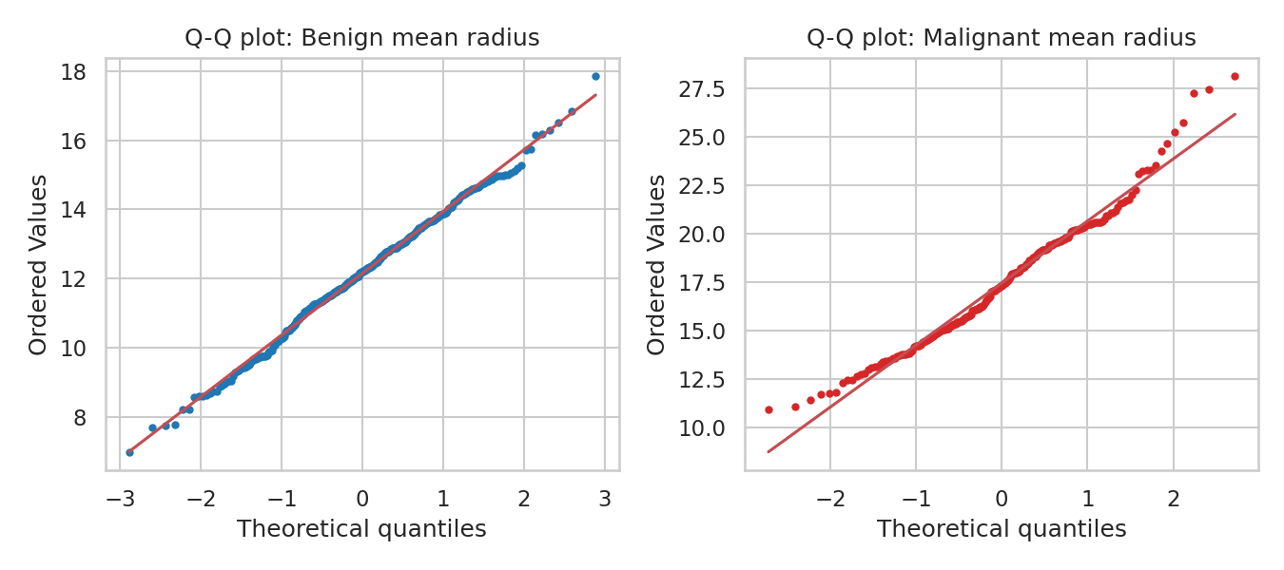
Figure 1: Q-Q plots of mean radius for benign and malignant tumours

4. Analysis and Results

4.1 Main hypothesis: mean radius (Welch t-test)
Measure | Result
Mean radius, benign (n = 357) | 12.15
Mean radius, malignant (n = 212) | 17.46
Difference (malignant − benign) | 5.32, 95% CI [4.85, 5.79]
Welch t-statistic | t = 22.21
p-value | 1.7 × 10⁻⁶⁴ (p < 0.001)
Effect size (Cohen's d) | 2.21 (very large)
Mann-Whitney U test | p = 2.7 × 10⁻⁶⁸ (same conclusion)

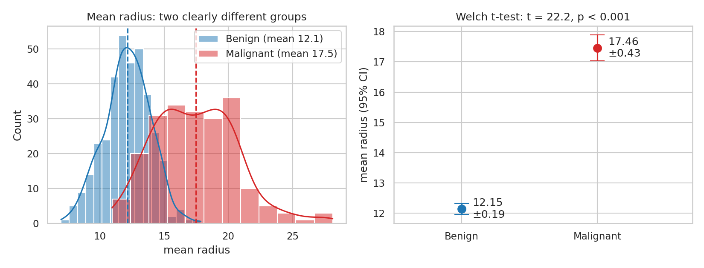
Figure 2: Left: distribution of mean radius with group means (dashed). Right: group means with 95% confidence intervals
Interpretation. H0 is rejected. The p-value means that if the true mean radii were equal, a difference this large or larger would almost never occur by chance. The 95% confidence interval says the true difference is plausibly between 4.85 and 5.79 units; it is far from zero, so the direction and size of the difference are both clear. The confidence intervals of the two group means in Figure 2 do not come anywhere near each other. A Cohen's d above 2 means the group averages are more than two standard deviations apart.

4.2 A feature with no detectable difference: mean fractal dimension
Measure | Result
Mean, benign / malignant | 0.0629 / 0.0627
Difference | −0.0002, 95% CI [−0.0014, 0.0011]
Welch t-test | t = −0.30, p = 0.767
Cohen's d | −0.03 (negligible)

Interpretation. H0 is not rejected. Not rejecting H0 is not proof that the groups are identical, but the confidence interval is narrow and centred on zero, so any real difference is tiny. This feature gives almost no help in separating the two classes. It is included on purpose to show that the tests do not simply flag everything as significant. Figure 3 shows the effect sizes of several features side by side: the fractal dimension interval is the only one that crosses zero.
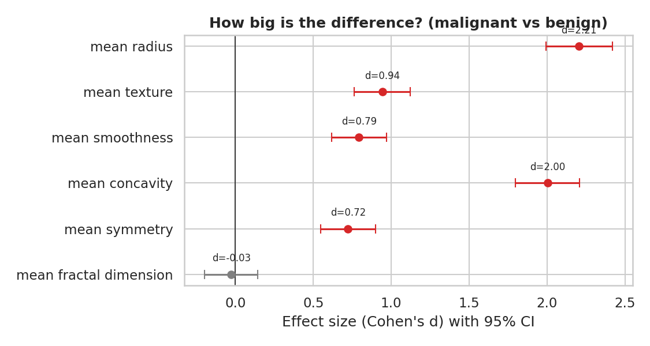
Figure 3: Effect sizes (Cohen's d) with 95% confidence intervals; grey means the interval includes zero

4.3 Is tumour size group associated with diagnosis? (chi-square)
Patients were split into four equal-sized groups by mean area (quartiles).
Size group | Benign | Malignant | % malignant
Q1 smallest | 141 | 3 | 2%
Q2 | 127 | 14 | 10%
Q3 | 83 | 59 | 42%
Q4 largest | 6 | 136 | 96%

H0: size group and diagnosis are independent. Result: χ² = 330.4, 3 degrees of freedom, p = 2.6 × 10⁻⁷¹, Cramér's V = 0.76 (a strong association). All expected counts were above 52, so the chi-square test is valid.
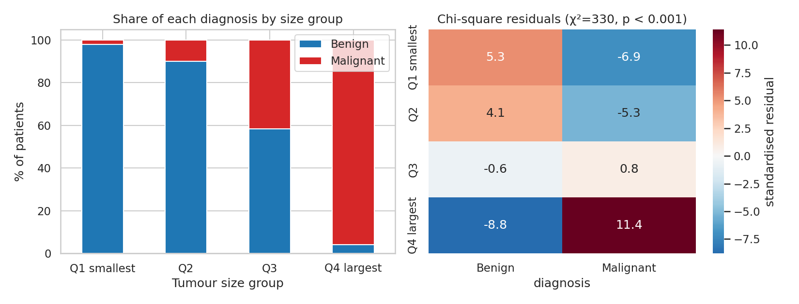
Figure 4: Left: diagnosis share by size group. Right: standardised residuals (positive = more cases than expected under independence)
Interpretation. H0 is rejected. The residual heatmap shows where the association comes from: small tumours are much more often benign than expected (+5.3) and large tumours much more often malignant (+11.4). The middle group (Q3) is close to the expected split. Association is not causation: size is an indicator in this dataset, not proof that large size makes a tumour malignant.

4.4 Do concave points differ across size groups? (one-way ANOVA)
H0: the mean of mean concave points is the same in all four size groups.
Size group | Mean concave points
Q1 smallest | 0.022
Q2 | 0.029
Q3 | 0.049
Q4 largest | 0.097

Result: F(3, 565) = 245.9, p = 4.6 × 10⁻¹⁰², eta-squared = 0.57, meaning size group explains about 57% of the variation in concave points. The Kruskal-Wallis check agrees (H = 310.7, p < 0.001). Tukey's post-hoc test shows that every pair of groups differs significantly except Q1 versus Q2 (p = 0.056, just above 0.05).
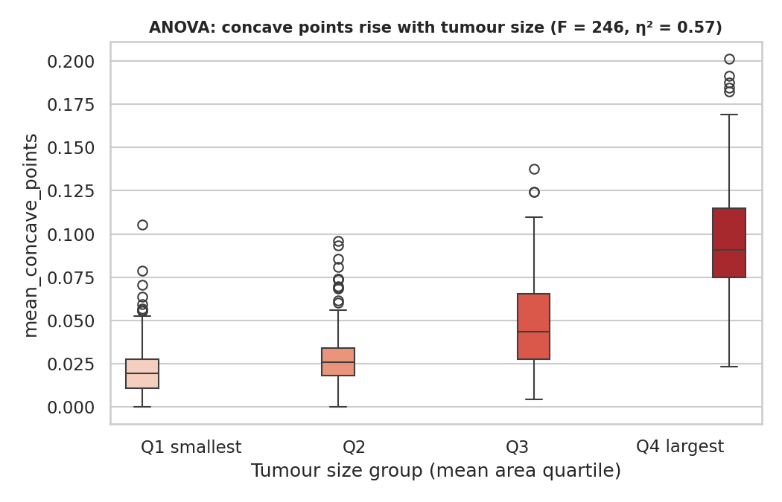
Figure 5: Mean concave points by tumour size group
Interpretation. H0 is rejected. Concave points increase steadily with size, and the largest group is far above the rest. The ANOVA only says that at least one group differs, which is why the post-hoc test is needed to say which ones.

4.5 Screening all 30 features with multiple-testing correction
Running 30 tests at α = 0.05 would produce about 1.5 false positives by chance alone, so the p-values were corrected. Welch t-tests were run for all 30 features (malignant vs benign).
Method | Features significant (of 30)
Uncorrected, p < 0.05 | 26
Bonferroni correction | 25
Benjamini-Hochberg (FDR) | 26

Four features are not significant after correction: mean fractal dimension, texture error, smoothness error and symmetry error. The largest effects are for worst concave points (d = 2.69), worst perimeter (2.60), mean concave points (2.55) and worst radius (2.54).
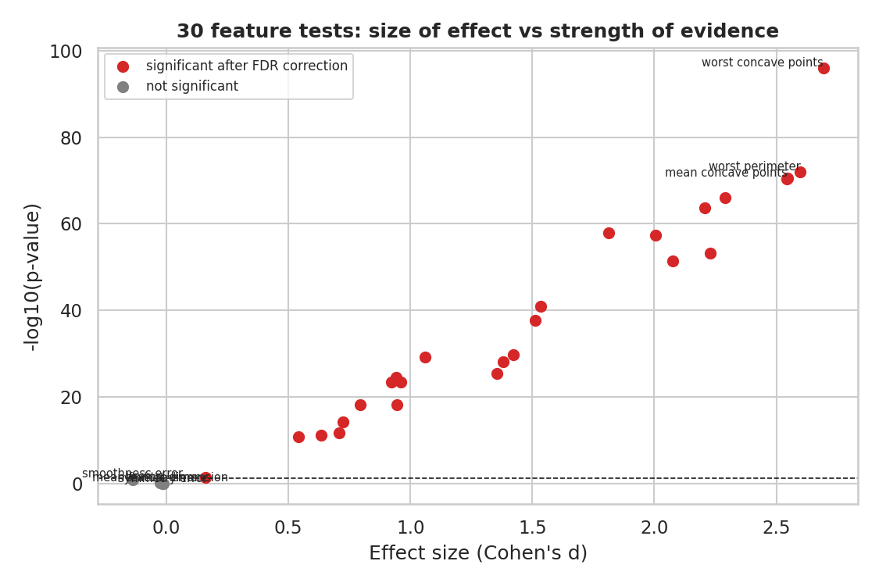
Figure 6: Effect size against strength of evidence for all 30 features; red points remain significant after FDR correction
Interpretation. The result is robust to correction: the features that matter stay significant under both the strict (Bonferroni) and the more flexible (FDR) approach. The figure also shows that p-values and effect sizes are different things. With 569 patients even small differences can reach tiny p-values, so effect size has to be read alongside them.

5. Validity of the Hypothesis and Discussion
- The main hypothesis is strongly supported: malignant tumours have a larger mean radius by about 5.3 units (95% CI 4.85 to 5.79), the result holds under a parametric and a non-parametric test, and the effect is very large.
- The supporting tests all point the same way: size group is strongly associated with diagnosis, and concave points rise across size groups.
- The negative result (fractal dimension) and the corrected screening show the analysis can also find no effect, so the findings are not simply a product of testing many things.
- Implication: size and boundary-irregularity measurements are strong candidates for screening and decision-support tools, while fractal dimension and the three error features listed above add little on their own.

Limitations
- A very small p-value does not mean a large or clinically useful effect; that is why effect sizes and confidence intervals are reported.
- The data come from one study of 569 patients, so the results may not carry over to other equipment or populations.
- These tests show association, not cause. They describe the data and are not clinical advice.
- Features are correlated with one another (Week 2), so the 30 tests are not independent evidence; they are best read as a screening step before modelling.
- Size groups come from quartile cut-points, which is a convenient but arbitrary way to group a continuous variable.

6. Conclusion
The null hypothesis that malignant and benign tumours have the same mean radius is rejected (t = 22.2, p < 0.001, difference 5.32 with 95% CI 4.85 to 5.79, Cohen's d = 2.21). Chi-square and ANOVA tests show that size group is strongly linked to both diagnosis and concave points, and a corrected screening of all 30 features shows that 26 of them differ between the groups while four do not. Together they give consistent, well-checked evidence that size and shape measurements separate the two tumour types, and they set up the next step of building and validating a predictive model.

Appendix: Complete Python Code
import pandas as pd, numpy as np, matplotlib
matplotlib.use("Agg")
import matplotlib.pyplot as plt, seaborn as sns
from scipy import stats
from sklearn.datasets import load_breast_cancer
sns.set_theme(style="whitegrid")
pal = {"Malignant":"#d62728","Benign":"#1f77b4"}
ALPHA = 0.05

# ---------- Data (raw values, no outlier capping: tests should see the real data) ----------
df = load_breast_cancer(as_frame=True).frame
df["diagnosis"] = df["target"].map({0:"Malignant",1:"Benign"}); df = df.drop(columns="target")
df.columns = [c.replace(" ","_") for c in df.columns]
M = df[df.diagnosis=="Malignant"]; Bn = df[df.diagnosis=="Benign"]
print("n malignant", len(M), "n benign", len(Bn))

def welch_ci(a, b, conf=.95):
diff = a.mean()-b.mean(); va, vb = a.var(ddof=1)/len(a), b.var(ddof=1)/len(b)
se = np.sqrt(va+vb); dof = (va+vb)**2/(va**2/(len(a)-1)+vb**2/(len(b)-1))
t = stats.t.ppf(1-(1-conf)/2, dof); return diff, diff-t*se, diff+t*se
def cohen_d(a,b):
sp = np.sqrt(((len(a)-1)*a.var(ddof=1)+(len(b)-1)*b.var(ddof=1))/(len(a)+len(b)-2)); return (a.mean()-b.mean())/sp

# ---------- Test 0: assumptions ----------
print("\n== Assumption checks: mean_radius ==")
for name,g in [("Malignant",M),("Benign",Bn)]:
w,p = stats.shapiro(g.mean_radius); print(f"Shapiro {name}: W={w:.3f}, p={p:.4f}")
lv = stats.levene(M.mean_radius, Bn.mean_radius); print(f"Levene: stat={lv.statistic:.2f}, p={lv.pvalue:.2e}")

# ---------- Test 1: Welch t-test, mean radius ----------
a,b = M.mean_radius, Bn.mean_radius
t,p = stats.ttest_ind(a,b,equal_var=False); diff,lo,hi = welch_ci(a,b); d = cohen_d(a,b)
print(f"\n== H1 Welch t-test mean_radius ==\nmeans M={a.mean():.2f} B={b.mean():.2f}; t={t:.2f}, p={p:.2e}; diff={diff:.2f} 95%CI[{lo:.2f},{hi:.2f}]; d={d:.2f}")
u,pu = stats.mannwhitneyu(a,b,alternative="two-sided"); print(f"Mann-Whitney U={u:.0f}, p={pu:.2e}")

# ---------- Test 2: non-significant example ----------
a2,b2 = M.mean_fractal_dimension, Bn.mean_fractal_dimension
t2,p2 = stats.ttest_ind(a2,b2,equal_var=False); diff2,lo2,hi2 = welch_ci(a2,b2)
print(f"\n== H2 Welch t-test mean_fractal_dimension ==\nmeans M={a2.mean():.4f} B={b2.mean():.4f}; t={t2:.2f}, p={p2:.3f}; diff={diff2:.5f} 95%CI[{lo2:.5f},{hi2:.5f}]; d={cohen_d(a2,b2):.2f}")

# ---------- Test 3: chi-square size group vs diagnosis ----------
df["size_group"] = pd.qcut(df.mean_area, 4, labels=["Q1 smallest","Q2","Q3","Q4 largest"])
ct = pd.crosstab(df.size_group, df.diagnosis); chi2,pc,dof,exp = stats.chi2_contingency(ct)
cv = np.sqrt(chi2/(ct.values.sum()*(min(ct.shape)-1)))
print(f"\n== H3 Chi-square ==\n{ct}\nchi2={chi2:.1f}, dof={dof}, p={pc:.2e}, Cramer's V={cv:.2f}; min expected={exp.min():.1f}")

# ---------- Test 4: ANOVA across size groups ----------
groups = [g.mean_concave_points.values for _,g in df.groupby("size_group", observed=True)]
F,pa = stats.f_oneway(*groups); H,pk = stats.kruskal(*groups)
grand = df.mean_concave_points.mean(); ssb = sum(len(g)*(g.mean()-grand)**2 for g in groups); sst = ((df.mean_concave_points-grand)**2).sum()
print(f"\n== H4 ANOVA mean_concave_points by size group ==\nF={F:.1f}, p={pa:.2e}, eta^2={ssb/sst:.2f}; Kruskal H={H:.1f}, p={pk:.2e}")
tk = stats.tukey_hsd(*groups); print("Tukey p-values (rows/cols = Q1..Q4):"); print(np.round(tk.pvalue,4))
print("group means:", df.groupby("size_group", observed=True).mean_concave_points.mean().round(3).to_dict())

# ---------- Test 5: all 30 features + multiple-testing correction ----------
rows=[]
for c in [c for c in df.columns if c not in ("diagnosis","size_group")]:
tt,pp = stats.ttest_ind(M[c],Bn[c],equal_var=False); rows.append((c,tt,pp,cohen_d(M[c],Bn[c])))
res = pd.DataFrame(rows, columns=["feature","t","p","d"])
res["p_bonf"] = np.minimum(res.p*len(res),1); res["p_bh"] = stats.false_discovery_control(res.p.values, method="bh")
print(f"\n== H5 30 t-tests ==\nraw p<0.05: {(res.p<ALPHA).sum()}; Bonferroni: {(res.p_bonf<ALPHA).sum()}; BH-FDR: {(res.p_bh<ALPHA).sum()}")
print("not significant after BH:", res.loc[res.p_bh>=ALPHA,"feature"].tolist())
print(res.reindex(res.d.abs().sort_values(ascending=False).index).head(5).round(3))

# ================= FIGURES =================
fig,ax = plt.subplots(1,2, figsize=(11,4.2))
for diag,g in [("Benign",Bn),("Malignant",M)]:
sns.histplot(g.mean_radius, kde=True, color=pal[diag], alpha=.5, ax=ax[0], label=f"{diag} (mean {g.mean_radius.mean():.1f})")
ax[0].axvline(g.mean_radius.mean(), color=pal[diag], ls="--")
ax[0].set_title("Mean radius: two clearly different groups"); ax[0].set_xlabel("mean radius"); ax[0].legend()
for i,(diag,g) in enumerate([("Benign",Bn),("Malignant",M)]):
m=g.mean_radius.mean(); h=stats.t.ppf(.975,len(g)-1)*g.mean_radius.sem()
ax[1].errorbar(i, m, yerr=h, fmt="o", color=pal[diag], capsize=8, markersize=9)
ax[1].text(i+0.08, m, f"{m:.2f}\n±{h:.2f}", va="center")
ax[1].set_xticks([0,1]); ax[1].set_xticklabels(["Benign","Malignant"]); ax[1].set_xlim(-.5,1.7)
ax[1].set_ylabel("mean radius (95% CI)"); ax[1].set_title(f"Welch t-test: t = {t:.1f}, p < 0.001")
plt.tight_layout(); plt.savefig("w3figs/s1_hist_ci.png", dpi=150); plt.close()

fig,ax = plt.subplots(1,2, figsize=(9,4))
for a_,(diag,g) in zip(ax,[("Benign",Bn),("Malignant",M)]):
stats.probplot(g.mean_radius, dist="norm", plot=a_); a_.set_title(f"Q-Q plot: {diag} mean radius")
a_.get_lines()[0].set_color(pal[diag]); a_.get_lines()[0].set_markersize(3)
plt.tight_layout(); plt.savefig("w3figs/s2_qq.png", dpi=150); plt.close()

feats = ["mean_radius","mean_texture","mean_smoothness","mean_concavity","mean_symmetry","mean_fractal_dimension"]
fig,ax = plt.subplots(figsize=(7.5,4))
for i,f in enumerate(feats):
x,y = M[f],Bn[f]; dd = cohen_d(x,y); n1,n2=len(x),len(y)
se = np.sqrt((n1+n2)/(n1*n2)+dd**2/(2*(n1+n2))); sigf = abs(dd)-1.96*se>0
ax.errorbar(dd, i, xerr=1.96*se, fmt="o", color="#d62728" if sigf else "grey", capsize=4)
ax.text(dd, i-0.28, f"d={dd:.2f}", ha="center", fontsize=8)
ax.axvline(0,c="k",lw=.8); ax.set_yticks(range(len(feats))); ax.set_yticklabels([f.replace("_"," ") for f in feats]); ax.invert_yaxis()
ax.set_xlabel("Effect size (Cohen's d) with 95% CI"); ax.set_title("How big is the difference? (malignant vs benign)", fontweight="bold")
plt.tight_layout(); plt.savefig("w3figs/s3_forest.png", dpi=150); plt.close()

fig,ax = plt.subplots(1,2, figsize=(11,4.2))
pct = ct.div(ct.sum(axis=1), axis=0)*100
pct[["Benign","Malignant"]].plot(kind="bar", stacked=True, color=[pal["Benign"],pal["Malignant"]], ax=ax[0], rot=0)
ax[0].set_ylabel("% of patients"); ax[0].set_xlabel("Tumour size group"); ax[0].set_title("Share of each diagnosis by size group"); ax[0].legend(title="")
resid = (ct.values-exp)/np.sqrt(exp)
sns.heatmap(pd.DataFrame(resid, index=ct.index, columns=ct.columns), annot=True, fmt=".1f", cmap="RdBu_r", center=0, ax=ax[1], cbar_kws={"label":"standardised residual"})
ax[1].set_title(f"Chi-square residuals (χ²={chi2:.0f}, p < 0.001)"); ax[1].set_ylabel("")
plt.tight_layout(); plt.savefig("w3figs/s4_chi2.png", dpi=150); plt.close()

plt.figure(figsize=(7,4.5))
sns.boxplot(data=df, x="size_group", y="mean_concave_points", hue="size_group", palette="Reds", legend=False)
plt.title(f"ANOVA: concave points rise with tumour size (F = {F:.0f}, η² = {ssb/sst:.2f})", fontsize=10, fontweight="bold")
plt.xlabel("Tumour size group (mean area quartile)"); plt.tight_layout(); plt.savefig("w3figs/s5_anova.png", dpi=150); plt.close()

plt.figure(figsize=(7.5,5))
sig = res.p_bh<ALPHA
plt.scatter(res.d[sig], -np.log10(res.p[sig]), c="#d62728", label="significant after FDR correction", s=40)
plt.scatter(res.d[~sig], -np.log10(res.p[~sig]), c="grey", label="not significant", s=40)
plt.axhline(-np.log10(ALPHA), ls="--", c="k", lw=.8)
for _,r in res.sort_values("d",key=abs,ascending=False).head(3).iterrows(): plt.text(r.d, -np.log10(r.p)+.4, r.feature.replace("_"," "), fontsize=7, ha="right")
for _,r in res[~sig].iterrows(): plt.text(r.d, -np.log10(r.p)+.4, r.feature.replace("_"," "), fontsize=7, ha="center")
plt.xlabel("Effect size (Cohen's d)"); plt.ylabel("-log10(p-value)"); plt.legend(loc="upper left", fontsize=8)
plt.title("30 feature tests: size of effect vs strength of evidence", fontweight="bold"); plt.tight_layout(); plt.savefig("w3figs/s6_volcano.png", dpi=150); plt.close()
res.round(4).to_csv("w3figs/all_feature_tests.csv", index=False)

