Machine Learning Model Development and Evaluation
Predicting malignant tumours from cell measurements
Virtual Data Science with Python Apprentice Intern – Week 4 Task

1. Introduction and Problem Definition
The goal of this task is to build, train and critically evaluate a basic machine learning model, and to document every step from preprocessing to final assessment. The problem is a binary classification: given 30 measurements of cell nuclei from a breast tissue sample, predict whether the tumour is malignant or benign.
In this problem the two types of mistake are not equally costly. Missing a malignant tumour (a false negative) is far more serious than flagging a benign one for extra checks (a false positive). For this reason malignant is treated as the positive class (label 1), and recall for that class receives special attention alongside overall accuracy.

2. Data Preparation
The Breast Cancer Wisconsin (Diagnostic) dataset from the UCI Machine Learning Repository was loaded through scikit-learn. It has 569 patients and 30 numeric features. Checks showed no missing values and no duplicate rows, and 37.3% of patients are malignant (212 of 569).
- Target: encoded so that malignant = 1 and benign = 0.
- Train/test split: 80% training (455 patients) and 20% test (114 patients), stratified so that both parts keep the same class balance (37.4% and 36.8% malignant). The test set was kept untouched until the final evaluation.
- Scaling: features were standardised (mean 0, standard deviation 1), which logistic regression needs because the features have very different ranges (area is in hundreds, smoothness below 0.2).
- Avoiding data leakage: the scaler is placed inside a scikit-learn Pipeline, so within cross-validation it is fitted only on the training folds and never sees the validation or test data.
- Outliers were not removed or capped here, because the models are evaluated on the data as it naturally occurs.
X_tr, X_te, y_tr, y_te = train_test_split(X, y, test_size=0.2, stratify=y, random_state=42)
pipe = Pipeline([('sc', StandardScaler()), ('m', LogisticRegression(max_iter=5000))])

3. Algorithm Selection and Justification
Three algorithms were compared so that the choice is evidence-based rather than assumed.
Model | Why it was included
Logistic Regression (chosen) | Simple, fast and interpretable: each feature gets one coefficient. Works well when classes are roughly linearly separable, which the earlier weeks suggested for this data.
Decision Tree | Easy to explain as a set of rules, but known to over-fit. Included as a baseline and to demonstrate over-fitting.
Random Forest | An ensemble of 300 trees, usually more accurate and stable than a single tree. Included as a stronger reference model.

Hyperparameters were tuned only on the training data with 5-fold stratified cross-validation, using recall as the scoring metric because missing a malignant case is the costly error. The best settings were C = 1 for logistic regression and a maximum depth of 8 for the decision tree.
Logistic regression was selected as the final model because it had the highest cross-validated accuracy (97.4%), an excellent ROC-AUC (0.996), the smallest gap between training and validation scores, and it is the easiest to explain to doctors or managers.

4. Evaluation

4.1 Metrics used
- Accuracy: share of all patients classified correctly.
- Precision: of the patients predicted malignant, how many truly are. High precision means few false alarms.
- Recall (sensitivity): of the truly malignant patients, how many were found. High recall means few missed cancers.
- F1-score: the balance between precision and recall.
- ROC-AUC: how well the model ranks malignant above benign across all thresholds (1.0 is perfect, 0.5 is random guessing).

4.2 Results on the unseen test set (114 patients)
Model | CV acc. | Train acc. | Test acc. | Precision | Recall | F1 | ROC-AUC
Logistic Regression | 0.974 | 0.987 | 0.965 | 0.975 | 0.929 | 0.951 | 0.996
Decision Tree | 0.923 | 1.000 | 0.930 | 0.905 | 0.905 | 0.905 | 0.925
Random Forest | 0.960 | 1.000 | 0.974 | 1.000 | 0.929 | 0.963 | 0.994

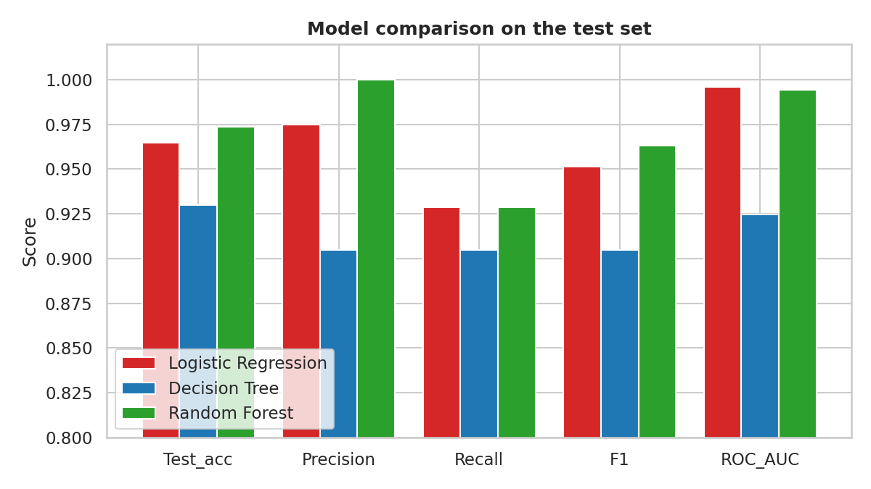
Figure 1: Test-set metrics for the three models
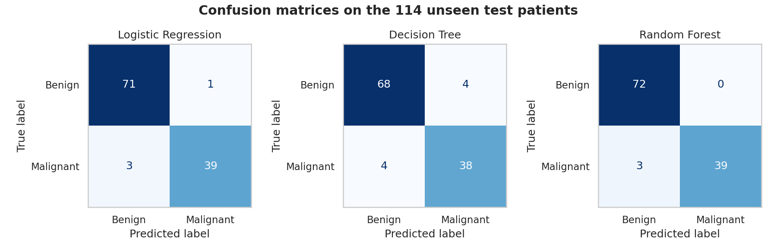
Figure 2: Confusion matrices on the test set (rows: true class, columns: predicted class)
Reading the confusion matrices. Logistic regression made 4 mistakes in 114: 1 false alarm (a benign tumour called malignant) and 3 missed malignant tumours. The decision tree made 8 mistakes (4 and 4), and the random forest made 3 mistakes (0 false alarms and 3 missed).
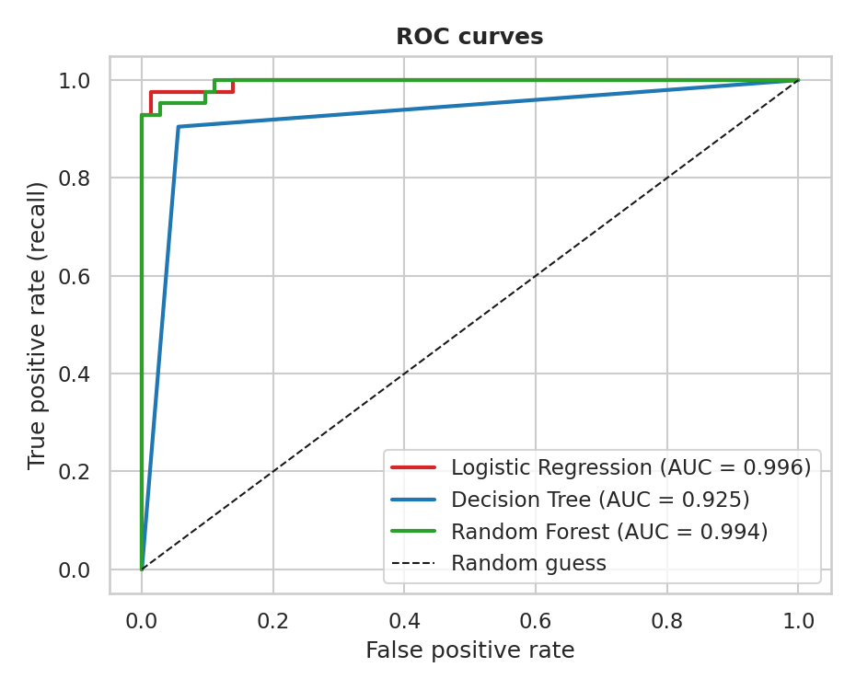
Figure 3: ROC curves; the closer to the top-left corner, the better
Reading the ROC curves. Logistic regression (AUC 0.996) and random forest (0.994) are nearly perfect rankers, while the decision tree (0.925) is clearly weaker because a single tree gives coarse, step-like probabilities.
How reliable are these numbers? The test set is small (114 patients, only 42 malignant), so a single accuracy figure is uncertain. A bootstrap on the logistic regression predictions gives a 95% confidence interval of 93.0% to 99.1% for accuracy and 84.1% to 100% for recall. The random forest's slightly higher test accuracy (97.4% against 96.5%) is a difference of one patient, which is well inside this uncertainty, and it had lower cross-validated accuracy (96.0% against 97.4%). The models should therefore be considered similar, with a clear gap only to the decision tree.

5. Over-fitting and Under-fitting
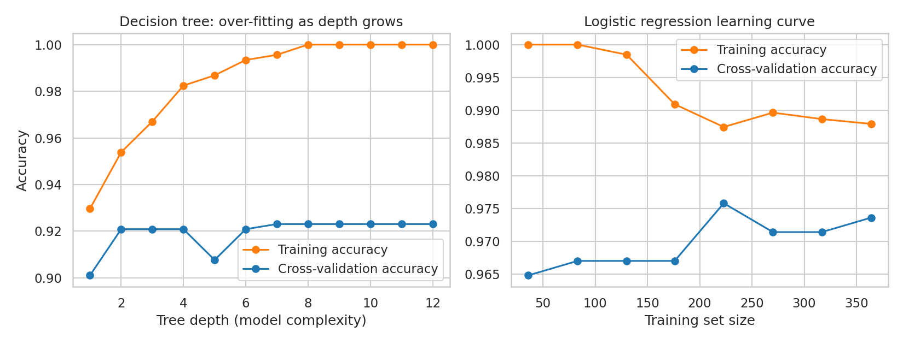
Figure 4: Left: decision tree training vs cross-validation accuracy as depth increases. Right: learning curve of the logistic regression
- Over-fitting (decision tree): training accuracy rises from 93.0% at depth 1 to 100% at depth 8, but cross-validation accuracy stays flat at about 92%. The 7.7-point gap at depth 8 shows the tree memorises the training data instead of learning general rules. The random forest has the same 100% training score but a 96% validation score, so it also fits the training data closely, though it generalises much better.
- Under-fitting: a tree of depth 1 (a single rule) scores only 90.1% in cross-validation, and its training score is also low, which is a sign of a model that is too simple.
- Good fit (logistic regression): training accuracy is 98.8% and cross-validation accuracy is 97.4%, a gap of only 1.4 points. Its learning curve shows the two lines close together, meaning the model generalises well and that more data would give only small gains.

6. Error Analysis
The four test errors of the logistic regression were inspected individually.
Patient | True class | Predicted | Probability malignant | Comment
A | Benign | Malignant | 0.51 | False alarm, right on the 0.5 boundary
B | Malignant | Benign | 0.49 | Missed by a hair, borderline case
C | Malignant | Benign | 0.32 | Missed, moderate confidence
D | Malignant | Benign | 0.06 | Confident miss, hardest case

Sources of error. Two of the four errors sit almost exactly on the decision boundary, so they are the natural overlap between the two classes. The three missed cancers have a mean radius of 13.8 to 15.1, which is between the benign average (about 12.2) and the malignant average (about 17.5), so these tumours look less extreme than typical malignant ones. This is a plausible reason rather than a proven one. Other sources include the small test set, the strong correlation between many features (radius, perimeter and area carry the same information), and the fact that a single linear boundary cannot capture every unusual case.
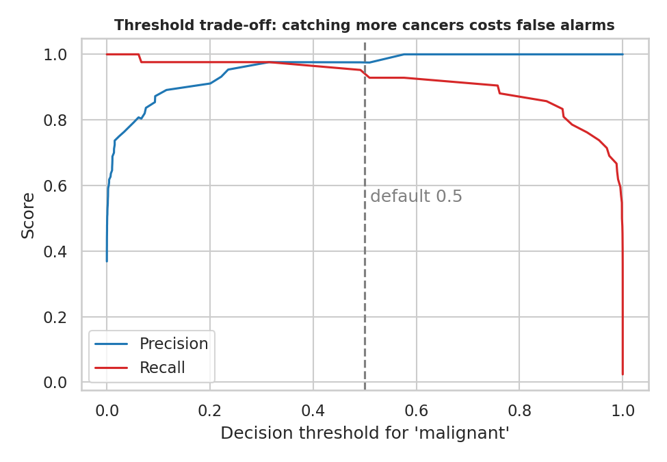
Figure 5: Precision and recall of the logistic regression as the decision threshold changes
Trade-off. Lowering the threshold for calling a case malignant finds more cancers at the cost of more false alarms. On the test set, a threshold of 0.3 reduced missed cancers from 3 to 1 (recall 97.6%) while keeping precision at 97.6%. Because this threshold was looked at on the test set itself, it is only an illustration. In real use the threshold must be chosen on validation data and then confirmed on fresh data.
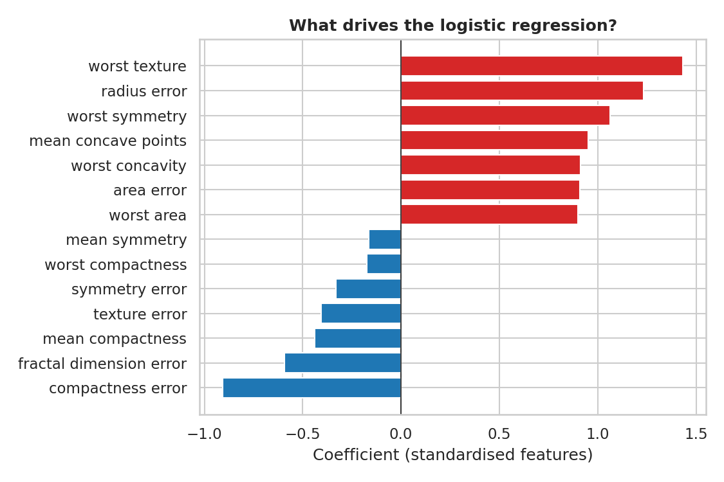
Figure 6: Largest positive (red) and negative (blue) coefficients of the logistic regression
Interpretation. Features such as worst texture, radius error, worst symmetry and concave points push predictions toward malignant. The coefficients should not be over-read as individual effects, because correlated features share the weight between them and the signs can be unstable.

7. Suggestions for Improvement
- Collect more data and test on an external dataset from a different hospital, because 569 patients from one source is a limited basis.
- Use repeated or nested cross-validation to get more stable performance estimates than a single 114-patient test set.
- Reduce the redundancy between features with PCA or feature selection (Week 2 showed that radius, perimeter and area are almost identical), and try regularisation settings such as L1.
- Choose the decision threshold on a separate validation set, based on the relative cost of a missed cancer and a false alarm.
- Try other models such as gradient boosting or a support vector machine, and tune the random forest, then compare using the same cross-validation.
- Add probability calibration and review the confident mistakes (such as patient D) with a domain expert.

8. Strengths and Limitations
Strengths: a clean, leak-free pipeline, a comparison of three models, tuning done only on training data, several complementary metrics, and uncertainty reported through a bootstrap interval. Limitations: the test set is small, the data come from one source, the results show statistical performance and not clinical readiness, and the model has not been tested on any data collected under different conditions. It should be treated as a learning exercise and not as a medical device.

9. Conclusion
A logistic regression pipeline reached 96.5% test accuracy, 97.5% precision, 92.9% recall and a ROC-AUC of 0.996 on unseen patients, with a small gap between training and validation scores. It matched a random forest and clearly outperformed an over-fitted decision tree while staying simple and explainable. The main weakness is the missed malignant cases (3 of 42), which makes recall the metric to improve first, for example by adjusting the decision threshold on validation data.

Appendix: Complete Python Code
import pandas as pd, numpy as np, matplotlib
matplotlib.use("Agg")
import matplotlib.pyplot as plt, seaborn as sns
from sklearn.datasets import load_breast_cancer
from sklearn.model_selection import train_test_split, GridSearchCV, StratifiedKFold, cross_val_score, learning_curve
from sklearn.pipeline import Pipeline
from sklearn.preprocessing import StandardScaler
from sklearn.linear_model import LogisticRegression
from sklearn.tree import DecisionTreeClassifier
from sklearn.ensemble import RandomForestClassifier
from sklearn.metrics import (accuracy_score, precision_score, recall_score, f1_score, roc_auc_score,
confusion_matrix, ConfusionMatrixDisplay, roc_curve, precision_recall_curve)
sns.set_theme(style="whitegrid"); RS = 42

# ---------- 1. Data preparation ----------
data = load_breast_cancer(as_frame=True)
X = data.data.copy(); X.columns = [c.replace(" ","_") for c in X.columns]
y = (data.target == 0).astype(int) # 1 = malignant (the class we must not miss), 0 = benign
print("Shape:", X.shape, "| missing:", int(X.isnull().sum().sum()), "| duplicates:", int(X.duplicated().sum()))
print("Malignant share: %.1f%%" % (y.mean()*100))
X_tr, X_te, y_tr, y_te = train_test_split(X, y, test_size=0.2, stratify=y, random_state=RS)
print("Train:", X_tr.shape, "Test:", X_te.shape, "| malignant in train/test: %.1f%% / %.1f%%" % (y_tr.mean()*100, y_te.mean()*100))

# ---------- 2. Models (scaler lives inside the pipeline so it is fitted on training folds only) ----------
cv = StratifiedKFold(5, shuffle=True, random_state=RS)
lr = GridSearchCV(Pipeline([("sc",StandardScaler()),("m",LogisticRegression(max_iter=5000))]),
{"m__C":[0.001,0.01,0.1,1,10,100]}, cv=cv, scoring="recall").fit(X_tr,y_tr)
dt = GridSearchCV(Pipeline([("sc",StandardScaler()),("m",DecisionTreeClassifier(random_state=RS))]),
{"m__max_depth":[1,2,3,4,5,6,8,None]}, cv=cv, scoring="recall").fit(X_tr,y_tr)
rf = Pipeline([("sc",StandardScaler()),("m",RandomForestClassifier(n_estimators=300, random_state=RS))]).fit(X_tr,y_tr)
print("Best LR params:", lr.best_params_, "| Best tree params:", dt.best_params_)
models = {"Logistic Regression":lr.best_estimator_, "Decision Tree":dt.best_estimator_, "Random Forest":rf}

# ---------- 3. Evaluation ----------
rows=[]; probs={}
for n,m in models.items():
pr = m.predict_proba(X_te)[:,1]; pd_ = (pr>=.5).astype(int); probs[n]=pr
cvacc = cross_val_score(m, X_tr, y_tr, cv=cv, scoring="accuracy").mean()
rows.append(dict(Model=n, CV_accuracy=cvacc, Train_acc=m.score(X_tr,y_tr), Test_acc=accuracy_score(y_te,pd_),
Precision=precision_score(y_te,pd_), Recall=recall_score(y_te,pd_), F1=f1_score(y_te,pd_), ROC_AUC=roc_auc_score(y_te,pr)))
R = pd.DataFrame(rows).set_index("Model"); print("\n", R.round(3).to_string())
for n,m in models.items():
tn,fp,fn,tp = confusion_matrix(y_te,(probs[n]>=.5).astype(int)).ravel(); print(f"{n}: TN={tn} FP={fp} FN={fn} TP={tp}")

# bootstrap CI for the chosen model on the test set
rng = np.random.default_rng(RS); pl = (probs["Logistic Regression"]>=.5).astype(int); yt = y_te.values; ba,br=[],[]
for _ in range(2000):
i = rng.integers(0,len(yt),len(yt)); ba.append((pl[i]==yt[i]).mean())
pos = i[yt[i]==1]; br.append((pl[pos]==1).mean())
print("Bootstrap 95%% CI test accuracy: [%.3f, %.3f]; recall: [%.3f, %.3f]" % (*np.percentile(ba,[2.5,97.5]), *np.percentile(br,[2.5,97.5])))

# ---------- 4. Error analysis ----------
best = models["Logistic Regression"]; pr = probs["Logistic Regression"]
err = X_te.assign(true=y_te, prob_malignant=pr, pred=(pr>=.5).astype(int))
err = err[err.true!=err.pred]
print("\nMisclassified (LR):\n", err[["true","pred","prob_malignant","mean_radius","mean_concavity","worst_perimeter"]].round(3).to_string())
coef = pd.Series(best.named_steps["m"].coef_[0], index=X.columns).sort_values(); print("\nTop + coefs:\n", coef.tail(5).round(2), "\nTop - coefs:\n", coef.head(5).round(2))
for t in [0.5,0.4,0.3,0.2,0.1]:
p_ = (pr>=t).astype(int); tn,fp,fn,tp = confusion_matrix(y_te,p_).ravel(); print(f"threshold {t}: FN={fn} FP={fp} recall={tp/(tp+fn):.3f} precision={tp/(tp+fp):.3f}")

# ---------- 5. Figures ----------
fig,ax = plt.subplots(1,3, figsize=(12,3.8))
for a,(n,m) in zip(ax,models.items()):
ConfusionMatrixDisplay(confusion_matrix(y_te,(probs[n]>=.5).astype(int)), display_labels=["Benign","Malignant"]).plot(ax=a, cmap="Blues", colorbar=False)
a.set_title(n); a.grid(False)
plt.suptitle("Confusion matrices on the 114 unseen test patients", fontweight="bold"); plt.tight_layout(); plt.savefig("w4figs/m1_confusion.png", dpi=150); plt.close()

plt.figure(figsize=(6.2,5))
for n,c in zip(models,["#d62728","#1f77b4","#2ca02c"]):
fpr,tpr,_ = roc_curve(y_te,probs[n]); plt.plot(fpr,tpr,color=c,lw=2,label=f"{n} (AUC = {R.loc[n,'ROC_AUC']:.3f})")
plt.plot([0,1],[0,1],"k--",lw=1,label="Random guess"); plt.xlabel("False positive rate"); plt.ylabel("True positive rate (recall)")
plt.title("ROC curves", fontweight="bold"); plt.legend(loc="lower right"); plt.tight_layout(); plt.savefig("w4figs/m2_roc.png", dpi=150); plt.close()

M = R[["Test_acc","Precision","Recall","F1","ROC_AUC"]]
ax_ = M.T.plot(kind="bar", figsize=(8,4.5), color=["#d62728","#1f77b4","#2ca02c"], rot=0, width=.8)
ax_.set_ylim(.8,1.02); ax_.set_ylabel("Score"); ax_.set_title("Model comparison on the test set", fontweight="bold"); ax_.legend(loc="lower left")
plt.tight_layout(); plt.savefig("w4figs/m3_metrics.png", dpi=150); plt.close()

fig,ax = plt.subplots(1,2, figsize=(11,4.2))
depths = list(range(1,13)); tr_s=[];cv_s=[]
for d_ in depths:
t_ = Pipeline([("sc",StandardScaler()),("m",DecisionTreeClassifier(max_depth=d_, random_state=RS))])
tr_s.append(t_.fit(X_tr,y_tr).score(X_tr,y_tr)); cv_s.append(cross_val_score(t_,X_tr,y_tr,cv=cv).mean())
ax[0].plot(depths,tr_s,"o-",c="#ff7f0e",label="Training accuracy"); ax[0].plot(depths,cv_s,"o-",c="#1f77b4",label="Cross-validation accuracy")
ax[0].set_xlabel("Tree depth (model complexity)"); ax[0].set_ylabel("Accuracy"); ax[0].set_title("Decision tree: over-fitting as depth grows"); ax[0].legend()
sz,trs,vas = learning_curve(best, X_tr, y_tr, cv=cv, train_sizes=np.linspace(.1,1,8), scoring="accuracy", random_state=RS)
ax[1].plot(sz,trs.mean(1),"o-",c="#ff7f0e",label="Training accuracy"); ax[1].plot(sz,vas.mean(1),"o-",c="#1f77b4",label="Cross-validation accuracy")
ax[1].set_xlabel("Training set size"); ax[1].set_title("Logistic regression learning curve"); ax[1].legend()
plt.tight_layout(); plt.savefig("w4figs/m4_fit.png", dpi=150); plt.close()
print("tree depth table:", [(d_,round(a,3),round(b,3)) for d_,a,b in zip(depths,tr_s,cv_s)])
print("LR learning curve final: train %.3f cv %.3f" % (trs.mean(1)[-1], vas.mean(1)[-1]))

sel = pd.concat([coef.head(7), coef.tail(7)])
plt.figure(figsize=(7.5,5)); plt.barh(sel.index.str.replace("_"," "), sel.values, color=["#1f77b4" if v<0 else "#d62728" for v in sel.values])
plt.axvline(0,c="k",lw=.8); plt.xlabel("Coefficient (standardised features)"); plt.title("What drives the logistic regression?", fontweight="bold")
plt.tight_layout(); plt.savefig("w4figs/m5_coef.png", dpi=150); plt.close()

fig,ax = plt.subplots(figsize=(6.5,4.5))
p_,r_,t_ = precision_recall_curve(y_te, pr)
ax.plot(t_, p_[:-1], label="Precision", c="#1f77b4"); ax.plot(t_, r_[:-1], label="Recall", c="#d62728")
ax.axvline(.5, ls="--", c="grey"); ax.text(.51,.55,"default 0.5",color="grey")
ax.set_xlabel("Decision threshold for 'malignant'"); ax.set_ylabel("Score"); ax.set_title("Threshold trade-off: catching more cancers costs false alarms", fontsize=10, fontweight="bold"); ax.legend()
plt.tight_layout(); plt.savefig("w4figs/m6_threshold.png", dpi=150); plt.close()
R.round(4).to_csv("w4figs/model_results.csv")

