Advanced Data Visualization and Storytelling with Python
How 30 measurements separate benign from malignant tumours
Virtual Data Science with Python Apprentice Intern – Week 2 Task

1. Introduction
Numbers in a table rarely convince a non-technical reader, but a well chosen picture can. This report turns a clinical dataset into a visual story: starting from which measurements differ between tumour types, moving to how much information is redundant, and ending with a result a doctor or manager can act on. Seven visualizations are used, and each one is explained, annotated and linked to the next.
The intended audience is a non-technical reader such as a hospital manager or a student. Titles are written as conclusions (for example "Risk climbs steeply with tumour size") instead of plain labels, so the message is clear before any axis is read.

2. Methods

2.1 Dataset
The Breast Cancer Wisconsin (Diagnostic) dataset from the UCI Machine Learning Repository is used, loaded with scikit-learn. It has 569 patients, 30 numeric measurements of cell nuclei (mean, standard error and worst value of radius, texture, perimeter, area, smoothness, compactness, concavity, concave points, symmetry and fractal dimension), and a diagnosis: 357 benign and 212 malignant. This is the same dataset as Week 1, so the cleaned data from that week is reused: no missing values or duplicates, and outliers capped at the IQR limits instead of deleted.

2.2 Tools and approach
- Python with Pandas and NumPy for data handling, Matplotlib and Seaborn for charts, and scikit-learn for PCA and a small validation check.
- A consistent colour code throughout: red means malignant, blue means benign. The reader learns the code once and never has to re-read legends.
- Chart types were chosen by the question being asked: distributions for comparison, a clustered heatmap for relationships, PCA for dimensionality, a bar chart for ranking, a pair plot for feature combinations, and a bar chart of rates for the final message. Visualization 6 shows the experiment of testing four chart types on the same data.

3. Visual Analyses

Visualization 1: Violin plots of key features
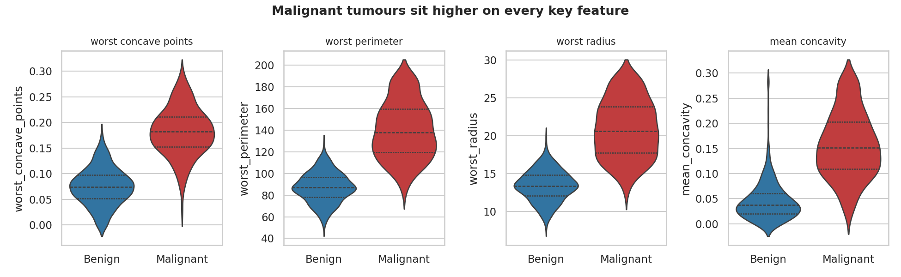
Figure 1: Distribution of four key features for benign and malignant tumours (lines mark quartiles)
What it shows. Across all four features the malignant group (red) sits clearly higher. For worst concave points the benign median is about 0.07 while the malignant median is about 0.18, and the two shapes overlap only slightly.
Why this chart type. A violin plot shows the whole distribution (shape, spread and quartiles) side by side, which a bar of averages would hide. Small multiples with free y-axes let features with different units sit in one row.
Contribution to the story. This is the opening of the story and answers the first question: do the two groups really differ? Yes, and consistently.

Visualization 2: Clustered correlation heatmap
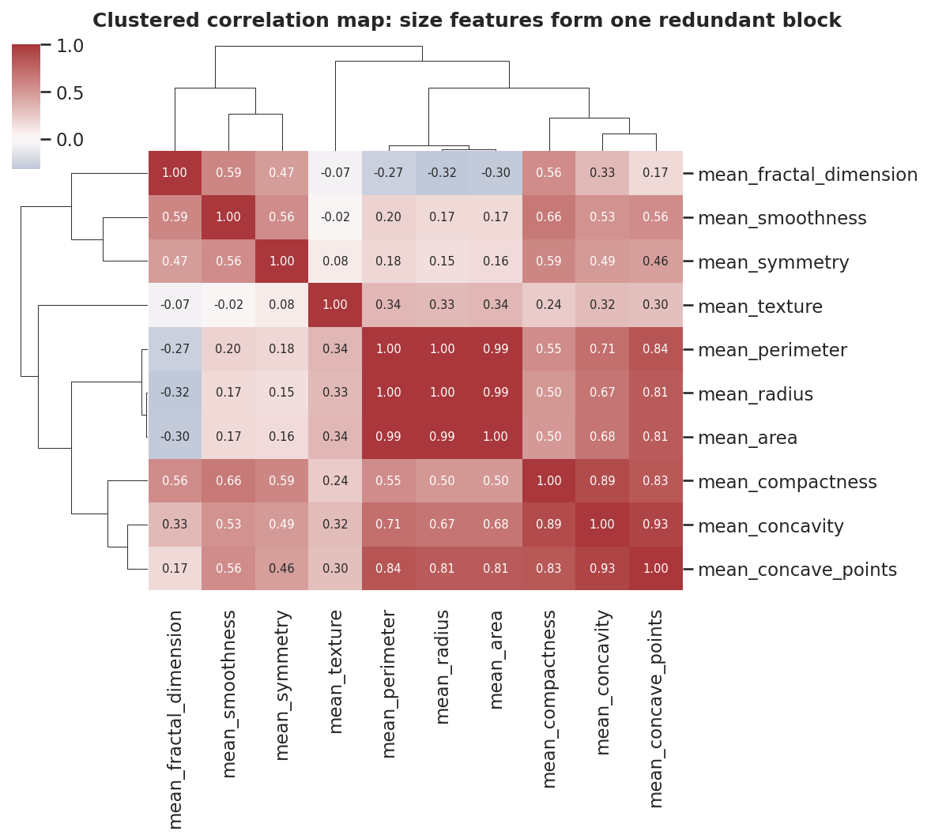
Figure 2: Clustered correlation matrix of the ten mean features; similar features are grouped by the dendrogram
What it shows. Two blocks appear. Radius, perimeter and area are almost the same measurement (correlations 0.99 to 1.00). Compactness, concavity and concave points form a second block (0.83 to 0.93). Texture, smoothness, symmetry and fractal dimension are largely independent.
Why this chart type. A plain heatmap is hard to read because related features are scattered. Clustering reorders rows and columns so redundant groups become visible blocks.
Contribution to the story. This explains why 30 measurements are not 30 independent pieces of evidence, and motivates the compression in the next chart.

Visualization 3: PCA scatter and scree plot
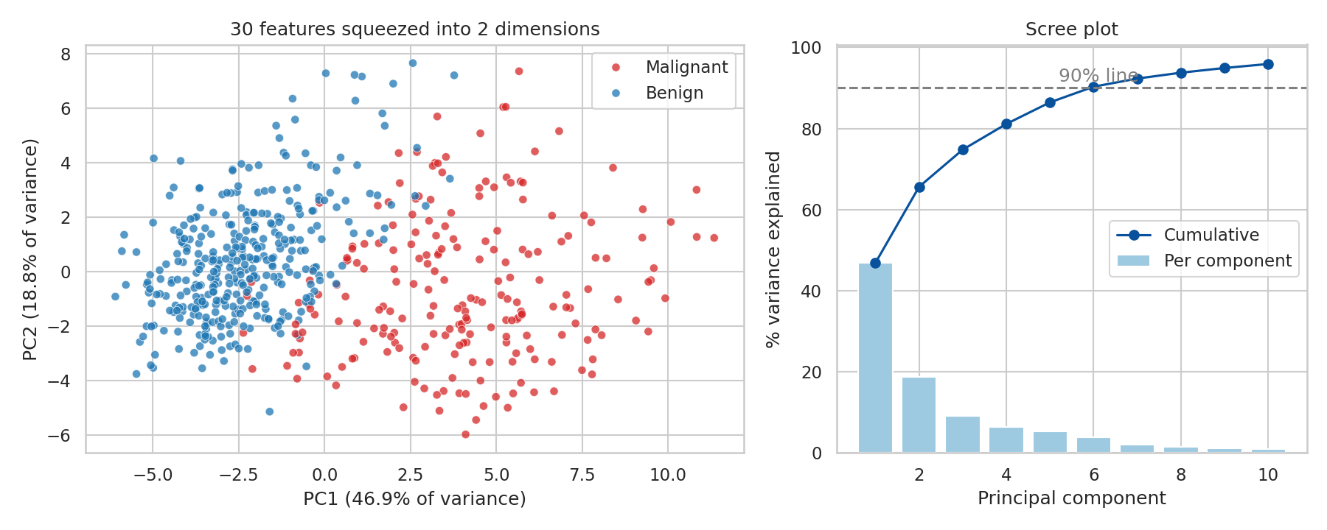
Figure 3: Left: all patients projected onto the first two principal components. Right: variance explained by each component
What it shows. The first component alone captures 46.9% of the variation and the first two capture 65.6%. Six components reach 90%. In the 2D map the red and blue patients form two mostly separate clouds with a thin overlap zone.
Why this chart type. PCA is the standard way to draw many features in two dimensions. The scree plot beside it shows how much information is kept, so the reader can judge whether the picture is trustworthy.
Contribution to the story. It moves the story from "features differ" to "the groups are separable as a whole". As a check, a simple logistic regression on just these two components reached 94.9% cross-validated accuracy, against 98.1% using all 30 features.

Visualization 4: Ranking features by link to malignancy
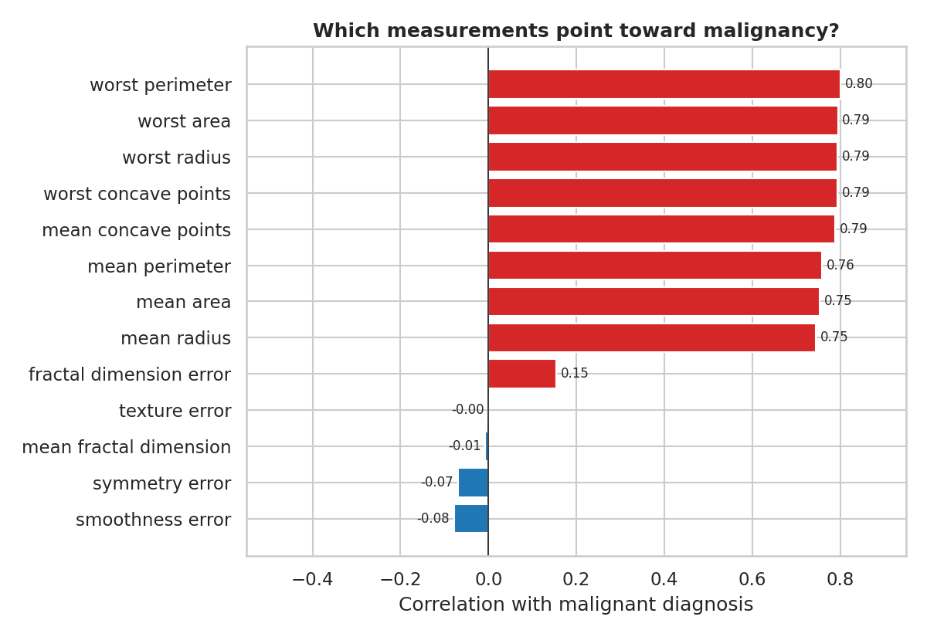
Figure 4: Correlation of each measurement with a malignant diagnosis (selected strongest and weakest)
What it shows. The strongest signals are worst perimeter (0.80), worst area, worst radius and worst concave points (0.79 each). Smoothness error, symmetry error, fractal dimension and texture error are close to zero, so they carry almost no signal on their own.
Why this chart type. A sorted horizontal bar chart with a diverging colour and value labels is the clearest way to rank and compare items, and long feature names stay readable.
Contribution to the story. It answers the practical question of which measurements matter, so a clinician or analyst knows where to look first.

Visualization 5: Pairwise feature view
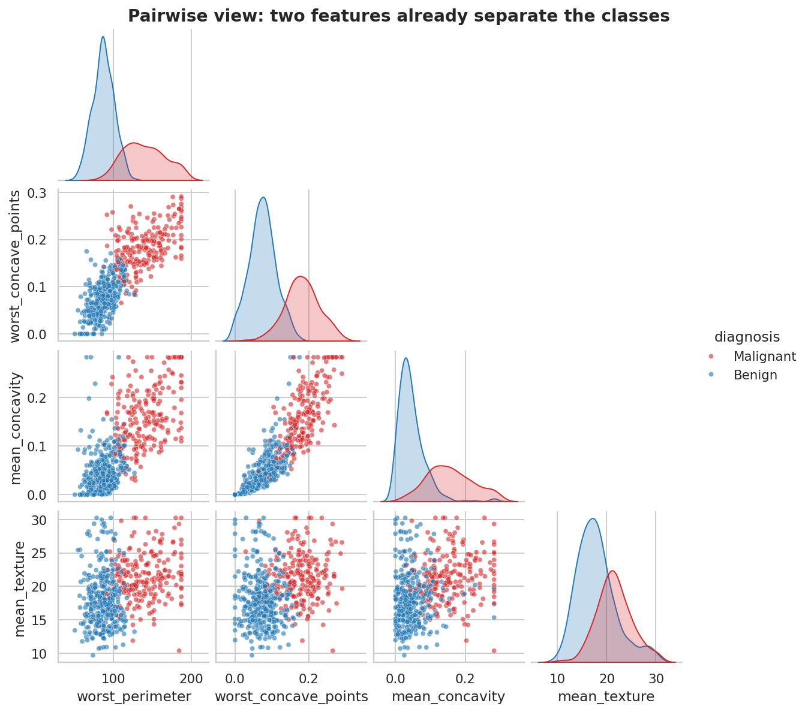
Figure 5: Scatter plots and densities for four top features, coloured by diagnosis
What it shows. Worst perimeter against worst concave points already separates most red and blue points with a diagonal boundary. Mean texture overlaps heavily between classes and adds little by itself.
Why this chart type. A pair plot compares every combination at once and shows both individual densities (diagonal) and relationships (off-diagonal), so useful pairs can be spotted visually.
Contribution to the story. It shows that a simple rule using two measurements can do a lot of the work, which supports the idea that the problem is learnable and the signal is not an artefact.

Visualization 6: Chart type experiment
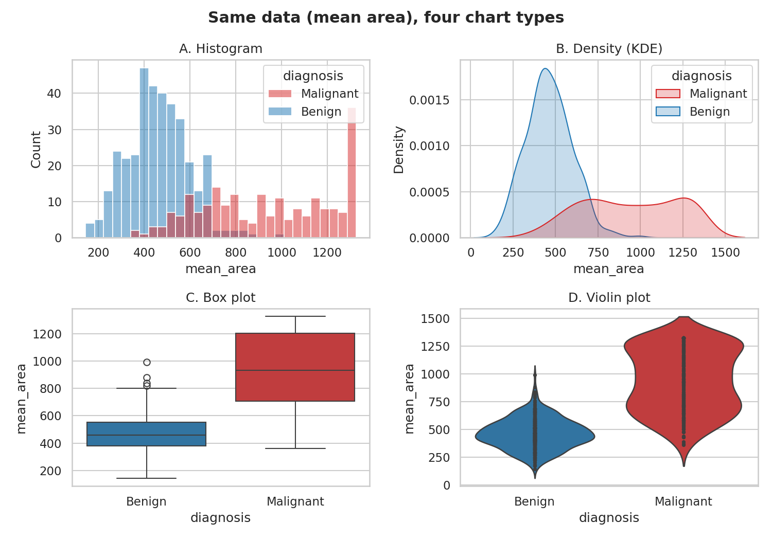
Figure 6: The same variable (mean area) drawn as a histogram, density, box plot and violin plot
What it shows. All four agree that malignant tumours are larger, but each reveals something different. The histogram shows counts and the capped values at the upper end, the density smooths this into clear shapes, the box plot gives median and outliers compactly, and the violin combines shape and spread.
Why this chart type. This is the deliberate experiment with chart types. The histogram is exact but noisy, the box plot is compact but hides the second bump in the malignant group, and the density and violin plots show it best.
Contribution to the story. It justifies the use of violin plots in Figure 1: for a non-technical reader the violin is the best balance of detail and simplicity.

Visualization 7: Risk by tumour size group
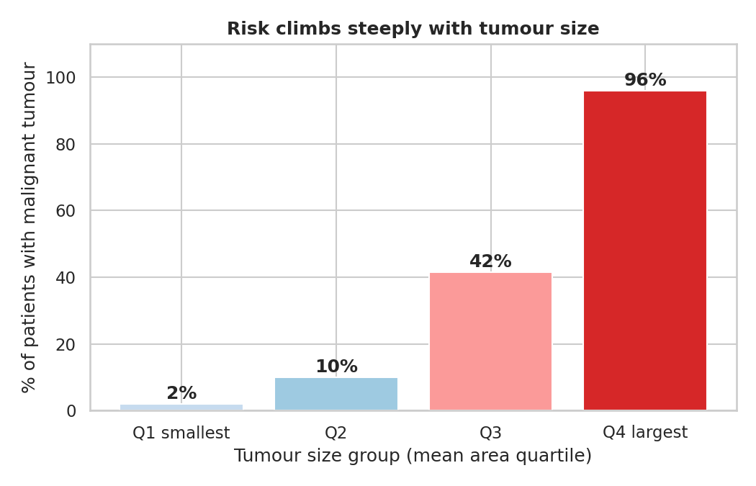
Figure 7: Share of patients with a malignant tumour in each quarter of the size range (about 142 patients per group)
What it shows. In the smallest quarter only 2% of tumours are malignant, then 10%, 42%, and finally 96% in the largest quarter. Risk rises sharply, and most of the jump happens between the second and fourth groups.
Why this chart type. Grouping a continuous measure into quartiles and plotting the rate turns a statistical relationship into a plain statement. Bars with direct labels are the simplest form for a general audience.
Contribution to the story. This is the closing message of the story: the earlier patterns translate into an easy-to-remember statement about risk.

4. The Story in One Paragraph
Malignant and benign tumours differ clearly on size and shape measurements (Figure 1). Many of those measurements repeat the same information (Figure 2), so 30 features can be compressed into a few components while keeping the two groups apart (Figure 3). A short list of measurements carries most of the signal (Figure 4), and two of them are enough to draw a good boundary (Figure 5). Choosing the right chart type matters for how clearly this is communicated (Figure 6). Finally, the effect is easiest to grasp as risk by tumour size: from 2% in the smallest group to 96% in the largest (Figure 7).

5. Business and Scientific Implications

For hospitals and clinicians
- Size and boundary-irregularity measurements are strong indicators, so a screening workflow can prioritise cases with high worst perimeter or high concave points for faster specialist review.
- Because 6 components capture 90% of the information, a decision-support tool can be built on a small set of inputs, making it cheaper to collect and easier to explain.

For data and research teams
- Strongly redundant features should be reduced (PCA or selecting one feature per block) before modelling, to avoid unstable models.
- Features with near-zero correlation (texture error, fractal dimension, symmetry error) are candidates for removal, though they should be checked in combination with others first.
- The classes are imbalanced (63% benign), so evaluation should use recall and precision, since missing a malignant case is much more costly than a false alarm.

6. Limitations
- The dataset has only 569 patients from one study, so the results may not carry over to other populations or imaging equipment.
- Correlation does not prove cause, and these charts describe patterns in the data, not clinical advice. Any real use would need clinical validation.
- The 94.9% and 98.1% accuracy figures are quick cross-validation checks for illustration, not a tuned or deployed model.

7. Conclusions
Seven visualizations told a single story about the same dataset: what differs, what is redundant, what can be compressed, what matters most, and what it means for risk. The main lesson is that the chart should be chosen for the question and the reader: violin plots for comparison, clustered heatmaps for redundancy, PCA for the big picture, ranked bars for priorities, and simple rate bars for the final message.

Appendix: Complete Python Code
import pandas as pd, numpy as np, matplotlib
matplotlib.use("Agg")
import matplotlib.pyplot as plt, seaborn as sns
from sklearn.datasets import load_breast_cancer
from sklearn.preprocessing import StandardScaler
from sklearn.decomposition import PCA
from sklearn.linear_model import LogisticRegression
from sklearn.model_selection import cross_val_score
sns.set_theme(style="whitegrid", font_scale=1.0)
pal = {"Malignant":"#d62728","Benign":"#1f77b4"}

# ---- Load + clean (same pipeline as Week 1) ----
d = load_breast_cancer(as_frame=True).frame
d["diagnosis"] = d["target"].map({0:"Malignant",1:"Benign"}); d = d.drop(columns="target")
d.columns = [c.replace(" ","_") for c in d.columns]
num = d.select_dtypes("number").columns
q1,q3 = d[num].quantile(.25), d[num].quantile(.75); iqr=q3-q1
df = d.copy(); df[num] = df[num].clip(q1-1.5*iqr, q3+1.5*iqr, axis=1)
df["y"] = (df.diagnosis=="Malignant").astype(int)

# ---- Fig 1: violin small multiples ----
feats = ["worst_concave_points","worst_perimeter","worst_radius","mean_concavity"]
fig, ax = plt.subplots(1,4, figsize=(13,4))
for a,f in zip(ax,feats):
sns.violinplot(data=df, x="diagnosis", y=f, hue="diagnosis", palette=pal, inner="quartile", ax=a, legend=False, order=["Benign","Malignant"])
a.set_title(f.replace("_"," "), fontsize=10); a.set_xlabel("")
fig.suptitle("Malignant tumours sit higher on every key feature", fontsize=13, fontweight="bold")
plt.tight_layout(); plt.savefig("w2figs/v1_violin.png", dpi=150); plt.close()

# ---- Fig 2: clustered heatmap ----
cols = [c for c in df.columns if c.startswith("mean_")]
g = sns.clustermap(df[cols].corr(), cmap="vlag", center=0, annot=True, fmt=".2f", annot_kws={"size":7}, figsize=(8,7), cbar_pos=(0.02,0.82,0.03,0.15))
g.fig.suptitle("Clustered correlation map: size features form one redundant block", y=1.01, fontsize=12, fontweight="bold")
g.savefig("w2figs/v2_cluster.png", dpi=150); plt.close("all")
order = [cols[i] for i in g.dendrogram_row.reordered_ind]
print("cluster order:", order)

# ---- Fig 3: PCA scatter + scree ----
X = StandardScaler().fit_transform(df[num]); p = PCA().fit(X); Z = p.transform(X)
ev = p.explained_variance_ratio_; cum = ev.cumsum()
print("PC1 %.1f PC2 %.1f cum2 %.1f; PCs for 90%%: %d; 95%%: %d" % (ev[0]*100, ev[1]*100, cum[1]*100, (cum<.90).sum()+1, (cum<.95).sum()+1))
fig, ax = plt.subplots(1,2, figsize=(12,4.8), gridspec_kw={"width_ratios":[1.4,1]})
sns.scatterplot(x=Z[:,0], y=Z[:,1], hue=df.diagnosis, palette=pal, alpha=.75, ax=ax[0], s=30)
ax[0].set_xlabel(f"PC1 ({ev[0]*100:.1f}% of variance)"); ax[0].set_ylabel(f"PC2 ({ev[1]*100:.1f}% of variance)")
ax[0].set_title("30 features squeezed into 2 dimensions"); ax[0].legend(title="")
ax[1].bar(range(1,11), ev[:10]*100, color="#9ecae1", label="Per component")
ax[1].plot(range(1,11), cum[:10]*100, "o-", color="#08519c", label="Cumulative")
ax[1].axhline(90, ls="--", c="grey"); ax[1].text(5.2, 91.5, "90% line", color="grey")
ax[1].set_xlabel("Principal component"); ax[1].set_ylabel("% variance explained"); ax[1].set_title("Scree plot"); ax[1].legend()
plt.tight_layout(); plt.savefig("w2figs/v3_pca.png", dpi=150); plt.close()
acc2 = cross_val_score(LogisticRegression(max_iter=1000), Z[:,:2], df.y, cv=5).mean()
accall = cross_val_score(LogisticRegression(max_iter=2000), X, df.y, cv=5).mean()
print("CV acc 2 PCs: %.3f ; all 30 feats: %.3f" % (acc2, accall))

# ---- Fig 4: correlation with malignancy (diverging bar) ----
r = df[list(num)+["y"]].corr()["y"].drop("y").sort_values()
sel = pd.concat([r.head(5), r.tail(8)])
plt.figure(figsize=(8,5.5))
plt.barh(sel.index.str.replace("_"," "), sel.values, color=["#1f77b4" if v<0 else "#d62728" for v in sel.values])
plt.axvline(0,c="k",lw=.8); plt.xlabel("Correlation with malignant diagnosis")
plt.title("Which measurements point toward malignancy?", fontweight="bold")
for i,v in enumerate(sel.values): plt.text(v+(0.01 if v>=0 else -0.01), i, f"{v:.2f}", va="center", ha="left" if v>=0 else "right", fontsize=8)
plt.xlim(-0.55,0.95); plt.tight_layout(); plt.savefig("w2figs/v4_bar.png", dpi=150); plt.close()
print(sel.round(2))

# ---- Fig 5: pairgrid of top features ----
top = ["worst_perimeter","worst_concave_points","mean_concavity","mean_texture"]
pg = sns.pairplot(df[top+["diagnosis"]], hue="diagnosis", palette=pal, corner=True, plot_kws={"alpha":.6,"s":18}, diag_kind="kde", height=2.1)
pg.fig.suptitle("Pairwise view: two features already separate the classes", y=1.01, fontweight="bold")
pg.savefig("w2figs/v5_pair.png", dpi=140); plt.close("all")

# ---- Fig 6: same feature, four chart types ----
fig, ax = plt.subplots(2,2, figsize=(10,7))
sns.histplot(df, x="mean_area", hue="diagnosis", palette=pal, bins=30, ax=ax[0,0]); ax[0,0].set_title("A. Histogram")
sns.kdeplot(df, x="mean_area", hue="diagnosis", palette=pal, fill=True, ax=ax[0,1]); ax[0,1].set_title("B. Density (KDE)")
sns.boxplot(df, x="diagnosis", y="mean_area", hue="diagnosis", palette=pal, ax=ax[1,0], order=["Benign","Malignant"]); ax[1,0].set_title("C. Box plot")
sns.violinplot(df, x="diagnosis", y="mean_area", hue="diagnosis", palette=pal, ax=ax[1,1], inner="point", order=["Benign","Malignant"]); ax[1,1].set_title("D. Violin plot")
fig.suptitle("Same data (mean area), four chart types", fontweight="bold"); plt.tight_layout(); plt.savefig("w2figs/v6_types.png", dpi=150); plt.close()

# ---- Fig 7: malignancy rate by area quartile ----
df["area_q"] = pd.qcut(df.mean_area, 4, labels=["Q1 smallest","Q2","Q3","Q4 largest"])
rate = df.groupby("area_q", observed=True).y.mean()*100
cnt = df.groupby("area_q", observed=True).size()
print(rate.round(1), cnt)
plt.figure(figsize=(7,4.5))
bars = plt.bar(rate.index.astype(str), rate.values, color=["#c6dbef","#9ecae1","#fb9a99","#d62728"])
for b,v in zip(bars, rate.values): plt.text(b.get_x()+b.get_width()/2, v+1.5, f"{v:.0f}%", ha="center", fontweight="bold")
plt.ylim(0,110); plt.ylabel("% of patients with malignant tumour"); plt.xlabel("Tumour size group (mean area quartile)")
plt.title("Risk climbs steeply with tumour size", fontweight="bold"); plt.tight_layout(); plt.savefig("w2figs/v7_risk.png", dpi=150); plt.close()

