Open classes in ruby
In Ruby, classes are never closed: you can always add methods to an existing class. This applies to the classes you write as well as the standard, built-in classes. All you have to do is open up a class definition for an existing class, and the new contents you specify will be added to whatever's there.

Ruby is unique in that classes are open. Generally once you close off those brackets in that class your writing, you can’t continue adding methods to it. In Ruby you can. You can extend (not in the same way as inheritance) a class once it’s been “closed”.
You can also extend Ruby’s core classes, such as String, Hash, Numeric, Fixnum, etc.

Example: Sanitizing a String
Say for instance you want to sanitize a string of all non alphanumeric characters. Let’s say the definition of sanitize, is to replace all non alphanumeric characters with an underscore.
I
1 | class String
2 | def sanitize
3 | self.gsub(/[^[:alnum:]]+/, '_')
4 | end
5 | end
6
7 | puts "Let's sanitize this string baby".sanitize

Difference between Argument and Parameter in ruby on rails

A parameter represents a value that the method expects you to pass when you call it.
An argument represents the value you pass to a method parameter when you call the method. The calling code supplies the arguments when it calls the method.
In simple words, parameters appear in method definitions; arguments appear in method calls.
For example, in below method, variables param1 and param2 are the parameters
def foo_method(param1, param2):
.......
end
while calling the method, arg1 and arg2 are the arguments
foo_method(arg1, arg2)

Modules
Ruby Modules are similar to classes in that they hold a collection of methods, constants, and other module and class definitions. Modules are defined much like classes are, but the module keyword is used in place of the class keyword. Unlike classes, you cannot create objects based on modules nor can you subclass them; instead, you specify that you want the functionality of a particular module to be added to the functionality of a class, or of a specific object. Modules stand alone; there is no "module hierarchy" of inheritance. Modules is a good place to collect all your constants in a central location.
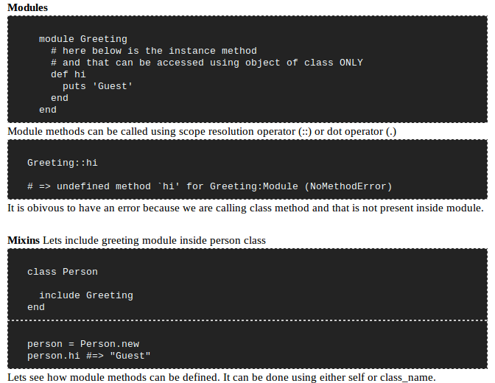

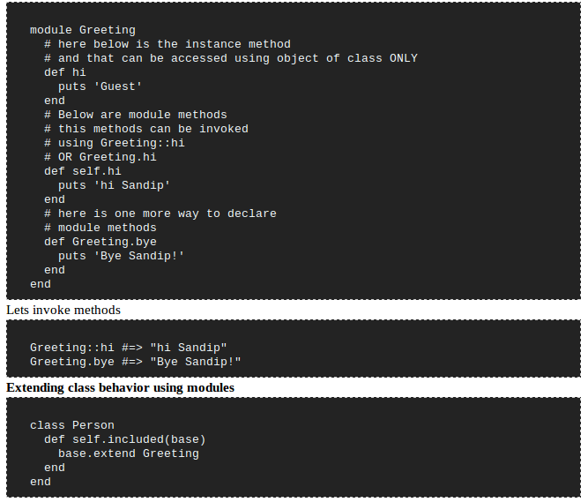
Dynamic Methods In Ruby
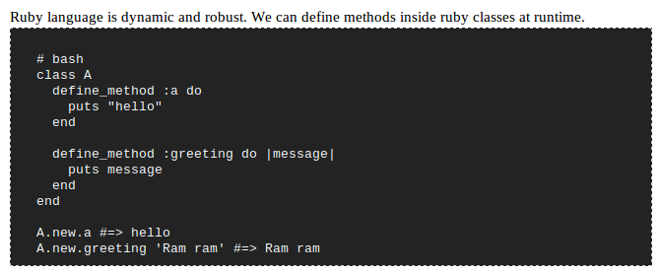
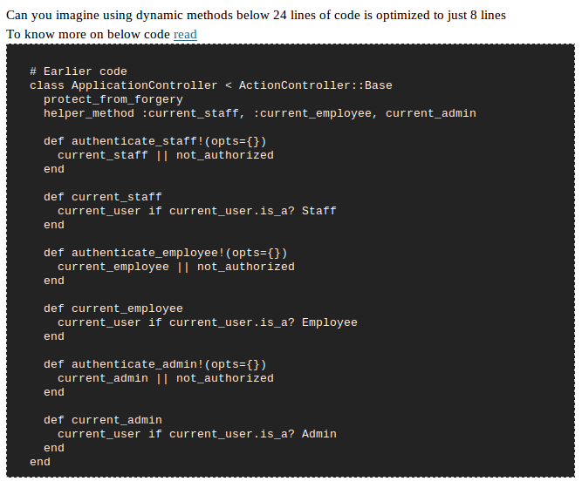
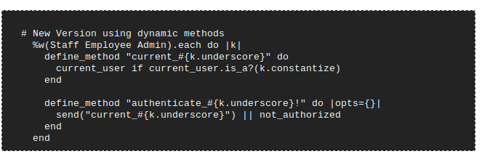

what do you not like about ruby on rails? identify its weak points.
the answers i expect here are fixtures, routes, scalability. bonus points for identifying the weakness in using multiple databases.
a good followup on scalability is: how have you in the past dealt with the scalability problems, and what does your preferred deployment environment look like?

what is the difference between a symbol and a string? when should they be used?
a symbol has a shorter reference number, which makes it faster to look up. if you’re using something as a reference string, a symbol is a good idea. if you’re planning on a string being editable, then a string is a better idea.

1. A Ruby symbol is the name of something, not just a blob of text
In Ruby, we would generally use symbols when referring to things by name:
find_speech(:gettysburg_address)
But to represent large chunks of text, we would use strings:
"Four score and seven years ago..."

2. A Ruby symbol is a label in a free-form enumeration
In C++ (and many other languages), we can use “enumerations” to represent families of related constants:
enum BugStatus { OPEN, CLOSED };
BugStatus original_status = OPEN;
BugStatus current_status = CLOSED;
But because Ruby is a dynamic language, we don’t worry about declaring a BugStatus type, or keeping track of the legal values. Instead, we represent the enumeration values as symbols:
original_status = :open
current_status = :closed
3. A Ruby symbol is a constant, unique name
In Ruby, we can change the contents of a string:
"foo"[0] = ?b # "boo"
But we can’t change the contents of a symbol:
:foo[0] = ?b # Raises an error
Similarly, we can have two different strings with the same contents:
# Same string contents, different strings.
"open".object_id != "open".object_id
But two symbols with the same name are always the same underlying object:
# Same symbol name, same object.
:open.object_id == :open.object_id

4. A Ruby symbol is an “interned” string
In Ruby, we can convert a string to a symbol using intern:
"foo".intern # returns :foo
intern maintains a hash table mapping strings to the corresponding symbol. The first time intern sees a string, it creates a new symbol and stores it the hash table. The next time intern sees a string, it retrieves the original object.
We could implement our own version of Symbol and intern as follows:
class MySymbol
TABLE={}
def initialize(str) @str = str end
def to_s() @str end
def ==(other)
self.object_id == other.object_id
end
end

class String
def my_intern
table = MySymbol::TABLE
unless table.has_key?(self)
table[self] = MySymbol.new(self)
end
table[self]
end
end

"foo".my_intern

5. A Ruby symbol is an object with O(1) comparison
To compare two strings, we potentially need to look at every character. For two strings of length N, this will require N+1 comparisons (which computer scientists refer to as “O(N) time”).
def string_comp str1, str2
return false if str1.length != str2.length
for i in 0...str1.length
return false if str1[i] != str2[i]
end
return true
end
string_comp "foo", "foo"
But since every appearance of :foo refers to the same object, we can compare symbols by looking at object IDs. We can do this with a single comparison (which computer scientists refer to as “O(1) time”).
def symbol_comp sym1, sym2
sym1.object_id == sym2.object_id
end
symbol_comp :foo, :foo

6. A Ruby symbol is a Lisp identifier
The earliest ancestors of Ruby symbols are Lisp symbols. In Lisp, symbols are used to represent “identifiers” (variable and function names) in a parsed program. Let’s say we have a have a file named double.l containing a single function:
(defun double (x)
(* x 2))
We can parse this file using read:
(read "double.l")
;; Returns '(defun double (x) (* x 2))
This returns a nested list containing the symbols defun, double, *, x (twice) and the number 2.

7. A Ruby symbol is a Ruby identifier
In Ruby, we can look up identifiers (variable, function and constant names) while the program is running. This is typically done using symbols.
class Demo
# The stuff we'll look up.
DEFAULT = "Hello"
def initialize
@message = DEFAULT
end
def say() @message end

# Use symbols to look up identifiers.
def look_up_with_symbols
[Demo.const_get(:DEFAULT),
method(:say),
instance_variable_get(:@message)]
end
end

Demo.new.look_up_with_symbols

8. A Ruby symbol is the keyword for a keyword argument
When passing keyword arguments to a Ruby function, we specify the keywords using symbols:
# Build a URL for 'bug' using Rails.
url_for :controller => 'bug',
:action => 'show',
:id => bug.id

9. A Ruby symbol is an excellent choice for a hash key
Typically, we’ll use symbols to represent the keys of a hash table:
options = {}
options[:auto_save] = true
options[:show_comments] = false

10. A Ruby symbol is like a Mac OSType
The MacOS uses four-character abbreviations to represent open-ended enumerations:
enum {
kSystemFolderType = 'macs',
kDesktopFolderType = 'desk',
// ...and so on...
kTrashFolderType = 'trsh'
};
OSType folder = kSystemFolderType;
In Ruby, we’d typically use symbols for the same purpose:
:system_folder
:desktop_folder
:trash_folder

11. A Ruby symbol is a memory leak
Because of the way Ruby symbols are stored, they can never be garbage collected. So if we create 10,000 one-off symbols that we’ll never use again, we’ll never get the memory back.
Some Scheme implementations use a clever version of intern that looks up symbols using a weak hash table. This allows symbols to be garbage collected without destroying their uniqueness properties.

when would you use request.xhr?
to test for an XmlHttpRequest, if you were writing a single method to deal with each request type. bonus: this has been dusted somewhat in rails 2, wherein you deal with the response where it belongs, in the response:

when would you use has_many :through?
to create an association without creating a new table, if the information can be related through an existing table.

when would you use a polymorphic association? is there a better method?
the better method is hasmanypolymorphs. generally, you want to use a polymorphic association when you want to treat a group of objects uniformly from a parent’s point of view.

when is it appropriate to use a helper method? where should that helper method live?
helper methods should generate markup. that is all. the helper method should live in the controller of a particular object if that markup is particular that object, especially if it is similar or has the same method signature across a number of objects, and each is handled differently (but share partials). generally applicable helpers should live in the helpers directory as modules:
[code lang=“ruby”]
def clean_date_url(date)
url_for :controller => ‘home’,
:action => ‘list_by_date’,
:year => date.year,
:month => (“%02d” % date.month),
:day => (“%02d” % date.day)
end

give an example of using metaprogramming in a view or partial?

look for code here. to have a content element render a partial for its type, for instance?

pname = “shared/#{content.class.to_s.downcase}”
render :partial => pname, :object => content

Key ideas taken from Merb into Rails 3
Merb is a lightweight and modular framework that is designed to give users more flexibility and better performance than Rails. Like Ruby on Rails, Merb is an MVC framework. Unlike Rails, Merb is ORM-agnostic, JavaScript library agnostic, and template language agnostic, preferring plugins that add in support for a particular feature rather than trying to produce a monolithic library with everything in the core. The core code in Merb is kept simple and well organised meaning it’s easier to understand, maintain, extend and lightweight.
On 23rd Decemember, 2008 announcement was done that Merb is Rails and Rails is Merb, i.e., Merbs 2 is Rails 3. Merb and Rails are joining forces and merging the two code bases for Rails-3.0
For Merb
This does not mean that Merb folks will not be left out in the cold. They will continue to support bug and security fixes for the merb 1.0.x line. And will provide a clear upgrade path to Rails 3.0 for merb apps.
For Rails
There are many key ideas that Merb team will bring into Rails 3. Some of them are:
- Modularity –
Rails will become more modular, starting with a rails-core, and including the ability to opt in or out of specific components. It will focus on reducing coupling across Rails, and making it possible to replace parts of Rails without disturbing other parts.
- Performance optimizations –
Rails 3 will get all the performance attention that the Merb guys are known for. Rails 3 will benefit from the performance optimizations that the Merb developers have made to some of the components that are shared between the two frameworks.
- Rigorous API –
Another critical characteristic of Merb is the strong API stability guarantee, which will make the extensibility of the framework more robust. This will allow users and plugin developers to have a clearer, more stable API to build against. It should also significantly reduce plugin breakage from release to release.
- Framework agnosticism -
Rails will always have a default answer to every question within the stack. If you don’t care about testing frameworks, you’ll get test/unit. If you don’t care about which ORM, you’ll get Active Record. But some people do care and want something else. Some people want RSpec for testing, others want to use Sequel or Data Mapper for ORM, others again prefer Haml for templating, and some might prefer jQuery for Ajax. All these people should feel like Rails is welcoming them with open arms. Yes, Rails have a default, but it shouldn’t have any form of discrimination against alternatives.
- Rails core -
Rails will make it easy to start with a “core” version of Rails (like Merb’s core generator), that starts with all modules out, and makes it easy to select just the parts that are important for your app. Think “rails myapp—core” (and “rails myapp—flat”).

Difference between Application server and Web Server
apache, nginx, IIS are web servers
mongrel, webrick, phusion passenger are app servers
App server is something which works with particular programming language and parses and executes the code
since mongrel and webrick can only work with rails, so they are app servers
Web servers are servers which can take the request from the browser.
Web servers normally works on port 80 though we can change the port in configuration
since mongrel and webrick can take that request directly, so they can be thought of as web servers but web servers do have a lot of other functionality like request pipeline, load balancing etc.
App servers lack these functionalities.
About Mongrel server:
mongrel work as web as well as app server if you are talking about dev environment
but in production, mongrel alone can not work it will be too slow
so we need a web server in front of mongrel
Thanks to Mr. Sumit Garg & Mr. Sidhant for clarifying these points in details.
I would love to have others view also on this.

Difference between Validations, Callbacks and Observers

Validations allow you to ensure that only valid data is stored in your database.
Example: validates_presence_of :user_name, :password
validates_numericality_of :value
We can write custom validation also as
def validate
errors.add(:price, “should be a positive value”) if price.nil?|| price < 0.01
end
Callbacks and observers allow you to trigger logic before or after an alteration of an object’s state.
Callbacks are methods that get called at certain moments of an object’s life cycle. With callbacks it’s possible to write code that will run whenever an Active Record object is created, saved, updated, deleted, validated, or loaded from the database.
Callbacks are hooks into the life cycle of an Active Record object that allow you to trigger logic before or after an alteration of the object state. This can be used to make sure that associated and dependent objects are deleted when destroy is called (by overwriting before_destroy) or to massage attributes before they’re validated (by overwriting before_validation)
Observers are similar to callbacks, but with important differences. Whereas callbacks can pollute a model with code that isn’t directly related to its purpose, observers allow you to add the same functionality outside of a model. For example, it could be argued that a User model should not include code to send registration confirmation emails. Whenever you use callbacks with code that isn’t directly related to your model, you may want to consider creating an observer instead.

Different types of joins in SQL
Inner Join - Inner join creates a new result table by combining column values of two tables (A and B) based upon the join-predicate. The query compares each row of A with each row of B to find all pairs of rows which satisfy the join-predicate. When the join-predicate is satisfied, column values for each matched pair of rows of A and B are combined into a result row. The result of the join can be defined as the outcome of first taking the Cartesian product (or Cross join) of all records in the tables (combining every record in table A with every record in table B)—then return all records which satisfy the join predicate
Inner joins is further classified as equi-joins, as natural joins, or as cross-joins.
Equi-join
An equi-join, also known as an equijoin, is a specific type of comparator-based join, or theta join, that uses only equality comparisons in the join-predicate. Using other comparison operators (such as <) disqualifies a join as an equi-join
Natural join
A natural join offers a further specialization of equi-joins. The join predicate arises implicitly by comparing all columns in both tables that have the same column-names in the joined tables. The resulting joined table contains only one column for each pair of equally-named columns.
Cross join
CROSS JOIN returns the Cartesian product of rows from tables in the join. In other words, it will produce rows which combine each row from the first table with each row from the second table
Outer Join
An outer join does not require each record in the two joined tables to have a matching record. The joined table retains each record—even if no other matching record exists. Outer joins subdivide further into left outer joins, right outer joins, and full outer joins, depending on which table(s) one retains the rows from (left, right, or both).
Left outer join
The result of a left outer join (or simply left join) for table A and B always contains all records of the "left" table (A), even if the join-condition does not find any matching record in the "right" table (B). This means that if the ON clause matches 0 (zero) records in B, the join will still return a row in the result—but with NULL in each column from B. This means that a left outer join returns all the values from the left table, plus matched values from the right table (or NULL in case of no matching join predicate). If the right table returns one row and the left table returns more than one matching row for it, the values in the right table will be repeated for each distinct row on the left table.
Right outer join
A right outer join (or right join) closely resembles a left outer join, except with the treatment of the tables reversed. Every row from the "right" table (B) will appear in the joined table at least once. If no matching row from the "left" table (A) exists, NULL will appear in columns from A for those records that have no match in B. A right outer join returns all the values from the right table and matched values from the left table (NULL in case of no matching join predicate). Result of right outer joins can also be produced with left outer joins by switching the table order
Full outer join
A full outer join combines the effect of applying both left and right outer joins. Where records in the FULL OUTER JOINed tables do not match, the result set will have NULL values for every column of the table that lacks a matching row. For those records that do match, a single row will be produced in the result set (containing fields populated from both tables).
Self-join
A self-join is joining a table to itself.

Difference between InnoDB and MyISAM storage engine in MySQL
InnoDB: A transaction-safe (ACID compliant) storage engine for MySQL that has commit, rollback, and crash-recovery capabilities to protect user data. InnoDB row-level locking (without escalation to coarser granularity locks) and Oracle-style consistent nonlocking reads increase multi-user concurrency and performance. InnoDB stores user data in clustered indexes to reduce I/O for common queries based on primary keys. To maintain data integrity, InnoDB also supports FOREIGN KEY referential-integrity constraints. InnoDB is the default storage engine as of MySQL 5.5.5.
MyISAM: The MySQL storage engine that is used the most in Web, data warehousing, and other application environments. MyISAM is supported in all MySQL configurations, and is the default storage engine prior to MySQL 5.5.5.
For example, customer bank records might be grouped by customer in InnoDB but by transaction date with MyISAM, so InnoDB would likely require fewer disk seeks and less RAM to retrieve and cache a customer account history
The major differences between these two storage engines are :
* InnoDB supports transactions which is not supported by tables which use MyISAM storage engine.
* InnoDB has row-level locking, relational integrity i.e. supports foreign keys, which is not possible in MyISAM.
* InnoDB ‘s performance for high volume data cannot be beaten by any other storage engines available.
Tables created in MyISAM are known to have higher speed compared to tables in InnoDB. But since InnoDB supports volume, transactions, integrity it’s always a better option which you are dealing with a larger database. A single database can have tables of different storage engines.
To check engines you can use command: mysql> Show engines;
You can change the engine while creating the table by command:
CREATE TABLE test name varchar(30) ENGINE = InnoDB;
It is also possible to convert from one engine to the other by command:
ALTER TABLE my_table ENGINE=new_engine;
When you will execute the above command, complete process will be as such - the table will get locked, dumped to a tmp space, then rebuilt with the new engine. Also you will be losing innodb-only info (foreign keys, etc.) and features if you’re going to MyISAM.

Q) What is ActiveRecord Migration?

Active Record Design Pattern:
Active record is an approach to accessing data in a database. A database object or view is wrapped into a class; thus an object instance is tied to a single row in the table. After creation of an object, a new row is added to the table upon save. Any object loaded gets its information from the database; when an object is updated, the corresponding row in the table is also updated. The wrapper class implements accessor methods or properties for each column in the table or view.
Migrations can manage the evolution of a schema used by several physical databases. It‘s a solution to the common problem of adding a field to make a new feature work in your local database, but being unsure of how to push that change to other developers and to the production server.
1. Why Ruby allows to use instance variable as class variable ?
class A
@v_one = 1

def self.get_v_one
@v_one
end

def why_this
p @v_one
p self.class.get_v_one # @v_one behaves as class variable here
end
end
A.new.why_this

# Output
>ruby test.rb
nil
1
Questions:
1. If I can use the "@" as class variable as shown above why Ruby has "@@". Just for convenience or is there anything else to it?
2. Why Ruby allows to put instance variable into class, how does it makes sense?
2. Why Ruby allows to call private methods from derived class ?
class Base
def why_this
p 'Called from derived class, it should not have.'
end
private :why_this
end

class Derived < Base
def call_me
why_this
end
end

Derived.new.call_me

# Output
>ruby test.rb
"Called from derived class, it should not have."
>Exit code: 0
Question:
1. Aren't private methods are specific to class only ? How come they are accessed in derived class?
3. Why Ruby gives Derived class variable value even if I use the Base class instance ?
class Base
@@v_one = 1
def why_this
p @@v_one
end
end
class Derived < Base
@@v_one = 2
end

Base.new.why_this

# Output
>ruby test.rb
2
>Exit code: 0
Questions:
1. Can this cause any security risks?
Anybody can subclass the Base class and redefine the value of class variables in Base.
4. Isn't the calling of private methods little bit inconsistent ?
class A
def why_this
p 'private method'
end
private :why_this
end
A.new.send(:why_this) # Output => "private method"
A.new.why_this # Out=> private method `why_this' called for #<A:0x2855688> (NoMethodError)
5. Why array subtraction is confusing ?

a = [1,2,2,3]
b = [2]
p a - b #=> [1,3]
# Ideally the result should have been [1,2,3]
Questions:
1. Why is it removing both members with value "2" ?
2. Does it internally use Set to perform subtraction?

Some of useful Rails3 Commands and their descriptions are listed below:
rails new ApplicationName – Create a new application
rails generate/g model ModelName – Creates a model with the specified model_name
rails generate/g controller ControllerName – Creates a controller with the specified controller_name
rails generate/g migration MigrationName – Creates a migration with the specified migration_name
rails generate/g scaffold ModelName ControllerName – A shortcut for creating your controller, model and view files etc.
rails destroy controller ControllerName – Destroys the created controller and its related file. Same way you can destroy your model, migration files etc.
rails server/s – start ruby server at http://localhost:3000
rails plugin install PluginName – Installs the specified plugin.
rails console/c – Opens the rails console for the current RAILS_ENV
rails dbconsole/db – Opens the DB console for the current RAILS_ENV
rails performance – For benchmarkering and profiling your application.
rake –tasks – Lists all available rake tasks
rake db:create – Create the database defined in config/database.yml for the current RAILS_ENV
rake db:drop – Drops the database for the current RAILS_ENV
rake db:migrate – Migrate the database through scripts in db/migrate folder.
rake db:reset – Drops and recreates the database from db/schema.rb for the current environment.
rake db:rollback – This will run the down method from the latest migration.
rake db:schema:dump – Create a db/schema.rb file that can be portably used against any DB supported by AR
rake doc:app – Build the RDOC HTML Files
rake db:sessions:create – Creates a sessions migration for use with CGI::Session::ActiveRecordStore
rake gems – List the gems that this rails application depends on
rake gems:install – Installs all required gems for this application.
rake log:clear – Truncates all *.log files in log/ to zero bytes
rake rails:freeze:gems – Lock this application to the current gems (by unpacking them into vendor/rails)
rake routes – Print out all defined routes in match order, with names.
rake test – Run all unit, functional and integration tests
rake test:functionals – Run tests for functionalsdb:test:prepare / Run the functional tests in test/functional
rake test:integration – Run tests for integrationdb:test:prepare / Run the integration tests in test/integration
rake test:units – Run tests for unitsdb:test:prepare / Run the unit tests in test/unit
rake tmp:clear – Clear session, cache, and socket files from tmp/
gem list – Lists all the installed gems.
gem install GemName – Installs the specified gem in to your machine.
gem uninstall GemName – Uninstalls the specified gem from your machine.
gem server – present a web page at http://localhost:8808/ with info about installed gems.

More useful source control system (SVN & GIT) commands for your reference.
svn checkout/co checkout-url – used to pull an SVN tree from the server.
svn update/up – Used to update the local copy with the changes made in the repository.
svn commit/ci – m “message” filename – Used to commit the changes in a file to repository with a message.
svn diff filename – shows up the differences between your current file and what’s there now in the repository.
svn revert filename – To overwrite local file with the one in the repository.
svn add filename – For adding a file into repository, you should commit your changes then only it will reflect in repository.
svn delete filename – For deleting a file from repository, you should commit your changes then only it will reflect in repository.
svn move source destination – moves a file from one directory to another or renames a file. It will effect your local copy immediately as well as on the repository after committing.
git config – Sets configuration values for your user name, email, file formats and more.
git init – Initializes a git repository – creates the initial ‘.git’ directory in a new or in an existing project.
git clone – Makes a Git repository copy from a remote source. Also adds the original location as a remote so you can fetch from it again and push to it if you have permissions.
git add – Adds files changes in your working directory to your index.
git rm – Removes files from your index and your working directory so they will not be tracked.
git commit – Takes all of the changes written in the index, creates a new commit object pointing to it and sets the branch to point to that new commit.
git status – Shows you the status of files in the index versus the working directory.
git branch – Lists existing branches, including remote branches if ‘-a’ is provided. Creates a new branch if a branch name is provided.
git checkout – Checks out a different branch – switches branches by updating the index, working tree, and HEAD to reflect the chosen branch.
git merge – Merges one or more branches into your current branch and automatically creates a new commit if there are no conflicts.
git reset – Resets your index and working directory to the state of your last commit.
git tag – Tags a specific commit with a simple, human readable handle that never moves.
git pull – Fetches the files from the remote repository and merges it with your local one.
git push – Pushes all the modified local objects to the remote repository and advances its branches.
git remote – Shows all the remote versions of your repository.
git log – Shows a listing of commits on a branch including the corresponding details.
git show – Shows information about a git object.
git diff – Generates patch files or statistics of differences between paths or files in your git repository, or your index or your working directory.
gitk – Graphical Tcl/Tk based interface to a local Git repository.

