SOP: Control of Documents
Table of Contents:
1. Purpose 3
1.1. General 3
1.2. eQMS – electronic Quality Management System 3
2. Scope 4
3. Definitions 6
3.1. Definitions 6
3.2. Abbreviations 6
4. Responsibilities 7
5. Process 9
5.1. Identification of Documents 9
5.1.1. Date Format 9
5.1.2. Document Number 9
5.1.3. Document Revision Control 9
5.1.4. Categorization of Documentation 9
5.1.5. Structure 9
5.1.6. Document Changes 10
5.1.7. Periodic Review of Quality Documents 10
5.1.8. Retirement of Documents 11
5.1.9. External documents 11
5.1.10. Control of Printed Documents 11
5.1.11. Distribution of Documents 11
5.1.12. List of Documents 11
5.2. Retention 11
5.3. Document Review and Approval 11
5.3.1. Approval Matrix 11
5.4. Workflow 12
5.4.1. Quality Documents without Change Request 13
5.4.2. Change Request with Quality Documents, Templates and/or Products 14
5.4.3. Template Management 14
6. References 14
6.1. SOPs 14
7. Revision History 15

Purpose

General
The purpose of this procedure is to ensure compliance with EN ISO 13485:2016.
The IT application SimplerQMS is used for establishing an electronic document control system and serves as an electronic QMS (eQMS).

eQMS – electronic Quality Management System
The eQMS is
- validated and compliant with MDR 2017/745, EN ISO 13485:2016, FDA 21 CFR Part 11, Part 211, Part 212, Part 820, and EU GMP Annex 11 and Part 1
- the single repository for all controlled documents required by the QMS
- used for managing all controlled documents
  - as electronic records
  - with electronic signatures for capturing formal approvals
  - processed through electronic workflows
- providing controls for
  - review and approval of new and changed documents for adequacy prior to release
  - update and re-approval of documents
  - ensuring that current status and changes to documents are identifiable
  - ensuring that relevant versions of applicable documents are available at point of use
  - ensuring that documents remain legible and readily identifiable
  - ensuring that documents of external origin are identified, and their distribution controlled
  - preventing deterioration or loss of documents
  - identification of retired documents and preventing the unintended use of retired documents
  - archiving all historical and retired versions of documents

Scope
This procedure applies to all documents required by the eQMS.
Document Area | Intended use | Document Class | Change Request | Peri-odic Review | Lear-ning Rule | Effecti-veness Check | Electro-nic Signa-ture | Con-trol-led Prin-ting | Requires Revision History
Template Manage-ment | Drafting, reviewing, approval and retirement of versioned document templates with effective dates and requiring Changes in Version history in the metadata | Controlled Template (Working Copy) | No | No | No | No | Yes | No | Yes
Quality Docu-ments | Drafting, reviewing, approval and retirement of any Quality Document using change request | Quality Document | Yes | Yes | Yes | No | Yes | No | Yes
 |  | Periodic Document Review | No | No | No | No | Yes | No | No
Document Attach-ments | Filing of documents without review and approval typically for files managed by external stakeholders like suppliers | Document Attachment | No | No | No | No | No | No | No
File | Filing of non-quality record requires no review or approval. Permissions allows for wide editor rights, a soft deletion option and a minimum of required metadata. | File | No | No | No | No | No | No | No
Change Control | Control of changes: draft, review and approval | Change Request | N/A | No | No | No | Yes | No | No
Learning Manage-ment | Users are notified of relevant template and/or document versions to read and system captures electronic signatures for acknowledgement of read and understood. Training effectiveness is assessed using Quizzes. | Learning Record | N/A | N/A | N/A | N/A | Yes | N/A | N/A
Post Market Surveil-lance | Scheduling and approval of internal audit, regulatory inspection, customer and supplier audits.  Drafting, reviewing, approval and retirement of audit plans, audit findings and any audit related documents.  Drafting, reviewing, approval and retirement of complaints, NCs, supplier issues, continuous improvements and CAPAs.  Automatic creation of CAPA effectiveness and recording of evidence | Recorded Issue Documents:  - Audit Plan  - Recorded Issue (NCs, Complaints, Audit Findings, Supplier Issues and Continuous Improvements) | No | No | No | No | Yes | No | Yes
 |  | - CAPAs | No | No | No | Yes | Yes | No | Yes
Document Collection | This is a group of links to documents that are either version-specific or latest versions. | Document Collection | No | No | No | No | Yes | No | No

Definitions

Definitions
Term | Definition
Document type | A document type must be defined for any document managed in eQMS and adds information about what the document is about e.g. Contract, Drawing or Equipment summary. The document types are key for making views available, for searching and is used in the naming of documents.  Document types control if documents are classified, if they require change request, if they require periodic review and/or if controlled printing is required.
Effectiveness (Check) | Scheduled periodic assessment of the success of actions taken
Effective document | An effective document is a pdf document which is a released (approved) version of the working copy that has passed the effective date.
eQMS | electronic Quality Management System – the SimplerQMS application
File version | Whenever a document is checked into the system, a new file version is created.
Learning rule | The filtering conditions in which specific SOPs and WIs are applicable for specific users
Major version | All new major versions are created when drafted or updated from a released version (each release of the document is a new major version).
Metadata | Properties describing the records’ relationships based on a fixed value list
Released document | After the working copy of a document has been approved, a released document is published.
User groups | All user groups are referenced in the System Description.
Reviewer and Approval Groups | A group of users that can be assigned collectively as reviewers and/or approvers. A group is either setup as a group where:  - All members must complete the task - All  - One member completes the task on behalf of the group - Any

Abbreviations
Abbreviation | Definition
CAPA | Corrective Action and Preventive Action
eQMS | electronic Quality Management System
NC | Non-conformities
SOP | Standard Operating Procedure
WI | Work Instruction

Responsibilities
All employees
- keep track of and respond to activities assigned to them in a timely manner;
- complete the assigned learning activities (for new controlled documents or new version of controlled documents) within the learning period;
- follow any procedure for documentation and approval of documents from third party and submission to a third party.
The QA Responsible Person
- ensures that the document control process is compliant with the relevant standards and regulatory requirements
- Can send CAPAs for approvals before Recorded Issues are finalized and approved
- Can decide to establish review and/or approval groups and if so, has the permission to create Approval and Review Groups. Can assign responsible person(s) for each group who can edit the members of a group and sign for changes.
- Establishes a set of rules for what groups to use for what purpose
The Management
- assigns a Process Manager responsible for each process.
The Process Manager
- is the overall responsible for documents related to the processes the person is responsible for;
- appoints the Responsible Person for each document and is the overall responsible for users and/or Approval and Review Groups being assigned to each role as either Author, Reviewer and/or Approver.
The Responsible Person
- acts on behalf of the Process Manager;
- assigns users to required roles – Authors, Approvers, and Reviewers (if relevant) – on controlled documents;
- assigns members in Approval and Review Groups where defined as the responsible person
- routes documents for review and approval and retires documents that are no longer relevant;
- assigns additional Approver(s) to a document when assigning oneself as the Author.
The Author
- prepares documents and sends them for review and/or approval when ready;
- updates documents to ensure that the content is accurate;
- follows up on the review and approval process to ensure that documents are processed until released;
- does the final preparation of documents before sending them for approval.
The Reviewer (optional)
- evaluates the documents based on the specialist and technical knowledge on the process for which the document is used;
- edits the documents during the review process to ensure accuracy as well as entering corrections and comments to the document (where relevant);
- marks the review task completed when done.
- Notifies responsible person on a record if involved in a review task that is outside of competence area
- Note: At least one of the Reviewer(s) is different from the Author of a document.
- Can act as a single reviewer for a group of reviewers (if using ANY reviewer groups)
The Approver
- reads documents sent for approval and either approves or rejects the document.
- Notifies responsible person on a record if involved in an approval task that is outside of competence area
- Can act as a single approver for a group of approvers (if using ANY approver groups)
- Note: The Approver is different from the Author (but can be the Reviewer) with the following exceptions:
  - Certificates
  - CR Plan Approvers if at least one Final Approver is different from the Author
  - CAPA Initial Approvers if at least one Final Approver is different from the Author
  - Externally approved documents
  - Previously approved documents migrated into eQMS
  - Document and Template updates done due to a metadata card update

Process

Identification of Documents

Date Format
The standardized date format for all documents shall be YYYY-MM-DD, where YYYY is the year, MM is the month, and DD is the day.

Document Number
All documents are assigned a unique document number by the eQMS from a number series shared across all document.
The unique document numbers are assigned in sequence starting from “00001” and counting one upwards for each new document added to the system.
In addition to the main sequence, there is a separate sequence for Periodic Tasks.
An exception is the File document class that only is identified by the built in M-files generated unique ID.

Document Revision Control
All documents have versioning default enabled and cannot be turned off. Documents cannot be deleted.
Documents in the file class are soft deleted after 90 days after entering the “Deleted” state which means that they cannot be found in searches and views. An admin can find all soft deleted file documents and restore them for normal access again.

Categorization of Documentation
All documents are categorized by
- a Department and Process to outline the ownership and origin of the document;
- a Document Type to outline what the document is about;
- a Label and Project to create a group of documents related to a specific subject, e.g “Risk Management File” or “Design History File”;
- a Document Class, which points out how the document is processed by determining the workflow.

Structure
The full title of each document is unique and composed by the system based on the following rules:
Document Class | Full Title | Example | State
Quality Document  Recorded Issue Document  CAPA  Audit Plan Document  Change Request | [Document Type]-  [Document Number]  [Short Title]  v[Major Version] | SOP-00022 Design Control v1 | Working copy
Quality Document  Recorded Issue Document  CAPA  Audit Plan Document  Change Request | [Document Type]-  [Document Number]  [Short Title]  v[Major Version]  [[Title State]] | SOP-00022 Design Control v1 [Effective] | Effective version
Quality Document  Audit Plan Document | [Document Type]-  [Document Number]  [Short Title]  v[Major Version]  [[Title State]] | If retired:  SOP-00022 Design Control v1 [Document Retired]  If superseded:  SOP-00022 Design Control v1 [Retired Version] | Document Retired  Retired version
Controlled Template | Template-  [Document Number]  [Short Title]  v[Major Version] | Template-00054 IT Environment Report v1 | Released template
Controlled Template | Template-  [Document Number]  [Short Title]  v[Major Version]  [[Title State]] | Template-00054 IT Environment Report v1 RETIRED | Retired template
Document Attachment | [Document Type]-  [Document Number]  [Short Title] | Attachment-00019 Supplier Certificate | Filed  Retired
File | [Short Title] | My email | Filed  Deleted  Soft Deleted
Document Collection | Collection-  [Document Number]  [Short Title] | Collection-00101 DHF | Approved Document Collection  Retired Collection

Document Changes
Document changes are recorded in new versions and historical versions are saved, retired and restricted access controls are implemented to limit access to retired (obsolete) versions. All historical versions are labelled “Retired Version” and historical documents are labelled “Document Retired”. All changes in documents and metadata are automatically captured and are recorded in an audit trail.

Periodic Review of Quality Documents
Quality Documents with Document Types that require Periodic Review shall be reviewed regularly by the Responsible Person(s) defined on the individual document. The review activity is recorded as a periodic task. During the processing of the periodic task the document is evaluated for any needed update, which is implemented, creating a new version of the document according to the normal workflow with review, approvals and learning acknowledged. Documents that require change request still needs a new change request for any change or retirement of the document.

Retirement of Documents
Whenever a document is selected for being discontinued, the document is retired and labelled as “Retired Document”.

External documents
Relevant documents of external origin are created as documents and maintained under the same procedure as internal documents.

Control of Printed Documents
All approved and effective documents include the document number, the effective date and the major version of the document. Furthermore, a vertical text on the left side of the document indicates the released major version number and the effective date. The approved documents also include the electronic signature at the end. This information helps to ensure controlled print of documents and to clearly identify the approved/effective version.

Distribution of Documents
Once a Quality Document or template is approved, any Learning Rule defined will ensure that all relevant users are made aware and evidence of “Read and Understood” is captured.

List of Documents
Quality Manual is accessible in the view “Quality Manual”.

Retention
Retention period is defined in the Procedure for Control of Quality Records.

Document Review and Approval

Approval Matrix
The following persons are authorized for the Author, Reviewer and Approver roles. Additional Reviewers and Approvers may be added in order to abide by the rules that the Reviewer and the Approver have to be different from the Author except the exceptions listed in section 4 of this document.
Document Class | Author | Reviewer | Approver
Quality Documents | All Contributor | Subject-matter expert (not author) | At minimum, Process Manager and/or QA/RA Responsible with the exception of training records and WIs, which can be approved by the relevant personnel
Controlled Templates |  | Subject-matter expert (not author) | Responsible Person
Document Collection |  | Subject-matter expert (not author) | At minimum, Process Manager and/or QA/RA Responsible and/or Responsible Person
Recorded Issue Document | Audit Handler  CAPA Handler  Complaint Handler  NC Handler  Reported Issue Manager | Subject-matter expert (not author) | At minimum, Process Manager and/or QA/RA Responsible
CAPA | CAPA Handler | Subject-matter expert (not author) | At minimum, Process Manager and/or QA/RA Responsible
Audit Plan Document | Audit Handler | Subject-matter expert (not author) | QA/RA Responsible
Change Request | All Contributor | Subject-matter expert (not author) on CR plan and on CR closure | At minimum, Process Manager and/or QA/RA Responsible on CR plan and on CR closure
Periodic Review Tasks | N/A (automatically created by the system) | N/A | Responsible Person
Document Attachment | N/A | N/A | N/A
File | N/A | N/A | N/A

Workflow
Documents are created and maintained through a pre-defined workflow controlled by the system, that ensures that their authoring, review, approval and retirement always follow the same process and captures the required actions like electronic signatures. The workflows are hardcoded to the document classes.

Quality Documents without Change Request
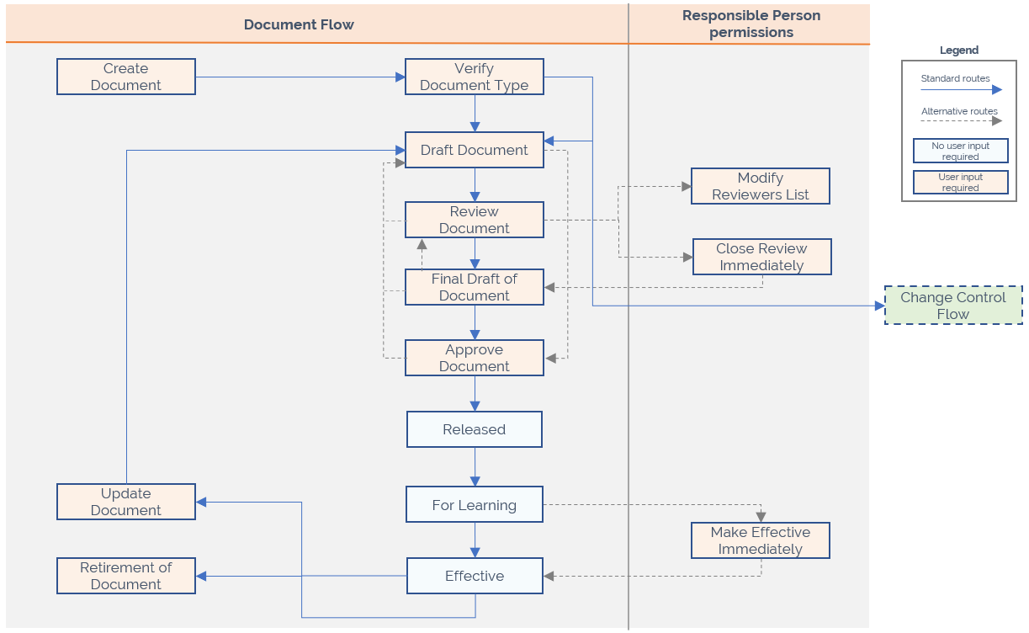

Change Request with Quality Documents, Templates and/or Products
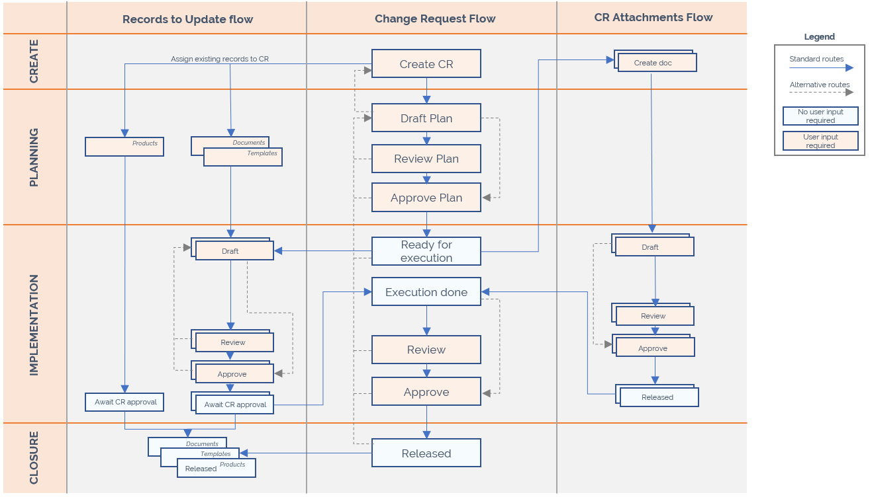

Template Management
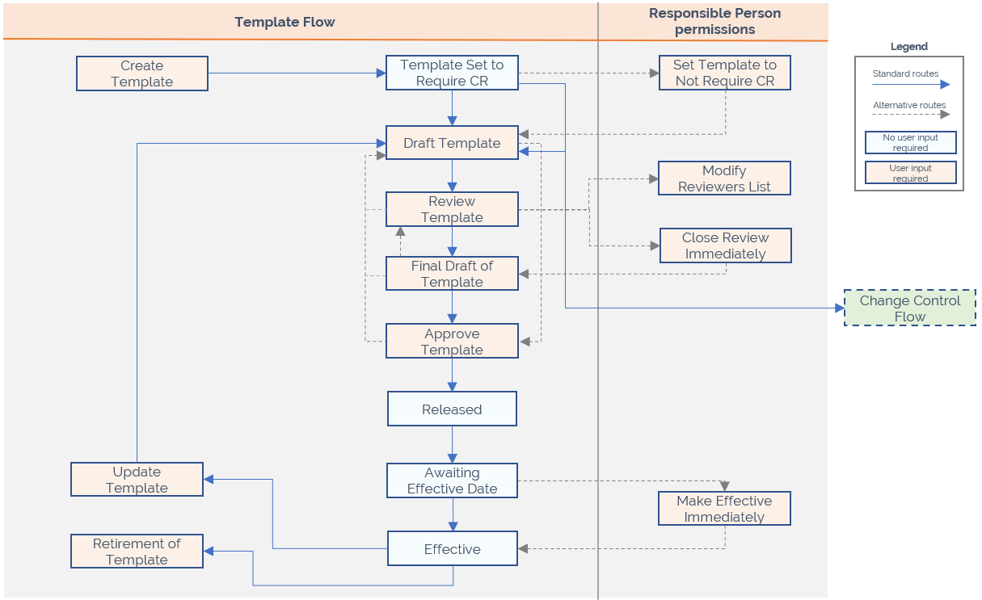

References

SOPs
- SOP-00009 Change Control (Desktop, Mobile, Classic Web)
- SOP-00011 Control of Quality Records (Desktop, Mobile, Classic Web)
- SOP-00027 Education and Training (Desktop, Mobile, Classic Web)

Revision History
Version | Date | Description of Change | Reason for Change | Author
 | 2022-03-08 | Adjusted the references for implementing SimplerQMS at SimplerQMS A/S | Moving to eQMS | AR
 | 2022-05-04 | Retention period references SOP-00011  QDs can be approved by relevant personnel for WIs and training records  Clarification that Reviewer role is optional | Minor adjustments | AR
 | 2022-09-16 | Added “Document Retired” to section 5.1.6  Added exceptions to Section 4. Responsibilities for the Approver | Exceptions for approvers | AR
 | 2022-11-10 | Update description in 5.1.2 to reflect the current use of number sequences | Incorrect description of number sequences | JS
 | 2023-06-06 | - Updated regulatory standards in Section 1.2  - Updated description of CR Requirement for Template Management from Yes to No  - Added mentioning of controlled printing | As per CR-02698 QM Review 2023 (Desktop, Web, Mobile, Classic Web) | KIP/JS
 | 2023-10-02 | - 5.1.2 outlines that File does not have a document number  - 5.1.3 outlines that Files can be soft deleted  - 5.1.5 Outlines File naming  - 5.3.1 Outlines Files has no author, reviewers or approvers | Updated due to File class introduction in version 3.1 | KIP/JS
7 | 2024-04-23 | Outlines the use of Approval and Review Groups and changes from Archive to Label. Added revision history in scope. | Update due to features in SimplerQMS 3.2 | JS/KIP/RF

