APADivisions.org Newsletter Guidelines
MS Word Template
Created December 07, 2022
(Applies only to newsletters published on www.apadivisions.org)

Part 1: General Guidelines
Part 2: Image Guidelines
Part 3: Issue Landing Page
Part 4: Articles
Part 5: Content for New Issue

Part 1: General Guidelines
- In January 2023, APA implemented a new newsletter process for divisions. Our APA team will create 3-4 highlighted articles in HTML to run on the division website and post a PDF version of the full newsletter that the division submits, for downloading purposes. Under the new process, divisions will identify 3-4 articles (APA suggests using at least one feature article) that APA will create in HTML. The division will also create a PDF version of the entire newsletter for APA to post along with the highlighted HTML articles.
- The 3-4 HTML articles must not be longer than 20 MS Word document pages, using the following formatting: 12-point Times New Roman font; single spacing; letter-size page; standard margins. This formatting is built into the newsletter template.
- There is no page limit to the PDF version of the full issue of the newsletter.
- Newsletters must be submitted using the below MS Word template only. Part 5 has been formatted to number the template pages so that you can keep track of the length of your newsletter submission. APA web editors and production specialists will use the content in this Word document to create the HTML version of the newsletter.
- Standard production time for a newsletter is 10 BUSINESS days. We strongly suggest you plan your newsletter submission accordingly.
- The 10-business-day production cycle begins only after all final copy is in, including full articles, teasers, images, and PDF. Placeholder content does not “start the clock.” You will receive a confirmation email with the production ticket number and projected completion date.
- Newsletter content must not duplicate other website content. Do not copy and paste text from previous newsletters or other web pages.
- The division should adhere to the APA Style guidelines (https://apastyle.apa.org/) when creating their content. The APA web editor will proofread and lightly copyedit content submitted by the divisions, particularly for grammar and APA web style guidelines to ensure consistency, clarity, and easy readability. If the newsletter contains a significant amount of APA Style errors, the APA web editor will send the version back to the division and ask for another review of APA Style.
- Text about APA (budget numbers, positions, actions, etc.) included in division newsletters may be tagged for review by appropriate APA staff. Any discrepancies will be shared with the division.

Part 2: Image Guidelines
- If you are submitting images, please include them in the Word template, or submit separately along with the Word document submission. If submitting the images separately, please indicate in the template which images belong to each article.
- When submitting images separately, please make sure you name your image accordingly, in reference to where it is being used within your newsletter. For example, article01_image01.jpg
- Minimum image size is 200 × 200px, 72dpi.
- If you would like our team to source a stock image, describe what you are looking for and APA web editors and production specialists will find an appropriate image.
- For all photos, outside of stock images chosen by APA web editors, the division must ensure it has permission from the owner of the photograph and the subjects to use it. Please see the Guide for photos, videos and other multimedia on division websites (https://www.apadivisions.org/websites/image-guide) for a sample photo release form. The division is responsible for retaining a record of permission for all photographs used.
- Make sure the image is clear and of a resolution of at least 72dpi. We recommend not using borders or any other distracting designs on your images.
- All images should be provided in their original format (JPEG, TIFF, PNG, etc.).
- Please submit an index image to illustrate your featured article on the newsletter's landing page. The specifications for newsletter's landing page images are 740 × 380px, 72dpi.
- Please submit headshots of authors. The specifications for headshot images are 200 × 200px, 72dpi.
- The APA web editor/production specialist will determine whether an image meets our image guidelines for use on the website, as referred to in the guide for photos, videos and other multimedia on division websites. We will notify the division if an image does not meet quality standards, and ask for a new version to be submitted.
Part 3: Issue Landing Page
Each issue’s landing page is created using the department (section), title, teaser, and author information and the index image provided with each article.
- Department: Three words max
- Article Title length: 1-2 lines suggested, use a max of 100 characters
- Teaser length: 2 lines suggested, use a max of 150 characters
- Author: Author information is pulled from APA’s site, and only includes person’s name and degree information
- Index image (740 × 380px, 72dpi.)

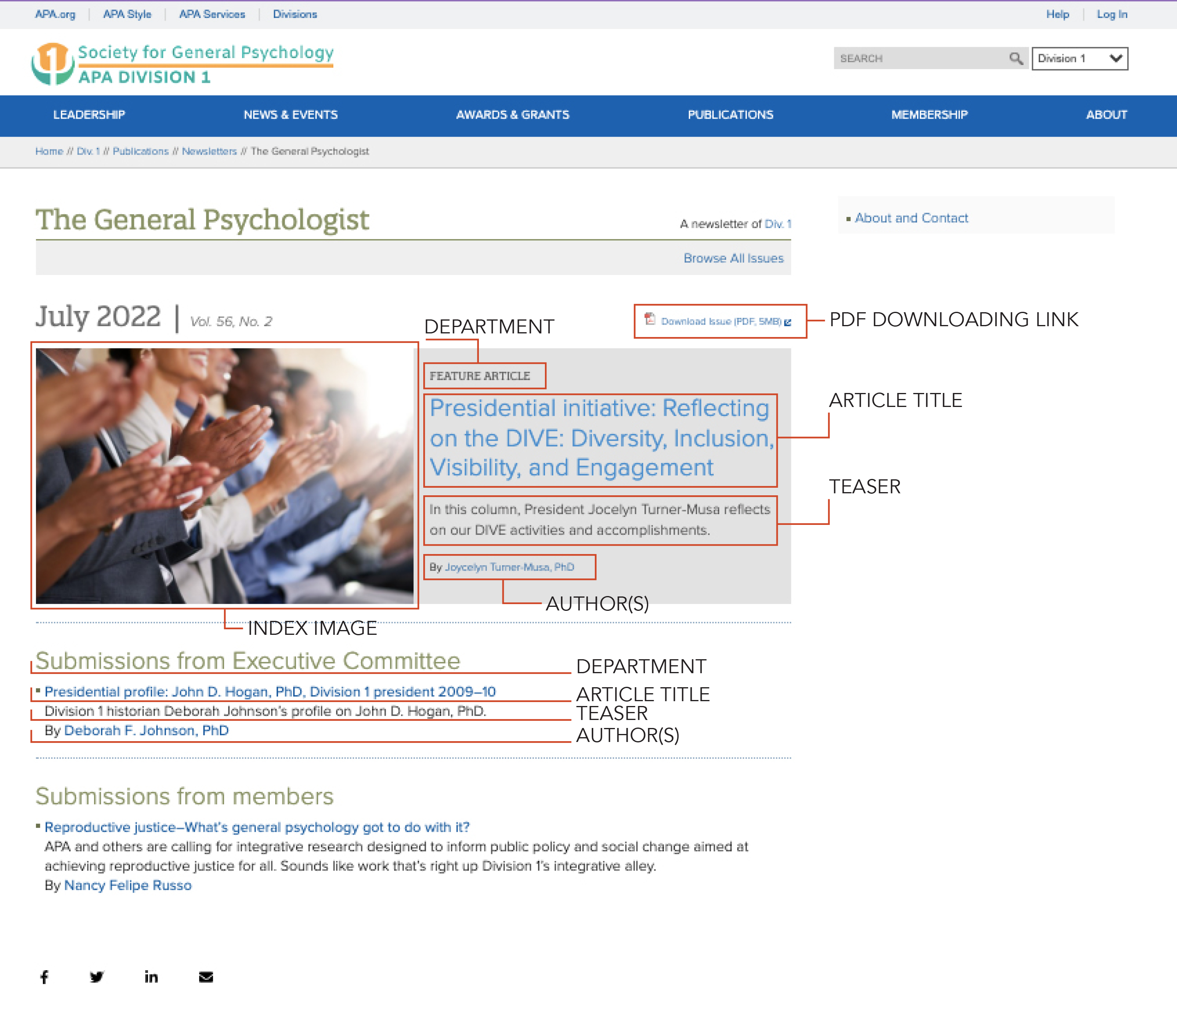

Part 4: Articles

Please provide each article’s department, title, teaser, content, author(s), and article text in order below. Number each article. Starred fields (*) are required.

Pages in Part 5 will number automatically as articles are added.

Example:
Article #1.
*Department: In This Issue
*Article Title: Psychology's contribution to the healthcare of military service members and their families
*Teaser: Ensuring that psychologists are in the forefront in providing services to military personnel, veterans, and their families.
*Author(s): Donald N. Bersoff, PhD, JD
Image(s): bersoff-heashot.jpg (shown below); bersoff-service-members.jpg (included in email submission along with Word version)

*Article Text: It is my pleasure to introduce this special issue of the CYF News devoted to articles addressing the impact of deployment and trauma on military children and their families. You may know that one of my presidential initiatives for 2013 is to ensure that psychologists are in the forefront in providing services to military personnel, veterans, and their families. Thus, this special issue is of particular relevance to me.
I selected this initiative for several reasons. But two reasons are personal. First, I served as an Air Force clinical psychologist from 1965 to 1968, two years of which were in Southeast Asia during the Vietnam War, as a result, I saw firsthand the effect war can take on both the body and the mind, not only on those who serve but on their partners and their children. Second, and perhaps even more directly apt given the nature of this special issue, is that I saw the toll World War II took on my father who served in North Africa and Europe from 1942 to 1946. He was a combat engineer and earned two bronze stars and at least one Purple Heart. But, when he returned home in 1946 he was essentially silent. He rarely spoke, never watched a war movie, and refused to talk about his combat experience, including his participation in the Battle of the Bulge. If there were such a diagnosis in WWII, he certainly would have been seen as suffering from PTSD. As a result of his almost lifelong silence and my separation from him from the time I was 2 to 7 years old, I have always regretted that he and I never had a close relationship.
The impact of the wars in Iraq and Afghanistan on military personnel and veterans is horrendous. But beyond the impact of those wars on the military, there is the impact on families. Four million parents have had a child deployed, 2 million children have had a parent deployed, and 1 million spouses are coping with deployment (see David Riggs’ quote in the December 2010 Monitor by Rebecca Clay). And, as Nansook Park notes in her January 2011 AP article, during the height of those wars, “the number of military children receiving outpatient mental health care doubled, and during that period inpatient visits by military children increased by 50 percent.” Long parental deployments affect academic performance and cause depression and anxiety as well as physical health problems. Obviously, the war not only affects veterans but can burden children and their families.
As Park points out, although programs and interventions exist, definitive conclusions about what really works are by and large lacking. “There is a significant shortage of evidence-based programs,” she writes. Thus, I agree with her that “Military children and families deserve sustained attention from psychology.” In that light, I applaud the Committee on Children, Youth and Families, and those at APA who staff the Committee for devoting this special issue of the CYF News to Military Children and their Families.

Part 5: Content for New Issue

Please include the following information for the issue - starred (*) items are required.
*Newsletter title:
*Issue date: (in Month Year format, for example, January 2023):
Volume/number: (for example, Vol. 41, No. 3):

Please paste content for your 3-4 highlighted articles below, following the example in Part 4. Pages in this section are numbered to help keep track of the submission’s length.
Article #1
* Department: Feature Article
*Article Title:
*Teaser:
*Author(s):
Image(s):
* Article Text:

Article #2
* Department:
*Article Title:
*Teaser:
*Author(s):
Image(s):
*Article Text:

Article #3
* Department:
*Article Title:
*Teaser:
*Author(s):
Image(s):
* Article Text:

Article #4
* Department:
*Article Title:
*Teaser:
*Author(s):
Image(s):
* Article Text:

