CENTER FOR CAREER DEVELOPMENT
RESUME GUIDE


CONTENTS

WHAT IS A RESUME?. 1
GENERAL RESUME WRITING TIPS. 3
DESCRIBING YOUR EXPERIENCES. 4
THE PAR METHOD. 5
USEFUL ACTION VERBS. 6
RESUME SAMPLE. 7
RESUME TIPS FOR DIFFERENT RESUME TYPES. 8
OTHER RESUME TYPES. 15
WORKS CONSULTED. 16

1

WHAT IS A RESUME?
A RESUME IS A DOCUMENT THAT SHOWCASES YOUR PROFESSIONAL EXPERIENCES, ACCOMPLISHMENTS, AND SKILLS.

BELOW IS AN EXAMPLE OF WHAT SHOULD BE
INCLUDED IN EACH SECTION OF A RESUME

YOUR NAME
Your Street Address City, State Zip Code Phone Number
email@marymount.edu (remove hyperlinks)

PROFESSIONAL SUMMARY (OPTIONAL)
Bulleted list or paragraph
Showcase your accomplishments, what makes you different from other candidates

EDUCATION
Marymount University, Arlington, VA Anticipated Graduation Month Year
Bachelor of in , Minor in (optional)
Include only schools from which you earned a degree. Do not include if you've transferred before earning a degree Optional – include study abroad
Optional – include relevant upper-level coursework
Optional – include relevant honors earned in college – Dean’s List, Honors program, scholarships, etc. Optional – include any professional associations you are part of in your field

EXPERIENCE
Company Name, City, State Start Date - End Date
Position
Start with your most recent experience
If it was a summer job, indicate that – Summer 2021
Use bullet points and concise phrases to highlight experience, skills, accomplishments
Aim for 3-5 bullet points per experience, begin the bullet point with a ROBUST action verb in the proper tense Focus on accomplishments. Ask yourself: How often? How Many? To whom? when writing each bullet point.

ACTIVITIES/VOLUNTEER WORK
Most recent/current club/organization name Dates of involvement
Title (if applicable, for example, if you had a leadership position)
This section can include your participation in organizations, clubs, sports teams, and volunteer work. If one of these experiences is relevant to the job, you can include it in the "Experience" section
Descriptions can be included, but are not necessary
Volunteer work and activities can be combined and listed as "Activities"

UNIVERSITY PROJECTS
This is mainly used when applying for research roles. This can also be used when there is no experience in the field. Senior project for a senior seminar for undergraduates, thesis or master’s project for graduates.

HONORS & AWARDS
Optional – include relevant honors earned in college – Dean’s List, Honors program, scholarships, etc. This can also be included in the "Education" section.

SKILLS
List concrete hard/technical skills and languages, if fluent 2

GENERAL WRITING RESUME TIPS
Employers generally spend 10 to 15 seconds looking at resumes, so it is important to ensure that the structure, layout, and overall design of your resume are optimal at highlighting your relevant skills, accomplishments, and experiences. Keep these tips in mind when writing a resume:

GENERAL RESUME RULES FORMATTING TIPS

Be consistent, organized, and thorough. Tailor your resume to each position you are applying for to match the specific position description, qualifications, and requirements. Include your accomplishments, do not write just a list of your job duties.
Undergraduate should be 1 page in length Resumes for professionals and higher education levels are typically two pages or more (Federal resumes and CVs are the exception.)

Keep font size between 10 PT and 12 PT. Keep margins from half-inch to 1 inch.
Use the same font for the entire document, chose an easy-to-read style (Times New Roman, Calibri, Arial).
Watch the spacing between lines and sections, be sure all spacing is the same. Use simple shapes for the bullet points. Ensure the overall look is appealing and there is not too much white space.
Use proper spelling, grammar, and punctuation.

DO'S & DON'TS
Do
List skills, experiences, and accomplishments.
Begin bullet points with an action verb in the proper tense.
Be direct and specific rather than general. Use concrete examples, outcomes, and accomplishments. Try to quantify any results you have accomplished.
Don't
Don't use personal pronouns (i.e. I, me, my, we, our, us).
Don’t include a picture with or on your resume; however, unless otherwise directed. Don’t include personal information regarding race, ethnicity, sex, gender, or religious affiliation.
Don’t use color or graphics unless it is for the design or arts industries.
Don’t use a template. Create your resume in Microsoft Word and submit it as a PDF.
3

TYPES OF RESUMES
Chronological
Most popular format that lists information in reverse chronological order (start with most recent and work backward).
Focuses on where and how skills were obtained.
Recommended for students or entry-level.
Functional
Very rarely used - if you want to use this format, please consult someone from Career Development.
Focuses on professional skills by grouping similar accomplishments and responsibilities together
Excludes details about work experience.
Combination
Classifies positions and responsibilities under functional headings in reverse chronological order.
Focuses on both accomplishments and responsibilities and the environment where it was developed.

DESCRIBING YOUR EXPERIENCES
Describing your experiences is important, whether that is work, volunteer, involvement with clubs and organizations, or research projects. It showcases your contributions and what makes you stand out. Here are few tips to remember when writing about your experience:

GENERAL TIPS

Use bullet points when writing about your experience.
Begin each bullet point with an action verb in the proper tense (refer to the next page for a list of action verbs).
Aim for 3-5 bullet points for each experience.
Focus on accomplishments, not just tasks- what did YOU do in this role? Showcase your contribution.
Be detailed, rather than general and vague.
If you're not sure which skills and achievements are most important, review the job listing and use bullet points on a resume to emphasize the qualifications you have that match the job.
Be specific – use concrete examples, outcomes, and believable accomplishments. Try to quantify any results you have accomplished.
Companies use Applicant Tracking System (ATS) to comb through resumes before a person looks at it ; Do NOT use online templates, graphics and ChatGPT

Section Headers

You can divide your experience into multiple sections.
Convey the duties and accomplishments that relate to the job in bullet points below the relevant job heading.
Examples of section headers are Experience, Teaching Experience, Leadership Experience, Volunteer Experience (or a combination of Experience & Volunteer), University Research & Projects.

THE PAR METHOD

Project - Action - Result (PAR)
The PAR method helps you write bullet point statements in a direct and succinct way when describing your experience.
It stresses your skills and achievements and conveys to the employer what you did and why and how you did it.
The PAR method has 3 components:
Project - describe the project - the job, the task, the "subject of the sentence".
Action - What were your actions? What specifically did you do? This is the "verb" of the sentence.

Result - What was the result, outcome, or goal of the project?
ACTION (VERB)
PROJECT
RESULT (OR WHY)

RESULT

TRAINED AND SUPERVISED

NEW, INCOMING STAFF

TO ENSURE CONSISTENCY OF SERVICE AND ADHERENCE TO POLICIES AND PROCEDURES AT ALL TIMES
TRAINED AND SUPERVISED NEW, INCOMING STAFF TO
ENSURE CONSISTENCY OF SERVICE AND ADHERENCE TO POLICIES AND PROCEDURES AT ALL TIMES.

USEFUL ACTION VERBS

MANAGEMENT
Administered Analyzed Authorized Consolidated Consulted Coordinated Developed Directed Enforced Enhanced Executed Generated Hired Improved Increased Led Managed Motivated Organized Oversaw Planned Prioritized Produced
Recommended Scheduled Supervised

TEACHING SKILLS
Adapted Advised Clarified Coached Communicated Conducted Coordinated Critiqued Developed Enabled Encouraged Evaluated Facilitated Guided Individualized Informed Instructed Persuaded Stimulated Taught
Tested Trained Tutored
ORGANIZING
Approved Arranged Categorized Collected Compiled Corrected Corresponded Distributed Executed Filed Generated Incorporated Maintained Obtained Organized Prepared Processed Provided Purchased Recorded Reserved Scheduled Updated

RESEARCH
Analyzed Clarified Collected Conducted Critique Determined Diagnosed Evaluated Examined Experimented Explored Formulated Gathered Inspected Interviewed Investigated Located Measured Organized Researched Reviewed Searched Solved Summarized Surveyed Tested
CREATIVE
Acted Adapted Combined Composed
Conceptualized Condensed Customized Designed Developed Directed Displayed
Drew Entertained Established Fashioned Formulated Founded Illustrated Initiated Instituted Integrated Introduced Invented Modeled Modified Originated Performed Photographed Planned Revised Revitalized Shaped Solved

COMMUNICATION
Addressed Advertised Arranged Articulated Collaborated Communicated Composed Condensed Conveyed Corresponded Debated Defined Developed Directed Discussed Drafted
COMMUNICATION CON'T
Edited Formulated Interpreted Interviewed Involved Joined Lectured Marketed Mediated Moderated Negotiated Outlined Presented Promoted Publicized Reconciled Recruited Referred Reported Responded Solicited Spoke Suggested Summarized Synthesized Translated Wrote

DATA/FINANCIAL SKILLS
Adjusted Allocated Analyzed Assessed Audited Balanced Budgeted Calculated Conserved Corrected Determined Developed Estimated Forecasted Managed Marketed Planned Prepared Programmed Projected Qualified
DATA/FINANCIAL SKILLS CON'T
Reconciled Reduced Researched Retrieved

HELPING SKILLS
Adapted Advocated Aided Answered Arranged Assisted Coached Contributed Counseled Demonstrated Diagnosed Educated Encouraged Ensured Expedited Furthered Guided Intervened Motivated Prevented Provided Referred Rehabilitated Resolved Simplified Supported Volunteered
MANUAL SKILLS
Arranged Assembled Built Constructed Controlled Designed Developed Drove Engineered Handled Installed Maintained Operated Remodeled Repaired Tested

SAMPLE RESUME

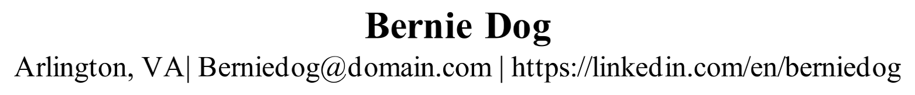
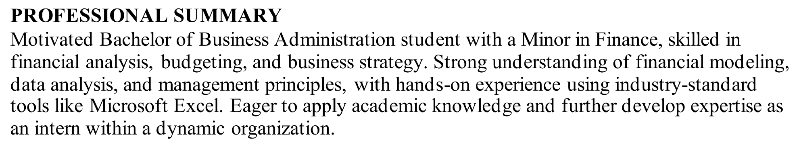
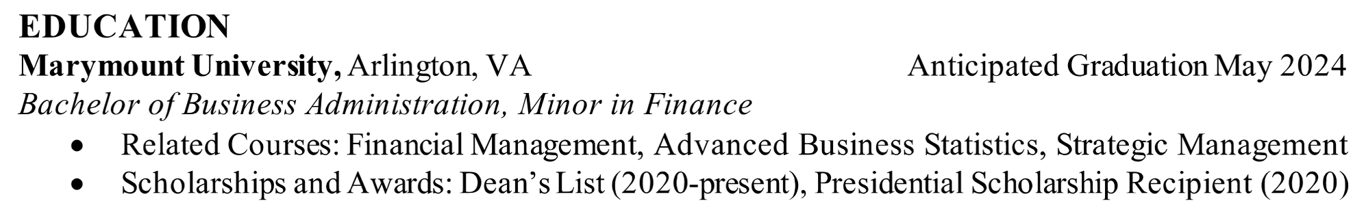
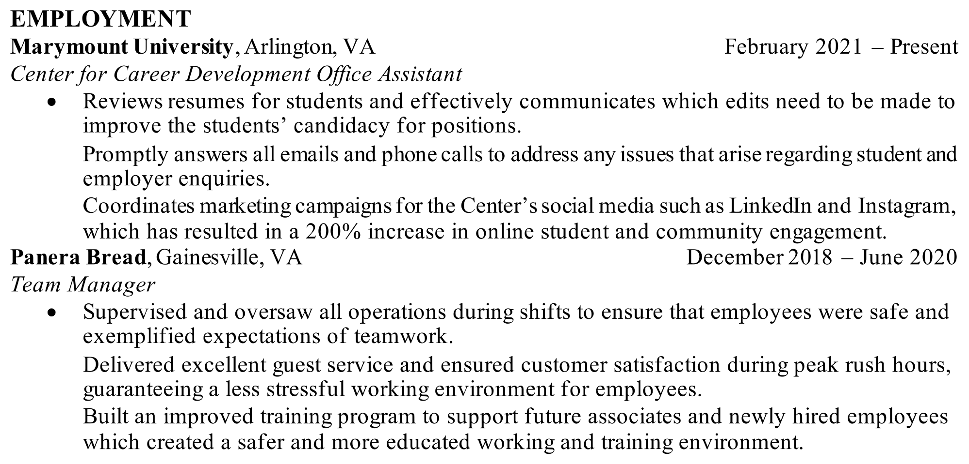
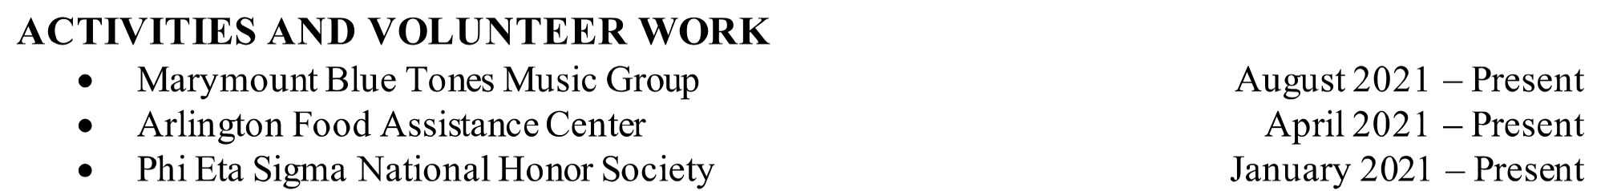
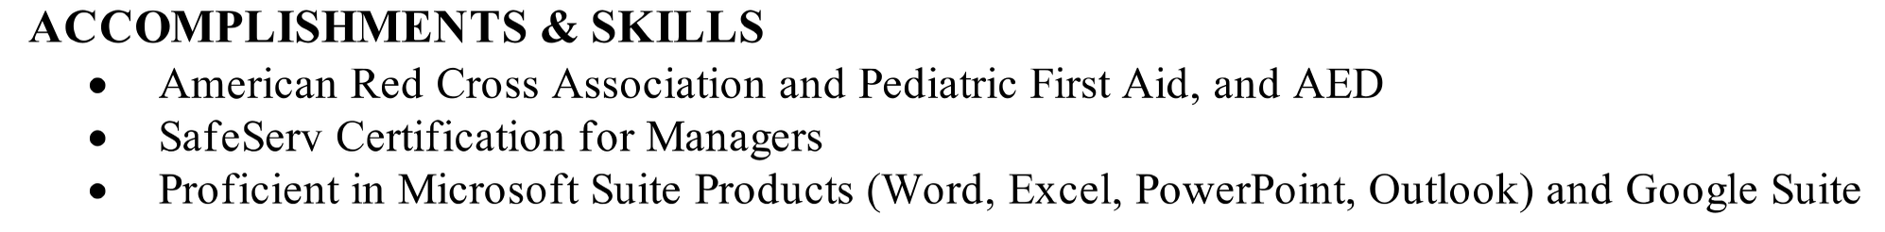

RESUME TIPS | NONPROFIT & SERVICE

TIPS
Your volunteer experience can be included as its own section or under Experience. List past experiences, paid or volunteer, that connect to the organization's mission. Non-Profit jobs and internships can expand across a variety of industries and job functions including research, writing and communications, advocacy, and more. Make sure you tailor your resume to fit the sub-category or role you are applying to.
Research roles - highlight research experience and projects, whether that is in or outside the classroom
Writing/communications roles - highlight experiences that demonstrate strong, written, verbal and graphical communication (such as grant writing). Include any other communications expertise such as social media platform management.
Advocacy/community organizing roles - highlight any fieldwork, community outreach and volunteer work, and event planning and orchestration.
Include languages that you are fluent in.
Include leadership roles, participation in special events, board or committees memberships, and participation in fundraising initiatives.
RELEVANT ACTION VERBS
Maintained Oversaw Managed | Collected Collaborated Organized | Delivered Performed Ensured |  | Increased Researched Provided | Coordinated Reported  Interviewed | Analyzed Addressed Drafted
RELEVANT TECHNICAL SKILLS
Report writing Grant writing
Data collection and analysis Stata
Proficiency in a foreign language
Microsoft Office Suite (Word, Excel, PowerPoint) Google Suite (Sheets, Docs, Forms, Slides)
Social Media Platforms & Analytics (Instagram, Twitter, Facebook, TikTok)

RESUME TIPS | CREATIVE

TIPS
Keep it simple - avoid using premade, flashy, or gimmicky templates.
If you choose to use color and other graphical or visual elements such as your logo, make sure it enhances the content of your resume rather than getting in the way of it. Include quality content, clear achievements, technical skills, and detailed experiences. Your resume can't just be about the design.
Use simple formatting alterations to enhance relevant information and experiences (such as bolding a header).
Make sure your resume is still easy to read - creative elements should not hinder the readability of your resume. Consider applicant tracking systems when creating your resume.
Include a link to your portfolio - it is a great place to showcase your creativity. Your cover letter, resume, and portfolio should work as a package and have consistency and cohesive branding.
The most common font used is Times New Roman at 12 points in size. You can choose other fonts including Cambria, Georgia, Garamond, Book Antiqua, and Didot. Sans serif fonts that work well include Calibri, Helvetica, Verdana, Trebuchet MS, and Lato.
RELEVANT ACTION VERBS
Built Created Produced | Edited Executed Directed | Designed Illustrated Customized | Conceptualized Drew Integrated | Modeled Performed Composed | Modified Planned Drafted
RELEVANT TECHNICAL SKILLS
AutoCAD LT, SketchUp Pro, Revit (Interior Design)
Adobe Creative Suite (Photoshop, InDesign, Illustrator, Premiere Pro, Lightroom) UX/UI Design
Sketching and Drawing Ability
Microsoft Office Suite (Word, Excel, PowerPoint) Google Suite (Sheets, Docs, Forms, Slides) Operation systems: Mac OS & Windows
Social Media Platforms & Analytics (Instagram, Twitter, Facebook, TikTok)

RESUME TIPS | BUSINESS & TECHNOLOGY

TIPS
Include projects you led or an idea you spearheaded that increased efficiency, saved the employer money and/or time, improved a process, or built a relationship.
Use metrics to describe your achievements when possible. Include dollars saved or percentage changes to show your successes and contributions.
You can also include accomplishments that are not quantifiable such as improving a relationship with a client.
Research your company/job to highlight relevant experiences/skills on your resume. Highlight transferable skills if you lack direct experience, such as leadership and time management skills you learned at a previous job.
Use a straightforward format - avoid using colorful templates, tables, graphics, which might not get picked up by an applicant tracking system (ATS) scan. Your resume should look clean and professional.
List the company/organization name first, then the location (city, state), job title, and start and end dates (dates should be right-justified).
Use an easy-to-read font such as Arial, Calibri, or Helvetica. List up-to-date skills in software and technology
RELEVANT ACTION VERBS
Analyzed Consolidated Consulted | Coordinated Developed Directed | Advertised Executed Generated |  | Increased Led Managed | Budgeted Audited Forecasted | Constructed Repaired Programmed
RELEVANT TECHNICAL SKILLS
JavaScript, CSS, C++, MySQL, PHP, HTML, Python, Cloud computing UX/UI Design
Microsoft Office Suite (Word, Excel, PowerPoint) Google Suite (Sheets, Docs, Forms, Slides)
Social Media Platforms & Analytics (Instagram, Twitter, Facebook, TikTok) Google AdWords and Google Analytics
Database Management Project Management

RESUME TIPS | GOVERNMENT & MEDIA

TIPS
Study government vacancy announcements and use them as a guide to writing your resume since they contain great details about the qualifications.
Include specific qualifications from the government job posting. These may include a number of years in the criminal justice field, a level of academic credential, and licensure or certification. Also include the job announcement number, title, and grade level(s) of the job for which you are applying, locations for which you are applying (if applicable), and veterans' preference, if applicable. Indicate if you are a US citizen (required by most Federal Jobs).
Include paid and unpaid experiences, and include volunteer work done with National Service programs (such as Peace Corps and AmeriCorps).
If you are transitioning from military work to civilian work, create a Military Experience section, and highlight the transferable skills. Transferable skills you can highlight in your bullet points under this section include leadership, financial responsibility, effective communication, integrity, and technology skills.
Read the job posting carefully to find out if they need a federal resume (read: federal resume on page 21), or if they will accept your regular resume.
RELEVANT ACTION VERBS
Advocated Aided Collaborated | Improved Negotiated Adhered | Established Developed  Compiled |  | Conducted Consolidated Coordinated | Authorized Advised Informed | Wrote Interpreted  Served
RELEVANT TECHNICAL SKILLS
Microsoft Office Suite (Word, Excel, PowerPoint) Google Suite (Sheets, Docs, Forms, Slides)
Social Media Platforms & Analytics (Instagram, Twitter, Facebook, TikTok) Adobe Creative Suite (Photoshop, InDesign, Illustrator, Premiere Pro, Lightroom) Security clearances
Proficiency in a foreign language Data analysis

RESUME TIPS | TEACHING

TIPS
Include all relevant teaching experience (volunteer positions, internships, coaching, and other and co-curricular activities that involve teaching.)
Include all certifications: teaching certifications, CPR/First-Aid, and other applicable certifications on your resume.
Questions to ask yourself when writing about your teaching accomplishments: Have you developed/led any academic or extracurricular after-school programs? Do you have a specialty or expertise in particular teaching methods?
Were you a mentor or peer tutor?
Did you elevate students' performance over a period of time? What strategies have you used to increase student engagement? Did you increase parental involvement?
Emphasize quantitative and qualitative accomplishments.
Customize information to the job requirement and qualifications, highlight specific and transferable skills. Include usage and knowledge of classroom technology.
Include keywords that are common in the teaching profession (e.g. planning, curriculum development, teaching across the curriculum, experiential learning, student success, teacher-parent relations, team teaching, and collaboration.)
Don't use abbreviations or acronyms, even if they are recognizable.
RELEVANT ACTION VERBS
Prepared Taught Collaborated | Organized Classified Implemented | Review Responded  Assessed |  | Maintained Coached  Coordinated | Encouraged Trained  Fostered | Aided Adapted  Enforced
RELEVANT TECHNICAL SKILLS
Microsoft Office Suite (Word, Excel, PowerPoint) Google Suite (Sheets, Docs, Forms, Slides)
Classroom management software and systems (Moodle, Blackboard, Canvas) Proficiency in a foreign language
Electronic presentations CPR/First-Aid certification

RESUME TIPS | HEALTHCARE

TIPS
List licensure and certification.
Include academic accomplishments such as research, special projects, presentations, and/or relevant thesis topics.
If you are new to the healthcare field, prioritize your Clinical Rotation section and any healthcare-related experience at the beginning of your resume.
What to include for your clinical rotations:
Only include the rotations that are relevant to the position you are applying for List the setting (unit), location (write out the full hospital/facility name, no abbreviations.), the semester you worked, and hours you completed.
If you have clinical experience outside of your rotations, include a Clinical Experience section after your Clinical Rotation Section. You can also include a Work Experience section to highlight jobs outside of the healthcare field.
Questions to ask yourself when writing about your healthcare accomplishments:
Did your work positively impact the organization? How? How many people benefited from your work?
Did you reduce cost, time, or effort?
Did you create any original work like reports, guides, proposals?
Did you develop a new program or strategy that saved time or increased efficiency?
RELEVANT ACTION VERBS
Admitted Advanced Advocated Facilitated | Diagnosed Monitored Aided | Distributed Practiced Assigned |  | Documented Briefed Assessed | Secured Corresponded Wrote | Detected Supported
RELEVANT TECHNICAL SKILLS
Microsoft Office Suite (Word, Excel, PowerPoint) Google Suite (Sheets, Docs, Forms, Slides) Proficiency in a foreign language
CPR/First-Aid/AED certification Check and monitor vital signs Catheterization
Electronic medical record systems Telemetry

RESUME TIPS | UNIVERSITY PROJECTS AS EXPERIENCE

TIPS
You can include university projects that are relevant to the job or internship you are applying to if you do not have any work, volunteer, or club and organization experience.
What to include when writing about your university projects:
Course name Name of professor
The semester you completed the project Project title
Use the PAR (Project - Action - Result) method highlighted in the Describing Your Experience to describe your projects, your role, key findings, learning outcomes, results, and accomplishments.
Highlight transferable skills when writing about your projects that are relevant to the role you are applying to, such as collecting and analyzing data, synthesizing information, creating recommendations, and solving problems.
RELEVANT ACTION VERBS
Advocated Aided Communicated | Organized Assessed  Analyzed | Collected Recommended  Produced |  | Surveyed Gathered Measured | Corresponded Recorded  Researched | Drafted Designed  Presented
RELEVANT TECHNICAL SKILLS
Microsoft Office Suite (Word, Excel, PowerPoint) Google Suite (Sheets, Docs, Forms, Slides)
JavaScript, CSS, C++, MySQL, PHP, HTML, Python, Cloud computing UX/UI Design
Social Media Platforms & Analytics (Instagram, Twitter, Facebook, TikTok) Proficient in a foreign language

OTHER TYPES OF RESUMES

CURRICULUM VITAE (CV)
Primarily for professors, high-level education, research No page limit
Includes sections for Research, Publications, Teaching, Training, Presentations Section order is not as important
Include more detail about types of accomplishments Highly tailored to each position
It is important to note that many other countries (especially European countries like the United Kingdom, France, etc.) refer to what Americans call a “traditional resume” as a “CV.” This means that if you are applying to a company in London, England, and they ask for a CV, they are really asking for your traditional 1-2 page US resume with some additional information.
FEDERAL RESUMES
Used for federal jobs. Read the job posting carefully to find out if the employer needs a federal resume, or if they will accept your regular resume.
Section headings can be the same as the regular resume headings. Experiences are described either in paragraphs or bullet points.
No page limit, length based on experience.
Include the job announcement number, title, and grade level(s) of the job for which you are applying, and locations for which you are applying (if applicable).
Include more personal information:
Social security number, veterans' preference, security clearances, indicate if you are a US citizen (required by most Federal Jobs).
Experiences include:
Salary, hours worked, company address, supervisor’s name, and contact (and if they can be contacted).
No timeline limit, include all work experiences

FOR INFORMATION ABOUT FEDERAL RESUMES OR RESUMES FOR CAREERS ABROAD, CONTACT THE CENTER FOR CAREER
15 DEVELOPMENT.

WORKS CONSULTED

Georgetown University Center for Career Services. (2017, August). Resume Writing Guide: Nursing. Georgetown.
Harvard University Faculty of Arts & Sciences Office of Career Services. (2021). OCS RESUMES & COVER LETTERS. Cambridge.
The National Archives and Records Administration. (n.d.). The Federal Resume Guide What You Should Know When Applying for a Federal Career.
Newfield, P. (2018, November 7). Things to include in a creative industry resume. Career Resumes. Retrieved September 9, 2021, from https://careerresumes.com/things-to-include-in-a-creative-industry-resume/. Pohle, A. (2021, May 11). 18 résumé writing tips to help you stand out. The Wall Street Journal. Retrieved September 9, 2021, from https://www.wsj.com/articles/18-resume-writing-tips-to-get-you-noticed- 11605107446.
Resume tips for Healthcare Professionals: Allen School. Allen School of Health Sciences. (2020, May 13). Retrieved September 9, 2021, from https://www.allenschool.edu/resume-tips-for-medical-insurance-billing/.
Sample resumes. Sample Resumes | Columbia CCE. (n.d.). Retrieved September 9, 2021, from https://www.careereducation.columbia.edu/resources/sample-resumes. Schild, I. (2021, May 17). How to write a nonprofit resume - nonprofit resume tips. Nonprofit Job Board & Foundation Jobs Site. Retrieved September 9, 2021, from https://www.foundationlist.org/how-to-write-a-resumetips-for- how-to-create-a-readable-resume/.
Stanford University Career Center. (n.d.). RESUMES/COVER LETTERS. Stanford.
Ten Resume Tips for Nonprofit Jobseekers. PND by Candid. (2007, May 2). Retrieved September 9, 2021, from https://philanthropynewsdigest.org/columns/mycareer-pnd/ten-resume-tips- for-nonprofit-jobseekers.
Top 10 transferable military skills to list on your resumé. Bachelor's Degree Completion. (2021, April 16). Retrieved September 9, 2021, from https://www.northeastern.edu/bachelors-completion/news/transferable- military-skills/.

FOR A COMPLETE LIST OF WORKS THAT WERE CONSULTED FOR THIS RESUME GUIDE, PLEASE CONTACT THE CENTER FOR CAREER DEVELOPMENT AT CAREERDEV@MARYMOUNT.EDU.

why)



FOR MORE INFORMATION
CONTACT OUR OFFICE
(703) 284-5960
CCDCE@marymount.edu @marymountcareer https://www.linkedin.com/company/mary mount-university-ccdce/

