Git Tasks

**1. Make a repository on GitHub with the name “InnovationPython_yourname”**

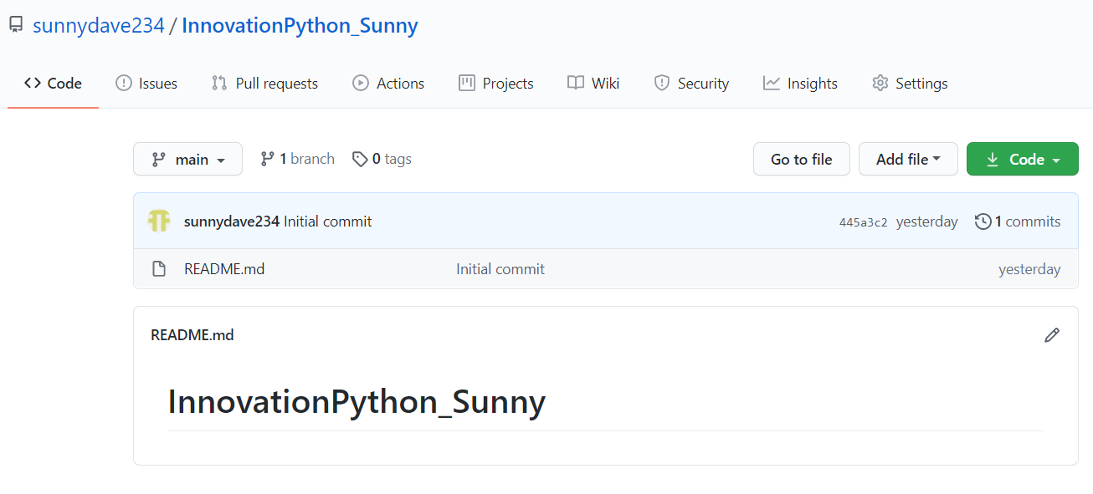

**2. Read about the difference between Git and GitHub**

Git: Git is a version control system that allows you to manage record of your code history.

GitHub: GitHub is a cloud based hosting service that allows you to manage your Git repository.

**3. Read about Git Workflow**

Git Workflow is a process for how to use Git to complete work in a reliable manner. Git workflows encourage users to leverage Git effectively and consistently. Git offers a lot of flexibility in how users manage changes.

**4. How many types of version control systems are there?**

There are three type of version control systems

1. Local Version Control Systems,
2. Centralized Version Control Systems,
3. Distributed Version Control Systems

**5. Explain Branching concept in Git.**

Making changes in the code of a project safely off to one side and merging that codes back to main branch once that works fine and changes are accurate without changing the main code. And version of the code can be changed and could switch to previous versions.

**6. Explain Forking Workflow in Git.**

Forking workflow is beneficial to improve someone’s open source project by copying code on your own repository and then to your local machine and updated code can be pushed to the main code after main project admin’s approval.