SECTION D - CONTRACT DOCUMENTS, EXHIBITS, OR ATTACHMENTS

Attachments A through O

ATTACHMENT (A) TECHNICAL SPECIFICATIONS
ATTACHMENT (B) PERFORMANCE WORK SUMMARY PLAN
ATTACHMENT (C) QUALITY ASSURANCE SURVEILLANCE PLAN
ATTACHMENT (D) CONTRACT DISCREPANCY REPORT FORM
ATTACHMENT (E) WORK SUMMARY AND PROGRESS REPORT
ATTACHMENT (F) RECOMMENDED EQUIPMENT LIST
ATTACHMENT (G) KERRVILLE NATIONAL CEMETERY FLORAL/GROUNDS POLICY
ATTACHMENT (H) CEMETERY MAP

ATTACHMENT (I) GROUNDS MAINTENANCE MAP

ATTACHMENT (J) PESTICIDE & FERTILIZER APPLICATION PLAN
ATTACHMENT (K) PESTICIDE & FERTILIZER APPLICATION PROPOSAL
ATTACHMENT (L) PESTICIDE APPLICATION RECORD
ATTACHMENT (M) FERTILIZER APPLICATION RECORD
ATTACHMENT (N) SOIL TEST RESULTS
ATTACHMENT (O) TREE WORKSHEET

ATTACHMENT (A)

TECHNICAL SPECIFICATIONS
SECTION 1
Headstone Maintenance & Cleaning
SECTION 2
Headstone Fine Tune Alignment
SECTION 3
Turf Maintenance: Fertilization, Pest Control, Aeration, and Dethatching
SECTION 4
Lawn Maintenance: Sodding and Seeding
SECTION 5
Lawn Maintenance: Mowing, Trimming, & Edging
SECTION 6
Leaf Collection
SECTION 7
Plant Material Maintenance
SECTION 8
Irrigation Maintenance and Operations
SECTION 9
Trash and Debris Removal
SECTION 10
Floral Removal

SECTION 1

HEADSTONE MAINTENANCE & CLEANING

  - GENERAL

All work performed in this section is subject to the General Requirements and contract documents forming a part of these specifications, and the Contractor shall be responsible for and governed by all the requirements thereunder.

  - SCOPE

NCA Standard: All upright headstones (hereafter referred to as “headstones”) shall be clean, free of debris and objectionable accumulations. The headstones located within the Cemetery are currently MARBLE.

Work consists of cleaning all headstones as specified by the Contracting Officer’s Representative (COR) to remove objectionable material and discoloration, such as environmental deposits, accumulations of bird droppings or dirt/mud, tire and hose markings, grass stains, residue from trees, mold, mildew, moss, algae, lichen, fungus, and so forth.

  - GENERAL SPECIFICATIONS

    - All headstones shall be cleaned prior to Memorial Day and Veteran’s Day and any other time as determined by the COR, with a washing of two (2) times per year minimal. The Contractor shall pressure wash entrance gate of the Cemetery. The natural surfaces shall be retained. They shall not be painted, white washed, or calcimined. Any headstones that have any dirt splash up or grass debris from mowing/trimming shall be promptly cleaned when found.

    - All equipment and supplies maintained and operated by the Contractor shall be consistent and fully compliant with all applicable Federal, State, and County laws, ordinances and regulations and meet State inspection, safety, licensing, registration, and insurance requirements.

  - PROCEDURE

    - Cleaning techniques shall demonstrate a clear understanding of, and the sensitivity to, such environmental issues as ground water contamination, wetlands, etc., and shall be consistent and fully compliant with all applicable Federal, State, and County laws, ordinances and regulations.

    - Clean water shall be used to clean headstones. Cleaning techniques with water shall include high pressure spraying, scrubbing and/or rinsing.

    - When water under pressure is used, the pressure shall not exceed 500 psi. Excessive soil, staining and/or discoloration may be removed with plain water and a stiff brush (no wire brushes, bleach, solvents, or abrasive cleaners/blasting shall be permitted), followed by rinsing with clear water.

    - The toning or patina of the stone will not be removed unless as a result of cleaning accomplished to remove the accumulations previously noted. In this instance the stone should be cleaned in its entirety so as to present a uniform appearance.

    - If water used in cleaning should soften the soil around the base of the headstone so that the headstone is loosened, care shall be taken not to tip the headstone out of plumb or alignment. Headstones shall be set and anchored firmly in place with no movement from forces subjected by the COR or inspector after cleaning has been completed.

    - In turfgrass areas, care shall be taken to protect the turf area from any damage. Any turf damaged by the Contractor shall be restored at Contractor's cost in accordance with “LAWN MAINTENANCE: SODDING/SEEDING.”

SECTION 2

HEADSTONE FINE TUNE ALIGNMENT

  - WORK OVERVIEW

The result of the Contractor’s performance must meet or exceed the requirements of this section. This section outlines upright headstone aligning, backfilling, and compacting. The Contractor shall provide all supervision, professional advice/guidance, labor, parts, materials, equipment, and personnel to provide the services defined herein. Work consists of resetting or realigning those already in place that have shifted out of vertical or horizontal alignment. It includes reporting physical defects to the Contracting Officer or his authorized representative.

  - RECORD KEEPING AND REPORTING

The Contractor’s Superintendent or his designee shall provide the COR with daily written reports accurately identifying all headstones set and replaced listed by deceased names and headstone numbers for each gravesite location.

  - GENERAL SPECIFICATIONS

    - Standard upright headstones are approximately 42 inches long, 13 inches wide, and 4 inches thick and weigh approximately 220 pounds. Headstones may vary in size and weight depending on their age with regard to the production date.

    - All temporary markers, floral, commemorative, or other type of decorations (arrangements) causing interference with the fine tune alignment of headstones shall be carefully, and in an orderly manner, moved during the installation and moved back to all gravesites upon completion by the Contractor. Prior to removal, the Contractor shall verify the numbering sequence and location of the headstone and associated decorations or vases.

    - Prior to starting work in each new initial burial section, coordinate the correct permanent gravesite control markers and the required gravesite row/gravesite spacing layout dimensions with the COR.

    - Trees or shrubs obstructing headstones shall be noted and the Contractor shall notify the COR for determination of remedial action or modification for installation.

    - The Contractor shall restore all damage caused during performance of this work. Repairs shall be completed by the Contractor within fourteen (14) workdays, unless otherwise agreed to with the COR.

    - Any headstones broken or damaged by the Contractor shall be reported to the COR by close of business each working day in order that the grave can be properly marked. The Contractor shall be responsible for the cost of the headstone replacement. All headstone replacements must be coordinated with the COR.

    - Any grid or sectional monuments disturbed, displaced or broken shall be replaced by the Contractor at his cost. All grid or sectional monuments disturbed, etc., shall be properly reset by a licensed land surveyor at Contractor’s expense.

    - Curbs, roads, walks, turf, trees, utilities, etc. existing above and below the ground that are damaged or disturbed by the contractor during performance of contract work shall be repaired at the expense of the contractor.

  - PROCEDURE

    - Specific headstones in each burial section shall be chosen and designated to be “Key” stones (keystones) for use throughout the fine tune alignment process. See Exhibit A. All keystones are to be vertically plumbed and aligned by leveling the front, back, and sides while raising or lowering the headstone as necessary to achieve a height of 25 inches above the mean (average) topsoil level. These keystones are headstones that are visibly in line with the majority of the rest of the headstones in both the rows and the columns and are as close as possible to the proper measurements for that particular section of headstones. Keystones shall be at a maximum spacing of every 10th headstone or at a more frequent spacing as required in areas of sloped or rolling terrain in order to achieve a flowing transition between the rows and columns.

    - Install heavy string lines along the front, sides, tops, and transversely of all applicable Keystones. The string lines shall be laid out to the correct dimensions as determined by Keystones such that the rows and columns are evenly spaced. All headstones shall be vertically plumbed and aligned by leveling the front, back, and sides while raising or lowering the headstone as required to achieve a height of 25 inches above the mean (average) topsoil level. IMPORTANT: To meet the requirement of a smooth, flowing transition, the Contractor may be required to set the headstone at a height other than at the required 25 inches above grade with approval by the COR. These measurements shall be adhered to as closely as possible and may be adjusted to suit unique site conditions with approval by the COR. See Exhibit B.

    - All remaining headstones in the rows, columns, and transverse directions are then aligned along the string lines front to back, side-to-side, transversely, and match the required row and column spacing for the section. All remaining headstones are to be vertically plumbed and aligned by leveling the front, back, and sides while raising or lowering the upright headstone as required to achieve a height of 25 inches above the mean (average) topsoil level. See Exhibit B. The installation, adjusting, and setting of the remaining headstones shall meet all requirements of this contract.

    - The Contractor shall use a wooden tamper to bump the headstone into alignment of the string line to the maximum extent possible without having to remove the headstone from the socket, while maintaining plus/minus (+/-) 1/8-inch maximum tolerance shall be maintained in the vertical, lateral, and transverse directions in accordance with the dimensional requirements. The alignment of the headstones should be checked frequently during this process because the tamping of the headstones may move the headstone out of level or off the mark on the line.

    - Headstones shall be installed to within one degree of fully vertical when measured on front and sides using a digital level.

    - The completed set headstones shall be anchored firmly in place so that the headstones are rigid with no give or play regardless of the soil and terrain conditions. All headstones shall be firmly set and anchored in place with no movement from forces subjected by the COR.

    - The measurements between rows or columns of headstones and between the headstones within each row or column may differ from one gravesite section to the next. This condition is to be discussed with COR where this is found to occur. Some variances may be allowed by the COR in order to keep a uniform appearance of headstones being aligned.

    - Headstones set shall be clean of all dirt, handprints, etc. by the close of the work day in accordance with HEADSTONE CLEANING.

    - Any headstones broken or damaged by the Contractor shall be reported to the COR by close of business each working day in order that the grave can be properly marked. The Contractor shall be responsible for the cost of the replacement. The cost of the replacement headstone(s) will be deducted from Contractor’s invoice(s). All headstone replacements must be coordinated with the COR. Any existing permanent gravesite control markers, temporary contractor installed control markers, grid or sectional monuments that are disturbed, displaced, or broken shall be replaced and properly reset by a licensed surveyor at the Contractor’s expense. Curbs, roads, walks, turf, trees, utilities, etc. existing above and below the ground that are damaged or disturbed by the Contractor during performance of contract work shall be repaired at the Contractor’s expense. The requirements of this paragraph shall be completed by the Contractor within fourteen (14) workdays, unless otherwise agreed to by the COR.

    - TURFGRASS REESTABLISHMENT: All turf areas that are disturbed where headstone setting or raise and realignment work has occurred, shall have turfgrass re-established in accordance with “LAWN MAINTENANCE: SODDING/SEEDING.”

SECTION 3

TURF MAINTENANCE: FERTILIZATION, PEST CONTROL, AERATION, AND DETHATCHING

  - GENERAL

All work performed under this section is subject to the General Requirements which form a part of these specifications, and the Contractor shall be responsible for and governed by all the requirements thereunder.

  - SCOPE

NCA STANDARD: High maintenance areas have a well-established, healthy, 95% weed-free stand of turf.

The Contractor shall be responsible for maintaining the turf areas of the Cemetery and the immediate area surrounding the Cemetery in a healthy condition utilizing turf management best practices, to include fertilization, soil amendments, weed and pest control, aeration and/or dethatching.

NCA Standard Operating Procedure 41-SOP-021 Turfgrass Maintenance serves as an additional reference for turf best management practices at all VA National Cemeteries.

The turfgrass at the cemetery is hybrid bermudagrass (Tif419).

  - EQUIPMENT AND SUPPLIES

    - The Contractor shall supply all necessary applicators, hoses and other equipment.

    - Water shall be furnished by the Government at no cost to the Contractor.

    - The Contractor shall furnish all required pesticides, fertilizers, soil amendments, and any other supplies.

    - The NCA (COR or representative) will have soil testing of the site performed approximately every three (years), or as needed for projects. A copy of the soil test results will be provided to the contractor and COR, along with recommendation and guidance for the application of any required soil amendments, as indicated by the soil testing.

    - The Contractor shall complete and submit a detailed Pesticide and Fertilizer Application Plan to the COR and/or Cemetery Leadership no later than 30 days following the award (Attachment J). The Contractor submitted plan shall directly correspond to the specifications in this Performance Work Statement.

    - No fertilizers and/or chemicals shall be applied to cemetery grounds without prior approval from the COR and the Continental District Agronomist.

  - PESTICIDE APPLICATOR LICENSE

    - When any and all pesticide applications are being performed, a “Licensed Applicator” shall serve as the “site manager” for this contract and will be provided on site by the Contractor; all herbicide applications shall be applied directly by or under the supervision of a current commercially licensed pesticide applicator.

    - The licensed applicator must be a commercially licensed Texas Certified Pesticide Applicator licensed by the Texas Department of Agriculture; the license must be active and include Category 3a Landscape Maintenance. All applications shall be performed as per the Rules and Regulations of the Texas Department of Agriculture and/or the Texas Structural Pest Control Board, whichever has jurisdiction over the contractor’s applicator. The contractor shall submit the license to the COR prior to commencing work.

    - The Licensed Applicator must have at least three (3) years’ experience performing herbicide applications in commercial (non-residential) turf and ornamental landscapes. The Licensed Applicator will ensure all specifications are being met, ensure contract work does not conflict with ceremonies and funerals, and ensure employees are adequately supervised and proper conduct is maintained.

    - Any proposed personnel change for the Licensed Applicator shall be approved a minimum of ten (10) business days prior to a pesticide application.

  - NOTIFICATION AND RECORDS

    - The Contractor shall complete and submit a detailed Pesticide and Fertilizer Application Plan to the COR and/or Cemetery Leadership no later than 30 days following the award (Attachment J). The Contractor submitted plan shall directly correspond to the specifications in this Performance Work Statement.

    - In accordance with the submitted Pesticide and Fertilizer Application Plan (Attachment J), the contractor shall schedule the pesticide or fertilizer application date with the COR and only apply once given approval by the COR. The contractor shall give the COR a minimum of five (5) business days’ notice prior to application.

    - A minimum of five (5) business days in advance of each pesticide or fertilizer application, the contractor shall provide the SDS (MSDS only if SDS not available) and Label for all chemical products (pesticides and adjuvants) as well as the completed Pesticide or Fertilizer Application Proposal (Attachment K). Required information on the proposal includes the company name, company contact information; names, titles, and license information of the company’s staff that will perform the application; proposed date of application; application type (broadcast or spot); size of area to be treated; restricted entry, follow-up instructions and/or control symptoms; application area; the chemicals proposed (trade name, EPA registration number, active ingredient, total amount to be applied, proposed application rate); and targeted pest(s).

    - The contractor shall provide the completed Pesticide Application Record (Attachment L) by 5:00 pm on the day of application. Required information on the log includes the company name, company contact information; names, titles, and license information of the company’s staff that performed the application; date and time of application; application type (broadcast or spot); size of area treated; restricted entry, follow-up instructions and/or control symptoms; application area; the chemicals used (trade name, EPA registration number, active ingredient, total amount applied, application rate); targeted weed(s); and weather conditions (including the temperature and the average wind speed) during the time of application.

    - The contractor shall provide the completed Fertilizer Application Record (Attachment M) by 5:00 pm on the day of application.

    - The Contractor shall be responsible for maintaining adequate signage in all areas where pesticides have been applied. As needed, chemical application signs shall be placed on all sides and no less than 25 feet apart for visibility from all entry points. The Contractor shall also be responsible for removal of the chemical application signs no less than 24 hours after application.

  - PROCEDURE

    - The Contractor shall be responsible for taking all precautions to prevent damage to the Cemetery, in any manner, including headstones, monuments, flower bases, trees and other structures during maintenance operations. The Contractor shall be charged current replacement costs for headstones, other Cemetery structures or property damaged as a result of actions by contractor personnel.

    - Fertilizer: The Contractor shall apply fertilizer to support healthy turf growth in accordance with soil test and regional best management practices .

      - Fertilizers shall be applied based on the results and recommendations of a representative soil test for the cemetery or section(s). The cemetery will conduct the soil test at a frequency of one (1) to three (3) years, and the COR will provide the most recent soil test results to the contractor by 31 January every year (Attachment N). Only a fertilizer or fertilizer program recommended by the soil test results shall be applied unless approved otherwise by the COR and District Agronomist. The most recent soil test was conducted in January 2025.

      - The fertilizer product shall meet the following requirements:

        - Comply to soil test recommendations

        - Be a granular formulation

        - Contain 50% slow-release N

        - Contain micronutrients (ie S, Mn, Mg, Fe) as/if indicated by soil test

      - The fertilizer application rates shall meet the following requirements:

        - Each individual application supplies approximately 1 to 1.5 lb N per 1000 sq ft; lower rates may be recommended during drought conditions.

        - All applications within one growing season total to 4 to 5 lbs N per 1000 sq ft;

        - Additional macronutrients at a rate not to exceed 1 lbs phosphate (P₂O₅) and 2 lbs potash (K₂O ) per 1,000 sq ft per year as/if indicated by soil test. (Most recent soil test in Jan 2025 require 0.9 lbs phosphate per 1,000 sq ft per year.)

      - Following the Grounds Management Plan, see the fertilizer program for hybrid bermudagrass at the cemetery with example product and rate:

Table 3.6. Example fertilizer program for hybrid bermudagrass at Kerrville National Cemetery – based upon January 2025 soil test results and off-the-shelf fertilizer products. Consult with District Agronomist for guidance.

Application | Prescription | Timing | Indicators | Example Product and Rate
#1 | 1.5 lb N per 1000 sq ft | March 15 to April 30 | Following emergence from winter dormancy and up to 3 mowings. | 3.5 lbs per 1000 sq ft of  29-0-5 with 40% SCU  AND  7.5 lbs per 1000 sq ft of 6-4-0 with 67% insoluble N
#2 | 1.5 lb N per 1000 sq ft | May 15 to June 30 | Approx 6 weeks after first application. Do not apply if drought conditions. | 3.5 lbs per 1000 sq ft of  29-0-5 with 40% SCU  AND  7.5 lbs per 1000 sq ft of 6-4-0 with 67% insoluble N
#3 | 1.5 lb N per 1000 sq ft | August 1 to September 15 | Do not apply if drought conditions. Grass is still green. At least 2 to 3 weeks prior to first frost. | 3.5 lbs per 1000 sq ft of  29-0-5 with 40% SCU  AND  7.5 lbs per 1000 sq ft of 6-4-0 with 67% insoluble N
This specific example meets the fertilizer requirements in the PWS by supplying 4.4 lbs N per 1000 sq ft per year with 48% slow-release N and 0.9 lbs per 1000 sq feet of phosphate per year.

      - All application methods of fertilizers shall be in strict accordance with manufacturer instructions, Department of Environmental Protection, and all applicable federal, state, and local laws.

      - The fertilizer application equipment shall be correctly calibrated to the specific product used and the application made to achieve a uniform distribution of the fertilizer throughout the application area.

      - The contractor shall provide written recommendations to COR to ensure that the fertilizer is properly watered in. The Contractor shall schedule and perform this watering requirement.

      - The contractor shall make sure that all headstones, flat markers, monuments, sidewalks, patios, and other like surfaces are free of fertilizer granules immediately after the application and before watering in of fertilizer occurs. This shall aid in avoiding staining of surfaces. The contractor shall be responsible for removal of any staining, marking, of headstones, flat markers, monuments, sidewalks, patios, and other like surfaces that occur as result of a fertilizer application made by the contractor.

    - Soil Amendments: When soil tests indicate a need for soil amendments, the Contractor shall apply amendments at the rates indicated in those tests. Time of application shall be in late fall or early winter, unless local practice indicates a more favorable time. Soil amendments could include lime, gypsum, elemental sulfur, wetting agents, or compost. The contractor must keep application records of all soil amendments and furnish a copy to the COR within one (1) business day of application. Records must show type, amount, application area, and weather conditions.

    - Weed Control: The Contractor shall control broadleaf and grassy weeds through execution of a weed control program appropriate for the area, in accordance with NCA Handbook 3410, Integrated Pest Management Procedures for VA National Cemeteries, and current federal, state, and local regulations. Control methods may include mowing, trimming, pulling, harrowing, and spraying, or any other method approved by the COR. All Turf areas shall be 95% weed free.

      - All herbicide applications shall be mixed and applied in such a manner as to bring about the optimal control of all broadleaf and grassy weeds in the improved turf areas of the cemetery, according to label direction. The contractor shall be responsible for the proper timing and method of each application so that the highest resulting weed control for that application shall be attained.

      - The herbicide product shall meet the following requirements:
        - Follow industry best practices and label instructions to rotate chemical chemistry / Mode of Action (MOA) to mitigate herbicide resistance. If a specific active ingredient is failing to provide control, it shall be rotated out.

        - No pre-emergent herbicide family may be used over a consistent twelve (12) month period; MOA should be rotated either within or between years. During 2025, the active ingredient indaziflam was used from MOA group 29.

        - Be labeled for control of weeds in ornamental turfgrass – specifically for hybrid bermudagrass

        - Include the weeds of concern at the cemetery on the label. Weeds within the turf areas at the cemetery include aster, bromegrass, thistle, needlegrass verbena, woodsorrel, and clovers. If the Contractor identifies additional weeds within the ornamental turf areas while on site, the Contractor shall provide this information to the COR in writing.

      - The herbicide application rates shall meet the following requirements:

        - Not be less than the minimum rate needed for control of the weeds of concern.

        - According to turf type, not be more than the maximum rate permitted per application nor total to more than the maximum annual use rate, according to label restrictions.

        - Split applications shall be used when identified as a best management practice for specific weeds of concern.

      - Following the Grounds Management Plan, see the herbicide program for hybrid bermudagrass at the cemetery with example product and rate.

        - Spring Pre-emergent Broadcast: The exact timing of application is based on soil temperatures (55°F) and weather conditions.

        - Fall Pre-emergent Broadcast: The exact timing of application is based on soil temperatures (70°F) and weather conditions.

        - Spring Post Emergent Broadcast: The exact timing based on weed development.

        - Summer Post Emergent Broadcast: The exact timing based on weed development and residual period of Spring Post Emergent.

        - Fall Post Emergent Broadcast: The exact timing based on weed development and residual period of Summer Post Emergent.

        - Spot applications occur as needed based on weed species, weed development, weather conditions, and order of the COR. The Contractor shall schedule spot applications within five (5) business days of written request from the COR. Spot application size will not exceed label restrictions.

Table 3.6.4. Example herbicide program for hybrid bermudagrass turf at Kerrville National Cemetery. Spot sprays as needed.

Month | Pre-emergent | Post Emergent
January |  | Dormant Application (if needed)
February
March | Spring Application - split | Spring Application
April
May
June |  | Summer Application (spot only if drought conditions)
July
August
September | Fall Application -split | Fall Application
October
November
December
Example Products | - Ronstar (oxadiazon, MOA 14)  - Barricade (prodiamine, MOA 3)  - Dimension (dithiopyr, MOA 3)  - Princep (simazine; MOA 5) | - 3-Way Product (2,4-D, mecoprop, dicamba; MOA 4)  - On Deck (dicamba, 2,4-D; MOA 4)  - Avenue South (2,4-D, dicamba, penoxsulam, sulfentrazone; MOA 4. 2, 14)

      - All application methods of herbicides shall be in strict accordance with manufacturer instructions, Department of Environmental Protection, and all applicable federal, state, and local laws. The Contractor is responsible for specifically the herbicide label at all times. This includes, but is not limited to, all safety, mixing, weather conditions, and application directions, and information.

      - All contractor personnel shall be properly clothed and wearing proper safety equipment during any and all applications.

      - All mixing of chemicals and filling of tanks shall be performed off site or only in an appropriate area of the cemetery as determined and directed by the COR.

      - The herbicide application equipment shall be correctly calibrated (if granular, to the specific product) and the application made to achieve a uniform distribution of the herbicide(s) throughout the application area.

      - The Contractor shall provide written instructions to the COR concerning the expected control timeline and symptoms.

      - The Contractor shall provide written recommendations to the COR concerning any watering requirements to activate chemicals, as needed. The Contractor shall schedule and perform this watering requirement.

      - The contractor shall be responsible for any and all repeat, follow-up, and/or spot spray herbicide applications, due to ineffective (based upon provided control symptom timeline and product label), uncalibrated, or inaccurate applications. These repeat, follow-up, and spot spray treatments shall be provided at no additional charge to the government within five (5) business days of notification.

      - Performance of work shall not impede nor disturb any burials or memorial services, or burial operations at any time. Generally, work should not take place within 1000 feet of the committal service area during a service, or during a ceremony in the Cemetery.

      - The Contractor shall be responsible for any damages and/or turf replacement due to weed invasion and/or misapplication of chemicals.

      - Plants, shrubs, trees, bushes, or other vegetative landscaping that are damaged or killed by the Contractor due to careless herbicide application shall be replaced with similar quality and size plantings at no additional cost to the government. The Contractor shall contact the COR prior to replacing any plantings.

    - Insect Control: All turf damaging insects or those that present a hazard to cemetery visitors shall be controlled by means of mowing, trimming, pulling, harrowing, and spraying, or any other method approved by the COR and in accordance with NCA Handbook 3410, Integrated Pest Management Procedures for VA National Cemeteries, and current federal, state, and local regulations. Control methods may include changes in cultural practices, mechanical removal, and spraying, or any other method approved by the COR.

      - Identified insect pests at Kerrville National Cemetery include fire ants. For staff and visitor safety, fire ants shall be treated with broadcast applications twice a year and other insect pests as identified, and damage threshold exceeded.
      - These applications shall be mixed and applied in such a manner as to bring about the optimal control of identified insect pests in the improved turf areas of the cemetery, according to label direction. The contractor shall be responsible for the proper timing and method of each application so that the highest resulting insect control for that application shall be attained.
      - The insecticide product shall meet the following requirements:
        - Follow industry best practices and label instructions to rotate chemical chemistry / Mode of Action (MOA) to mitigate pesticide resistance. If a specific active ingredient is failing to provide control, it shall be rotated out.
        - Be labeled for control of identified insect pest in ornamental turfgrass – specifically for hybrid bermudagrass.
      - The insecticide application rates shall meet the following requirements:
        - Not be less than the minimum rate needed for control of the identified insect pest.
        - According to turf type, not be more than the maximum rate permitted per application nor total to more than the maximum annual use rate, according to label restrictions.
      - Following the Grounds Management Plan, see the insecticide program for hybrid bermudagrass at the cemetery with example products.
        - Spring Fire Ant Broadcast: This application shall occur between April 15 and May 31. The insecticide shall include both a fast- and slow-acting active ingredient / bait product such as a combination of hydramethylnon and methoprene.
        - Fall Fire Ant Broadcast: This application shall occur between September 15 and October 31. The insecticide shall include both a fast- and slow-acting active ingredient / bait product such as a combination of hydramethylnon and methoprene.
        - Army Worm / Chinch Bug / Other Pest Broadcast: The COR may request additional insecticide treatments as necessary. The insect pest will be identified and documented to exceed or predicted to exceed damage thresholds.
        - Spot or fire ant mound applications occur as needed based on insect populations, visitor safety, damage thresholds, and order of the COR. The Contractor shall schedule spot applications within five (5) business days of written request from the COR. Spot application size will not exceed label restrictions.

    - Disease Control: The Contractor shall control turf-damaging diseases through execution of an disease control program appropriate for the area, in accordance with NCA Handbook 3410, Integrated Pest Management Procedures for VA National Cemeteries, and current federal, state, and local regulations. Control methods may include changes in cultural practices, mechanical removal, and spraying, or any other method approved by the COR. See Section 3.4 on Pesticide Applicator License and Section 3.5 on Notifications and Records.

    - Prairie Dogs, Gophers and Moles and any other Pest: Prairie dogs, gophers and moles and any other pest shall be controlled by accepted industry practices and standards appropriate for the pests present or by elimination of their food source through the use of pesticides. All measures to eliminate or control pests shall be performed and supervised by a state licensed applicator/pest control specialist. The Contractor shall ensure that soil shall be tamped into holes and turf replaced or reseeded, or aggregate mulch replaced and tamped to ensure acceptable appearance at all times.

    - Aeration: The cemetery shall be core aerated at a minimum of one time per year, generally either in spring (April or May) or fall (September).

      - When conditions are favorable (i.e., grass not stressed and is actively growing, soil not too wet or dry), typically in early fall, all accessible turf shall be core aerified. Compacted and high traffic areas may need to be core aerified twice per year, once when conditions are favorable in late spring to early summer and once in late summer to early fall, at discretion of the COR. Scheduled time frames for aerification are subject to change and shall be based on annual weather conditions.

      - When conditions are favorable (i.e., grass not stressed and is actively growing, soil not too wet or dry), typically in early fall, all accessible turf shall be core aerified. Compacted and high traffic areas may need to be core aerified twice per year, once when conditions are favorable in late spring to early summer and once in late summer to early fall, at discretion of the COR. Scheduled time frames for aerification are subject to change and shall be based on annual weather conditions.

      - Prior to core aerification, but no earlier than 48 hours, the Contractor shall mark all irrigation heads with blue marker flags. The contractor shall remove flags once the aerification is complete. Once initiated, core aerification of all cemetery turf shall be completed within three (3) business days.

      - Aerification must reach a minimum depth of 3 inches with a diameter of 5/8 to 1 inch. A minimum of 12 cores or holes per square foot should be achieved. Aerification cores are to be left on the soil surface.

      - A rotary, pneumatic or pull-behind core aerator may be used, but two or more passes may be required to achieve the minimum 12 holes per square foot.

      - Turf immediately within headstone rows and surrounding irrigation heads (within about one foot on either side of the headstone rows and irrigation heads) shall not be aerified to reduce risk of damage to the headstones, markers, and irrigation heads. It is imperative that headstones, grave markers, and section markers not be chipped, scratched, or otherwise damaged in any way.

      - Contractor shall clean any soil or other debris resulting from this operation off all roads and sidewalks immediately following the work.

      - To prevent importation of weeds or other pests, the equipment shall be cleaned and sanitized with a diluted environmentally approved disinfectant cleaning solution prior to bringing it to the cemetery. All equipment shall be subject to inspection by the COR, or their designated representative, prior to use on cemetery grounds. The contractor shall attest, in writing, that all equipment has been cleaned/sanitized prior to use on cemetery grounds. Any cross contamination or associated turf damage resulting from Contractor negligence shall be repaired, treated, or replaced at the Contractor’s expense.

      - The contractor is responsible for all training, supplies, personal protective equipment (PPE), equipment, and/or tractor attachments required to complete semi-annual aeration.

      - Any damage to headstones, cemetery fixtures, grounds or equipment during grounds maintenance operations must be reported to the COR immediately and repair / replacement shall be the responsibility of the Contractor at no cost to the Government.

    - Dethatching: De-thatching of turf areas will only occur when necessary. If mowing is performed with the correct equipment and all other proper turfgrass maintenance procedures followed, thatch will not build up to a problematic level. In addition, de-thatching performed incorrectly can damage turf stands, so extreme caution must be used. The turf shall be dethatched at the discretion of the COR and/or the District Agronomist.

SECTION 4

LAWN MAINTENANCE: SODDING AND SEEDING

4.1 GENERAL

All work performed under this section is subject to the General Requirements and Contract Documents to Bidders, which form a part of these specifications, and the Contractor shall be responsible for and governed by all the requirements thereunder.

  - SCOPE

NCA STANDARD: Turf used shall be compatible with the geographic region and adheres to the Cemetery Master Plan, where applicable. Guidance from COR, Agronomist in Continental District, or Landscape Architects in NCA Central Office is adhered to regarding turf selection and installation.

Work consists of sod bed preparation and sodding/seeding of areas of the Cemetery where the turf has been disturbed or has died. The Contractor shall be responsible for the removal and disposition of dead ground and shall refill the site with quality topsoil and perform the sodding/seeding to include the bare areas to ensure a quality turf. Delivery tickets, indicating date, weight, analysis, purity, and vendor’s name, etc. are to be submitted to the COR.

  - EQUIPMENT AND SUPPLIES

    - Tif419 Hybrid Bermudagrass

      - Only cultivars of grass sod that have been adapted in the State of Texas and certified by the State Agronomy Testing Laboratory will be accepted. Sod must be Tif419 Bermudagrass.

      - The sod will be freshly cut, weed, disease, and insect free, and of healthy appearance with uniform color, leaf texture, and shoot density. Grass sod shall be relatively free of thatch, less than 0.5 inch (uncompressed). Grass sod shall be machine cut at a uniform soil thickness of 0.60 inch, plus or minus .25 inch, at the time of cutting. Measurement for thickness shall exclude top growth and any thatch. Irregular sized pads, broken pads, and torn or uneven ends will not be acceptable. Standard sized sections of grass sod shall be strong enough that it can be picked up and handled without damage. Grass sod shall not be harvested or transplanted when its moisture content (excessively dry or wet) may adversely affect its survival. The COR shall reject any sod with yellow leaves, signs of mold or mildew, is brown or straw-like indicating sod has remained on pallets or has been stacked too long, or has reduced vigor and will establish poorly.

      - If overseeding thin areas, use a regionally adaptive 2- or 3-way blend. Acceptable cultivars include Sahara, Blackjack, Monaco, and Princess 77.

    - Topsoil

      - Screened planting topsoil shall have been screened through a 1” screen or smaller.

      - The topsoil shall be a loam, sandy loam, clay loam, silt loam, and/or sandy clay loam. The texture must conform to the following soil particle percentages: Sand: 20-70%; Silt: 10-60%; and Clay: 5-30%

      - The topsoil shall have 4 to 8 percent soil organic matter.

      - The pH range of shall be 5.5 to 8.0. A pH value up to 8.5 may be approved by the COR and District Agronomist in areas with prevailing geologic conditions.

      - The electrical conductivity (soluble salts) should not exceed 2 mmhos/cm.

      - The topsoil shall be free of weed seeds, noxious weeds, invasive plants, gravel, stones 1 inch or larger in any dimension, roots, viable plants, sod, clay lumps, foreign matter, refuse, and other extraneous materials harmful to plant growth.

      - Topsoil shall not be infested with nematodes, grubs, other pests, pest eggs, or other undesirable organisms and disease-causing plant pathogens.

      - The topsoil shall be friable and with sufficient structure to give good tilth and aeration to serve as a suitable medium for plant growth.

  - PROCEDURE

    - A firm seedbed/sod bed should be prepped with four (4) to six (6) inches of topsoil.

    - Grass sod shall be installed to match the existing grade of turf. All joints shall be butted tightly to eliminate any gaps or visible seams. Lateral joints shall be staggered to promote more uniform growth and strength. Care shall be exercised to ensure that sod pieces are not stretched or overlapped. Installed grass sod shall be properly rolled with sod roller to correct firmness.

    - The Contractor shall be responsible for mowing and watering all sodded/seeded areas and maintaining them in a healthy and vigorous condition.

    - The Contractor shall, at his own expense, replace any sod which has died or been damaged during the establishment period.

    - Healthy turf shall be re-established within 30 days on all grave re-openers during the growing season.

    - Overseeding with bermudagrass seed may be necessary to improve turf density and uniform turf appearance. Follow common and local landscaping practices. Overseeding shall be broadcast by a spreader or hand spread in small patches at a rate of 1 lb PLS per 1000 sq ft. Overseeding shall occur in late winter to late spring – optimum timing is when soil temperatures are 60 to 70°F.

SECTION 5

LAWN MAINTENANCE: MOWING, TRIMMING, & EDGING

  - GENERAL

All work performed under this section is subject to the General Requirements and contract documents which form a part of these specifications, and the Contractor shall be responsible for and governed by all the requirements thereunder.

  - SCOPE

NCA STANDARD: Turf shall be maintained at a height within one-inch range of that which is professionally recommended for the recommended grass type for that geographic region. Optimally, the height is no more than one-half an inch (½”) above that range. Turf surrounding a headstone shall be trimmed to its recommended height. There shall be no signs of “grass burns” caused by mowers. There shall be no scalping of turf by mowers or trimmers.

The Contractor shall be responsible for mowing, edging and trimming all grass within the Cemetery and outside perimeter fence as specified by the COR and grounds map.

  - DEFINITIONS:

    - IMPROVED BURIAL AREAS include all burial sections of established turf with occupied gravesites including all developed land (turf, walks, beds, planter beds, drainage ditches, and tree/shrubs within and directly surrounding the burial areas).

    - IMPROVED SPECIALTY AREAS include highly visible areas, specifically: (1) Main Entrance, and Parking; (2) Public Information Areas; (3) Flag Pole Ceremony Areas; (4) POW and Service Flag Area and Walkways; (5) Memorial Walkways, and (6) all developed land, including (but not all inclusive) turf, walks, beds, planter beds, drainage ditches, tree/shrub, roads, and plazas within and directly surrounding the specialty areas.

    - IMPROVED NON-BURIAL AREAS are defined as unoccupied burial sections including areas in front of and between these sections and all developed land to borders and wetlands, including drainage ditches.

    - UNIMPROVED/NATIVE GRASS AND SHRUB AREAS are defined as all undeveloped land to cemetery borders and wetlands, including drainage ditches, as identified on the Grounds Maintenance Map.

  - EQUIPMENT

    - Commercial grade rear discharge or mulching riding mowers may be used provided that they are not operated within six (6) inches of headstones, monuments, tree trunks or other vertical surfaces.

    - Commercial grade power trimmers and power edgers shall be used to trim grass from around headstones, monuments, etc. (see TRIMMING below).

    - Cutting blades on mowing and trimming equipment must be kept sharp so that grass tips are properly cut - not torn or damaged. Cutting heights of all mowing equipment shall be set according to heights specified below, or as instructed by the COR. The height of grass is what is measured to get correct cutting height.

  - PROCEDURE

    - Turf shall be cut to maintain heights as set forth below, or as instructed by the COR. The COR, with input from the Continental District Agronomist, shall direct the contractor on the particular height to mow at any given time:

Cutting Height, Inches Turfgrass Species
2 to 3” Tif419 hybrid bermudagrass

    - Mowing will be inspected by the COR on an unscheduled basis during the week. The growing season may require more than a weekly mowing in some areas. Mowing should be performed often enough so that no more than 1/3 of leafage is removed at any one mowing. Turf in burial and specialty areas should be maintained at a height within one inch range of that which is professionally recommended for the recommended grass type for that geographic region. Optimally, the height should be no more than half an inch above that range. For example, the height of the grass should be 2.5” and in partial shaded areas that height of 3 inches is the best. The growing season may require mowing twice weekly due to weather conditions to keep the turf from growing more than one half (1/2) inch above the maximum recommended height of 3” (three) inches. During dormant periods, mowing shall be done as necessary to maintain National Cemetery Standards. Grass is trimmed on borders.

    - Mowed areas shall be free of scalping, rutting, bruising, and uneven and rough cutting. Use of cutting equipment that is out of adjustment, thereby causing streaks or irregularities, uneven cutting, plowing, or gouging of the soil is not permitted. After cutting, grass will have a uniform height.

    - New seed/sod will be present at all newly buried gravesites, second interment gravesites, and repaired gravesite locations. New seed/sod areas shall be hand mowed until it is fully established to the point where it will not be damaged by riding mowers.

    - Contractor shall be familiar with and utilize different mowing patterns and shall change direction, cross-cutting, change patterns, and vary mower wheel width patterns with after each mowing thereby reducing turf wear, prevent wheel rutting, and provide a neater appearance. All mowing around trees will be accomplished in a manner that prevents a “ringing pattern” around the tree and associated damage to turf.

    - There may be periods of excessive rainfall when the Contractor cannot access areas for mowing due to excessive wetness. The COR has the authority to stop work if weather conditions are such that work that day will do more damage than good to the Cemetery grounds. During these periods, the Contractor will be expected to ensure the grass is cut in less than a week’s time once grass is suitable for mowing.

    - All streets, curbs, walkways, tree wells and shrub beds shall be edged inside and outside Cemetery grounds. COR will conduct random inspections of edging on an unscheduled basis.

    - All un-mowed grass around headstones, monuments, and other vertical surfaces shall be trimmed/edged to keep the grass at the height standard described herein without scalping between stones or around stones. The finished height of the trimmed grass will exactly match the height of the mowed grass. Areas will be mowed first, followed by the trimming operation.
    - The walkways (inside and out), flagpole bases, interment area, and roads shall be cleaned up of grass clippings and leaves after mowing, weed-eating, edging, and trimming.

    - All streets, curbs, walkways, tree wells, permanent building/structure lines, and planting beds shall be stick-edged. Edging shall provide a clear zone ½” to 1” wide by 2” to 3” deep with all vegetation removed from joints and cracks. Damage to asphalt/concrete shall be avoided. Edging events will be completed as ordered by the COR. The first edging cycle will be completed approximately at the start of the mowing season, the second cycle one week prior to Memorial Day, the third during the month of July, and a fourth edging during the month of September. At least two additional edging events may be scheduled by the COR. The exact dates will be provided by the COR.

    - Trash and debris removal (as part of recurring mowing, trimming, & edging)

      - All trash, debris, and fallen tree limbs shall be removed from within the developed portion of the Cemetery grounds daily or more frequently as necessary. All trash, etc. shall be removed from the ditch line and right-of-way about every two weeks or more frequently as necessary.
      - Leaves, nuts, and twigs shall be hand raked, vacuumed, or blown by walk-behind push type machines from interment areas into the roadways, and then collected and properly disposed of from Cemetery grounds which includes right of way outside Cemetery fence. Any accumulations of mulched leaves shall be removed from the Cemetery grounds and properly disposed of.
      - The Contractor shall provide the necessary labor and suitable conveyance each week for pickup of this debris from the Cemetery grounds.
      - Removal of debris and disposal away from the Cemetery grounds shall be the responsibility of the Contractor.
      - All walkways, roads, and parking areas shall be swept on a weekly basis, or as directed by the COR.
      - The cemetery grounds area includes all the Cemetery property to include surrounding areas inside and outside the fence to the road.

SECTION 6

LEAF COLLECTION

  - GENERAL

All work performed under this section is subject to the General Requirements and Contract Documents to Bidders which form a part of these specifications, and the Contractor shall be held responsible for and governed by all the requirements thereunder.

  - SCOPE

NCA STANDARD: All turf, roadways and sidewalks shall be free of debris (i.e. leaves, nuts, fallen branches and trash).

Work consists of collecting and removing from the Cemetery grounds and the immediate area outside the Cemetery fence, all fallen leaves, nuts, and twigs as frequently as necessary to keep a debris free appearance. Random and unscheduled inspections will be conducted by the COR.

  - GENERAL SPECIFICATIONS

Leaf collection and removal shall be accomplished from January 1 through December 31 annually. All fallen leaves shall be removed during this period, except when delayed by the onset of severe weather conditions. The Contractor shall schedule removal work accordingly.

  - PROCEDURE

    - Leaves, nuts, and twigs shall be hand raked, vacuumed or blown by walk-behind push type machines from interment areas into the roadways, and then collected and properly disposed of from Cemetery grounds which includes right of way outside Cemetery fence. Any accumulations of mulched leaves shall be removed from the Cemetery grounds and properly disposed of.

    - The Contractor shall inspect all areas of the Cemetery grounds during this period and ensure that there are no accumulations of leaves in any area.

SECTION 7

TREE MAINTENANCE

  - GENERAL

All work performed in this section is subject to the General Requirements and instructions to bidders which form a part of these specifications, and the Contractor shall be responsible for and governed by all the requirements thereunder. Personnel shall be properly trained in the operations they are to perform.

  - SCOPE

NCA STANDARD:

- Trees are to be maintained in a healthy, vigorous condition free of pests and disease.

- Trees shall be trimmed and maintained at a proper size and shape for its particular size and type according to industry standards.

- Trees shall be maintained in a condition free of broken limbs or branches.

- Ornamental trees and shrubs shall be maintained so that they enhance and do not detract from the appearance of public areas.

- Ornamental trees and shrubs shall be pruned in a manner that ensures they do not pose a hazard to staff and visitors.

- Woodland areas are maintained so that they enhance and do not detract from public areas.

- High maintenance areas, in which turf is not a part of the Cemetery design, shall be maintained in a manner that is appropriate for the medium in place.

  - GENERAL REQUIREMENTS

    - Work consists of, but is not limited to, maintaining shrubs and trees in a healthy and attractive condition by proper watering, pruning, removal of dead branches, cultivation, fertilization, and mulching.

    - Notify COR of any pest infestation in trees and obtain further guidance from the COR. If pesticide applications are performed, the contractor shall follow the requirements detailed in 2.4 Pesticide Applicator License and 3.5 Notification and Records.

    - Personnel shall be properly trained in the operations they are to perform.

  - EQUIPMENT AND SUPPLIES

    - All necessary equipment for this maintenance performance shall be furnished by the Contractor unless specifically stated otherwise.

    - All cutting tools shall be kept sharp and properly functioning.

    - Materials for spraying and fertilizing shall be supplied by the Contractor and proper records kept in accordance with state regulations.

  - CERTIFIED ARBORIST

    - A “Certified Arborist” shall serve as the “site manager” for this contract and will be provided by the Contractor on site when pruning work is being performed in 8.6.2 - other than trash and debris pick-up. The certified arborist must be certified by International Society of Arboriculture, or other acceptable national or state certifying agency, society, or association. The Contractor shall submit the arborist’s current certificate to the COR prior to commencing work.

    - The Certified Arborist must have at least three (3) years’ experience as a direct supervisor of a commercial tree maintenance operation that included removal, trimming, and stump removal in commercial, industrial, or public sites. The Certified Arborist will ensure all specifications are being met, ensure contract work does not conflict with ceremonies and funerals, and ensure employees are adequately supervised and proper conduct is maintained.

    - Any proposed personnel change for the Certified Arborist shall be approved a minimum of ten (10) business days prior to any tree work.

  - PROCEDURE

    - Tree Maintenance: The contractor shall be required to maintain all trees on the cemetery grounds and its entirety regardless of height (Ornamental, or not). In the event of damage, disease, storm damage, or dead, etc. resulting in the need for tree(s) to be replaced, the Contractor shall be required to maintain the replaced/replanted tree(s).

      - All trees shall be maintained in a condition that is free of broken limbs, low branches, and “suckers” that pose a safety hazard to people, service animals, property, vehicles and/or equipment. Safety equipment such as cones, caution tape etc. shall be used to identify the hazards so that ALL internal, and external customers, employees, and contracted employees can safely navigate (stay away from) around, not park near, said hazard, until corrective actions have been completed. Identified safety concerns will be marked for further action. Identified/marked safety concerns shall be resolved within three (3) business days of notification.

      - All cutting, trimming, and pruning equipment shall be sanitized with a diluted environmentally approved disinfectant cleaning solution mixture after each use. In situations where more than one tree is being trimmed/pruned or cut, all equipment must be sanitized between trees.

      - All new trees shall be staked for one (1) year or during the growing season. Any tree showing adverse effect from high winds shall also be staked.

      - The mulched saucers (watering basins) around newly planted trees shall be kept free of grass and weeds. Shredded pine or fir bark mulch (or equivalent) shall be added when required and/or ordered by the COR or his authorized representative. No bark chips or nuggets shall be allowed. Mulch shall be pulled back 4” from the trunks of trees, shrubs, hedges, and bushes and level with the surrounding area to reduce the potential of pest damage and allow for the bark to dry then gradually sloped up to the 4” depth.

      - If leaf chlorosis or other nutrient deficiency symptoms are present or documented, trees shall be fertilized with the appropriate micronutrients.

      - All trees shall be watered to the degree needed to maintain an attractive appearance should natural rainfall fail to provide the moisture needed.

    - Tree Pruning: Young trees shall receive developmental pruning every 2 years as requested by the COR (Attachment O). Mature trees shall receive pruning every 3 to 5 years as requested by the COR (Attachment O). As much as feasible, pruning shall occur when the tree is dormant.

      - The types of pruning generally used in the tree industry are as follows: Crown Cleaning, Crown Thinning, Crown Raising, and Crown Restoration as found in ANSI A300 standards.

        - Crown thinning: the selective removal of dead, diseased, broken or weakly attached branches (Crown Cleaning); and the removal of branches to increase light penetration and air movement through the crown; thinning towards the branch tip to reduce the wind-sail effect of foliar clumps in the crown; and thinning to relieve the weight of heavy limbs.

        - Crown cleaning: The selective removal of dead, diseased, broken or weakly attached branches of any size, and aerial roots. This constitutes regular landscape maintenance pruning that will correct small growth problems before they become larger, more costly problems.

        - Crown reduction: Pruning to reduce the size of the tree and to provide a symmetrical shape to the tree crown.

        - Crown raising: The removal of the lower branch of a tree to provide clearance for buildings, signs, vehicles, pedestrians and vistas.

      - All work shall comply with Best Management Practices: Tree Pruning (2018 ISA or latest edition) companion publication to the ANSI A300 (Part 1) -2017 or latest edition: Tree, Shrub, and Other Woody Plant Maintenance – Standard Practices, Pruning.

        - The Contractor is responsible to ensure that all pruning cuts shall be made just outside the collar or shoulder ring (branch bark ridge/swollen trunk collar) close to parent stem so that healing can readily start under normal conditions.

        - The Contractor is responsible to ensure that when reducing the tree height and spread, he/she shall retain the natural shape of the tree by removing the entire lateral branches back to their point of origin also known as drop crotching or thinning.

        - The Contractor is responsible to ensure that all limbs one inch in diameter or over must be precut to prevent splitting. All branches and/or tree material 3 1/2" in diameter or larger shall be lowered by proper lowering methods, such as using ropes.

        - The Contractor is responsible to ensure that all trees shall be pruned and shaped to retain the trees natural crown characteristics and patterns.

        - The Contractor is responsible to ensure that all trees shall have the live branches removed to permit penetration of sunlight and circulation of air through the canopy in conjunction to the aesthetic appearance, natural crown characteristics, and growth patterns.

        - The Contractor is responsible to ensure care when removing living and/or dead crossed or rubbing branches, where practicable, so the removal will not leave large holes in the aesthetic appearance, natural crown characteristics and growth patterns of the tree.

        - The Contractor is responsible to ensure that when pruning trees known to be diseased or susceptible to diseases, tools are disinfected with alcohol after each cut and between trees, where there is known to be danger of transmitting the disease on the tools.

        - The Contractor is responsible for reporting to the COR all the following conditions: when old scars are not healing properly; where callus growth is not already established; visible girdling roots, and when there are any structural weaknesses such as but not limited to decayed trunk or branches, and split trunk/branch crotches.

        - The following methods of pruning are NOT acceptable therefore, the contractor is responsible to ensure that these methods are never performed: topping, heading-back, stubbing, de-horning, lion-tailing, and pollarding.

        - The Contractor is responsible to ensure that in lifting the bottom branches of the trees for under clearance, care shall be given to symmetrical appearance, esthetic appearance, natural crown characteristics and growth patterns of the trees.

        - In general, the Contractor shall ensure when reducing the size of a tree and with respect to retaining the tree’s natural crown characteristics and patterns, not more than 1/4 of the total area shall be reduced at a single operation, unless instructed in writing to do so by the COR.

        - The Contractor is required to dispose of all debris and other waste materials generated by his/her work at a licensed off-site landfill or recycling center, unless otherwise directed in writing by the COR. NOTE: The Government shall NOT provide receptacle(s) for disposal of debris related to this contract.

        - The contractor will take all necessary precautions to prevent damage to trees while performing pruning. The use of climbing spikes is prohibited, unless prior permission is obtained from the COR in writing, and on a tree by tree basis. This permission will only be granted in cases where there are no other means to access the work to be performed, as determined by the COR.

SECTION 8

IRRIGATION MAINTENANCE AND OPERATIONS

  - GENERAL

All work performed under this section is subject to the General Requirements and contract documents which form a part of these specifications, and the Contractor shall be responsible for and governed by all the requirements thereunder.

  - SCOPE

The Cemetery is an improved area requiring irrigation and shall receive sufficient amounts of water as necessary to present a healthy turf stand and no barren areas (where there is supposed to be turf) resulting from lack of water, and healthy foliage for trees, bushes, and plants. During periods of summer dormancy due to extreme heat (air temperatures exceeding 90 F or soil temperatures exceeding 80 F), the turf may enter dormancy with a brown color. Irrigation shall be maintained to keep the grass crowns and roots alive and healthy during dormancy but not to coax green foliage.

The irrigation system is composed of a singular Hunter controller and 1 backflow device connected to a municipal water system – Kerrville City Public Works. The controller operates approximately 10 zones with 45 turf rotor heads.

The Contractor is responsible for operating the entire irrigation system and repairing the irrigation system at and downstream of all zone valves including the internals of the zone valve boxes. The contractor shall repair and replace as required all items within the zone valve boxes and all downstream piping and water application devices (heads, bubblers, etc.)

The contractor is responsible for adjusting and providing adequate and appropriate coverage to maintain healthy, and adequate flow for trees, bushes, and plants. The Government will provide general training on the use of the Cemetery irrigation system. The Contractor’s use of the Cemetery irrigation system shall be mandatory, with full operation and reporting when operation is interrupted.

  - PROCEDURE

    - The Contractor shall coordinate with the COR prior to the Contractor charging up the irrigation system. The Contractor shall commence charging of systems (weather permitting) no earlier than March 1, with all irrigation lines charged by March 31. Concurrently with charging the system the contractor shall perform backflow preventor test by certified professional. The Contractor shall inspect irrigation system for proper operation on a daily basis throughout the irrigation season (typically March 1 through November 30 annually).

    - The Contractor shall coordinate with the COR prior to the Contractor winterizing the irrigation system. The Contractor shall commence winterizing systems (weather permitting) no later than November 30, with all irrigation lines and pump station winterized according to manufacturer’s recommendations.

    - The Government does not guarantee 100 percent coverage by irrigation systems. The Contractor shall ensure all improved areas receive water and shall further prevent runoff into the streets or drainage ditches, or accumulation of water in low areas. The Government retains the right to operate all irrigation systems, to include the timers or main valves. The Contractor shall adjust watering times such that all systems have adequate pressure to function properly and do not reduce pressure in water mains such to cause operational problems. The Contractor shall also adjust irrigation scheduling based upon current evapotranspiration (ET) rates for the local region and soil moisture content (a goal of 25-75% soil within the 0-6” rooting zone). The irrigation schedule set at the main controller shall be adjusted in coordination with the COR.

    - The Contractor shall seek to improve the efficiency of the irrigation system. Irrigation heads shall be adjusted whenever their coverage or volume is inadequate or too plentiful. The Contractor shall abide by any local, state, or other water agency regulations or controls in force at the time of this contract.

    - Due to certain functions, events and practices, special requests for timers and sprinkler systems adjustments may be required to meet these activities.

    - The Contractor shall provide all labor supervision, equipment, parts, replacement parts, materials, etc. to maintain sprinkler heads, bubblers, sprayers, and riser connections as necessary to eliminate obstructions, leaks, and other defects which would prevent proper operation of the irrigation system, at no additional cost to the Government. Sprinkler heads, bubblers and sprayers shall be maintained clear of dirt and other debris for approximately 1 inch around their outside circumference. The contractor shall notify the COR when a head cannot be repaired or maintained to functional condition and a replacement head is necessary. Replacement sprinkler heads, bubblers, and sprayers shall be of the same make, manufacturer, model, flow rate, and spray pattern as existing. The Contractor shall plan for replacing approximately 20% of the sprinkler heads. Additional costs for replacement heads above 20% when needed shall be addressed on a case-by-case basis through the changes clause of this contract.

    - The Contractor shall provide all required labor, supervision, equipment, parts, replacement parts, materials, etc. to maintain the installed sprinkler system, to include, but not limited to, valve systems, underground piping, sprinkler heads, bubblers, sprayers, and riser connections. Any damage to such systems caused by the Contractor shall be repaired or replaced by the Contractor at no expense to the Government. The Contractor shall promptly report damage to or malfunction of any sprinkler system to the COR. The Contractor shall operate and maintain the irrigation systems in good working order and repairable condition at all times. The Contractor shall exercise all manual control and shut-off valves at least twice per year according to American Water Works Association (AWWA) guidelines. Exercising the valve is operating the valve at least on full cycle until the valve operates freely with little resistance; this may take several full cycles and should be done slowly to avoid damage due to water hammer. Hoses, portable sprinklers, portable pipes, and similar irrigation equipment shall be removed from areas at the end of each workday or when not actually in use. All valves, covers, and valve box covers shall be kept closed at all times except when in actual use.

    - The Contractor shall repair the sprinkler system by locating and repairing defective and broken electric and manual valves, valve control boxes, irrigation valve pit covers, controller, controller boxes, electrical wiring (between timer and valves), controller pedestals, sprinkler heads, bubblers, sprayers, risers, water lines, automatic and manual drains, backflow preventers, air vacuum breakers, all types of fittings (tees, unions, ells, nipples, clamps, etc.), and pipes. Sprinkler heads and valve control boxes shall be flush with the ground and level. The Contractor shall clean out sprinkler heads, bubblers, sprayers, and nozzles when plugged with debris. The Contractor shall regularly clean out or replace sprinkler head/sprayer filters. The Contractor shall regularly clean accumulated sediment from the valve boxes. When repair is not possible the Contractor shall notify the COR and additional costs for replacement parts shall be addressed on a case-by-case basis through the changes clause of this contract.

    - The Contractor shall respond within thirty (30) minutes during business hours and within two (2) hours during non-duty hours, after notification, for repairing leaks, breaks, faulty controllers, valves not completely shut off or controllers identified as being stuck in the "on" position. When it is determined that there is a leak, break or stuck "on" situation, the Contractor shall immediately isolate the irrigation line using the nearest isolation gate valve at no additional cost to the Government. Additional costs for line or valve replacements shall be addressed on a case-by-case basis through the changes clause of this contract. The Contractor may be required to flush out the systems with either water pressure, air pressure, or both to remove accumulation of debris from the water lines as a result of water line breaks. Faulty water main supply valves are the Government’s responsibility.

SECTION 9

TRASH AND DEBRIS REMOVAL

  - GENERAL

All work performed under this section is subject to the General Requirements to bidders which form a part of these specifications, and the Contractor shall be responsible for and governed by all the requirements thereunder.

  - SCOPE

Work consists of collecting and removing all trash, debris, dead or unsightly flowers, tree limbs, as well as any other debris within area defined by the Contracting Officer's Representative (COR), in accordance with the floral regulations of the Cemetery (Attachment G).

  - GENERAL SPECIFICATIONS

    - All trash, debris, contents of trash cans, dead or unsightly flowers and fallen tree limbs shall be removed from within the developed portion of the Cemetery grounds daily or more frequently as necessary.

    - All floral decorations shall be removed as needed and/or in accordance with Cemetery floral regulations.

    - The Contractor shall provide the necessary labor and suitable conveyance each workday for pickup of this debris from the Cemetery grounds.

    - Removal of debris and disposal away from the Cemetery grounds shall be the responsibility of the Contractor.

    - All walkways, roads, and parking areas shall be swept prior to interment services or on a weekly basis, whichever is more frequent.

    - Storm Clean-Up (wind, rain, hail, snow, ice, etc.): Cemetery grounds should be checked and cleaned up next working day following the storm unless the extent of the storm prompts civil defense authorities to declare emergency movement only. Should this occur, clean-up should be done as soon as emergency restrictions are lifted.

    - Cemetery grounds area includes all of the Cemetery property to include surrounding areas inside and outside the fence to the road (Attachment I).

SECTION 10

FLORAL ARRANGEMENT REMOVAL AND DISPOSAL

  - GENERAL

    - The Contractor shall remove and dispose of once a month (starting the first Tuesday of the month or as designated by cemetery staff) all floral arrangements, floral holders, and grave decorations placed at gravesites in accordance with cemetery floral regulations (Attachment G). During the removal, the following guidance is as follows:

    - The Contractor shall discard all floral arrangements in trash bags/liners and place in Cemetery-owned flower holders in their designated containers.

    - The Contractor shall neatly roll all American flags and give to the grounds or maintenance foreman for proper disposal. The Contractor shall not dispose of flags in dumpsters or trash receptacles of any kind.

    - The Contractor shall be responsible for transporting and disposing of the items picked up at a licensed off-site landfill.

    - Contractor shall provide the necessary labor, tools, equipment, and suitable conveyance for each work day for pickup of floral items from the cemetery grounds.

    - Removal of the floral items and disposal at an off-site landfill shall be included in the monthly price and is the responsibility of the Contractor.

TECHNICAL SPECIFICATION EXHIBITS
EXHIBIT NUMBER | EXHIBIT TITLE
A | Plan View – Upright Headstone Burial Section Layout and Realignment
B | Elevation View – Upright Headstone Burial Section Vertical Alignment

EXHIBIT A
PLAN VIEW – UPRIGHT HEADSTONE BURIAL SECTION LAYOUT AND REALIGNMENT
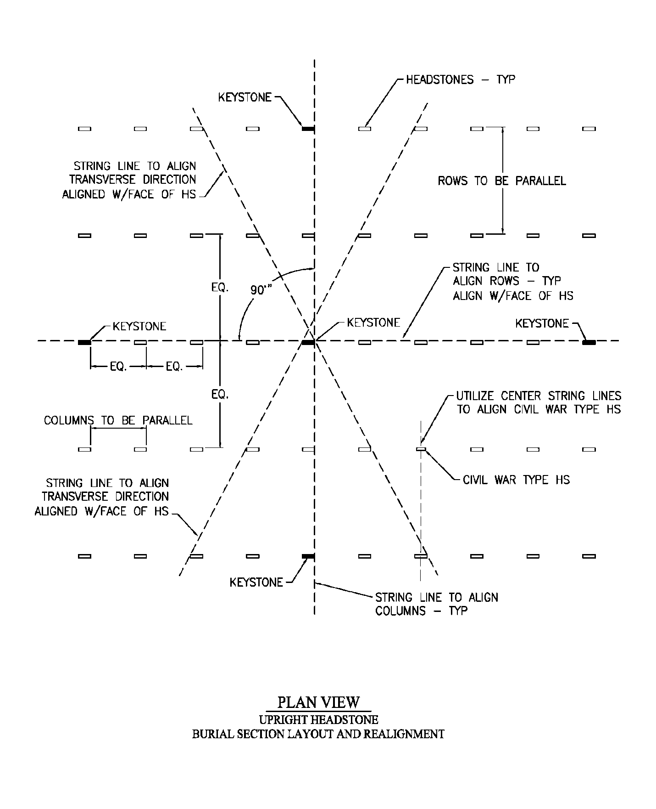

EXHIBIT B
ELEVATION VIEW – UPRIGHT HEADSTONE BURIAL SECTION VERTICAL ALIGNMENT
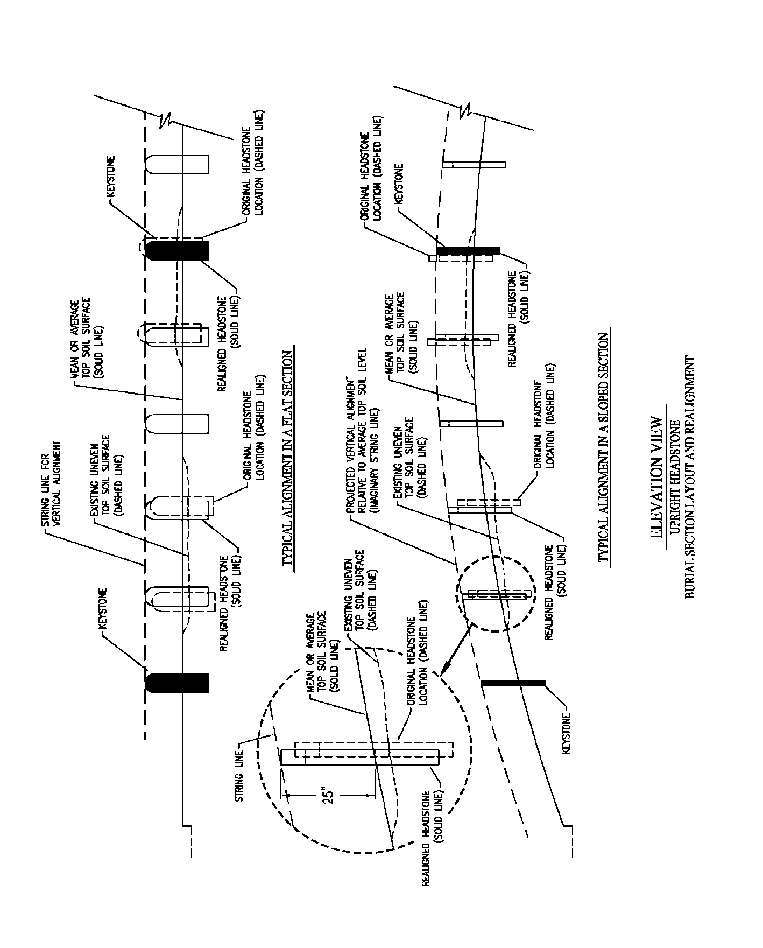

ATTACHMENT (B)

PERFORMANCE WORK SUMMARY PLAN

1. The purpose of this attachment is to:

- List the contract requirements considered most critical to acceptable contract performance.

- Show, where applicable, the maximum allowable degree of deviation from perfect performance for each requirement that shall be allowed by the Government before contract performance is considered unsatisfactory.

- Define the procedure the Government shall use in reducing the Contractor's monthly payment if satisfactory performance is not rendered and/or minimum acceptable level is not obtained.

2. The Government's quality assurance procedures are based on the actual performance of the contract and all areas shall be reviewed periodically, (e.g. weekly, monthly, quarterly, semi-annually, etc.).

3. The criteria for acceptable and unacceptable performance are as follows:

- Contract requirements. The criteria for requirements are the level of performance deemed acceptable to the Government.

- If the quality of work does not comply with the contract requirements the Contracting Officer's Representative shall initiate and the Contractor shall be required to complete a Contract Discrepancy Report (CDR).

- The CDR shall require the Contractor to explain in writing why performance was unacceptable, how performance shall be returned to an acceptable level, and how recurrence of the problem shall be prevented in the future. The Contractor shall not be paid for services not rendered in accordance with the standards set forth in this contract.

- If the level of performance is deemed unacceptable to the Government concurrent with two unsatisfactory ratings, monthly payment shall be reduced for unsatisfactory performance by the percentage as shown in the charts below.

PERFORMANCE STANDARD CHARTS

Performance Objective | Minimum Acceptable Level, MAL (Performance Standard) | Method of Assessment | Remedy
Ground maintenance | 95% of the turfgrass area is maintained to the following requirements:  Turf is maintained within one inch (1”) of the recommended mowing height. 98% of all un-mowed grass around upright headstones, monuments, section markers, and other vertical surfaces within the gravesite sections, other site structures, curbs and drives are trimmed to match the exact height of adjacent mowed turfgrass. | Periodic surveillance and verified customer complaints | Re-performance within 1 work day of notification. Document performance in CPARS.
Pre and Post Emergent Herbicide Applications | The Cemetery is generally weed-free, and the weed population does not distract from the overall appearance of the Cemetery. Proper herbicide is applied in such a manner as to bring about the total control of all broadleaf and grassy weeds in the improved turf areas of the Cemetery. Repeat, follow-up, and/or spot spray herbicide applications, as needed, have been applied. | 100% inspection | Repeat, follow-up, and/or spot spray herbicide applications, as needed within 2 work days of notification. Document performance in CPARS.
Fertilizer Applications | Proper fertilizer is applied at the appropriate rate and in a manner that achieves uniform coverage throughout the area of application. | 100% Inspection | Re-performance within 2 work days of notification. Document performance in CPARS.
Irrigation | Irrigation scheduling is based upon current local evapotranspiration (ET) to maintain a healthy turf stand of uniform color. | 100% inspection | Adjustment within 2 work days of notification. Document performance in CPARS
Headstones Fine Tuning | 95% of all upright headstones are properly installed upon initial inspection:  a) Uniform in height of 25 inches above finish grade with inscriptions visible;  b) vertically aligned with adjacent headstones in section to create smooth and “pleasing” top line while compensating for ground contours;  c) Aligned laterally in both directions and transversely/diagonally with the headstones on other gravesites within 1/8 inch;  d) Plumbed within one degree of fully vertical when measured on front and sides using a digital level;  e) Excavated, backfilled, and tamped correctly.  100% of identified issues are corrected and re-inspected/approved within 5 work days. | 100% Inspection | Re-performance within 1 work day of notification. Document performance in CPARS.
Headstones cleaning | Cleaning all headstones to remove objectionable material and discoloration, such as environmental deposits, accumulations of bird droppings or dirt/mud, tire and hose markings, grass stains, residue from trees, mold, mildew, moss, algae, lichen, fungus, and so forth. | Periodic Validation, customer complaint | Re-performance within 2 work days of notification. Document performance in CPARS
Interment, grave excavation and backfilling | Gravesite is ready for viewing by next of kin within 1 ½ hours after the interment service 90% of the time. | 100% Inspection | Re-performance within 1 work day of notification. Document performance in CPARS.
Plant & tree maintenance | Plants and Trees are 85% free of pests and are maintained at a healthy, shaped and trimmed to proper height and shape for size and type of tree. | Periodic surveillance | Re-performance within 2 work day of notification. Document performance in CPARS
Leave collection and disposal | Collect and remove from the cemetery grounds and the immediate area outside the cemetery wall, all fallen leaves, nuts, and twigs as frequently as necessary to keep a debris free appearance | Periodic Validation, customer complaint | Re-performance within 2 work days of notification. Document performance in CPARS
Floral collection and disposal | Removing and disposing of all floral arrangements, floral holders, and grave decorations placed at gravesites in accordance with cemetery floral regulations | Periodic surveillance | Re-performance within 1 work day of notification. Document performance in CPARS
Report Submittals | Turns in all required submittals 95% of the time. | Quality assurance reviews | Document performance in CPARS.
Safety Maintained during operations | No accidents or incidents due to Contractor’s failure to take safety precautions. | Random quality inspections | Document performance in CPARS.

ATTACHMENT (C)

QUALITY ASSURANCE SURVEILLANCE PLAN

PERFORMANCE OBJECTIVE | INDICATORS OF SUCCESS
GROUNDS MAINTENANCE SERVICES
TURF MAINTENANCE
FERTILIZATION | Fertilizer applied in accordance with the approved fertilizer application plan (encompasses growing season March to October with applications approximately in spring, summer, and fall).
 | Fertilizer shall be applied based on the results and recommendations of a soil test for each section. In 2025, the current recommendation is a ratio of 3:1:2 (N-P-K) with 50% slow-release nitrogen and micronutrients (i.e. S, Mn, Mg, Fe).
 | Fertilizer applied at a rate to achieve 3 to 4 pounds of N (nitrogen) per 1000 square feet per year.
 | Fertilizer equipment was calibrated, and application provided a uniform distribution of fertilizer.
 | Records of applications showing type, amount, application area, and weather conditions provided to COR the day of application.
SOIL AMENDMENTS | If soil tests indicated a need for soil amendments, they were applied at the indicated rate.
 | Records of applications showing type, amount, application area, and weather conditions provided to COR the day of application.
WEED CONTROL | Turf in burial and other public areas is 95% weed free.
 | All applications completed under a Texas State Certified Pesticide Applicator.
 | Herbicides applied in accordance with approved herbicide application plan (2 pre-emergent and 3 post emergent broadcast treatments with spot treatments as necessary).
 | Records of applications showing company name, company contact information, and the names, titles, and license information of the company’s staff that performed the application provided to COR the day of application. The written record shall specify application area, the chemicals used (trade name, chemical, amount/dose), targeted weeds, and weather conditions (including the temperature and the average wind speed) during the time of application.
INSECT CONTROL | No surface application or space spray shall be made while tenant personnel are present. The Contractor shall take all necessary precautions to ensure tenant and employee safety, and all necessary steps to ensure the containment of the pesticide to the site of application.
 | Records of applications showing company name, company contact information, and the names, titles, and license information of the company’s staff that performed the application provided to COR the day of application. The written record shall specify application area, the chemicals used (trade name, chemical, amount/dose), targeted weeds, and weather conditions (including the temperature and the average wind speed) during the time of application.
DISEASE CONTROL | Turf in burial and other public areas is 95% disease free.
 | All pesticide applications are completed under a Texas State Certified Pesticide Applicator.
 | Records of applications showing company name, company contact information, and the names, titles, and license information of the company’s staff that performed the application provided to COR they day of application. The written record shall specify application area, the chemicals used (trade name, chemical, amount/dose), targeted weeds, and weather conditions (including the temperature and the average wind speed) during the time of application.
PRAIRIE DOGS/GOPHERS/MOLES/ PESTS | Control or elimination pests using recommended industry standard practices by a licensed pest control specialist; report provided to COR on appropriate form within 5 working days.
 | All pesticide applications are completed under a Texas State Certified Pesticide Applicator.
 | Soil tamped into holes and turf replaced or reseeded to insure acceptable appearance at all times.
PESTICIDES AND HERBICIDES | Record of pesticides/herbicides applied (type, amount, application area, weather conditions) furnished to COR they day of application.
 | Appropriate signs posted informing the public of the time and date the chemical was applied.
AERATION | From a minimum of 20 soil penetrometer readings to a depth of 6 inches, less than 50% have a PSI reading greater than 300.
 | Cores are a minimum of 3 inches deep with a diameter of 5/8 to 1 inch. More than 12 cores are achieved in a square foot.
DETHATCHING | Turf thatch layer is less than 0.5 inches.
MOWING | Weekly inspections shall be done during site visits of the COR and/or Cemetery Director; mowing inspection reveals compliance with NCA standards for grass height.
 | Turf in burial and public areas is maintained at a height of 2½ to 3 inches, or as instructed by the COR.
 | The contractor has mowed, edged and trimmed all grass within the Cemetery and outside perimeter enclosure fence as specified by the COR.
 | All turf areas are mowed such that no more than 1/3 of the height of the grass is removed at any one mowing.
 | Evident grass clippings, leaves, fallen branches and trash have been removed.
EDGING | Inspections reveal edging of streets, curbs, walkways, tree wells and shrub beds have been edged both inside and outside Cemetery.
 | Evident grass clippings/leaves have been removed from walkways (inside and out), flagpole bases, interment area and roads.
TRIMMING/EDGING | Unmowed grass around headstones, monuments, and vertical surfaces has been trimmed to a height of 2 ½ to 3 inches to match mown height.
 | The readability of the headstone is not obstructed
 | There are no signs of turf being “scalped” by string trimmers.
SODDING & SEEDING | All newly dug or refilled graves have been properly re-sodded or seeded with quality sod/seed to ensure quality turf. Sod/seed is free of noxious weeds.
 | Contractor has removed and disposed of all dead turf and has replaced any sod which has died or has been damaged during the establishment period (30 days).
 | Delivery tickets indicating weight, analysis, purity and vendor’s name, etc. have been submitted to the COR within 2 days of analysis.
LEAF COLLECTION | All fallen leaves/twigs have been collected and removed from the grounds and the immediate area outside the Cemetery between Jan 1 and December 31 of the calendar year, except when delayed by the onset of severe weather conditions.

PERFORMANCE OBJECTIVE | INDICATORS OF SUCCESS
PLANT AND TREE MAINTENANCE
TREE MAINTENANCE  Trees eighteen (18’) inches in diameter or larger that require a professional tree service shall be the responsibility of the Cemetery. | Trees are free of weeds, pests and disease.
 | Trees are free of broken limbs, low branches, and “suckers” that pose a safety hazard to people, service animals, property, vehicles and/or equipment.
 | Trees are kept free of suckers.
 | Trees shall be trimmed and maintained to the form, shape, size, and type according to their species and in accordance with industry standards
 | All cuts have been made to ANSI A300 Standards.
 | Watering basins around newly planted trees are free of grass and weeds.
 | Shredded pine or fir bark mulch has been added when required. (No bark chips or nuggets allowed.)
 | New trees have been staked per specifications.
 | Trees showing adverse effect from high winds have been staked.
 | Damaged trees have been reported to the COR.
IRRIGATION | Irrigation lines are charged by March 31 and winterized by November 31.
 | Irrigation schedule is adjusted for current local evapotranspiration (ET) rates, soil texture and infiltration, and water pressure.
 | Soil moisture content is between 25-75% in the turf rooting zone of 0-60 inches.
 | Irrigation runoff is not evident.
 | Contractor adheres to any local, state, or other water agency regulations.
 | Sprinkler heads, bubblers and sprayers are maintained clear of dirt and other debris for approximately 1 inch around their outside circumference.
 | COR is informed of any need for replacement irrigation heads (replaced in kind), pump malfunction or breakage, or sprinkler system.
 | Contractor conducts all weekly, monthly, quarterly and seasonal pump maintenance according to the manufacturer’s preventative maintenance schedule as well as exercise all manual control and shut-off valves at least twice per year according to American Water Works Association (AWWA) guidelines.

PERFORMANCE OBJECTIVE | INDICATORS OF SUCCESS
HEADSTONE CLEANING AND MAINTENANCE | All objectionable material and discoloration, such as accumulations of bird droppings or mud, tire and hose markings, grass stains, residue from trees, fungus, mold, etc. have been removed from each headstone.
Headstones are cleaned:
- Prior to Memorial Day
- As determined by the COR
 | Sidewalks, curbs and entrance gate to Cemetery grounds have been pressure-washed.
 | Headstones have remained plumb and aligned after cleaning.
 | Turf surrounding headstones remain undamaged by cleaning.
 | Headstones having any accidental dirt splash-up or grass debris have been promptly cleaned.
 | The percentage of headstones inspected in a defined time period and on a regular basis are acceptably clean and debris-free.

PERFORMANCE OBJECTIVE | INDICATORS OF SUCCESS
HEADSTONE ALIGNMENT | Breakage or damage of a headstone due to Contractor negligence has been reported to the COR immediately.
 | Headstones are set plumb and aligned laterally, transversely and diagonally with the headstones on other graves.
 | Measurements were taken from the selection layout control points and not from headstones previously set.
 | In new sections, all upright headstones are set at a height of 25 inches from the finished grave to the top of the arc. Minor deviations in less than nominal height are permissible to provide a uniform appearance in the top line to compensate for slight ground rises or depression within a burial section.
 | Contractor has submitted report to the COR explaining any situations where there is a problem realigning a headstone.

ATTACHMENT (D)

CONTRACT DISCREPANCY REPORT FORM

Contract Discrepancy Report
Contract Number: |  |  |  | Report No. for this Discrepancy:
To: (Contractor/Manager’s Name) |  |  |  | From: (Name of COR)
5. Date(s)
5a. Prepared: |  | 5b. Returned by Contractor: |  |  |  |  | 5c. Action Complete:
Discrepancy or Problem: (Describe in detail. Include reference to PWS Directive; attach additional sheet if necessary.)

Signature of Contracting Officer or COR:

Completed by the Contractor
8a. To: (Contracting Officer and/or COR) |  |  |  | 8b. From: (Contractor)
9. Contractor Response as to Cause, Corrective Action and Actions to Prevent Recurrence: (attach additional sheet if necessary.)

10a. Signature of Contractor Representative: |  |  |  |  |  | 10b. Date:
Completed by the Government
11. Government Evaluation: (Acceptance, partial acceptance, reflection; attach additional sheet if necessary.)

12. Government Actions: (Reduced payment, cure notice, show cause, other)

13. Close Out
 | Name |  | Title |  | Signature |  |  | Date
a. Contractor
b. COR
c. CO

Duplicate form as necessary.

ATTACHMENT (E)

WORK SUMMARY AND PROGRESS REPORT

WORK SUMMARY & PROGRESS REPORT |  | Period Covered: | From: |  | To:
Cemetery Location: |  | Contractor Information:
Project Title:
Contract No:
Inspection / Acceptance: The Contractor shall only tender for acceptance those items that conform to the requirements of this contract. The Government reserves the right to inspect or test some or all of the services that have been tendered for acceptance. The Government may require re-performance of nonconforming services at no increase in contract price. The Government shall exercise its post-acceptance rights:
1. Within a reasonable time after the defect was discovered or should have been discovered; and
2. Before any substantial change occurs in the condition of the item, unless the change is due to the defect in the item.
WORK COMPLETED & SUBMITTED FOR ACCEPTANCE
(This form is not to be used as an Invoice)
1 | Mowing of Improved Turf Areas (including removal and disposal of grass clippings, trash, and debris) |  |  | Quantity / Unit |  | Job
 |  |  |  | Date Completed:
2 | String Trimming of and all features within Improved Turf Areas throughout Cemetery (including removal and disposal of grass clippings, trash, and debris) |  |  | Quantity / Unit |  | Job
 |  |  |  | Date Completed:
3 | Trimming of Upright Headstones |  |  | Quantity / Unit |  | Job
 |  |  |  | Date Completed:
4 | Blade Edging of Curbs and Sidewalks |  |  | Quantity / Unit |  | Linear Feet
 |  |  |  | Date Completed:
5  &  6 | Pre- or Post-Emergent Herbicide Applications |  |  | Quantity / Unit |  | Job
 |  |  |  | Date Completed:
7 | Monthly weed monitoring |  |  | Quantity / Unit |  | Job
 |  |  |  | Date Completed:

8 | Fertilizer Application |  |  | Quantity / Unit |  | Job
 |  |  |  | Date Completed:
9 | Setup/pickup gravesite flags |  |  | Quantity / Unit |  | Job
 |  |  |  | Date Completed:
10 | Custodial Services |  |  | Quantity / Unit |  | Weekly
 |  |  |  | Date Completed:
Report below any circumstances which may have adversely affected work progress such as weather, strikes, delays by the Government, etc.
Signature of Contractor: |  | Date Signed | Signature of Cemetery Director / COR |  | Date Signed
Note: Contractor shall sign confirming that services indicated have been completed. Government shall also sign in acknowledgment of receipt of the Progress Report.

ATTACHMENT (F)

RECOMMENDED EQUIPMENT LIST
The following suggested equipment list is not all encompassing and should not be considered a complete list necessary to accomplish the entire contract scope.
- Backhoe or small excavator
- Utility vehicle(s) (Toro Workman, John Deere Gator, etc.)
- Commercial mower(s) with mulching deck(s) or rear discharge deck(s) (riding and/or push)
- String trimmer(s)
- Blade/stick edger(s)
- Leaf blower(s)/vacuum(s)
- Gasoline powered tamper(s)
- Pedestrian plate and/or steel roller compactor(s)
- Granular Fertilizer Spreader(s)
- Herbicide Sprayer(s)
- Misc. hand tools
- Commercial Chainsaws

ATTACHMENT (G)

KERRVILLE NATIONAL CEMETERY FLORAL/GROUNDS POLICY
Cemetery policies are conspicuously posted and readily visible to the public.
Floral arrangements accompanying the casket or urn at the time of burial will be placed on the completed grave. Natural cut flowers may be placed on graves at any time of the year. They will be removed when they become unsightly or when it becomes necessary to facilitate cemetery operations such as mowing.
Artificial flowers and potted plants will be permitted on graves during periods when their presence will not interfere with grounds maintenance. As a general rule, artificial flowers and potted plants will be allowed on graves for a period extending 10 days before through 10 days after Easter Sunday and Memorial Day.
Christmas wreaths, grave blankets and other seasonal adornments may be placed on graves from Dec. 1 through Jan. 20. They may not be secured to headstones or markers.
Permanent plantings, statues, vigil lights, breakable objects and similar items are not permitted on the graves. The Department of Veterans Affairs does not permit adornments that are considered offensive, inconsistent with the dignity of the cemetery or considered hazardous to cemetery personnel. For example, items incorporating beads or wires may become entangled in mowers or other equipment and cause injury.
Dogs and pets are not allowed in the National Cemetery, unless they are licensed service dogs. Picnicking, tailgating, exercise activities and loitering are not allowed in the national cemetery.

ATTACHMENT (H)

CEMETERY MAP

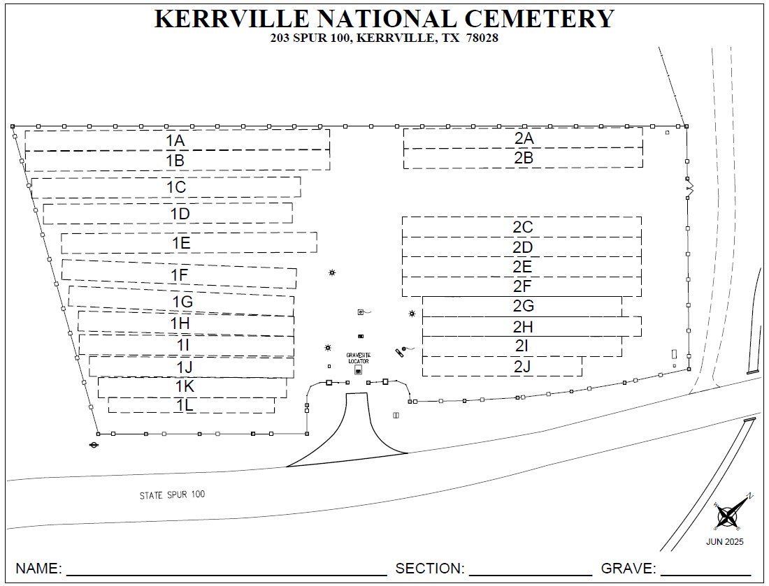

ATTACHMENT (I)

GROUNDS MAINTENANCE MAP

Grounds consist of 1.62 acres of turf stand

Unimproved grounds border (non-irrigated consist of 0.18 acres

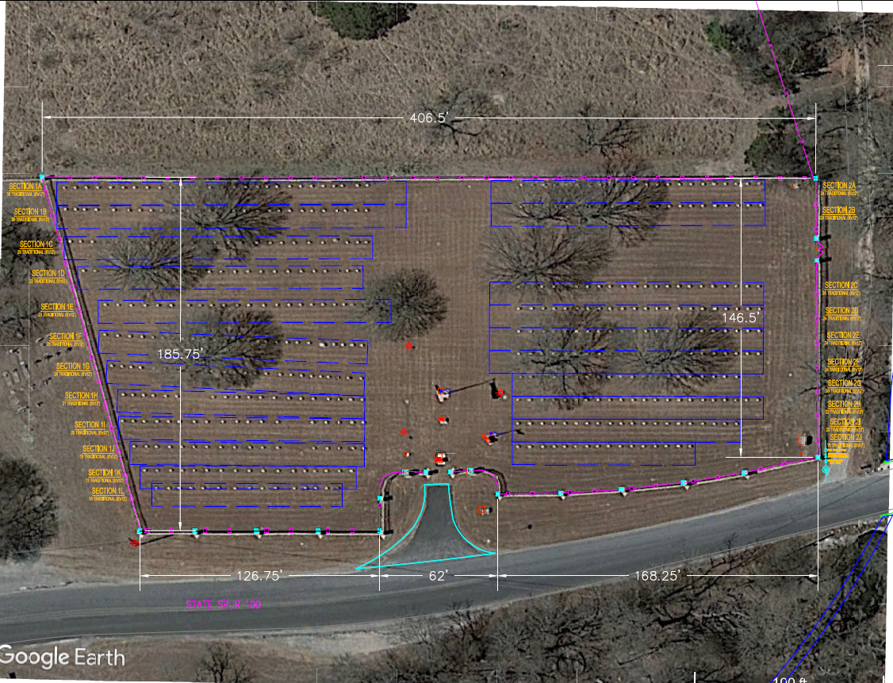

ATTACHMENT (L)

PESTICIDE & FERTILIZER APPLICATION PLAN
Pesticide and Fertilizer Application Plan
LOCATION INFORMATION
Location |  |  | Contract # |  | Date
 |  |  | Turf Information
APPLICATOR INFORMATION
Contractor Name |  |  | Applicator(s)
Phone Number |  |  | Name | Title | License # | Exp Date
Address
Commercial License #
APPLICATION PLAN
Month | Fertilizer Application Information |  | Herbicide Application Information
January
February
March
April
May
June
July
August
September
October
November
December

ATTACHMENT (K)

PESTICIDE & FERTILIZER APPLICATION PROPOSAL
Pesticide or Fertilizer Application Proposal
LOCATION INFORMATION
Location |  |  | Contract # |  |  | CLIN(s)
 |  |  | Turf Information
APPLICATOR INFORMATION
Contractor Name |  |  |  | Applicator(s)
Phone Number |  |  |  | Name | Title | License # | Exp Date
Address
Commercial License #
APPLICATION INFORMATION
Date Range |  |  | Application Type (circle one) |  |  | BROADCAST
 |  |  |  |  |  | SPOT
Amount of Area To Treat |  | Targeted Weed / Pest / Pathogen
 | sq feet
 | acres
Restricted Entry
 | hours
PROPOSED PRODUCTS SUMMARY
* Include Pesticide(s) and Adjuvant(s) Applied
Product | EPA Reg # | Active Ingredient | Total Proposed Amount | Units | Proposed Application Rates
 |  |  |  |  | per 1000 sq feet | per acre | %V/V
Example on 11 acres | ###-#### | ai | 64 | ounces | 0.133 | 5.81 | N/A; spot
* Fertilizer
Product | N-P-K Ratio | % Slow Release N | Total Proposed Amount | Units | Proposed Application Rates
 |  |  |  |  | per 1000 sq feet | per acre | lbs N per 1000 sq ft
Example for 30 acres | 28-7-14 | 50 | 5500 | lbs | 4.2 | 183 | 1.2

ATTACHMENT (L)

PESTICIDE APPLICATION RECORD
Pesticide Application Record
LOCATION INFORMATION
Location |  |  | Contract # |  |  | CLIN(s)
 |  |  | Turf Information
APPLICATOR INFORMATION
Contractor Name |  |  |  | Applicator(s)
Phone Number |  |  |  | Name | Title | License # | Exp Date
Address
Commercial License #
APPLICATION INFORMATION
Date | Start Time | End Time | Application Type (circle one) |  |  | BROADCAST
 |  |  |  |  |  | SPOT
Amount of Area Treated |  | Targeted Weed / Pest / Pathogen
 | sq feet
 | acres
Restricted Entry
 | hours
Weather Conditions |  |  | Equipment Information
Temperature Range |  |  |  | Type
Wind Speed/Direction |  |  |  | Operating Pressure
Other |  |  |  | Calibration Rate
Notes / Follow-up Instructions / Expected Control Symptoms

PRODUCTS APPLIED SUMMARY
* Include Pesticide(s) and Adjuvant(s) Applied
Product | EPA Reg # | Active Ingredient | Total Amount Applied | Units | Application Rates
 |  |  |  |  | per 1000 sq feet | per acre | %V/V
Example on 11 acres | ###-#### | ai | 64 | ounces | 0.133 | 5.81 | N/A; spot
Applicator Signature and Date

ATTACHMENT (M)
FERTILIZER APPLICATION RECORD
Fertilizer Application Record
LOCATION INFORMATION
Location |  |  | Contract # |  |  | CLIN(s)
 |  |  | Turf Information
APPLICATOR INFORMATION
Contractor Name |  |  |  | Applicator(s)
Phone Number |  |  |  | Name | Title
Address
Commercial License #
APPLICATION INFORMATION
Date | Start Time | End Time | Size of Area Treated
 |  |  |  |  |  | sq feet
 |  |  |  |  |  | acres
Weather Conditions |  |  | Equipment Information
Temperature Range |  |  |  | Type
Wind Speed/Direction |  |  |  | Operating Pressure
Other |  |  |  | Calibration Rate
Notes / Follow-up Instructions
PRODUCTS APPLIED SUMMARY
* Fertilizer
Product | N-P-K Ratio | % Slow Release N | Total Amount Applied | Units | Application Rates
 |  |  |  |  | per 1000 sq feet | per acre | lbs N per 1000 sq ft
Example for 30 acres | 28-7-14 | 50 | 5500 | lbs | 4.2 | 183 | 1.2
Other Product Information (micronutrients, etc)
Applicator Signature and Date

ATTACHMENT (N)
SOIL TEST RESULTS
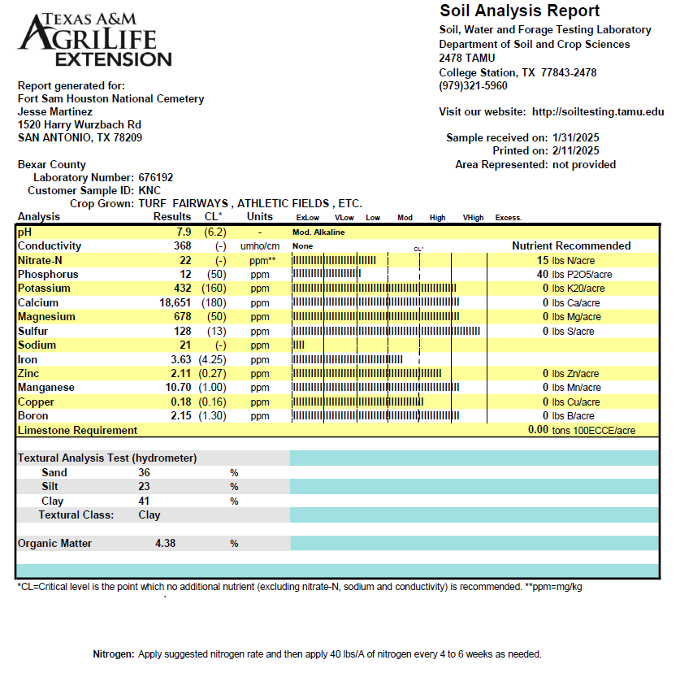

ATTACHMENT (O)

TREE WORKSHEET
Individual Tree | Section | Site ID# | Species | DBH (inch) | Height (feet) | Maint. Req.
1 | 1L | 6 | Chinquapin Oak | 2 | <40 | Developmental pruning – estimated every 2 years. Newly planted 9/9/2024.
2 | 1L | 15 | Chinquapin Oak | 2 | <40
3 | 2J | 6 | Chinquapin Oak | 2 | <40
4 | 2J | 16 | Chinquapin Oak | 2 | <40
5 | 2G | 3 | Shumard Oak | 22 | >40 | Routine pruning – estimated every 3 to 5 years for overall health and safety.
6 | 2B | 3 | Shumard Oak | 22 | >40
7 | 2G | 12 | Shumard Oak | 25 | >40
8 | 1E | 21 | Cedar Elm | 25 | >40
9 | 1G | 8 | Shumard Oak | 25 | >40
10 | 2C | 1 | Shumard Oak | 26 | >40
11 | 2B | 6 | Shumard Oak | 26 | >40
12 | 1B | 12 | Shumard Oak | 26 | >40
13 | 1D | 4 | Shumard Oak | 28 | >40

