Statement of Work (SOW)
Project: CHILLER #8 MOTOR REPLACEMENT

GENERAL INFORMATION

- Scope of Work: The USDA/NCAH at Ames, IA is in need to have a chiller service to provide qualified services and required labor, equipment and parts to perform the scope of work listed below. All work will be performed in accordance with EPA rules and regulations as they pertain to refrigerants.

2.0 Background: The National Centers for Animal Health (NCAH) campus is located at 1920 Dayton Ave. Ames IA. The USDA/NCAH campus is a premier facility dedicated to safeguarding animal health through advanced research, diagnostics, and disease control measures, comprising of National Animal Disease Center NADC), National Veterinary Services Laboratories (NVSL, and the Center for Veterinary Biologics (CVB). The NCAH serves as a critical hub for addressing both endemic and foreign animal diseases. These facilities conduct vital work in biosafety levels (BSL) 2 and 3 laboratories, involving the study of zoonotic diseases, vaccine development, and diagnostic testing. Established to enhance the USDA’s capacity to support the livestock industry and protect public health, the NCAH is equipped with state-of-art laboratories and containment facilities. The center’s mission aligns with the USDA’s broader goals of ensuring a safe, abundant food supply, and improving animal health and welfare through scientific excellence and innovation.

The NCAH central utility plant provides chilled water throughout the campus for animal containment areas, offices, and laboratories. The chiller in question is an extremely important part of being able to provide cooling for these areas. Without the repairs, animals, equipment, and personnel would be under undue hardship with the possibility of loss of animal life and scientific data.
Motor data: YORK HP 1215, volts 4160, HZ 60, FLA 149, LRA 960, RPM 3600
YORK serial # W20000379-EK, York part # 024-35880-407, Frame 5810DY
ENCL LN-ODP, WT 6800 LBS
Chiller data: YORK EQUIPMENT DESCR: YKTGTBJ3-DDFS 1600 TON

CONTRACTOR REQUIREMENTS

3.0 Technical Requirements/Tasks:

- Provide York OEM replacement motor.
- Provide York OEM retrofit kit.
- Provide a crane, receive delivery of motor and offload from truck.
- Install motor on chiller utilizing crane.
- Couple motor to compressor and verify proper alignment.
- Perform start-up on chiller and verify proper operation.

4.0 Government Furnished: Access to the USDA facility at 1920 Dayton Ave, Ames, Iowa 50010 will be during normal business hours only, excluding nights, weekends, and government and other holidays. Access can possibly be obtained on a case-by-case basis with a 2-week notice.

5.0 Deliverables / Schedule:

Key Deliverables
Item No. | Deliverable | Objective | Due
1. | Provide York OEM motor. | YORK HP 1215, volts 4160, HZ 60, FLA 149, LRA 960, RPM 3600  YORK serial # W20000379-EK, York part # 024-35880-407, Frame 5810DY  ENCL LN-ODP, WT 6800 LBS
 | Provide York OEM retrofit kit | OEM retrofit kit
3. | Crane | Provide crane to receive delivery of motor | Day of repairs
4. | Install | Install motor on chiller utilizing crane. | Day of repairs
5. | Install | Couple the motor to compressor and verify proper alignment. | Day of repairs
6. | Start-up | Perform start-up on chiller and verify proper operation. | Day of repairs

6.0 Travel: N/A

7.0 Contractor’s Key Personnel: N/A

8.0 Security Requirements: Vendor personnel shall be US Citizens (must have real ID). All contractors must check-in at the main gate each day to receive a contractor pass. All contractor personnel shall always be in the presence of a USDA escort while on location.

9.0 Data Rights: N/A

10.0 Section 508 – Electronic and Information Technology Standards:

Attachment:

Appendix A

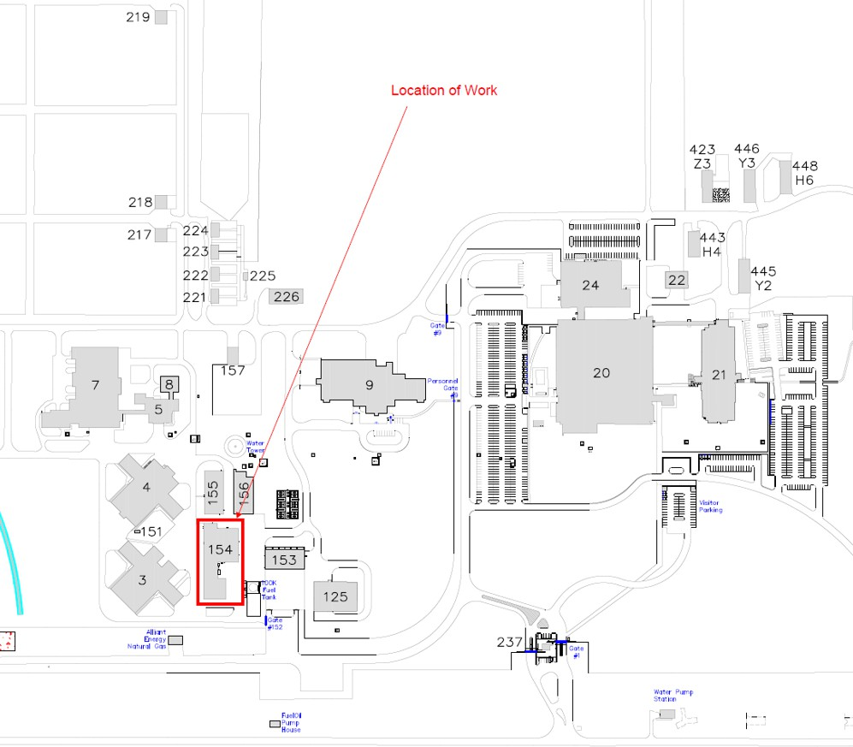

Appendix B
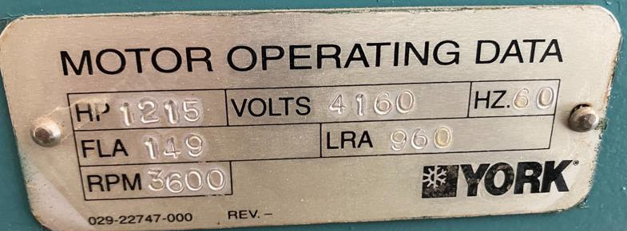
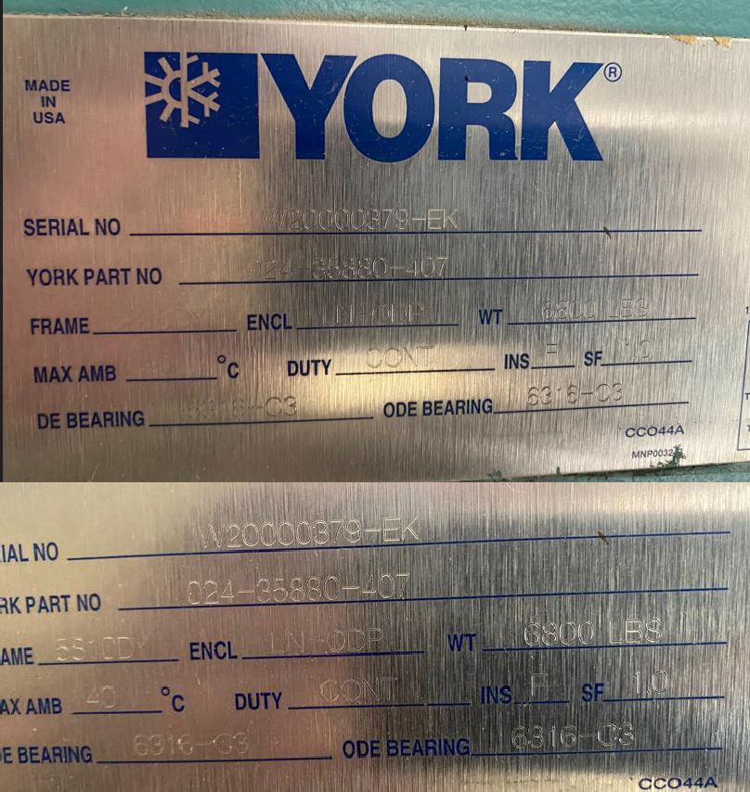

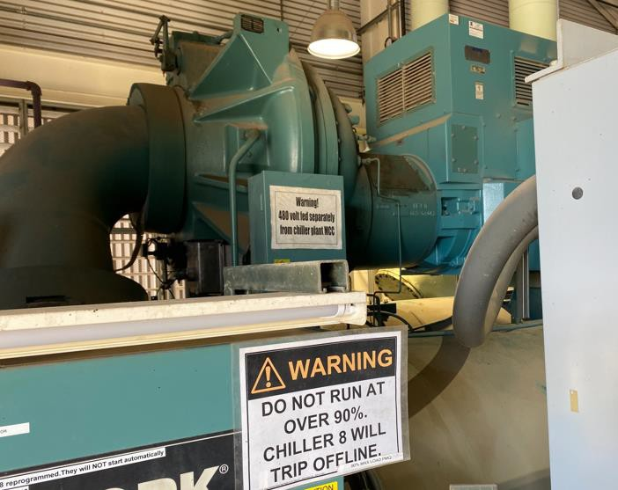
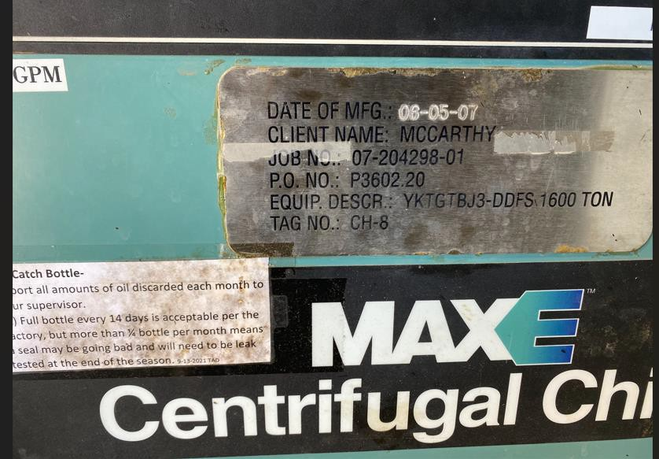
Appendix C

5
