**HUISSTIJL DOCUMENT**

**lettertypes**

Logo Fira Sans

Pay Off Helvetica Neue

Koppen Fira Sans

Content Helvetica Neue

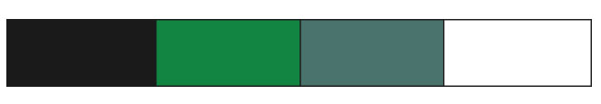**kleuren**

Donker #1a1a1a

Groen #118542

Grijs/Groen #49736b

Wit #ffffff

**briefpapier**

