

**Course Name**: Computer Architecture Lab

**Course Number and Section**: **14:332:333:02**

**Experiment**: Lab 3 – Arithmetic Operations (Basic and Float) and Combinatorial Logic

**Lab Instructor**: Bangtian Liu

**Date Performed**: 2/21/18

**Date Submitted**: 3/7/18

**Submitted by**: Yuqing Feng (yf184)

Purpose

In this lab experiment, the focus was on bit operations and floating point number manipulation. Logical operations using not, and, and or can be done on the bits of numbers. The main focus was on floating point numbers. After learning about the floating point format, we know that floating point numbers are not exact when stored, which is why doubles are more accurate as they have more bytes to get more exact numbers. Floating point numbers use different registers, different reading and printing system calls, and different commands to perform operations on them. Operations with floating point numbers, from mathematical problems to array sorting, were explored in this lab and in the assignments.

Approach

Reading and Printing Floating Pointer Numbers

For reading and printing, “syscall” is used. For syscall to know what to do, $v0 must be loaded with a code. To read a float, $v0 must be set to 6 and the value inputted is located in $f0, which must be moved before another syscall is called. To print a float, the value must be loaded into $f12 and $v0 code should be 2.

|  |  |  |
| --- | --- | --- |
| $v0 code | What it does | Arguments needed |
| 1 | Print int | Value in $a0 |
| 2 | Print float | Value in $f12 |
| 3 | Print double | Value in $f12 |
| 4 | Print string | Value in $a0 |
| 5 | Read int | - |
| 6 | Read float | - |
| 7 | Read double | - |
| 8 | Read string | Addr. to store $a0  No. of char $a1 |
| 9 | Memory allocation | Bytes storage $a0 |
| 10 | Exit program |  |
| 11 | Print character | Integer in $a0 |
| 12 | Read character |  |

Bit Operations

1. A or B – each bit of A is ored with the corresponding B and if there is at least one 1 in the pair, the output bit is 1
2. A and B – both bits must be 1 for the output bit to be 1
3. not A – inverts every bit of A, so if one bit is 0, it will be 1 in the output, and vice versa

Range Checking

1. Integers:
   1. blt A, B– branches if A is less than B 🡪 checks ranges of user inputs
2. Floating Point:
   1. c.lt.s $f1, $f4
   2. bc1t inputError
   3. nop

c.lt.s compares $f1 with $f4 and sets the conditional bit if $f1 < $f4.

bclt L1 branches to L1 if the condition bit is true. This is used to error check user inputs.

nop is to give bclt time to happen, does nothing

Operations (Float)

The format for operations are the same, but the commands are different, mostly with a .s appended. The ones I used in these assignments are:

1. mul.s
2. div.s
3. mov.s
4. li.s
5. sub.s

Loading and Saving (Array)

Declaring the array of floats in data was done in the format “array: .float #”.

1. Loading
   1. lwc1 $f1, 0($s1) 🡪 loads the value at $s1 in the array into $f1.
2. Saving
   1. swc1 $f1, 0($s2) 🡪 saves $f1 value into $s2 location in array
   2. used for swapping and putting new value into the array index

Results (and screenshots of program results)

Assignment 1

The program reads three integers and calculates F = (A OR C)’ AND (B AND C)’. My program reads in three integers: A, B, and C. I then OR A and C and store it in A. I invert it with NOT, so $t0 stores (A OR C)’. I then AND B and C and then invert it with NOT. $t1 now stores (B AND C)’. Finally, I AND $t0 and $t1 values together to get the value of F.

The results from the code are below:

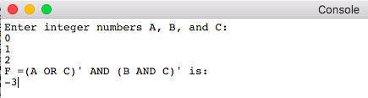

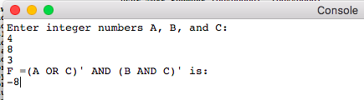

MIPS Code:

#Yuqing Feng

#170006296 yf184

.data

inputStr: .asciiz "Enter integer numbers A, B, and C:\n"

outputStr: .asciiz "F =(A OR C)' AND (B AND C)' is: \n"

.text

main:

li $v0, 4

la $a0, inputStr

syscall

li $v0, 5

syscall

move $t0, $v0 # a

li $v0, 5

syscall

move $t1, $v0 # b

li $v0, 5

syscall

move $t2, $v0 # c

or $t0, $t0, $t2 # a = a or c

not $t0, $t0 # a = a'

and $t1, $t1, $t2 # b = b and c

not $t1, $t1 # b = b'

and $t1, $t0, $t1 # $t1 = a and b

li $v0, 4

la $a0, outputStr

syscall

li $v0, 1

move $a0, $t1

syscall

li $v0, 10

syscall

Assignment 2

This program asks for integers a and b between 1 and 1000 and calculates a/b. I first checked to make sure they were within the range and ended the program if the inputs were wrong. I used sub instructions to divide the two numbers.

The results from the code is below. As you can see, the integer divisions are done correctly and the code rejects inputs outside the given range (1 – 1000 inclusive).

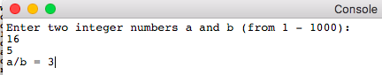

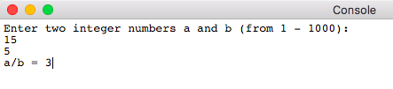

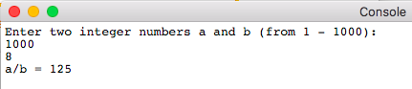

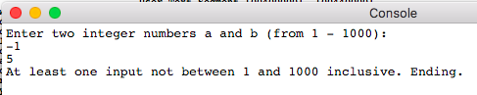

MIPS Code:

#Yuqing Feng

#170006296 yf184

.data

inputStr: .asciiz "Enter two integer numbers a and b (from 1 - 1000):\n"

outputStr: .asciiz "a/b = "

badStr: .asciiz "At least one input not between 1 and 1000 inclusive. Ending."

.text

main:

li $v0, 4

la $a0, inputStr

syscall

li $v0, 5

syscall

move $t0, $v0 # a

li $v0, 5

syscall

move $t1, $v0 # b

#check ranges and make sure within the range

li $t2, 1

bltu $t0, $t2, badInput

bltu $t1, $t2, badInput

li $t2, 1000

bltu $t2, $t0, badInput

bltu $t2, $t1, badInput

#divide using subtraction

li $t2, 0 #number of divisions

j loop

loop:

blt $t0, $t1, endLoop #if a less than b, endLoop

sub $t0, $t0, $t1

addi $t2, $t2, 1

j loop

endLoop:

li $v0, 4

la $a0, outputStr

syscall

li $v0, 1

move $a0, $t2

syscall

li $v0, 10

syscall

badInput:

li $v0, 4

la $a0, badStr

syscall

li $v0, 10

syscall

Assignment 3

1. Calculate the decimal number from this:

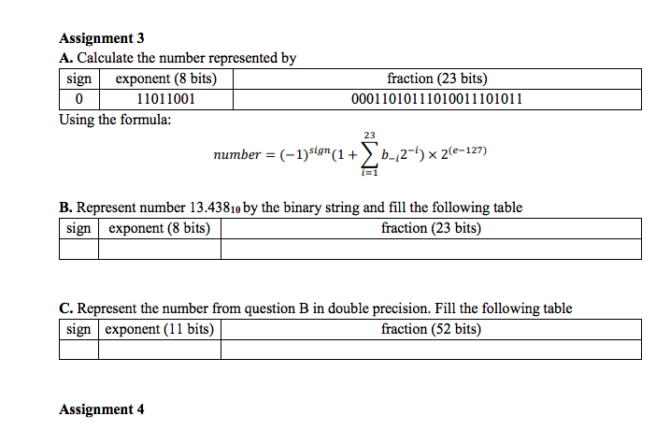

The sign 0 means the number is positive. The exponent is (0d127) 01111111 + power = 11011001. The power number is equal to 90, so the floating point expression is 1.00011010111010011101011 * 2 ^ 90 = **1.2381*10^27**.

1. Turn 13.438 into binary and make the table for floating point below:

|  |  |  |
| --- | --- | --- |
| Sign | Exponent (8 bits) | Fraction (23 bits) |
| 0 | 10000010 | 10101110000001000001100 |

-13.428 in binary is 1101.01110000001000001100

-in exponential form: 1.10101110000001000001100 * 2^3

-the exponent section is 127+3 = 10000010 in binary.

-The fraction is everything after the decimal point (23 bits)

1. Turn 13.438 into binary and make the table for double point below:

|  |  |  |
| --- | --- | --- |
| Sign | Exponent (11 bits) | Fraction (52 bits) |
| 0 | 00010000010 | 1010111000000100000110001001001101110100101111000110 |

-13.428 in binary is 1101.0111000000100000110001001001101110100101111000110101

-in exponential form: 1.1010111000000100000110001001001101110100101111000110 * 2^3

-the exponent section is 127+3 = 00010000010 in binary.

-The fraction is everything after the decimal point (52 bits)

Assignment 4

This program calculates the area of a circular sector using the equation A = pi*r^2*angle/360. The inputs and outputs are floating point numbers. The radius and angle were put into floating point registers and the constants pi and 360.0 were loaded into registers. Using divisions and multiplications but for floating point numbers, the formula was calculated and outputted to the user.

The results from the program are below: (the results were checked for accuracy with an online calculator)

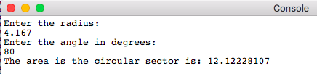

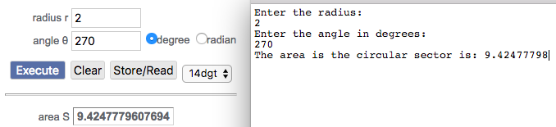

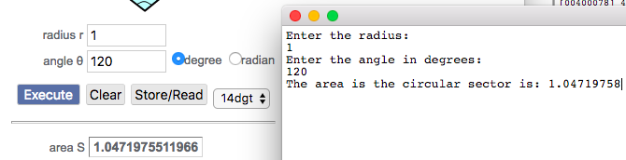

MIPS Code:

#Yuqing Feng

#170006296 yf184

.data

inputRadStr: .asciiz "Enter the radius:\n"

inputAngStr: .asciiz "Enter the angle in degrees:\n"

outputStr: .asciiz "The area is the circular sector is: "

.text

main:

li $v0, 4

la $a0, inputRadStr

syscall

li $v0, 6

syscall

mov.s $f1, $f0 #f1 = radius

li $v0, 4

la $a0, inputAngStr

syscall

li $v0, 6

syscall

mov.s $f2, $f0 #f2 = angle

li.s $f3, 360.0 #f3 = 360

li.s $f4, 3.14159265359 #f4 = pi

div.s $f2, $f2, $f3 # angle = angle/360

mul.s $f1, $f1, $f1 # r = r^2

mul.s $f1, $f1, $f4 # r = r^2 * pi

mul.s $f12, $f1, $f2 # f12 = pi*r^2 * angle/360

li $v0, 4

la $a0, outputStr

syscall

li $v0, 2

syscall

li $v0, 10

syscall

Assignment 5

The program calculates the cost to fill up the gas in a car. To get the amount of money to fill up the tank, I subtracted the fullness of the tank from 1 to get the proportions of an empty tank. I multiplied that with the total gallons to get the gallons needed to fill up the tank. To get the amount of money to fill up, the gallons needed * price per gallon = price to fill up. The program also error checked to make sure the fullness of the tank is a number between 0 and 1 (because fraction of the tank that is full) and is nonnegative. I also made sure the gallons of gas and price of the gas are nonnegative, and if any inputs are in the wrong format, the program ends (shown below).

The results from the program is below:

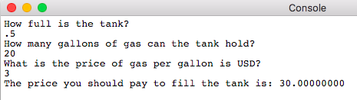

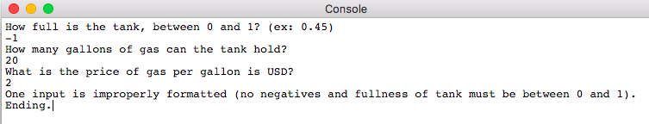

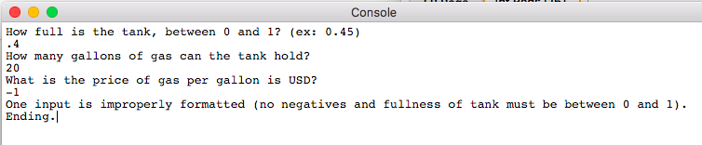

MIPS Code:

#Yuqing Feng

#170006296 yf184

.data

inputFullStr: .asciiz "How full is the tank, between 0 and 1? (ex: 0.45)\n"

inputGalStr: .asciiz "How many gallons of gas can the tank hold? \n"

inputPriceStr: .asciiz "What is the price of gas per gallon is USD? \n"

outputStr: .asciiz "The price you should pay to fill the tank is: "

errorStr: .asciiz "At least one input is improperly formatted. Ending."

.text

main:

li $v0, 4

la $a0, inputFullStr

syscall

li $v0, 6

syscall

mov.s $f1, $f0 #f1 = how full tank is

li $v0, 4

la $a0, inputGalStr

syscall

li $v0, 6

syscall

mov.s $f2, $f0 #f2 = total gal tank can hold

li $v0, 4

la $a0, inputPriceStr

syscall

li $v0, 6

syscall

mov.s $f3, $f0 #f3 = price per gallon

#error checking --> referenced https://chortle.ccsu.edu/AssemblyTutorial/Chapter-32/ass32_3.html

li.s $f4, 1.0

c.lt.s $f4, $f1

bc1t inputError #if fullness of tank greater than 1, bad

nop

li.s $f4, 0.0

c.lt.s $f1, $f4

bc1t inputError #if fullness of tank less than 0, bad

nop

c.lt.s $f2, $f4

bc1t inputError #is total gas tank is less than 0, bad

nop

c.lt.s $f3, $f4

bc1t inputError #if price is less than or equal to 0, bad

nop

#calculations

li.s $f4, 1.0

sub.s $f1, $f4, $f1 #f1 = 1-f1 --> how empty tank is

mul.s $f1, $f1, $f2 #how empty tank is * total gal = gallons needed

mul.s $f12, $f1, $f3 #gal needed * price per gallon = total price

li $v0, 4

la $a0, outputStr

syscall

li $v0, 2

syscall

li $v0, 10

syscall

inputError:

li $v0, 4

la $a0, errorStr

syscall

li $v0, 10

syscall

Assignment 6

This program declares an array of 10 floating point elements in the data section and then sorts it in the code. Bubblesort is used, and I used <https://www.javatpoint.com/bubble-sort-in-java> as a reference for how to bubblesort because I never learned it in a class before. I print the old array and then jump to the sorting loop before printing again. I set up all my registers before going into the sections (sorting and printing) to make sure the values I’m expecting are in there. I bubble sort with two loops and I swap values if they are less than the next array index’s values. I keep sorting until no more swaps are made, and I check this with a swap counter in the inner loop.

The results for two arrays I tested this on are below:

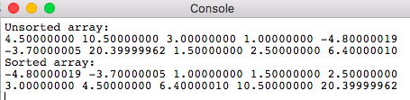

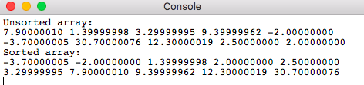

MIPS Code:

#Yuqing Feng

#170006296 yf184

#Bubble sort floating point array

.data

unsortedArrayStr: .asciiz "Unsorted array:\n"

sortedArrayStr: .asciiz "Sorted array:\n"

spaceStr: .asciiz " "

newLineStr: .asciiz "\n"

swapStr: .asciiz " swapped with "

#10 elements

#array: .float 4.5, 10.5, 3.0, 1.0, -4.8, -3.7, 20.4, 1.5, 2.5, 6.4

array: .float 7.9, 1.4, 3.3, 9.4, -2.0, -3.7, 30.7, 12.3, 2.5, 2.0

.text

main:

li $v0, 4

la $a0, unsortedArrayStr

syscall

#set up printing array

li $t0, 0 #counter i

li.s $f1, 0.0 #stores value of item

li $t2, 40 #stores only 10 items (8*10)

la $s0, array #base address

la $s1, array #incrementing address

jal printArray

#set up sorting array

li $t0, 0 #counter i

li $t1, 0 #counter j

li.s $f1, 0.0 #float for arr[j]

li.s $f2, 0.0 #float for arr[j+1]

li $t2, 1 #number of swaps

li $t3, 36 #n-1

li $t4, 0 #n-1-i for j

la $s0, array #base address

la $s1, array #incrementing address

la $s2, array #will be always $s1 + 4 --> arr[j+1]

jal sortOuter

li $v0, 4

la $a0, sortedArrayStr

syscall

#set up printing array

li $t0, 0 #counter i

li.s $f1, 0.0 #stores value of item

li $t2, 40 #stores only 10 items (8*10)

la $s0, array #base address

la $s1, array #incrementing address

jal printArray

li $v0, 10

syscall

sortOuter:

beqz $t2, endOuter #end when num swaps = 0

#reinitialize

li $t1, 0 #j = 0

li $t2, 0 #num swaps = 0

sub $t4, $t3, $t0 #t1 = $t3 - $t0 --> n-1-i

la $s1, array #incrementing address for j

la $s2, array #will be always $s1 + 4 --> arr[j+1]

sortInner:

beq $t1, $t4, endInner #if j = n-1-i, end inner loop

lwc1 $f1, 0($s1) #arr[j]

addi $s2, $s1, 4 #j+1 of array

lwc1 $f2, 0($s2) #arr[j+1]

c.le.s $f1, $f2

bc1t continueInner #if arr[j] <= arr[j+1], skip swap

nop

#here, arr[j] > arr[j+1] --> do swap

swc1 $f2, 0($s1) #arr[j] = arr[j+1] value

swc1 $f1, 0($s2) #arr[j+1] = arr[j] value

addi $t2, $t2, 1 #increment number of swaps

continueInner:

addi $t1, $t1, 4 #j++

add $s1, $s0, $t1

j sortInner

endInner:

addi $t0, $t0, 4 #i++

j sortOuter

endOuter:

jr $ra

printArray:

#load with floating point -> reference: http://www.ece.lsu.edu/ee4720/2014/lfp.s.html

lwc1 $f1, 0($s1)

beq $t0, $t2, endPrint #counter

mov.s $f12, $f1

li $v0, 2

syscall

li $v0, 4

la $a0, spaceStr

syscall

addi $t0, $t0, 4 #4 because float = 4 bytes

add $s1, $s0, $t0

j printArray

endPrint:

li $v0, 4

la $a0, newLineStr

syscall

jr $ra

Conclusion

Assignment 1 introduced me to bit logic and operations by using and, or, and not to get the result of F. Assignment 2 forces me to divide without using div, so I used subtractions for the two integers to divide them. Assignment 3 taught me how to convert from floating point format and to convert to floating and double format. Assignment 4 and 5 are applications of using floating point numbers and operations on them for common math and real-life problems. Finally, Assignment 6 puts my knowledge on sorting, bubble sort, and floating point number arrays together to bubble sort floating point numbers. Overall, the same operations for integers apply for floating point numbers but with a “.s” at the end of commands, different registers for use, and different ways to load and save floating point numbers.