

A PROJECT REPORT ON

### “Statistical analysis on causes behind failure of transformer and due to this, problem faced by farmers”

##### A PROJECT REPORT SUBMITED TO DEPARTMENT OF STATISTICS,MODERN COLLEGE OF ARTS, SCIENCE & COMMERCE GANESHKHIND, PUNE – 16

FOR THE PARTIAL FULFILLMENT OF THE DEGREE

###### M.Sc. Statistics (Part-II) (2022-2023)

BY

**Mr. Dhone Ashutosh Namdeo**

**Mr. Gadhe Sunny Tukaram**

**Mr. Maind Sudhakar Vitthal**

**Mr. Sakore Mangesh Gorakh**

UNDER THE GUIDANCE OF

Prof. Varsha Mhetre

**DEPARTMENT OF STATISTICS**

**MODERN COLLEGE OF ARTS, SCIENCE & COMMERCE GANESHKHIND, PUNE – 16**



**Department of Statistics,**

CERTIFICATE

This is to certify that the project entitled **“Statistical analysis on causes behind failure of transformer and due to this, problem faced by farmers"** as partial fulfillment for the award of the degree of M.Sc. in statistics of Modern College of Arts, Science & Commerce Ganeshkhind, Pune – 16 , is a record of bonafide work carried out by them under my supervision and guidance. To the best of my knowledge, the matter presented in the project has not been submitted elsewhere earlier.

This project is submitted by:

Mr. Dhone Ashutosh Namdeo

Mr. Gadhe Sunny Tukaram

Mr. Maind Sudhakar vitthal

Mr. Sakore Mangesh Gorakh

|  |  |  |
| --- | --- | --- |
| Place:pune | Prof. Varsha Mhetre | Prof.Mrs.R.Umrani |
| Date:29/05/2023 | Project Guide | Head of Department, |
|  | | Department of Statistics, |
| Modern College of Arts, Science & Commerce Ganeshkhind, Pune – 16 |
|  |

# Acknowledgement

We are privileged to express my sincere thanks with great respect and gratitude to Mrs.Varsha Mhetre for their aspiring guidance. They helped with kind of co-operation and constant encouragement. We are grateful to thank them for providing us with all necessary facilities.

We would like to thank all teaching and non-teaching staff of the department for their help and co-operation. Also, we would like to thank all our friends for their help which we received throughout this workout.

**INDEX**

|  |  |  |
| --- | --- | --- |
| **Sr.No** | **Title** | **Page No.** |
| 1 | Introduction | 5-6 |
| 2 | Objectives | 7 |
| 3 | About Data and Methodology | 8 |
| 4 | Statistical Analysis | 9-37 |
| 5 | Failure Report Analysis | 38-40 |
| 6 | Limitation | 41 |
| 7 | Major Findings | 42-43 |
| 8 | Reference | 44 |
| 9 | Appendix | 45 |

**INTRODUCTION**

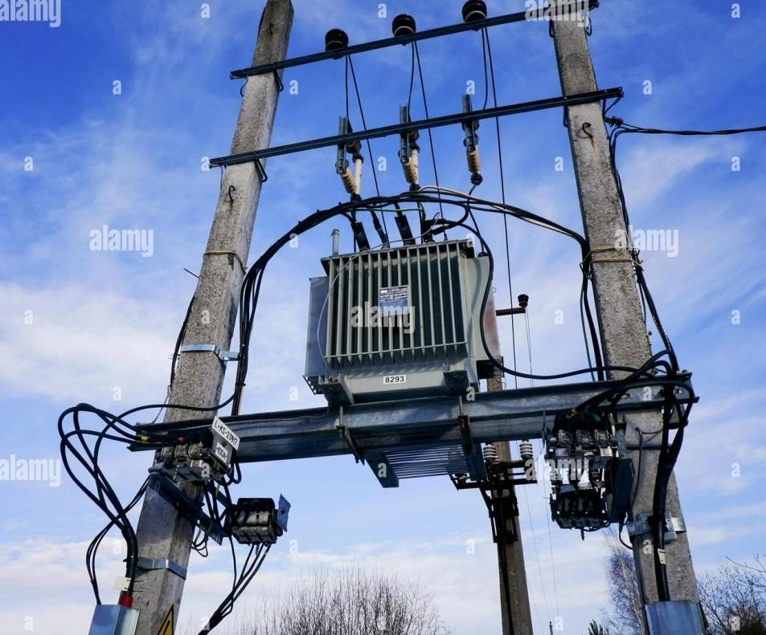

Transformer is a static machine with very high efficiency and it transfers electric energy from one alternating current to one or more other circuit. The rate of failure of distribution transformers in India is higher (12-17%) as compared to developed countries (2-3%). This high failure rate is cause of concern to all the Distribution Companies in the country. Every year, nearly 200 Crore of Indian Rupees (INR) are spent by the company for repair and replacement of distribution transformers. The loss becomes enormous due to the transformer failure, if the revenue loss for supply outage is also taken into consideration. It has become a serious problem due to increasing failure rate every year.

The distribution transformer is a most important component of the distribution system to provide uninterrupted power supply to the consumers and it should be highly reliable and efficient. The transformer failures result in loss, not only on account of repair or replacement of failed transformer, but also, the revenue loss to the utility on account of power not supplied to the consumers.

The role of transformer begins at generating station as the power is generated at maximum value of 11 KV in generating stations in India, far away from the

load centres. This power needs stepping up to extra high voltages for reduction of current thereby the losses during transmission. Thereafter it is stepped down to 66/11KV at substations for primary distribution network and further stepped down to 11KV/400V using distribution transformers.

Other important disadvantage is reduced reliability of the system, because of frequent failure of power supply. The risk of failure is defined as the product of probability of failure and consequences.

To improve the reliability of the system and to reduce the risk of failure, it is important to bring down the failure rates. This requires a systematic study of distribution transformer failures which further needs a real time data collection for failure of distribution transformer from the field. There are various international standards formulated to incorporate above concern about transformer failures.

The outcome of this work would help electricity utilities provide more reliable and cost effective services to farmers.

## OBJECTIVES

###### This project aims at the reasons of transformer failure in distribution system so that in future these problems may be avoided to save the distribution transformers failure and huge money loss of the company along with improvement in quality and reliability of the distribution system. Accordingly following are some objectives of this study.

* Statistical analysis on reasons behind failure of transformer and try to remove it.
* Aware about the responsibility of farmers and MSEB workers for not failing the transformer.

## About Data and Methodology

**Description of data:** We perform questionnaire on the basis of causes behind transformer burns and due to that problems faced by farmers. There are 39 questions in our questionnaire, in which we ask about reasons behind failure of transformer (i.e. overloading, use of capacitors, neutral earthing and can MSEB workers do time to time inspection of transformers etc.). On the behalf of the questionnaire we ask about MSEB related questions to the farmers like how many hours power supply received per day, how do you pay bills and do you have any complaints about MSEB and many more failure of transformer related questions.

**Data:** Shape of the data: (321, 39)

In our dataset, there are 321 instances and 39 columns. Each instance represents one response of farmer. Each instance is characterized by 39 attributes.

**Sampling technique:**

We take samples by convenient sampling. From questionnaire we got

321 farmers responses from 6 different tehsils namely Shahuwadi, Shrirampur, Man, Khatav, Pandharpur, Malshiras.

|  |  |
| --- | --- |
| **Tehsil** | **Sample size** |
| Shahuwadi | 98 |
| Shrirampur | 75 |
| Man | 41 |
| Khatav | 36 |
| Pandharpur | 36 |
| Malshiras | 35 |

**Statistical Tools Used for Data Analysis**

* R software
* Minitab
* Excel
* SPSS

#### Statistical analysis

##### Summary of responses:

|  |  |
| --- | --- |
| **Tehsil** | **Responses (%)** |
| Shahuwadi | 30.52 |
| Shrirampur | 23.36 |
| Man | 12.77 |
| Khatav | 11.21 |
| Pandharpur | 11.21 |
| Malshiras | 10.90 |

* + There are 321 farmer’s responses we get in our study area. Out of them most of the responses are coming from shahuwadi taluka i.e. 30.52% and 10.90% responses are coming from malshiras taluka which is less in number.

##### Cause and effect diagram of reasons behind transformer fail:

* + Above cause and effect diagram shows that, what the main factors of failure of transformer. There are many factor are arises due to failure of transformer like that overload, Environment, Farmers and also MSEB are caused due to failure of transformer.

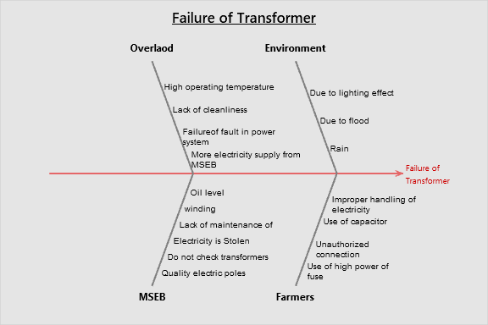

* + In this diagram the factor overload consist of many causes like that due to high operating temperature, lack of cleanliness, failure of fault in Power system and transformer is failed due to more electricity supply from MSEB.
  + Transformer is failure due to environment effect such environment effect like due to lighting effect, due to flood also transformer can be fail due to rain.
  + MSEB is also responsible for failure of transformer. If oil in transformer decreases then transformer can be fail. Also winding, Lack of maintenance of transformers are the reasons behind transformers burn, transformer is also failed due to bad quality of electric poles.
  + Farmers are also responsible for failure of transformer. In many times farmers do not use capacitor for their motor pumps, uses high power fuses and take unauthorized connection as well as transformer is fail due to electricity is stolen by farmers.

##### Contribution of male and female farmers to field

We want to know how many female and male farmers are under our study area. We want to know the contribution of male and female farmers to the field. Below is the summary of contribution of male and female farmers.

* + - From this we see that, under our study area contribution of male farmers to farm is 81% and contribution of female farmers to farm is 19%.

**Gender**

19%

Male

Female

81%

* + - From this we concluded that, contribution of male farmers to farm is greater than contribution of female farmers to farm.

##### Summary of HP Motor used by farmers

We asked to farmers that how much HP Motor pump they use viz (3HP, 5HP, 7HP etc). Below is the summary of HP Motor pumps used by farmers.

**HP motor used by**

**farmers**

9%

6% 12%

11%

7%

36%

19%

3HP

5HP

7HP

8HP

10HP

12HP

15HP

* + - * From graph we can see that, most of the farmers use 5HP motor pumps for their field.
      * Very less farmers uses 15HP, 12HP and 8HP motor for their fields.

Then we are interested to know about, in which taluka which HP Motor pump farmers use most for their fields. Then we make distinct categories of taluka. In the table below we make Taluka wise summary of HP Motor used by farmers for their fields.

|  |  |  |  |  |  |  |  |
| --- | --- | --- | --- | --- | --- | --- | --- |
| **How much horse power (HP) motor do you use** | **Percentage of responses** | | | | | | |
| **Tehsil** | **3HP** | **5HP** | **7HP** | **8 HP** | **10 HP** | **12HP** | **15HP** |
| Khatav | 1.87 | 3.36 | 2.87 | 0.62 | 1.33 | 0.93 | 0.62 |
| Malshiras | 1.25 | 3.43 | 3.12 | 0.93 | 1.25 | 0.62 | 0.00 |
| Man | 1.54 | 3.43 | 2.53 | 1.25 | 2.58 | 0.63 | 0.61 |
| Pandharpur | 1.87 | 4.27 | 1.31 | 0.62 | 0.93 | 1.36 | 1.59 |
| Shahuwadi | 3.23 | 13.40 | 4.58 | 1.56 | 3.59 | 2.18 | 1.56 |
| Shrirampur | 2.40 | 8.21 | 4.67 | 1.87 | 1.39 | 3.23 | 1.76 |
| **Grand Total** | **12.15** | **36.10** | **19.08** | **6.85** | **11.07** | **8.96** | **6.14** |

###### Conclusion:

* From above table we observed that, most of the farmers uses 5HP motor i.e. 36% farmers uses 5HP motor for their field out of that 13.40% farmers from shahuwadi taluka use 5HP motor for their fields.
* The least motor used by farmers is 15HP i.e. 6.14%. Out of that no farmers from malshiras taluka use 15HP motor for their motor.
* Second most HP motor used by farmers is 7HP which is 19% out of that most farmers from shrirampur taluka uses 7HP motor pump i.e. 4.67% farmer’s uses 7HP motor pump for their field.

We wanted to know, which transformer farmers mostly use for their motor pumps. So we asked to farmers that which type of transformers did they get connection from. Below is the summary of most used transformer.

|  |  |  |  |  |  |
| --- | --- | --- | --- | --- | --- |
| **Number of Motor** | **Type of transformer and no of connections** | | | | |
| **100KVA** | **150KVA** | **200KVA** | **63KVA** | **Grand Total** |
| 4-6 | 0.62 | 0 | 0 | 0.31 | 0.93 |
| 5-8 | 9.66 | 10.59 | 2.18 | 9.35 | 31.46 |
| 9-12 | 16.2 | 6.23 | 4.98 | 5.92 | 32.71 |
| Less than 4 | 4.67 | 8.41 | 3.43 | 6.23 | 22.74 |
| More than 12 | 7.17 | 2.49 | 2.8 | 0.62 | 12.15 |
| **Grand Total** | **38.32** | **27.73** | **13.4** | **22.43** | **1** |

###### Conclusion:

* From above table we see that, the most used transformer by farmers is 100KVA which is about 38.32% and least used transformer is 200KVA which is about 13.4%.
* From above table we see that, More than 12 number of motor pumps are connected to 100KVA which is greater than number of motor pumps connected to other KVA transformers.
* As compared to 150KVA and 200KVA transformer, 100KVA transformer is less powerful but the maximum connections are connected only this 100KVA transformer not to 150, 200KVA transformer.

##### Capacitor:

* + Capacitors are useful to reduce voltage pulsation .when high voltage applied to parallel circuit the capacitor is charged and on other hand, it discharged with low voltage.
  + If farmers don’t use capacitor for their motors then their motors can take high current e.g. if 3HP motors doesn’t connect with capacitor then this motor can take 5-8 HP motor current.
  + So, it will create overload on transformer and eventually transformer burns or fails.

In the reason of failure of transformer we think, not use of capacitor for their motors is major reason behind the transformer fail. So we asked to farmers about use of capacitor and get responses given below

* + - From this graph we observed that, 52.02% farmer’s uses capacitors for their motors and 47.98% farmers do not use capacitors for their motors.

**Capacitor use**

48%

52%

Yes

No

Then we are interested to know about, in which taluka how much farmers use capacitor for their motor pumps. Then we make distinct categories of taluka. In the table below we make Taluka wise summary of capacitor used by farmers.

|  |  |  |  |  |  |
| --- | --- | --- | --- | --- | --- |
| **Do you use capacitor for your motor?** | **Response** | |  | **% of response** | |
| **Tehsil** | **Yes** | **No** | **Grand Total** | **Yes** | **No** |
| Khatav | 19 | 17 | 36 | 52.78 | 47.22 |
| Malshiras | 18 | 17 | 35 | 51.43 | 48.57 |
| Man | 24 | 17 | 41 | 58.54 | 41.46 |
| Pandharpur | 26 | 10 | 36 | 72.22 | 27.78 |
| Shahuwadi | 55 | 43 | 98 | 56.12 | 43.88 |
| Shrirampur | 25 | 50 | 75 | 33.33 | 66.67 |
| **Grand Total** | **167** | **154** | **321** | **52.02** | **47.98** |

###### Conclusion:

* From above table we observed that, 52.02% farmer’s uses capacitors for

their motors and 47.98% farmers do not use capacitors for their motors.

* In Pandharpur taluka, 72.22% farmer’s uses capacitors for their motors and

in Shrirampur taluka, 66.67% farmers do not use capacitors for their motors.

* Khatav, Malshiras, Man, Pandharpur, Shahuwadi all these taluka’s farmers uses more than 50% capacitors. Only in Shrirampur taluka farmers uses less than 50% capacitors.

##### Neutral Earthing:

* + Neutral earthing used to limit the fault current in transformers when a phase two earth occurs, the fault current is limited only by the soil resistance. This current, which can be very high, can damage the winding.
  + If farmers don’t use neutral earthing then their motors are unsafe because, if sometimes high voltage pass through circuit then motor fails or burns.
  + Eventually, motor gets high voltage. This impact on transformer and leads to failure of transformer.

In the reasons behind failure of transformer we think, not making neutral earthing is one of the major reason behind the transformer fail. So we asked to farmers about neutral earthing and get responses given below.

**Neutral Earthing**

21.18

%

78.82

%

No

Yes

* + - From this graph we observed that, 78.82% farmer’s doing neutral earthing for their motors and 47.98% farmers do not use do neutral earthing for their motors.

Then we are interested to know about, in which taluka how much farmers do neutral earthing for their motor pumps. Then we make distinct categories of taluka. In the table below we make Taluka wise summary of neutral earting done by farmers.

|  |  |  |  |  |  |
| --- | --- | --- | --- | --- | --- |
| **Have you done neutral earthing?** | **Response** | |  | **Percentage of response** | |
| **Tehsil** | **Yes** | **No** | **Grand Total** | **Yes** | **No** |
| Khatav | 33 | 3 | 36 | 91.67 | 8.33 |
| Malshiras | 27 | 8 | 35 | 77.14 | 22.86 |
| Man | 39 | 2 | 41 | 95.12 | 4.88 |
| Pandharpur | 31 | 5 | 36 | 86.11 | 13.89 |
| Shahuwadi | 80 | 18 | 98 | 81.63 | 18.37 |
| Shrirampur | 43 | 32 | 75 | 57.33 | 42.67 |
| **Grand Total** | **253** | **68** | **321** | **78.82** | **21.18** |

###### Conclusion:

* From above table we observed that, 78.82% farmers do neutral earthing for their motors and 21.18% farmers do not do neutral earthing for their motors.
* In khatav taluka, most of the (91.67%) farmer’s do neutral earthing for their motor pumps and in man taluka, very less (4.88%) farmers are not doing neutral earthing for their motor pumps.
* Khatav, Malshiras, Man, Pandharpur, Shahuwadi, shrirampur all these taluka’s farmers did more than 50% neutral earthing for their motors. That means, there are almost 50% farmers did neutral earthing for their motors.

##### Power Theft:

* + We all are known “Power theft” is one of the major reason behind failure of transformer. Most of the farmers used motors by taking unauthorized connection from transformer. It will create overload on transformer.
  + If the capacity of transformer is 100KVA and we take unauthorized connection or power theft then the power consumed by motors exceeds the power of transformer that is 100KVA. This impact on transformer and leads to transformer fail.

In the reason of failure of transformer we think, Power theft is one of the major reason behind the transformer fail. So we asked to farmers about their opinion about power theft in their areas and get responses as below.

**Power theft**

38%

No

Yes

62%

* + - From above diagram we observed that, there are 61.68 % farmers are agreed with the power theft in their area, and 38.32 % farmers are disagreed with the power theft in their area.

Then we are interested to know about, in which taluka power theft happens mostly. Then we make distinct categories of taluka’s. In the table below we make Taluka wise summary of opinion about power theft happens in their area.

**Percentage**

Reason count

Ask for bribe

The bill is too high

Do not have sufficient money

Connection was not provided by MSEB

###### Conclusion:



**Is there a power theft in your area?**

100%

80%

60%

40%

20%

0%

86%

81%

72%

63%

44%

41%

Response(%) Yes

**Tehsil**

* In Pandharpur and Shrirampur taluka 83.33% and 80.00% farmers are saying that the power theft happens in their area respectively. Pandharpur and Shrirampur talukas have the highest number of power theft in their areas.
* In Shahuwadi taluka 58.16 % farmers are saying that there is no power theft in their area. The least number of power thefts happens in Shahuwadi taluka.

Some farmers steal electricity because MSEB do not provide them official motor pump connection or they do not want to have an official connection. For this reason we asked to farmers that why they operate their motor pumps without connection and got responses as below.

Pareto Chart of Without conection motor uses

Summary Report

Defects Ordered by Frequency of Occurrence

Focus on the defects with the greatest impact on your process.

300

250

200

150

100

50

0

Without conection motor use

|  |  |  |  |  |
| --- | --- | --- | --- | --- |
| Count | 114 | 65 | 44 | 41 |
| Percent | 43.2 | 24.6 | 16.7 | 15.5 |
| Cum % | 43.2 | 67.8 | 84.5 | 100.0 |

###### Conclusion:

Count of causes

Lack of maintenance

use of high power fuses

More connections

Electricity stolen

More electricity supply

* From above graph we observe that, there are 43.3% farmers operate their motor pump without connection and steals electricity because of MSEB workers **asks bribe for motor connection** and 24.6% farmers operate their motor pumps without connection because they have **high bills** from MSEB.
* 16% farmers operate their motor pumps without connection and steals electricity because of money problem; they **do not have sufficient money** for paying bills. There are 15% farmers which operate their motor pumps without connection because their **connection was not provided by MSEB**.

###### From all over, it is clear that, MSEB is more responsible for power

**theft did by farmers. MSEB don’t do their work properly.**

We have seen that, not use of capacitor, not doing neutral earthing, power theft are the major reasons behind motor pump transformer fails. Apart from that we asked to farmers of their opinion about **what are the causes behind motor pump transformer fails**. Below are some other and major reasons that cause transformer fails.

Pareto Chart of Causes behinds tranformer burns

Summary Report

Defects Ordered by Frequency of Occurrence

Focus on the defects with the greatest impact on your process.

350

300

250

200

150

100

50

0

Causes behind transformer burns

|  |  |  |  |  |  |
| --- | --- | --- | --- | --- | --- |
| Count | 141 | 59 | 52 | 48 | 21 |
| Percent | 43.9 | 18.4 | 16.2 | 15.0 | 6.5 |
| Cum % | 43.9 | 62.3 | 78.5 | 93.5 | 100.0 |

###### Conclusion:

* From above graph we observe that, the main reason behind transformer failure is because of **lack of maintenance of transformers**. 43.9% farmers giving reason behind transformer failure is because of lack of maintenance of transformers. 18.4% farmers giving reason that farmer uses **high power fuses**.
* 18% and 16% farmers giving reason behind transformer failure is because of farmers take **more motor pump connection than allowed** and **electricity was stolen** respectively. There are only 6% farmers which giving reason that a transformer fails because of **MSEB supply more electricity**.

###### Summary of opinion of farmers on the reason behind transformer burn:

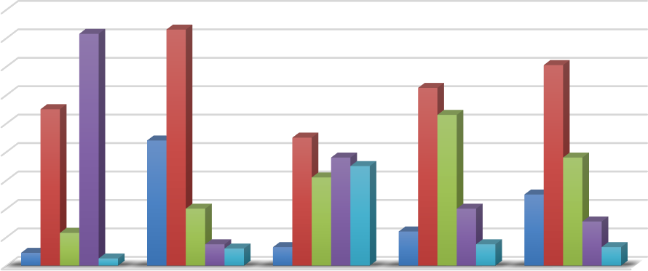

**Chart Title**

180

160

140

120

100

80

60

40

20

0

lack of More Light Schedule Supply More High Power maintenance Connections Electricity Fuses

Strongly Agree Agree Neutral Disagree Strongly Disagree

**Conclusion:**

* Most of the Farmers Agreed about, farmers take more connections than official connections so that transformer burns out.
* Some farmers are Agree and some farmers are strongly disagreeing with the light schedule of MSEB.
* when we asked do you agree with the reason that most of the transformer burns because of MSEB supplies more electricity so, some farmers agree and some farmers disagree about this reason.
* Also, most of farmers are agree with the reason that farmer installs high power fuses so the transformer burns out.

###### Summary of Crop damage

There are many reasons behind failure of transformer. For this sense, we asked question on whether crop has been damaged due to failure of transformer. By the responses we got following result.

* + From diagram there are 76% farmers are saying that their crop has been damaged due to the failure of transformer and 24% farmers are saying that their crop has not been damaged due to failure of transformer.

**Crop Damage**

24%

No

Yes

76%

Instead of not only asked crop has been damaged, we also ask if, crop has been damaged then how much damage was done. Below are summary of crop damaged due to failure of transformer.

|  |  |  |  |  |  |  |  |  |  |
| --- | --- | --- | --- | --- | --- | --- | --- | --- | --- |
| **If crop damaged, then how much**  **damage was done** | **Response (In Rs)** | | | |  | **% of response** | | | |
| **Tehsil** | **10000**  **–**  **30000** | **30000-**  **50000** | **Less**  **than 10000** | **More**  **than 50000** | **Grand Total** | **10000**  **- 30000** | **30000-**  **50000** | **Less**  **than 10000** | **More**  **than 50000** |
| Khatav | 9 | 5 | 14 | 1 | 29 | 31.03 | 17.24 | 48.28 | 3.45 |
| Malshiras | 12 | 5 | 6 | 8 | 31 | 38.71 | 16.13 | 19.35 | 25.81 |
| Man | 14 | 4 | 16 | 3 | 37 | 37.84 | 10.81 | 43.24 | 8.11 |
| Pandharpur | 11 | 6 | 4 | 11 | 33 | 33.33 | 18.18 | 12.12 | 33.33 |
| Shahuwadi | 17 | 11 | 20 | 10 | 58 | 29.31 | 18.97 | 34.48 | 17.24 |
| Shrirampur | 25 | 10 | 10 | 11 | 56 | 44.64 | 17.86 | 17.86 | 19.64 |
| **Grand Total** | **89** | **41** | **70** | **44** | **244** | **36.48** | **16.80** | **28.69** | **18.03** |

###### Conclusion:

* From above table we seen that , there are 36.48% farmers who suffered from crop damage due to failure of transformer and the damage done was in between (10000-30000 Rs.) and 16.80% farmer’s crops was damaged in between (30000-50000 Rs.)
* 28.69% farmer’s crop was damaged in (Less than 10000 Rs.)
* 18.03% farmer’s crop was damaged in (More than 50000 Rs.)
* In Shahuwadi taluka, highest number of crops was damaged due to failure of transformer and it is about 23.77%.
* In Khatav taluka, lowest number of crops was damaged due to failure of transformer and it is about 11.88%.

###### Cost per head of farmers of crop damaged due to failure of transformer:

|  |  |  |  |  |  |
| --- | --- | --- | --- | --- | --- |
| Damage | Count  of farmers | LB | UB | Mi | Fi*Mi |
| Less than 10000 Rs | 70 | 1 | 10000 | 4999.5 | 349965 |
| 10000-30000 Rs | 89 | 10000 | 30000 | 10000 | 890000 |
| 30000-50000 Rs | 41 | 30000 | 50000 | 10000 | 410000 |
| Greater than 50000 Rs | 44 | 50000 | 200000 | 75000 | 3300000 |
| Total | 244 |  |  |  | 4949965 |

Cost per head=∑ 𝐹𝑖∗𝑀𝑖

∑ 𝐹𝑖

= 20286

###### Conclusion:

* + From above study we observed that there are 76.01% farmers have been suffered from crop damage.
  + The average loss of crop damage is 20286 per head of 76.01% farmers and it is in between 10000-30000Rs.
  + The average loss of crop damage is 15420 per head of all farmers and it is in between 10000-30000Rs
  + From above study we concluded that, crop damages for all farmers and crop damages for only those farmers who suffered from crop damage is same and it is lies between 10000-30000Rs.

##### Summary of meter use

Some farmers do not use meter for their motor pumps and some farmers do not received any meter from MSEB. For this sense we asked to the farmers that they have meter or not. Below is the summary of meter has or not.

* + - From diagram we observed that, there are 29.28% farmers who do not have meters for their motors, and 70.72 % farmers have meters for their motors.

**Meter Users**

29%

No

Yes

71%

Then we are interested to know about, in which taluka farmer’s uses meters for their motor pumps. Then we make distinct categories of taluka. In the table below we make Taluka wise summary of meter used by farmers for their motors.

|  |  |  |  |  |  |
| --- | --- | --- | --- | --- | --- |
| **Do you have meter?** | **Response** | |  | **% of response** | |
| **Tehsil** | **Yes** | **No** | **Grand Total** | **No** | **Yes** |
| Khatav | 25 | 11 | 36 | 30.56 | 69.44 |
| Malshiras | 22 | 13 | 35 | 37.14 | 62.86 |
| Man | 27 | 14 | 41 | 34.15 | 65.85 |
| Pandharpur | 30 | 6 | 36 | 16.67 | 83.33 |
| Shahuwadi | 81 | 17 | 98 | 17.35 | 82.65 |
| Shrirampur | 42 | 33 | 75 | 44.00 | 56.00 |
| **Grand Total** | **227** | **94** | **321** | **29.28** | **70.72** |

###### Conclusion:

* From above table we observed that, there are 29.28% farmers who do not have meters for their motors, and 70.72 % farmers have meters for their motors.
* In Shrirampur taluka farmers uses lowest number of meters, there are 44% farmers who do not use meter for their motors.
* In Shahuwadi taluka farmers uses highest number of meters, there are 83.33% farmers who uses meters for their motors.

In previous analysis we asked to farmers that they have meter or not. Then after we are interested to know whether MSEB workers check meter readings or not. Whether MSEB provide you bill according to meter reading. For this concern we asked to the farmers that whether MESB workers can check your meter reading periodically. Below is the summary of meter reading checked or not.

**Check meter reading**

49%

51%

Meter

reading not checked

Meter reading checked

* + From the diagram, it is clear that 51% farmers says that their meter reading is checked by MSEB workers periodically and 49% farmers says that their meter reading is not checked by MSEB workers periodically.

##### Summary of Mode of paying bills

As per the farmers information some farmers pay bills by fixed amount e.g. (use of 3HP motors by farmers pay 500-1000Rs per month also for use of 5HP motors by farmers pay 1000-1500Rs bill per month). Some farmers pay bill according to meter reading and some farmers don’t pay bill because of some personal reason

**Mode of Paying Bills**

7%

30%

Fixed pay

according to meter reading

63%

Not paying Bill

* + - From the diagram we see that maximum farmers 63%are paying bill according to meter reading and 30% farmers pay fixed bill given by MSEB while 7% farmers do not pay bills.

Then we are interested to know about, how farmers pay bills in different talukas. In the table below we make Taluka wise summary of bill paid by farmers (According to meter reading, Fixed pay, Not Paying bills).

|  |  |  |  |  |  |  |  |
| --- | --- | --- | --- | --- | --- | --- | --- |
| **How do you pay bills?** | **Response** | | | | **Percentage of response** | | |
| **Tehsil** | **Fixed pay** | **According to meter reading** | **Not paying the bills** | **Grand Total** | **Fixed pay** | **According to meter reading** | **Not paying the bills** |
| Khatav | 25 | 9 | 2 | 36 | 69.44 | 25 | 5.56 |
| Malshiras | 22 | 8 | 5 | 35 | 62.86 | 22.86 | 14.29 |
| Man | 25 | 16 | 0 | 41 | 60.98 | 39.02 | 0 |
| Pandharpur | 20 | 13 | 3 | 36 | 55.56 | 36.11 | 8.33 |
| Shahuwadi | 73 | 18 | 7 | 98 | 74.49 | 18.37 | 7.14 |
| Shrirampur | 38 | 31 | 6 | 75 | 50.67 | 41.33 | 8 |
| **Grand Total** | **203** | **95** | **23** | **321** | **63.24** | **29.60** | **7.17** |

###### Conclusion:

* In shahuwadi taluka maximum number of farmes that is 74.49% farmers paying bill according to fixed pay and in Shrirampur taluka maximum farmers that is 41.33% farmers pay bills according to meter reading.
* The farmers from man taluka pay bill either fixed pay or according to meter reading. There are 0% farmers who do not pay bills.
* Maximum number of farmers that is 14.29% farmers from Malshiras taluka does not pay bills.

Then we wanted to know average bill, minimum and maximum bill paid by farmers by different mode of paying bills from different taluka. Below are the summay of bill paid by farmers.

Some farmers pay **fixed bill**. Below is the taluka wise summary of fixed bill paid by farmers.

|  |  |  |  |
| --- | --- | --- | --- |
| **Fixed Bills** | **Bills** | | |
| **Tehsil** | **Min of last year bill** | **Max of last year bill** | **Average of last year bill** |
| Khatav | 1500 | 21400 | 16637.50 |
| Malshiras | 10000 | 19800 | 19212.50 |
| Man | 10000 | 25000 | 18653.33 |
| Pandharpur | 1200 | 20000 | 12575.00 |
| Shrirampur | 3000 | 30000 | 18193.33 |
| Shahuwadi | 1200 | 25000 | 11555.00 |
| **Grand Total** | **4483.33** | **23533.33** | **16137.78** |

###### Conclusion:

* From above table we see that, average bill paid by farmers is about 16137Rs per year. Out of that, farmers from Malshiras taluka pays highest average bill which is about 19212Rs per year and farmers from Shahuwadi taluka pays lowest average bill which is about 11555Rs.
* Average of maximum bill paid by farmers from all these talukas is 23533Rs per year. Out of that, farmers from Shrirampur taluka pays highest bill which is about 30000Rs and farmers from Malshiras taluka pays lowest bill which is about 19800Rs per year.
* Average of minimum bill paid by farmers from all these talukas is 4483Rs per year. Out of that, farmers from Malshiras and Man taluka pays highest bill which is about 10000Rs and farmers from Shahuwadi and Pandharpur taluka pays lowest bill which is about 1200Rs per year.

Some farmers pay **According to meter reading bill**. Below is the taluka wise summary of according to meter reading bill paid by farmers.

|  |  |  |  |
| --- | --- | --- | --- |
| **According to meter reading** | **Bill's** | | |
| **Tehsil** | **Min of last year bill** | **Max of last year bill** | **Average of last year bill** |
| Khatav | 10000 | 25000 | 17032.50 |
| Malshiras | 1300 | 25000 | 16518.42 |
| Man | 9000 | 27000 | 18419.23 |
| Pandharpur | 5000 | 25000 | 16270.00 |
| Shrirampur | 1300 | 25000 | 17531.58 |
| Shahuwadi | 2000 | 25000 | 14820.77 |
| **Grand Total** | **4766.67** | **25333.33** | **16765.41** |

###### Conclusion:

* From above table we see that, average bill paid by farmers is about 16765Rs per year. Out of that, farmers from Man taluka pays highest average bill which is about 18419Rs per year and farmers from Shahuwadi taluka pays lowest average bill which is about 14820Rs per year.
* Average of maximum bill paid by farmers from all these talukas is 25333Rs per year. Out of that, farmers from Man taluka pays highest bill which is about 27000Rs and farmers from all other talukas except Man, pays lowest bill which is about 19800Rs per year.
* Average of minimum bill paid by farmers from all these talukas is 4766Rs per year. Out of that, farmers from Khatav taluka pays highest bill which is about 10000Rs and farmers from Shrirmpur and Malshiras taluka pays lowest bill which is about 1300Rs per year.

###### From all over, it is clear that, the bill paid by farmers by both the methods (According to meter reading and fixed pay) is nearly equal.

* + From above Graph we observe that, 65% farmers from these 6 talukas have approved connection. Which means that 65% farmers uses motor pump as approved by MSEB

**Approved Connection**

Approved

13%

connections

22%

65%

Above

Approved Conections

Below Approved Connection

* + 22% farm**e**rs have above approved connection. This means that 22% farmers from these 6 talukas uses motor pump of higher capacity than the official connection provided by MSEB.
* 13% farmers have below approved connection. This means that 13% farmers from these 6 talukas uses motor pump of lower capacity than the official connection provided by MSEB.

##### Summary of Power supply received and power supply use

We asked to the farmers that for how many hours of power supply do they receive per day (day and night) and in between them for how many hours they use motor pumps. Do they receive sufficient power supply from MSEB. For this concern we asked to the farmers power supply received and power supply use. Below are the summary of power supply received and use.

|  |  |  |  |  |  |  |
| --- | --- | --- | --- | --- | --- | --- |
| **Count of power supply use** | **Power supply used** | | | | | |
| **Power supply recived** | 10-12 hr | 1-3 hr | 4-6 hr | 4-6 hr, 7-9 hr | 7-9 hr | **Grand Total** |
| 10-12 hr | 0.62 | 0.93 | 0.93 | 0.00 | 0.62 | 3.12 |
| 1-3 hr | 0.00 | 13.40 | 0.31 | 0.00 | 0.00 | 13.71 |
| 4-6 hr | 0.00 | 19.00 | 25.55 | 0.00 | 0.62 | 45.17 |
| 7-9 hr | 0.00 | 5.61 | 10.90 | 0.31 | 18.38 | 35.20 |
| More than 12 hr | 0.62 | 0.31 | 1.25 | 0.00 | 0.62 | 2.80 |
| **Grand Total** | 1.25 | 39.25 | 38.94 | 0.31 | 20.25 | 100.00 |

###### Conclusion:

* From above graph we see that, 45% farmers receives on an average 4-6 hours power supply from MSEB and 39% farmers uses both 1-3 hours and 4-6 hours power supply. **From this we concluded that MSEB provide sufficient power supply to the farmers**.
* MSEB do not provide more than 10 hours power supply to farmers and also farmers do not use their motor pumps more than 10 hours.

##### Summary of Light schedule

In the most of the rural area light schedule of the MSEB is tentative for agricultural purpose

e.g. Light schedule of agricultural purpose in rural area

“Afternoon- 4PM to 9PM (tentative)” “Night- 12PM to 8AM (tentative)”

This light schedule changes week by week so we asked to farmers that whether they are satisfied and agree with the light provided by MSEB. Below are summary of light schedule provided by MSEB to farmers.

**How do you agree with the light schedule**

30.00%

25.00%

20.00%

15.00%

10.00%

5.00%

0.00%

25.86% 23.68%

23.68%

22.43%

4.36%

Agree

Disagree Neutral

**Response**

Strongly Agree

Strongly Disagree

**Percentage**

###### Conclusion:

* + From our survey, 26% farmers are agreed with the light schedule provided by the MSEB and 23.68% farmers are disagree and neutral with the light schedule provided by MSEB.

##### Summary of Bill should be waived or not

In previous analysis, we have seen that how the farmers are paying bills (i.e fixed pay, according to meter reading). By the farmers responses, farmers are requested to waived the electric bill. Below is the summary of bill should be waived or not.

**Bill should be waived or not**

12%

Yes

No

88%

* + - From graph we see that, 88% farmers wanted their bill should be waived and 12% farmers do not want their bill should be waived.

Then we are interested to know why farmers want their electric bill should be waived. What are the reasons behind bill should be waived? Below is the summary of electric bill should be waived or not.

Reasons of bill waived

160

140

120

100

80

60

40

20

0

Don’t have

sufficient money

bogus bill

Natural

disaster

Irregular

power supply

Reasons

Other

Bills are

high

###### Conclusion:

* + From above graph we see that, the main reason behind electricity bill should be waived is MSEB provides high electricity bills to the farmers.
  + Some farmers also do not have sufficient money for paying bill. So they want their electricity bill should be waived.

###### How much of farmers and MSEB responsible for this confusion

We asked to the farmers under our study area, about How MSEB and Farmers are responsible for all this confusion, then they gave us responses. we plot a bar diagram on the given responses.

**How responsible MSEB and Farmers for all this confusion**

MSEB Responsible for all confusion

55.76

Farmers Responsible for all confusion

37.69

37.38

32.71

21.50

8.41

5.92

0.62

1-25%

25-50%

50-75%

75-100%

###### Conclusion:

* + From the above graph we conclude that, there are 21.50% farmers saying that 75-100% (Maximum) MSEB is responsible for this all confusion, that is MSEB is more responsible for being reason behind failure of transformer and 55.76% farmers saying that there are 1-25% (Minimum) farmers are responsible for all this confusion, that is farmers is least responsible for being reason behind failure of transformer.

##### Summary of use of solar pumps in future or not, under our study area:

We asked to the farmers under our study area about the use of solar pumps in future, and then they gave us responses as given below in the table.

|  |  |  |  |  |  |
| --- | --- | --- | --- | --- | --- |
| **Will you use solar motor pump in future** | **Response** | |  | **Percentage of response** | |
| **Tehsil** | **Yes** | **No** | **Grand**  **Total** | **Yes** | **No** |
| Khatav | 33 | 3 | 36 | 91.67 | 8.33 |
| Malshiras | 32 | 3 | 35 | 91.43 | 8.57 |
| Man | 41 | 0 | 41 | 100.00 | 0.00 |
| Pandharpur | 36 | 0 | 36 | 100.00 | 0.00 |
| Shahuwadi | 77 | 21 | 98 | 78.57 | 21.43 |
| Shrirampur | 72 | 3 | 75 | 96.00 | 4.00 |
| **Grand Total** | **291** | **30** | **321** | **90.65** | **9.35** |

###### Conclusion:

* + From above table we concluded that, there is a 90.65% farmer who says that they will use solar motor pumps in future, and 9.35 % farmers Says that they will not use solar motor pumps in future.
  + In both Man and Pandharpur taluka 100% farmers says they will use solar motor pumps in future.
  + Maximum farmers from shahuwadi taluka are not interested in using solar motor pumps in future. 21.43% farmers from shahuwadi taluka will not use solar motor pumps in future.

**ANOVA**

###### Electric bill of motors whose meter reading are not checked

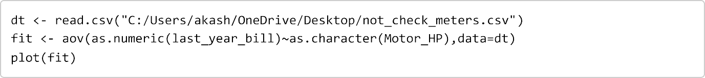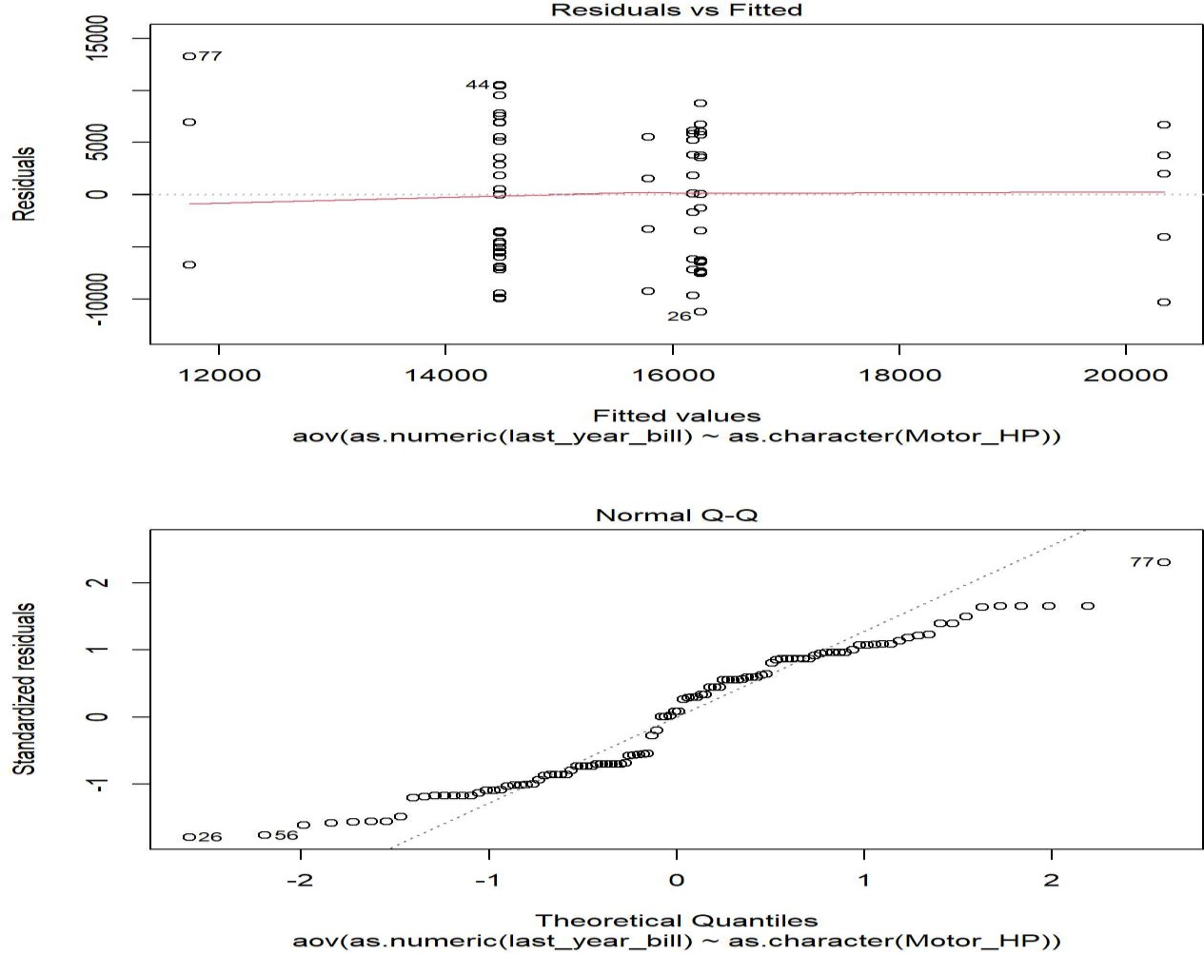

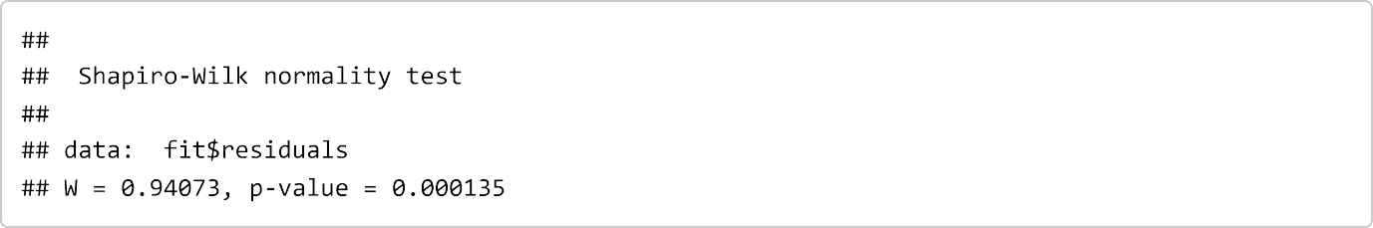

The Shapiro Wilk test is significant so we can assume non-normality of residuals.



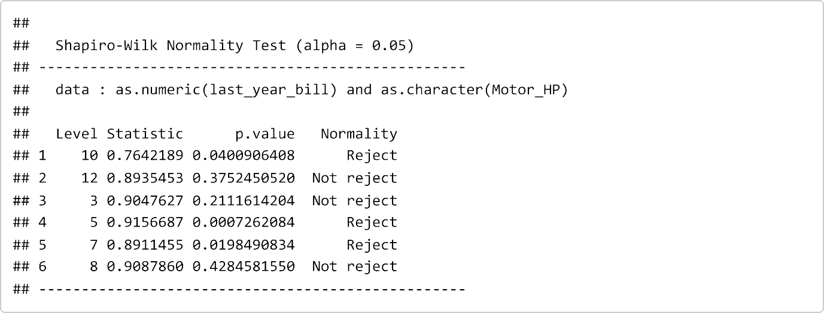

Bill from 10HP, 5HP, 7HP motor pumps is not normal.

Therefore, we use non-parametric alternative test for ANOVA is Kruskal Wallis test.

H0: Different HP motor light bill median are equal. H1: Different HP motor light bill median are different.

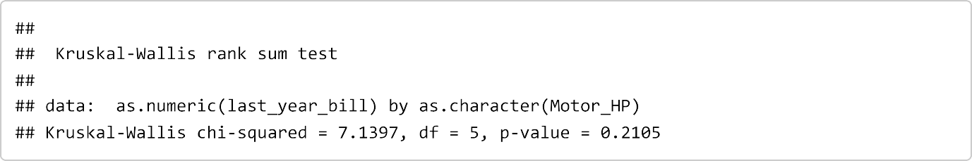

###### Different HP motor does not affect lite bill when MSEB gives bill according to meter reading without checking meter reading.

* + **Electric bill of motors whose meter reading are checked**

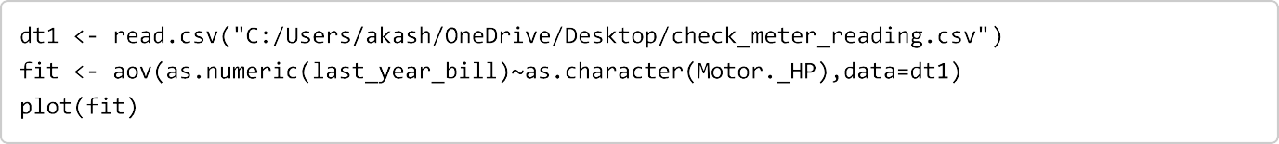

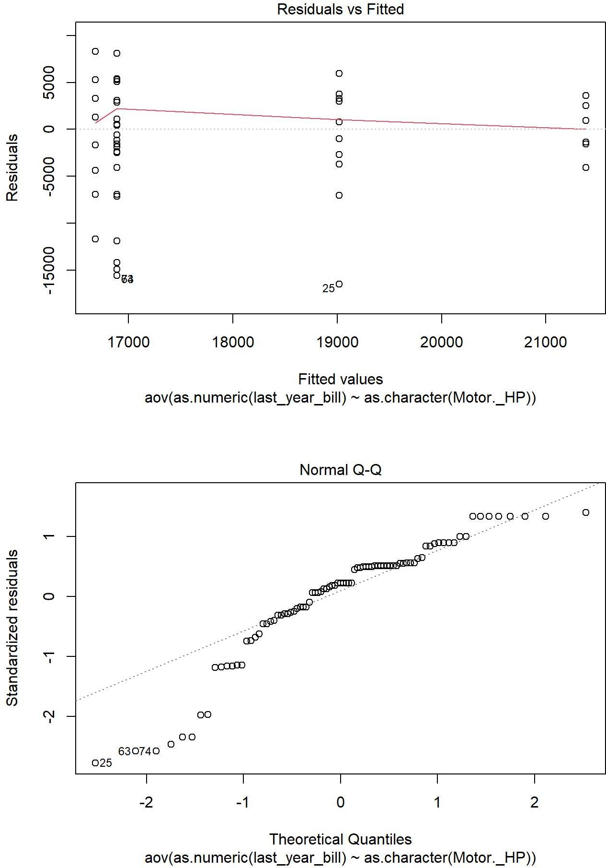

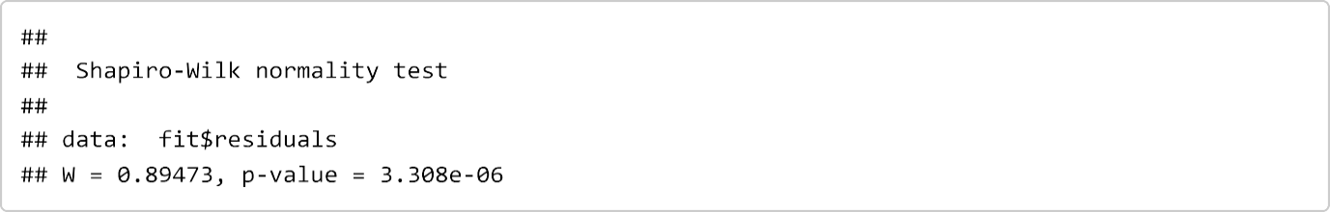

The Shapiro Wilk test is significant so we can assume non-normality of residuals.

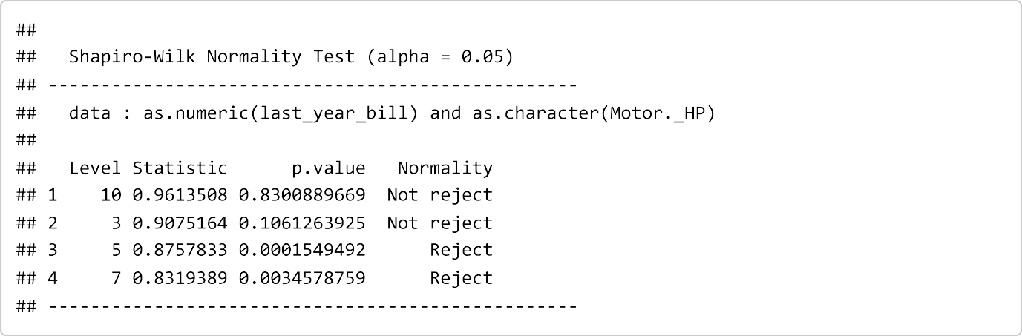

Bill from 5HP and 7HP are not normal.

Therefore, we use non-parametric alternative test for ANOVA is Kruskal Wallis test.

H0: Different HP motor light bill median are equal. H1: Different HP motor light bill median are different.

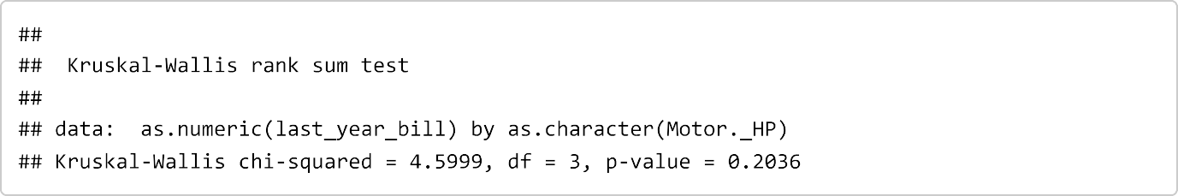

**Different HP motor does not affect lite bill when MSEB gives us light bills according to meter reading checked.**

**ANOCOVA**

H0: Different HP motor light bill is equivalent for all farm size.

H1: Different HP motor light bill are not equivalent for all farm size.

###### Tests of Normality

|  |  |  |  |  |  |  |
| --- | --- | --- | --- | --- | --- | --- |
|  | Kolmogorov-Smirnova | | | Shapiro-Wilk | | |
| Statistic | df | Sig. | Statistic | df | Sig. |
| Farmsize | .196 | 109 | .000 | .870 | 109 | .000 |
| lastyearbill | .185 | 109 | .000 | .923 | 109 | .000 |

From above table we see that, farm size and last year bills significance level is

0.000 < 0.05. Therefore farm size and last year bill are not normal.

###### Tests of Between-Subjects Effects

Dependent Variable: Unstandardized Residual

|  |  |  |  |  |  |  |
| --- | --- | --- | --- | --- | --- | --- |
| Source | Type III Sum of Squares | df | Mean Square | F | Sig. | Partial Eta Squared |
| Corrected Model | 3454.333a | 8 | 431.792 | .873 | .542 | .065 |
| Intercept | 143.658 | 1 | 143.658 | .290 | .591 | .003 |
| RFarmsiz | 5.817 | 1 | 5.817 | .012 | .914 | .000 |
| MotorHP | 3454.333 | 7 | 493.476 | .997 | .438 | .065 |
| Error | 49482.180 | 100 | 494.822 |  |  |  |
| Total | 52936.512 | 109 |  |  |  |  |
| Corrected Total | 52936.512 | 108 |  |  |  |  |

1. R Squared = .065 (Adjusted R Squared = -.010)

Farm size (covariate) 0.914 > 0.05 therefore we accept null hypothesis.

From above we concluded that, different HP motors electricity bill is equivalent for all farm size.

###### Tests of Normality

|  |  |  |  |  |  |  |
| --- | --- | --- | --- | --- | --- | --- |
|  | Kolmogorov-Smirnova | | | Shapiro-Wilk | | |
| Statist ic | df | Sig. | Statistic | df | Sig. |
| lastyearbill | .175 | 92 | .000 | .875 | 92 | .000 |
| Farmsize | .189 | 92 | .000 | .923 | 92 | .000 |

**Tests of Between-Subjects Effects**

Dependent Variable: Unstandardized Residual

|  |  |  |  |  |  |
| --- | --- | --- | --- | --- | --- |
| Source | Type III Sum of Squares | df | Mean Square | F | Sig. |
| Corrected Model | 2796.363a | 6 | 466.060 | 1.437 | .210 |
| Intercept | 59.129 | 1 | 59.129 | .182 | .671 |
| MotorHP | 2796.363 | 6 | 466.060 | 1.437 | .210 |
| Error | 27574.094 | 85 | 324.401 |  |  |
| Total | 30370.457 | 92 |  |  |  |
| Corrected Total | 30370.457 | 91 |  |  |  |

a. R Squared = .092 (Adjusted R Squared = .028)

|  |  |  |  |  |  |  |
| --- | --- | --- | --- | --- | --- | --- |
|  |  | y = 50.194x + 9891.4 | 30000  25000  20000  15000  10000  5000  0 | 0 | 10  HP | y = -44.411x + 15532 R² = 0.0004  20 30 |
|  |  | R² = 0.3515 |
| 30000 |  |  |
| 25000 |  |  |
| 20000 |  |  |
| 15000 |  |  |
| 10000 |  |  |
| 5000 |  |  |
| 0 |  |  |
|  | 0 | 100 200 300 |
|  |  | farm size |

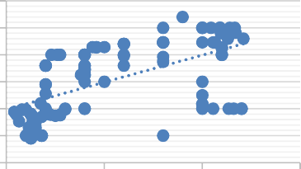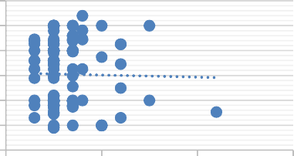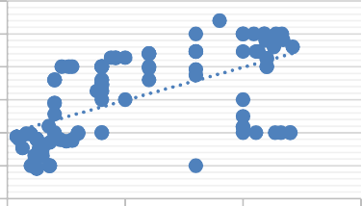

y = -44.411x + 15532

R² = 0.0004

30000

25000

20000

15000

10000

5000

0

0

10

20

30

HP

300

200

100

farm size

0

y = 50.194x + 9891.4

R² = 0.3515

30000

25000

20000

15000

10000

5000

0

Last year bill

Last year bill

Last year bill

Last year bill

Last year bill

Last year bill

|  |  |  |
| --- | --- | --- |
| **Correlation** | **Last Year Bill VS Farm Size** | **Lasy Year Bill VS HP Motor** |
| Meter Not Check | 0.5928 | -0.0193 |
| Meter Check | 0.6329 | 0.1612 |
| Fixed bill | 0.4342 | 0.2541 |

###### Conclusion:

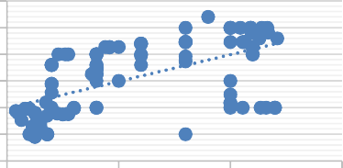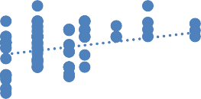

40000

30000

20000

10000

0

y = 589x + 12457

R² = 0.0646

0

5

10

15

20

HP

300

200

100

farm size

0

y = 50.194x + 9891.4

R² = 0.3515

30000

25000

20000

15000

10000

5000

0

* From the above graph we see that there is a moderate correlation between

farm size and last year’s bill.

* Different types of paying bill methods, are completely independent of HP motor used.

**Transformer Failure report**

When we go to collect the data from MSEB Division office they only give failure report of three month and B-6 report (i.e. failure report) of 63kva and 100kva. Failure report of data contains Transformer failure date, Division, Section, Village, DTC Name, DTC Code, Capacity of Transformer and remark .There are almost 273 transformer fail in various division

###### Count of the transformer(division):

|  |  |
| --- | --- |
| **Transformer**  **(kva)** | **Count of**  **transformer** |
| 16 | 17 |
| 25 | 1 |
| 63 | 56 |
| 100 | 194 |
| 200 | 5 |
| **Grand Total** | **273** |



**Transformer used**

250

200

150

100

50

0

16

25

63

100

200

**Conclusion:**

* + In the all of the above division, most of the people are used 100kva transformer for their agriculture used.

###### Count of failure transformer (In section):

|  |  |
| --- | --- |
| **Row Labels** | **Count of S/Dn** |
| **Babhabhleshvar(BBLR)** | **87** |
| BBLR | 17 |
| Loni 1 | 21 |
| Loni 2 | 20 |
| Mamdapur | 15 |
| Satral | 14 |
| **Deolali** | **64** |
| Deolali R | 12 |
| Deolali U | 10 |
| Kolhar | 21 |
| Kolhar | 1 |
| Pathre | 15 |
| Ta.Miya | 5 |
| **Deolali** | **2** |
| Ta.Miya | 2 |
| **Rahuri** | **47** |
| Ba.nandur | 9 |
| Bramhani | 16 |
| Rahuri U | 10 |
| Wambori | 12 |
| **Shrirampur(SRM)** | **73** |
| Belapur | 24 |
| Haregaon | 15 |
| MIDC | 3 |
| SRM U | 1 |
| Sutgirni | 8 |
| Ta.Bhan | 22 |
| **Grand Total** | **273** |



**Division-wise failure report**

(blank)

SRM

Rahuri

Deolali

Total

Deolali

BBLR

0

20

40

60

80

100

**Conclusion:**

* + In the above Failure report, we have seen that in the division of Babhaleshvar most of the transformers are fail (87).
* **Count of section-wise fail of transformer:**



|  |  |
| --- | --- |
| **Section** | **Count of Section** |
| Ba.nandur | 9 |
| BBLR | 17 |
| Belapur | 24 |
| Bramhani | 16 |
| Deolali R | 12 |
| Deolali U | 10 |
| Haregaon | 15 |
| Kolhar | 21 |
| Kolhar | 1 |
| Loni 1 | 21 |
| Loni 2 | 20 |
| Mamdapur | 15 |
| MIDC | 3 |
| Pathre | 15 |
| Rahuri U | 10 |
| Satral | 14 |
| SRM U | 1 |
| Sutgirni | 8 |
| Ta.Bhan | 22 |
| Ta.Miya | 7 |
| Wambori | 12 |
| **Grand Total** | **274** |

|  |  |
| --- | --- |
| 30  25  20  15  10  5  0 | **sectionwise failure of transformer** |
| Belapur Ta.Bhan Kolhar Loni 1  Loni 2 BBLR  Bramhani Haregaon Mamdapur  Pathre Satral Deolali R Wambori Deolali U Rahuri U Ba.nandur Sutgirni Ta.Miya MIDC  Kolhar  SRM U |

###### Conclusion:

* + From above graph we see that, in of the above sections most of the transformer failures are in Belapur (24) section and then just after that Taklibhan (22).
  + Here it is interesting to note that, In section wise Belapur get a hotspot area which is in shrirampur division not in Babhabhaleshvar division.

###### Summary of transformer failure repaired at site:

**Conclusion**:

14

12

10

8

6

4

2

0

Double Entry

Repaired At Site (blank)

16 25 63 100 200

* + - In this failure report form, There are only 12 transformers are repaired at site out of 273 transformers.

# LIMITATION

* This study is concluded for only 6 talukas. For different talukas in different districts it may be different
* By the using of convenience sampling data are collected through different regions so bias results, due to this reason some people choose to take part and some do not.
* Some farmers did not give us real information therefore there is some bias in results.

# Major findings

In this project, failure mode of transformer is discussed and failure analysis of distribution transformer carried out on 6 subdivisions (viz Man, Khatav, Malshiras, pandharpur, Shahuwadi, Shrirampur). failure analysis are carried out an transformers of various capacity.

There are many reasons to failure of transformer due to lack of farmers awareness and MSEB responsibilities. In this project we have studied what are the major reasons behind transformer failure. From MSEB perception, farmers are more responsible for transformer burning. Farmers do not use capacitor for their motors, do not do neutral earthing, use high power fuses, take and unauthorized connection, power theft etc are the major reasons behind the failure of transformer.

* Reasons of failure of transformer :
* Capacitor: From our project, more than 50% farmers use capacitor for their motor and also 49% don’t use capacitor for their motor. 67% farmers from Shrirampur taluka do not use capacitors for their motors.
* Neutral Earthing: More than 50% farmers do neutral earthing for their motors. Maximum farmers from Shrirampur taluka do not do neutral earthing for their motors.
* Power Theft: From farmer’s perception, there are 62% farmers agreed with power theft happen in their area. Farmers from Pandharpur and Shrirampur taluka say that maximum power theft happen in their area.
* Lack of Maintenance of transformers: 44% farmers say that major reason behind failure of transformer is lack of maintenance of transformers.
* 36% farmers under our study area are suffered from crop damaged due to failure of transformer. In shahuwadi taluka highest number of crop damaged due to failure of transformer.
* From above study we concluded that, crop damages for all farmers and crop damages for only those farmers who suffered from crop damage is same and it is lies between 10000-30000Rs.
* In our study, the bill paid by farmers by both the methods (According to meter reading and fixed pay) is nearly equal.
* From pareto charts we have seen that 58% MSEB is responsible for failure of transformer. So MSEB should improve their work.
* In future purpose there are 91% farmers say that they will use solar motor pump in future.
* From the three-month failure report, there are 273 transformer fail in various subdivision. Out of which, most of transformer are 100Kva and only 12 transformers are repaired at site.
* From the failure report most of the transformer is failed in Babhaleshvar division and second most transformer failed in Shrirampur division. Here it is interesting to note that, In section wise Belapur get a hotspot area which is in shrirampur division not in Babhabhaleshvar division.

**REFERENCES**

* Singh, R. and Singh, A, “Causes of failure of distribution transformers

Electrical Engineering (EEEIC), Prague, Czech Republic ,2010

* ANSI/IEEE C57.117 - 1986, “IEEE guide for reporting failure data for

power transformers and shunt reactors on electric utility power

* ANOCOVA(quads test)
  + [https://www.statisticshowto.com/ancova/#:~:text=ANCOVA%20is%20a%20blend%](https://www.statisticshowto.com/ancova/#%3A~%3Atext%3DANCOVA%20is%20a%20blend%20of%2Cthe%20influence%20of%20the%20others) [20of,the%20influence%20of%20the%20others](https://www.statisticshowto.com/ancova/#%3A~%3Atext%3DANCOVA%20is%20a%20blend%20of%2Cthe%20influence%20of%20the%20others)
  + https://www.google.com/url?sa=t&source=web&rct=j&url=https://m.youtube.com/w atch%3Fv%3Djozx59H5IHw&ved=2ahUKEwi63KS9t- j4AhVt63MBHWl4D2UQwqsBegQIFhAF&usg=AOvVaw3nerh9Vk3HV16qP87Wh F6h

# Appendix

Questionnaire:- [https://docs.google.com/forms/d/e/1FAIpQLSdwY7VayQ42xFADy-t_ZT-](https://docs.google.com/forms/d/e/1FAIpQLSdwY7VayQ42xFADy-t_ZT-ItEcw_rQEHBHI4dexooeC_i63Hg/viewform?usp=sf_link) [ItEcw_rQEHBHI4dexooeC_i63Hg/viewform?usp=sf_link](https://docs.google.com/forms/d/e/1FAIpQLSdwY7VayQ42xFADy-t_ZT-ItEcw_rQEHBHI4dexooeC_i63Hg/viewform?usp=sf_link)

