- Skewness: -2.3854306471764377

- excess kurtosis: 10.197730163512697

- average of log daily return: -0.039111353216

- standard deviation of log daily return: 0.0193081087309

- correlation: -0.0890973368553

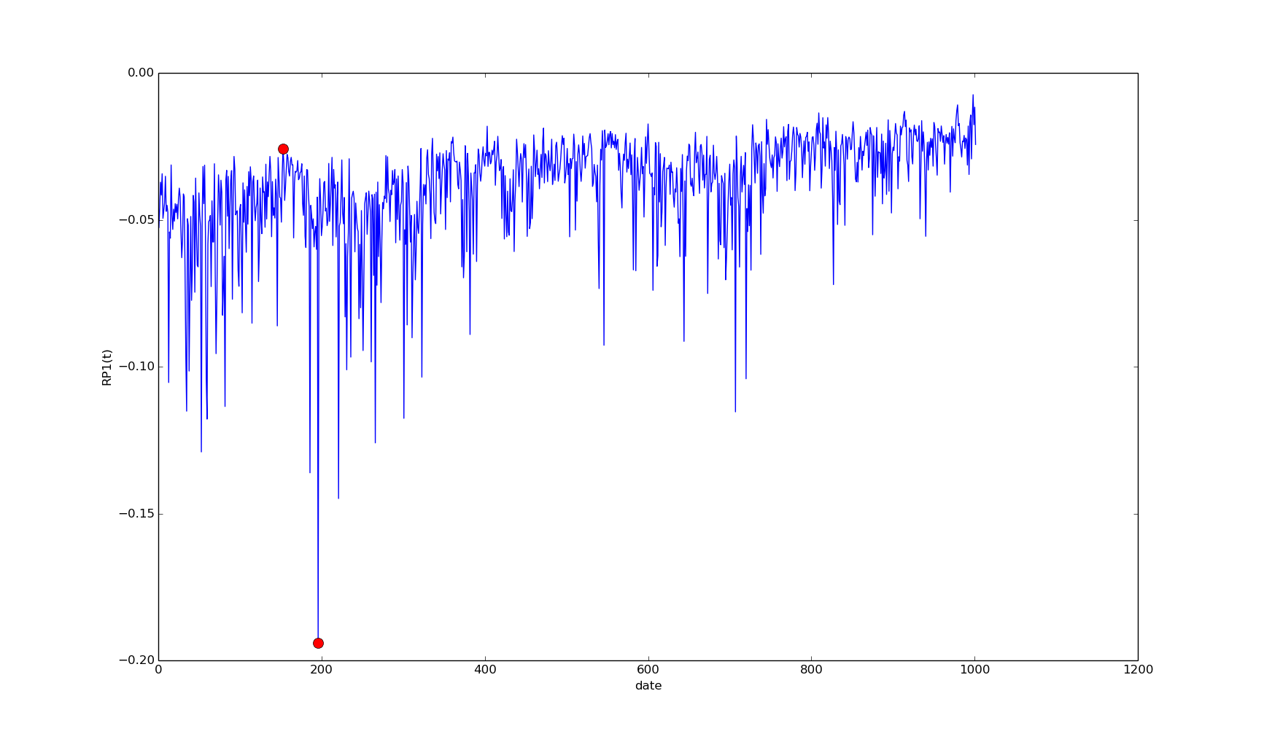
Maximum Drawdown Period

start end

RP1 153 196

peak-to-through cumulative return is : -2.06869029207

