[GUN VIOLENCE] Incidents_by_state

1585107 이지인

2018년 12월 3일

# 인구대비 사고수가 많은 지역 순서대로 정렬해보았다.  
b %>% arrange(desc(acc_pop))

## # A tibble: 51 x 7  
## state code lat long pop acc acc_pop  
## <chr> <int> <dbl> <dbl> <int> <int> <dbl>  
## 1 District of Columbia 11 38.9 -77.0 693972 2177 314  
## 2 Alaska 2 61.4 -152. 739795 1142 154  
## 3 Louisiana 22 31.2 -91.9 4684333 5749 123  
## 4 Delaware 10 39.3 -75.5 961939 1083 113  
## 5 Illinois 17 40.3 -89.0 12802023 13600 106  
## 6 South Carolina 45 33.9 -80.9 5024369 4906 98  
## 7 Mississippi 28 32.7 -89.7 2984100 2542 85  
## 8 Tennessee 47 35.7 -86.7 6715984 5650 84  
## 9 Missouri 29 38.5 -92.3 6113532 4984 82  
## 10 Alabama 1 32.8 -86.8 4874747 3804 78  
## # ... with 41 more rows

# District of Columbia주에서 이상치 300이 넘는 값을 보이므로 제외하고 상위 10개주를 차트로 나타내보자.  
b %>%  
 filter(state != "District of Columbia",  
 rank(desc(acc_pop)) < 11)%>%  
 ggplot(aes(reorder(state,acc_pop),acc_pop,  
 fill=acc_pop))+  
 geom_bar(stat="identity") +   
 ylab(label = "Incidents")+  
 xlab(label = "State") +  
 scale_fill_gradient(low="yellow", high="red")+  
 theme(axis.text.x = element_text(angle=30))

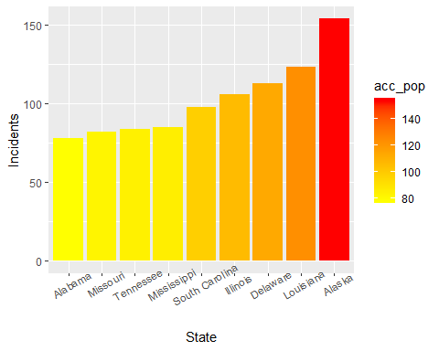

# 사고 수 가장 많은 지역인 DC 확대 지도에   
# 3년간 사고 발생지를 표시해보고자 한다.  
# DC 정보 code lat long pop acc  
b %>% filter(state=="District of Columbia")

## # A tibble: 1 x 7  
## state code lat long pop acc acc_pop  
## <chr> <int> <dbl> <dbl> <int> <int> <dbl>  
## 1 District of Columbia 11 38.9 -77.0 693972 2177 314

# DC발생 총기사고 long, lat 뽑아냄  
c <- df1 %>%   
 filter(state=="District of Columbia") %>%  
 select(long, lat)   
  
# DC 지도  
dc<-map_data('county', region='district of columbia')  
head(dc)

## long lat group order region subregion  
## 1 -77.01699 38.97259 1 1 district of columbia washington  
## 2 -76.93105 38.89238 1 2 district of columbia washington  
## 3 -77.05136 38.80643 1 3 district of columbia washington  
## 4 -77.05136 38.82935 1 4 district of columbia washington  
## 5 -77.06283 38.86373 1 5 district of columbia washington  
## 6 -77.07428 38.88664 1 6 district of columbia washington

#인구대비 사고 수 많은 주 확대지도  
ggplot(dc, aes(long,lat))+  
 geom_polygon(aes(group=group),fill="lightblue",colour="grey50")+  
 geom_point(aes(long,lat), data=c, colour="red", alpha=0.2)+  
 coord_quickmap()

## Warning: Removed 54 rows containing missing values (geom_point).

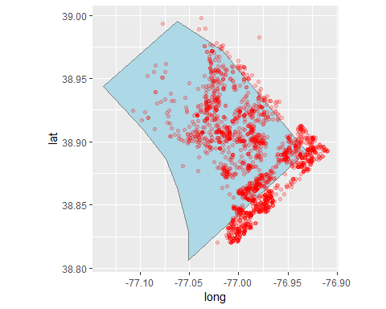

DC<-get_map("District of Columbia", zoom=12,  
 maptype = "terrain")

## Source : https://maps.googleapis.com/maps/api/staticmap?center=District%20of%20Columbia&zoom=12&size=640x640&scale=2&maptype=terrain&language=en-EN&key=xxx

## Source : https://maps.googleapis.com/maps/api/geocode/json?address=District%20of%20Columbia&key=xxx

ggmap(DC, extent="device") +   
 theme_void()+  
 geom_point(aes(long,lat), data=c, colour="red", alpha=0.15)+  
 ggtitle("District of Columbia")

## Warning: Removed 162 rows containing missing values (geom_point).

