“Design and Development of a Linux Performance Benchmarking Tool”
A Project Report Submitted in the partial fulfillment of the requirements for the award of the degree of

BACHELOR OF TECHNOLOGY
In

DEPARTMENT OF COMPUTER SCIENCE ENGINNERING

By

K. ROHAN 2520030513

P. SHIVA SAI 2520030596

V. TARUN 2520030526

Under the Esteemed Guidance of

Dr. Soumya
Assistant Professor
Department of Computer Science and Engineering




K L (Deemed to be) University DEPARTMENT OF COMPUTER SCIENCE ENGINEERING
&

DEPARTMENT OF COMPUTER SCIENCE AND INFORMATION TECHNOL

Declaration

The Project Report entitled “Design and Development of a Linux Performance Benchmarking Tool” is a record of Bonafide work of K. ROHAN - 2520030513, P. SHIVA SAI - 2520030596, V. TARUN - 2520030526 submitted in
partial fulfillment for the award of B. Tech in Computer Science and Engineering (or) Computer Science and Information Technology to the K L University. The results embodied in this report have not been copied from any other departments/University/Institute.

K. ROHAN 2520030513

P. SHIVA SAI 2520030596

V. TARUN 2520030526

K L (Deemed to be) University

DEPARTMENT OF COMPUTER SCIENCE ENGINEERING

CERTIFICATE

This is certify that the mini project based report entitled “Design and Development of a Linux Performance Benchmarking Tool” is a bonafide work done and submitted by K. ROHAN - 2520030513, P. SHIVA SAI - 2520030596, V. TARUN - 2520030526 ,
in partial fulfillment of the requirements for the award of the degree of BACHELOR OF TECHNOLOGY in Department of Computer Science Engineering, K L (Deemed to be University), during the academic year 2024-2025.

Signature of the Guide

Signature of the Course Coordinator Signature of the HOD

ACKNOWLEDGEMENT
The success in this project would not have been possible but for the timely help and guidance rendered by many people. Our wish to express my sincere thanks to all those who has assisted us in one way or the other for the completion of my project.

Our greatest appreciation to my Course Coordinator Dr. Soumya, and my guide Dr. Soumya, Department of Computer Science which cannot be expressed in words for his/her tremendous support, encouragement and guidance for this project.

We express our gratitude to Dr. P Venkateshwara Roa (CSE), Head of the Department for Computer Science Engineering for providing us with adequate facilities, ways and means by which we are able to complete this project-based Lab.

We thank all the members of teaching and non-teaching staff members, and also who have assisted me directly or indirectly for successful completion of this project. Finally, I sincerely thank my parents, friends and classmates for their kind help and cooperation during my work.

K. ROHAN 2520030513

P. SHIVA SAI 2520030596

V. TARUN 2520030526
Abstract

Understanding how a program uses the processor, memory and storage is essential for writing efficient software, yet developers usually rely on separate tools such as time, top and iostat, each showing only one aspect and each giving a single, noisy measurement. This project addresses that gap through the Design and Development of a Linux Performance Benchmarking Tool that measures and compares the CPU, memory and I/O performance of different programs.

The tool starts each program as a child process and uses the Linux wait4 system call to obtain the kernel's own resource-usage record: user and system CPU time, peak resident memory, disk blocks read and written, context switches and page faults. Every program is run several times, one after another so that runs do not disturb each other, and the results are summarized with mean, minimum, maximum and standard deviation, together with a relative score against the best program.

The system is built with Python and Flask. It offers a command-line interface and a responsive web dashboard that shows side-by-side bar charts, a detailed result table and CSV export. Three sample workloads (CPU-heavy, memory-heavy and I/O-heavy) were used to verify the tool, and their measured behaviour matched operating system theory: the CPU program was compute-bound, the memory program reached about 160 MB of peak memory, and the I/O program wrote about 100 MB to disk and spent most of its time waiting. The project shows how core operating system concepts can be turned into a practical, easy-to-use performance comparison utility.

Index

S. No. | Chapter | Topics / Subtopics | Page No.
 | Acknowledgement |  | i
 | Abstract |  | ii
1 | Introduction |  | 8–9
 |  | 1.1 Background of the Project
 |  | 1.2 Problem Statement
 |  | 1.3 Scope of the Project
 |  | 1.4 Objectives of the Project
 |  | 1.5 Importance of the Application
 |  | 1.6 Target Users / Audience
2 | OS Concepts and Background Study |  | 10–11
 |  | 2.1 Operating System Concepts Related to the Project
 |  | 2.2 Existing Methods / Algorithms
 |  | 2.3 Proposed Approach
 |  | 2.4 Advantages of the Proposed Approach
3 | System Requirements |  | 12
 |  | 3.1 Hardware Requirements
 |  | 3.2 Software Requirements
 |  | 3.3 Operating System Environment – Ubuntu / WSL
 |  | 3.4 Development Tools and Compilers
4 | Technology and Tools Used |  | 13
 |  | 4.1 Python Programming
 |  | 4.2 Flask Web Framework
 |  | 4.3 Linux System Calls
 |  | 4.4 Process Management and Synchronization
 |  | 4.5 Linux Commands and Utilities
 |  | 4.6 Other Tools / Libraries Used
5 | System Architecture and Design |  | 14–15
 |  | 5.1 Overall System Architecture
 |  | 5.2System Workflow
 |  | 5.3 Flowchart / Data Flow
 |  | 5.4 Module Description
 |  | 5.5 Input and Output Design
6 | Implementation |  | 16–18
 |  | 6.1 Module-wise Implementation
 |  | 6.2 Algorithm / Pseudocode
 |  | 6.3 Core Python Implementation
 |  | 6.4 Linux System Calls / APIs Used
 |  | 6.5 Process / Thread Implementation
 |  | 6.6 IPC / Synchronization Implementation
 |  | 6.7 Memory Management Implementation
 |  | 6.8 Optional User Interface Implementation
7 | Execution and Demonstration |  | 19–20
 |  | 7.1 Installation and Setup in Ubuntu
 |  | 7.2 Execution Commands
 |  | 7.3 Sample Inputs and Outputs
 |  | 7.4 Screenshots of Execution
 |  | 7.5 Demonstration of OS Concepts
8 | Conclusion |  | 21
 |  | 8.1 Summary of the Project
 |  | 8.2 Objectives Achieved
 |  | 8.3 Results Achieved
 |  | 8.4 Skills and Learning Outcomes
9 | References |  | 22
 |  | 9.1 Books
 |  | 9.2 Research Papers
 |  | 9.3 Linux / GNU Documentation
 |  | 9.4 Online Resources

CHAPTER - 1 INTRODUCTION

1.1 Background of the Project
Every program that runs on a computer competes for three basic resources: processor time, memory and storage. How well a program uses them decides how fast it feels, how many copies of it a server can run and how much it costs to operate. Developers usually judge this by feel ("it seems slower") or by running one command at a time, such as time, top or iostat. Each of those tools reports only one part of the picture, and each has its own output format.
The Linux kernel already keeps detailed accounting data for every process: user and system CPU time, peak resident memory, blocks read and written, context switches and page faults. This project builds a Linux Performance Benchmarking Tool that collects those figures for several programs under the same conditions and compares them side by side, through both a command-line interface and a web dashboard.

1.2 Problem Statement
There is no simple, single tool that (a) runs several different programs repeatedly under identical conditions, (b) measures CPU, memory and I/O performance together, and (c) presents the results in one comparable view. Running a program once gives noisy numbers because of caching, scheduling and background load. Collecting figures from several tools by hand is slow and error-prone. The problem addressed by this project is to develop a benchmarking utility that measures and compares the CPU, memory and I/O performance of different programs.

1.3 Scope of the Project
The project covers:
- Benchmarking any executable command on Linux, including programs that start child processes.
- Repeating each command a chosen number of times and reporting the mean, minimum, maximum and standard deviation.
- Measuring wall-clock time, user and system CPU time, peak memory, disk I/O, context switches and page faults.
- A command-line interface and a browser dashboard with charts, a detail table and CSV export.
- Three ready-made sample workloads (CPU-heavy, memory-heavy, I/O-heavy) for demonstration.
The project does not cover per-function profiling, network or GPU benchmarking, remote multi-user access, or native Windows and macOS support.

1.4 Objectives of the Project
- To measure the CPU, memory and I/O resource usage of a program using Linux kernel accounting.
- To compare multiple programs fairly by running them the same number of times in the same environment.
- To report statistically meaningful results instead of single noisy measurements.
- To present the results in a clear web dashboard and in a scriptable command-line form.
- To demonstrate core operating system concepts: processes, scheduling, virtual memory and block I/O.

1.5 Importance of the Application
Benchmarking helps developers choose between algorithms and implementations, helps administrators size servers, and helps students see operating system theory at work. Because the tool reads counters kept by the kernel itself, the results do not depend on the program being instrumented or recompiled, so any existing program can be tested.

1.6 Target Users / Audience
- Software developers comparing implementations or checking for performance regressions.
- System administrators and DevOps engineers sizing machines and containers.
- Students and teachers of operating systems and computer architecture courses.
- Researchers who need repeatable measurements with simple statistics.

CHAPTER - 2 OS CONCEPTS AND BACKGROUND STUDY

2.1 Operating System Concepts Related to the Project
Process creation and termination. A new program starts when the parent process creates a child (fork) and the child loads the program (exec). The parent then calls wait to collect the exit status. The wait4 system call also returns a resource-usage record for the child, which is the main data source of this project.
CPU scheduling and CPU time. The scheduler shares processor time between runnable processes. The time a process spends running application code is user time; time spent inside the kernel on its behalf (system calls) is system time. Wall-clock time is the real elapsed time and also includes waiting. A large gap between wall time and CPU time means the process was waiting, for example on disk or on a timer. A voluntary context switch happens when a process blocks and gives up the CPU; an involuntary one happens when the scheduler preempts it.
Virtual memory. Each process has its own virtual address space, mapped to physical memory in pages. The resident set size (RSS) is the part currently in RAM, and its highest value (the peak RSS) shows how much memory a program really needed. A minor page fault is resolved without disk access; a major page fault needs a read from storage and is much slower.
File systems, the page cache and block I/O. Reads and writes normally pass through the page cache in RAM. Data that must reach the disk is transferred as blocks, and the kernel counts these per process. A program that only reads a file already in the cache causes no block reads, which is why disk I/O figures can be zero for cached data.
Resource accounting. The kernel records resource use for each process and adds the totals of finished, waited-for children to their parent. This allows one measurement to cover a program and everything it launches.

2.2 Existing Methods / Algorithms
Tool | What it does | Limitation for this problem
time / GNU time -v | Reports elapsed time, CPU time and peak memory of one command | One program, one run, text output only
top / htop | Live view of CPU and memory per process | Sampling view; no repeatable result or comparison
perf | Hardware counters and profiling | Powerful but complex; needs privileges; not a side-by-side comparer
iostat / vmstat | System-wide disk and memory statistics | Not tied to a single program
hyperfine | Repeated command timing with statistics | Focuses on time; limited memory and I/O view
sysbench / fio | Synthetic CPU, memory and disk benchmarks | Test fixed workloads, not your own programs

Table 2.1: Existing tools and their limitations

2.3 Proposed Approach
- Start each program as a child process and wait for it with wait4(), so the kernel reports its resource usage on exit.
- Repeat the run N times and compute mean, minimum, maximum and standard deviation of every metric.
- Run all commands one after another, never in parallel, so they do not disturb each other.
- Compute a relative score for each program against the best one.
- Expose the engine through a Flask web API and a browser dashboard, and also through a command-line tool.

2.4 Advantages of the Proposed Approach
- No changes to the tested program: it works with any executable.
- Accurate figures straight from the kernel, including child processes.
- Repeated runs reduce the effect of noise; standard deviation shows how stable a result is.
- One view for CPU, memory and I/O, instead of several separate tools.
- Light-weight: only Python and Flask are needed, and the dashboard has no external libraries.

CHAPTER - 3 SYSTEM REQUIREMENTS

3.1 Hardware Requirements
Component | Minimum | Recommended
Processor | Dual-core, 1.5 GHz | Quad-core or better
Memory (RAM) | 2 GB | 8 GB (the memory sample uses about 160 MB)
Storage | 100 MB free | 1 GB free (the I/O sample writes 100 MB temporarily)
Display | 1024 x 768 | 1366 x 768 or better

Table 3.1: Hardware requirements

3.2 Software Requirements
Software | Version | Purpose
Linux (Ubuntu) | 20.04 or later (tested with kernel 6.x) | Provides wait4 and kernel accounting
Python | 3.8 or later (tested with 3.12) | Benchmark engine and server
Flask | 3.0 or later | Web server and JSON API
Web browser | Any current browser | Dashboard

Table 3.2: Software requirements

3.3 Operating System Environment - Ubuntu / WSL
The tool runs on native Ubuntu or any other Linux distribution. On Windows it runs inside WSL 2 (Windows Subsystem for Linux), which uses a real Linux kernel; WSL 1 is not recommended because it emulates system calls and its accounting differs. Once the Ubuntu terminal is open, the setup is the same on both:
sudo apt update
sudo apt install python3 python3-pip
pip install -r requirements.txt

3.4 Development Tools and Compilers
Python is an interpreted language, so the project needs no separate compilation step. Development used a text editor, the Python interpreter, pip for packages, and a web browser with its developer tools to test the dashboard.

CHAPTER - 4 TECHNOLOGY AND TOOLS USED

4.1 Python Programming
The engine and server are written in Python 3. The standard library supplies everything needed for measurement: the os module (wait4, waitstatus_to_exitcode), subprocess (starting programs), shlex (safe command splitting), time (wall clock) and statistics (mean and standard deviation). Python was chosen for short, readable code that is easy to extend.

4.2 Flask Web Framework
Flask is a small web framework. In this project it serves the dashboard files and provides two API routes: GET /api/samples and POST /api/benchmark. Requests and responses use JSON.

4.3 Linux System Calls
The measurement relies on a few kernel interfaces: fork and exec (through subprocess), wait4 (wait for a child and receive its resource usage) and the rusage structure defined by getrusage. These are described in Section 6.4.

4.4 Process Management and Synchronization
Programs under test are separate processes created and waited for by the engine. The benchmarks run strictly one after another; this serial execution is the synchronization strategy, because running programs at the same time would make them compete for the CPU, memory and disk and distort the comparison.

4.5 Linux Commands and Utilities
- python3, pip: run the project and install Flask.
- sleep, ls, gzip and similar commands: used as example programs to benchmark.
- time, top and iostat: used to cross-check the tool results during testing.

4.6 Other Tools / Libraries Used
- HTML5, CSS3 and JavaScript: the dashboard. Charts are drawn with plain HTML and CSS bars, so no chart library is downloaded.
- The Fetch API sends the benchmark request and reads the JSON reply; a Blob download link provides the CSV export.

CHAPTER - 5 SYSTEM ARCHITECTURE AND DESIGN

5.1 Overall System Architecture
The system has four layers. The browser dashboard collects the request and shows the results. The Flask server validates the request and calls the benchmark engine. The engine starts the programs and reads the kernel counters. The Linux kernel does the actual accounting.
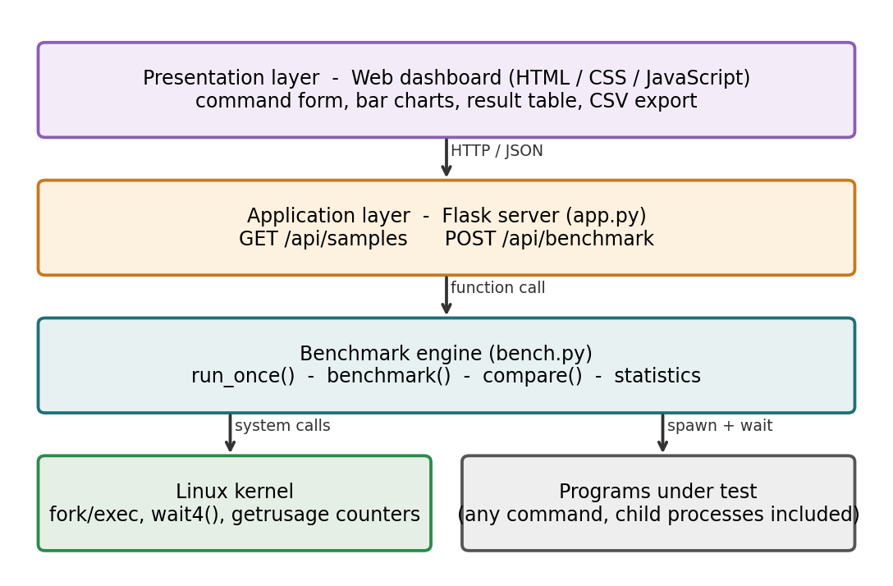
Figure 5.1: Overall system architecture

5.2 System Workflow
- The user enters one to eight commands and the number of runs in the dashboard.
- The browser sends them to POST /api/benchmark as JSON.
- The server checks the input and calls compare() in bench.py.
- For every command the engine runs it N times and records the resource usage of each run.
- The engine computes the statistics and a relative score for each program.
- The server returns the result as JSON and the dashboard draws charts and a table.

5.3 Flowchart / Data Flow
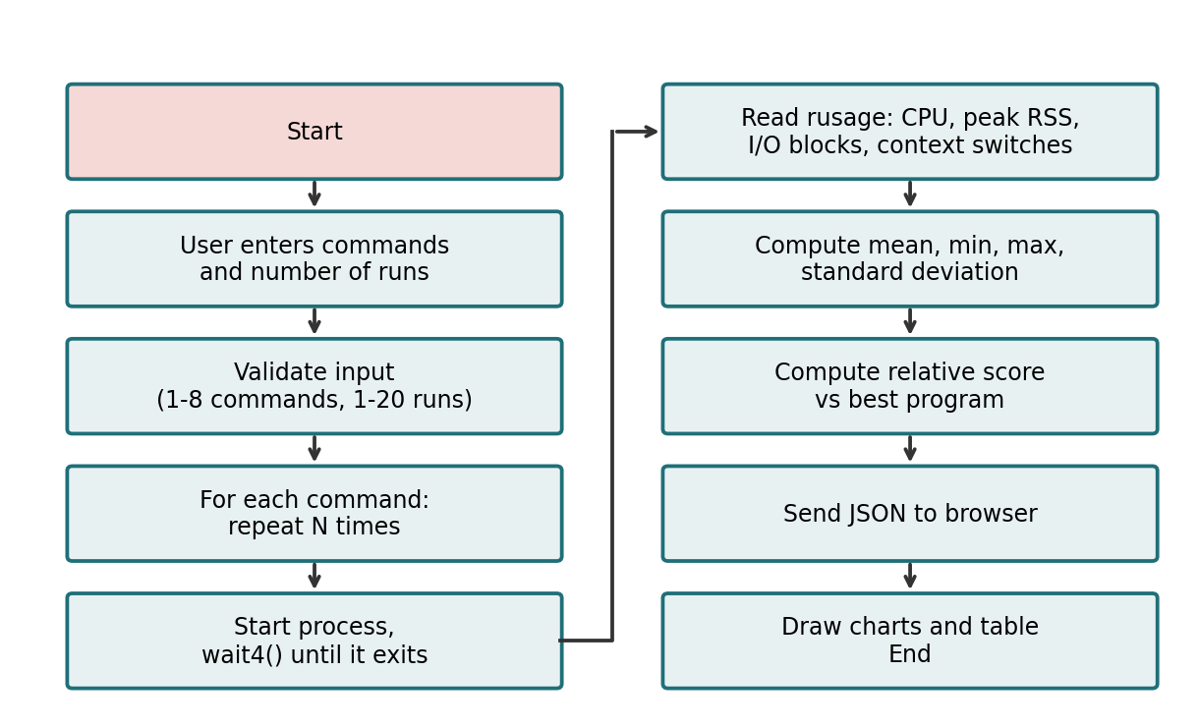
Figure 5.2: Flowchart of a benchmark request

5.4 Module Description
Module | File | Responsibility
Measurement engine | bench.py | Runs commands, reads rusage, computes statistics, provides the command-line interface
Web server | app.py | Serves the dashboard, validates input, exposes the JSON API
Dashboard | static/index.html, style.css, app.js | Input form, bar charts, result table, CSV export
Sample workloads | samples/cpu_work.py, mem_work.py, io_work.py | Programs with a known CPU, memory or I/O profile for demonstration

Table 5.1: Modules of the system

5.5 Input and Output Design
Input: a list of commands (1 to 8) and the number of runs per command (1 to 20). Example request body:
{ "commands": ["python3 samples/cpu_work.py", "sleep 1"], "runs": 3 }

Output: for every command, the mean, minimum, maximum and standard deviation of wall time, CPU time, user time, system time, peak memory in MB, disk I/O in MB, voluntary and involuntary context switches and page faults, plus a relative score against the best program. Commands that cannot start are reported with an error message instead of failing the whole request.

CHAPTER - 6 IMPLEMENTATION

6.1 Module-wise Implementation
The engine (bench.py) has three layers of functions. run_once() performs a single measured run. benchmark() repeats it and calculates statistics. compare() applies benchmark() to every command, handles errors and adds the relative scores. The Flask module only translates between HTTP and these functions, and the dashboard only displays the JSON it receives.

6.2 Algorithm / Pseudocode
function COMPARE(commands, runs):
for each command in commands:
samples = []
repeat runs times:
start timer
child = START(command)
(status, usage) = WAIT4(child)
samples.add(wall time, usage.cpu, usage.rss, usage.io, ...)
result[command] = mean, min, max, stdev of every metric
best = lowest mean of each metric over all commands
for each result: relative = mean / best
return result

6.3 Core Python Implementation
Single measured run (bench.py):
def run_once(cmd, timeout=120):
"""Run one command, return resource usage measured by the kernel."""
args = shlex.split(cmd)
start = time.perf_counter()
p = subprocess.Popen(args, stdout=subprocess.DEVNULL, stderr=subprocess.DEVNULL)
try:
_, status, ru = _wait(p, timeout)
except TimeoutError:
p.kill(); os.wait4(p.pid, 0)
raise
wall = time.perf_counter() - start
return {
"wall_s": wall,
"user_s": ru.ru_utime,
"sys_s": ru.ru_stime,
"cpu_s": ru.ru_utime + ru.ru_stime,
"max_rss_mb": ru.ru_maxrss / 1024, # KB on Linux
"io_read_blocks": ru.ru_inblock, # 512-byte blocks
"io_write_blocks": ru.ru_oublock,
"io_mb": (ru.ru_inblock + ru.ru_oublock) * 512 / 1048576,
"ctx_voluntary": ru.ru_nvcsw,
"ctx_involuntary": ru.ru_nivcsw,
"minor_faults": ru.ru_minflt,
"major_faults": ru.ru_majflt,
"exit_code": os.waitstatus_to_exitcode(status),
}

Repeated runs and statistics (bench.py):
def benchmark(cmd, runs=5, timeout=120):
samples = [run_once(cmd, timeout) for _ in range(runs)]
out = {"command": cmd, "runs": runs, "exit_codes": [s["exit_code"] for s in samples]}
for m in METRICS:
vals = [s[m] for s in samples]
out[m] = {"mean": statistics.mean(vals), "min": min(vals), "max": max(vals),
"stdev": statistics.stdev(vals) if len(vals) > 1 else 0.0}
return out

6.4 Linux System Calls / APIs Used
Call / API | Used for
fork + exec (via subprocess.Popen) | Create the child process and load the program under test
wait4(pid, options) | Wait for the child and receive its resource usage (rusage) from the kernel
rusage fields: ru_utime, ru_stime | User and system CPU time
ru_maxrss | Peak resident memory (kilobytes on Linux)
ru_inblock, ru_oublock | Blocks read from and written to storage (512 bytes each)
ru_nvcsw, ru_nivcsw | Voluntary and involuntary context switches
ru_minflt, ru_majflt | Minor and major page faults
kill (Popen.kill) | Stop a program that exceeds the time limit

Table 6.1: System calls and resource-usage fields

6.5 Process / Thread Implementation
Every measured run is a separate child process, started without a shell (the command is split with shlex), and its output is discarded so that terminal printing does not affect the timing. The parent polls wait4 with the non-blocking WNOHANG option every 5 ms. This allows a timeout (120 seconds by default) after which the child is killed and the error is reported. No threads are used for the measurement.

6.6 IPC / Synchronization Implementation
Between the browser and the server, communication uses HTTP with JSON bodies. Between the engine and a tested program, the only channel is the process itself: the exit status and the resource-usage record returned by the kernel. Runs are executed serially, one program at a time, so no locks are needed and the programs never compete with each other during a measurement.

6.7 Memory Management Implementation
Memory use is taken from ru_maxrss, the high-water mark of the resident set, so a short spike is not missed the way it can be with periodic sampling. Because the value is reported in kilobytes on Linux, it is divided by 1024 to give megabytes. The engine keeps only small summary numbers for each run, so its own memory use stays low. Samples are discarded after the statistics are computed.

6.8 Optional User Interface Implementation
The dashboard is a single page. The top panel lets the user add or remove program rows, choose the number of runs and press "Run benchmark". Example buttons fill in the sample workloads. When the server replies, four bar charts (wall time, CPU time, peak memory, disk I/O) are drawn with the best program highlighted in green, followed by a detail table and a "Download CSV" button. The page supports light and dark mode and adapts to narrow screens.

CHAPTER - 7 EXECUTION AND DEMONSTRATION

7.1 Installation and Setup in Ubuntu
No compilation is required. Extract the project, install Flask and start the server:
unzip linux-bench.zip
cd linux-bench
pip install -r requirements.txt

7.2 Execution Commands
Web dashboard:
python3 app.py
# then open http://127.0.0.1:5000 in a browser

Command line:
python3 bench.py "python3 samples/cpu_work.py" "sleep 1" -n 5
python3 bench.py "ls -R /usr" --json

7.3 Sample Inputs and Outputs
Input: the four example programs, three runs each (Ubuntu, Linux kernel 6.x, Python 3.12):
python3 bench.py "python3 samples/cpu_work.py" "python3 samples/mem_work.py" \
"python3 samples/io_work.py" "sleep 1" -n 3

Output:
command wall(s) cpu(s) rss(MB) io(MB)
python3 samples/cpu_work.py 1.039 1.007 13.3 0.00
python3 samples/mem_work.py 0.122 0.114 159.5 0.00
python3 samples/io_work.py 0.248 0.087 13.4 100.02
sleep 1 1.005 0.002 13.3 0.01

7.4 Screenshots of Execution
Figure 7.1 shows the command-line output above. The dashboard shows the same measurements as four bar charts and a detail table.
[Insert screenshot of the dashboard here: Run benchmark page with results]
Figure 7.1: Dashboard result view

7.5 Demonstration of OS Concepts
Program | Observation | OS concept shown
cpu_work.py | CPU time 1.007 s of 1.039 s wall time | CPU-bound process: it is always runnable, so wall time is almost equal to CPU time
mem_work.py | Peak memory 159.5 MB against about 13 MB for the others | Virtual memory: pages touched by the program become resident and are counted in the peak RSS
io_work.py | 100.02 MB of disk I/O; wall time 0.248 s but CPU only 0.087 s | Block I/O and blocking: the process waits for the disk (fsync), so wall time is much larger than CPU time
sleep 1 | Wall 1.005 s, CPU 0.002 s | Voluntary context switch: the process gives up the CPU while it waits for a timer

Table 7.1: Measured results explained by OS concepts

CHAPTER - 8 CONCLUSION

8.1 Summary of the Project
The project delivers a Linux performance benchmarking utility with a command-line interface and a web dashboard. It starts programs as child processes, reads CPU, memory and I/O usage from the kernel through wait4, repeats the runs, summarizes them statistically and displays a clear side-by-side comparison.

8.2 Objectives Achieved
- CPU, memory and I/O usage were measured directly from kernel accounting.
- Several programs were compared under the same conditions using repeated serial runs.
- Mean, minimum, maximum and standard deviation were reported for every metric.
- Results were presented in a dashboard, in the terminal and as CSV.
- The sample programs demonstrated process, scheduling, memory and I/O behaviour.

8.3 Results Achieved
The sample workloads produced clearly different profiles, as expected: the prime-number program was limited by the CPU (1.007 s of CPU time), the array program used about 159.5 MB of peak memory, the file program transferred about 100 MB to disk and spent most of its time waiting, and the sleep program used almost no CPU. These results match the behaviour that operating system theory predicts.

8.4 Skills and Learning Outcomes
- Understanding of process creation, wait and resource accounting in Linux.
- Practical knowledge of user and system time, context switches, page faults and block I/O.
- Designing a REST-style API with Flask and a responsive front end.
- Benchmarking method: repetition, statistics and fair comparison.
- Limitations and future work: the tool does not profile inside a program, measures only the process itself (not whole-system load), and cached files can hide disk I/O. Possible extensions are stored run history, live graphs during execution, a PDF report and container (cgroup) based limits.

CHAPTER - 9 REFERENCES

9.1 Books
- A. Silberschatz, P. B. Galvin and G. Gagne, Operating System Concepts, Wiley.
- M. Kerrisk, The Linux Programming Interface, No Starch Press, 2010.
- R. Love, Linux Kernel Development, Addison-Wesley.
- A. S. Tanenbaum and H. Bos, Modern Operating Systems, Pearson.

9.2 Research Papers
- T. Mytkowicz, A. Diwan, M. Hauswirth and P. F. Sweeney, "Producing wrong data without doing anything obviously wrong!", ASPLOS, 2009.
- A. Georges, D. Buytaert and L. Eeckhout, "Statistically rigorous Java performance evaluation", OOPSLA, 2007.
- M. Raasveldt, P. Holanda, T. Gubner and H. Muhleisen, "Fair benchmarking considered difficult: Common pitfalls in database performance testing", DBTest, 2018.

9.3 Linux / GNU Documentation
- Linux manual pages: wait4(2), getrusage(2), fork(2), execve(2), proc(5), https://man7.org/linux/man-pages/
- GNU time and GNU coreutils documentation, https://www.gnu.org/software/

9.4 Online Resources
- Python documentation: os, subprocess, shlex and statistics modules, https://docs.python.org/3/
- Flask documentation, https://flask.palletsprojects.com/
- MDN Web Docs: Fetch API, https://developer.mozilla.org/

