SKILL 3 AND SKILL 4
COMPLETED PROGRAMS & EXECUTION(2520030526)
C Programming Practical Submission

1. Skill 3 – Command History
This program demonstrates command input, storing command history, navigating previous and next commands, clearing history, and releasing allocated memory.

Source Code – skill3_history.c
#include <stdio.h>
#include <stdlib.h>
#include <string.h>
#define MAX_HISTORY 10
#define MAX_INPUT 256
void print_history(char *history[], int count) {
printf("\n--- Command History ---\n");
for (int i = 0; i < count; i++)
printf("%d: %s\n", i + 1, history[i]);
}
int main(void) {
char *history[MAX_HISTORY] = {0};
int count = 0, current = -1;
char input[MAX_INPUT];
printf("Skill 3 - Command History Demo\n");
printf("Commands: history, prev, next, clear, exit\n");
while (1) {
printf("\nshell> ");
if (!fgets(input, sizeof(input), stdin)) break;
input[strcspn(input, "\n")] = '\0';
if (strcmp(input, "exit") == 0) break;
if (strcmp(input, "history") == 0) {
print_history(history, count);
continue;
}
if (strcmp(input, "prev") == 0) {
if (count == 0) printf("No previous command.\n");
else {
if (current == -1) current = count - 1;
else if (current > 0) current--;
printf("Previous command: %s\n", history[current]);
}
continue;
}
if (strcmp(input, "next") == 0) {
if (count == 0 || current == -1) printf("No next command.\n");
else if (current < count - 1) {
current++;
printf("Next command: %s\n", history[current]);
} else {
current = -1;
printf("Next command: <empty>\n");
}
continue;
}
if (strcmp(input, "clear") == 0) {
for (int i = 0; i < count; i++) free(history[i]);
count = 0; current = -1;
printf("History cleared.\n");
continue;
}
if (input[0] != '\0') {
if (count == MAX_HISTORY) {
free(history[0]);
memmove(history, history + 1, (MAX_HISTORY - 1) * sizeof(char *));
count--;
}
history[count++] = strdup(input);
current = -1;
printf("Stored command: %s\n", input);
}
}
for (int i = 0; i < count; i++) free(history[i]);
printf("\nMemory released. Program ended.\n");
return 0;
}

Execution Screenshot
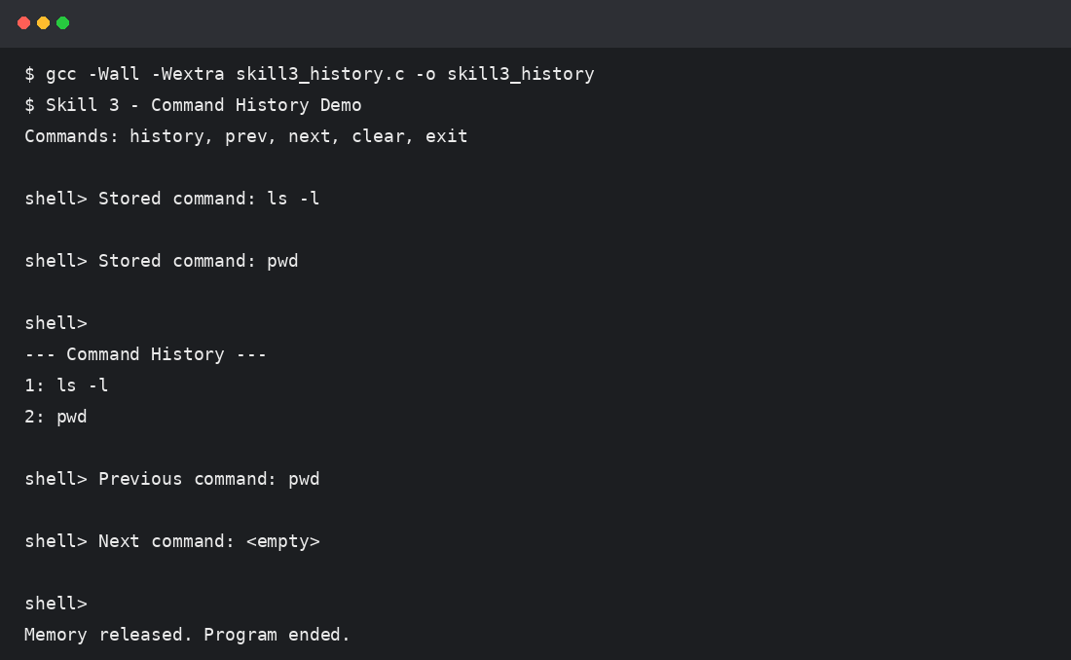

2. Skill 3 – Dynamic Memory and Linked List
This program demonstrates dynamic array allocation and resizing using malloc/realloc, linked-list creation, and correct memory release. It also provides the Valgrind command for verification.

Source Code – skill3_dynamic.c
#include <stdio.h>
#include <stdlib.h>
typedef struct Node {
int data;
struct Node *next;
} Node;
int main(void) {
int capacity = 2, size = 0;
int *arr = malloc(capacity * sizeof(int));
if (!arr) return 1;
printf("Skill 3 - Dynamic Buffer / Linked List Demo\n");
for (int i = 1; i <= 6; i++) {
if (size == capacity) {
capacity *= 2;
int *temp = realloc(arr, capacity * sizeof(int));
if (!temp) {
free(arr);
return 1;
}
arr = temp;
printf("Buffer resized to %d integers.\n", capacity);
}
arr[size++] = i * 10;
}
printf("Dynamic array: ");
for (int i = 0; i < size; i++) printf("%d ", arr[i]);
printf("\n");
Node *head = NULL;
for (int i = 1; i <= 3; i++) {
Node *n = malloc(sizeof(Node));
if (!n) {
free(arr);
return 1;
}
n->data = i * 100;
n->next = head;
head = n;
}
printf("Linked list: ");
for (Node *p = head; p; p = p->next) printf("%d ", p->data);
printf("\n");
while (head) {
Node *temp = head;
head = head->next;
free(temp);
}
free(arr);
printf("All dynamically allocated memory released successfully.\n");
printf("Run: valgrind --leak-check=full ./skill3_dynamic\n");
return 0;
}

Execution Screenshot
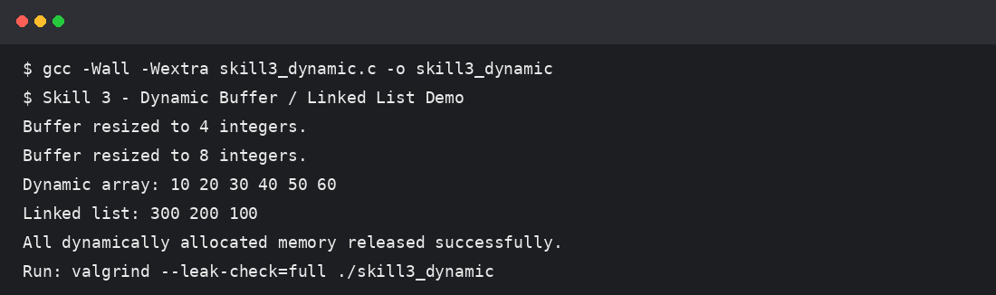

3. Skill 4 – Tokenizer
This program splits command input into tokens, identifies delimiters, handles whitespace, creates token structures, and validates the resulting token stream.

Source Code – skill4_tokenizer.c
#include <stdio.h>
#include <stdlib.h>
#include <string.h>
#include <ctype.h>
typedef struct {
char *text;
int type; /* 0=WORD, 1=DELIMITER */
} Token;
int main(void) {
char input[256];
Token tokens[100];
int count = 0;
printf("Skill 4 - Input Tokenizer\n");
printf("Enter a command: ");
if (!fgets(input, sizeof(input), stdin)) return 1;
input[strcspn(input, "\n")] = '\0';
char *p = input;
while (*p && count < 100) {
while (isspace((unsigned char)*p)) p++;
if (!*p) break;
if (strchr("|&;()", *p)) {
tokens[count].text = malloc(2);
tokens[count].text[0] = *p;
tokens[count].text[1] = '\0';
tokens[count].type = 1;
count++;
p++;
} else {
char *start = p;
while (*p && !isspace((unsigned char)*p) && !strchr("|&;()", *p)) p++;
size_t len = (size_t)(p - start);
tokens[count].text = malloc(len + 1);
memcpy(tokens[count].text, start, len);
tokens[count].text[len] = '\0';
tokens[count].type = 0;
count++;
}
}
printf("\nTokens:\n");
for (int i = 0; i < count; i++)
printf("%d. %-10s %s\n", i + 1, tokens[i].type ? "DELIMITER" : "WORD", tokens[i].text);
printf("\nToken stream validated: %d tokens found.\n", count);
for (int i = 0; i < count; i++) free(tokens[i].text);
return 0;
}

Execution Screenshot
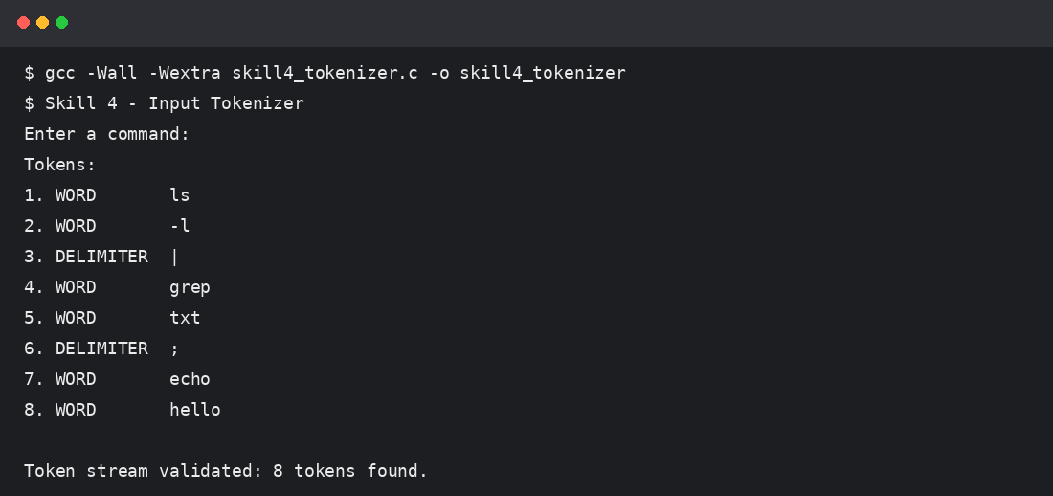

4. Skill 4 – Parser
This program validates command syntax, detects errors, handles empty commands, and produces a simple execution structure/parse-tree representation.

Source Code – skill4_parser.c
#include <stdio.h>
#include <string.h>
#include <ctype.h>
int valid_command(const char *s) {
int paren = 0, have_word = 0, last_delim = 0;
for (int i = 0; s[i]; i++) {
char c = s[i];
if (isspace((unsigned char)c)) continue;
if (c == '(') { paren++; last_delim = 0; }
else if (c == ')') {
if (paren == 0) return 0;
paren--; last_delim = 0;
} else if (strchr("|&;", c)) {
if (!have_word || last_delim) return 0;
last_delim = 1;
} else {
have_word = 1;
last_delim = 0;
}
}
return have_word && paren == 0 && !last_delim;
}
void parse_tree(const char *s, int depth) {
while (*s && isspace((unsigned char)*s)) s++;
if (!*s) return;
printf("%*sROOT\n", depth * 2, "");
printf("%*s└── COMMAND: %s\n", depth * 2, "", s);
}
int main(void) {
char input[256];
printf("Skill 4 - Simple Parser\n");
printf("Enter command: ");
if (!fgets(input, sizeof(input), stdin)) return 1;
input[strcspn(input, "\n")] = '\0';
if (input[0] == '\0') {
printf("Error: empty command.\n");
return 0;
}
if (valid_command(input)) {
printf("Syntax: VALID\n");
printf("Parse tree:\n");
parse_tree(input, 1);
printf("Execution structure generated successfully.\n");
} else {
printf("Syntax: INVALID\n");
printf("Error detected: check operators, parentheses, or command order.\n");
}
return 0;
}

Execution Screenshot
