DIGITAL WRITE REPLICATOR

A PROJECT REPORT

Submitted by

Sunny karira-9913103471

Nitish bansal-9913103470

Anant gupta-9913103476

Utkarsh mishra-9913103465

In partial fulfillment for the award of the degree

Of

BACHELOR OF TECHNOLOGY

IN

Computer science & engineering

JIIT UNIVERSITY:: NOIDA 201301

(may-2015)

TO

Prof kritika mehta

ACKNOWLEDGEMENT

We are using this opportunity to express our gratitude to everyone who supported us throughout the making of this mpc project. We are thankful for their aspiring guidance, invaluably constructive criticism and friendy advice during the project work. We are sincerely grateful to them for sharing their truthful and illuminating views on a number of issues related to the project.
We express our warm thanks to Miss kritika mehta and for their support and guidance in our project
we would also like to thank all the people who provided us with the facilities being required and conductive conditions for our mpc project

Thank you,
Sunny karira(3471)
Nitish bansal(3470)
Anant gupta(3476)

Utkarsh mishra(3465)

ABSTRACT

We are making digital write replicator using arduino uno. Digital write replicator uses a pen to write out the text on a small piece of dry erase board. The design is made of two small 9g servos, with one to lift the pen off the writing surface and the other to control a pair of connected jointed arms for the x and y - axis. The text which is being written on the board comes from the mobile app of digital write replicator which is connected to arduino through bluetooth module hc-06. So what we write on the app directly transmitted to the arduino and the pen immitates the text on the erase board

TABLE OF CONTENT

ACKNOWLEDGEMENT (ii)

ABSTRACT (iii)

LIST OF CONTENT (iv)

LIST OF FIGURES

CODE

FLOW CHART

LIST OF REFERENCES

LIST OF COMPONENTS

- Arduino uno

- Bluetooth module (HC-06)

- Bread board

4. 2 servos motors

- Pen

- Erase board

- UART cable

- Usb cable

- Nuts, bolts

LIST OF FIGURES

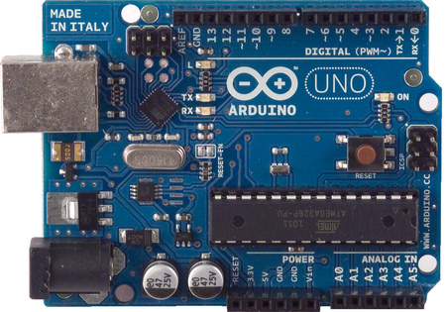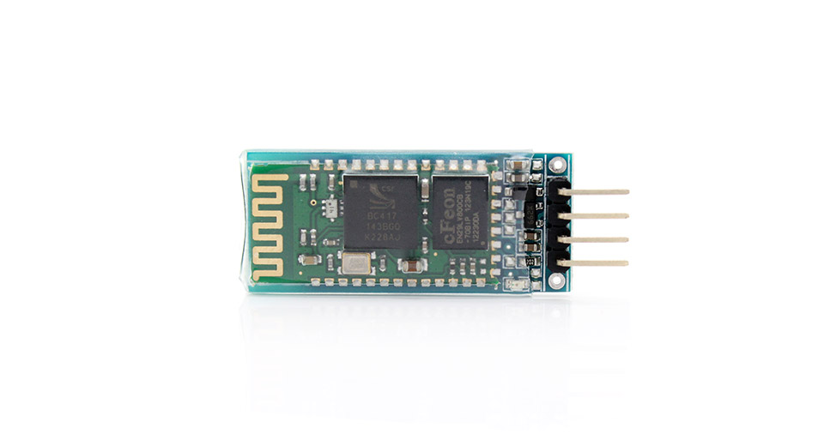
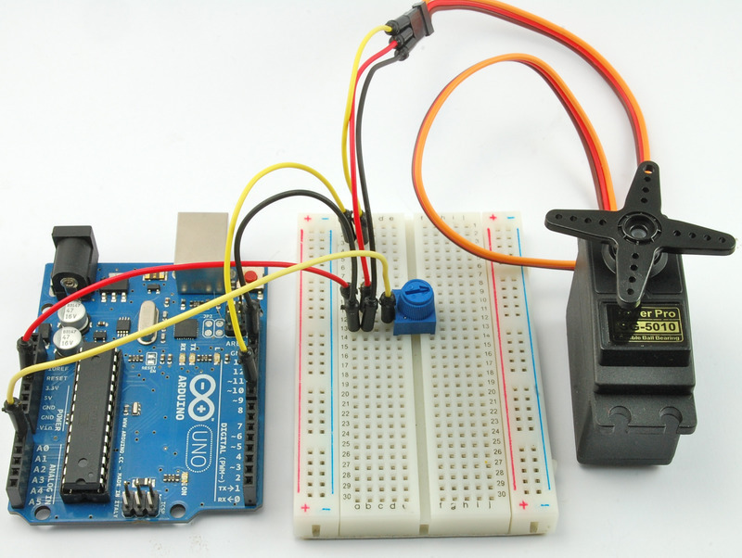

CODE

/* Sweep
by BARRAGAN <http://barraganstudio.com>
This example code is in the public domain.

modified 8 Nov 2013
by Scott Fitzgerald
http://arduino.cc/en/Tutorial/Sweep
*/

#include <Servo.h> //to be included for servomotor
#include<SoftwareSerial.h> //to be included to send or recieve data
Servo left; //object for left motor

int incoming=0; //to save incoming co-ordinate
int x=0; //to save x coordinate
int y=0; //to save y co-ordinate

Servo right; //right motor object
SoftwareSerial recieve(4,5); //RX,TX //to send or recieve data from bluetooth and app 4 th pin of arduino as RX , and 5th pin TX

int uppos;
int pos = 0; // variable to store the servo position
int leftturn=0;
int i=0; //incrementor
Servo up;
void setup()
{
left.attach(8); // left motor configure
right.attach(9); // right motor configure
up.attach(7); //hold up motor configure
recieve.begin(9600); // begin recieving from bluetooth
Serial.begin(9600); // begin recieving from serial monitor

}

void loop()
{
if(Serial.available()>0){
int switcher=Serial.parseInt(); //serial.parseint() converts data available at serial monitor into integer
if(switcher==1){
int leftservoleftturn=Serial.parseInt();
Serial.write(leftservoleftturn); //for calibration
for(pos=leftservoleftturn;pos>=0;pos-=1){ //recieve input from serial monitor
left.write(pos); //and move left motor by left turn
delay(20);
}

}

if(switcher==2){
int leftservorightturn=Serial.parseInt();
Serial.write(leftservorightturn);
for(pos=0;pos<=leftservorightturn;pos+=1){ //for calibration
left.write(pos); //move left motor by right turn
delay(20);
}
}

if(switcher==3){
int rightservoleftturn=Serial.parseInt(); //for calibration
Serial.write(rightservoleftturn); //move right motor by left turn
for(pos=rightservoleftturn;pos>=0;pos-=1){
right.write(pos);
delay(20);
}

}
if(switcher==4){
int rightservorightturn=Serial.parseInt(); //for calibration
Serial.write(rightservorightturn); //move right motor by right turn
for(pos=0;pos<=rightservorightturn;pos+=1){
right.write(pos);
delay(20);
}

}

}

if(recieve.available()>0){ //if data from app to bluetooth is available

i++; //incement
incoming=recieve.read(); //read data into incoming variable
incoming=map(incoming,0,255,0,60); // map it from 0-255 to 0-60 degrees
if(i==1){ //if i=1 means x-cordinate is coming from app
for(uppos=0;uppos<=30;uppos+=1){ //move up motor by 30 degrees up
up.write(30-uppos);
}
x=incoming; //save the x cordinate
Serial.write(incoming);
for(pos=0;pos<=x;pos+=1){
leftturn=1; //move left and right motor x degrees with delay 30
left.write(pos);
right.write(pos);
delay(30);
}
}
if(i==2){ //if i=2 means y cordinate is coming from app
i=0;
y=incoming; //save y coordinate
Serial.write(incoming);
for(pos=0;pos<=y;pos+=1){
right.write(pos); //move right motor right
left.write(y-pos); //move left motor left to traverse y coordinate on paper
delay(30);
}
//iskey baad wapas band karenge

for(uppos=0;uppos<=180;uppos+=1){
up.write(uppos);
delay(10);
}

for(uppos=180;uppos>=0;uppos-=1){
up.write(uppos);
delay(10);
}

}

}
else{
if(leftturn==1){ //this is the code to bring motors to the position where they started writing on paper
for(pos=0;pos<=y;pos+=1){
right.write(y-pos);
left.write(pos);
delay(30);
}
for(pos=0;pos<=x;pos+=1){
left.write(x-pos);
right.write(x-pos);
delay(30);

}
leftturn=0;
}
}
delay(200);
}

LIST OF REFERENCES

- Arduino.cc

- Instructable.com

- Google.com

- Thingiverse.com

5. wikipedia.org

