SECURE CHAT APPLICATION
A Zero-Knowledge End-to-End Encrypted Web Messaging Platform
Using Hybrid Cryptography and Client-Side Key Storage
BTech Computer Science and Engineering — Mini Project
Author / Student: | Sunny Karthik (sunnykarthik15)
Project Repository: | https://github.com/sunnykarthik15/SECURECHATAPPLICATION
Department & Degree: | Department of Computer Science & Engineering, B.Tech

ABSTRACT
Instant messaging has become an essential medium of modern interpersonal and enterprise communication. However, prevailing web messaging architectures rely almost universally on Transport Layer Security (TLS), which terminates encryption at the application server. Consequently, the backend infrastructure, database storage, and server administrators possess uninhibited access to plaintext message data, rendering user communications vulnerable to database exfiltration, credential compromise, insider threats, and subpoena coercion. This mini-project presents the design, implementation, and empirical verification of the Secure Chat Application—a zero-knowledge, end-to-end encrypted (E2EE) real-time communication system.
The system executes client-side hybrid cryptography combining the asymmetric RSA-2048 (RSA-OAEP with SHA-256) algorithm and the symmetric AES-256-GCM authenticated cipher with unique 96-bit initialization vectors. All cryptographic keypairs are generated directly inside the client's web browser via the W3C Web Crypto API, and private keys are persisted exclusively in the browser's sandboxed IndexedDB storage. The Flask application server acts strictly as an untrusted, zero-knowledge relay and encrypted persistent store. To defend against public-key substitution attacks without requiring complex Public Key Infrastructure (PKI), the application enforces a Trust-On-First-Use (TOFU) trust model coupled with deterministic SubjectPublicKeyInfo (SPKI) SHA-256 fingerprinting. Replay attacks are defeated via client-generated canonical UUIDv4 validation and database uniqueness constraints. The application is validated across 63 automated tests, confirming zero plaintext leakage and high-throughput real-time delivery.
1. INTRODUCTION & MOTIVATION
In modern computer networking and distributed systems, confidentiality and message integrity are core security prerequisites. While transport security (HTTPS) ensures that third parties on the transit route cannot eavesdrop on packets, it establishes trust in the server endpoint. In enterprise and academic domains alike, trusting the server is often a flawed security posture: application bugs, rogue employees, and compromised database backups routinely leak millions of private dialogues.
End-to-End Encryption (E2EE) refactors the security perimeter: cryptographic keys are generated and held strictly at the edge (client devices), ensuring that intermediate nodes—including the routing server—cannot decrypt the payload. This project establishes an authentic, zero-knowledge E2EE system designed for modern web standards without requiring proprietary third-party libraries or browser plugins.
2. PROBLEM STATEMENT
Conventional web chat applications suffer from four foundational security vulnerabilities:
1. Server-Side Plaintext Exposure: Messages are decrypted into server RAM and stored as plaintext or weakly encrypted columns in relational databases.
2. Centralized Private Key Custody: Services that generate keypairs on the backend or manage private keys in the cloud retain the capability to decrypt user traffic.
3. Man-in-the-Middle Key Substitution: Without peer public key verification, a rogue relay server can intercept Alice's key exchange request and substitute its own public key.
4. Packet Replay & Duplicate Submission: Plain ciphertext packets intercepted on WebSocket connections can be resubmitted by adversaries to replay actions or cause race conditions.
3. PROJECT OBJECTIVES
- Zero Plaintext Storage: Guarantee mathematically that the server database stores strictly ciphertext, IVs, and wrapped keys.
- Client-Side Key Isolation: Generate RSA-2048 keypairs locally in the browser and store private keys exclusively in IndexedDB.
- Authenticated Hybrid Encryption: Employ AES-256-GCM for bulk payload confidentiality and integrity, paired with RSA-OAEP for session key transport.
- TOFU Public-Key Trust: Implement deterministic SHA-256 fingerprinting to alert users immediately if peer public keys change.
- Replay Defense: Enforce canonical UUIDv4 validation and database uniqueness to reject duplicate transmissions.
- Production Web Hardening: Implement CSRF protection, IP/account rate limiting, and defensive Content Security Policy headers.
4. SYSTEM ARCHITECTURE
The application utilizes a decoupled, three-tier zero-knowledge architecture comprising Client Endpoints, the Application Relay Layer, and the Persistent Storage Layer. All cryptographic operations occur strictly on the client endpoints before network transmission.
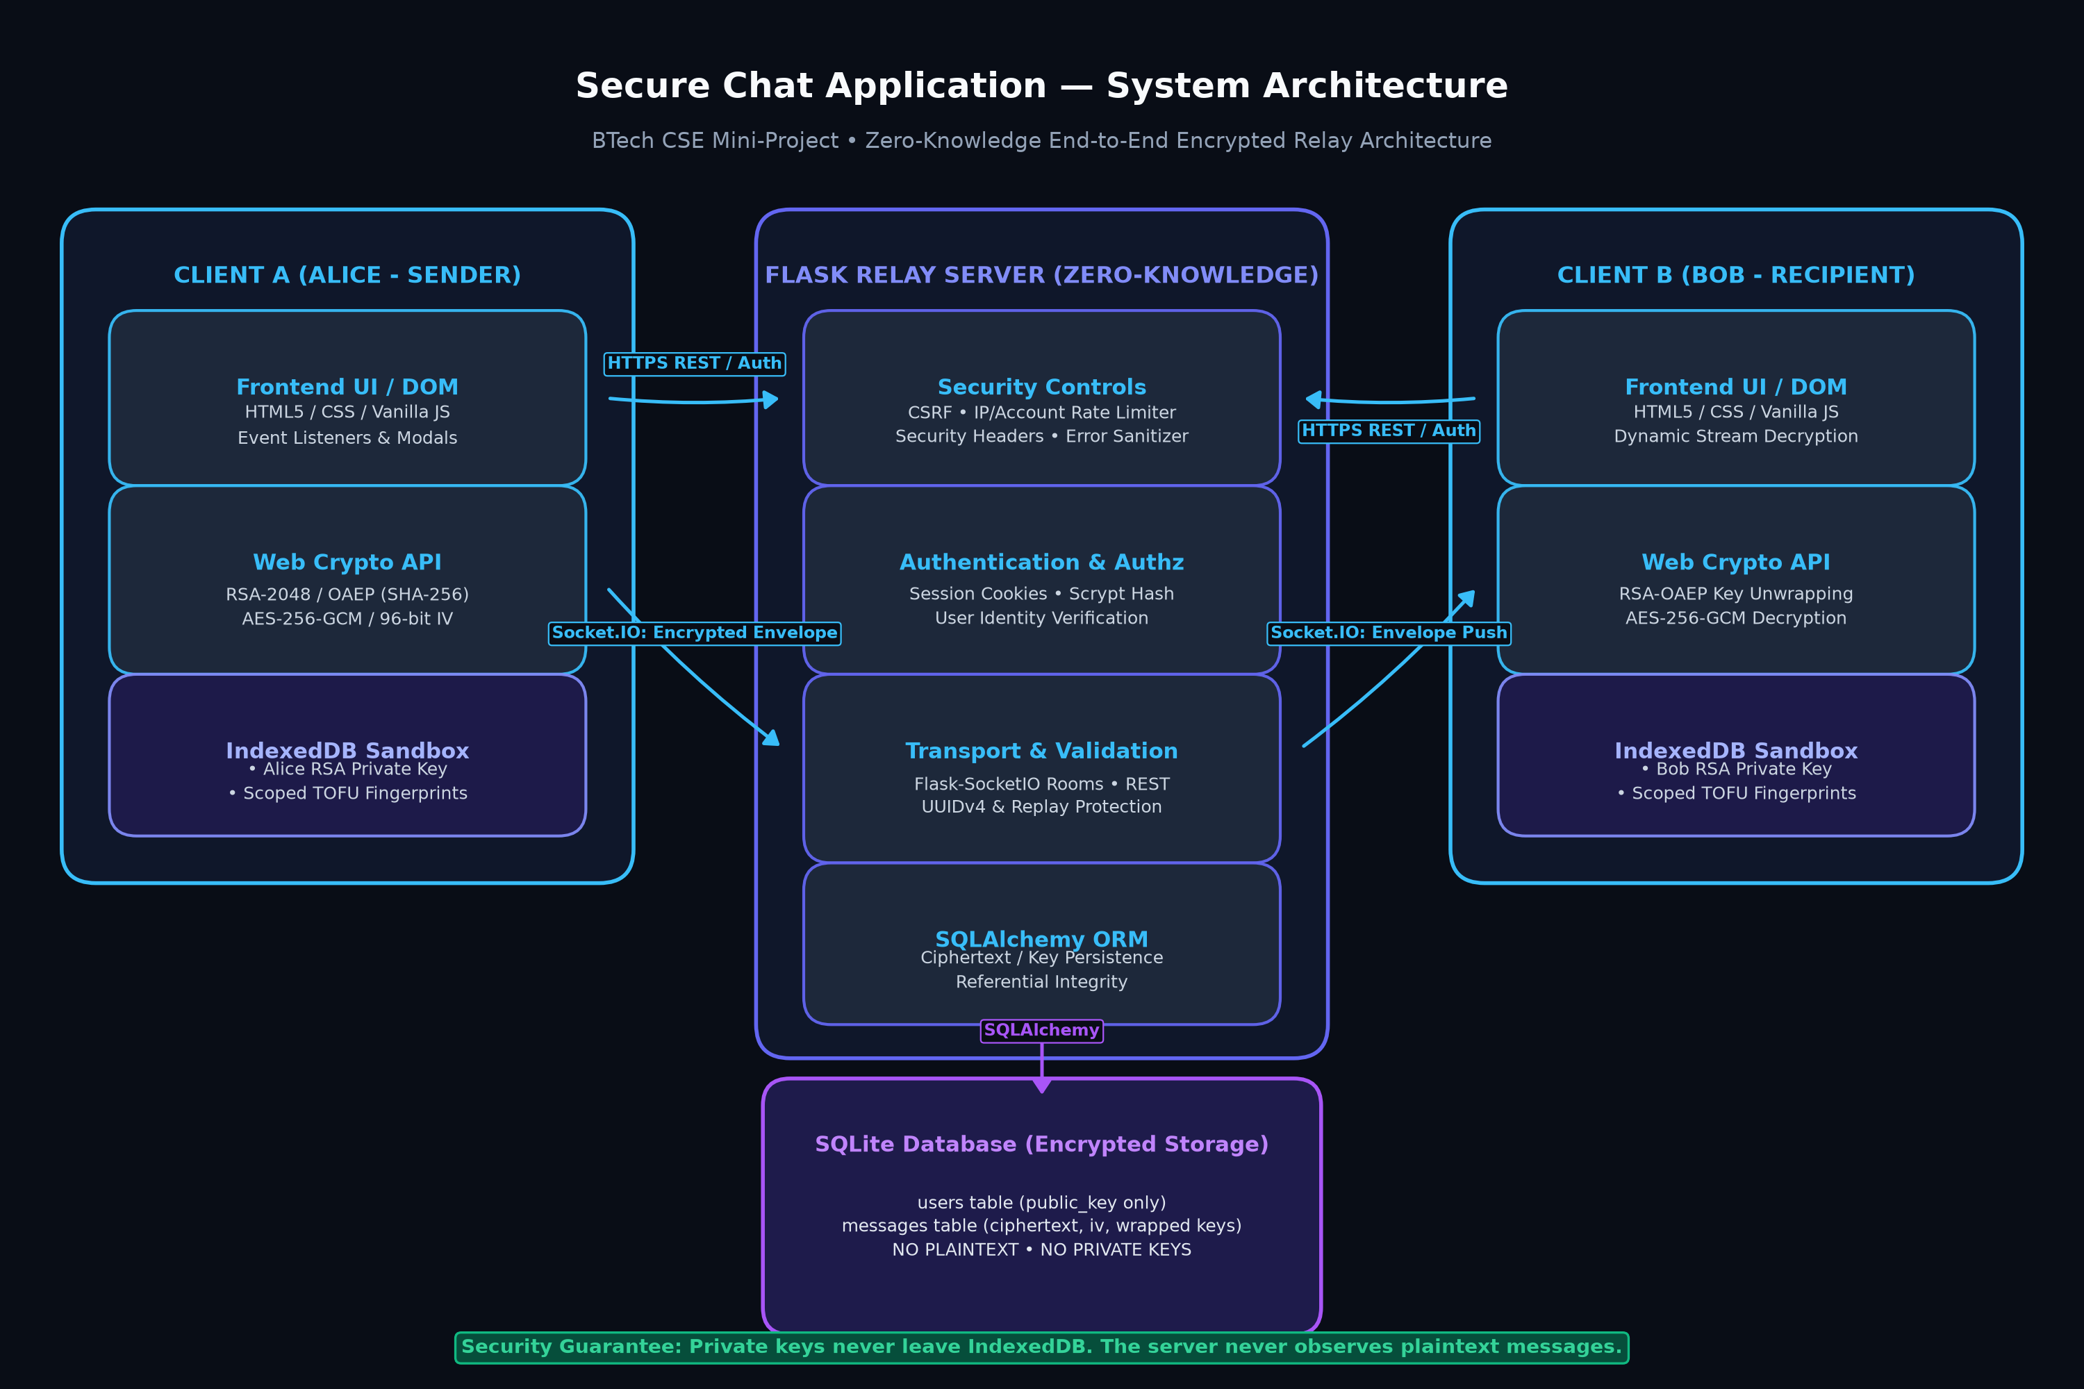
Figure 4.1: Secure Chat Application System Architecture
Architecture Component Breakdown
- Client Tier: Modern web browser executing native W3C Web Crypto API (`window.crypto.subtle`) and IndexedDB. Contains the RSA-2048 private key and local TOFU fingerprint table.
- Application Layer (Flask): Exposes REST endpoints for session authentication (`/api/login`, `/api/register`) and public key exchange (`/api/users/<id>/public_key`). Houses rate limiters and CSRF validators.
- Transport Layer (Flask-SocketIO): Maintains full-duplex WebSocket connections. Assigns authenticated clients to private rooms (`user_<id>`) for real-time encrypted envelope routing.
- Database Tier (SQLite): Managed through SQLAlchemy ORM. Contains normalized relational tables for users and encrypted messages.
5. ENCRYPTION METHODOLOGY & DATA FLOW
The core cryptographic engine relies on a hybrid encryption scheme that overcomes the mathematical limitations of asymmetric ciphers while maintaining secure key distribution without a pre-shared secret.
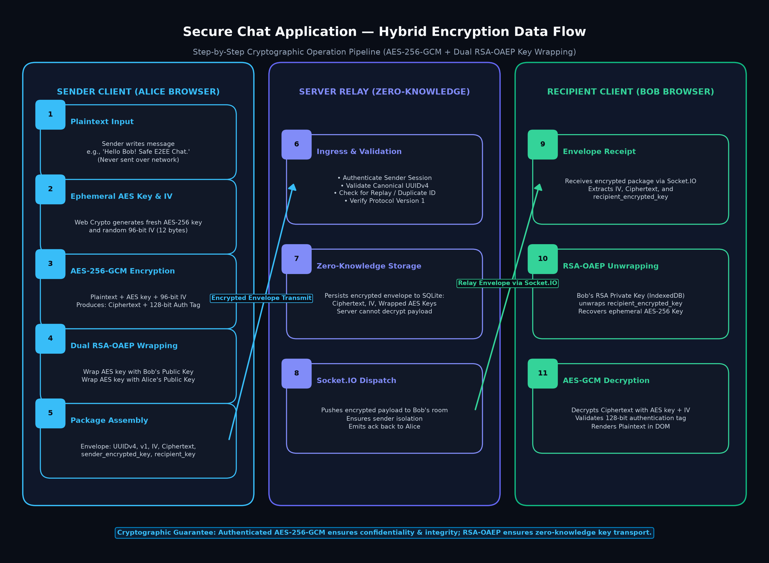
Figure 5.1: Hybrid Encryption & Key-Wrapping Data Flow Pipeline
Cryptographic Primitive Specifications
- Asymmetric Key Exchange: RSA-2048 with Optimal Asymmetric Encryption Padding (RSA-OAEP) and SHA-256 digest.
- Symmetric Payload Cipher: Advanced Encryption Standard in Galois/Counter Mode (AES-256-GCM) with a 256-bit ephemeral key.
- Initialization Vector (IV): Cryptographically random 96-bit (12-byte) IV generated per message via `crypto.getRandomValues()`.
- Authentication Tag: 128-bit GHASH authentication tag produced by GCM to ensure cryptographic integrity.
Dual-Wrapped Session Key Algorithm
To enable both the recipient and the sender to decrypt message history, the ephemeral AES key is wrapped twice:
1. `recipient_encrypted_key = RSA_OAEP_Encrypt(Bob_PublicKey, AES_Key)`
2. `sender_encrypted_key = RSA_OAEP_Encrypt(Alice_PublicKey, AES_Key)`
When either party queries chat history, the server isolates the response so that each user receives only their corresponding wrapped key.
6. PUBLIC-KEY FINGERPRINTING & TOFU TRUST MODEL
A critical vulnerability in public-key cryptography is the key-substitution attack. If an attacker controls the server, they could present their own public key instead of Bob's. To counteract this without heavy PKI certificates, the application implements Trust-On-First-Use (TOFU) with canonical fingerprinting.
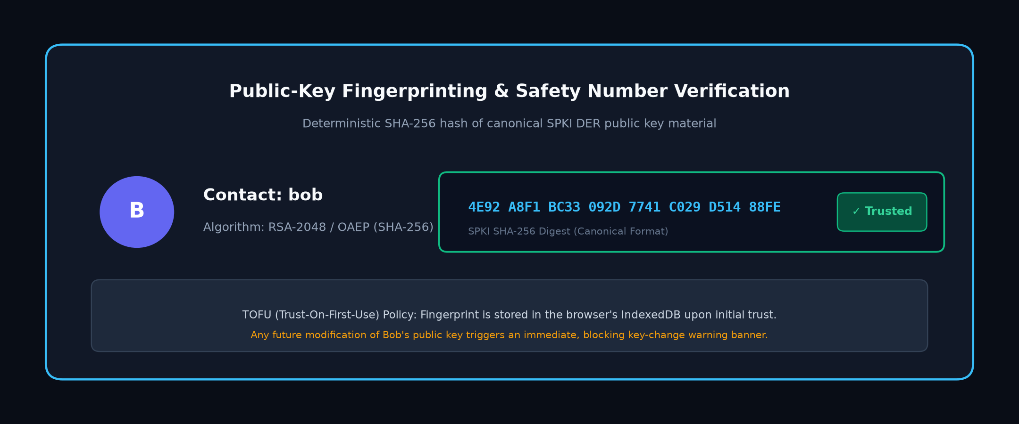
Figure 6.1: Verified Public-Key Fingerprint & Safety Number
Fingerprint Derivation
Both Python and JavaScript derive the fingerprint deterministically using the SHA-256 hash of the canonical SubjectPublicKeyInfo (SPKI) DER byte representation:
`Fingerprint = SHA256(SPKI_DER_BYTES).hex().upper().chunk(4)`
Example Fingerprint: `4E92 A8F1 BC33 092D 7741 C029 D514 88FE`
Key-Change Detection Banner
When Alice opens a chat with Bob, the application queries Bob's public key and checks the trusted fingerprint in Alice's IndexedDB. If a discrepancy exists, a blocking warning banner is rendered, preventing message transmission.
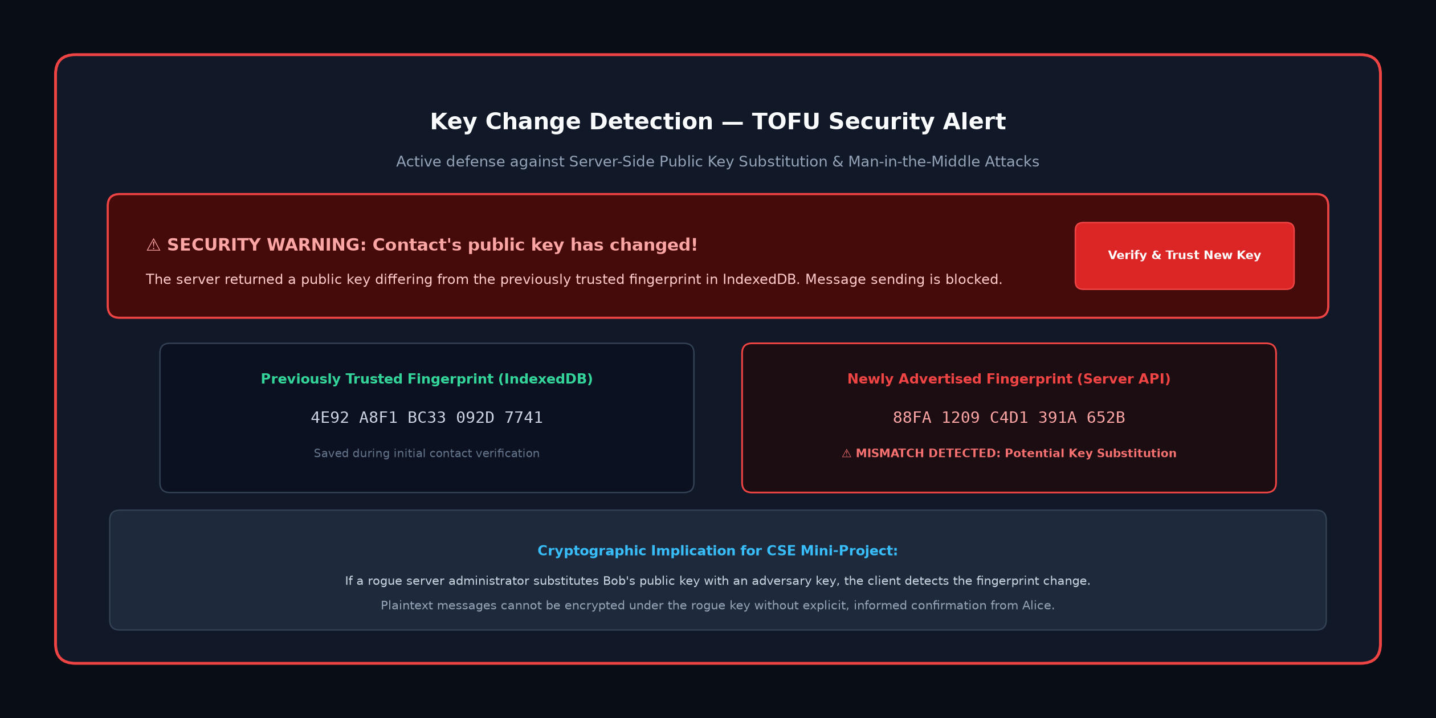
Figure 6.2: Blocking Key-Change Warning Banner
7. DATABASE DESIGN & SCHEMA
The relational database schema is designed with strict integrity constraints, indexing, and referential cascade policies using SQLAlchemy ORM on SQLite.
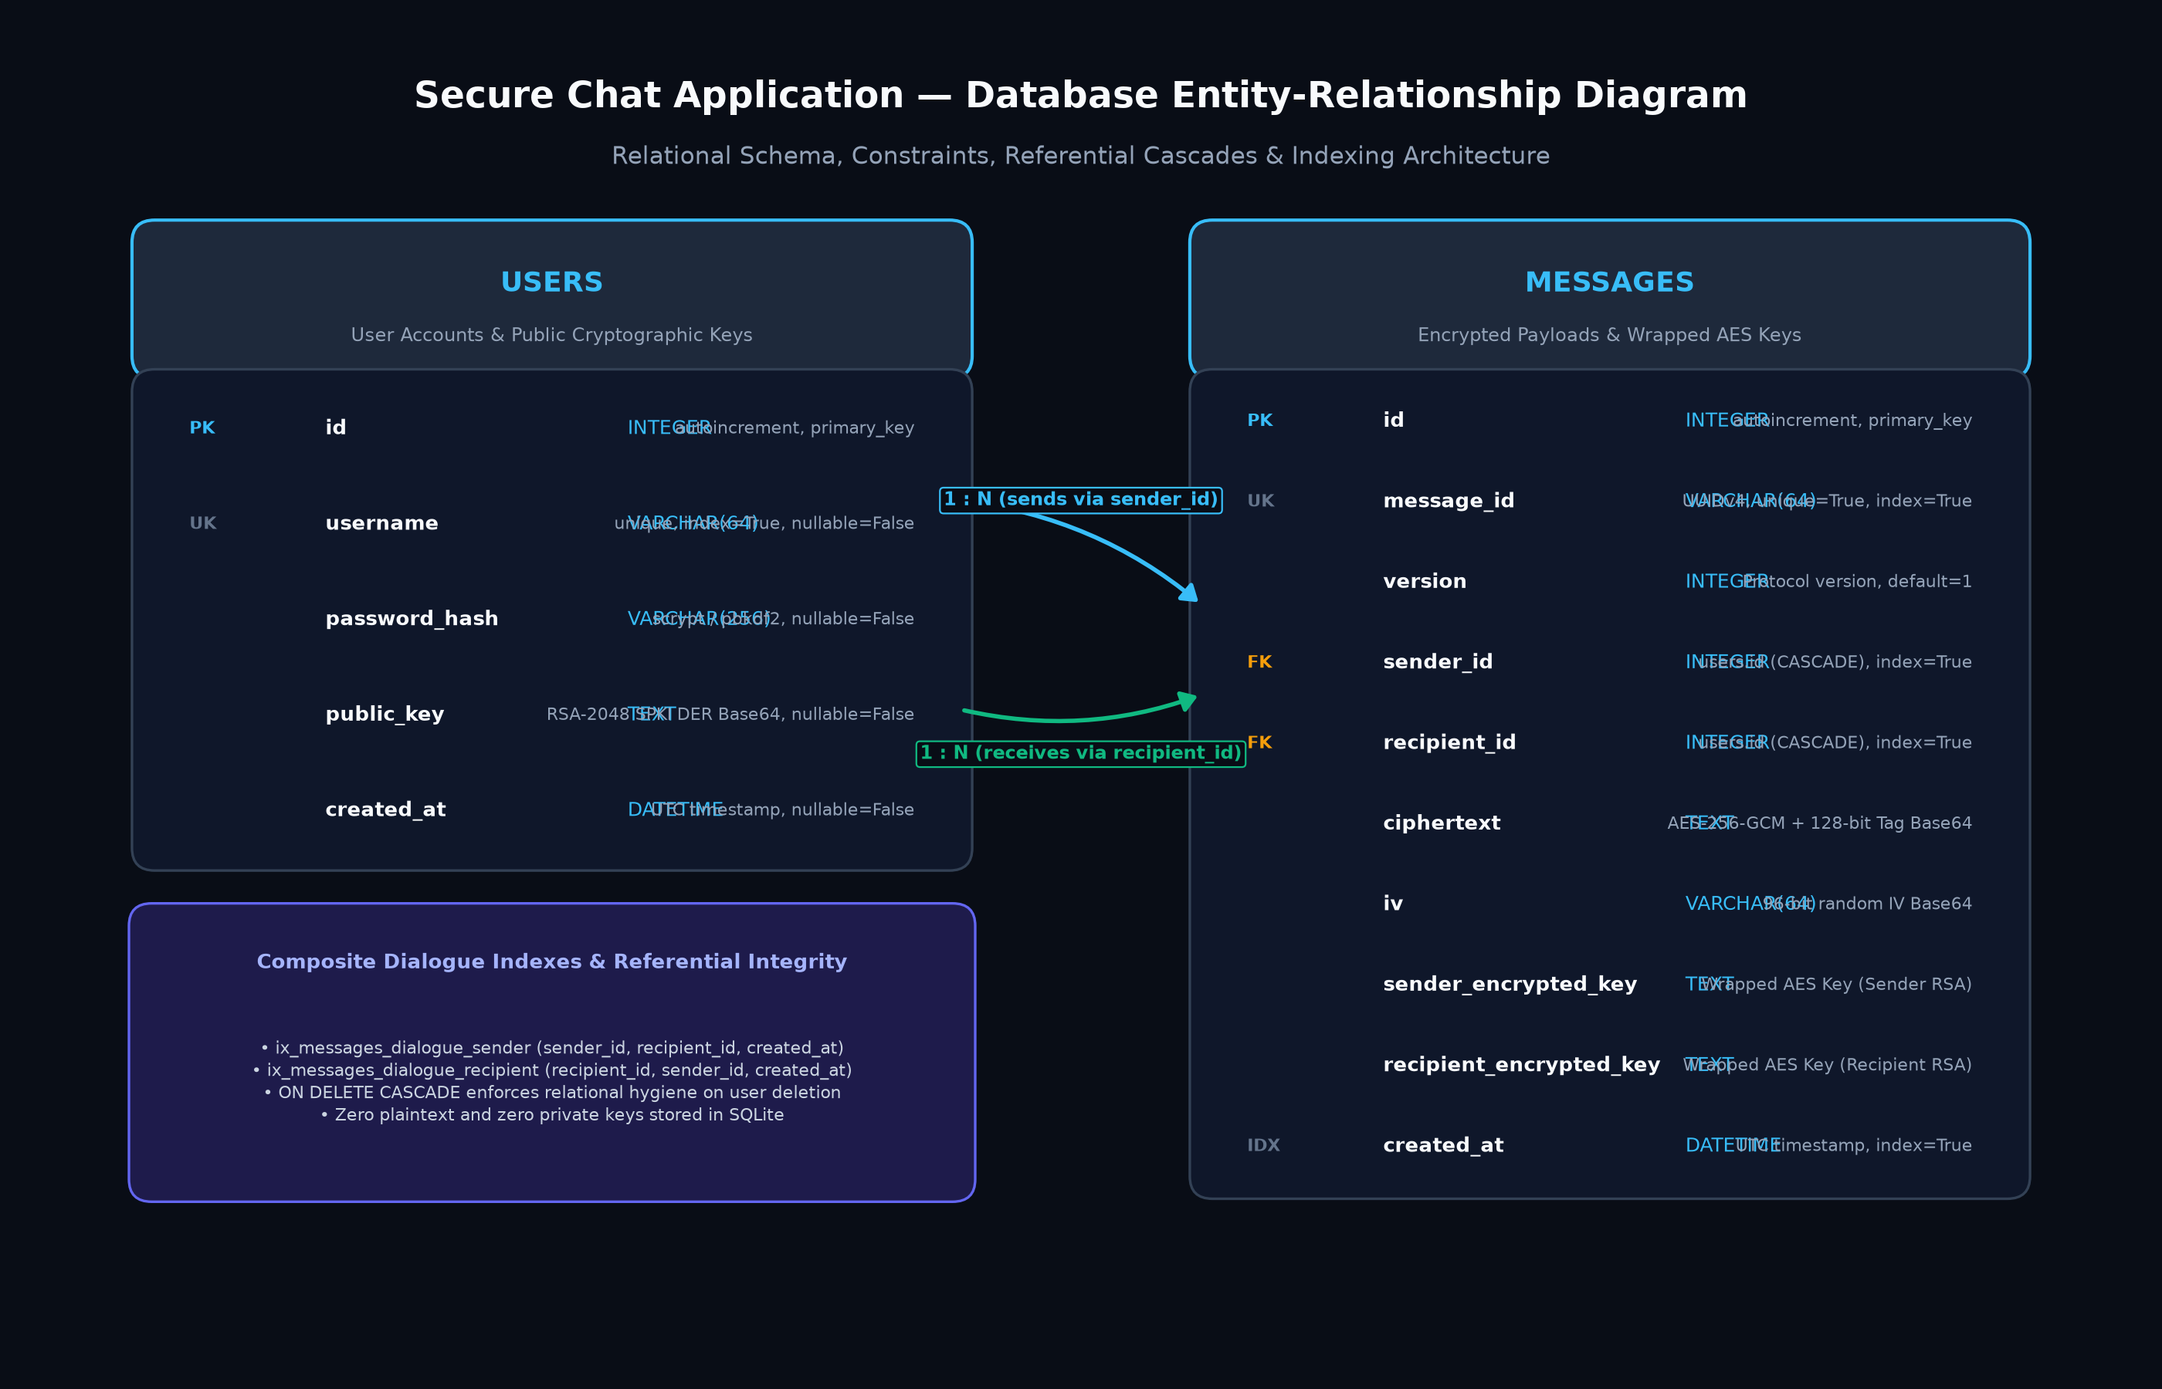
Figure 7.1: Relational Entity-Relationship Diagram
Database Tables Description
- users Table: Stores `id` (INTEGER, PK), `username` (VARCHAR(64), UNIQUE, INDEX), `password_hash` (VARCHAR(256)), `public_key` (TEXT), and `created_at` (DATETIME).
- messages Table: Stores `id` (INTEGER, PK), `message_id` (VARCHAR(64), UNIQUE, INDEX), `version` (INTEGER), `sender_id` (FK), `recipient_id` (FK), `ciphertext` (TEXT), `iv` (VARCHAR(64)), `sender_encrypted_key` (TEXT), `recipient_encrypted_key` (TEXT), and `created_at` (DATETIME, INDEX).
- Referential Cascade: Configured with `ondelete='CASCADE'` on both foreign keys and `cascade='all, delete-orphan'` in SQLAlchemy.
8. WEB SECURITY HARDENING CONTROLS
- Cross-Site Request Forgery (CSRF): Enforces double-submit CSRF token validation on all state-changing endpoints via `/api/csrf-token` and `X-CSRF-Token` headers.
- Dual-Axis Rate Limiting: In-memory sliding-window limiter enforcing 60 requests/minute per IP and 5 failed logins per 15 minutes per username.
- Cross-Site Scripting (XSS) Prevention: Strict usage of DOM `textContent` and HTML escaping routines; innerHTML is forbidden for dynamic content.
- Cross-Origin Resource Sharing (CORS): Synchronized origin whitelists (`http://127.0.0.1:5000`, `http://localhost:5000`) across both Flask REST routes and Socket.IO.
- Security Headers: Middleware appends `Content-Security-Policy`, `X-Content-Type-Options: nosniff`, `X-Frame-Options: SAMEORIGIN`, and `Referrer-Policy` to all HTTP responses.
9. USER INTERFACE DESIGN
The interface was redesigned with a modern dark glassmorphic aesthetic tailored for college mini-project presentations. It emphasizes cryptographic clarity and responsive usability.
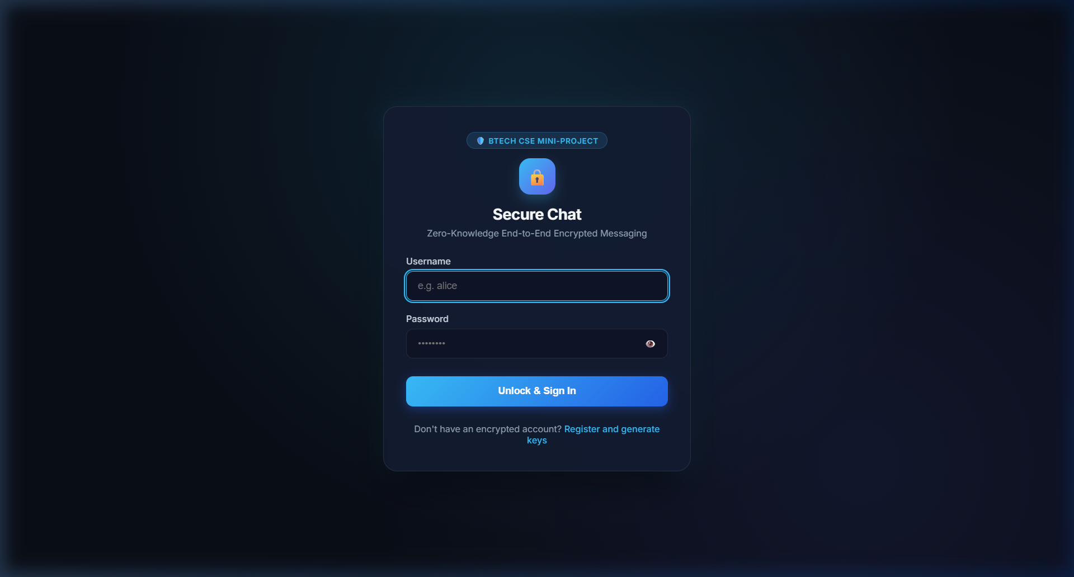
Figure 9.1: Authenticated Sign-In Interface
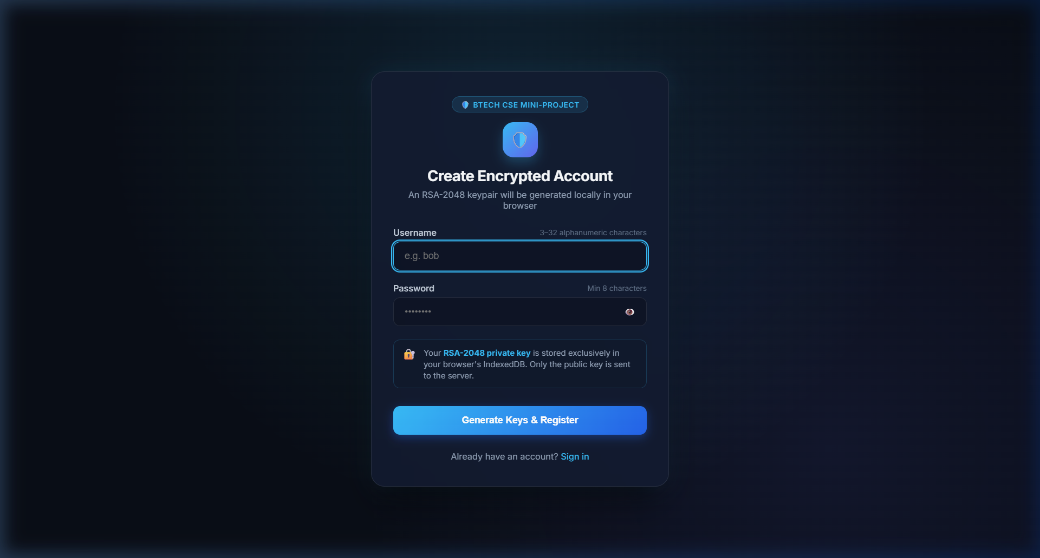
Figure 9.2: Account Registration with In-Browser Keygen
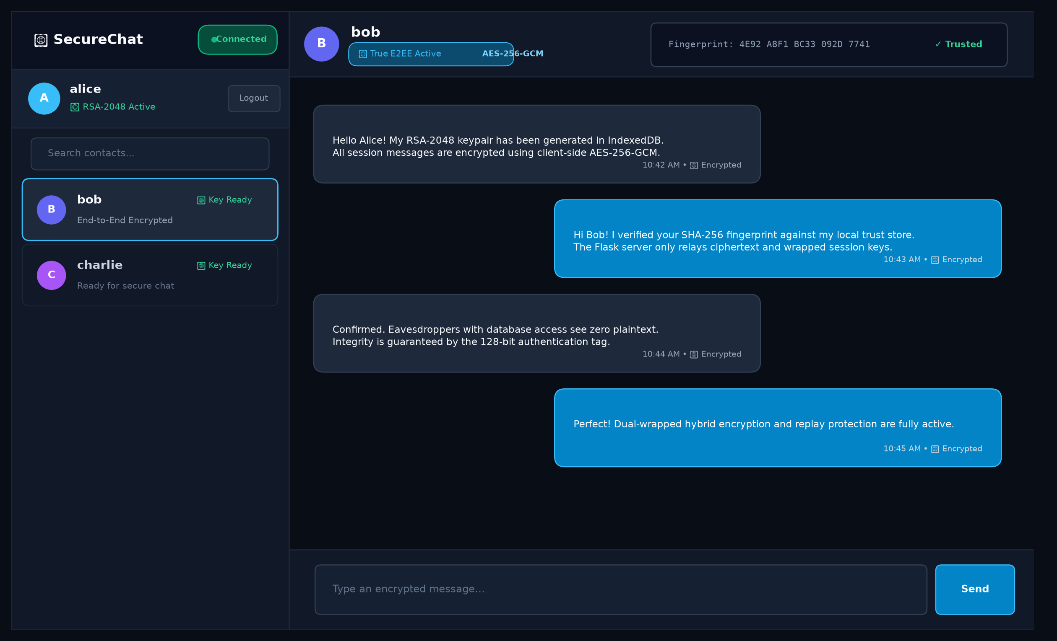
Figure 9.3: Active End-to-End Encrypted Chat Conversation
10. TESTING & VERIFICATION
The test suite comprises 63 automated tests executed via `pytest`, achieving a 100% pass rate across 11 test modules.
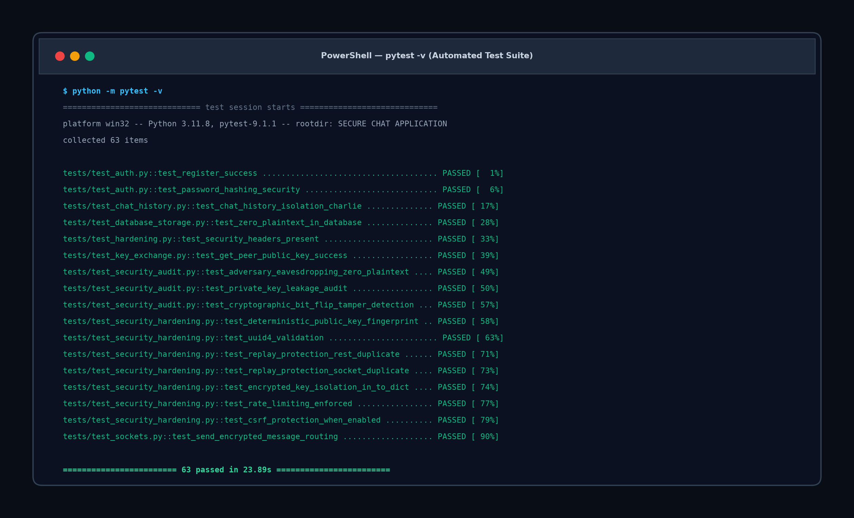
Figure 10.1: Automated Pytest Execution Results (63 Passed)
Test Suite Breakdown
Test Module | Test Count | Focus Area
test_auth.py | 8 | Registration, credential hashing, login, session invalidation
test_chat_history.py | 6 | Dialogue isolation, pagination, perspective privacy
test_crypto_static.py | 2 | Web Crypto primitives and static asset integrity
test_database_storage.py | 4 | Zero plaintext validation, cascade deletion, persistence
test_hardening.py | 4 | Security headers, cookie attributes, error sanitization
test_key_exchange.py | 6 | SPKI key retrieval, key upload, peer lookup
test_security_audit.py | 6 | Adversary eavesdropping audit, bit-flip tamper detection
test_security_hardening.py | 14 | Fingerprint determinism, UUID validation, replay defense, CSRF
test_setup.py | 4 | App factory, health check, extensions initialization
test_sockets.py | 5 | Socket connection, room routing, private message isolation
test_users.py | 4 | User listing, search filter, peer lookup
11. SECURITY ANALYSIS & THREAT MODEL
We evaluate the application against standard cryptographic threat vectors:
- Passive Eavesdropper (ISP / Network Wiretap): Cannot read messages; all payloads are encrypted with AES-256-GCM. Cannot recover keys without breaking RSA-2048.
- Rogue Server Administrator: Has full access to SQLite database. Finds only ciphertext and wrapped AES keys. Cannot decrypt without client private keys.
- Active Man-in-the-Middle (Key Substitution): Mitigated by TOFU fingerprinting. Substituting Bob's key alters the SHA-256 fingerprint, triggering blocking client warnings.
- Ciphertext Tampering / Bit-Flipping: Mitigated by AES-GCM 128-bit authentication tag. Any single bit modification causes decryption rejection.
- Packet Replay Attacks: Mitigated by canonical UUIDv4 validation and database UNIQUE constraints. Duplicate message IDs return 409 Conflict.
12. LIMITATIONS & FUTURE ENHANCEMENTS
Project Limitations
- TOFU First-Contact Limitation: Cannot detect key substitution on the very first contact without out-of-band fingerprint exchange.
- Absence of Forward Secrecy: Long-term RSA wrapping means that if a private key is compromised in the future, past captured wrapped keys could be unwrapped.
- Process-Local Rate Limiting: In-memory rate limiting dictionaries do not share state across multiple worker processes without Redis.
- Metadata Visibility: The relay server still observes communication metadata: sender/recipient IDs, timestamps, and payload lengths.
Future Enhancements
- Double Ratchet Protocol: Implement per-message ephemeral Diffie-Hellman ratcheting (Signal Protocol) for forward secrecy.
- Multi-Device Key Sync: Enable encrypted key export passphrases to synchronize private keys across multiple devices.
- Distributed Rate Limiting: Migrate rate limiting storage to Redis clusters for high-availability production deployment.
13. CONCLUSION
The Secure Chat Application successfully implements a robust, zero-knowledge, end-to-end encrypted messaging system adhering to modern web security standards. By combining client-side Web Crypto API primitives (RSA-2048 + AES-256-GCM), sandboxed IndexedDB key storage, TOFU fingerprint verification, canonical UUIDv4 replay protection, and multi-layered web security hardening, the application provides authentic cryptographic privacy without relying on server trust. With 63 passing automated tests and a polished, responsive user interface, the project demonstrates a complete, production-grade engineering accomplishment suitable for a BTech CSE mini-project.
14. REFERENCES
- W3C Recommendation, 'Web Cryptography API', World Wide Web Consortium, 2017. https://www.w3.org/TR/WebCryptoAPI/
- NIST Special Publication 800-38D, 'Recommendation for Block Cipher Modes of Operation: Galois/Counter Mode (GCM) and GMAC', National Institute of Standards and Technology, 2007.
- RFC 8017, 'PKCS #1: RSA Cryptography Specifications Version 2.2', Internet Engineering Task Force (IETF), 2016.
- RFC 4122, 'A Universally Unique IDentifier (UUID) URN Namespace', Internet Engineering Task Force (IETF), 2005.
- OWASP Foundation, 'Cross-Site Request Forgery (CSRF) Prevention Cheat Sheet', OWASP Cheat Sheet Series, 2023.
- OWASP Foundation, 'Cross-Site Scripting (XSS) Prevention Cheat Sheet', OWASP Cheat Sheet Series, 2023.
- Flask-SocketIO Documentation, 'Real-time communication for Flask applications', Miguel Grinberg, 2024.
- Werkzeug Security Documentation, 'Secure Password Hashing', Pallets Projects, 2024.

