**A Project Report**

**On**

**“ Customer Satisfaction ”**

**Submitted in partial fulfillment of Learning Business Intelligence Tools**



**Department of Data Science**

**Emerging India Analytics**

**Submitted By :- Submitted To :-**

**Sunny Kumar Uttam Sir**

**(**[**kumarsunnydh468@gmail.com**](mailto:kumarsunnydh468@gmail.com)**) Ravi Sir**

**Rohan Sir**

**Certificate**

This is to certify that Project entitled “ Customer Satisfaction ” which is submitted by Sunny Kumar pursuing Data Science cource at Emerging India Analytics in the guidance of our respected Uttam Sir , Ravi Sir and Rohan Sir.

The content of this project has not been submitted to any institution or organization for award of any degree or diploma.

------------------------------------

Uttam Sir

(Project Guide)

Date : 17/04/2025

Place : Patna

**About The Project**

**Objective :-**

This project aims to analyze customer satisfaction data from Kashmir Cafe to identify key

factors influencing customer experiences and develop strategies for improving service

quality. SQL will be used for data processing, while Power BI or Tableau will be used to

visualize the insights effectively.

**Dataset Overview :-**

The dataset contains customer feedback data from Kashmir Cafe, including ratings for delivery experience, food quality, and delivery speed, along with order accuracy details. The goal is to understand the overall satisfaction level and pinpoint areas for improvement, such as food quality, delivery speed, and order accuracy.

Columns Overview:

1. Customer: Unique identifier for each customer.

2. Overall Delivery Experience (Rating): Rating scale (1-5).

3. Food Quality (Rating): Rating scale (1-5).

4. Speed of Delivery (Rating): Rating scale (1-5).

5. Order Accuracy: Yes/No (Whether the order was accurate or not).

**Exploratory Data Analysis (EDA) with SQL :-**

1. SQL Queries :-

○ To Analyze customer distribution by region (if available) and age group.

○ To Identify the most common ratings for delivery experience, food quality, and

delivery speed.

○ To Investigate how order accuracy impacts customer satisfaction.

○ To Explore correlations between various ratings (e.g., food quality vs. delivery

speed, overall satisfaction).

**# Dashboard Using Power BI :-**

Dashboard – 1(Customer Satisfaction Overview)

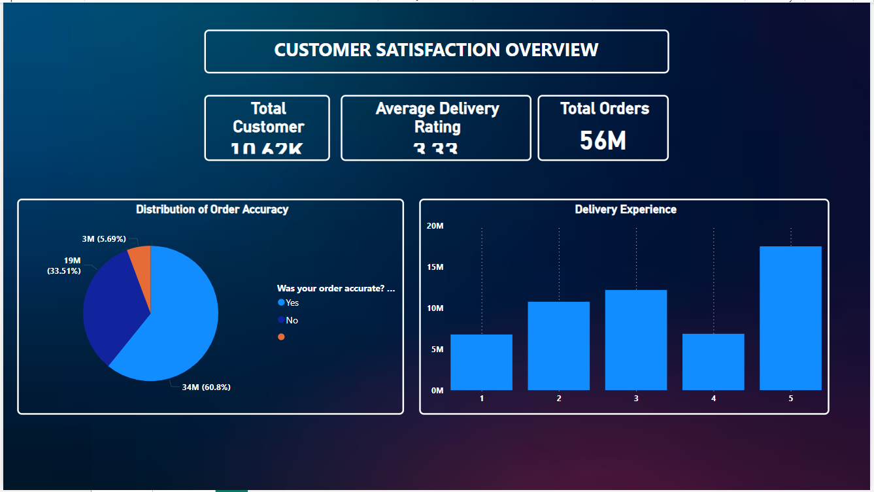

Dashboard – 2 (Rating Analysis Dashboard)

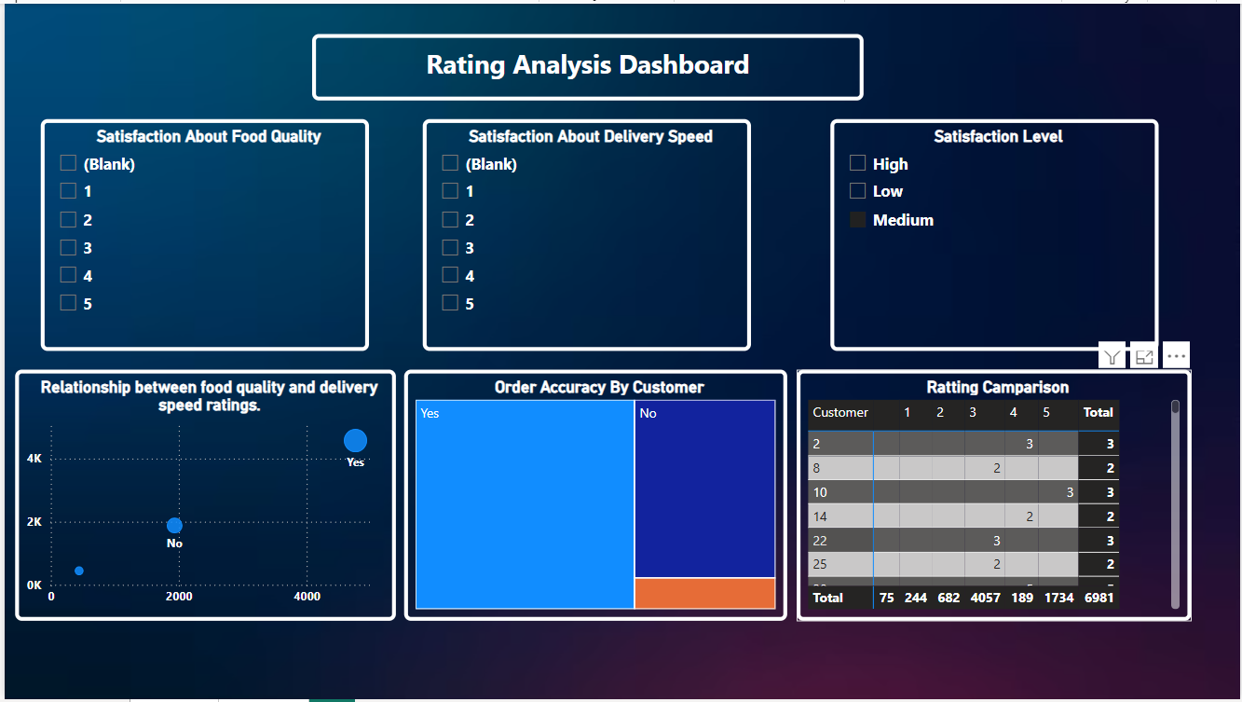

THE END