**A Project Report**

**On**

**“ HR Analytics ”**

**Submitted in partial fulfillment of Learning Business Intelligence Tools**



**Department of Data Science**

**Emerging India Analytics**

**Submitted By :- Submitted To :-**

**Sunny Kumar Uttam Sir**

**(**[**kumarsunnydh468@gmail.com**](mailto:kumarsunnydh468@gmail.com)**) Ravi Sir**

**Rohan Sir**

**Certificate**

This is to certify that Project entitled “ HR Analytics ” which is submitted by Sunny Kumar pursuing Data Science cource at Emerging India Analytics in the guidance of our respected Uttam Sir , Ravi Sir and Rohan Sir.

The content of this project has not been submitted to any institution or organization for award of any degree or diploma.

------------------------------------

Ravi Sir

(Project Guide)

Date : 17/04/2025

Place : Patna

**About The Project**

**Objective :-**

The goal of this project is to analyze employee data and gain insights related to employee

attrition, satisfaction, job roles, and financial metrics using SQL for data processing and

Power BI/Tableau for data visualization. The objective is to provide actionable

recommendations that can help HR departments improve employee retention and overall job

satisfaction.

**Dataset Overview :-**

The dataset contains detailed information about employees, including demographic data, job

satisfaction, salary details, and attrition status. This analysis will help in understanding the

factors that contribute to employee turnover and other critical HR-related insights.

Columns Overview:

● Employee Information:

○ EmpID : Unique identifier for each employee

○ Age : Age of the employee

○ Gender : Male / Female

○ MaritalStatus : Marital status (Single/Married/Divorced)

○ Department : The department the employee works in (Sales, R&D, etc.)

○ JobRole : Employee's job role (e.g., Sales Representative, Research Scientist)

● Job and Performance Details:

○ Attrition: Whether the employee left the company (Yes/No)

○ Job Satisfaction: Employee's job satisfaction (1 to 4)

○ PerformanceRating: Employee's performance rating (1 to 4)

○ JobInvolvement: Level of involvement in the job (1 to 4)

○ Overtime: Whether the employee works overtime (Yes/No)

● Financial Metrics:

○ MonthlyIncome: Monthly income of the employee

○ DailyRate: Daily rate of pay

○ HourlyRate: Hourly rate of pay

○ PercentSalaryHike: Percentage increase in salary

○ StockOptionLevel: Level of stock options

**Exploratory Data Analysis (EDA) with SQL :-**

1. SQL Queries:

○ Attrition Analysis : Analyze the distribution of attrition across different

departments, job roles, and age groups.

“ select Department,Attrition,JobRole,AgeGroup from HR_Analytics offset 1 limit 10 ”

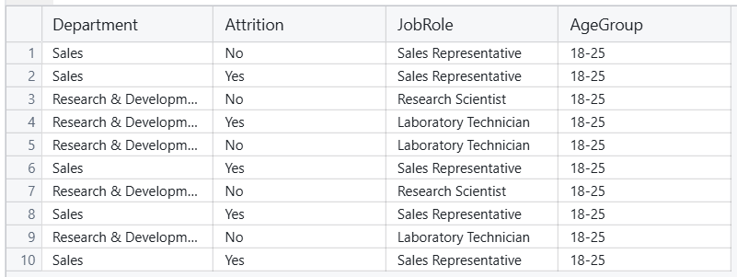

○ Job Satisfaction vs. Attrition : Compare job satisfaction levels for employees

who left vs. those who stayed.

○ Salary Trends : Calculate average salaries across departments, job roles, and

levels.

“ select Department,JobRole,JobLevel,avg(MonthlyRate) as "Average Salary" from HR_Analytics group by Department,JobRole,JobLevel ”

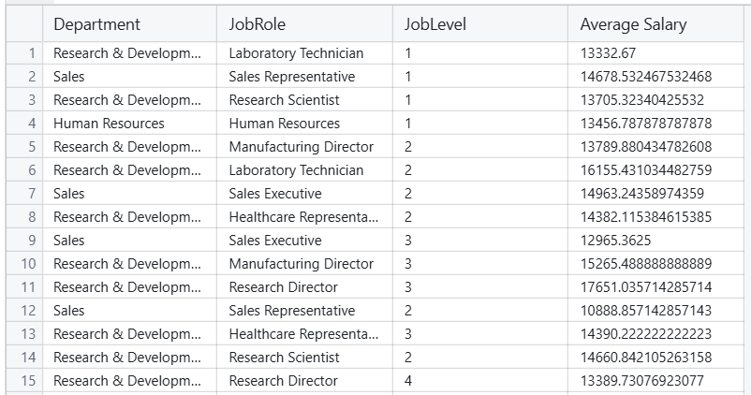

○ Overtime and Job Involvement : Analyze the impact of overtime work and

job involvement on employee satisfaction and attrition.

“ select OverTime,JobInvolvement,JobSatisfaction,Attrition from HR_Analytics ”

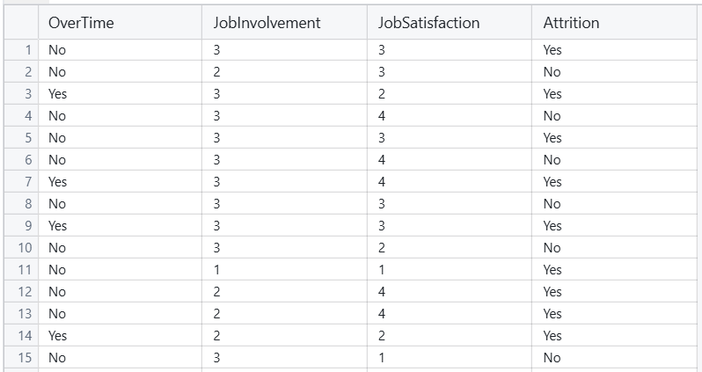

**# Dashboard Using Power BI :-**

Dashboard – 1 (HR Overview Dashboard)

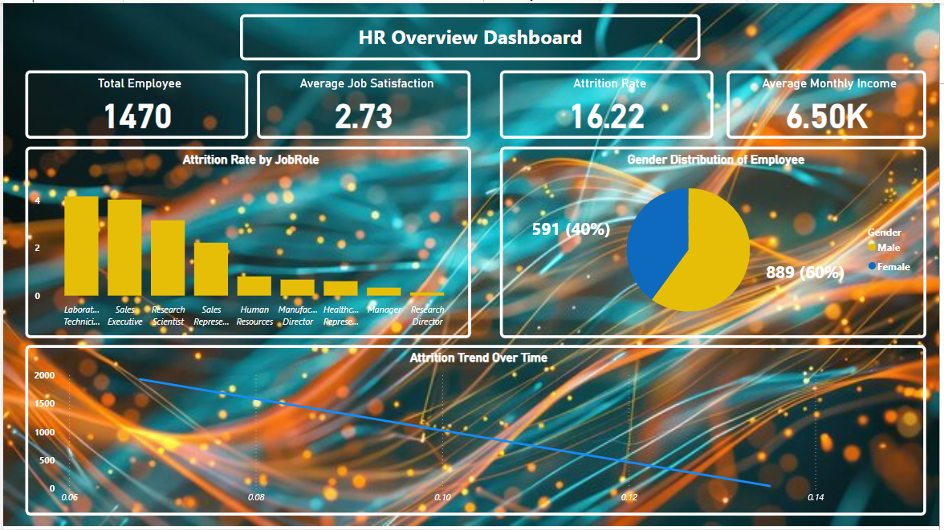

Dashboard – 2 ()

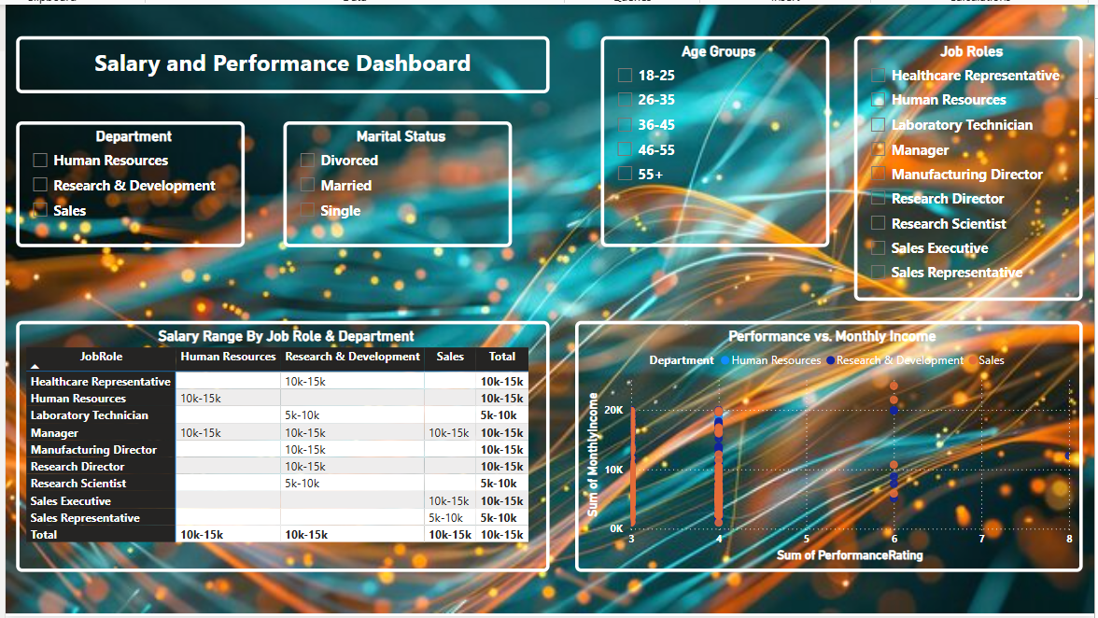

THE END