**A Project Report**

**On**

**“ Healthcare Analytics ”**

**Submitted in partial fulfillment of Learning Business Intelligence Tool**



**Department of Data Science**

**Emerging India Analytics**

**Submitted By :- Submitted To :-**

**Sunny Kumar Uttam Sir**

**(**[**kumarsunnydh468@gmail.com**](mailto:kumarsunnydh468@gmail.com)**) Ravi Sir**

**Rohan Sir**

**Certificate**

This is to certify that Project entitled “ Health care Analytics ” which is submitted by Sunny Kumar pursuing Data Science cource at Emerging India Analytics in the guidance of our respected Uttam Sir , Ravi Sir and Rohan Sir.

The content of this project has not been submitted to any institution or organization for award of any degree or diploma.

------------------------------------

Uttam Sir

(Project Guide)

Date : 20/04/2025

Place : Patna

**About The Project**

**Objective :-**

This project focuses on analyzing a healthcare dataset using SQL for data processing and

Power BI/Tableau for visualization. The goal is to extract meaningful insights, identify

trends, and present findings effectively for data-driven decision-making in the healthcare

sector.

**Dataset Overview :-**

**📌 Columns Overview:**

**Patient Information:**

**● Patient_ID: Unique identifier for each patient.**

**● Age: Age of the patient.**

**● Gender: Male / Female.**

**● Region: Geographic location of the patient.**

**Medical Details:**

**● Diagnosis: Medical condition diagnosed.**

**● Treatment_Type: Type of treatment received.**

**● HospitalStayDays: Duration of hospital stay.**

**● Doctor_ID: ID of the treating doctor.**

**Financial Metrics:**

**● Medical_Cost: Cost of treatment.**

**● Insurance_Covered: Amount covered by insurance.**

**● Out_of_Pocket: Patient's direct expense.**

**# Dashboard Using Power BI :-**

Dashboard -1 (Healthcare Overview Dashoard)

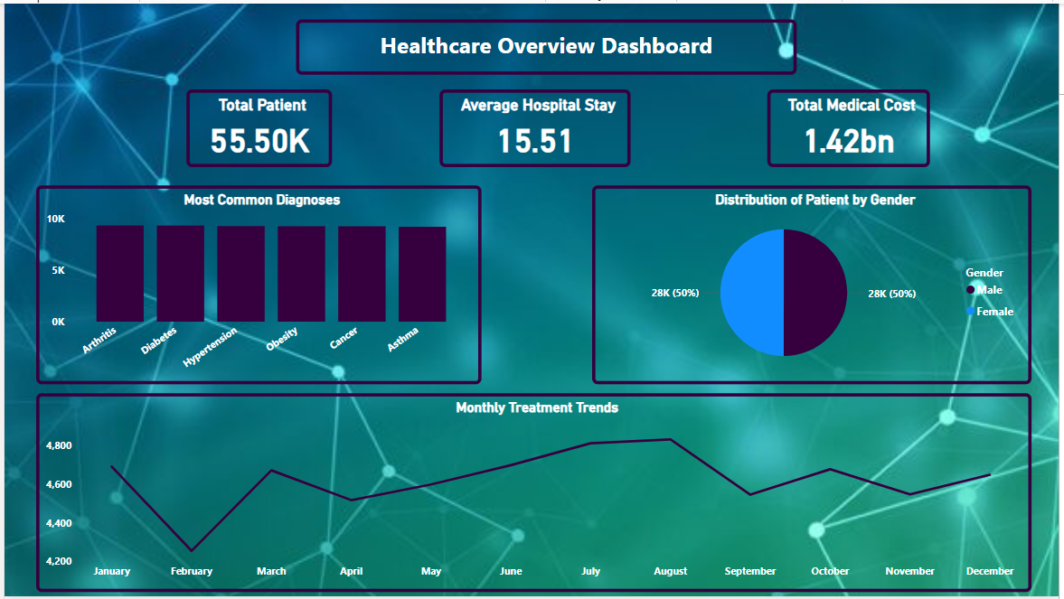

Dashboard – 2 (Financial Analysis Dashboard)

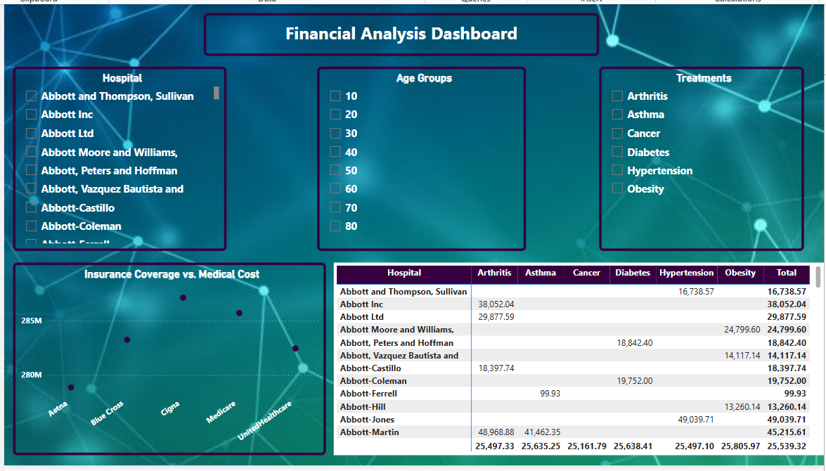

THE END