**A Project Report**

**On**

**“ Sales Performance Analysis ”**

**Submitted in partial fulfillment of Learning Business Intelligence Tools**



**Department of Data Science**

**Emerging India Analytics**

**Submitted By :- Submitted To :-**

**Sunny Kumar Uttam Sir**

**(**[**kumarsunnydh468@gmail.com**](mailto:kumarsunnydh468@gmail.com)**) Ravi Sir**

**Rohan Sir**

**Certificate**

This is to certify that Project entitled “ Sales Performance Analysis ” which is submitted by Sunny Kumar pursuing Data Science cource at Emerging India Analytics in the guidance of our respected Uttam Sir , Ravi Sir and Rohan Sir.

The content of this project has not been submitted to any institution or organization for award of any degree or diploma.

------------------------------------

Uttam Sir

(Project Guide)

Date : 17/04/2025

Place : Patna

**About The Project**

**Objective :-**

The Sales Performance Analysis project aims to analyze historical sales patterns, customer

behavior, and product performance. Using SQL for data extraction and transformation and

Power BI/Tableau for visualization, this project will provide insights into sales trends,

regional performance, and customer segmentation.

**Dataset Overview :-**

Columns Overview:

1. Order Information:

● ORDERNUMBER – Unique identifier for each order

● QUANTITYORDERED – Number of units purchased

● PRICEEACH – Unit price of the product

● ORDERLINENUMBER – Line item number within an order

● SALES – Total sale amount

● ORDERDATE – Date when the order was placed

● STATUS – Order status (Shipped, Pending, etc.)

2. Product Information:

● PRODUCTLINE – Category of the product

● MSRP – Manufacturer’s Suggested Retail Price

● PRODUCTCODE – Unique product identifier

● DEALSIZE – Deal classification (Small, Medium, Large)

3. Customer Information:

● CUSTOMERNAME – Name of the customer

● PHONE – Contact number

● ADDRESSLINE1, ADDRESSLINE2 – Customer address details

● CITY, STATE, POSTALCODE, COUNTRY – Customer location

● TERRITORY – Sales region

● CONTACTLASTNAME, CONTACTFIRSTNAME – Contact person’s name

**# Exploratory Data Analysis (EDA) using SQL :-**

Code for Identifying Top-Selling Products –

“select PRODUCTLINE,SALES from Sales order by SALES desc offset 0 limit 10”

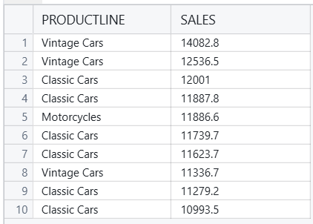

Code for Analyzing Sales Trends Over Time -

“select YEAR_ID,sum(SALES) as "Total_Sale" from Sales group by YEAR_ID order by YEAR_ID”

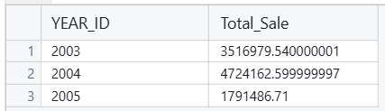

Code for Identifying Seasonal Sales Patterns -

“select MONTH_ID,sum(SALES) as "Total_Sale" from Sales group by MONTH_ID order by MONTH_ID”

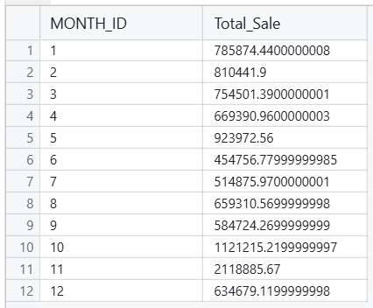

Code for Performing Territorial Sales Analysis -

“select TERRITORY,sum(SALES) as "Total_Sale" from Sales group by TERRITORY order by Total_Sale”

