**A Project Report**

**On**

**“ Supply Chain Analysis ”**

**Submitted in partial fulfillment of Learning Business Intelligence Tools**



**Department of Data Science**

**Emerging India Analytics**

**Submitted By :- Submitted To :-**

**Sunny Kumar Uttam Sir**

**(**[**kumarsunnydh468@gmail.com**](mailto:kumarsunnydh468@gmail.com)**) Ravi Sir**

**Rohan Sir**

**Certificate**

This is to certify that Project entitled “ Supply Chain Analysis ” which is submitted by Sunny Kumar pursuing Data Science cource at Emerging India Analytics in the guidance of our respected Uttam Sir , Ravi Sir and Rohan Sir.

The content of this project has not been submitted to any institution or organization for award of any degree or diploma.

------------------------------------

Ravi Sir

(Project Guide)

Date : 17/04/2025

Place : Patna

**About The Project**

**Objective :-**

This project aims to analyze and optimize key supply chain metrics using SQL for data

analysis and Power BI for visualization. Learners will explore data on product trends,

supplier performance, shipping efficiency, and manufacturing quality.

**Dataset Overview :-**

Dataset Name : Supply Chain Performance

Total Records : 100+

**Columns Overview** :-

● Product Information:

○ Product type, SKU, Price, Stock levels, Availability, Number of products sold,

Revenue generated

● Supplier and Location Details:

○ Supplier name, Location, Routes, Lead time

● Shipping and Costs:

○ Shipping times, Shipping costs, Transportation modes, Order quantities

● Quality Metrics:

○ Inspection results, Defect rates, Manufacturing costs, Manufacturing lead time

Data Source & Format:

● Provided as an Excel (.xlsx) file and CSV (.csv) file

● Can be imported into SQL databases for structured queries.

Exploratory Data Analysis (EDA) using SQL & Power BI :-

Option 1: Performing EDA using SQL :-

Using SQL, we can explore the dataset, perform aggregations, and generate insights.

To Identify missing or inconsistent data

To Perform summary statistics (mean, median, min, max)

“select max(Price) as Max_Price,

min(Price) as Min_Price,

avg(Price) as Avg_Price,

stddev(Price) as Std_price,

from Supply_Chain_Table”



To Calculate Product Type and Sales

“ select "Product type" ,sum("Revenue generated") as "Total Sales" from Supply_Chain_Table group by "Product type" ”

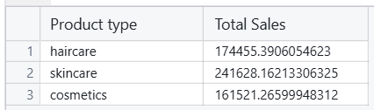

To Identify top-performing products and suppliers

“ select "Product type","Supplier name",sum("Revenue generated") as "Total Sales" from Supply_Chain_Table group by "Product type","Supplier name" ”

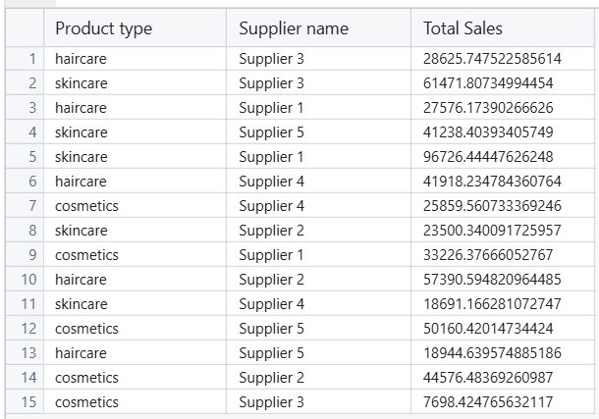

**# Dashboard Using Power BI :-**

Dashboard -1(Supply Chain Analysis)

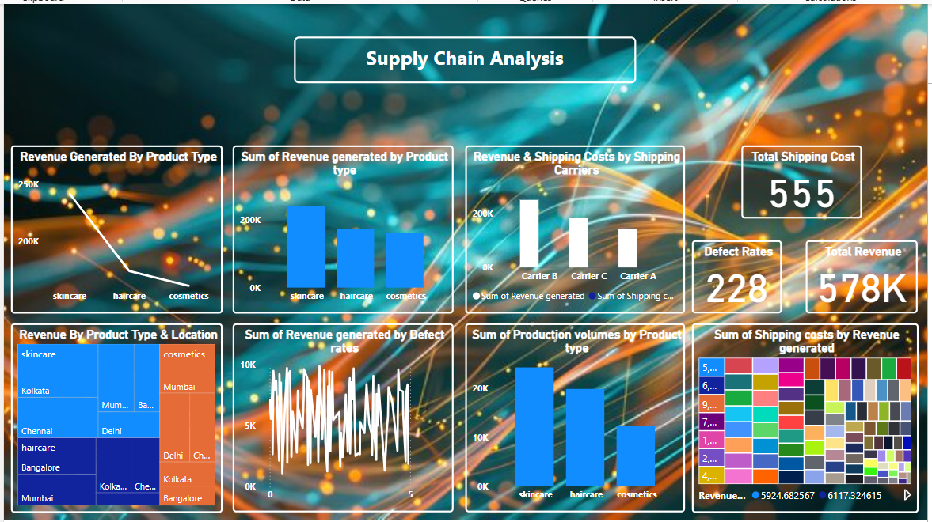

THE END