Name: Mukesh Raju Mahajan

Emp-ID- 143686

**Project Report**

**Of**

**Antilock Braking System**

**Introduction:**

**How does the Anti-Lock Braking System work?**

ABS works by releasing and then reapplying or 'pumping' the brakes to a motorcycle wheel or car wheels in heavy braking situations. Sensors on each wheel are used to detect 'locking' or when a wheel stops moving and starts to skid. Although not all ABS systems are the same, with some only preventing wheels on the rear axle from locking up. When a lock-up is detected, ABS pumps the brakes, 100's of times a second. This stops the wheel or wheels from skidding and helps keep the driver in control of the vehicle. So essentially, ABS works in three stages:

1. Brake pedal is pushed
2. Wheel sensors detect skidding or 'locking'
3. ABS pumps the brakes

#### How does ABS benefit racing drivers?

In the racing world driver aids such as ABS and traction control systems (TCS) take on different roles. ABS can be used to change when a driver commits to braking before a corner and can also help protect tires from excessive wear.

**Anti**-**lock brakes** assist drivers to have better control and shorter stopping distances on slippery surfaces or through panic **braking**. The **system** monitors each wheels activity individually with the help of sensors. The **brake** pressure is then regulated to stop the wheels **locking** up and avoid slippage.

**System Model:**

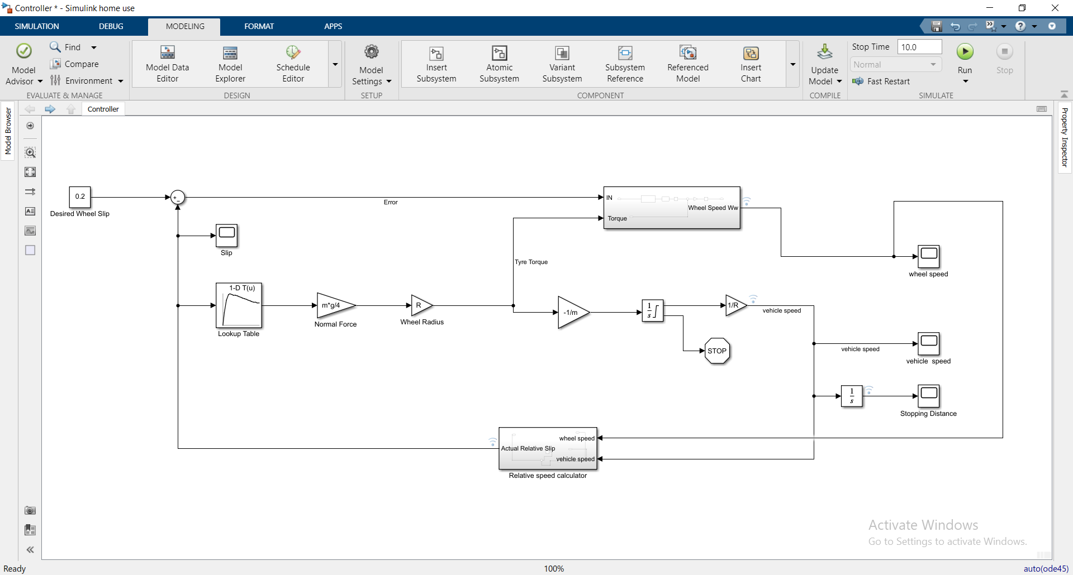

**Output on data Inspector:**

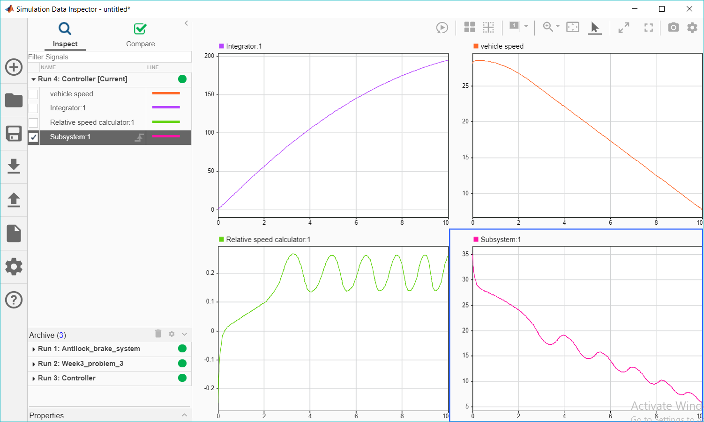

**Lookup Table values:**

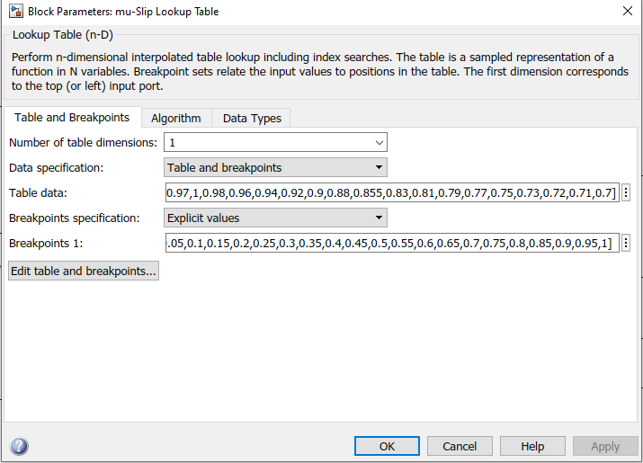

**Solver information:**

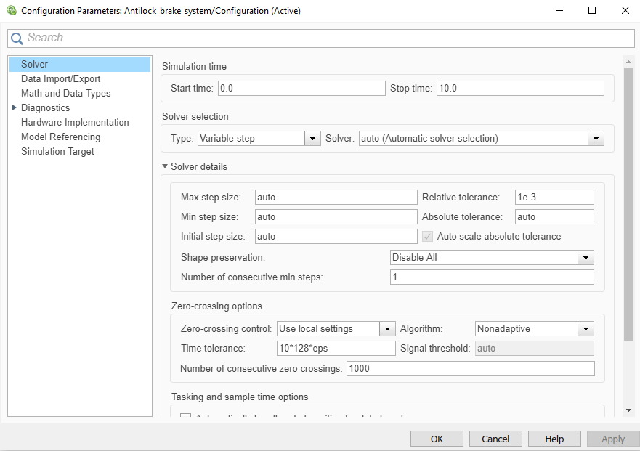

**Callbacks:**

