I was able to provision an EKS cluster in AWS without errors on 06 Jun 2024 Thursday 0100AM.

The codes and tutorials are taken from HashiCorp tutorial site and I updated the files to include dev.tfvars and prod.tfvars files.

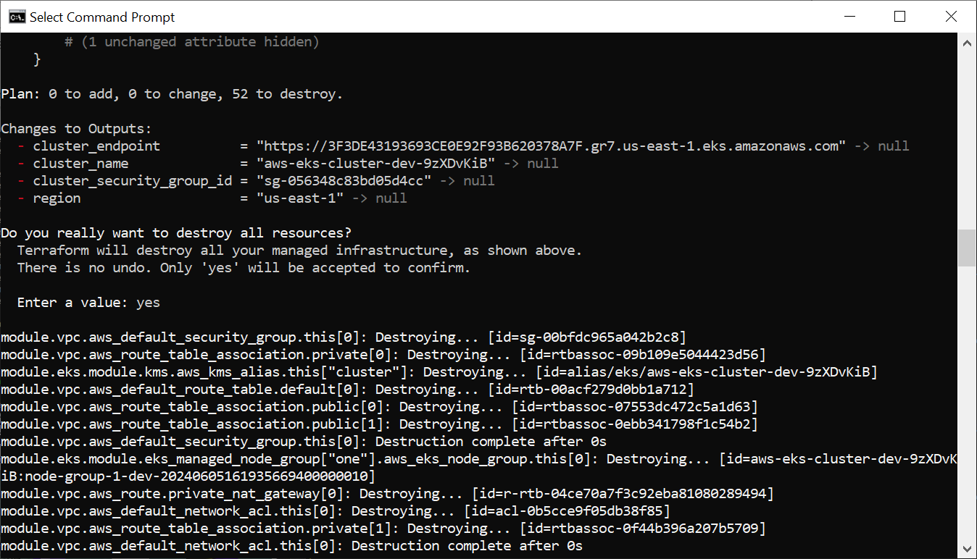

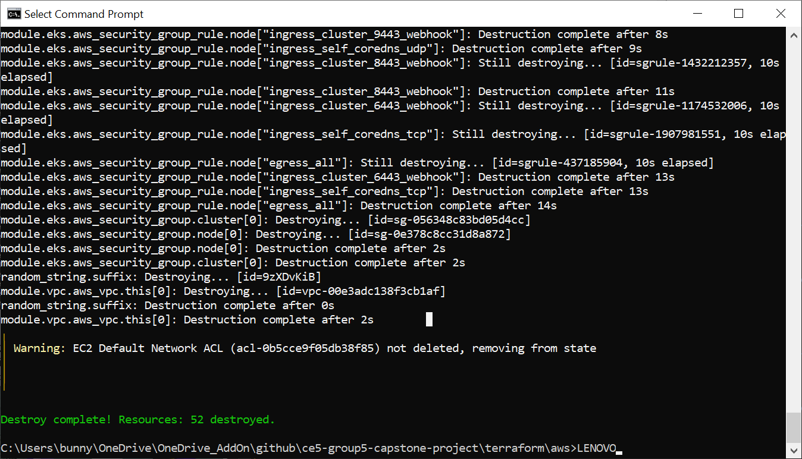

**Plan: 0 to add, 0 to change, 52 to destroy.**

**Changes to Outputs:**

**- cluster_endpoint = "https://3F3DE43193693CE0E92F93B620378A7F.gr7.us-east-1.eks.amazonaws.com" -> null**

**- cluster_name = "aws-eks-cluster-dev-9zXDvKiB" -> null**

**- cluster_security_group_id = "sg-056348c83bd05d4cc" -> null**

**- region = "us-east-1" -> null**

**Do you really want to destroy all resources?**

**Terraform will destroy all your managed infrastructure, as shown above.**

**There is no undo. Only 'yes' will be accepted to confirm.**

**Enter a value: yes**

**module.vpc.aws_default_security_group.this[0]: Destroying... [id=sg-00bfdc965a042b2c8]**

**module.vpc.aws_route_table_association.private[0]: Destroying... [id=rtbassoc-09b109e5044423d56]**

**module.eks.module.kms.aws_kms_alias.this["cluster"]: Destroying... [id=alias/eks/aws-eks-cluster-dev-9zXDvKiB]**

**module.vpc.aws_default_route_table.default[0]: Destroying... [id=rtb-00acf279d0bb1a712]**

**module.vpc.aws_route_table_association.public[0]: Destroying... [id=rtbassoc-07553dc472c5a1d63]**

**module.vpc.aws_route_table_association.public[1]: Destroying... [id=rtbassoc-0ebb341798f1c54b2]**

**module.vpc.aws_default_security_group.this[0]: Destruction complete after 0s**

**module.eks.module.eks_managed_node_group["one"].aws_eks_node_group.this[0]: Destroying... [id=aws-eks-cluster-dev-9zXDvKiB:node-group-1-dev-20240605161935669400000010]**

**module.vpc.aws_route.private_nat_gateway[0]: Destroying... [id=r-rtb-04ce70a7f3c92eba81080289494]**

**module.vpc.aws_default_network_acl.this[0]: Destroying... [id=acl-0b5cce9f05db38f85]**

**module.vpc.aws_route_table_association.private[1]: Destroying... [id=rtbassoc-0f44b396a207b5709]**

**module.vpc.aws_default_network_acl.this[0]: Destruction complete after 0s**

**module.vpc.aws_default_route_table.default[0]: Destruction complete after 0s**

**module.vpc.aws_route.public_internet_gateway[0]: Destroying... [id=r-rtb-097c2915187fa473b1080289494]**

**module.irsa-ebs-csi.aws_iam_role_policy_attachment.custom[0]: Destroying... [id=AmazonEKSTFEBSCSIRole-aws-eks-cluster-dev-9zXDvKiB-2024060516190608550000000d]**

**module.eks.aws_iam_role_policy_attachment.cluster_encryption[0]: Destroying... [id=aws-eks-cluster-dev-9zXDvKiB-cluster-20240605160856722300000002-2024060516093045950000000c]**

**module.eks.module.kms.aws_kms_alias.this["cluster"]: Destruction complete after 1s**

**module.eks.aws_iam_openid_connect_provider.oidc_provider[0]: Destroying... [id=arn:aws:iam::255945442255:oidc-provider/oidc.eks.us-east-1.amazonaws.com/id/3F3DE43193693CE0E92F93B620378A7F]**

**module.vpc.aws_route_table_association.private[1]: Destruction complete after 2s**

**module.vpc.aws_route_table_association.public[1]: Destruction complete after 2s**

**module.vpc.aws_route_table_association.private[0]: Destruction complete after 3s**

**module.vpc.aws_route_table_association.public[0]: Destruction complete after 3s**

**module.vpc.aws_route.private_nat_gateway[0]: Destruction complete after 3s**

**module.vpc.aws_nat_gateway.this[0]: Destroying... [id=nat-0fb165f3bcf58512c]**

**module.vpc.aws_route_table.private[0]: Destroying... [id=rtb-04ce70a7f3c92eba8]**

**module.vpc.aws_route.public_internet_gateway[0]: Destruction complete after 4s**

**module.vpc.aws_route_table.public[0]: Destroying... [id=rtb-097c2915187fa473b]**

**module.eks.aws_iam_openid_connect_provider.oidc_provider[0]: Destruction complete after 3s**

**module.eks.aws_iam_role_policy_attachment.cluster_encryption[0]: Destruction complete after 4s**

**module.eks.aws_iam_policy.cluster_encryption[0]: Destroying... [id=arn:aws:iam::255945442255:policy/aws-eks-cluster-dev-9zXDvKiB-cluster-ClusterEncryption2024060516092891510000000b]**

**module.irsa-ebs-csi.aws_iam_role_policy_attachment.custom[0]: Destruction complete after 6s**

**module.irsa-ebs-csi.aws_iam_role.this[0]: Destroying... [id=AmazonEKSTFEBSCSIRole-aws-eks-cluster-dev-9zXDvKiB]**

**module.vpc.aws_route_table.public[0]: Destruction complete after 2s**

**module.vpc.aws_route_table.private[0]: Destruction complete after 4s**

**module.irsa-ebs-csi.aws_iam_role.this[0]: Destruction complete after 3s**

**module.eks.aws_iam_policy.cluster_encryption[0]: Destruction complete after 5s**

**module.eks.module.eks_managed_node_group["one"].aws_eks_node_group.this[0]: Still destroying... [id=aws-eks-cluster-dev-9zXDvKiB:node-group-1-dev-20240605161935669400000010, 10s elapsed]**

**module.vpc.aws_nat_gateway.this[0]: Still destroying... [id=nat-0fb165f3bcf58512c, 10s elapsed]**

**module.eks.module.eks_managed_node_group["one"].aws_eks_node_group.this[0]: Still destroying... [id=aws-eks-cluster-dev-9zXDvKiB:node-group-1-dev-20240605161935669400000010, 20s elapsed]**

**module.vpc.aws_nat_gateway.this[0]: Still destroying... [id=nat-0fb165f3bcf58512c, 20s elapsed]**

**module.eks.module.eks_managed_node_group["one"].aws_eks_node_group.this[0]: Still destroying... [id=aws-eks-cluster-dev-9zXDvKiB:node-group-1-dev-20240605161935669400000010, 30s elapsed]**

**module.vpc.aws_nat_gateway.this[0]: Still destroying... [id=nat-0fb165f3bcf58512c, 30s elapsed]**

**module.eks.module.eks_managed_node_group["one"].aws_eks_node_group.this[0]: Still destroying... [id=aws-eks-cluster-dev-9zXDvKiB:node-group-1-dev-20240605161935669400000010, 40s elapsed]**

**module.vpc.aws_nat_gateway.this[0]: Still destroying... [id=nat-0fb165f3bcf58512c, 40s elapsed]**

**module.eks.module.eks_managed_node_group["one"].aws_eks_node_group.this[0]: Still destroying... [id=aws-eks-cluster-dev-9zXDvKiB:node-group-1-dev-20240605161935669400000010, 50s elapsed]**

**module.vpc.aws_nat_gateway.this[0]: Still destroying... [id=nat-0fb165f3bcf58512c, 50s elapsed]**

**module.eks.module.eks_managed_node_group["one"].aws_eks_node_group.this[0]: Still destroying... [id=aws-eks-cluster-dev-9zXDvKiB:node-group-1-dev-20240605161935669400000010, 1m0s elapsed]**

**module.vpc.aws_nat_gateway.this[0]: Still destroying... [id=nat-0fb165f3bcf58512c, 1m0s elapsed]**

**module.vpc.aws_nat_gateway.this[0]: Destruction complete after 1m3s**

**module.vpc.aws_eip.nat[0]: Destroying... [id=eipalloc-04743cd0a45ed13e5]**

**module.vpc.aws_subnet.public[0]: Destroying... [id=subnet-0b6c4858987a4945b]**

**module.vpc.aws_subnet.public[1]: Destroying... [id=subnet-0bb5cd25ab5d9dbc2]**

**module.vpc.aws_eip.nat[0]: Destruction complete after 3s**

**module.vpc.aws_internet_gateway.this[0]: Destroying... [id=igw-013f3210e3b39c4dd]**

**module.vpc.aws_subnet.public[0]: Destruction complete after 3s**

**module.vpc.aws_subnet.public[1]: Destruction complete after 3s**

**module.eks.module.eks_managed_node_group["one"].aws_eks_node_group.this[0]: Still destroying... [id=aws-eks-cluster-dev-9zXDvKiB:node-group-1-dev-20240605161935669400000010, 1m10s elapsed]**

**module.vpc.aws_internet_gateway.this[0]: Destruction complete after 1s**

**module.eks.module.eks_managed_node_group["one"].aws_eks_node_group.this[0]: Still destroying... [id=aws-eks-cluster-dev-9zXDvKiB:node-group-1-dev-20240605161935669400000010, 1m20s elapsed]**

**module.eks.module.eks_managed_node_group["one"].aws_eks_node_group.this[0]: Still destroying... [id=aws-eks-cluster-dev-9zXDvKiB:node-group-1-dev-20240605161935669400000010, 1m30s elapsed]**

**module.eks.module.eks_managed_node_group["one"].aws_eks_node_group.this[0]: Still destroying... [id=aws-eks-cluster-dev-9zXDvKiB:node-group-1-dev-20240605161935669400000010, 1m40s elapsed]**

**module.eks.module.eks_managed_node_group["one"].aws_eks_node_group.this[0]: Still destroying... [id=aws-eks-cluster-dev-9zXDvKiB:node-group-1-dev-20240605161935669400000010, 1m50s elapsed]**

**module.eks.module.eks_managed_node_group["one"].aws_eks_node_group.this[0]: Still destroying... [id=aws-eks-cluster-dev-9zXDvKiB:node-group-1-dev-20240605161935669400000010, 2m0s elapsed]**

**module.eks.module.eks_managed_node_group["one"].aws_eks_node_group.this[0]: Still destroying... [id=aws-eks-cluster-dev-9zXDvKiB:node-group-1-dev-20240605161935669400000010, 2m10s elapsed]**

**module.eks.module.eks_managed_node_group["one"].aws_eks_node_group.this[0]: Still destroying... [id=aws-eks-cluster-dev-9zXDvKiB:node-group-1-dev-20240605161935669400000010, 2m20s elapsed]**

**module.eks.module.eks_managed_node_group["one"].aws_eks_node_group.this[0]: Still destroying... [id=aws-eks-cluster-dev-9zXDvKiB:node-group-1-dev-20240605161935669400000010, 2m30s elapsed]**

**module.eks.module.eks_managed_node_group["one"].aws_eks_node_group.this[0]: Still destroying... [id=aws-eks-cluster-dev-9zXDvKiB:node-group-1-dev-20240605161935669400000010, 2m40s elapsed]**

**module.eks.module.eks_managed_node_group["one"].aws_eks_node_group.this[0]: Still destroying... [id=aws-eks-cluster-dev-9zXDvKiB:node-group-1-dev-20240605161935669400000010, 2m50s elapsed]**

**module.eks.module.eks_managed_node_group["one"].aws_eks_node_group.this[0]: Still destroying... [id=aws-eks-cluster-dev-9zXDvKiB:node-group-1-dev-20240605161935669400000010, 3m0s elapsed]**

**module.eks.module.eks_managed_node_group["one"].aws_eks_node_group.this[0]: Still destroying... [id=aws-eks-cluster-dev-9zXDvKiB:node-group-1-dev-20240605161935669400000010, 3m10s elapsed]**

**module.eks.module.eks_managed_node_group["one"].aws_eks_node_group.this[0]: Still destroying... [id=aws-eks-cluster-dev-9zXDvKiB:node-group-1-dev-20240605161935669400000010, 3m20s elapsed]**

**module.eks.module.eks_managed_node_group["one"].aws_eks_node_group.this[0]: Still destroying... [id=aws-eks-cluster-dev-9zXDvKiB:node-group-1-dev-20240605161935669400000010, 3m30s elapsed]**

**module.eks.module.eks_managed_node_group["one"].aws_eks_node_group.this[0]: Still destroying... [id=aws-eks-cluster-dev-9zXDvKiB:node-group-1-dev-20240605161935669400000010, 3m40s elapsed]**

**module.eks.module.eks_managed_node_group["one"].aws_eks_node_group.this[0]: Still destroying... [id=aws-eks-cluster-dev-9zXDvKiB:node-group-1-dev-20240605161935669400000010, 3m50s elapsed]**

**module.eks.module.eks_managed_node_group["one"].aws_eks_node_group.this[0]: Still destroying... [id=aws-eks-cluster-dev-9zXDvKiB:node-group-1-dev-20240605161935669400000010, 4m0s elapsed]**

**module.eks.module.eks_managed_node_group["one"].aws_eks_node_group.this[0]: Still destroying... [id=aws-eks-cluster-dev-9zXDvKiB:node-group-1-dev-20240605161935669400000010, 4m10s elapsed]**

**module.eks.module.eks_managed_node_group["one"].aws_eks_node_group.this[0]: Still destroying... [id=aws-eks-cluster-dev-9zXDvKiB:node-group-1-dev-20240605161935669400000010, 4m20s elapsed]**

**module.eks.module.eks_managed_node_group["one"].aws_eks_node_group.this[0]: Still destroying... [id=aws-eks-cluster-dev-9zXDvKiB:node-group-1-dev-20240605161935669400000010, 4m30s elapsed]**

**module.eks.module.eks_managed_node_group["one"].aws_eks_node_group.this[0]: Still destroying... [id=aws-eks-cluster-dev-9zXDvKiB:node-group-1-dev-20240605161935669400000010, 4m40s elapsed]**

**module.eks.module.eks_managed_node_group["one"].aws_eks_node_group.this[0]: Still destroying... [id=aws-eks-cluster-dev-9zXDvKiB:node-group-1-dev-20240605161935669400000010, 4m50s elapsed]**

**module.eks.module.eks_managed_node_group["one"].aws_eks_node_group.this[0]: Still destroying... [id=aws-eks-cluster-dev-9zXDvKiB:node-group-1-dev-20240605161935669400000010, 5m0s elapsed]**

**module.eks.module.eks_managed_node_group["one"].aws_eks_node_group.this[0]: Still destroying... [id=aws-eks-cluster-dev-9zXDvKiB:node-group-1-dev-20240605161935669400000010, 5m10s elapsed]**

**module.eks.module.eks_managed_node_group["one"].aws_eks_node_group.this[0]: Still destroying... [id=aws-eks-cluster-dev-9zXDvKiB:node-group-1-dev-20240605161935669400000010, 5m20s elapsed]**

**module.eks.module.eks_managed_node_group["one"].aws_eks_node_group.this[0]: Still destroying... [id=aws-eks-cluster-dev-9zXDvKiB:node-group-1-dev-20240605161935669400000010, 5m30s elapsed]**

**module.eks.module.eks_managed_node_group["one"].aws_eks_node_group.this[0]: Still destroying... [id=aws-eks-cluster-dev-9zXDvKiB:node-group-1-dev-20240605161935669400000010, 5m40s elapsed]**

**module.eks.module.eks_managed_node_group["one"].aws_eks_node_group.this[0]: Still destroying... [id=aws-eks-cluster-dev-9zXDvKiB:node-group-1-dev-20240605161935669400000010, 5m50s elapsed]**

**module.eks.module.eks_managed_node_group["one"].aws_eks_node_group.this[0]: Still destroying... [id=aws-eks-cluster-dev-9zXDvKiB:node-group-1-dev-20240605161935669400000010, 6m0s elapsed]**

**module.eks.module.eks_managed_node_group["one"].aws_eks_node_group.this[0]: Still destroying... [id=aws-eks-cluster-dev-9zXDvKiB:node-group-1-dev-20240605161935669400000010, 6m10s elapsed]**

**module.eks.module.eks_managed_node_group["one"].aws_eks_node_group.this[0]: Still destroying... [id=aws-eks-cluster-dev-9zXDvKiB:node-group-1-dev-20240605161935669400000010, 6m20s elapsed]**

**module.eks.module.eks_managed_node_group["one"].aws_eks_node_group.this[0]: Destruction complete after 6m25s**

**module.eks.module.eks_managed_node_group["one"].aws_launch_template.this[0]: Destroying... [id=lt-083b02d3ca1c89fc7]**

**module.eks.module.eks_managed_node_group["one"].aws_launch_template.this[0]: Destruction complete after 2s**

**module.eks.module.eks_managed_node_group["one"].aws_iam_role_policy_attachment.this["arn:aws:iam::aws:policy/AmazonEKS_CNI_Policy"]: Destroying... [id=node-group-1-dev-eks-node-group-20240605160856717600000001-20240605160900128400000003]**

**module.eks.module.eks_managed_node_group["one"].aws_iam_role_policy_attachment.this["arn:aws:iam::aws:policy/AmazonEC2ContainerRegistryReadOnly"]: Destroying... [id=node-group-1-dev-eks-node-group-20240605160856717600000001-20240605160901088500000006]**

**module.eks.time_sleep.this[0]: Destroying... [id=2024-06-05T16:19:33Z]**

**module.eks.module.eks_managed_node_group["one"].aws_iam_role_policy_attachment.this["arn:aws:iam::aws:policy/AmazonEKSWorkerNodePolicy"]: Destroying... [id=node-group-1-dev-eks-node-group-20240605160856717600000001-20240605160900547300000004]**

**module.eks.time_sleep.this[0]: Destruction complete after 0s**

**module.eks.aws_eks_cluster.this[0]: Destroying... [id=aws-eks-cluster-dev-9zXDvKiB]**

**module.eks.module.eks_managed_node_group["one"].aws_iam_role_policy_attachment.this["arn:aws:iam::aws:policy/AmazonEC2ContainerRegistryReadOnly"]: Destruction complete after 1s**

**module.eks.module.eks_managed_node_group["one"].aws_iam_role_policy_attachment.this["arn:aws:iam::aws:policy/AmazonEKS_CNI_Policy"]: Destruction complete after 1s**

**module.eks.module.eks_managed_node_group["one"].aws_iam_role_policy_attachment.this["arn:aws:iam::aws:policy/AmazonEKSWorkerNodePolicy"]: Destruction complete after 2s**

**module.eks.module.eks_managed_node_group["one"].aws_iam_role.this[0]: Destroying... [id=node-group-1-dev-eks-node-group-20240605160856717600000001]**

**module.eks.module.eks_managed_node_group["one"].aws_iam_role.this[0]: Destruction complete after 1s**

**module.eks.aws_eks_cluster.this[0]: Still destroying... [id=aws-eks-cluster-dev-9zXDvKiB, 10s elapsed]**

**module.eks.aws_eks_cluster.this[0]: Still destroying... [id=aws-eks-cluster-dev-9zXDvKiB, 20s elapsed]**

**module.eks.aws_eks_cluster.this[0]: Still destroying... [id=aws-eks-cluster-dev-9zXDvKiB, 30s elapsed]**

**module.eks.aws_eks_cluster.this[0]: Still destroying... [id=aws-eks-cluster-dev-9zXDvKiB, 40s elapsed]**

**module.eks.aws_eks_cluster.this[0]: Still destroying... [id=aws-eks-cluster-dev-9zXDvKiB, 50s elapsed]**

**module.eks.aws_eks_cluster.this[0]: Still destroying... [id=aws-eks-cluster-dev-9zXDvKiB, 1m0s elapsed]**

**module.eks.aws_eks_cluster.this[0]: Still destroying... [id=aws-eks-cluster-dev-9zXDvKiB, 1m10s elapsed]**

**module.eks.aws_eks_cluster.this[0]: Still destroying... [id=aws-eks-cluster-dev-9zXDvKiB, 1m20s elapsed]**

**module.eks.aws_eks_cluster.this[0]: Still destroying... [id=aws-eks-cluster-dev-9zXDvKiB, 1m30s elapsed]**

**module.eks.aws_eks_cluster.this[0]: Still destroying... [id=aws-eks-cluster-dev-9zXDvKiB, 1m40s elapsed]**

**module.eks.aws_eks_cluster.this[0]: Still destroying... [id=aws-eks-cluster-dev-9zXDvKiB, 1m50s elapsed]**

**module.eks.aws_eks_cluster.this[0]: Still destroying... [id=aws-eks-cluster-dev-9zXDvKiB, 2m0s elapsed]**

**module.eks.aws_eks_cluster.this[0]: Still destroying... [id=aws-eks-cluster-dev-9zXDvKiB, 2m10s elapsed]**

**module.eks.aws_eks_cluster.this[0]: Still destroying... [id=aws-eks-cluster-dev-9zXDvKiB, 2m20s elapsed]**

**module.eks.aws_eks_cluster.this[0]: Still destroying... [id=aws-eks-cluster-dev-9zXDvKiB, 2m30s elapsed]**

**module.eks.aws_eks_cluster.this[0]: Still destroying... [id=aws-eks-cluster-dev-9zXDvKiB, 2m40s elapsed]**

**module.eks.aws_eks_cluster.this[0]: Still destroying... [id=aws-eks-cluster-dev-9zXDvKiB, 2m50s elapsed]**

**module.eks.aws_eks_cluster.this[0]: Still destroying... [id=aws-eks-cluster-dev-9zXDvKiB, 3m0s elapsed]**

**module.eks.aws_eks_cluster.this[0]: Still destroying... [id=aws-eks-cluster-dev-9zXDvKiB, 3m10s elapsed]**

**module.eks.aws_eks_cluster.this[0]: Destruction complete after 3m17s**

**module.eks.aws_security_group_rule.node["ingress_cluster_443"]: Destroying... [id=sgrule-865993743]**

**module.eks.aws_cloudwatch_log_group.this[0]: Destroying... [id=/aws/eks/aws-eks-cluster-dev-9zXDvKiB/cluster]**

**module.eks.aws_security_group_rule.node["ingress_nodes_ephemeral"]: Destroying... [id=sgrule-371491619]**

**module.eks.aws_iam_role_policy_attachment.this["AmazonEKSClusterPolicy"]: Destroying... [id=aws-eks-cluster-dev-9zXDvKiB-cluster-20240605160856722300000002-20240605160901191500000007]**

**module.eks.aws_security_group_rule.node["ingress_cluster_kubelet"]: Destroying... [id=sgrule-1161599786]**

**module.vpc.aws_subnet.private[1]: Destroying... [id=subnet-03feec34781ce6519]**

**module.vpc.aws_subnet.private[0]: Destroying... [id=subnet-00936f371d11f6772]**

**module.eks.module.kms.aws_kms_key.this[0]: Destroying... [id=f84b56f5-349a-4e3b-b9d1-6d5a4b554b66]**

**module.eks.aws_security_group_rule.node["ingress_cluster_4443_webhook"]: Destroying... [id=sgrule-1891399628]**

**module.eks.aws_security_group_rule.node["ingress_cluster_9443_webhook"]: Destroying... [id=sgrule-838656080]**

**module.eks.aws_iam_role_policy_attachment.this["AmazonEKSClusterPolicy"]: Destruction complete after 1s**

**module.eks.aws_security_group_rule.node["ingress_self_coredns_udp"]: Destroying... [id=sgrule-706289920]**

**module.eks.module.kms.aws_kms_key.this[0]: Destruction complete after 1s**

**module.eks.aws_security_group_rule.node["ingress_cluster_8443_webhook"]: Destroying... [id=sgrule-1432212357]**

**module.eks.aws_cloudwatch_log_group.this[0]: Destruction complete after 2s**

**module.eks.aws_security_group_rule.node["ingress_cluster_6443_webhook"]: Destroying... [id=sgrule-1174532006]**

**module.eks.aws_security_group_rule.node["ingress_nodes_ephemeral"]: Destruction complete after 3s**

**module.eks.aws_security_group_rule.node["ingress_self_coredns_tcp"]: Destroying... [id=sgrule-1907981551]**

**module.vpc.aws_subnet.private[1]: Destruction complete after 3s**

**module.eks.aws_iam_role_policy_attachment.this["AmazonEKSVPCResourceController"]: Destroying... [id=aws-eks-cluster-dev-9zXDvKiB-cluster-20240605160856722300000002-20240605160901057500000005]**

**module.vpc.aws_subnet.private[0]: Destruction complete after 3s**

**module.eks.aws_security_group_rule.node["egress_all"]: Destroying... [id=sgrule-437185904]**

**module.eks.aws_iam_role_policy_attachment.this["AmazonEKSVPCResourceController"]: Destruction complete after 0s**

**module.eks.aws_security_group_rule.cluster["ingress_nodes_443"]: Destroying... [id=sgrule-754235582]**

**module.eks.aws_security_group_rule.node["ingress_cluster_443"]: Destruction complete after 4s**

**module.eks.aws_iam_role.this[0]: Destroying... [id=aws-eks-cluster-dev-9zXDvKiB-cluster-20240605160856722300000002]**

**module.eks.aws_security_group_rule.cluster["ingress_nodes_443"]: Destruction complete after 1s**

**module.eks.aws_security_group_rule.node["ingress_cluster_kubelet"]: Destruction complete after 5s**

**module.eks.aws_iam_role.this[0]: Destruction complete after 1s**

**module.eks.aws_security_group_rule.node["ingress_cluster_4443_webhook"]: Destruction complete after 6s**

**module.eks.aws_security_group_rule.node["ingress_cluster_9443_webhook"]: Destruction complete after 8s**

**module.eks.aws_security_group_rule.node["ingress_self_coredns_udp"]: Destruction complete after 9s**

**module.eks.aws_security_group_rule.node["ingress_cluster_8443_webhook"]: Still destroying... [id=sgrule-1432212357, 10s elapsed]**

**module.eks.aws_security_group_rule.node["ingress_cluster_8443_webhook"]: Destruction complete after 11s**

**module.eks.aws_security_group_rule.node["ingress_cluster_6443_webhook"]: Still destroying... [id=sgrule-1174532006, 10s elapsed]**

**module.eks.aws_security_group_rule.node["ingress_self_coredns_tcp"]: Still destroying... [id=sgrule-1907981551, 10s elapsed]**

**module.eks.aws_security_group_rule.node["egress_all"]: Still destroying... [id=sgrule-437185904, 10s elapsed]**

**module.eks.aws_security_group_rule.node["ingress_cluster_6443_webhook"]: Destruction complete after 13s**

**module.eks.aws_security_group_rule.node["ingress_self_coredns_tcp"]: Destruction complete after 13s**

**module.eks.aws_security_group_rule.node["egress_all"]: Destruction complete after 14s**

**module.eks.aws_security_group.cluster[0]: Destroying... [id=sg-056348c83bd05d4cc]**

**module.eks.aws_security_group.node[0]: Destroying... [id=sg-0e378c8cc31d8a872]**

**module.eks.aws_security_group.node[0]: Destruction complete after 2s**

**module.eks.aws_security_group.cluster[0]: Destruction complete after 2s**

**random_string.suffix: Destroying... [id=9zXDvKiB]**

**module.vpc.aws_vpc.this[0]: Destroying... [id=vpc-00e3adc138f3cb1af]**

**random_string.suffix: Destruction complete after 0s**

**module.vpc.aws_vpc.this[0]: Destruction complete after 2s**

**╷**

**│ Warning: EC2 Default Network ACL (acl-0b5cce9f05db38f85) not deleted, removing from state**

**│**

**│**

**╵**

**Destroy complete! Resources: 52 destroyed.**

**C:\Users\bunny\OneDrive\OneDrive_AddOn\github\ce5-group5-capstone-project\terraform\aws>LENOVO**

Command to run: **terraform apply -var-file=dev.tfvars**.

Started at 0009AM 06 Jun 2024 Thursday.

Ended at 0022AM 06 Jun 2024 Thursday.

Runtime: 13 minutes without errors.

Command to run: **terraform destroy -var-file=dev.tfvars**

Started at 0024AM 06 Jun 2024 Thursday.

Ended at 0034AM 06 Jun 2024 Thursday.

Runtime: 10 minutes without errors.