I was able to provision an GKE cluster in GCP without errors on 06 Jun 2024 Thursday 0210AM.

The codes and tutorials are taken from HashiCorp tutorial site and I updated the files to include dev.tfvars and prod.tfvars files.

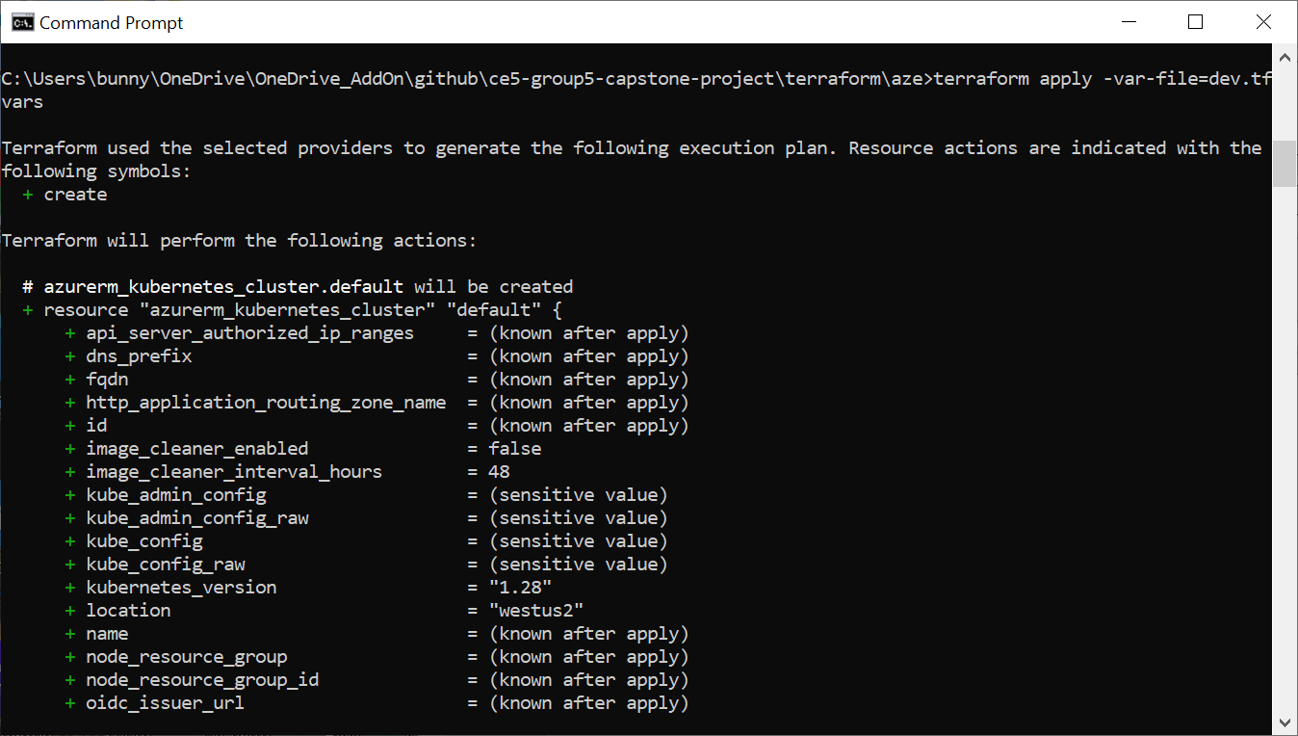

**C:\Users\bunny\OneDrive\OneDrive_AddOn\github\ce5-group5-capstone-project\terraform\gcp>terraform apply -var-file=dev.tfvars**

**data.google_container_engine_versions.gke_version: Reading...**

**data.google_container_engine_versions.gke_version: Read complete after 2s [id=2024-06-05 17:27:21.7474962 +0000 UTC]**

**Terraform used the selected providers to generate the following execution plan. Resource actions are indicated with the**

**following symbols:**

**+ create**

**Terraform will perform the following actions:**

**# google_compute_network.vpc will be created**

**+ resource "google_compute_network" "vpc" {**

**+ auto_create_subnetworks = false**

**+ delete_default_routes_on_create = false**

**+ gateway_ipv4 = (known after apply)**

**+ id = (known after apply)**

**+ internal_ipv6_range = (known after apply)**

**+ mtu = (known after apply)**

**+ name = "enhanced-option-423814-n0-vpc"**

**+ network_firewall_policy_enforcement_order = "AFTER_CLASSIC_FIREWALL"**

**+ numeric_id = (known after apply)**

**+ project = "enhanced-option-423814-n0"**

**+ routing_mode = (known after apply)**

**+ self_link = (known after apply)**

**}**

**# google_compute_subnetwork.subnet will be created**

**+ resource "google_compute_subnetwork" "subnet" {**

**+ creation_timestamp = (known after apply)**

**+ external_ipv6_prefix = (known after apply)**

**+ fingerprint = (known after apply)**

**+ gateway_address = (known after apply)**

**+ id = (known after apply)**

**+ internal_ipv6_prefix = (known after apply)**

**+ ip_cidr_range = "10.10.0.0/24"**

**+ ipv6_cidr_range = (known after apply)**

**+ name = "enhanced-option-423814-n0-subnet"**

**+ network = "enhanced-option-423814-n0-vpc"**

**+ private_ip_google_access = (known after apply)**

**+ private_ipv6_google_access = (known after apply)**

**+ project = "enhanced-option-423814-n0"**

**+ purpose = (known after apply)**

**+ region = "us-east1"**

**+ secondary_ip_range = (known after apply)**

**+ self_link = (known after apply)**

**+ stack_type = (known after apply)**

**}**

**# google_container_cluster.primary will be created**

**+ resource "google_container_cluster" "primary" {**

**+ cluster_ipv4_cidr = (known after apply)**

**+ datapath_provider = (known after apply)**

**+ default_max_pods_per_node = (known after apply)**

**+ deletion_protection = false**

**+ enable_cilium_clusterwide_network_policy = false**

**+ enable_intranode_visibility = (known after apply)**

**+ enable_kubernetes_alpha = false**

**+ enable_l4_ilb_subsetting = false**

**+ enable_legacy_abac = false**

**+ enable_shielded_nodes = true**

**+ endpoint = (known after apply)**

**+ id = (known after apply)**

**+ initial_node_count = 1**

**+ label_fingerprint = (known after apply)**

**+ location = "us-east1"**

**+ logging_service = (known after apply)**

**+ master_version = (known after apply)**

**+ monitoring_service = (known after apply)**

**+ name = "enhanced-option-423814-n0-gke"**

**+ network = "enhanced-option-423814-n0-vpc"**

**+ networking_mode = (known after apply)**

**+ node_locations = [**

**+ "us-east1-b",**

**]**

**+ node_version = (known after apply)**

**+ operation = (known after apply)**

**+ private_ipv6_google_access = (known after apply)**

**+ project = (known after apply)**

**+ remove_default_node_pool = true**

**+ self_link = (known after apply)**

**+ services_ipv4_cidr = (known after apply)**

**+ subnetwork = "enhanced-option-423814-n0-subnet"**

**+ tpu_ipv4_cidr_block = (known after apply)**

**}**

**# google_container_node_pool.primary_nodes will be created**

**+ resource "google_container_node_pool" "primary_nodes" {**

**+ cluster = "enhanced-option-423814-n0-gke"**

**+ id = (known after apply)**

**+ initial_node_count = (known after apply)**

**+ instance_group_urls = (known after apply)**

**+ location = "us-east1"**

**+ managed_instance_group_urls = (known after apply)**

**+ max_pods_per_node = (known after apply)**

**+ name = "enhanced-option-423814-n0-gke"**

**+ name_prefix = (known after apply)**

**+ node_count = 2**

**+ node_locations = (known after apply)**

**+ operation = (known after apply)**

**+ project = "enhanced-option-423814-n0"**

**+ version = "1.27.12-gke.1115000"**

**+ node_config {**

**+ disk_size_gb = (known after apply)**

**+ disk_type = (known after apply)**

**+ effective_taints = (known after apply)**

**+ guest_accelerator = (known after apply)**

**+ image_type = (known after apply)**

**+ labels = {**

**+ "env" = "enhanced-option-423814-n0"**

**}**

**+ local_ssd_count = (known after apply)**

**+ logging_variant = (known after apply)**

**+ machine_type = "n1-standard-1"**

**+ metadata = {**

**+ "disable-legacy-endpoints" = "true"**

**}**

**+ min_cpu_platform = (known after apply)**

**+ oauth_scopes = [**

**+ "https://www.googleapis.com/auth/logging.write",**

**+ "https://www.googleapis.com/auth/monitoring",**

**]**

**+ preemptible = false**

**+ service_account = (known after apply)**

**+ spot = false**

**+ tags = [**

**+ "gke-node",**

**+ "enhanced-option-423814-n0-gke",**

**]**

**}**

**}**

**Plan: 4 to add, 0 to change, 0 to destroy.**

**Changes to Outputs:**

**+ kubernetes_cluster_host = (known after apply)**

**+ kubernetes_cluster_name = "enhanced-option-423814-n0-gke"**

**+ project_id = "enhanced-option-423814-n0"**

**+ region = "us-east1"**

**╷**

**│ Warning: Value for undeclared variable**

**│**

**│ The root module does not declare a variable named "node_pool" but a value was found in file "dev.tfvars". If you**

**│ meant to use this value, add a "variable" block to the configuration.**

**│**

**│ To silence these warnings, use TF_VAR_... environment variables to provide certain "global" settings to all**

**│ configurations in your organization. To reduce the verbosity of these warnings, use the -compact-warnings option.**

**╵**

**╷**

**│ Warning: Value for undeclared variable**

**│**

**│ The root module does not declare a variable named "service_account" but a value was found in file "dev.tfvars". If**

**│ you meant to use this value, add a "variable" block to the configuration.**

**│**

**│ To silence these warnings, use TF_VAR_... environment variables to provide certain "global" settings to all**

**│ configurations in your organization. To reduce the verbosity of these warnings, use the -compact-warnings option.**

**╵**

**Do you want to perform these actions?**

**Terraform will perform the actions described above.**

**Only 'yes' will be accepted to approve.**

**Enter a value: yes**

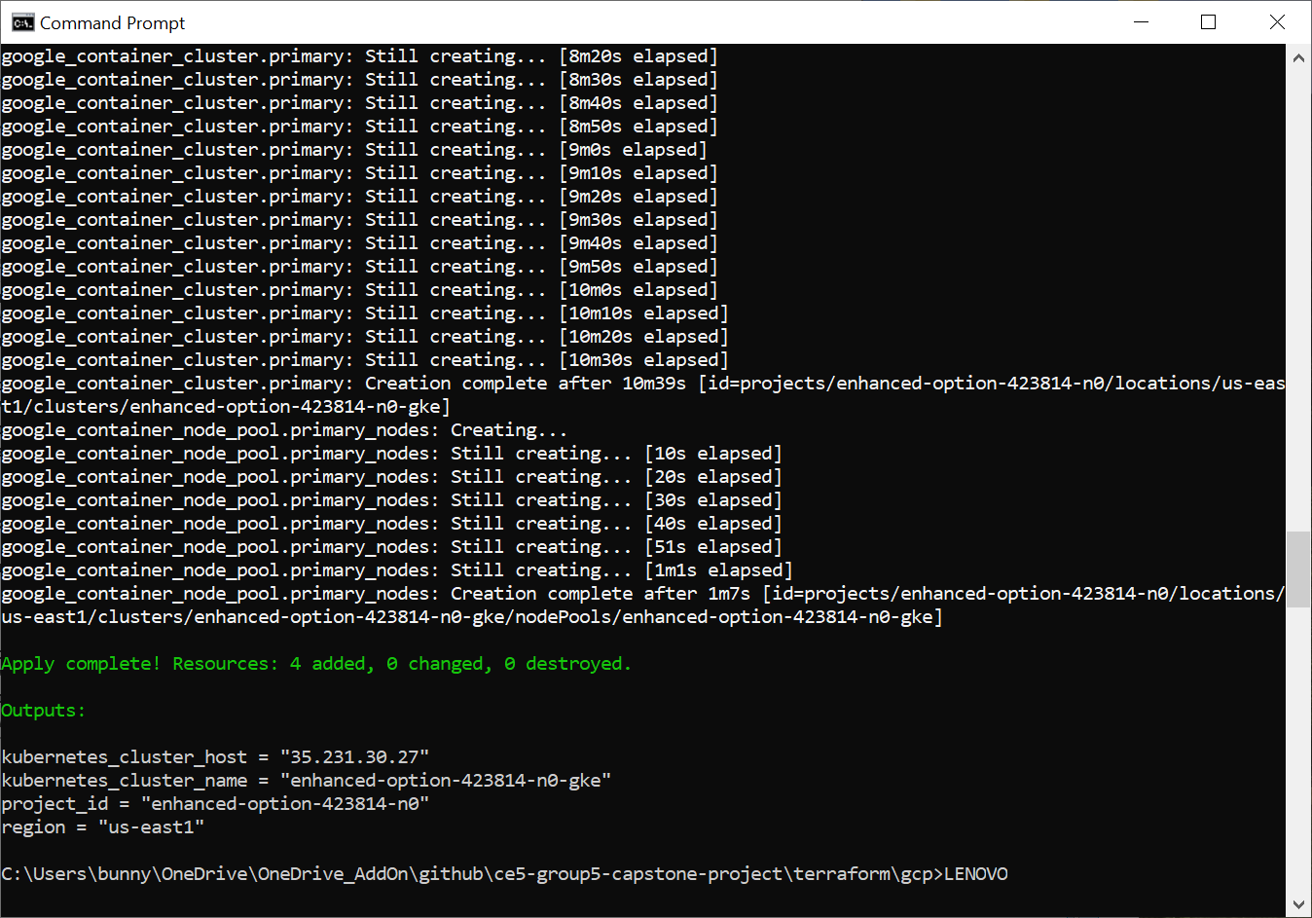

**google_compute_network.vpc: Creating...**

**google_compute_network.vpc: Still creating... [10s elapsed]**

**google_compute_network.vpc: Still creating... [20s elapsed]**

**google_compute_network.vpc: Creation complete after 28s [id=projects/enhanced-option-423814-n0/global/networks/enhanced-option-423814-n0-vpc]**

**google_compute_subnetwork.subnet: Creating...**

**google_compute_subnetwork.subnet: Still creating... [10s elapsed]**

**google_compute_subnetwork.subnet: Creation complete after 17s [id=projects/enhanced-option-423814-n0/regions/us-east1/subnetworks/enhanced-option-423814-n0-subnet]**

**google_container_cluster.primary: Creating...**

**google_container_cluster.primary: Still creating... [10s elapsed]**

**google_container_cluster.primary: Still creating... [20s elapsed]**

**google_container_cluster.primary: Still creating... [30s elapsed]**

**google_container_cluster.primary: Still creating... [40s elapsed]**

**google_container_cluster.primary: Still creating... [50s elapsed]**

**google_container_cluster.primary: Still creating... [1m0s elapsed]**

**google_container_cluster.primary: Still creating... [1m10s elapsed]**

**google_container_cluster.primary: Still creating... [1m20s elapsed]**

**google_container_cluster.primary: Still creating... [1m30s elapsed]**

**google_container_cluster.primary: Still creating... [1m40s elapsed]**

**google_container_cluster.primary: Still creating... [1m50s elapsed]**

**google_container_cluster.primary: Still creating... [2m0s elapsed]**

**google_container_cluster.primary: Still creating... [2m10s elapsed]**

**google_container_cluster.primary: Still creating... [2m20s elapsed]**

**google_container_cluster.primary: Still creating... [2m30s elapsed]**

**google_container_cluster.primary: Still creating... [2m40s elapsed]**

**google_container_cluster.primary: Still creating... [2m50s elapsed]**

**google_container_cluster.primary: Still creating... [3m0s elapsed]**

**google_container_cluster.primary: Still creating... [3m10s elapsed]**

**google_container_cluster.primary: Still creating... [3m20s elapsed]**

**google_container_cluster.primary: Still creating... [3m30s elapsed]**

**google_container_cluster.primary: Still creating... [3m40s elapsed]**

**google_container_cluster.primary: Still creating... [3m50s elapsed]**

**google_container_cluster.primary: Still creating... [4m0s elapsed]**

**google_container_cluster.primary: Still creating... [4m10s elapsed]**

**google_container_cluster.primary: Still creating... [4m20s elapsed]**

**google_container_cluster.primary: Still creating... [4m30s elapsed]**

**google_container_cluster.primary: Still creating... [4m40s elapsed]**

**google_container_cluster.primary: Still creating... [4m50s elapsed]**

**google_container_cluster.primary: Still creating... [5m0s elapsed]**

**google_container_cluster.primary: Still creating... [5m10s elapsed]**

**google_container_cluster.primary: Still creating... [5m20s elapsed]**

**google_container_cluster.primary: Still creating... [5m30s elapsed]**

**google_container_cluster.primary: Still creating... [5m40s elapsed]**

**google_container_cluster.primary: Still creating... [5m50s elapsed]**

**google_container_cluster.primary: Still creating... [6m0s elapsed]**

**google_container_cluster.primary: Still creating... [6m10s elapsed]**

**google_container_cluster.primary: Still creating... [6m20s elapsed]**

**google_container_cluster.primary: Still creating... [6m30s elapsed]**

**google_container_cluster.primary: Still creating... [6m40s elapsed]**

**google_container_cluster.primary: Still creating... [6m50s elapsed]**

**google_container_cluster.primary: Still creating... [7m0s elapsed]**

**google_container_cluster.primary: Still creating... [7m10s elapsed]**

**google_container_cluster.primary: Still creating... [7m20s elapsed]**

**google_container_cluster.primary: Still creating... [7m30s elapsed]**

**google_container_cluster.primary: Still creating... [7m40s elapsed]**

**google_container_cluster.primary: Still creating... [7m50s elapsed]**

**google_container_cluster.primary: Still creating... [8m0s elapsed]**

**google_container_cluster.primary: Still creating... [8m10s elapsed]**

**google_container_cluster.primary: Still creating... [8m20s elapsed]**

**google_container_cluster.primary: Still creating... [8m30s elapsed]**

**google_container_cluster.primary: Still creating... [8m40s elapsed]**

**google_container_cluster.primary: Still creating... [8m50s elapsed]**

**google_container_cluster.primary: Still creating... [9m0s elapsed]**

**google_container_cluster.primary: Still creating... [9m10s elapsed]**

**google_container_cluster.primary: Still creating... [9m20s elapsed]**

**google_container_cluster.primary: Still creating... [9m30s elapsed]**

**google_container_cluster.primary: Still creating... [9m40s elapsed]**

**google_container_cluster.primary: Still creating... [9m50s elapsed]**

**google_container_cluster.primary: Still creating... [10m0s elapsed]**

**google_container_cluster.primary: Still creating... [10m10s elapsed]**

**google_container_cluster.primary: Still creating... [10m20s elapsed]**

**google_container_cluster.primary: Still creating... [10m30s elapsed]**

**google_container_cluster.primary: Creation complete after 10m39s [id=projects/enhanced-option-423814-n0/locations/us-east1/clusters/enhanced-option-423814-n0-gke]**

**google_container_node_pool.primary_nodes: Creating...**

**google_container_node_pool.primary_nodes: Still creating... [10s elapsed]**

**google_container_node_pool.primary_nodes: Still creating... [20s elapsed]**

**google_container_node_pool.primary_nodes: Still creating... [30s elapsed]**

**google_container_node_pool.primary_nodes: Still creating... [40s elapsed]**

**google_container_node_pool.primary_nodes: Still creating... [51s elapsed]**

**google_container_node_pool.primary_nodes: Still creating... [1m1s elapsed]**

**google_container_node_pool.primary_nodes: Creation complete after 1m7s [id=projects/enhanced-option-423814-n0/locations/us-east1/clusters/enhanced-option-423814-n0-gke/nodePools/enhanced-option-423814-n0-gke]**

**Apply complete! Resources: 4 added, 0 changed, 0 destroyed.**

**Outputs:**

**kubernetes_cluster_host = "35.231.30.27"**

**kubernetes_cluster_name = "enhanced-option-423814-n0-gke"**

**project_id = "enhanced-option-423814-n0"**

**region = "us-east1"**

**C:\Users\bunny\OneDrive\OneDrive_AddOn\github\ce5-group5-capstone-project\terraform\gcp>LENOVO**

Command to run: **terraform apply -var-file=dev.tfvars**.

Started at 0131AM 06 Jun 2024 Thursday.

Ended at 0144AM 06 Jun 2024 Thursday.

Runtime: 13 minutes without errors.

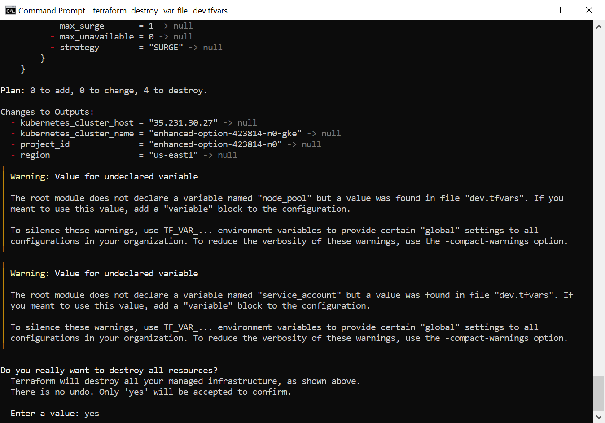

**Plan: 0 to add, 0 to change, 4 to destroy.**

**Changes to Outputs:**

**- kubernetes_cluster_host = "35.231.30.27" -> null**

**- kubernetes_cluster_name = "enhanced-option-423814-n0-gke" -> null**

**- project_id = "enhanced-option-423814-n0" -> null**

**- region = "us-east1" -> null**

**╷**

**│ Warning: Value for undeclared variable**

**│**

**│ The root module does not declare a variable named "node_pool" but a value was found in file "dev.tfvars". If you**

**│ meant to use this value, add a "variable" block to the configuration.**

**│**

**│ To silence these warnings, use TF_VAR_... environment variables to provide certain "global" settings to all**

**│ configurations in your organization. To reduce the verbosity of these warnings, use the -compact-warnings option.**

**╵**

**╷**

**│ Warning: Value for undeclared variable**

**│**

**│ The root module does not declare a variable named "service_account" but a value was found in file "dev.tfvars". If**

**│ you meant to use this value, add a "variable" block to the configuration.**

**│**

**│ To silence these warnings, use TF_VAR_... environment variables to provide certain "global" settings to all**

**│ configurations in your organization. To reduce the verbosity of these warnings, use the -compact-warnings option.**

**╵**

**Do you really want to destroy all resources?**

**Terraform will destroy all your managed infrastructure, as shown above.**

**There is no undo. Only 'yes' will be accepted to confirm.**

**Enter a value: yes**

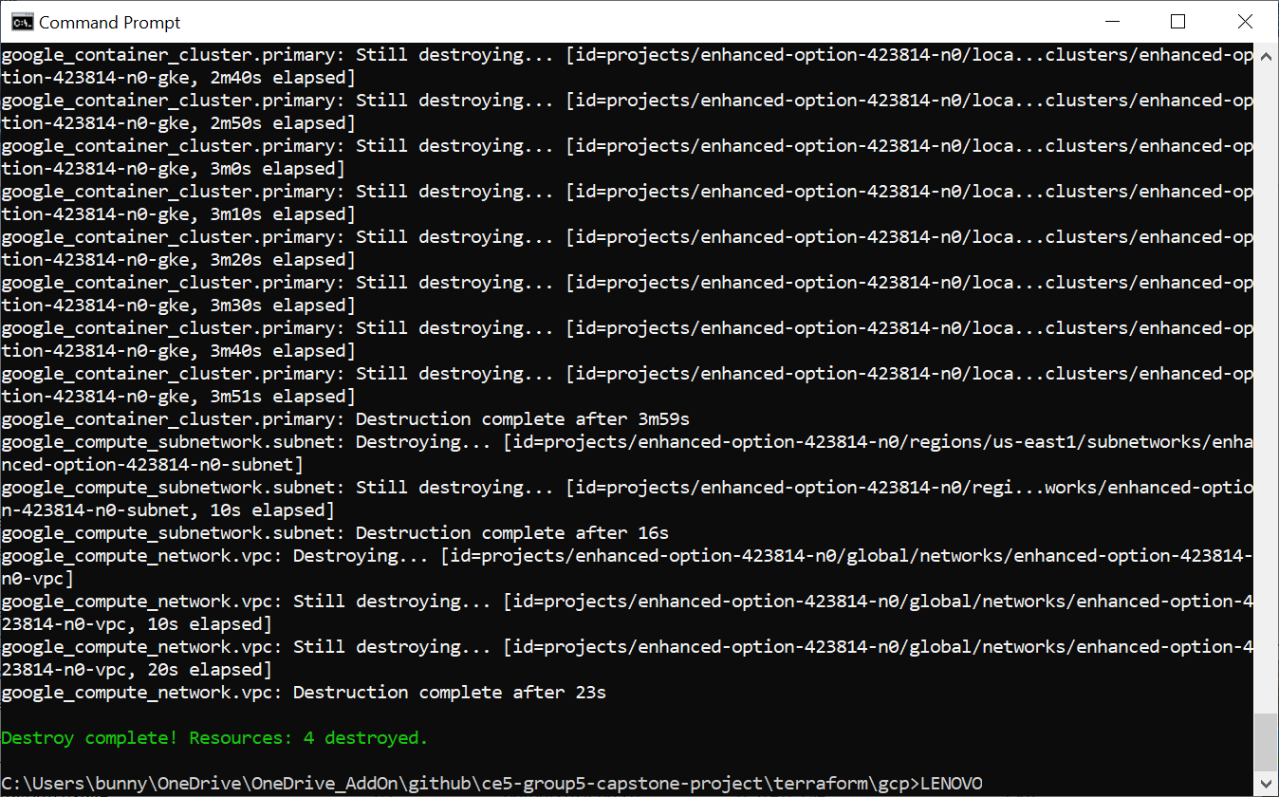

**google_container_node_pool.primary_nodes: Destroying... [id=projects/enhanced-option-423814-n0/locations/us-east1/clusters/enhanced-option-423814-n0-gke/nodePools/enhanced-option-423814-n0-gke]**

**google_container_node_pool.primary_nodes: Still destroying... [id=projects/enhanced-option-423814-n0/loca...odePools/enhanced-option-423814-n0-gke, 10s elapsed]**

**google_container_node_pool.primary_nodes: Still destroying... [id=projects/enhanced-option-423814-n0/loca...odePools/enhanced-option-423814-n0-gke, 20s elapsed]**

**google_container_node_pool.primary_nodes: Still destroying... [id=projects/enhanced-option-423814-n0/loca...odePools/enhanced-option-423814-n0-gke, 30s elapsed]**

**google_container_node_pool.primary_nodes: Still destroying... [id=projects/enhanced-option-423814-n0/loca...odePools/enhanced-option-423814-n0-gke, 40s elapsed]**

**google_container_node_pool.primary_nodes: Still destroying... [id=projects/enhanced-option-423814-n0/loca...odePools/enhanced-option-423814-n0-gke, 50s elapsed]**

**google_container_node_pool.primary_nodes: Still destroying... [id=projects/enhanced-option-423814-n0/loca...odePools/enhanced-option-423814-n0-gke, 1m0s elapsed]**

**google_container_node_pool.primary_nodes: Still destroying... [id=projects/enhanced-option-423814-n0/loca...odePools/enhanced-option-423814-n0-gke, 1m10s elapsed]**

**google_container_node_pool.primary_nodes: Still destroying... [id=projects/enhanced-option-423814-n0/loca...odePools/enhanced-option-423814-n0-gke, 1m20s elapsed]**

**google_container_node_pool.primary_nodes: Still destroying... [id=projects/enhanced-option-423814-n0/loca...odePools/enhanced-option-423814-n0-gke, 1m30s elapsed]**

**google_container_node_pool.primary_nodes: Still destroying... [id=projects/enhanced-option-423814-n0/loca...odePools/enhanced-option-423814-n0-gke, 1m40s elapsed]**

**google_container_node_pool.primary_nodes: Still destroying... [id=projects/enhanced-option-423814-n0/loca...odePools/enhanced-option-423814-n0-gke, 1m50s elapsed]**

**google_container_node_pool.primary_nodes: Still destroying... [id=projects/enhanced-option-423814-n0/loca...odePools/enhanced-option-423814-n0-gke, 2m0s elapsed]**

**google_container_node_pool.primary_nodes: Still destroying... [id=projects/enhanced-option-423814-n0/loca...odePools/enhanced-option-423814-n0-gke, 2m10s elapsed]**

**google_container_node_pool.primary_nodes: Still destroying... [id=projects/enhanced-option-423814-n0/loca...odePools/enhanced-option-423814-n0-gke, 2m20s elapsed]**

**google_container_node_pool.primary_nodes: Still destroying... [id=projects/enhanced-option-423814-n0/loca...odePools/enhanced-option-423814-n0-gke, 2m30s elapsed]**

**google_container_node_pool.primary_nodes: Still destroying... [id=projects/enhanced-option-423814-n0/loca...odePools/enhanced-option-423814-n0-gke, 2m40s elapsed]**

**google_container_node_pool.primary_nodes: Still destroying... [id=projects/enhanced-option-423814-n0/loca...odePools/enhanced-option-423814-n0-gke, 2m50s elapsed]**

**google_container_node_pool.primary_nodes: Still destroying... [id=projects/enhanced-option-423814-n0/loca...odePools/enhanced-option-423814-n0-gke, 3m0s elapsed]**

**google_container_node_pool.primary_nodes: Still destroying... [id=projects/enhanced-option-423814-n0/loca...odePools/enhanced-option-423814-n0-gke, 3m10s elapsed]**

**google_container_node_pool.primary_nodes: Still destroying... [id=projects/enhanced-option-423814-n0/loca...odePools/enhanced-option-423814-n0-gke, 3m20s elapsed]**

**google_container_node_pool.primary_nodes: Still destroying... [id=projects/enhanced-option-423814-n0/loca...odePools/enhanced-option-423814-n0-gke, 3m30s elapsed]**

**google_container_node_pool.primary_nodes: Still destroying... [id=projects/enhanced-option-423814-n0/loca...odePools/enhanced-option-423814-n0-gke, 3m40s elapsed]**

**google_container_node_pool.primary_nodes: Still destroying... [id=projects/enhanced-option-423814-n0/loca...odePools/enhanced-option-423814-n0-gke, 3m50s elapsed]**

**google_container_node_pool.primary_nodes: Still destroying... [id=projects/enhanced-option-423814-n0/loca...odePools/enhanced-option-423814-n0-gke, 4m0s elapsed]**

**google_container_node_pool.primary_nodes: Still destroying... [id=projects/enhanced-option-423814-n0/loca...odePools/enhanced-option-423814-n0-gke, 4m10s elapsed]**

**google_container_node_pool.primary_nodes: Still destroying... [id=projects/enhanced-option-423814-n0/loca...odePools/enhanced-option-423814-n0-gke, 4m20s elapsed]**

**google_container_node_pool.primary_nodes: Still destroying... [id=projects/enhanced-option-423814-n0/loca...odePools/enhanced-option-423814-n0-gke, 4m30s elapsed]**

**google_container_node_pool.primary_nodes: Still destroying... [id=projects/enhanced-option-423814-n0/loca...odePools/enhanced-option-423814-n0-gke, 4m40s elapsed]**

**google_container_node_pool.primary_nodes: Still destroying... [id=projects/enhanced-option-423814-n0/loca...odePools/enhanced-option-423814-n0-gke, 4m50s elapsed]**

**google_container_node_pool.primary_nodes: Still destroying... [id=projects/enhanced-option-423814-n0/loca...odePools/enhanced-option-423814-n0-gke, 5m0s elapsed]**

**google_container_node_pool.primary_nodes: Still destroying... [id=projects/enhanced-option-423814-n0/loca...odePools/enhanced-option-423814-n0-gke, 5m10s elapsed]**

**google_container_node_pool.primary_nodes: Still destroying... [id=projects/enhanced-option-423814-n0/loca...odePools/enhanced-option-423814-n0-gke, 5m20s elapsed]**

**google_container_node_pool.primary_nodes: Still destroying... [id=projects/enhanced-option-423814-n0/loca...odePools/enhanced-option-423814-n0-gke, 5m30s elapsed]**

**google_container_node_pool.primary_nodes: Still destroying... [id=projects/enhanced-option-423814-n0/loca...odePools/enhanced-option-423814-n0-gke, 5m40s elapsed]**

**google_container_node_pool.primary_nodes: Still destroying... [id=projects/enhanced-option-423814-n0/loca...odePools/enhanced-option-423814-n0-gke, 5m50s elapsed]**

**google_container_node_pool.primary_nodes: Still destroying... [id=projects/enhanced-option-423814-n0/loca...odePools/enhanced-option-423814-n0-gke, 6m0s elapsed]**

**google_container_node_pool.primary_nodes: Still destroying... [id=projects/enhanced-option-423814-n0/loca...odePools/enhanced-option-423814-n0-gke, 6m10s elapsed]**

**google_container_node_pool.primary_nodes: Still destroying... [id=projects/enhanced-option-423814-n0/loca...odePools/enhanced-option-423814-n0-gke, 6m20s elapsed]**

**google_container_node_pool.primary_nodes: Still destroying... [id=projects/enhanced-option-423814-n0/loca...odePools/enhanced-option-423814-n0-gke, 6m30s elapsed]**

**google_container_node_pool.primary_nodes: Still destroying... [id=projects/enhanced-option-423814-n0/loca...odePools/enhanced-option-423814-n0-gke, 6m40s elapsed]**

**google_container_node_pool.primary_nodes: Still destroying... [id=projects/enhanced-option-423814-n0/loca...odePools/enhanced-option-423814-n0-gke, 6m50s elapsed]**

**google_container_node_pool.primary_nodes: Still destroying... [id=projects/enhanced-option-423814-n0/loca...odePools/enhanced-option-423814-n0-gke, 7m0s elapsed]**

**google_container_node_pool.primary_nodes: Still destroying... [id=projects/enhanced-option-423814-n0/loca...odePools/enhanced-option-423814-n0-gke, 7m10s elapsed]**

**google_container_node_pool.primary_nodes: Still destroying... [id=projects/enhanced-option-423814-n0/loca...odePools/enhanced-option-423814-n0-gke, 7m20s elapsed]**

**google_container_node_pool.primary_nodes: Still destroying... [id=projects/enhanced-option-423814-n0/loca...odePools/enhanced-option-423814-n0-gke, 7m30s elapsed]**

**google_container_node_pool.primary_nodes: Still destroying... [id=projects/enhanced-option-423814-n0/loca...odePools/enhanced-option-423814-n0-gke, 7m40s elapsed]**

**google_container_node_pool.primary_nodes: Still destroying... [id=projects/enhanced-option-423814-n0/loca...odePools/enhanced-option-423814-n0-gke, 7m50s elapsed]**

**google_container_node_pool.primary_nodes: Still destroying... [id=projects/enhanced-option-423814-n0/loca...odePools/enhanced-option-423814-n0-gke, 8m0s elapsed]**

**google_container_node_pool.primary_nodes: Still destroying... [id=projects/enhanced-option-423814-n0/loca...odePools/enhanced-option-423814-n0-gke, 8m10s elapsed]**

**google_container_node_pool.primary_nodes: Still destroying... [id=projects/enhanced-option-423814-n0/loca...odePools/enhanced-option-423814-n0-gke, 8m20s elapsed]**

**google_container_node_pool.primary_nodes: Still destroying... [id=projects/enhanced-option-423814-n0/loca...odePools/enhanced-option-423814-n0-gke, 8m30s elapsed]**

**google_container_node_pool.primary_nodes: Still destroying... [id=projects/enhanced-option-423814-n0/loca...odePools/enhanced-option-423814-n0-gke, 8m40s elapsed]**

**google_container_node_pool.primary_nodes: Still destroying... [id=projects/enhanced-option-423814-n0/loca...odePools/enhanced-option-423814-n0-gke, 8m50s elapsed]**

**google_container_node_pool.primary_nodes: Still destroying... [id=projects/enhanced-option-423814-n0/loca...odePools/enhanced-option-423814-n0-gke, 9m0s elapsed]**

**google_container_node_pool.primary_nodes: Still destroying... [id=projects/enhanced-option-423814-n0/loca...odePools/enhanced-option-423814-n0-gke, 9m10s elapsed]**

**google_container_node_pool.primary_nodes: Still destroying... [id=projects/enhanced-option-423814-n0/loca...odePools/enhanced-option-423814-n0-gke, 9m20s elapsed]**

**google_container_node_pool.primary_nodes: Still destroying... [id=projects/enhanced-option-423814-n0/loca...odePools/enhanced-option-423814-n0-gke, 9m30s elapsed]**

**google_container_node_pool.primary_nodes: Still destroying... [id=projects/enhanced-option-423814-n0/loca...odePools/enhanced-option-423814-n0-gke, 9m40s elapsed]**

**google_container_node_pool.primary_nodes: Still destroying... [id=projects/enhanced-option-423814-n0/loca...odePools/enhanced-option-423814-n0-gke, 9m50s elapsed]**

**google_container_node_pool.primary_nodes: Still destroying... [id=projects/enhanced-option-423814-n0/loca...odePools/enhanced-option-423814-n0-gke, 10m0s elapsed]**

**google_container_node_pool.primary_nodes: Still destroying... [id=projects/enhanced-option-423814-n0/loca...odePools/enhanced-option-423814-n0-gke, 10m10s elapsed]**

**google_container_node_pool.primary_nodes: Still destroying... [id=projects/enhanced-option-423814-n0/loca...odePools/enhanced-option-423814-n0-gke, 10m20s elapsed]**

**google_container_node_pool.primary_nodes: Still destroying... [id=projects/enhanced-option-423814-n0/loca...odePools/enhanced-option-423814-n0-gke, 10m30s elapsed]**

**google_container_node_pool.primary_nodes: Still destroying... [id=projects/enhanced-option-423814-n0/loca...odePools/enhanced-option-423814-n0-gke, 10m40s elapsed]**

**google_container_node_pool.primary_nodes: Still destroying... [id=projects/enhanced-option-423814-n0/loca...odePools/enhanced-option-423814-n0-gke, 10m50s elapsed]**

**google_container_node_pool.primary_nodes: Still destroying... [id=projects/enhanced-option-423814-n0/loca...odePools/enhanced-option-423814-n0-gke, 11m0s elapsed]**

**google_container_node_pool.primary_nodes: Still destroying... [id=projects/enhanced-option-423814-n0/loca...odePools/enhanced-option-423814-n0-gke, 11m10s elapsed]**

**google_container_node_pool.primary_nodes: Still destroying... [id=projects/enhanced-option-423814-n0/loca...odePools/enhanced-option-423814-n0-gke, 11m20s elapsed]**

**google_container_node_pool.primary_nodes: Still destroying... [id=projects/enhanced-option-423814-n0/loca...odePools/enhanced-option-423814-n0-gke, 11m30s elapsed]**

**google_container_node_pool.primary_nodes: Still destroying... [id=projects/enhanced-option-423814-n0/loca...odePools/enhanced-option-423814-n0-gke, 11m40s elapsed]**

**google_container_node_pool.primary_nodes: Still destroying... [id=projects/enhanced-option-423814-n0/loca...odePools/enhanced-option-423814-n0-gke, 11m50s elapsed]**

**google_container_node_pool.primary_nodes: Still destroying... [id=projects/enhanced-option-423814-n0/loca...odePools/enhanced-option-423814-n0-gke, 12m0s elapsed]**

**google_container_node_pool.primary_nodes: Still destroying... [id=projects/enhanced-option-423814-n0/loca...odePools/enhanced-option-423814-n0-gke, 12m10s elapsed]**

**google_container_node_pool.primary_nodes: Still destroying... [id=projects/enhanced-option-423814-n0/loca...odePools/enhanced-option-423814-n0-gke, 12m20s elapsed]**

**google_container_node_pool.primary_nodes: Still destroying... [id=projects/enhanced-option-423814-n0/loca...odePools/enhanced-option-423814-n0-gke, 12m30s elapsed]**

**google_container_node_pool.primary_nodes: Destruction complete after 12m33s**

**google_container_cluster.primary: Destroying... [id=projects/enhanced-option-423814-n0/locations/us-east1/clusters/enhanced-option-423814-n0-gke]**

**google_container_cluster.primary: Still destroying... [id=projects/enhanced-option-423814-n0/loca...clusters/enhanced-option-423814-n0-gke, 10s elapsed]**

**google_container_cluster.primary: Still destroying... [id=projects/enhanced-option-423814-n0/loca...clusters/enhanced-option-423814-n0-gke, 20s elapsed]**

**google_container_cluster.primary: Still destroying... [id=projects/enhanced-option-423814-n0/loca...clusters/enhanced-option-423814-n0-gke, 30s elapsed]**

**google_container_cluster.primary: Still destroying... [id=projects/enhanced-option-423814-n0/loca...clusters/enhanced-option-423814-n0-gke, 40s elapsed]**

**google_container_cluster.primary: Still destroying... [id=projects/enhanced-option-423814-n0/loca...clusters/enhanced-option-423814-n0-gke, 50s elapsed]**

**google_container_cluster.primary: Still destroying... [id=projects/enhanced-option-423814-n0/loca...clusters/enhanced-option-423814-n0-gke, 1m0s elapsed]**

**google_container_cluster.primary: Still destroying... [id=projects/enhanced-option-423814-n0/loca...clusters/enhanced-option-423814-n0-gke, 1m10s elapsed]**

**google_container_cluster.primary: Still destroying... [id=projects/enhanced-option-423814-n0/loca...clusters/enhanced-option-423814-n0-gke, 1m20s elapsed]**

**google_container_cluster.primary: Still destroying... [id=projects/enhanced-option-423814-n0/loca...clusters/enhanced-option-423814-n0-gke, 1m30s elapsed]**

**google_container_cluster.primary: Still destroying... [id=projects/enhanced-option-423814-n0/loca...clusters/enhanced-option-423814-n0-gke, 1m40s elapsed]**

**google_container_cluster.primary: Still destroying... [id=projects/enhanced-option-423814-n0/loca...clusters/enhanced-option-423814-n0-gke, 1m50s elapsed]**

**google_container_cluster.primary: Still destroying... [id=projects/enhanced-option-423814-n0/loca...clusters/enhanced-option-423814-n0-gke, 2m0s elapsed]**

**google_container_cluster.primary: Still destroying... [id=projects/enhanced-option-423814-n0/loca...clusters/enhanced-option-423814-n0-gke, 2m10s elapsed]**

**google_container_cluster.primary: Still destroying... [id=projects/enhanced-option-423814-n0/loca...clusters/enhanced-option-423814-n0-gke, 2m20s elapsed]**

**google_container_cluster.primary: Still destroying... [id=projects/enhanced-option-423814-n0/loca...clusters/enhanced-option-423814-n0-gke, 2m30s elapsed]**

**google_container_cluster.primary: Still destroying... [id=projects/enhanced-option-423814-n0/loca...clusters/enhanced-option-423814-n0-gke, 2m40s elapsed]**

**google_container_cluster.primary: Still destroying... [id=projects/enhanced-option-423814-n0/loca...clusters/enhanced-option-423814-n0-gke, 2m50s elapsed]**

**google_container_cluster.primary: Still destroying... [id=projects/enhanced-option-423814-n0/loca...clusters/enhanced-option-423814-n0-gke, 3m0s elapsed]**

**google_container_cluster.primary: Still destroying... [id=projects/enhanced-option-423814-n0/loca...clusters/enhanced-option-423814-n0-gke, 3m10s elapsed]**

**google_container_cluster.primary: Still destroying... [id=projects/enhanced-option-423814-n0/loca...clusters/enhanced-option-423814-n0-gke, 3m20s elapsed]**

**google_container_cluster.primary: Still destroying... [id=projects/enhanced-option-423814-n0/loca...clusters/enhanced-option-423814-n0-gke, 3m30s elapsed]**

**google_container_cluster.primary: Still destroying... [id=projects/enhanced-option-423814-n0/loca...clusters/enhanced-option-423814-n0-gke, 3m40s elapsed]**

**google_container_cluster.primary: Still destroying... [id=projects/enhanced-option-423814-n0/loca...clusters/enhanced-option-423814-n0-gke, 3m51s elapsed]**

**google_container_cluster.primary: Destruction complete after 3m59s**

**google_compute_subnetwork.subnet: Destroying... [id=projects/enhanced-option-423814-n0/regions/us-east1/subnetworks/enhanced-option-423814-n0-subnet]**

**google_compute_subnetwork.subnet: Still destroying... [id=projects/enhanced-option-423814-n0/regi...works/enhanced-option-423814-n0-subnet, 10s elapsed]**

**google_compute_subnetwork.subnet: Destruction complete after 16s**

**google_compute_network.vpc: Destroying... [id=projects/enhanced-option-423814-n0/global/networks/enhanced-option-423814-n0-vpc]**

**google_compute_network.vpc: Still destroying... [id=projects/enhanced-option-423814-n0/global/networks/enhanced-option-423814-n0-vpc, 10s elapsed]**

**google_compute_network.vpc: Still destroying... [id=projects/enhanced-option-423814-n0/global/networks/enhanced-option-423814-n0-vpc, 20s elapsed]**

**google_compute_network.vpc: Destruction complete after 23s**

**Destroy complete! Resources: 4 destroyed.**

**C:\Users\bunny\OneDrive\OneDrive_AddOn\github\ce5-group5-capstone-project\terraform\gcp>LENOVO**

Command to run: **terraform destroy** **-var-file=dev.tfvars**.

Started at 0151AM 06 Jun 2024 Thursday.

Ended at 0209AM 06 Jun 2024 Thursday.

Runtime: 18 minutes without errors.