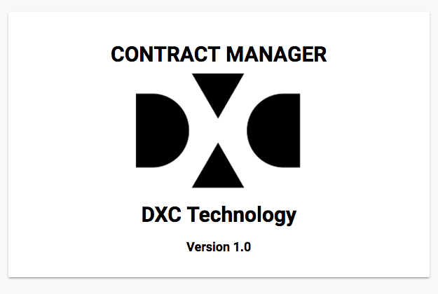

Contract Manager

User Guide

Table of Contents

1.1. Header 3

1.1.1. Menu 3

1.1.2. Current User Information 3

1.1.3. Quick Program Search 3

1.2. Section Editor 3

1.3. Tool bar 3

1.4. Pagination 3

1.5. Footer 3

2.1. Recently Updated 4

2.2. Recently Created 4

2.3. Recently Viewed 4

2.4. Advance Search 4

3.1. List of programs 5

3.1.1. Filters 5

3.1.2. List 5

3.2. Program Viewer 5

3.2.1. General 5

3.2.2. Affiliations 7

3.2.3. Contacts 7

3.2.4. Financials 7

3.2.5. Terms & Conditions 8

3.2.6. History & Contract Mods 8

3.2.7. Orders 8

3.2.8. Documents 10

3.3. Downloads 11

3.3.1. Program Details 11

3.3.2. Order Details 11

4.1. Financial Report 12

4.2. Order Modification Report 12

5.1. Program Editor 13

5.1.1. General 13

5.1.2. Affiliations 15

5.1.3. Contacts 15

5.1.4. Financials 15

5.1.5. Terms & Conditions 16

5.1.6. History & Contract Mods 16

5.1.7. Orders 17

5.1.8. Documents 19

5.5. Deleting a Program 19

6.1. Users 19

6.1.1. List 19

6.1.2. Creating a new user 19

6.2. Contacts 20

6.2.1. List 20

6.3. Places 20

6.3.1. List 20

6.3.2. Creating new place 20

# Structure of the Application

Following are the elements of the application

## Header

### Menu



### Current User Information



### Quick Program Search



The search bar helps you search program and switch to it.

## Section Editor

Each section has an edit button. Use it to change values within that section. Once done you can save it or revert back the changes



## Tool bar

A program and order can be downloaded in pdf format. User the **Print** button to download it.



At few places we have **Delete** button, this would delete the the entity under consideration



## Pagination

The lists are supported with pagination at the bottom; use it navigate between the pages



## Footer



It shows application’s versions and you can download this guide from there

# Home

It has list of programs grouped by recent actions

1. Name of the program
2. Date when the program was updated
3. Navigate to program

## Recently Updated

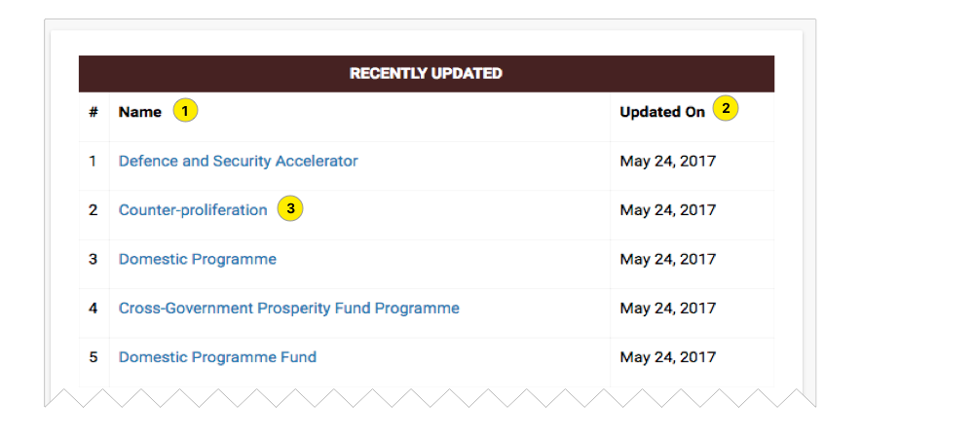

## Recently Created

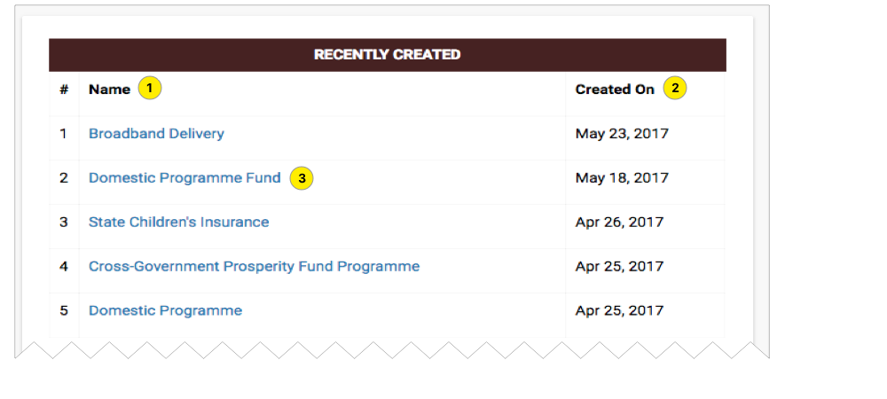

## Recently Viewed

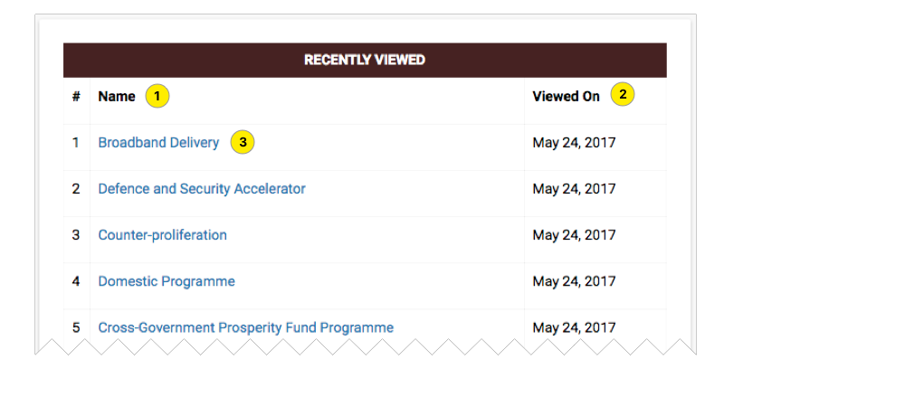

## Advance Search

Using this you should be able to drill down to specific set of programs

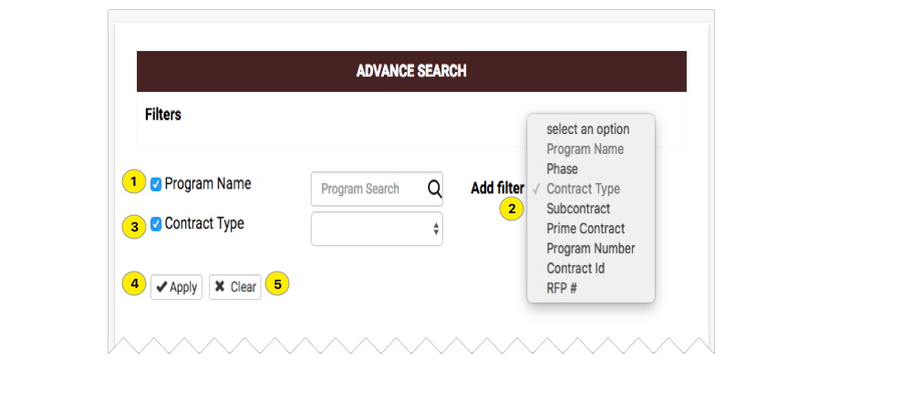

1. Program Name- - the default filter; you can deselect it
2. Add Filter – use it to add more filters

* Phase
* Contract Type
* Subcontract
* Prime Contract
* Program Number
* Contract Id
* RFP#

1. Contract Type – newly added filter
2. Apply – button to go to results.
3. Clear – to reset values of filter

# Programs

## List of programs

### Filters

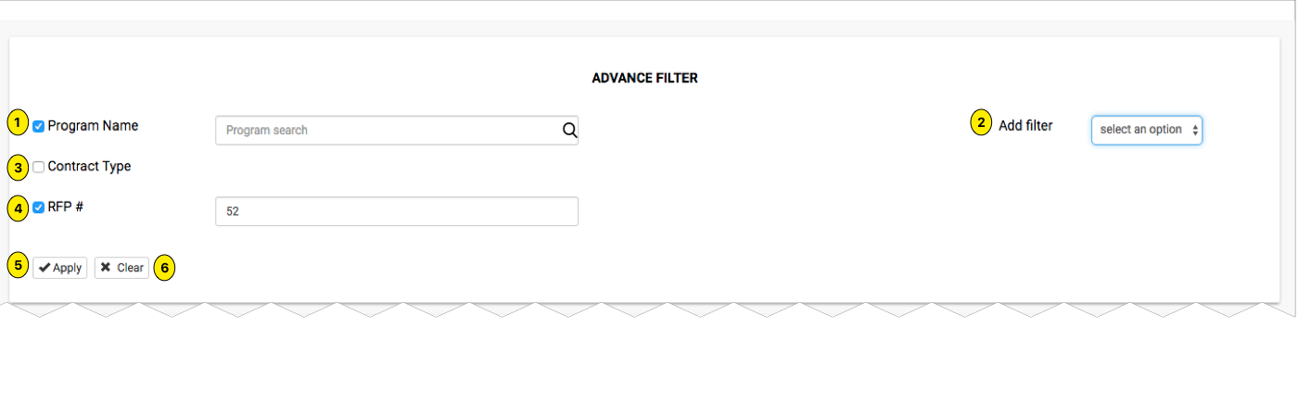

1. Program name
2. Add Filter
3. Contact Type
4. RFP #
5. Apply
6. Clear

### 

### List

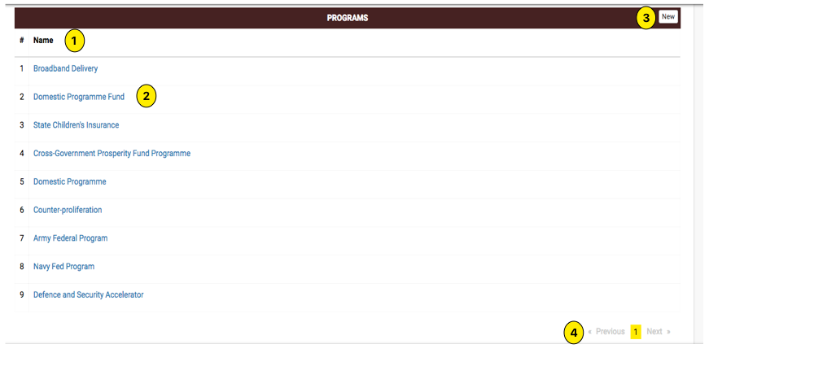

1. Name of program
2. Click on any program to show detail

## 

## Program Viewer

A program’s details has been segregated into following 8 tabs

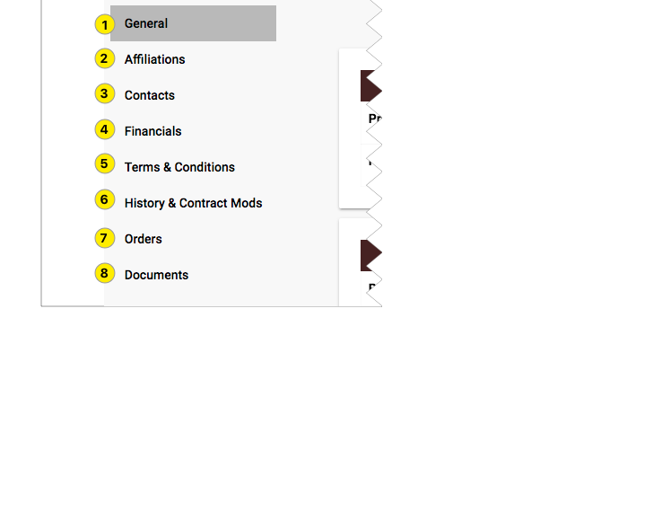

### General

#### General Information

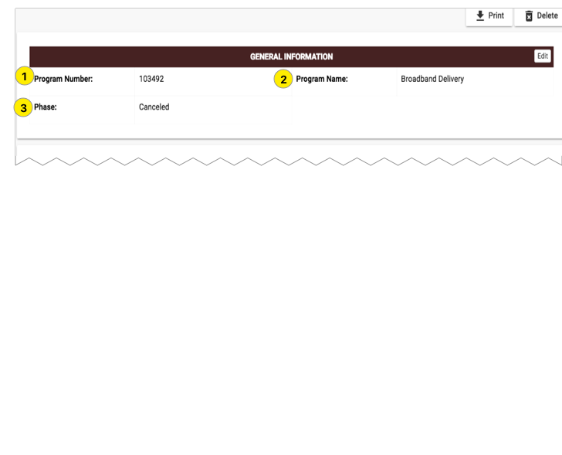

1. Auto generated program number -
2. The program name
3. Phase

#### 

#### Summary Information

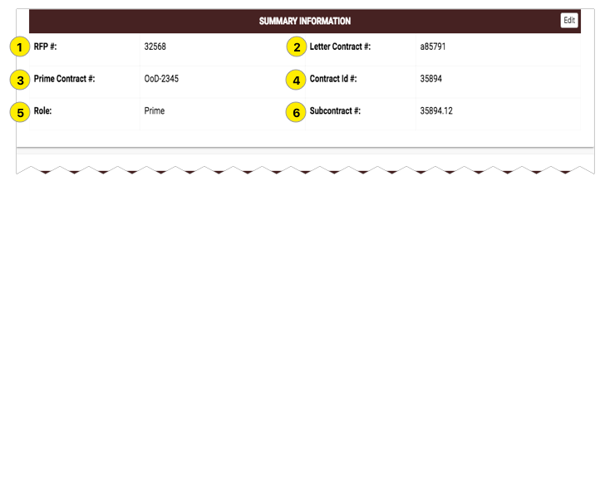

1. RFP#
2. Letter Contract #
3. Prime Contract #
4. Contract Id#
5. Role
6. Subcontract #

#### 

#### Contract Types

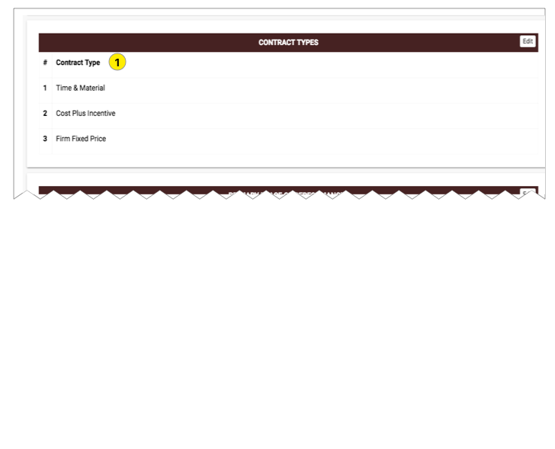

1. It can take multiple values like
   * Time and Material
   * Level of efforts
   * Letter Contract
   * Labour hours
   * IDIQ
   * Fixed Unit Price
   * Fixed Price
   * Level of efforts
   * Firm Fixed with EPA
   * Firm Fixed Price
   * Firm fixed Incentives
   * Cost sharing
   * Cost reimbursable
   * cost plus incentive
   * Cost plus Fixed fees
   * Cost plus Award fees

#### 

#### Primary Place of Performances

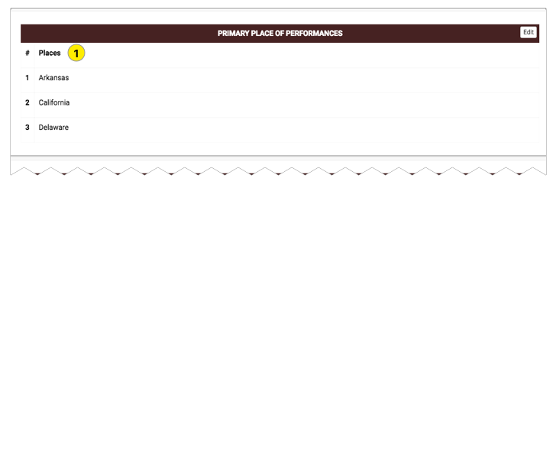

1. Multiple Places

#### 

#### Award Basis

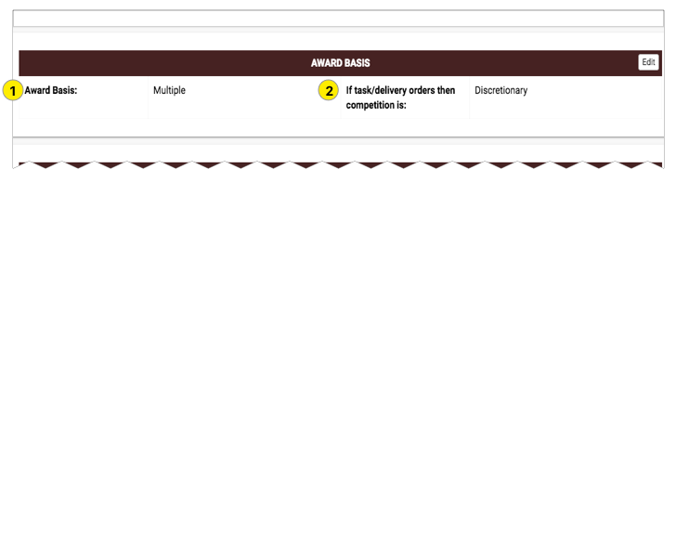

1. Multiple or Single
2. can be one of
   * Discretionary
   * None
   * Required

#### 

#### Service Offerings

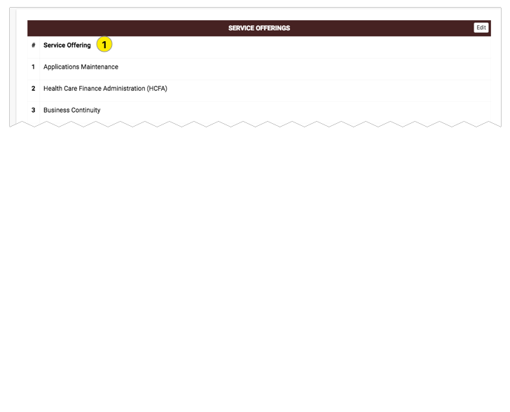

1. Multiple Values

#### 

#### Corporate Identifier

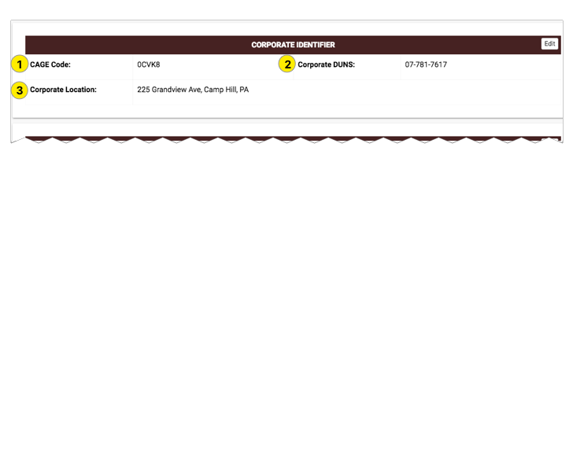

1. CAGE Code
2. Corporate DUNS attached with cage code
3. Corporate Location

#### 

#### Renewal

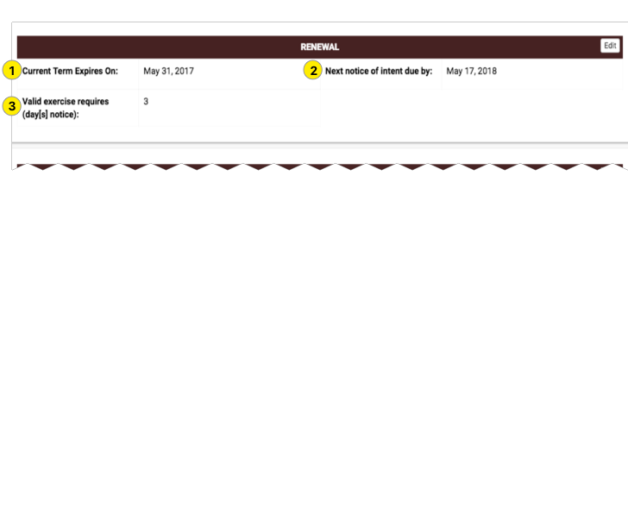

1. Current Term Expire On
2. Next notice of intent due by
3. Valid exercise requires (day[s]notice)

#### Dates

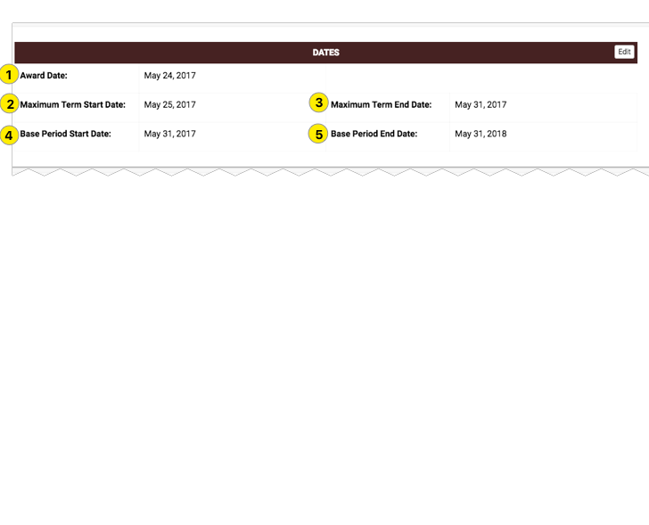

1. Award Date
2. Maximum Term Start Date
3. Maximum Term End Date
4. Base Period Start Date
5. Base Period End Date

#### 

#### Option Periods

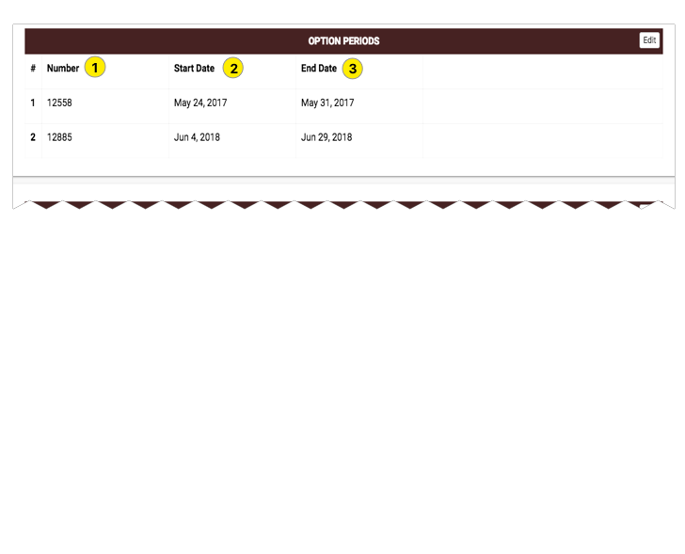

1. Number
2. Start Date
3. End Date

#### 

#### Procurement Regulations

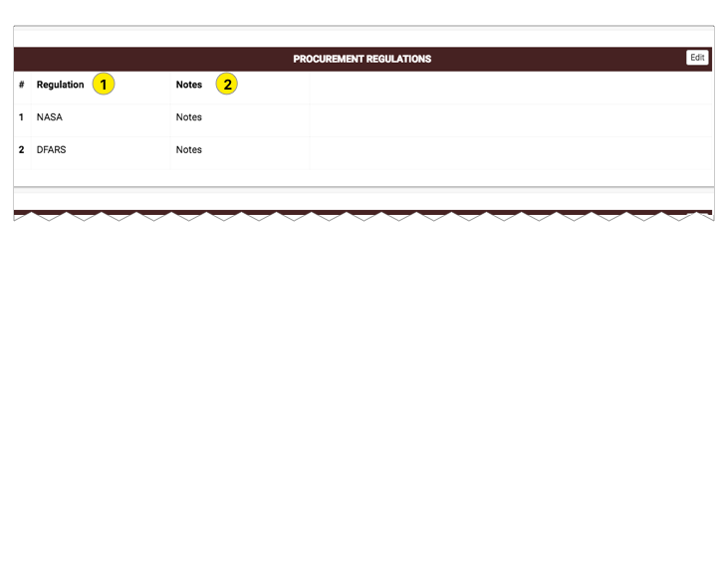

1. Regulation
2. Notes

#### Owners

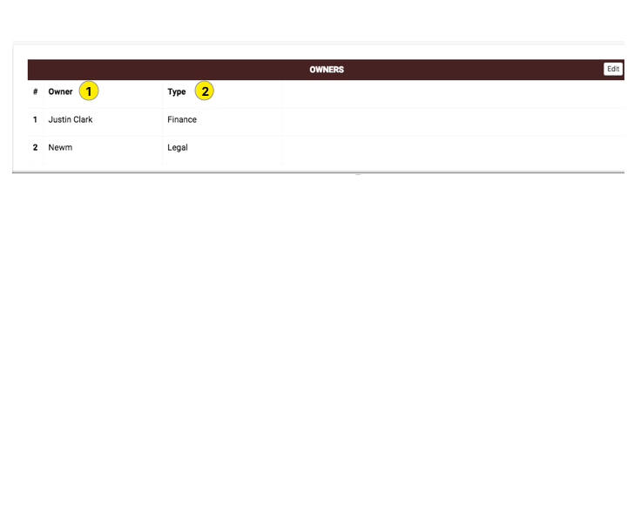

1. Owners
2. Type

### Affiliations

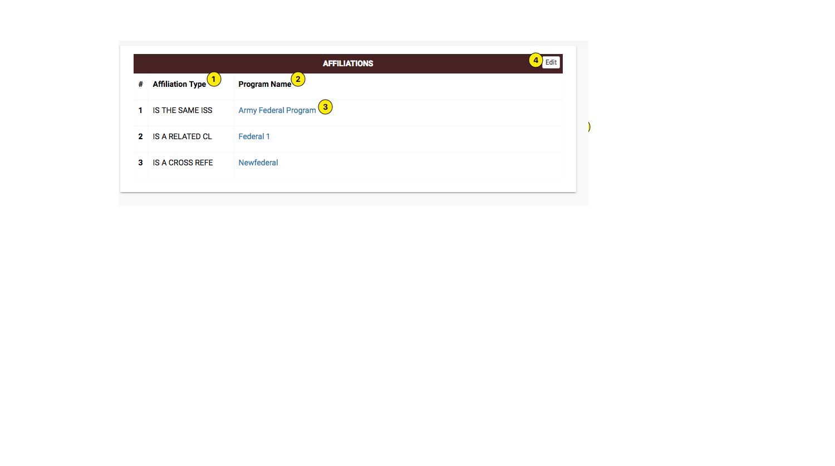

1. Affiliation Type
2. Program Name
3. Click on any program to detail.

### 

### Contacts

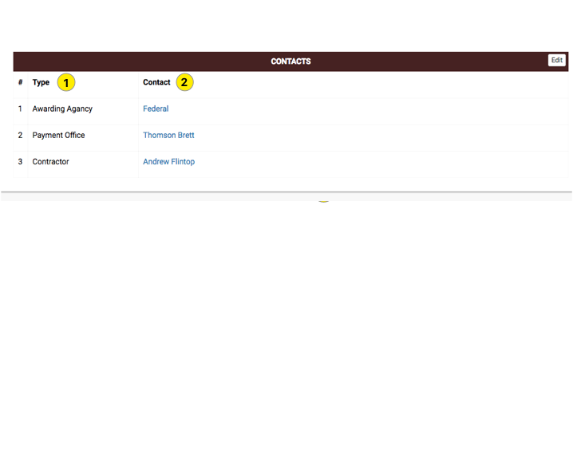

1. Type
2. Contact

### 

### Financials

#### Financial Control data

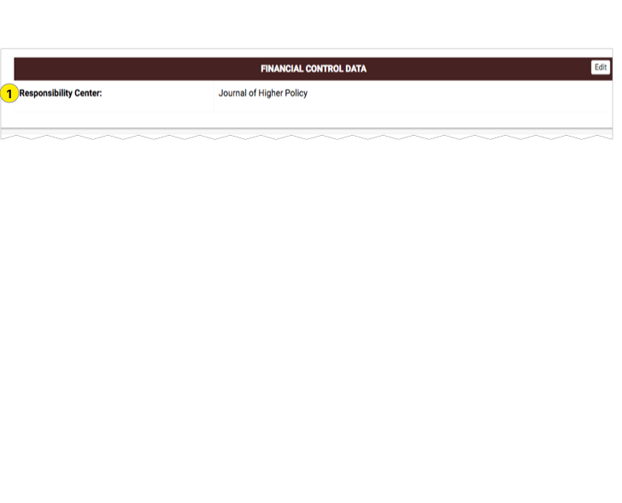

1. Responsibility Centre

#### Payment Information

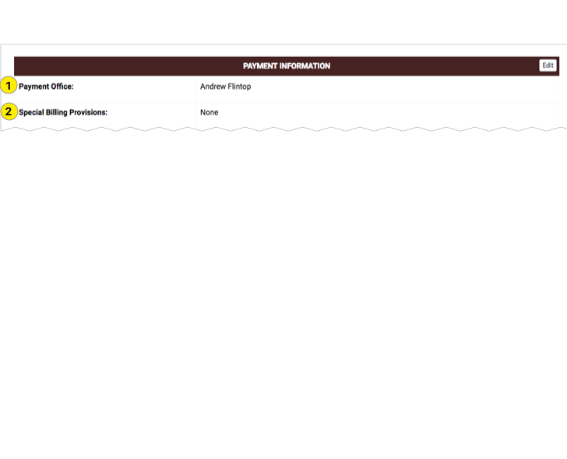

1. Payment office
2. Special Billing Provisions

#### Mechanics

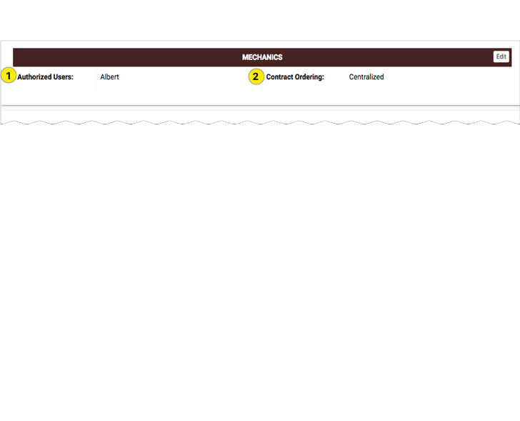

1. Authorized Users
2. Contract Ordering

#### Financial

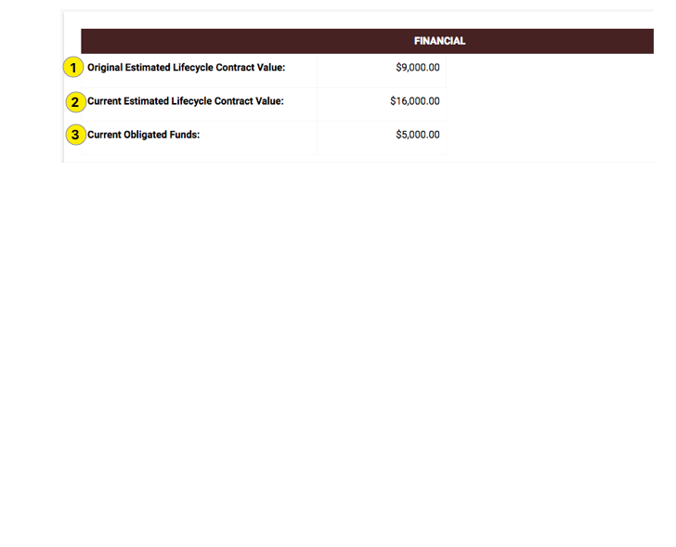

1. Original Estimated Lifecycle Contract Value
2. Current Estimated Lifecycle Contract Value
3. Current Obligated Funds

### 

### Terms & Conditions

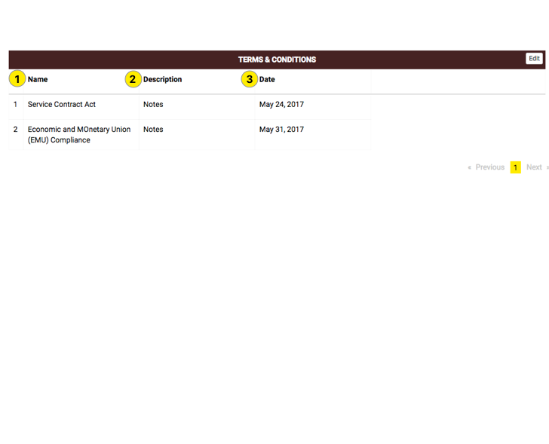

1. Name
2. Description
3. Date

### 

### History & Contract Mods

#### History

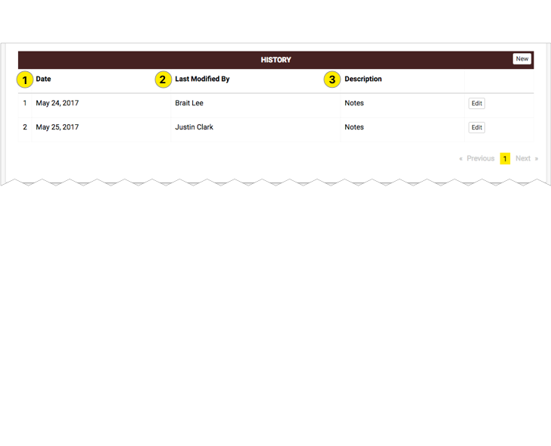

1. Date
2. Last Modified By
3. Description

#### Show Cause/ Cure Notice

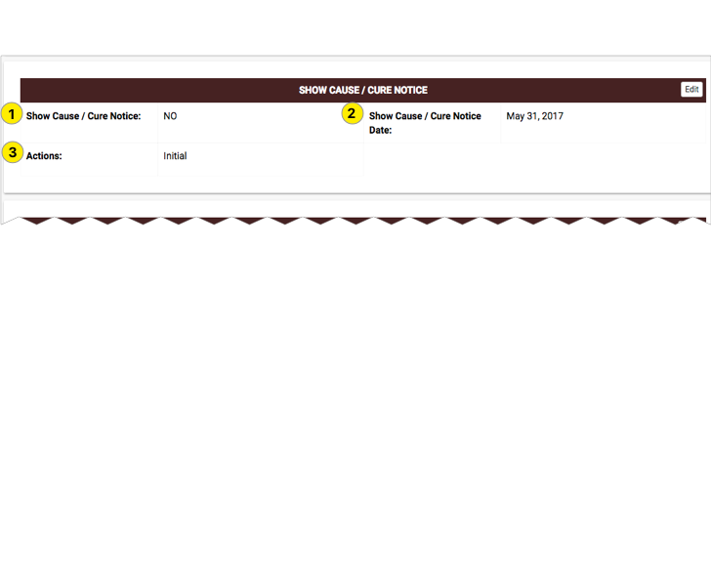

1. Show Cause / Cure Notice
2. Show Cause / Cure Notice Date
3. Actions

#### Contract Mods

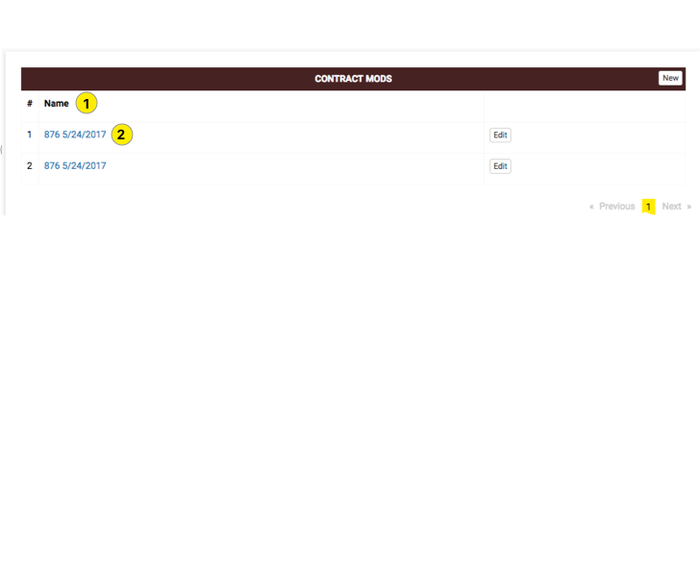

1. Name - Which contains list of contract mods
2. If user click on any name, then user will get the detail

### Orders

#### List

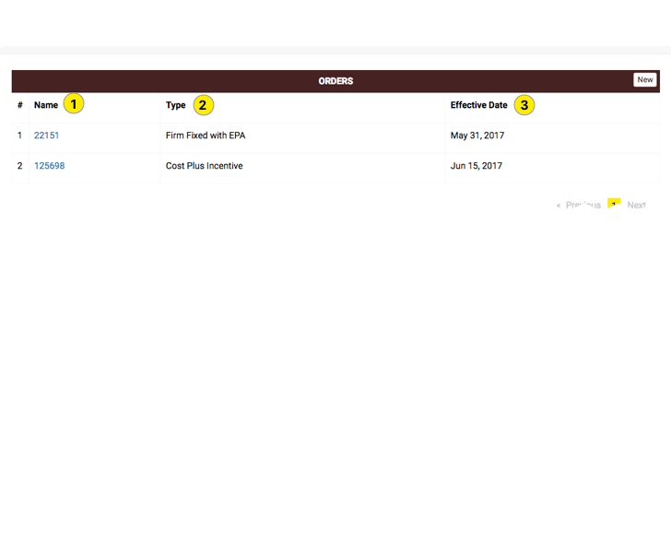

1. Orders Name
2. Type
3. Effective Date

#### Details

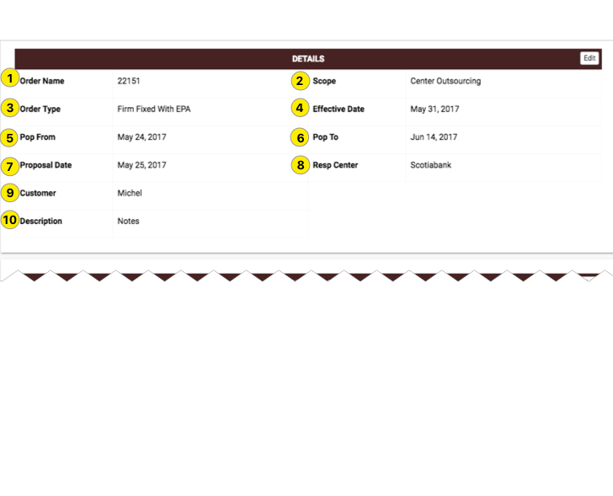

1. Orders Name
2. Scope
3. Order Type
4. Effective Date
5. Pop From
6. Pop To
7. Proposal date
8. Resp Center
9. Customer
10. Description

#### Financials

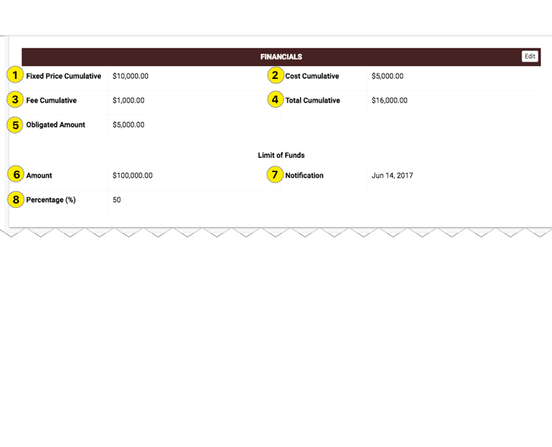

1. Fixed Price Cumulative
2. Cost Cumulative
3. fee Cumulative
4. Total Cumulative
5. Obligated Amount
6. Limit of Funds Amount
7. Limit of Funds Notification
8. Limit of Funds Percentage

#### Decentralized Order

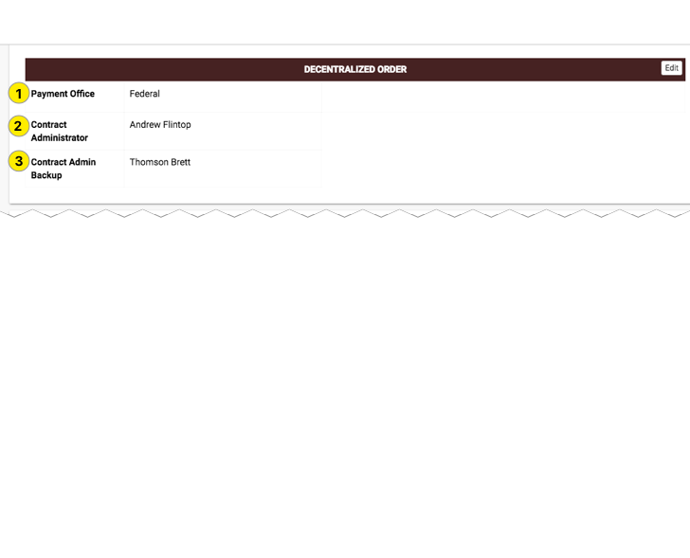

1. Payment Office
2. Contract Administrator
3. Contract Admin Backup

#### Contracting Officer

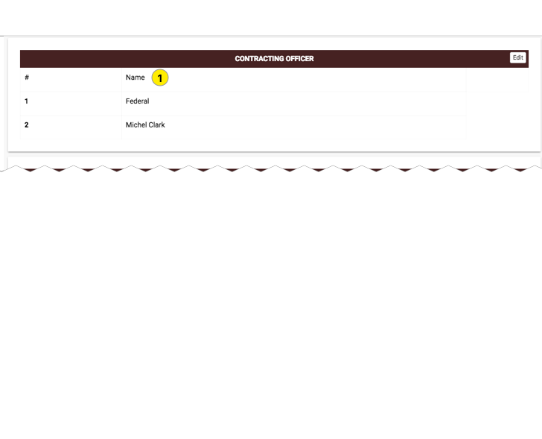

1. Name of Contracting Officer

#### Account Manager

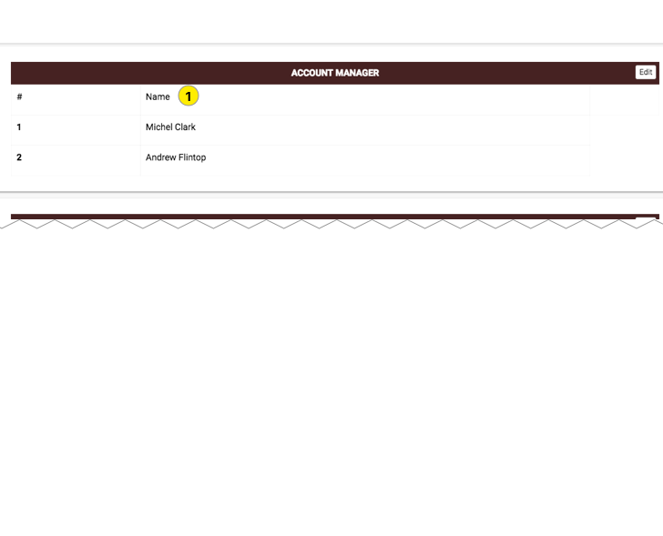

1. Name of Account Manager

#### Security

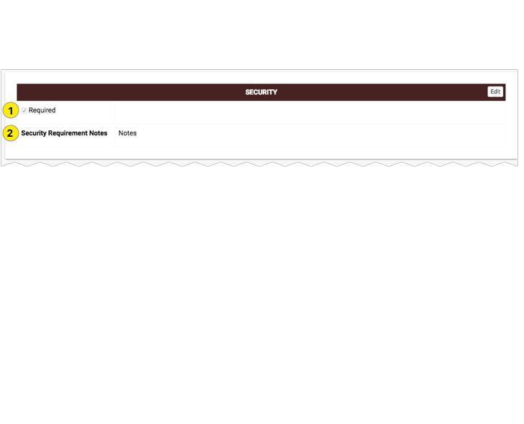

1. Required
2. Security Requirement Notes

#### Modifications

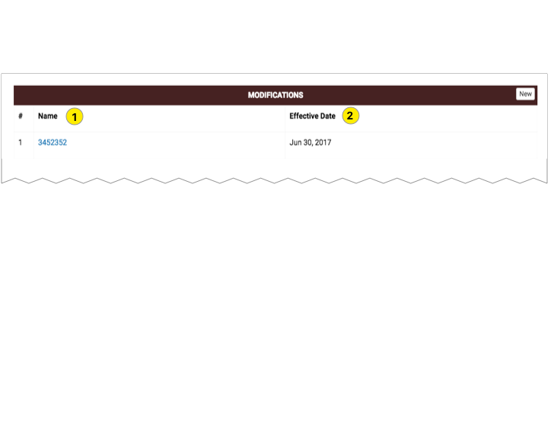

1. Name
2. Effective Date

##### Modification Details

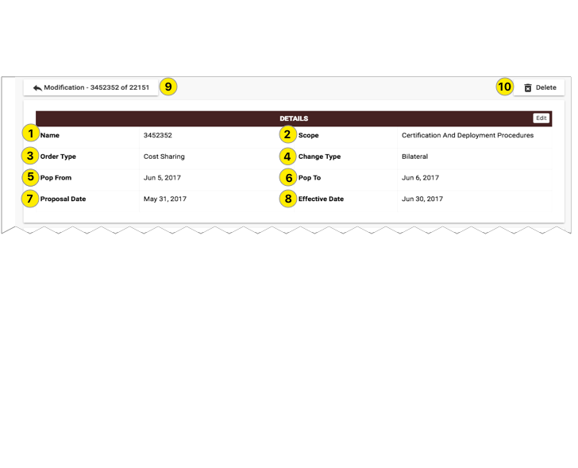

1. Orders Name
2. Scope
3. Order Type
4. Change Type
5. Pop From
6. Pop To
7. Proposal date
8. Effective Date
9. Back to list

##### Modification Financials

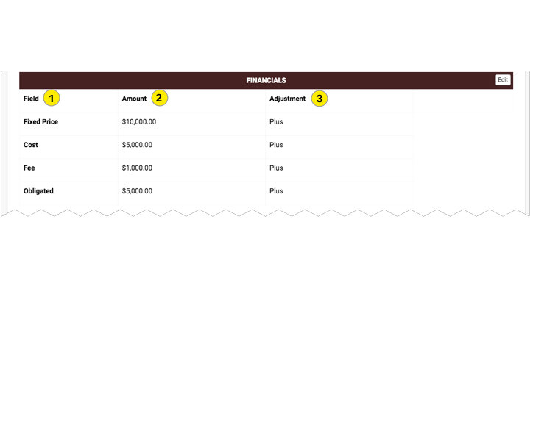

1. Fields
2. Amount
3. Adjustment

##### Modifications Changes Made

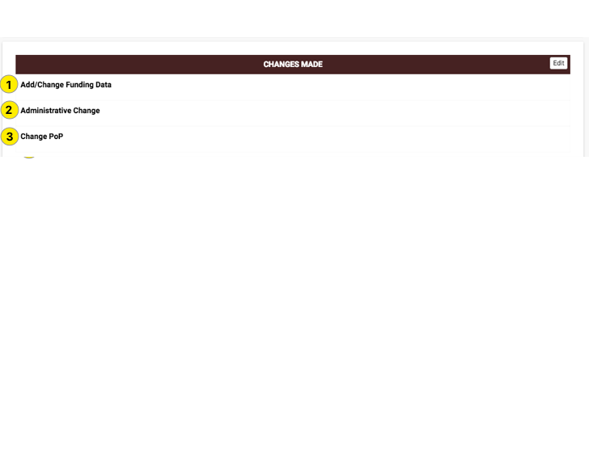

1. Add/ Change Funding Data
2. Administrative Change
3. Change Pop

### 

### Documents

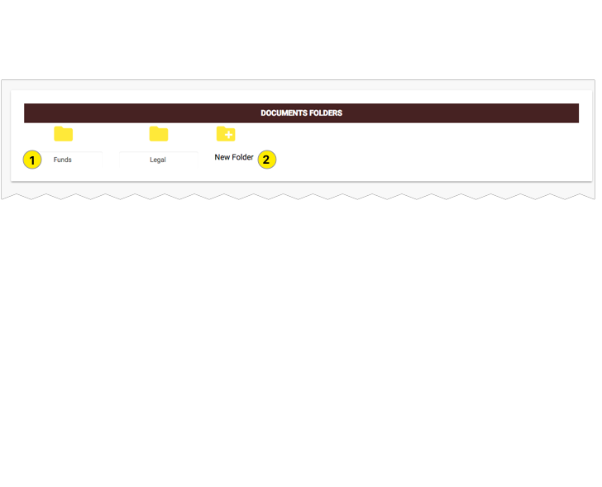

1. Folder
2. New Folder

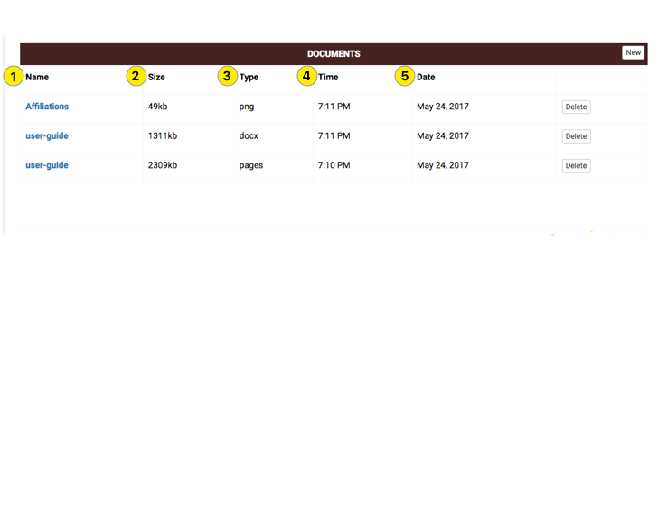

1. Name
2. Size
3. Type
4. Time
5. Date

## 

## Downloads

### Program Details

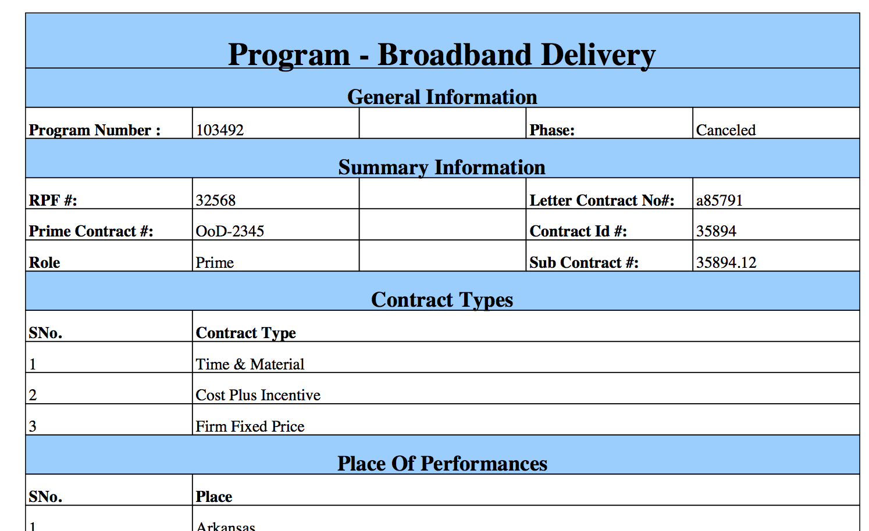

### Order Details

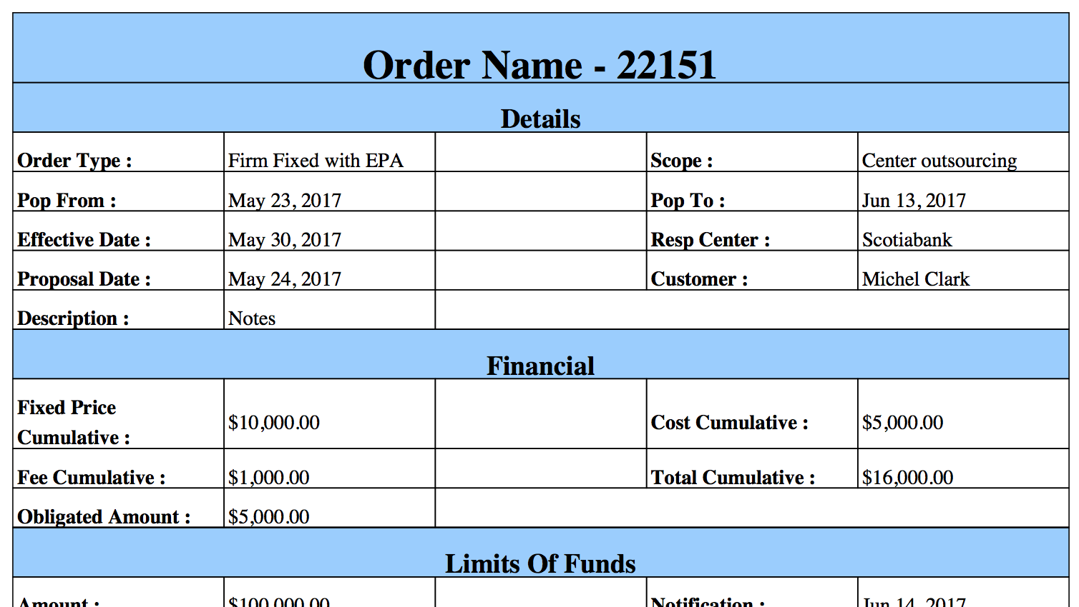

# Reports

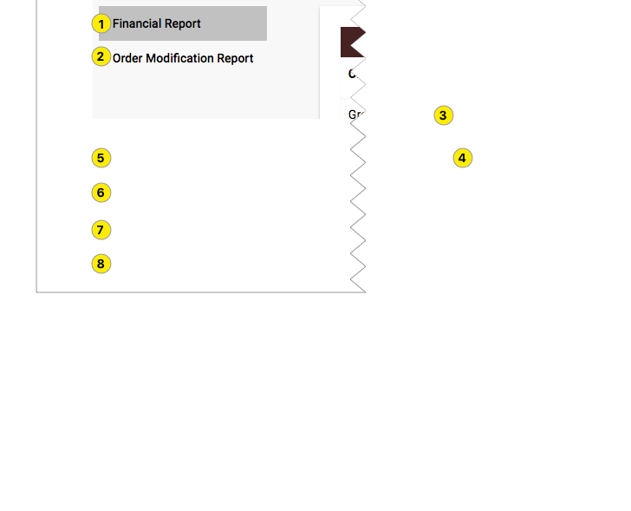

1. Financial report
2. Order Modification Report

### Financial Report

##### Step 1

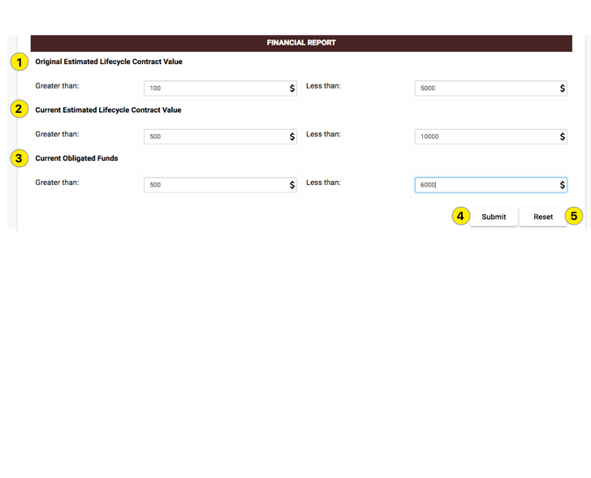

1. Original Estimated Lifecycle Contract Value
2. Current Estimated Lifecycle Contract Value
3. Current Obligated Funds
4. Submit
5. Reset

##### Step 2

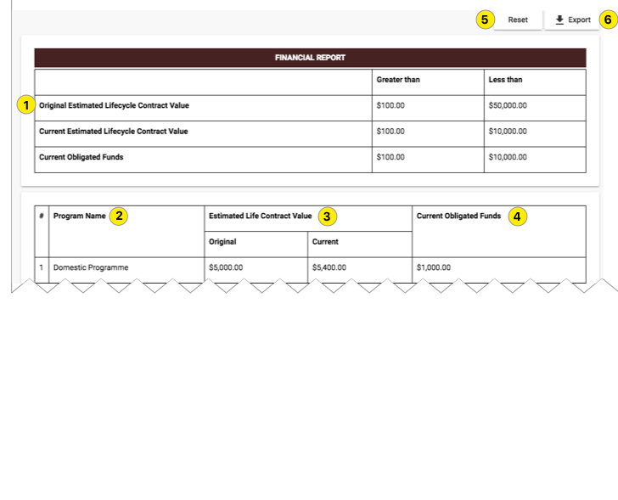

1. Original Estimated Lifecycle Contract Value
2. Program Name
3. Estimated Lifecycle Contract Value
4. Current Obligated Funds
5. Reset
6. Export

### 

### Order Modification Report

##### Step 1

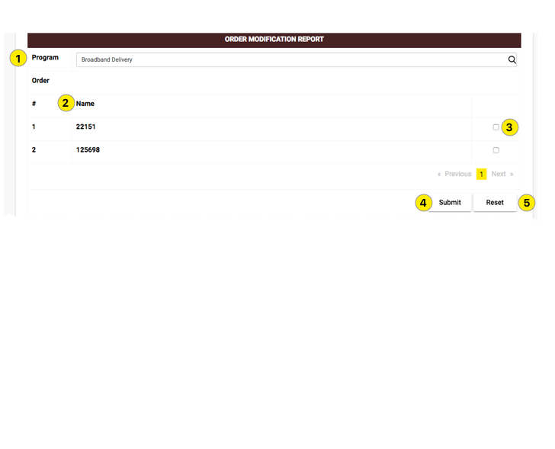

1. Program
2. Order Names
3. Check box
4. Submit
5. Reset

##### Step 2

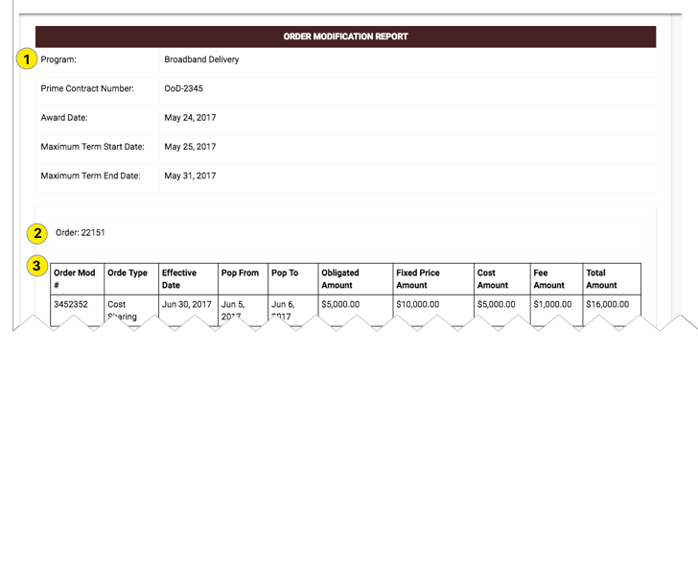

1. Program
2. Order no.
3. Order modification Fields

# 

# Modifying a Program

## Program Editor

### General

#### General Information

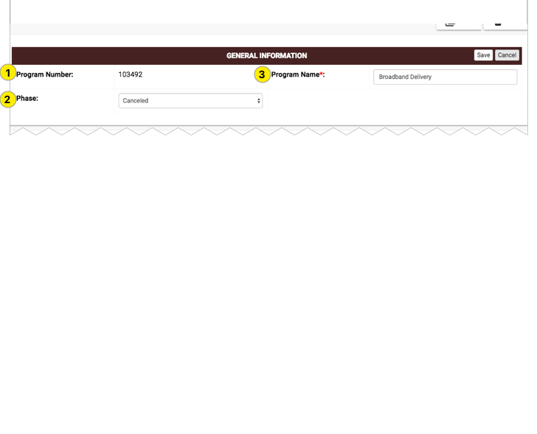

1. Program Number – auto generated number and cannot be edited
2. Program Name – text which is used to identify the program
3. Phase – it can take one of the following values

* Active
* Approved
* Approved (Pending)
* Cancelled
* Cancelled (Pending)
* Close
* Close - Out
* Closed
* Contract Administration
* Error
* Inactive
* Locked
* Lost
* Not Submitted
* Open With IT
* Open-OLD
* Pending Approval
* Pre-Proposal
* Processed
* Proposal
* Re-Open
* Rejected
* rejected (Pending)
* Reopen
* Research Pending
* Submitted

#### Summary Information

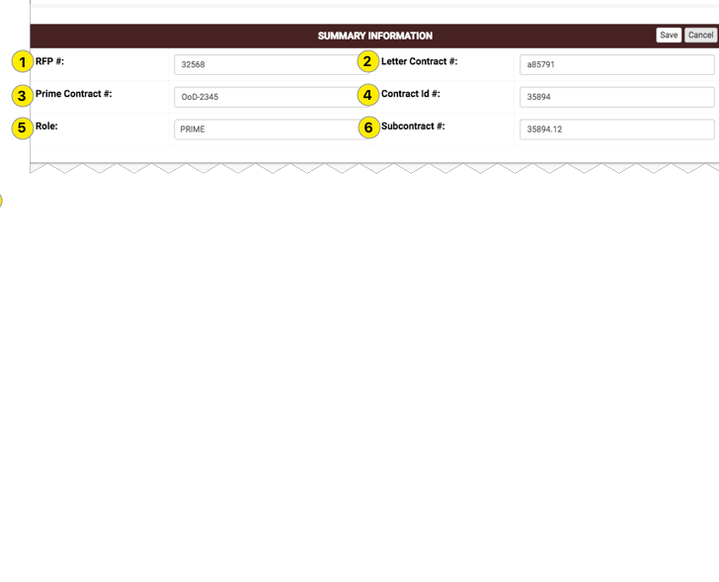

1. RFP #
2. Letter Contract #
3. Prime Contract #
4. Contract Id #
5. Role – User can take one of the following values
   * Prime
   * Subcontractor
6. Subcontract Id #

#### Contract Types

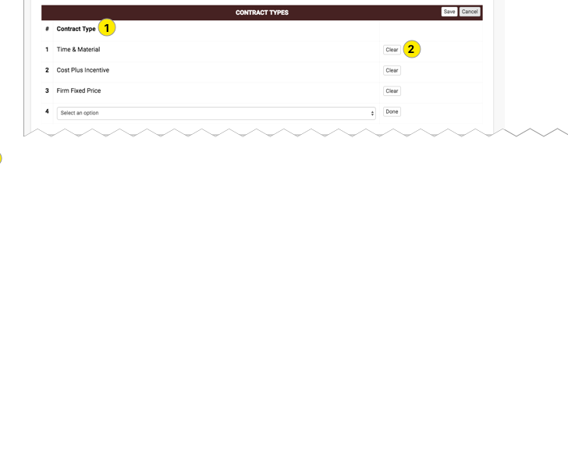

1. Contract Type- User can take one of the following values
   * Time and Material
   * Level of efforts
   * Letter Contract
   * Labour hours
   * IDIQ
   * Fixed Unit Price
   * Fixed Price , Level of efforts
   * Firm Fixed with EPA
   * Firm Fixed Price
   * Firm fixed Incentives
   * Cost sharing
   * Cost reimbursable
   * Cost Plus incentive
   * Cost Plus Fixed fees
   * Cost plus Award fees
2. Clear - User can clear the selected contract type.

#### Primary Place of Performance

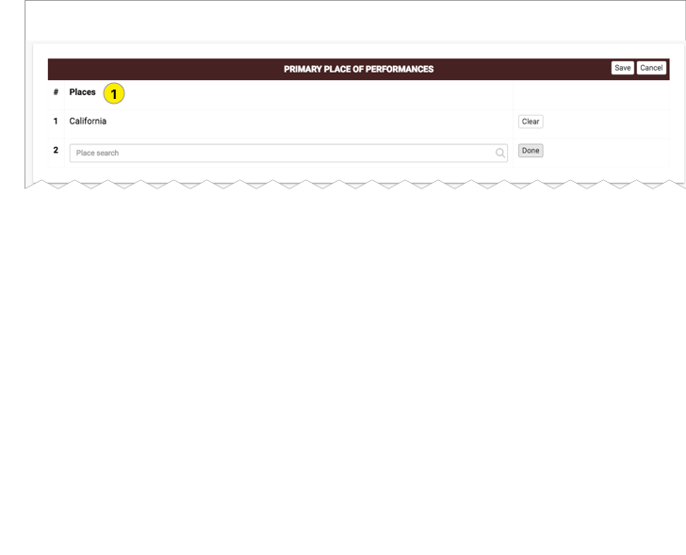

1. Places - user can select multiple.

#### Award Basis

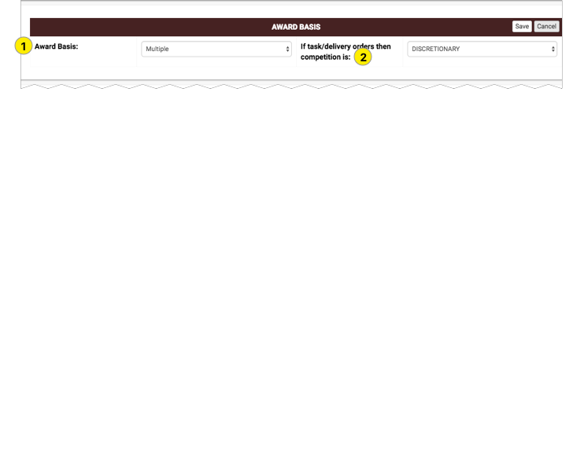

1. Award Basis : User can take one of the following values

* Multiple
* Single

1. If task/delivery orders then competition is:

* Discretionary
* None
* Required

#### Service Offerings

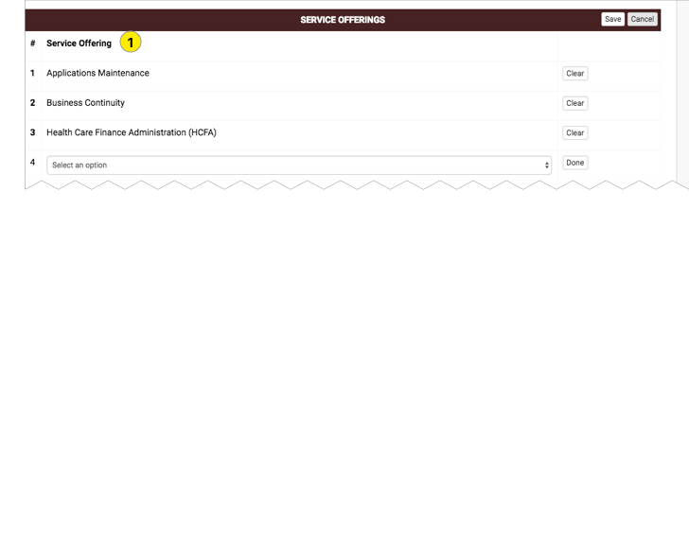

1. Options

* Applications Development & Mgt
* Applications Maintenance
* Asset Mgt and Maintenance
* Business Continuity
* Claims or Settlement Processing
* Consulting
* Desktop/Client Server
* E Communities
* Enterprise Customer Management
* Health Care Finance Administration (HCFA)
* Help Desk
* Internet Solutions & Applications
* Mainframe
* Midrange
* Procurement
* Project Support
* Télécommunications
* Training and Education

#### Corporate Identifier

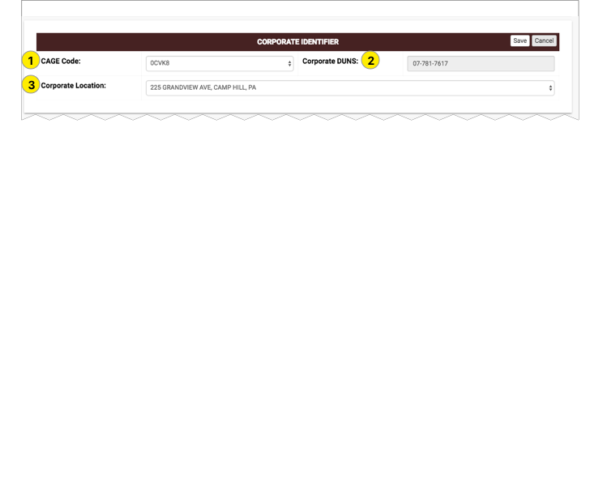

1. Cage Code

* 05HD8
* 1U305
* 0CVK8
* 00MK8
* TBD
* 1D6O3
* 4TJT0

1. Corporate DUNS –Auto generated
2. Corporate Location

* 5400 Legacy Drive, Plano, TX
* 13600 EDS Drive, Herndon, VA
* 225 Grandview Ave, Camp Hill, PA
* 1600 North Beauregard Street, Alexandria, VA
* 7900 Westpark Dr, T-600, McLean, VA
* SafeGuard Services
* Falls Church, VA
* 4646 Needmore Rd, P.O. Box 24593, Dayton, OH 45424
* NHIC

#### Renewal

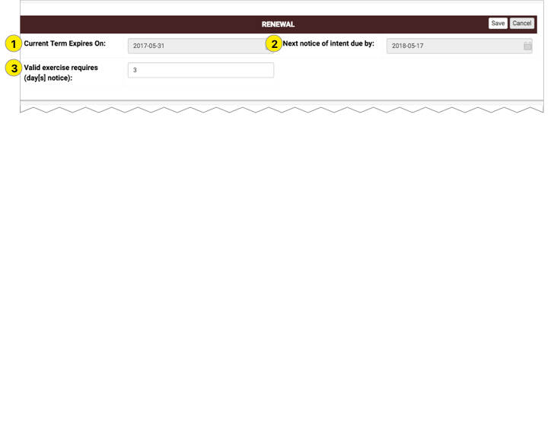

1. Current Term Expire On
2. Next notice of Intent due by
3. Valid exercise requires (day[s] notice)

#### Dates

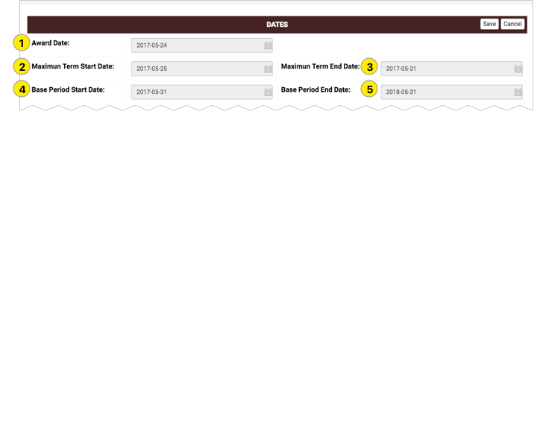

1. Award Date
2. maximum Term Start Date
3. Maximum Term End Date
4. Base Period Start Date
5. Base Period End Date

#### Option Periods

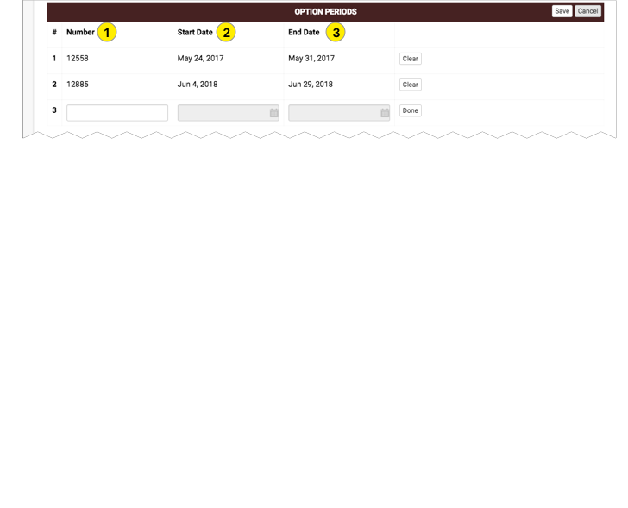

1. Number
2. Start Date
3. End Date

#### Procurement Regulations

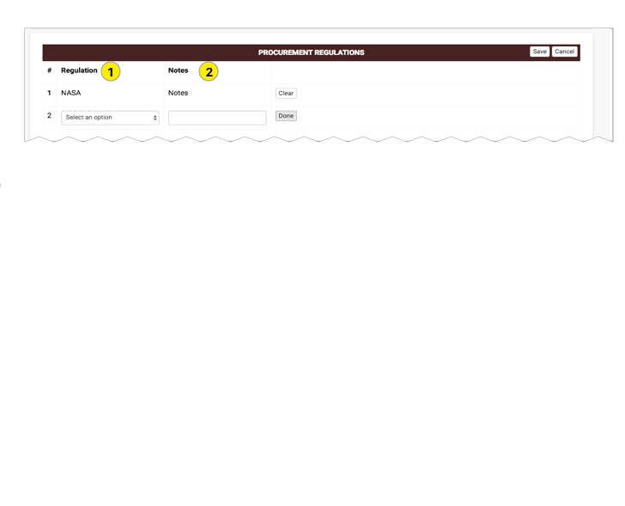

1. Number
2. Start Date
3. End Date

#### Owners

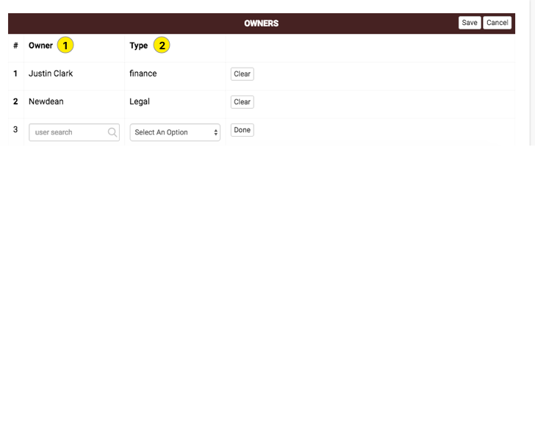

1. Owner
2. Type

### 

### Affiliations

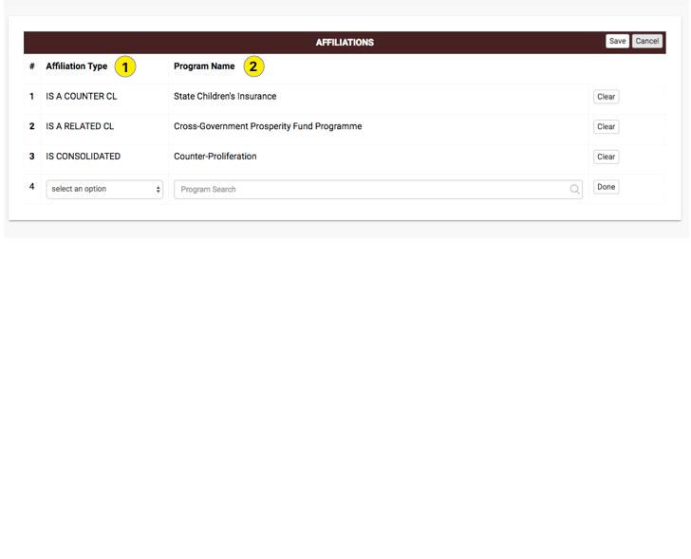

1. Affiliation Type
2. Program Name

### 

### Contacts

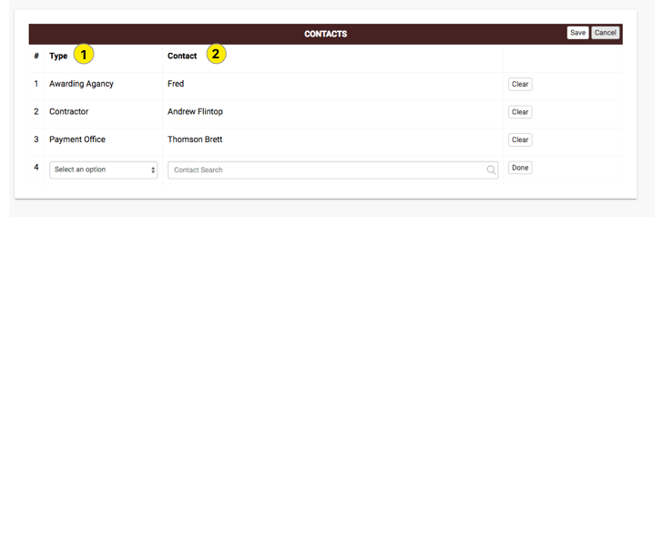

1. Type
2. Contact

### 

### Financials

#### Financial Control Data

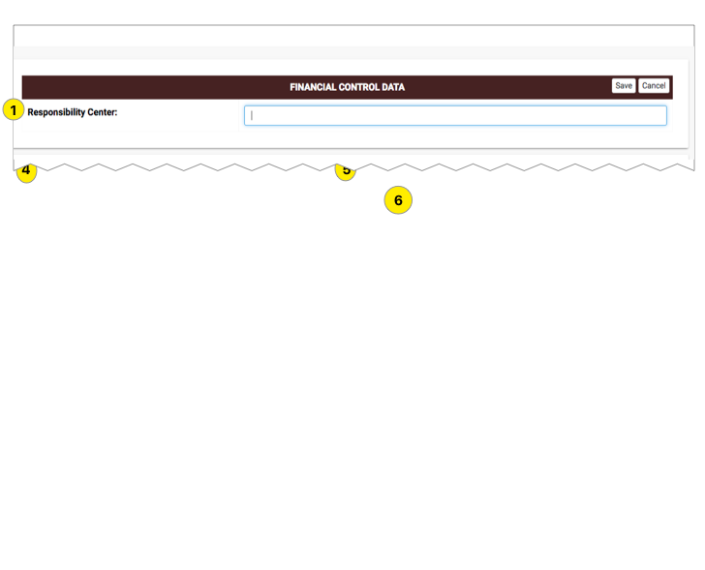

1. Responsibility Center

#### Payment Information

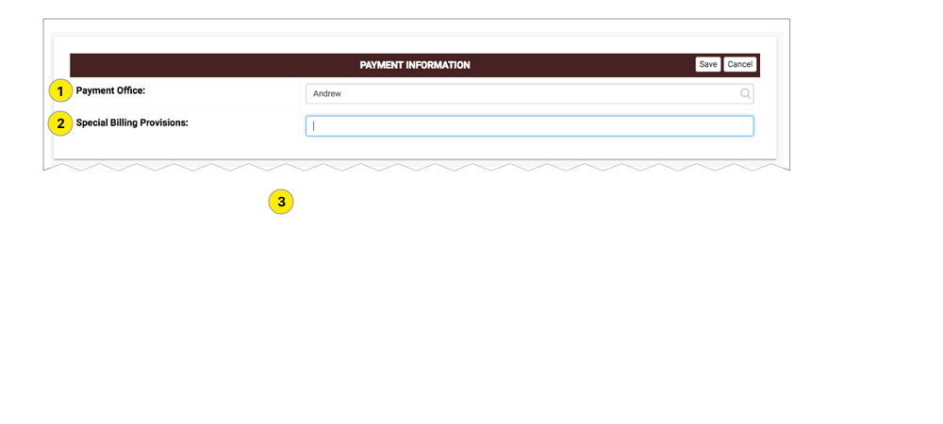

1. Payment Office
2. Special Billing Provisions

#### Mechanics

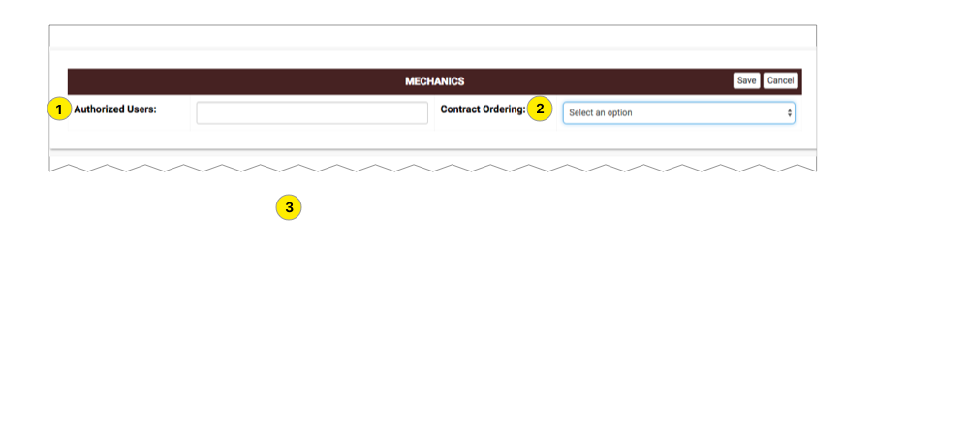

1. Authorized Users
2. Contract Ordering

#### Financial

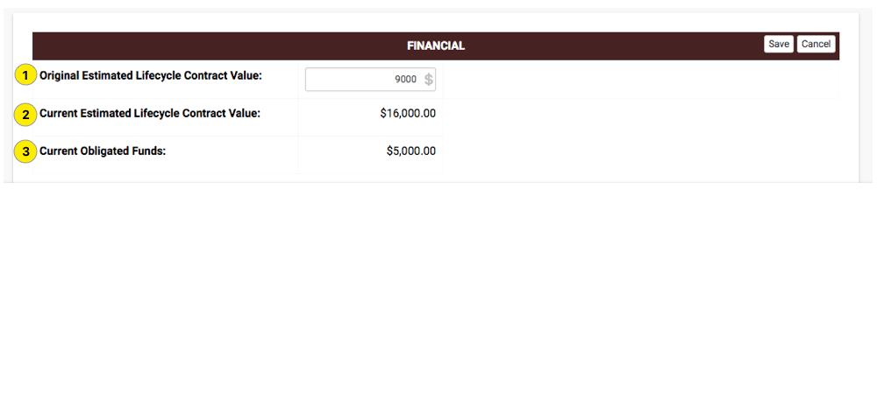

1. Original Estimated Lifecycle Contract Value
2. Current Estimated Lifecycle Contract Value
3. Current Obligated Funds

### Terms & Conditions

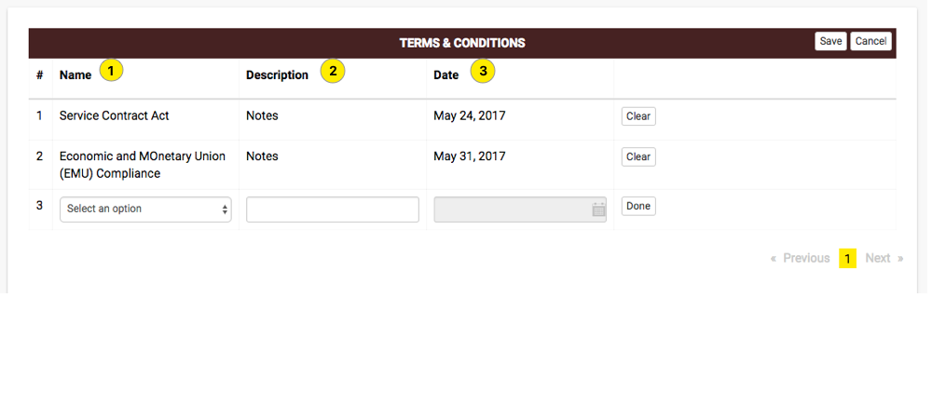

1. Name
2. Description
3. Date

### 

### History & Contract Mods

#### New History

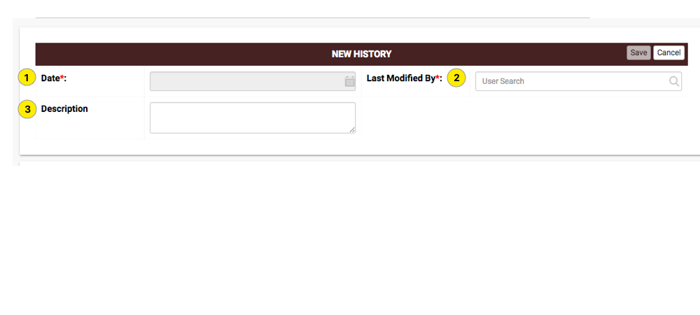

1. Date
2. Last Modified By
3. Description

#### Show Cause / Cure Notice

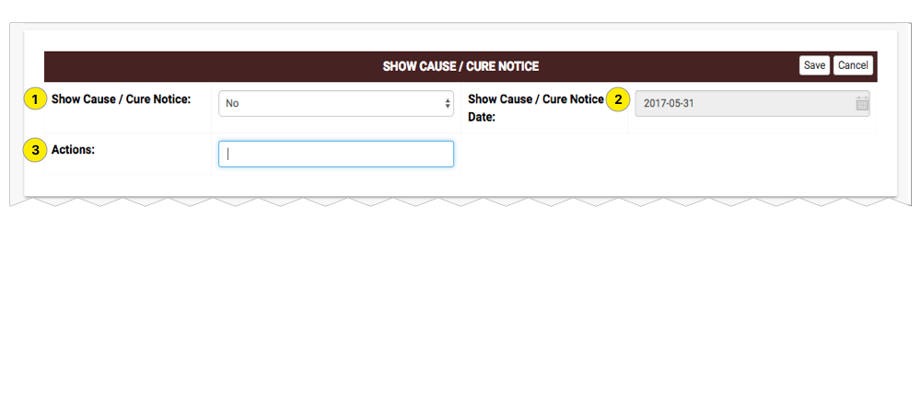

1. Show Cause/Cure Notice
2. Show Cause/ Cure Notice Date
3. Actions

#### New Contract Mods

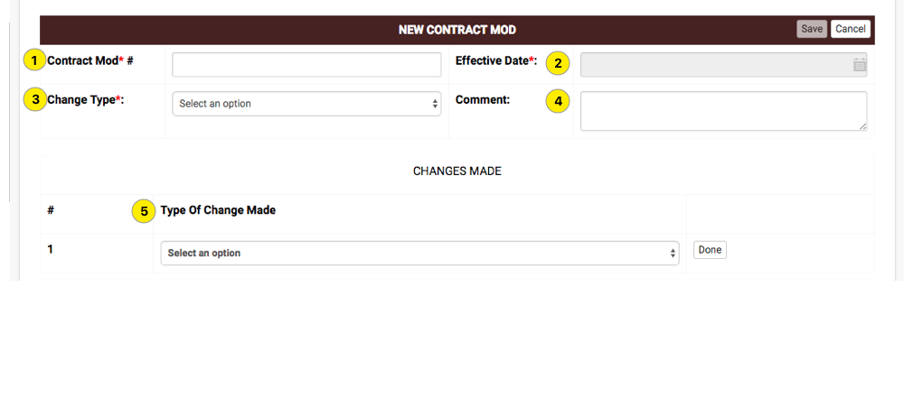

1. Contract Mod#
2. Effective Date
3. Change Type
4. Comment
5. Type of Change Made

### 

### Orders

#### New Order

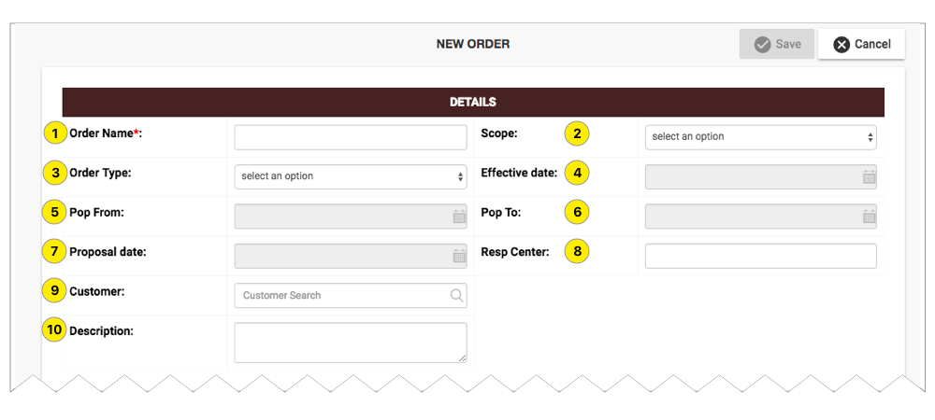

1. Orders Name
2. Scope
3. Order Type
4. Effective Date
5. Pop From
6. Pop To
7. Proposal date
8. Resp Center
9. Customer
10. Description

#### Order Detail

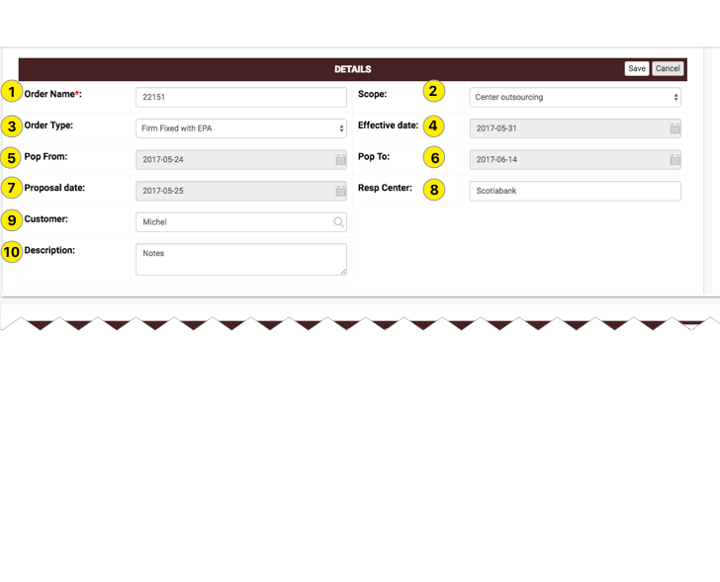

1. Orders Name
2. Scope
3. Order Type
4. Effective Date
5. Pop From
6. Pop To
7. Proposal date
8. Resp Center
9. Customer
10. Description

#### Financials

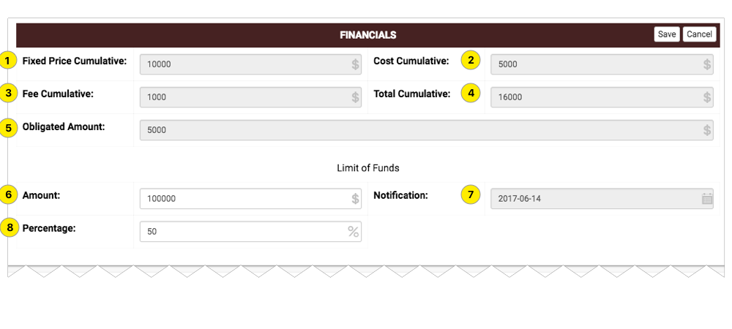

1. Fixed Price Cumulative
2. Cost Cumulative
3. fee Cumulative
4. Total Cumulative
5. Obligated Amount
6. Limit of Funds Amount
7. Limit of Funds Notification
8. Limit of Funds Percentage

#### Decentralized Order

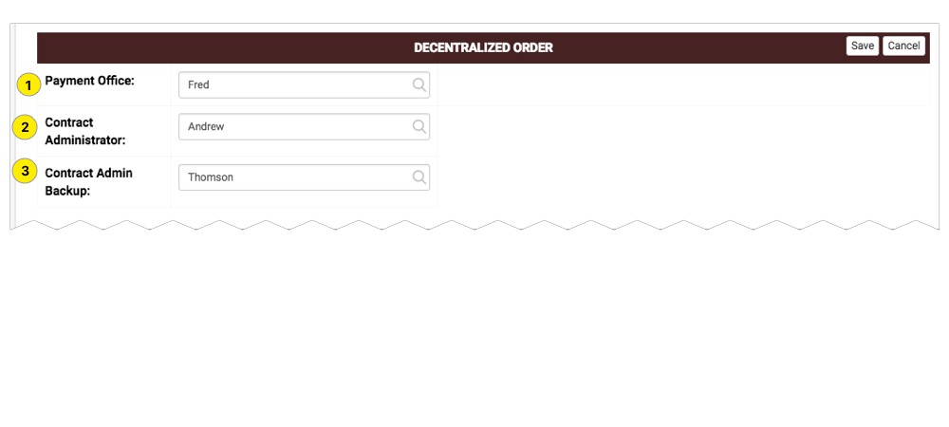

1. Payment Office
2. Contract Administrator
3. Contract Admin Backup

#### Contracting Officer

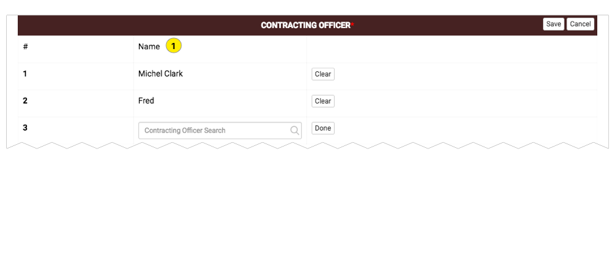

1. Name

#### Account Manager

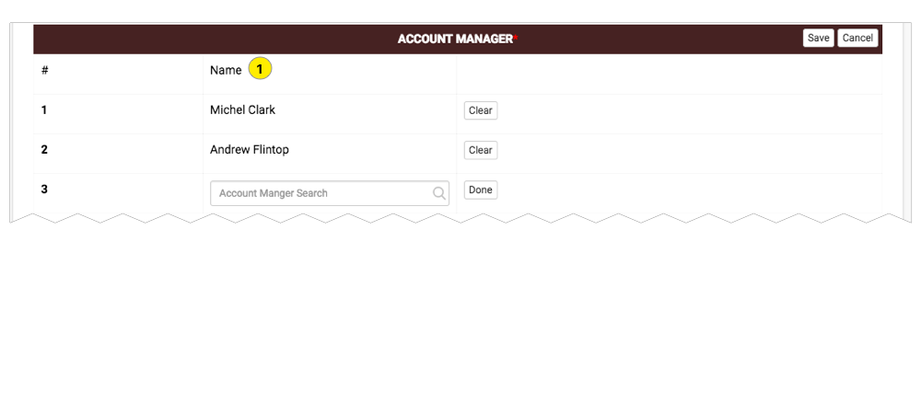

1. Name

#### Security

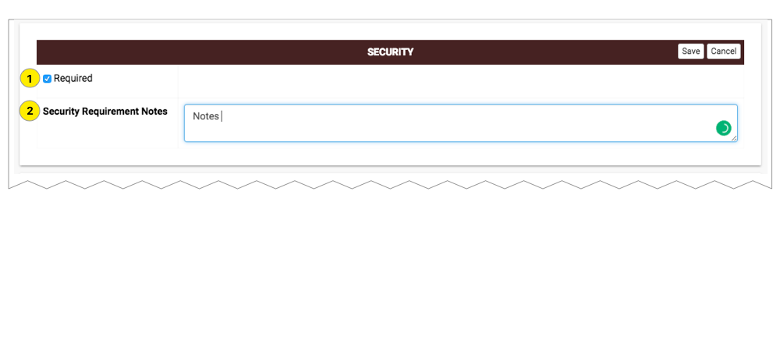

1. Required
2. Security Requirement Notes

#### New Modification

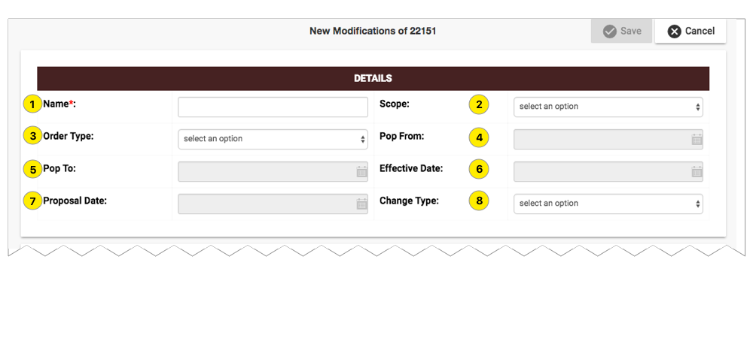

1. Name
2. Scope
3. Order Type
4. Change Type
5. Pop From
6. Pop To
7. Proposal date
8. Effective Date

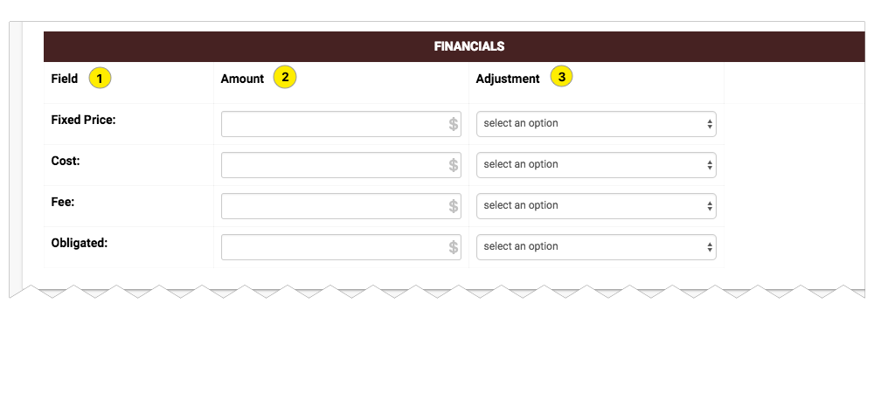

1. Field
2. Amount
3. Adjustment

### 

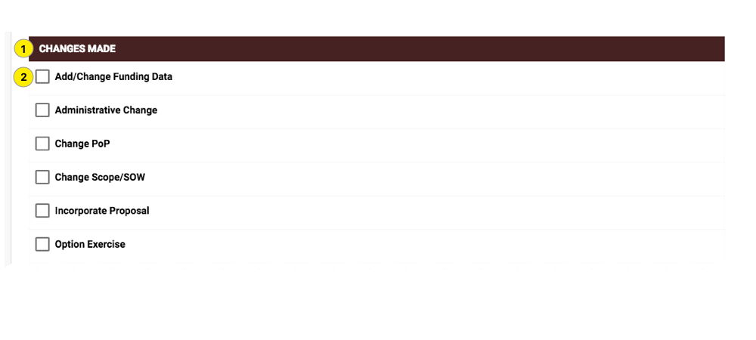

1. Change Made
2. Check Box

### Documents

#### New Document

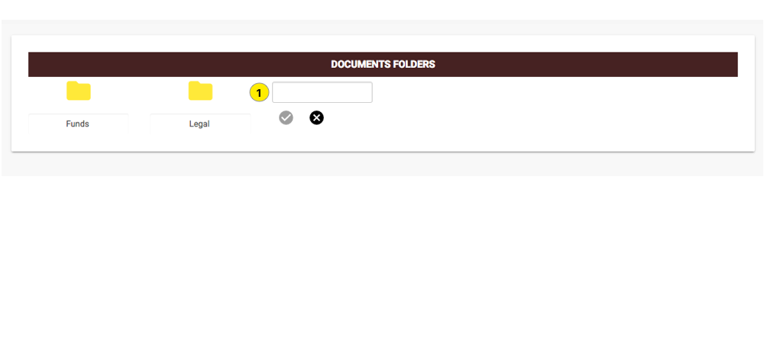

1. New Folder

#### New File

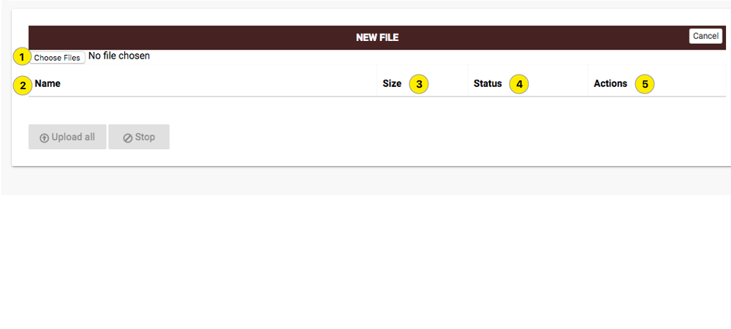

1. Choose File
2. Name
3. Size
4. Status
5. Actions

## 

## Deleting a Program

see Tool bar section

# Settings

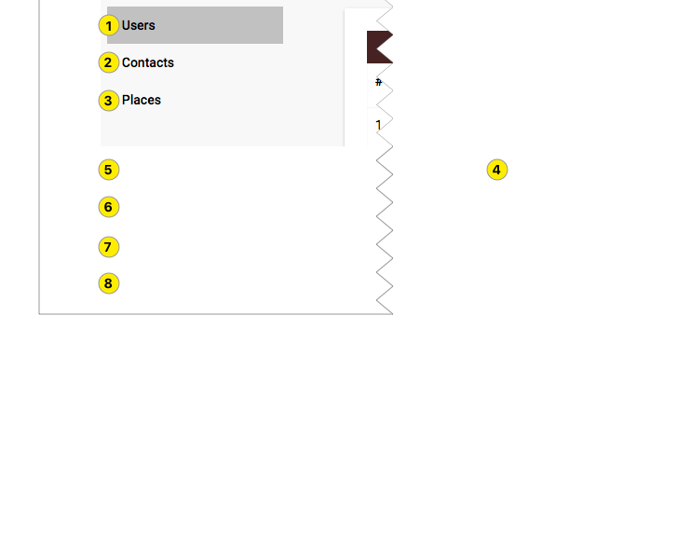

1. Users
2. Contacts
3. Places

### 

### Users

### List

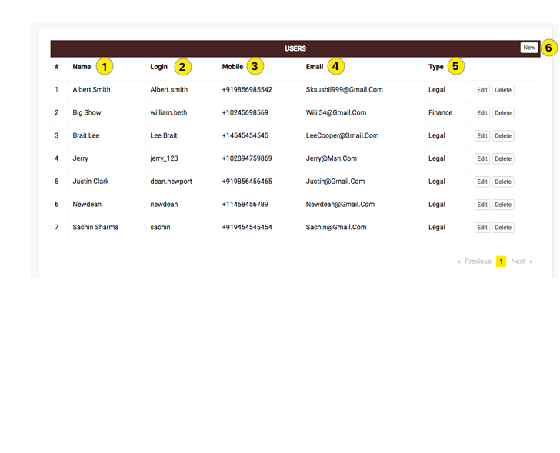

1. Name
2. Login
3. Mobile
4. Email
5. Type

### 

### Creating a new user

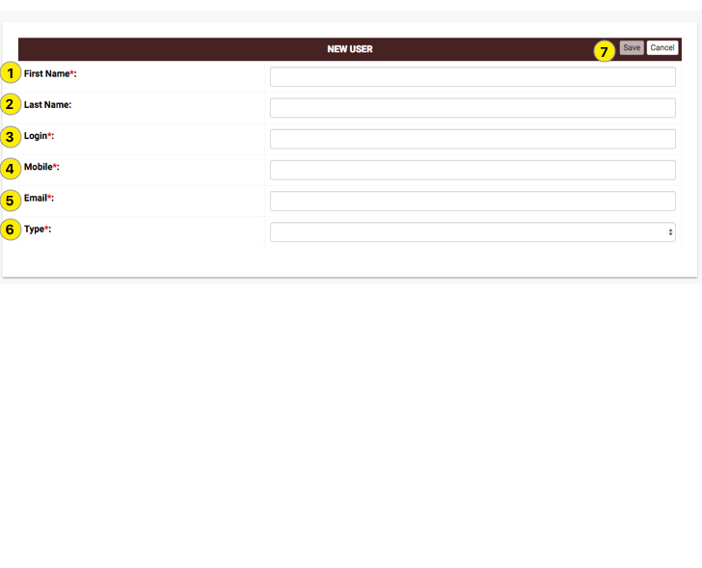

1. First Name
2. Last name
3. Login
4. Mobile
5. Email
6. Type
7. Save

### Contacts

### List

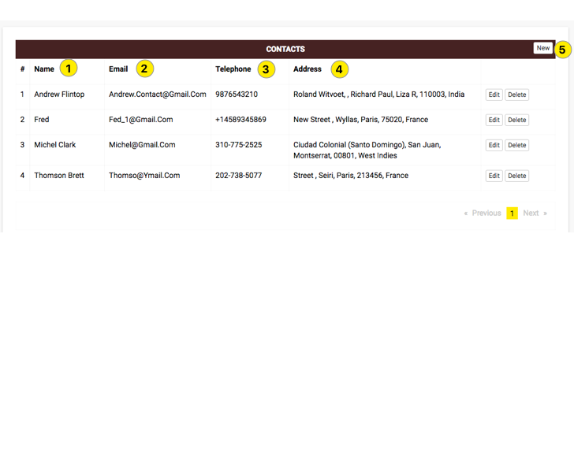

1. Name
2. Email
3. Telephone
4. Address

### 

### Places

### List

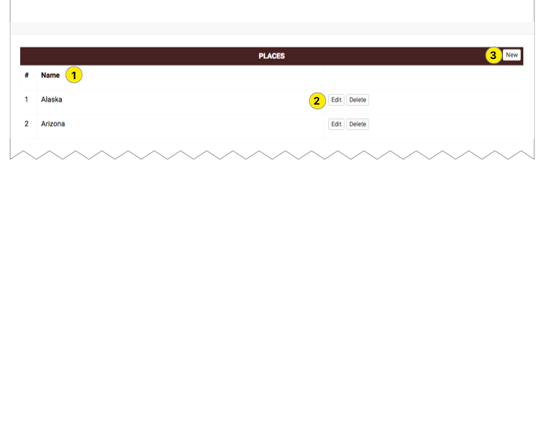

1. Name
2. Edit/Delete

### 

### Creating new place

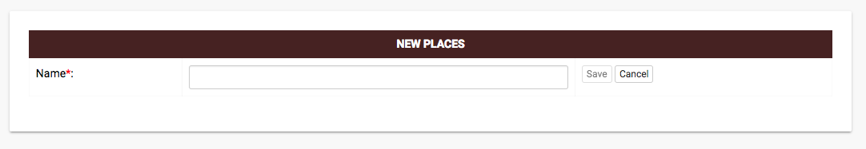

1. Name