ECE 4180 Lab 1 – Basic I/O with mbed

Due Date: Jan 27 odd groups – Jan 28 even groups

Names:_________________________ _____________________________

Item | Lab Demo | Extra Credit | Extra Credit Pts
4180 LAB 1
Digital I/O |  | n/a | n/a
Digital I/O using PWM |  | n/a | n/a
Digital I/O Port Expander |  | n/a | n/a
WatchDog Timer | n/a |  | 2.5%
ARM Assembly | n/a |  | 5%
ShiftBrite Module | n/a |  | 2.5%
Power Management | n/a |  | 5%
Two MCP23S17s on one Bus | n/a |  | 2.5%

Even/Odd group names rule: Add the ASCII value of the first character of last names for each student in lab team and do % 2 to determine even (0) or odd (1). Using the official last name found on the class roll.

TA Signoff: __________________________

Note: Bring your student protoboard to the lab and any jumper wires you may have. We have around ten large protoboards in the lab that can be used, but it may not be possible to leave your setup on the board, if you don’t finish once you start.
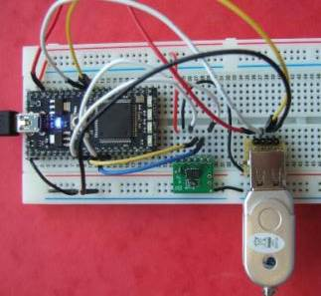

The purpose of this lab is to build and demo several types of widely used I/O interfaces to a small microcontroller. The easy to use mbed 1768 modules www.mbed.org have an ARM processor, use a web-based C++ compiler, and work like a USB flash drive. To get started, plug the mbed USB cable into the PC and click the MBED.HTM link on the flash drive that appears. The mbed must be attached to signup for a new account. Click signup, and create an new account. You will also save your source files on the cloud server using this code. You will need to setup and logon this account to compile on the web. The signup page is something like the one seen below (might have some minor changes).

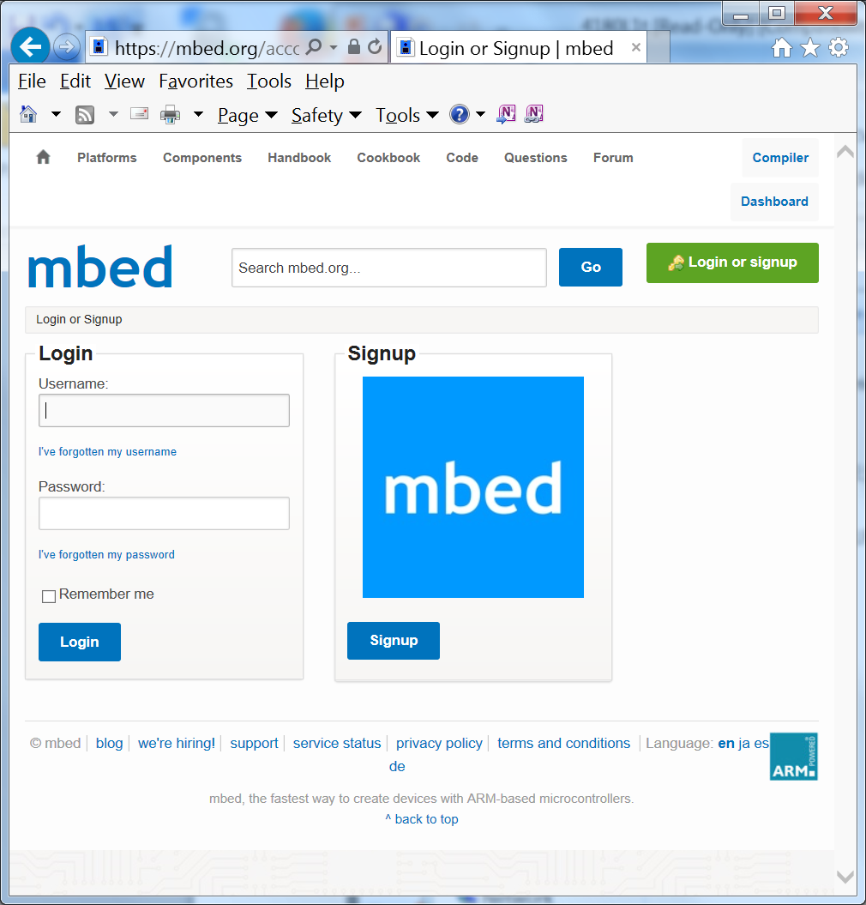
After you signup and create your account, run the HelloWorld example on the mbed board, save the program to the mbed flash drive, and push the blue button on the mbed board to reset. This will start running the most recently downloaded program. The program will flash a blue LED once it runs. Then switch to the compiler window to write code. Read through the HelloWorld C code and note the use of DigitalOut and LED1. If you cannot find HelloWorld in your Program Workspace in the online compiler, click on “New” and enter “HelloWorld” for the Program Name and click “OK” to create a new project with the demo code.
If you want your own mbed 1768 modules they are available at www.digikey.com for $49 or at the ECE lab web store listed on the class webpage. The mbed handbook has info and examples using the built-in I/O APIs. The mbed cookbook has more complex project examples. We will have the mbed modules already installed on the lab protoboards and try to just leave them in there. If you ever need to remove one, remember the cautionary notes on the back of the next page.

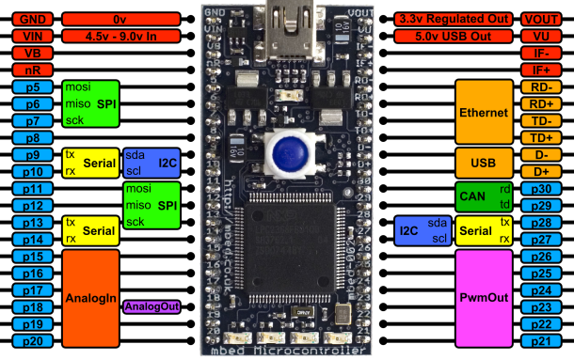

Here is a handy image and pin out of the mbed board. In C++ code, you can use the pin’s name to read or send a value to the pin. Note that power (3.3V and 5V up to 460MA) is available for the protoboard from the upper pins. On chip power circuits produce this voltage using power from the USB cable (500MA max). Vin is for an external power source like a battery – don’t connect anything to it while using the USB cable. VB is for a real-time clock battery backup, so skip it. There are four blue user LEDs at the bottom of the board (LED1 – LED4). They are handy for status displays. Over the USB cable, you can also set it up to send serial data to the PC using printf.
This mbed Microcontroller is based on an ARM Cortex-M3 Core running at 96MHz, with 512KB FLASH, 64KB RAM and a load of interfaces including Ethernet, USB Device, CAN, SPI, I2C and other I/O. RS232 serial, CAN, USB, and Ethernet outputs require a breakout board with a connector. Many of these are available from Sparkfun and we have an assortment available in the lab.

A schematic of mbed is available at http://mbed.org/media/uploads/chris/mbed-005.1.pdf and the 32-bit NXP ARM Cortex-M3 LPC 1768 processor data sheet and a user manual is also available at http://ics.nxp.com/products/lpc1000/datasheet/lpc1763.lpc1764.lpc1765.lpc1766.lpc1767.lpc1768.lpc1769.pdf , but you will likely never need it. The various devices have I/O registers on the machine, but the handy built-in C API calls for I/O hide the nasty 78 pages of I/O register details with another layer of abstractions. The LEDs will flash on the bottom of the mbed board if you ever have a compiler run time error.
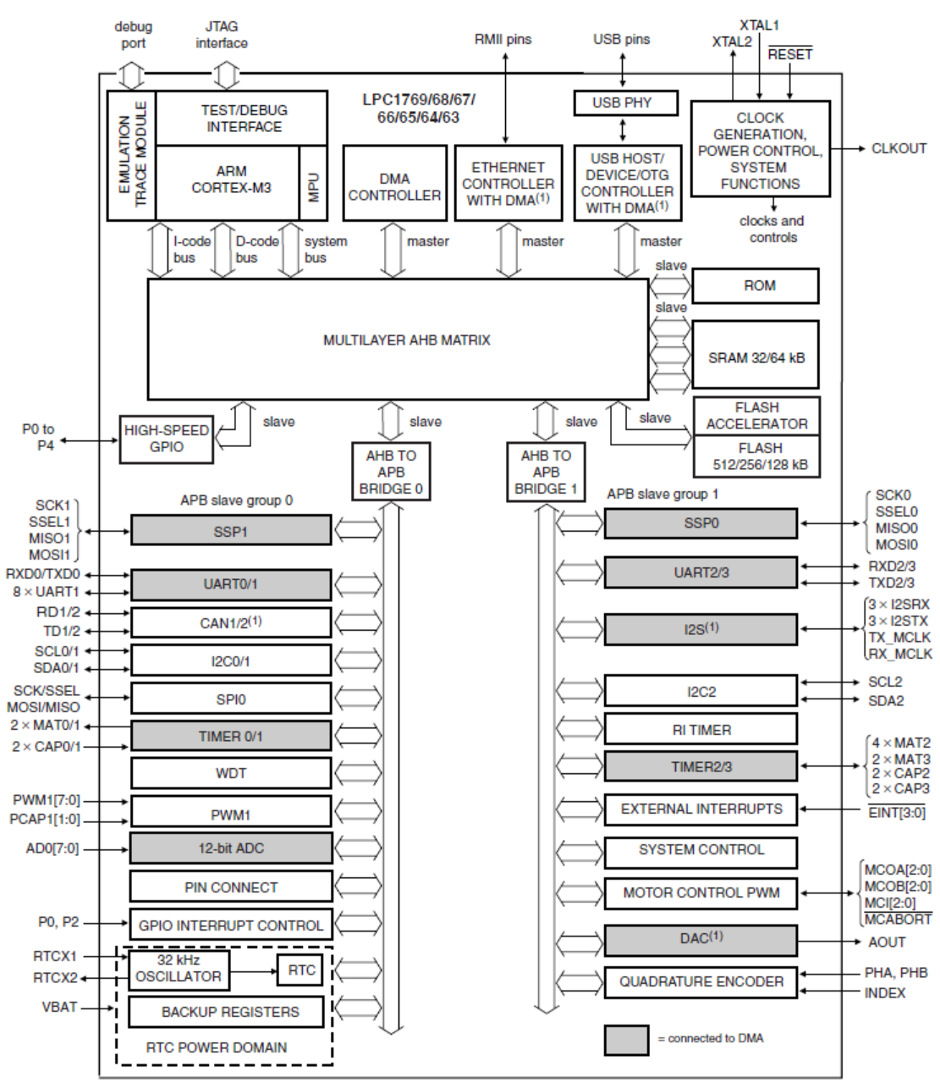

NXP LPC 1768 Block Diagram

Note the wide range of I/O features built into mbed’s ARM Cortex–M3 processor chip. They include GPIO, ADC, DAC, Serial (UART), SPI (SSP), I2C, PWM, USB, and Ethernet. We will be using all of these in the lab exercises that follow.

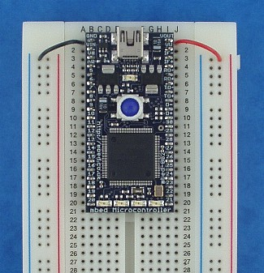

Inserting an mbed into a breadboard
Note: The mbed Microcontroller is fragile, and inserting it in to breadboard will require some force; ensure you line up the holes, then press evenly until it goes in to the board fully. Mess up and pins will break!

Removing an mbed from a breadboard
Never try and remove the mbed Microcontroller by pulling on the USB lead or USB connector. You'll just pull off the USB connector itself!
It is best to leave the mbed Microcontroller in the board whenever possible; if you do need to remove it, be patient and do it carefully. Use a small jewelers screwdriver or similar, and lever it a bit at a time from each of the four corners in turn, ensuring you pull up with the screwdriver so you are pressing against the breadboard with the tip and the edge of the microcontroller with the shaft, rather than the tip touching the bottom of the microcontroller (which might damage the components on the underside).
So remember..
- Don't pull on the lead/connector (it will just pull off the connector; you should avoid there being force on the connector at all times)
- Don't pull it out from one side (you will bend and break the pins!)
- Don't lever the device where it touches the bottom of the microcontroller (there are lots of components there, and you will damage them!)

Turning Power Off
You can push the button on the mbed to reboot, but to turn power off on the mbed board disconnect the USB cable. The small USB connector on the mbed module is a bit fragile, so use the larger USB connector that plugs into the PC. If the blue LED is on you have power to the mbed. Always Remove power when changing wiring on the breadboard!
ECE 4180 Laboratory Assignment 1
Part 1 - Basic Digital Input and Output (40%)
Any numbered pin, Px, can be used for general purpose digital I/O (GPIO) but stay clear of the analog, serial, SPI, networking, and I²C pins, they will be used later. Attach an external switch input using a DIP switch module and 2.2K ohm pull-up and at least one LED using a discrete LED or an LED DIP module. Don’t forget the resistor in series with the 2.2V LED to drop the voltage a bit. 100 ohm seems to work well. Note that the mbed takes power from USB and has power pins to power external devices. Use 3.3V by default since the chips I/O pins use 3.3V and not 5V level logic. Write C++ code to read in the DIP switch and output to the LED and loop forever. http://mbed.org/handbook/Homepage has a handy list of built-in C I/O API calls. Check out DigitalIn and DigitalOut in the mbed handbook. Use the external switch pullup resistor for this first lab assignment, but there is a way to avoid it later and even debounce the pushbuttons that is explained in the pushbutton tutorial at http://mbed.org/users/4180_1/notebook/pushbuttons/ . Extra switches, LEDs, pushbuttons, and resistors are in a gray parts cabinet in the lab on a scope cart (left center back of lab near TA desk).

Part 2 - Using PWM with Digital Output (40%)

Add code to dim and brighten an LED using Pulse Width Modulation (PWM) using additional switches or pushbuttons for control. Check out the PwmOut API in the mbed handbook. Note that it is more energy efficient to control devices using PWM instead of an analog output. LEDs also emit light only in a limited voltage range. Using analog out will dissipate more heat in the transistor driver circuits than PWM since the transistors are not driven to saturation. As an example, if an analog driver circuit is turned on half way, this means that half of the power is dissipated as heat in the driver transistor. Monitor the PWM output and duty cycle using an oscilloscope in the lab. Capture the scope image and hand it in at checkout.

Part 3 - Expanding Digital I/O ports (20%)
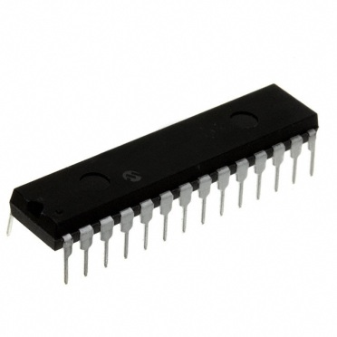

When extra digital I/O pins are needed in small microcontrollers, I/O expander chips are typically used. The MCP23S17 IC is an addressable 16-Bit I/O Expander with an SPI interface. SPI is a low cost 1-bit serial bus with a clock that works just like a shift register. As seen in the image above, is available in a 28-pin DIP package that will plug directly into a protoboard. The mbed cookbook has a link for a MCP23S17 and a library code example using this chip at http://mbed.org/users/romilly/notebook/mcp23s17-addressable-16-bit-io-expander-with-spi/ with test demo code at http://mbed.org/users/4180_1/programs/MCP23S17_Basic_IO_Demo/llprau . The library code uses the mbed compiler’s SPI API function for low-level operations and adds a layer of functions to configure, read, and write the MCP23S17 chip using mbed’s built-in hardware SPI controller. A datasheet for the MCP23SA17 chip can be found at http://ww1.microchip.com/downloads/en/DeviceDoc/21952b.pdf.

Be sure to correctly configure the reset pin on the MCP23S17 chip and note the wiring suggestions on the next page. Reset cannot be just left floating high on this chip per the data sheet.

Repeat Part 1 using the I/O expander IC by attaching an LED to a bit on an output port, a switch to a bit on an input port, and writing code to read the switch and output to the LED. Capture an input and output SPI bus cycle using a logic analyzer or the mixed signal oscilloscope in the lab. Be sure to demo it on the scope or LA to the GTA, or capture the image and hand it in later at checkout. The MCP23O17 is an I²C bus version of this IC and we also have some of them in the lab for use later in design projects. Make sure you don’t get the wrong chip from the parts bin. If you need to review how to use a logic analyzer a tutorial is available.

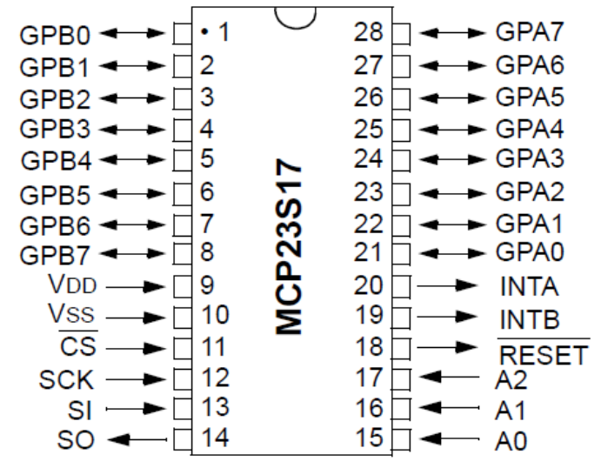
mbed | MCP23S17
GND | A0, A1, A2
P20 | /CS
P14 | /RESET
P5, P6, P7 | SI, SO, SCK
3.3V | V_{DD}
GND | V_{SS}

Extra Credit Options for Lab 1
(2.5%) Add a WatchDog timer example to your Part 1 demo. Include a simulated fault that occurs after a few seconds. See http://mbed.org/cookbook/WatchDog-Timer for more info and examples.
(5%) Do Part 1 using only ARM assembly language. See http://mbed.org/cookbook/Assembly-Language for more info and examples.
(2.5%) Like Part 2, write code for the RGB LED on the ShiftBrite Module, to vary the brightness and mix the RGB output color. See http://mbed.org/users/4180_1/notebook/shiftbrite1/ for more info and examples.
(5%) Use Power Management to minimize the power consumption on your Part 2 demo. Hook up an external 5V power supply to V_{in} (with USB cable not connected!) and monitor the current saved. See http://mbed.org/cookbook/Power-Management for more info and examples.
(2.5%) Connect two MCP23S17 devices to a single SPI bus without toggling chip select. Do the Part 3 LED and switch demo with the LED on one MCP23S17 IC and the switch on the other MCP23S17 IC.
Early Bird Bonus (5%) extra credit to first two groups to demo the regular lab 1 assignment. The first couple of lab teams to finish it will likely wind up doing a bit of extra work blazing a path forward for everyone else. So they will get extra credit.

