April 2nd, 2025

4719 South Hemlock

Battlefield, MO 65619

Dear Homeowner,

We were just reaching out, the filters on the drinking water system are expired, and we have been trying to reach you regarding those. To ensure the safety of your water, please call us as soon as possible to schedule your filter change. Per the manufacturer, these filters need to be replaced at least once a year. Ask yourself, would you drink expired milk?

If you could call me at (316) 265-6111 so that I can update the full file with your information and go over any product and maintenance information you need. Any information would be very helpful. You can call or email me at [service.schedule@moorewatertreatment.com](mailto:service.schedule@moorewatertreatment.com) if that's easier.

Sincerely,

Leigha Foster

Moore Water & Air

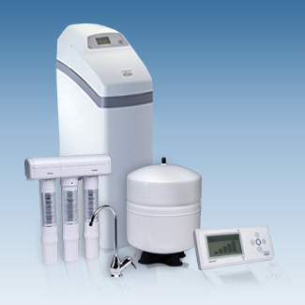 Check us out at [www.ecowaterofkansas.com](http://www.ecowaterofkansas.com/)