**Module 1: Assignment 1 – Installation of Tools (Integrated Development Environment)**

Sunny Polamuri

Dinesh Sthapit

January 22nd, 2024

**1**.**Visual Studio Code Installation**

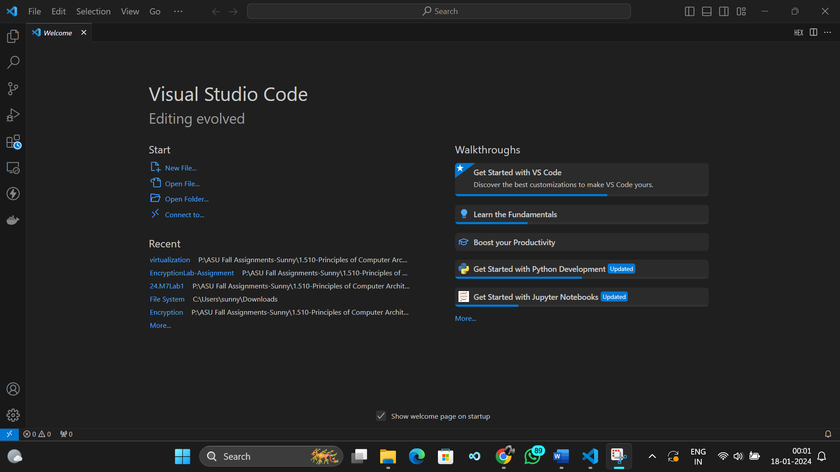

**2.Node.js Installation**

