**Module 1: Activity 2 – Project Setup**

Sunny Polamuri

Dinesh Sthapit

January 22nd, 2024

**Visual Studio Code Installation Proof:**

**Screenshot 1:**

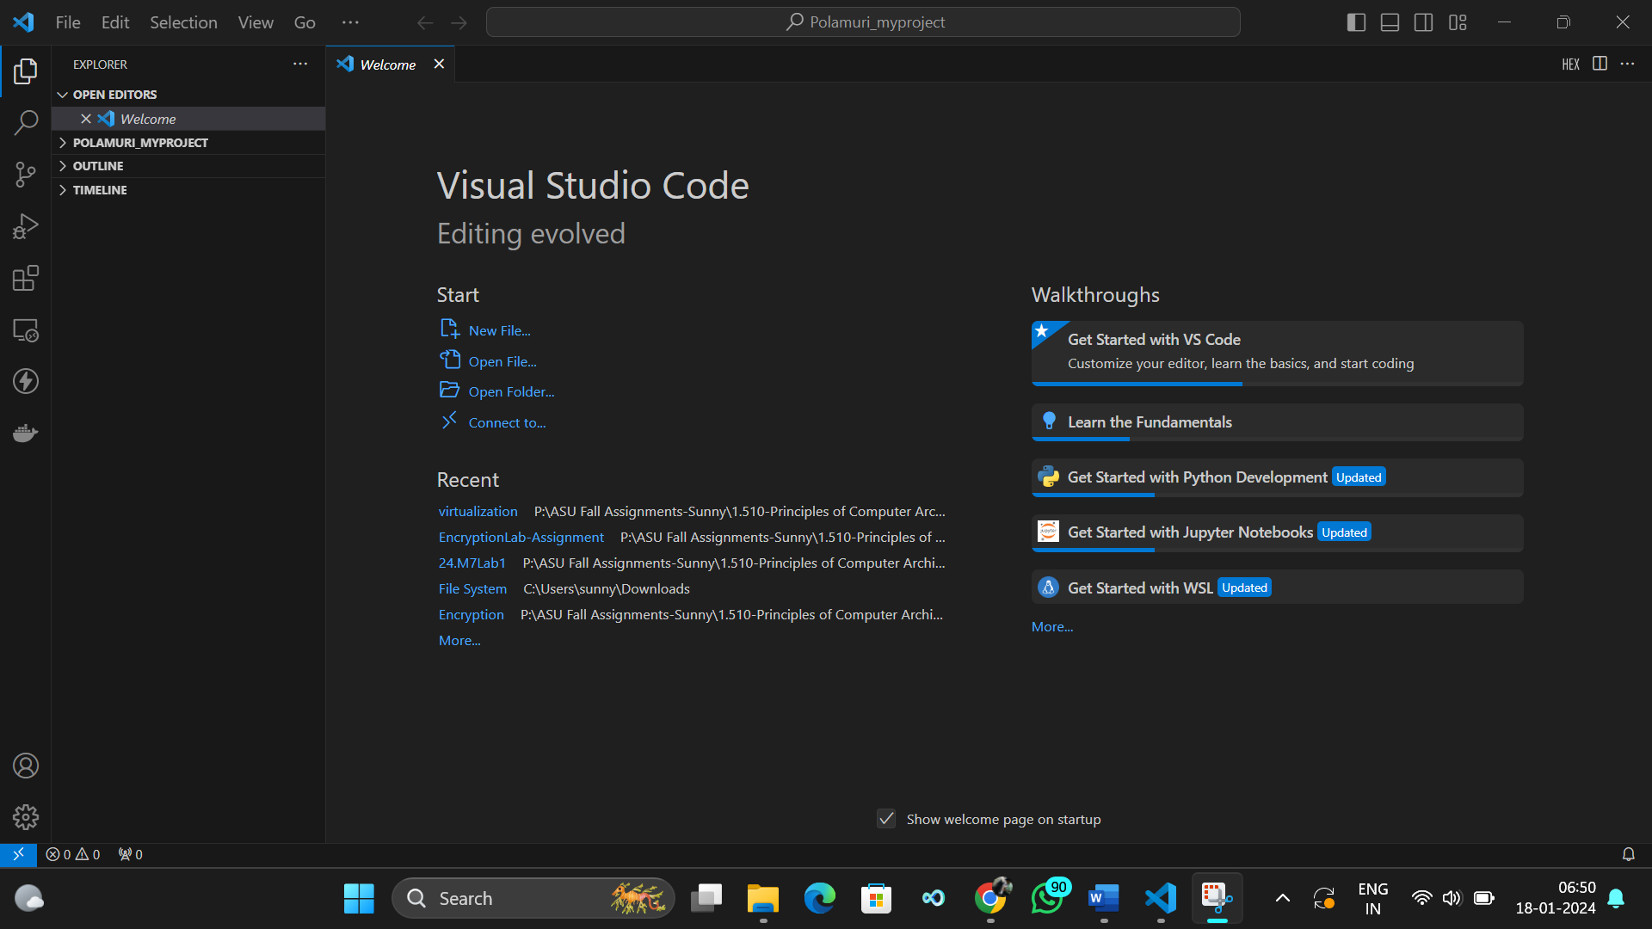

**Node.js Installation Proof:**

**Screenshot 2:**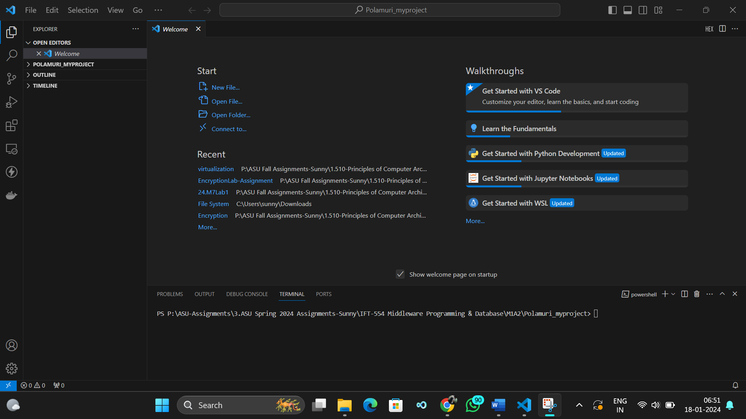

**Screenshot 3:**

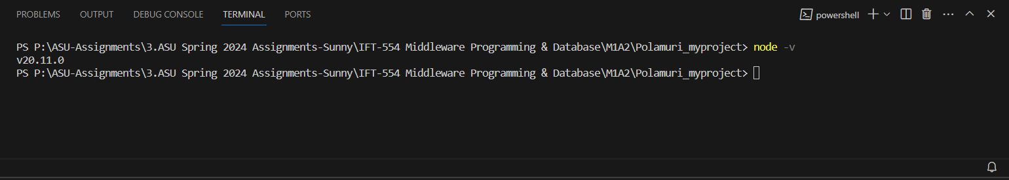

**Screenshot 4:**

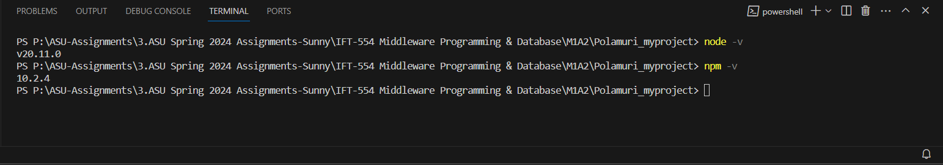

**Workspace and Project Directory Creation:**

**Screenshot 5:**

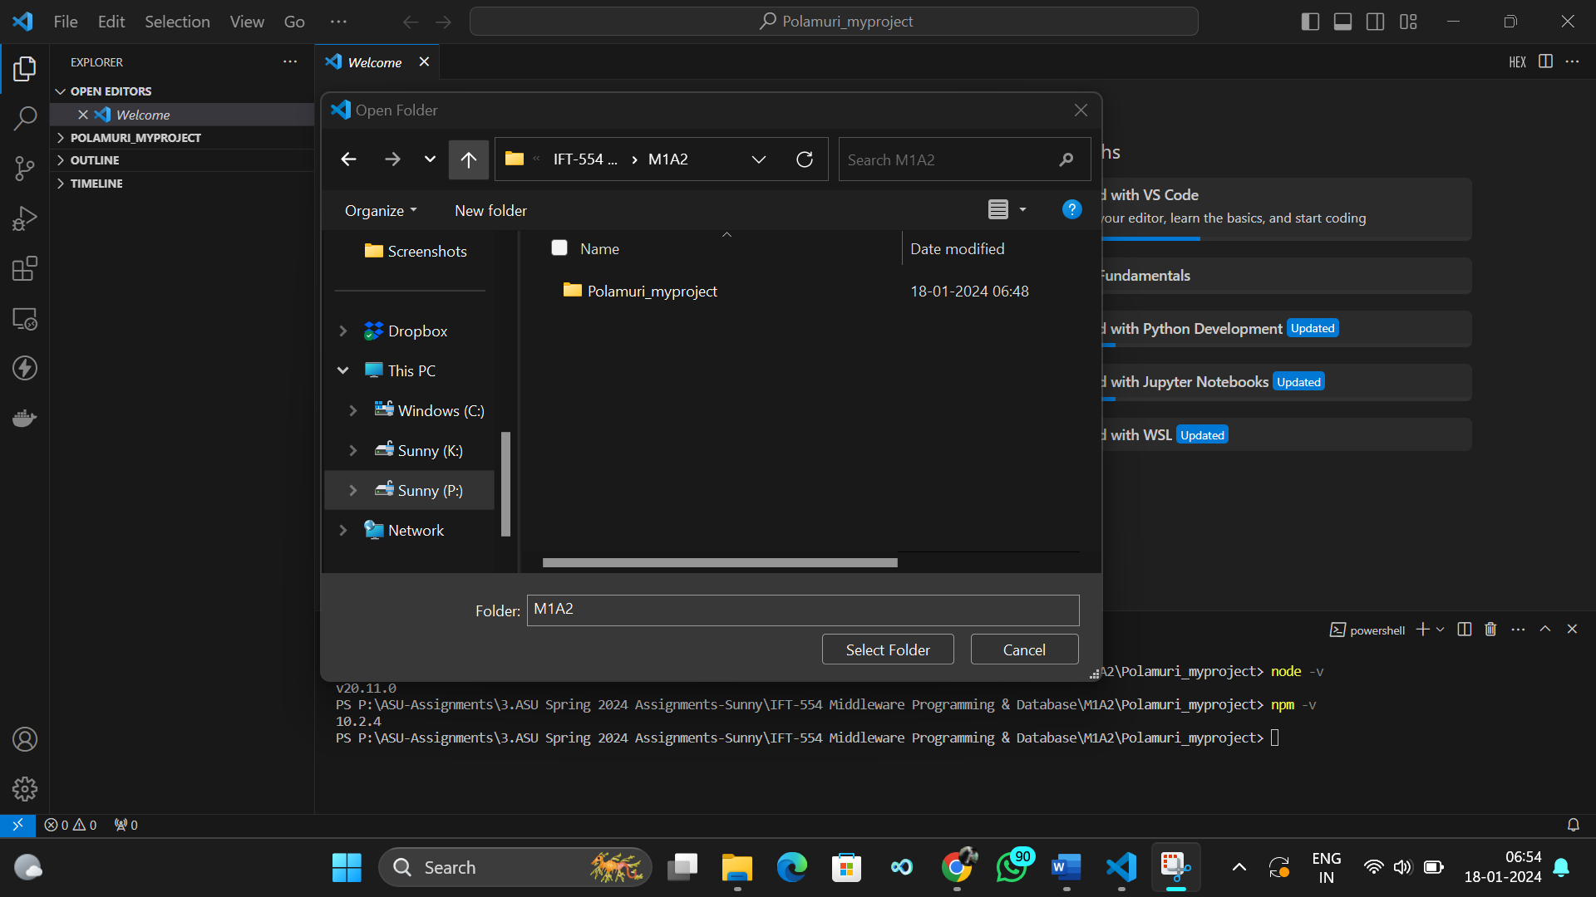

**Node.js Project Initialization:**

**Screenshot 6:**

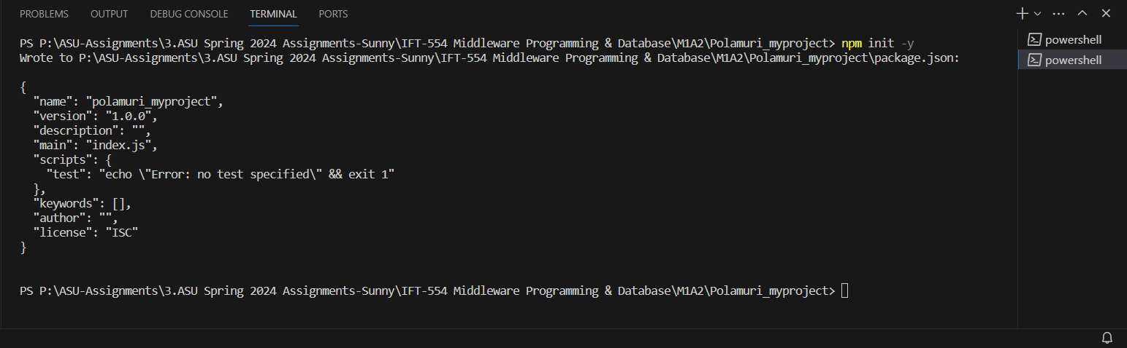

**Creation of Project's Entry Point:**

**Screenshot 7:**

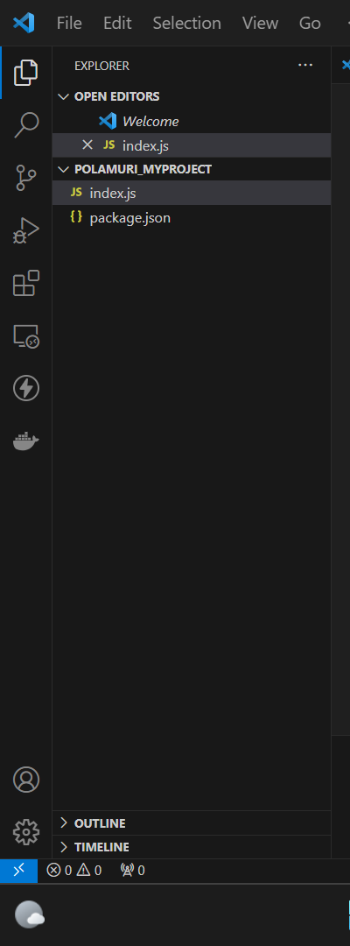

**Screenshot 8:**

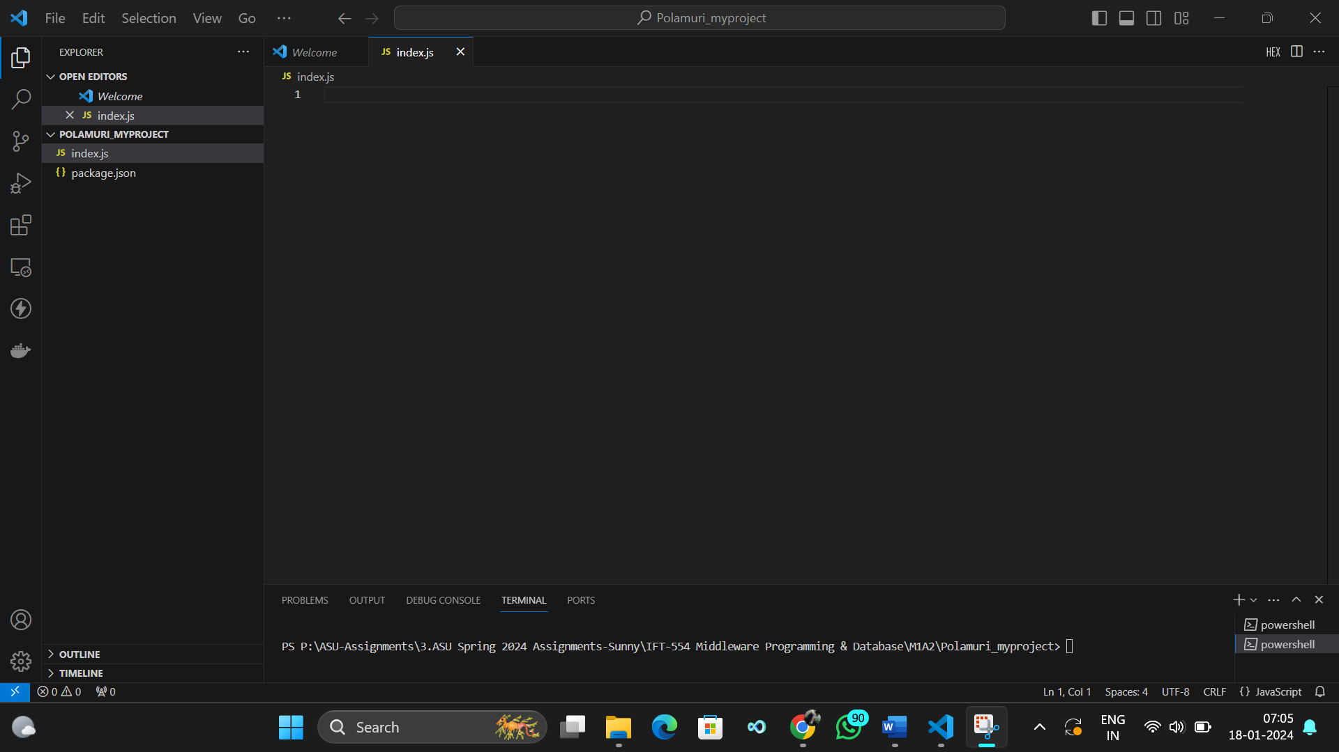

**Installation of Necessary Packages:**

**Screenshot 9:**

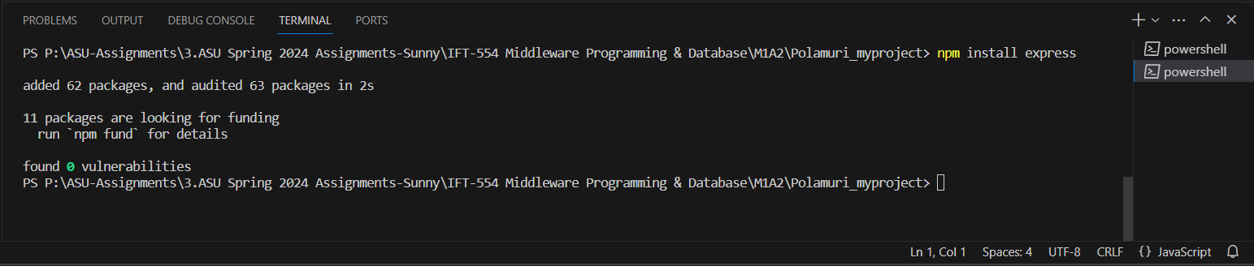

**Running the Node.js Project:**

**Screenshot 10:**

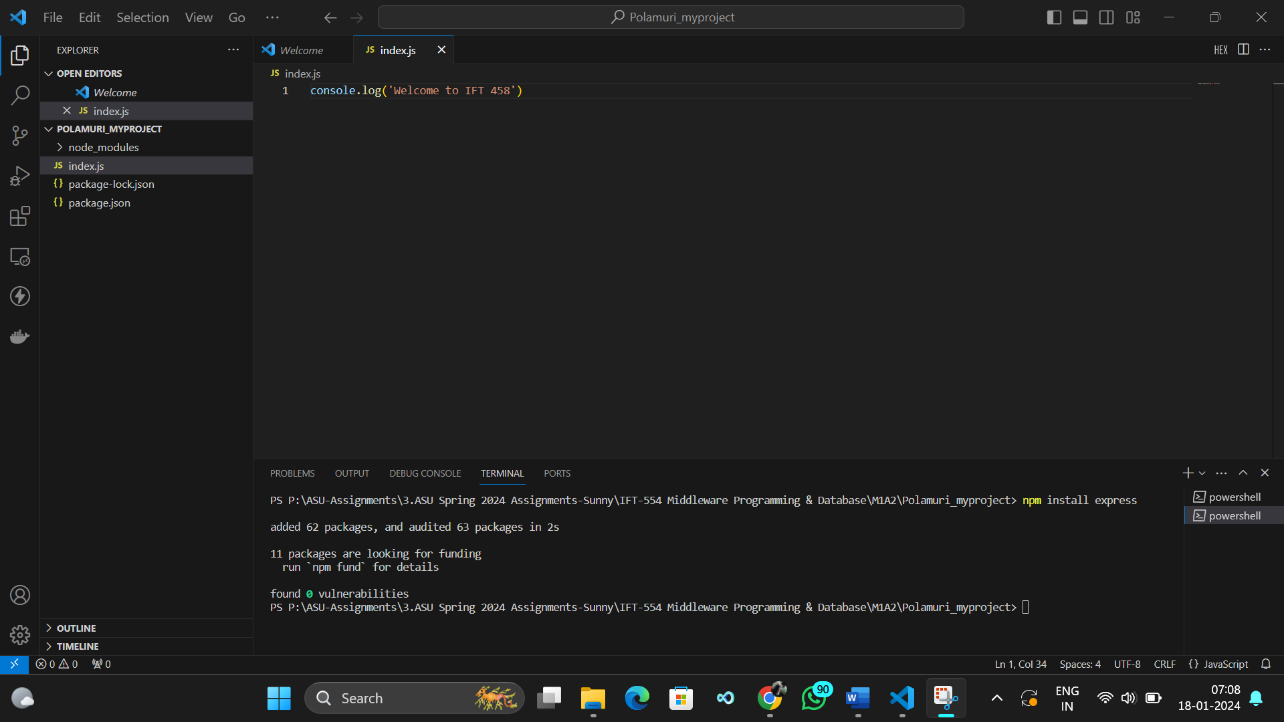

**Screenshot 11:**

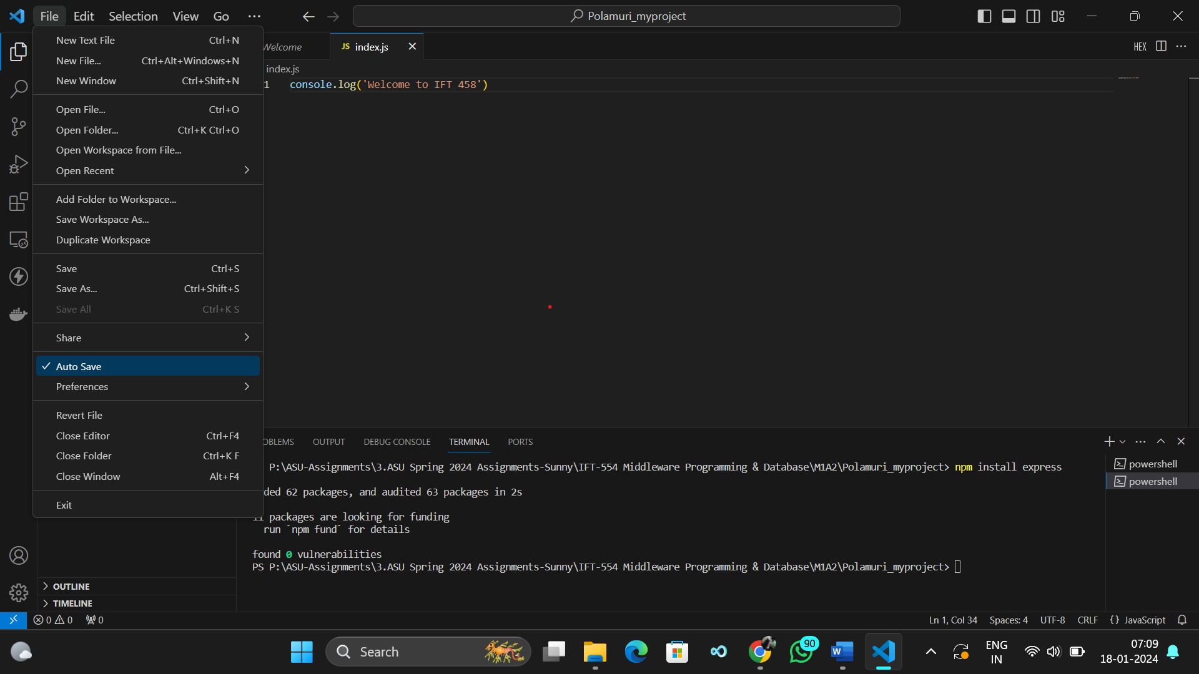

**Screenshot 12:**

