**Module 1: Lab 1– JavaScript Hello World**

Sunny Polamuri

Dinesh Sthapit

January 22nd, 2024

**Task 1: Create a Project**

**Screenshot 1:**

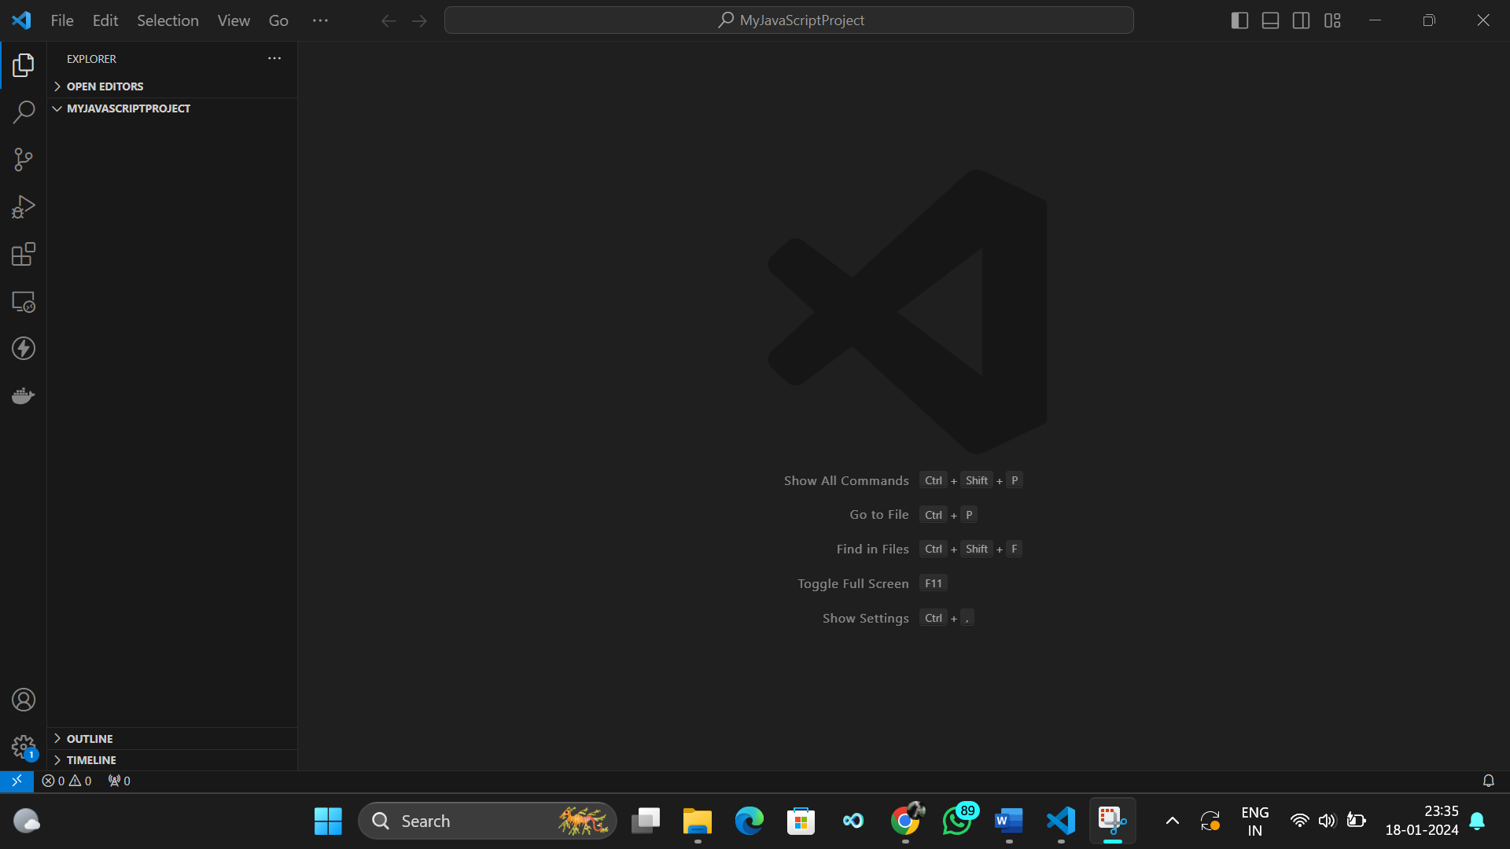

**Task 2: Create a JavaScript File**

**Screenshot 2:**

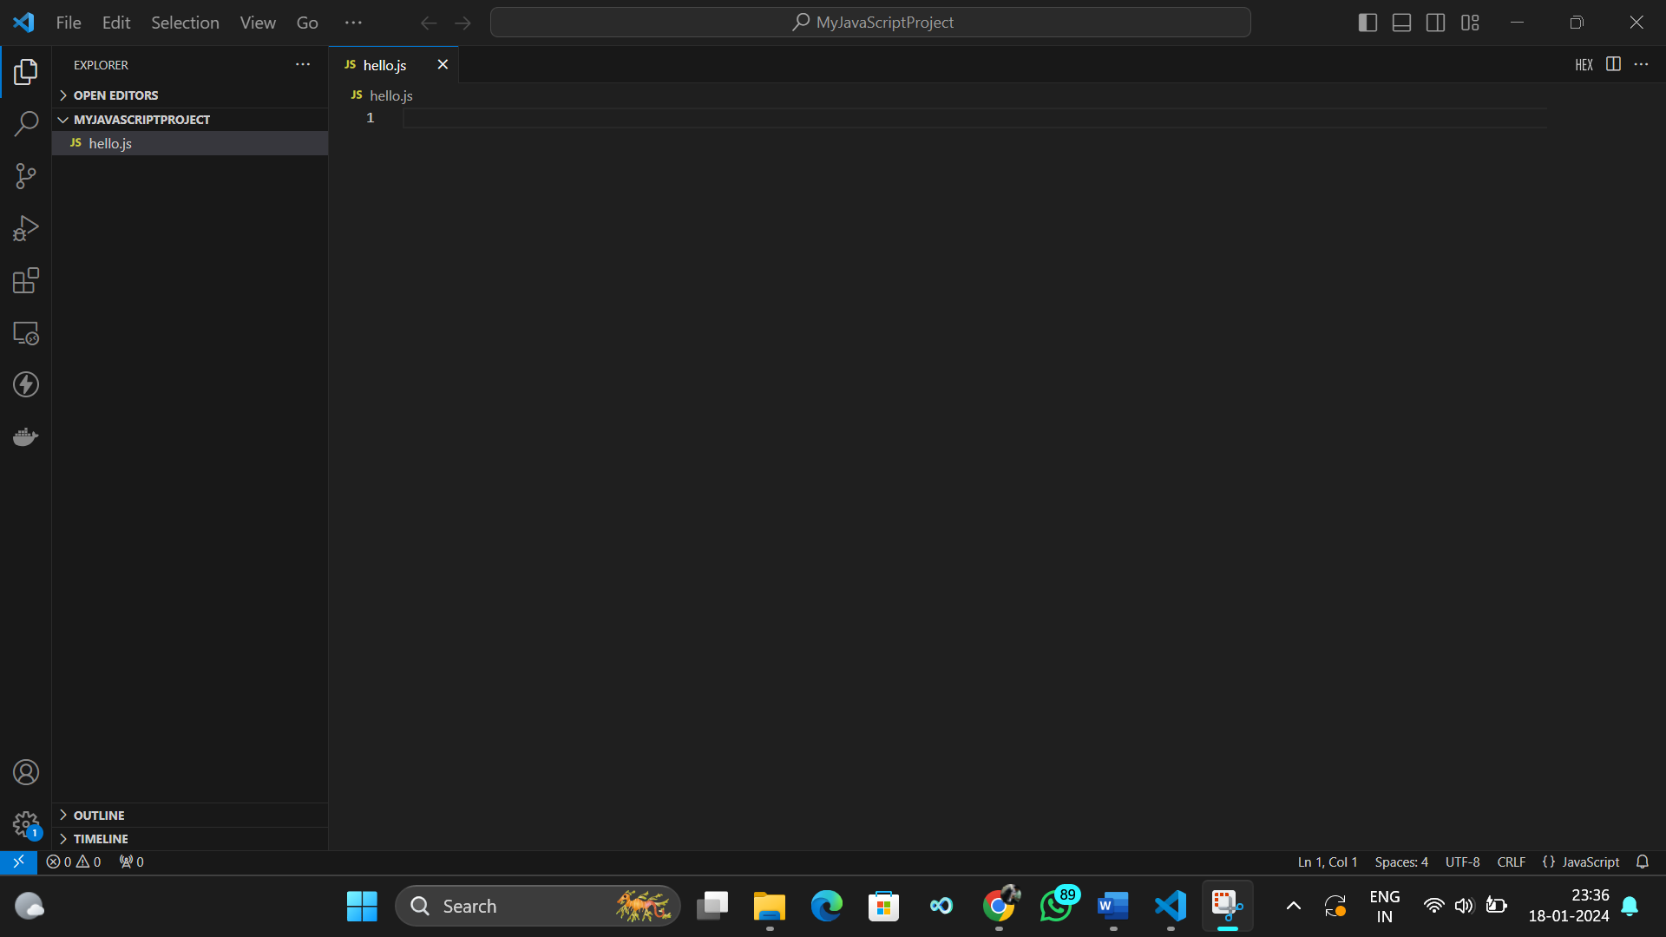

**Task 3: Write a JavaScript Program**

**Screenshot 3:**

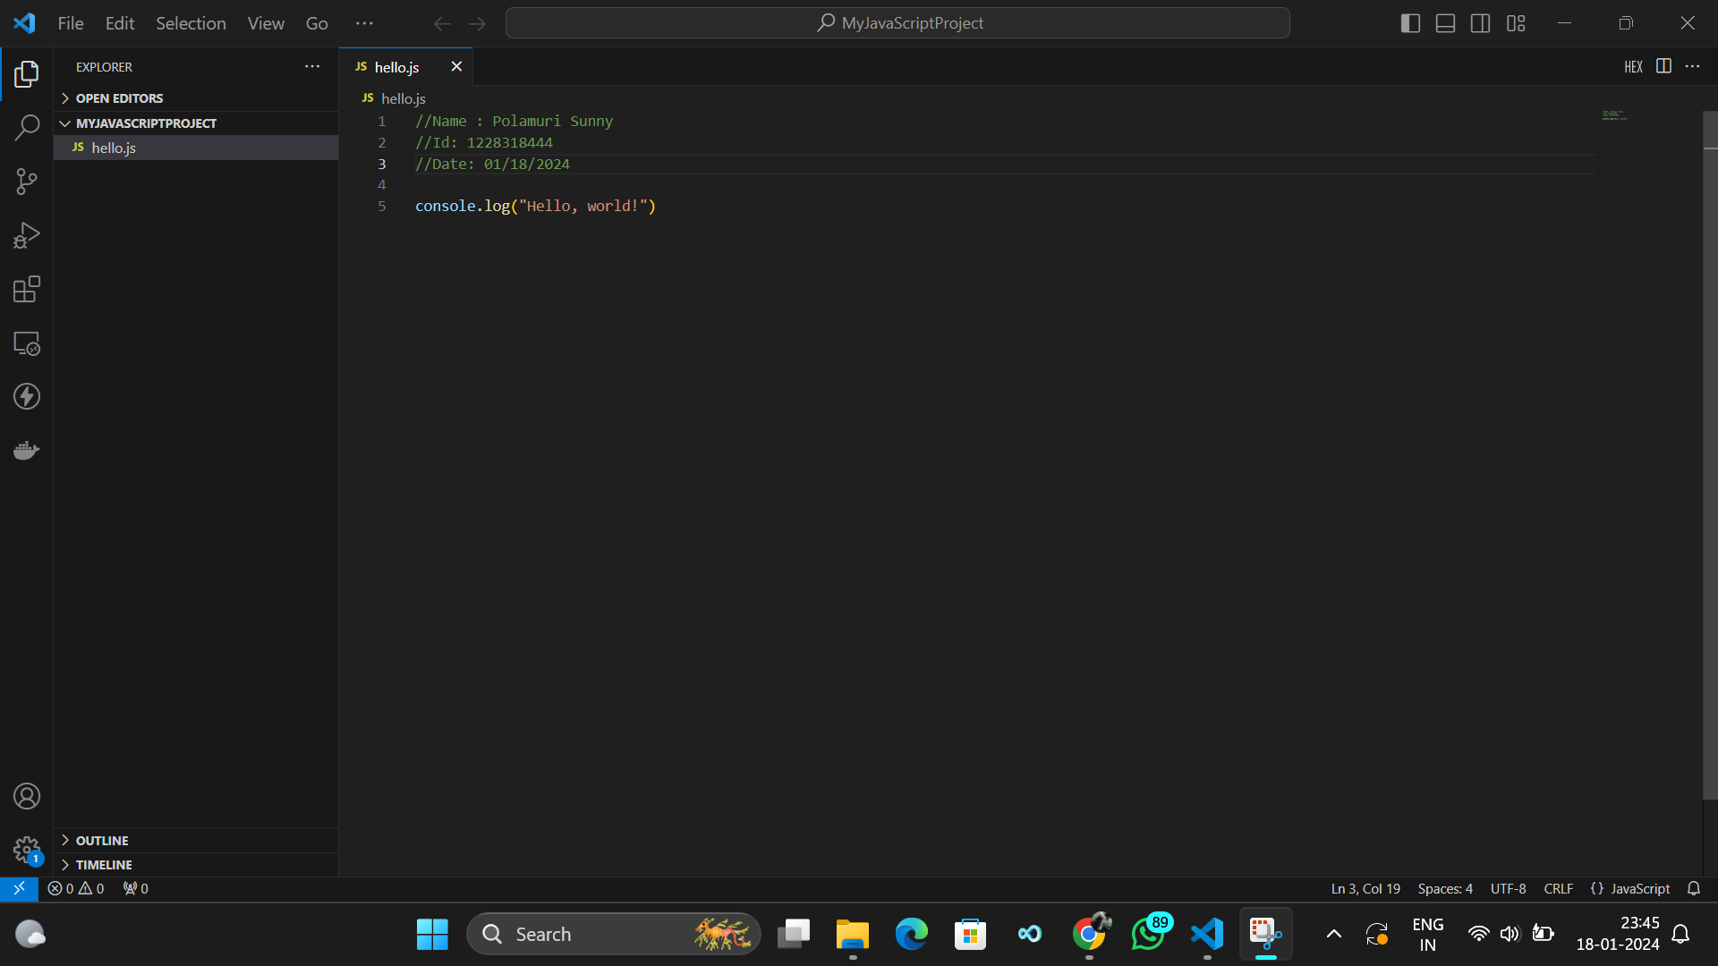

**Task 4: Execute the JavaScript File**

**Screenshot 4:**

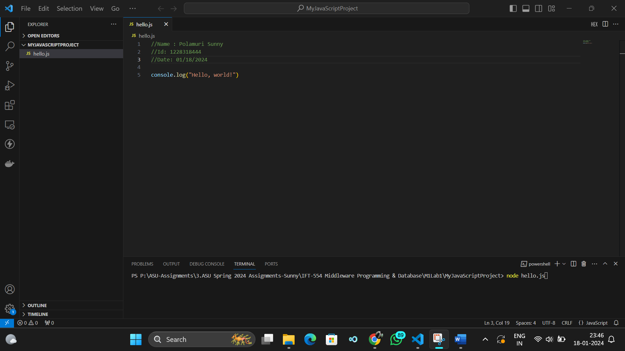

**Task 5: Observe the Output**

**Screenshot 5:**

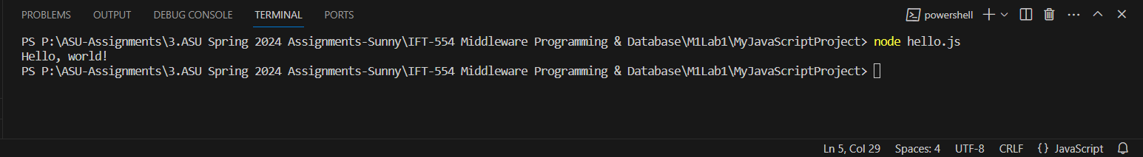

**Task 6: Create Screenshots**

**Screenshot 6:**

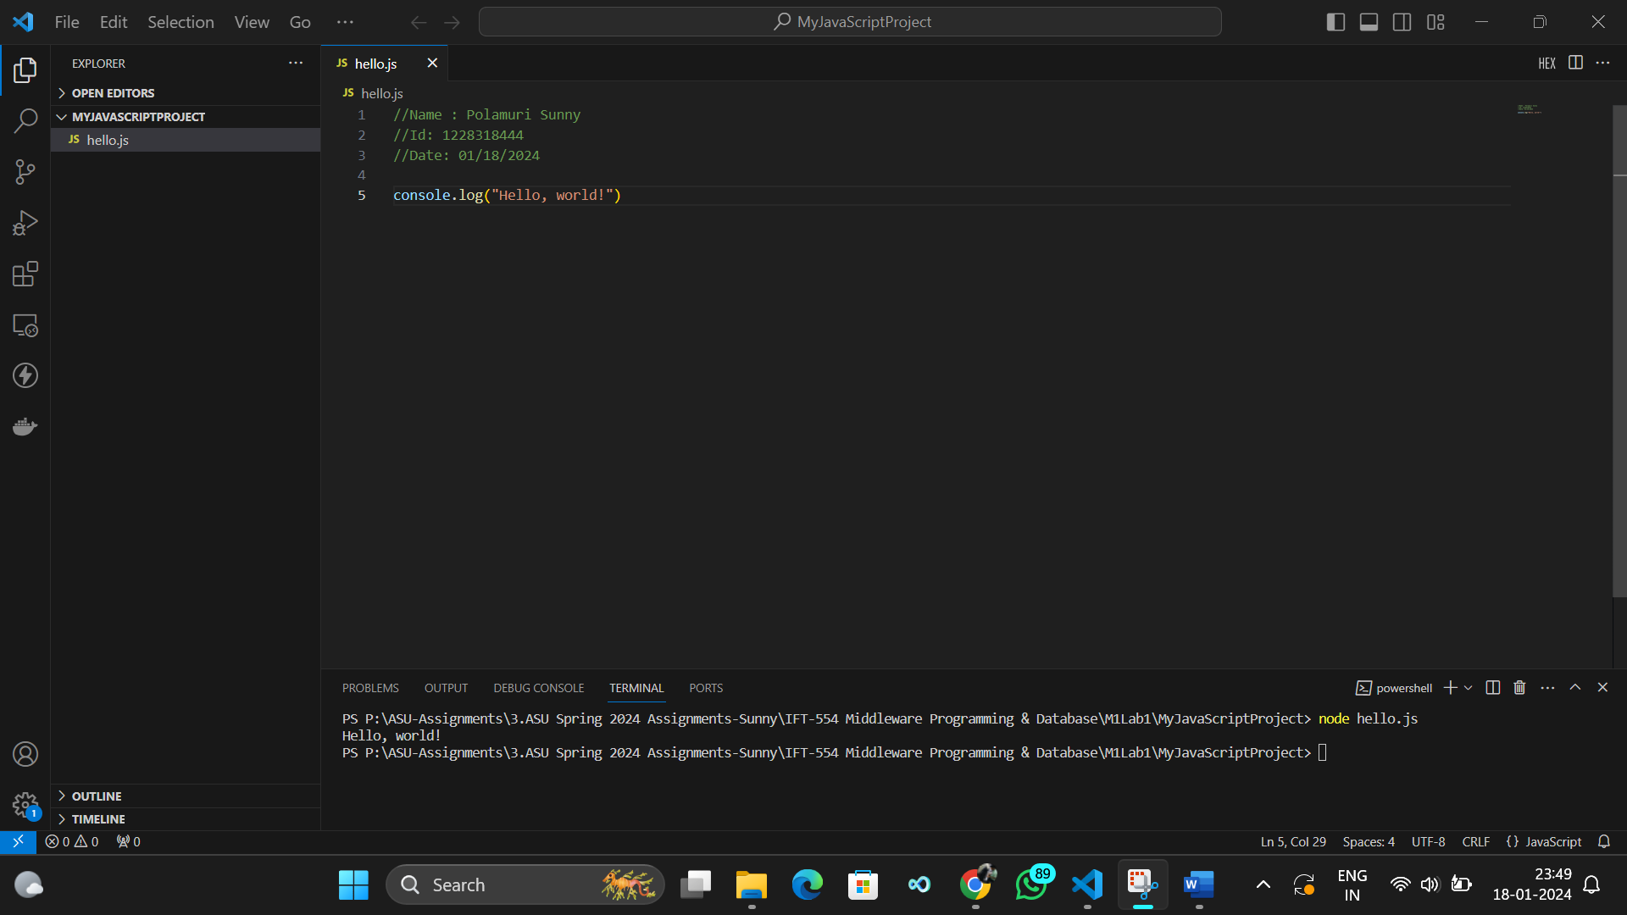

**Screenshot 7:**

