**Module 2: Activity 1 – Basic Static Web Project Using Node.JS and EJS**

Sunny Polamuri

Dinesh Sthapit

February 04th, 2024

**Screenshot 1:** **Installation of EJS**

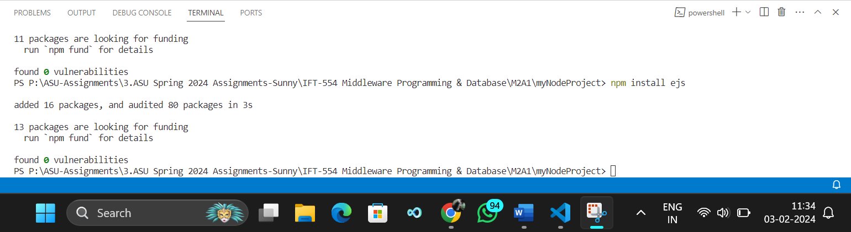

**Screenshot 2: Displaying the creation of a new file named “app.js”**

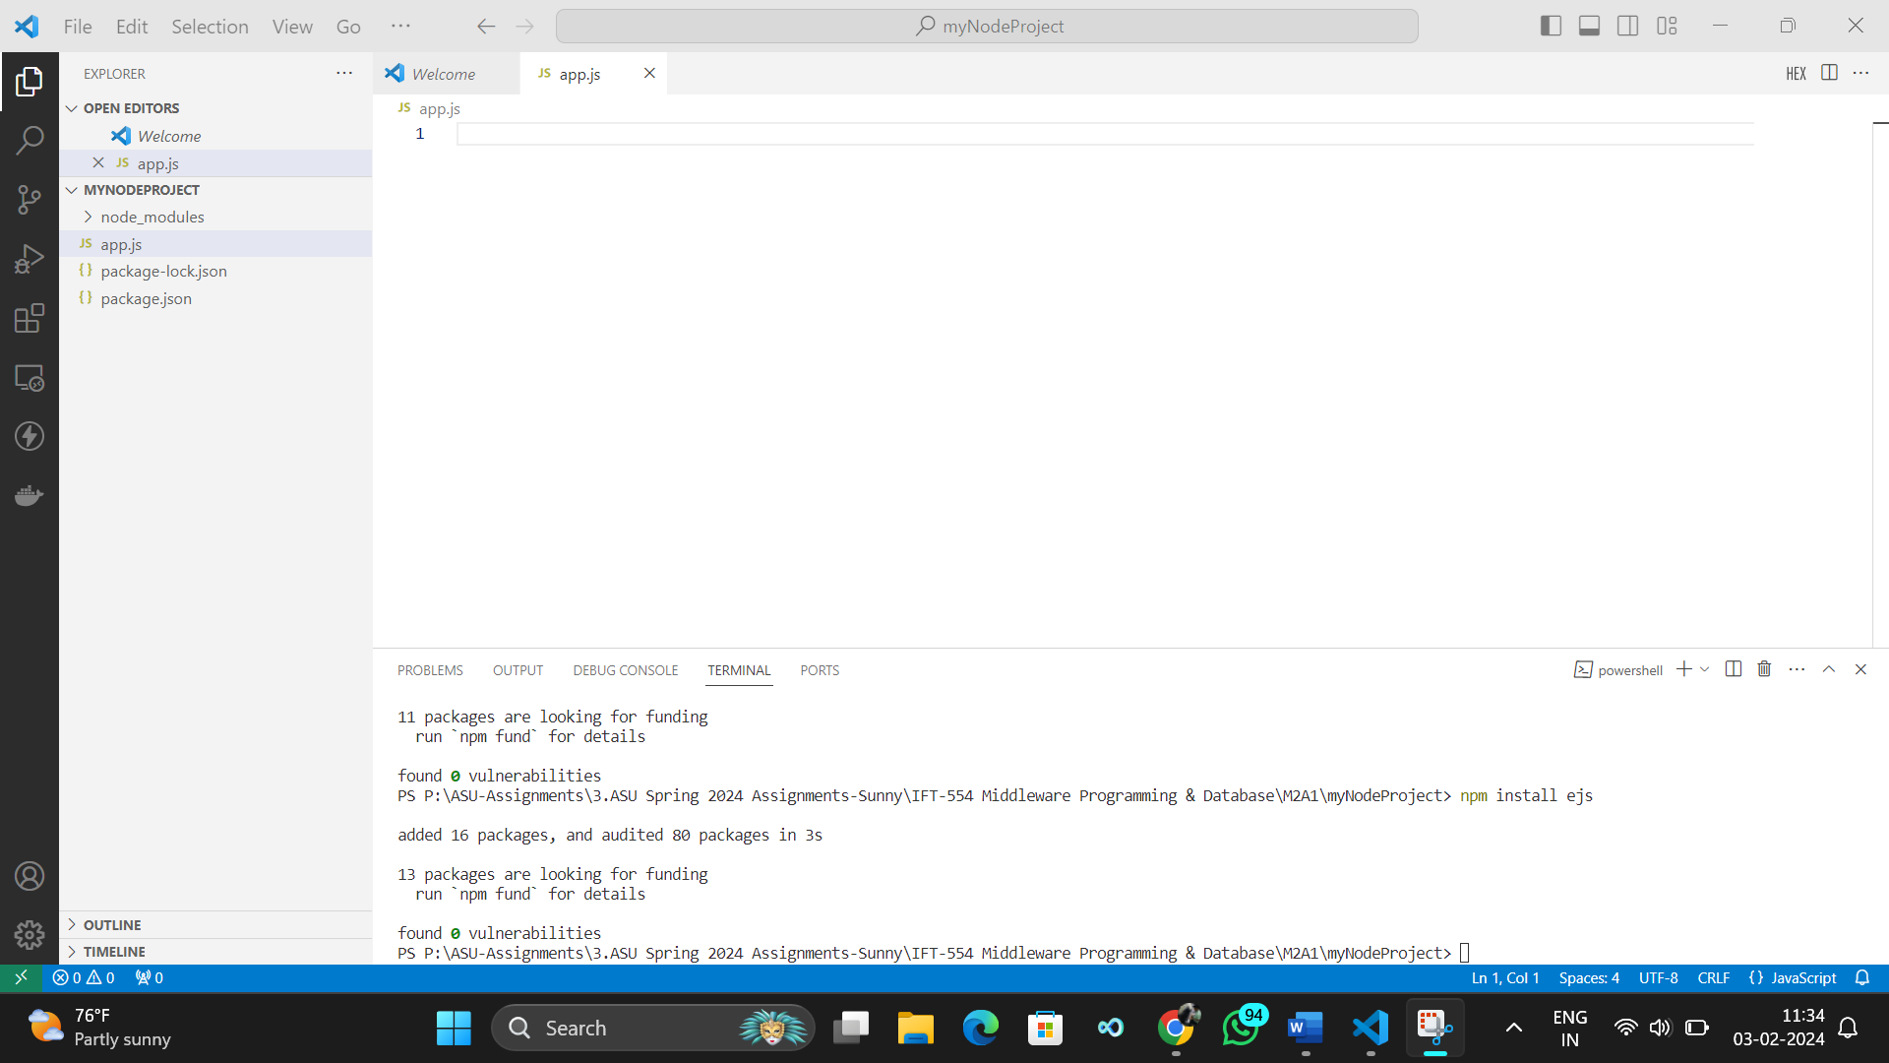

**Screenshot 3: Opened "app.js" file with code**

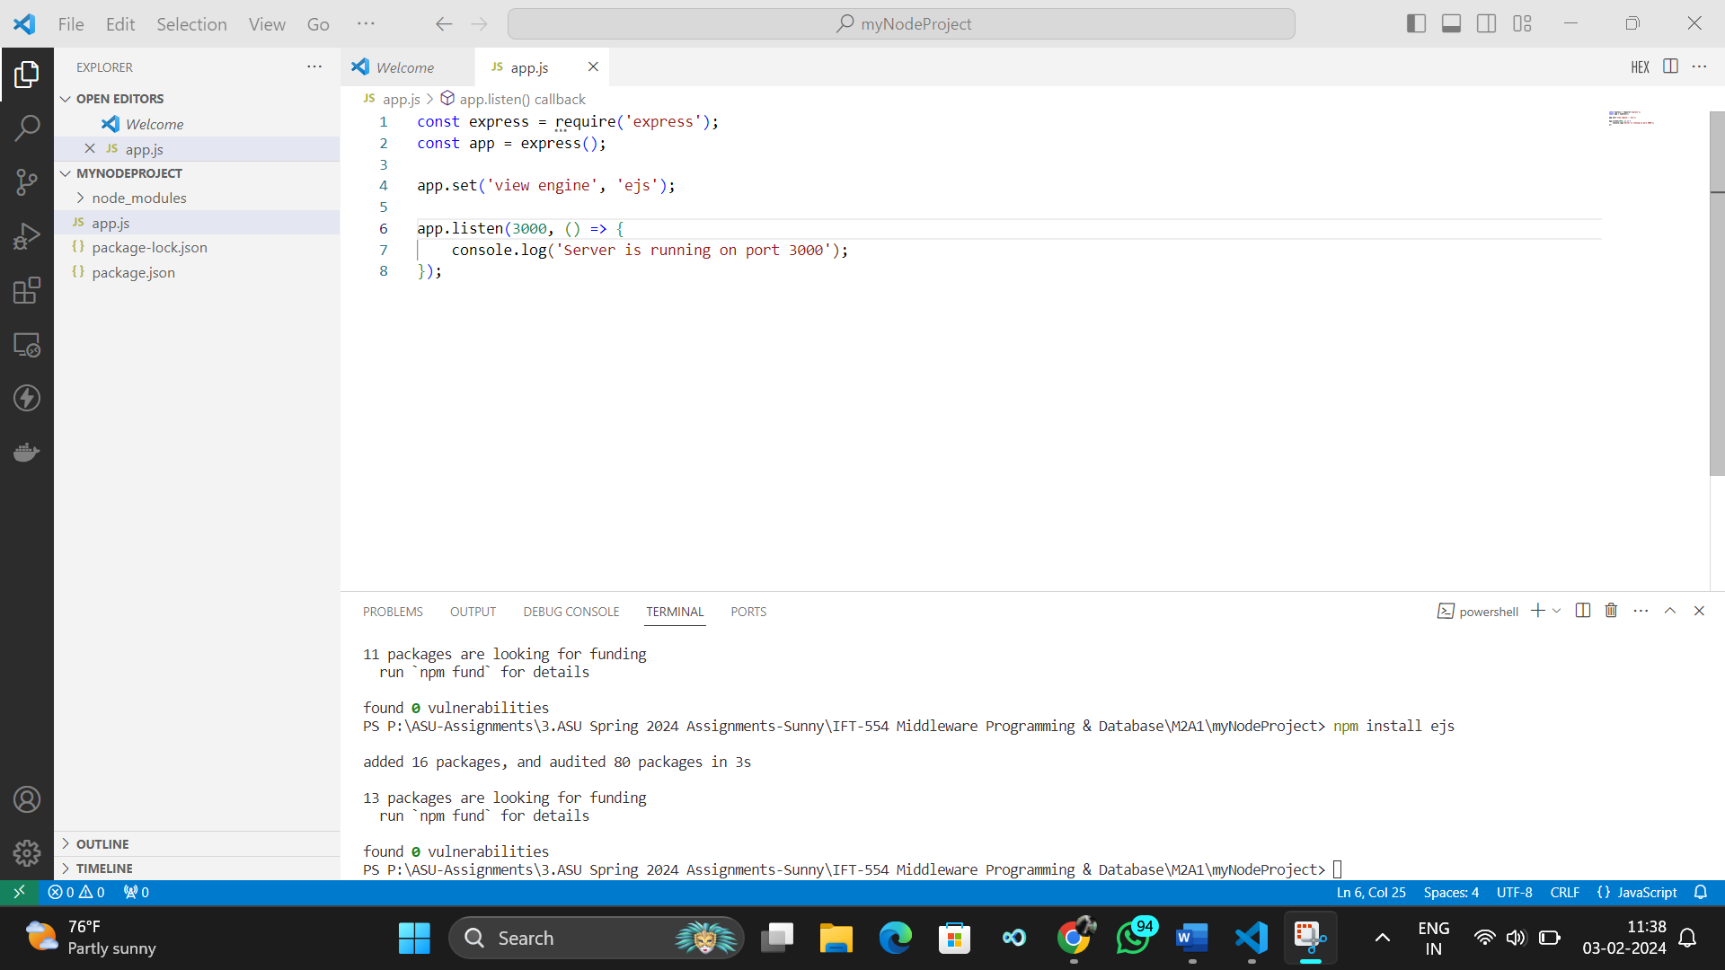

**Screenshot 4: Displaying the creation of a new folder named "views"**

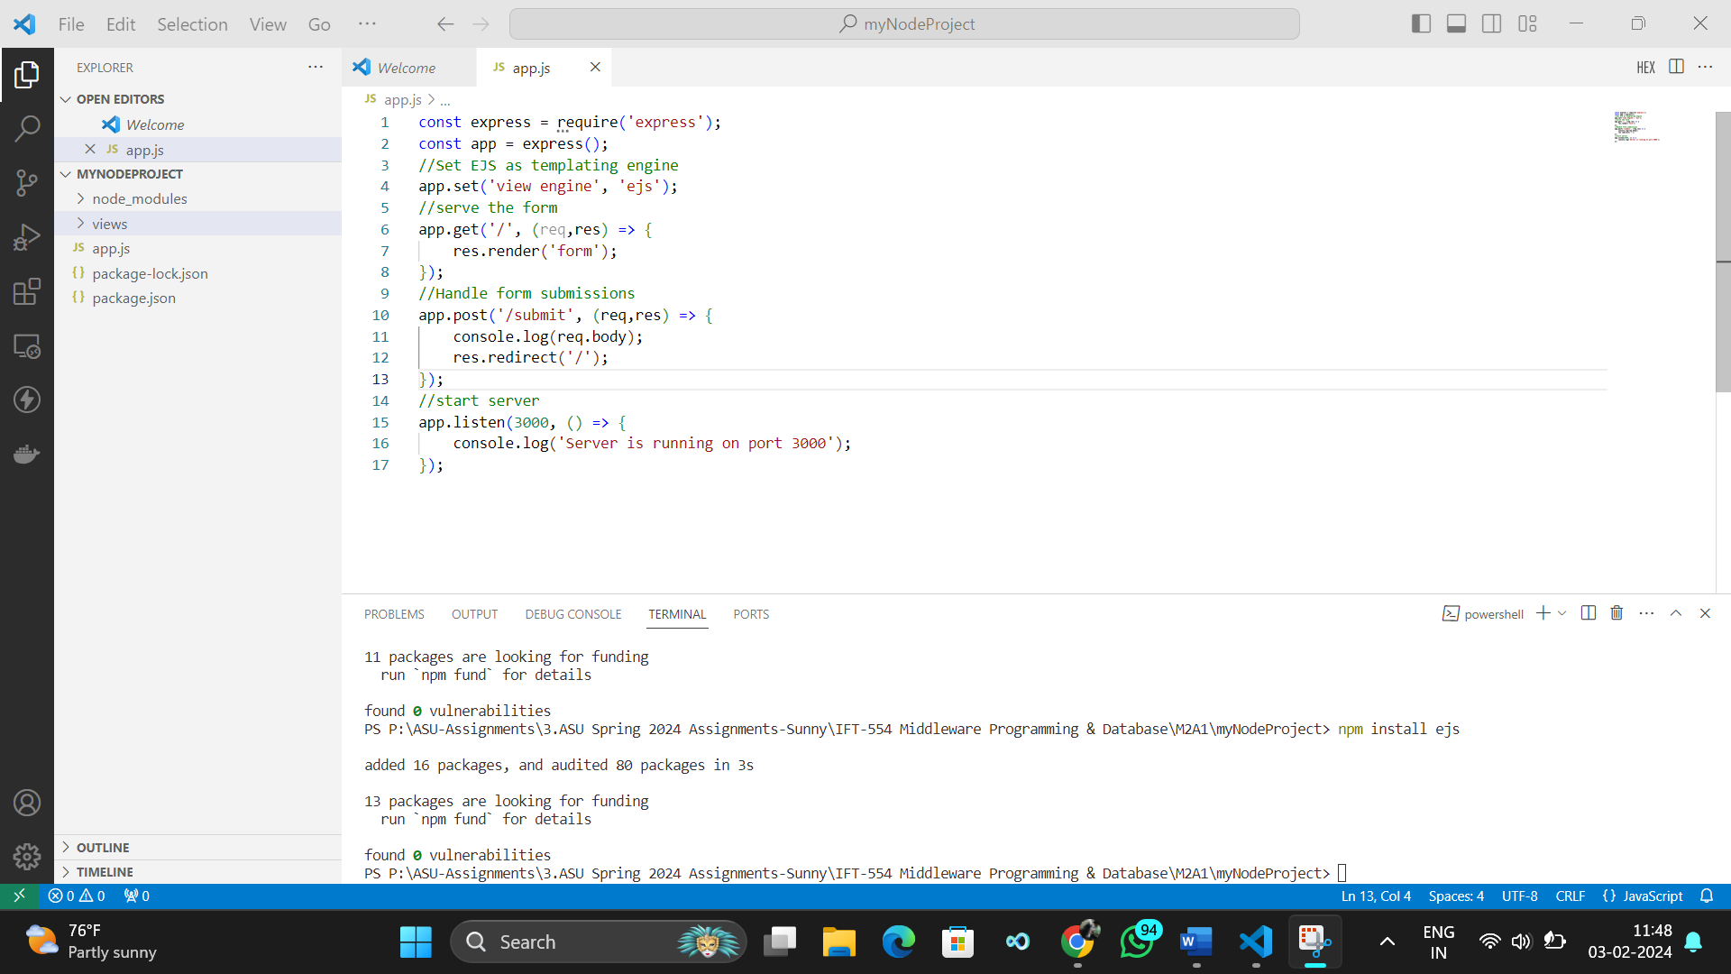

**Screenshot 5: Displaying the creation of a new EJS file named "form.ejs"**

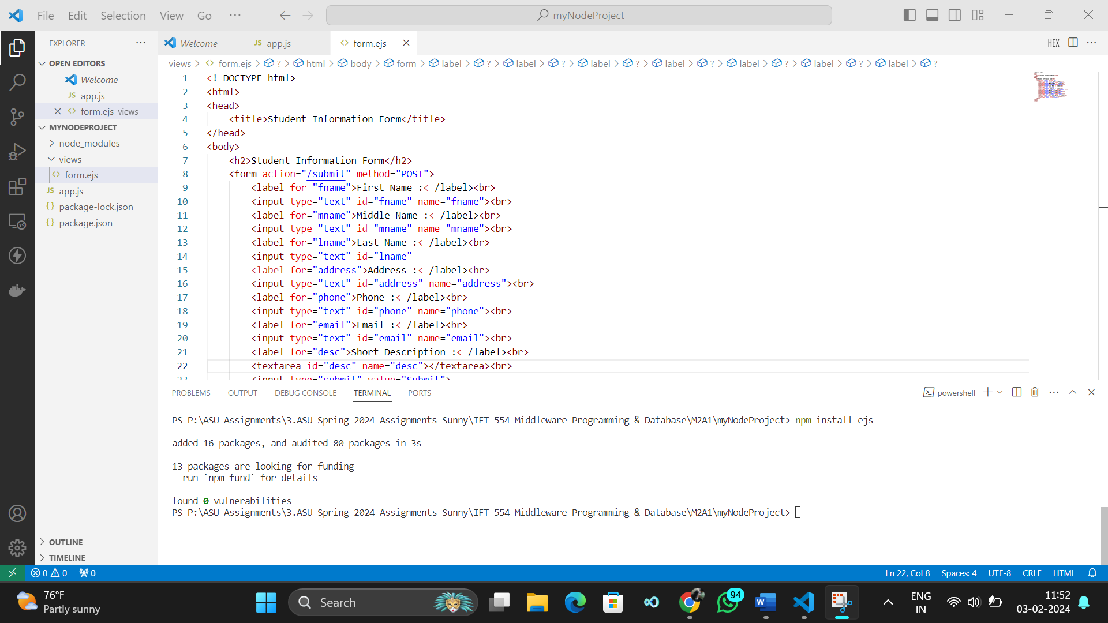

**Screenshot 6: Added code to parse incoming request bodies**

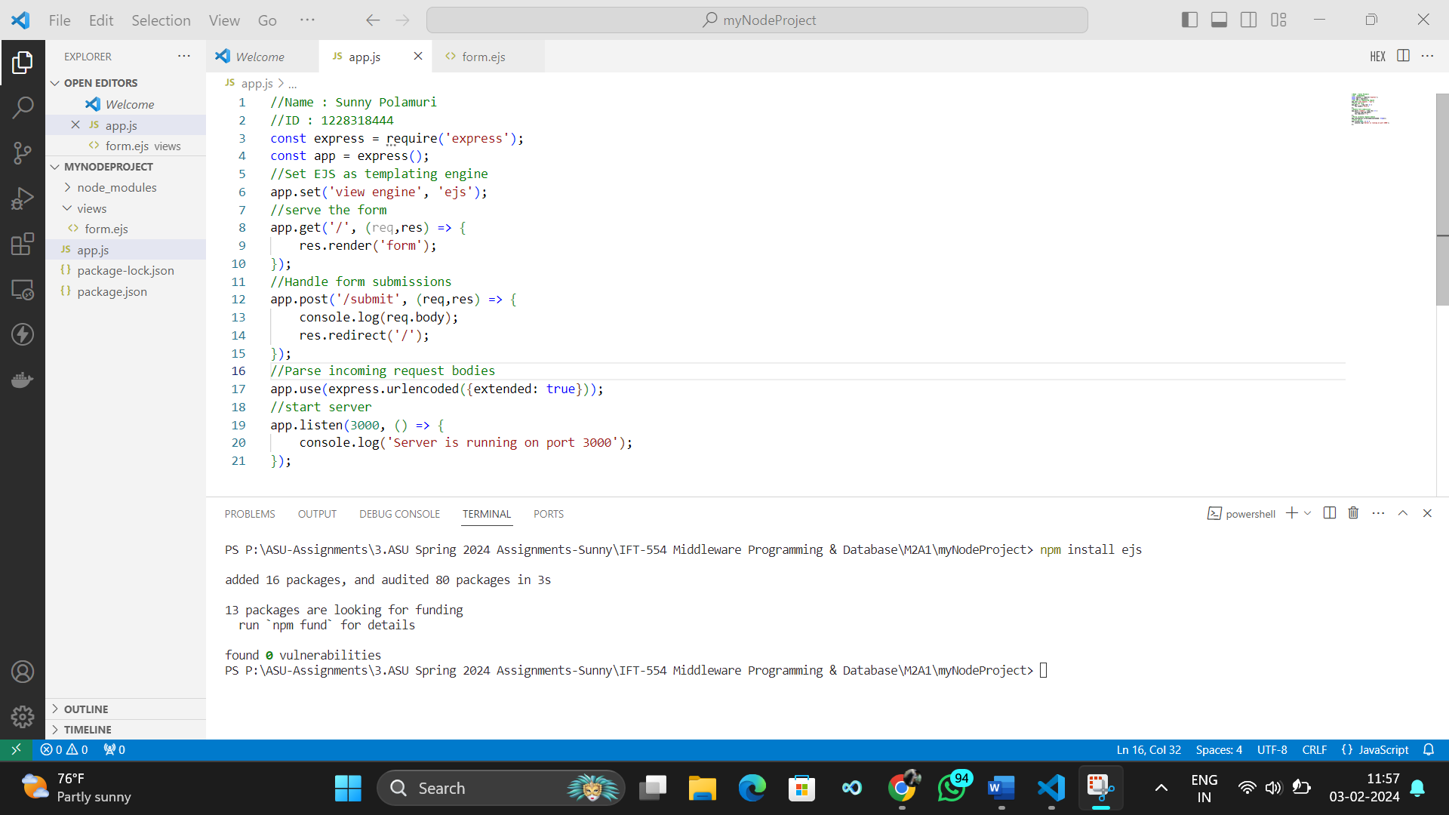

**Screenshot 7: Running the Node.js application and display the server running**   
