**Module 2: Lab 1– Building a Simple Web Application Using Node.js and EJS**

Sunny Polamuri

Dinesh Sthapit

February 04th, 2024

**Screenshot 1:** **Terminal displaying the initialized Node.js project**

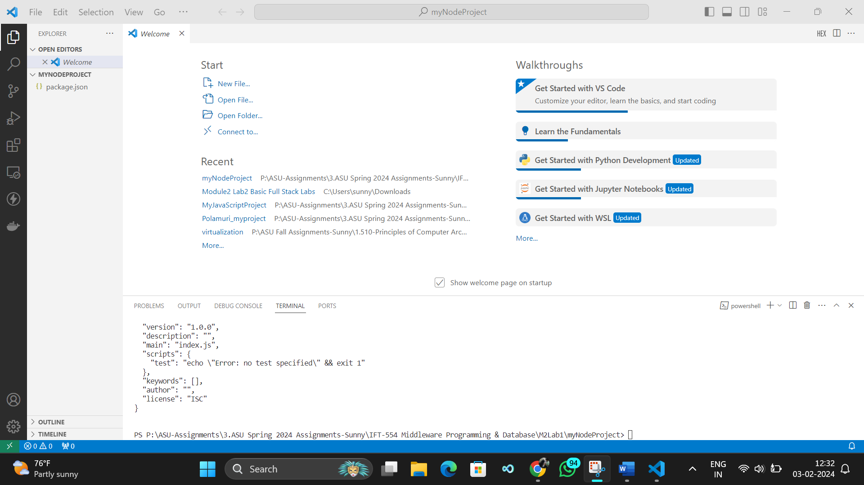

**Screenshot 2: Terminal showing the successful installation of Express.js**

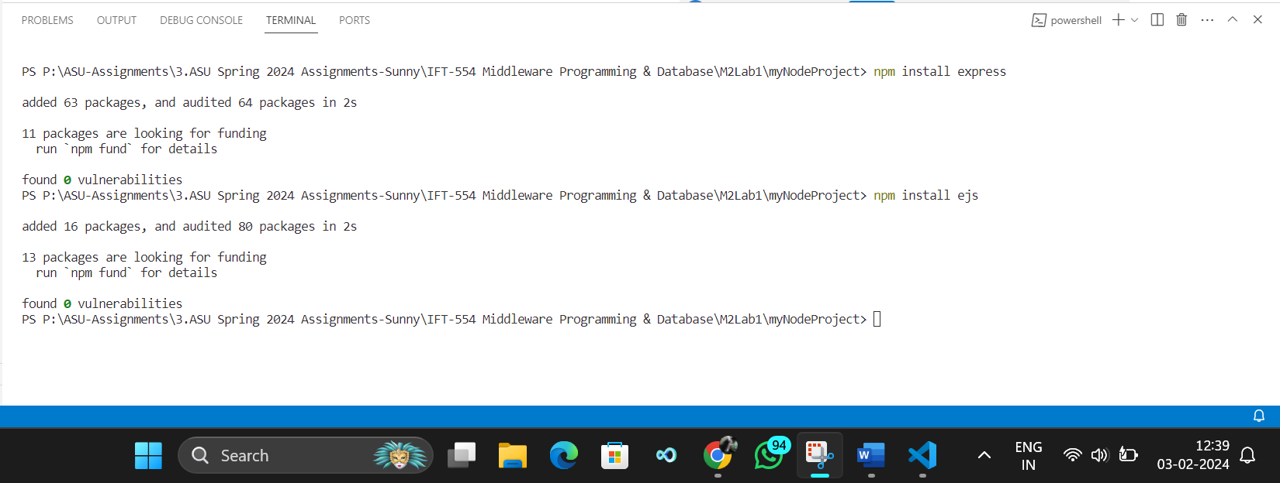

**Screenshot 3: app.js File Creation and Setup**

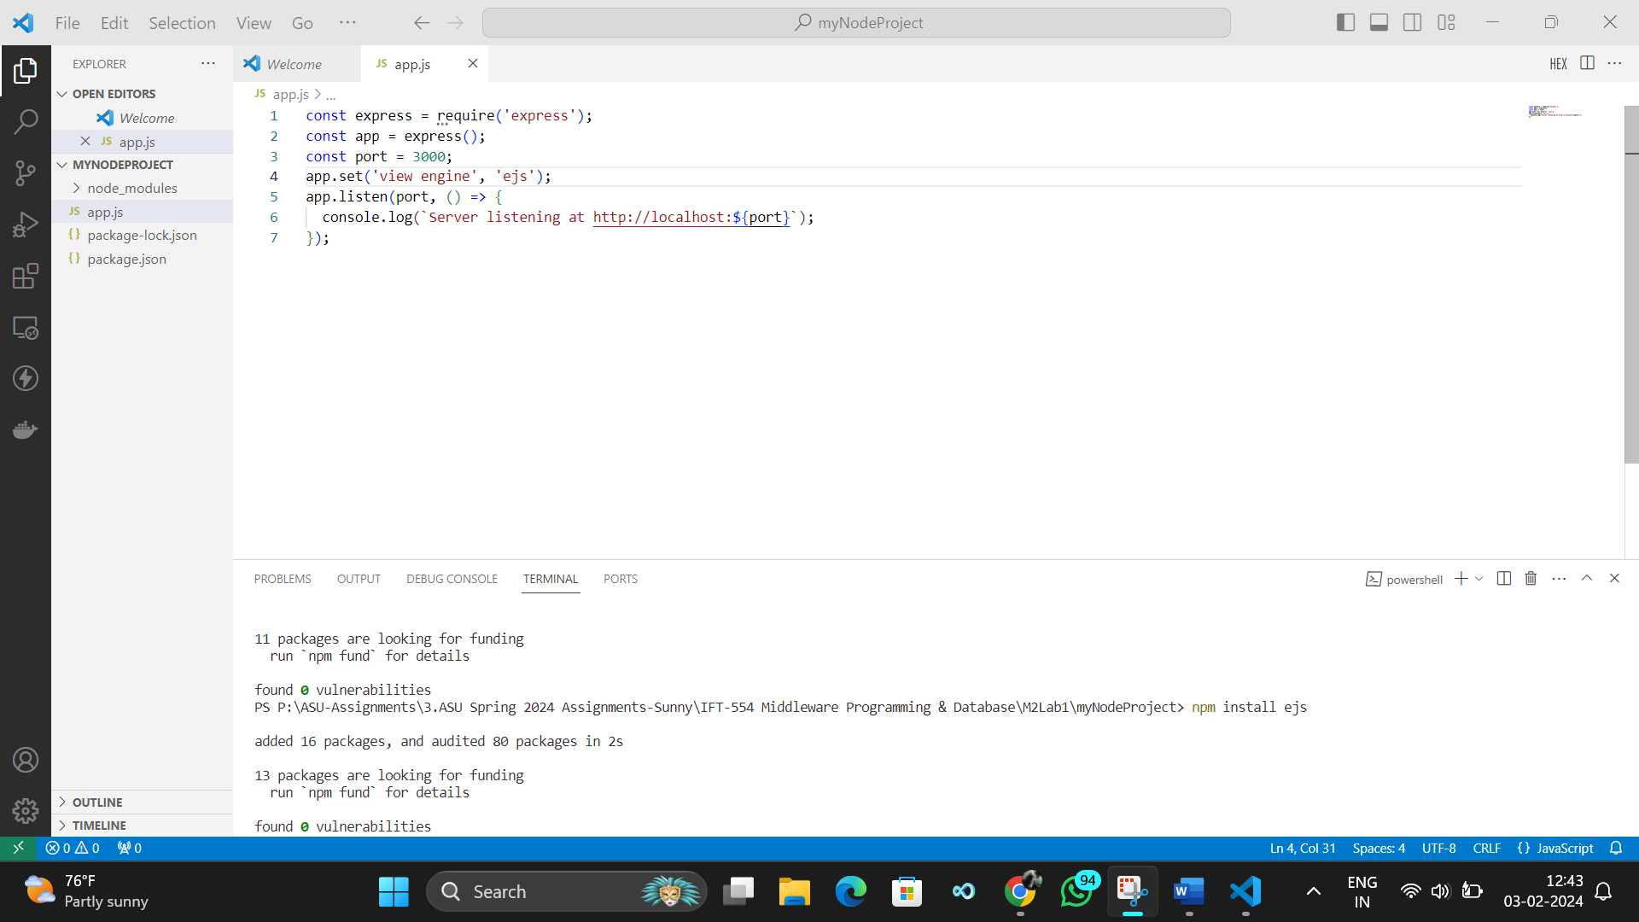

**Screenshot 4: Newly created views folder**

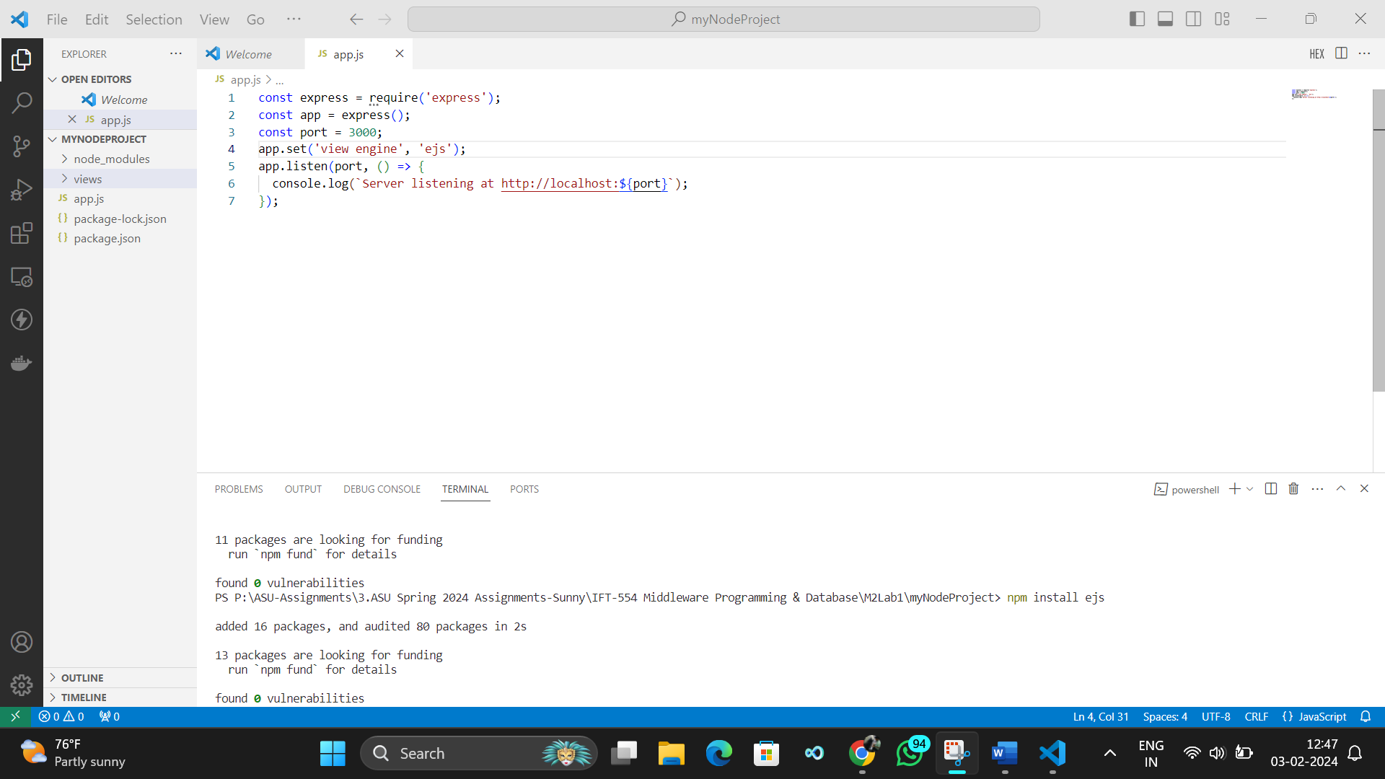

**Screenshot 5: Student information form**

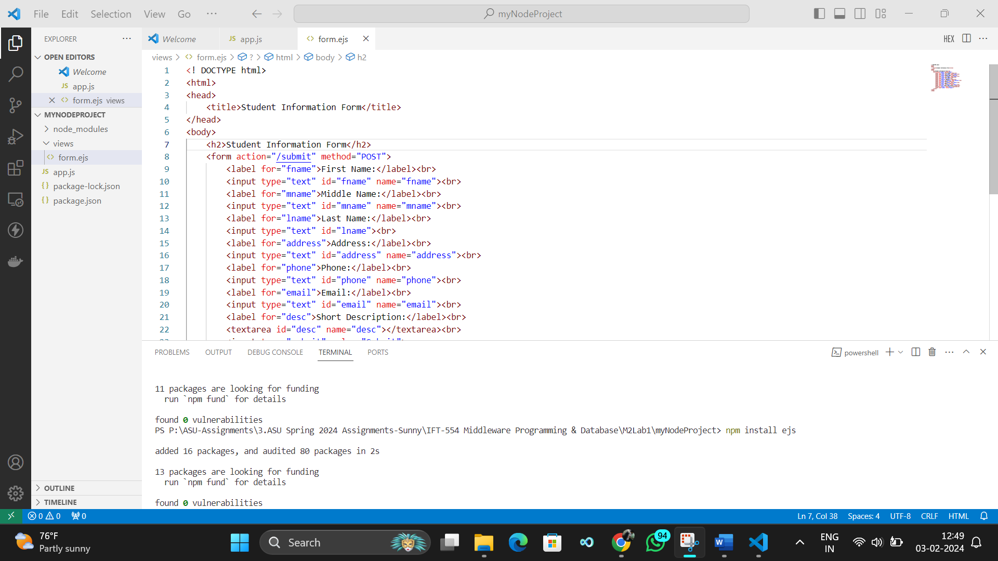

**Screenshot 6: Code for serving the form and handling form submissions**

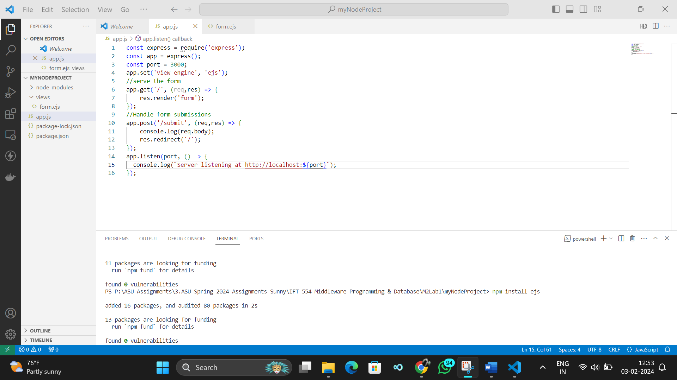

**Screenshot 7: Running the Node.js application**

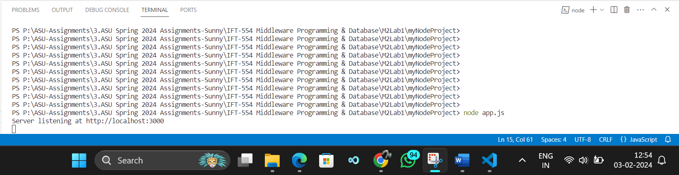

**Screenshot 8: Web browser displaying the student information form**

