**Module 3: Activity 1 – MongoDB/Atlas setup**

Sunny Polamuri

Dinesh Sthapit

February 18th, 2024

**Screenshot 1:** **E-mail confirmation**

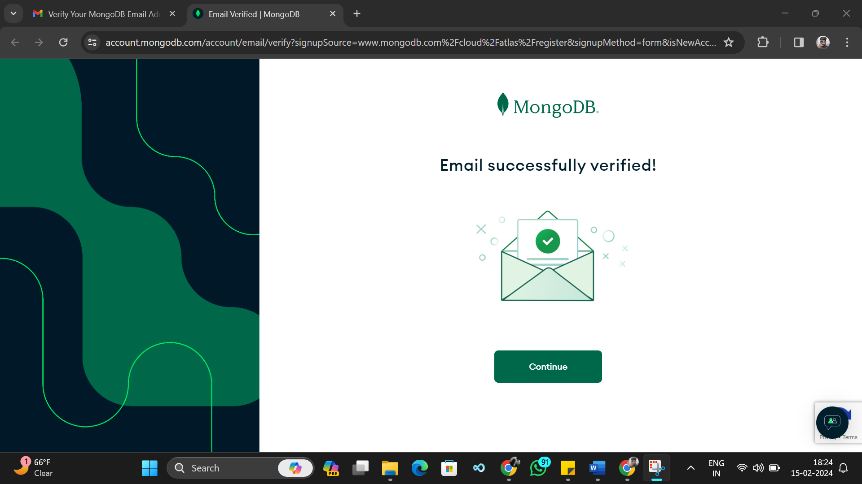

**Screenshot 2: New Project Setup**

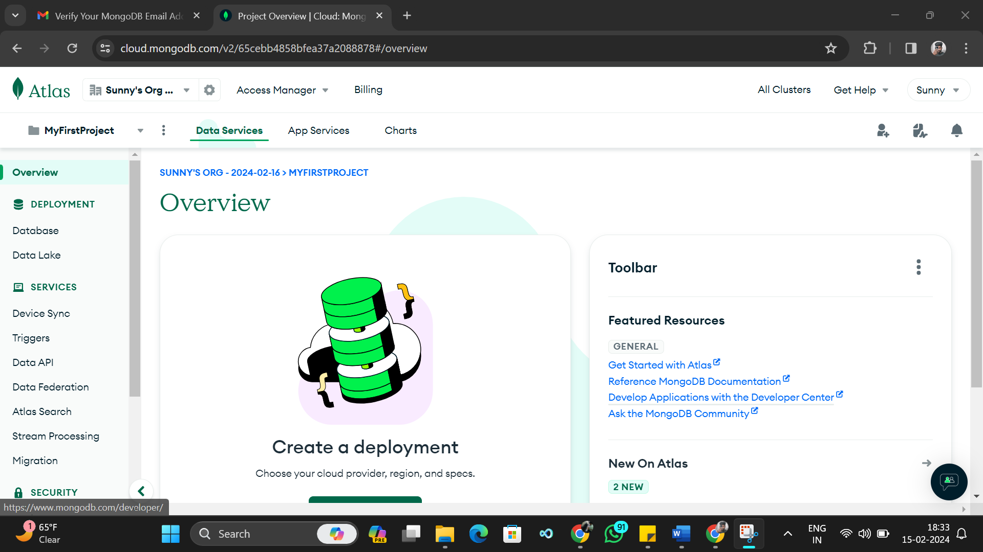

**Screenshot 3: New Cluster**

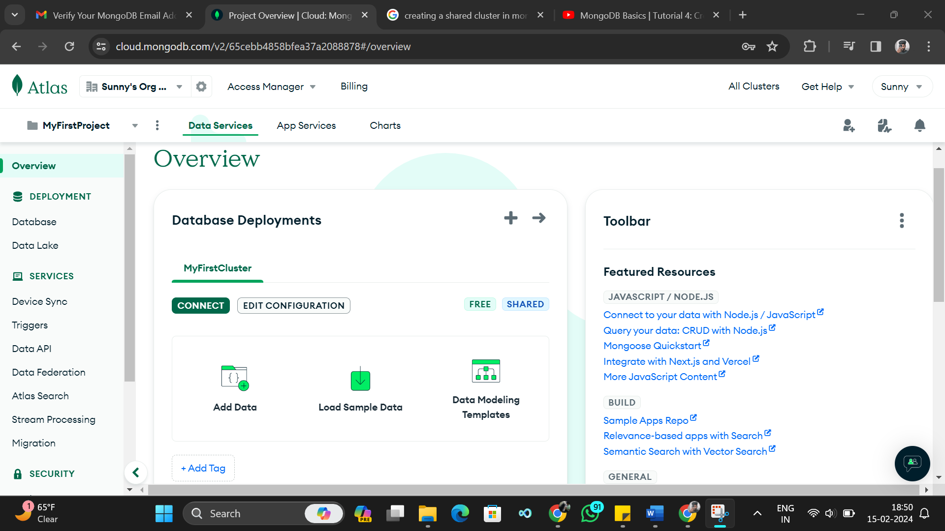

**Screenshot 4: Database and Collections**

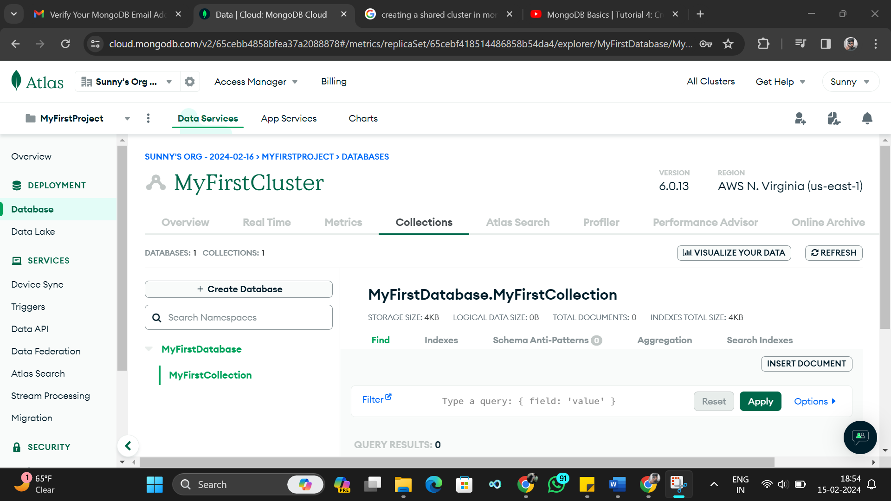

**Screenshot 5: Connection IP and User Setup**

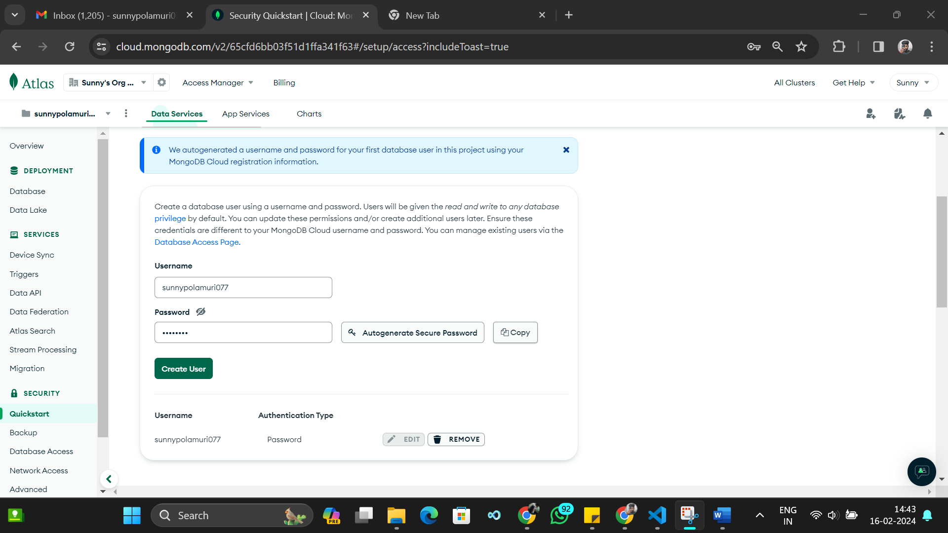

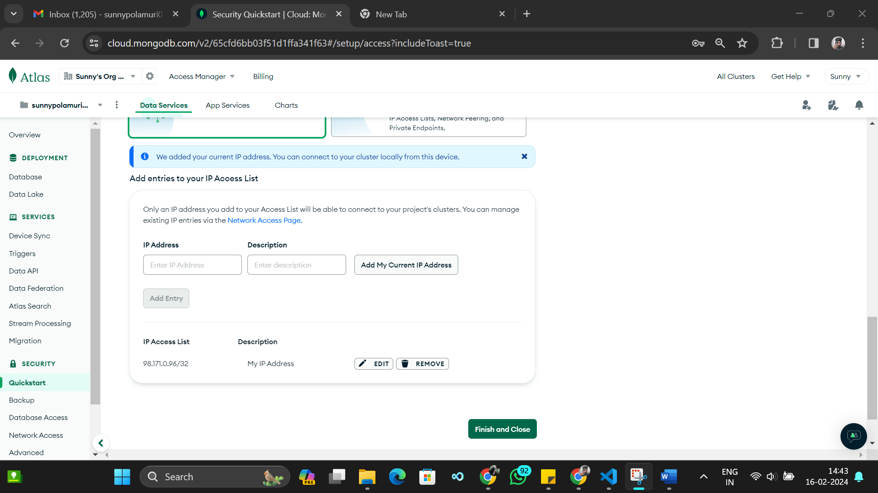

**Screenshot 6:Connection String**

