**Module 3: Activity 2 – Understanding MongoDB**

Sunny Polamuri

Dinesh Sthapit

February 18th, 2024

**Screenshot 1: package.json File**

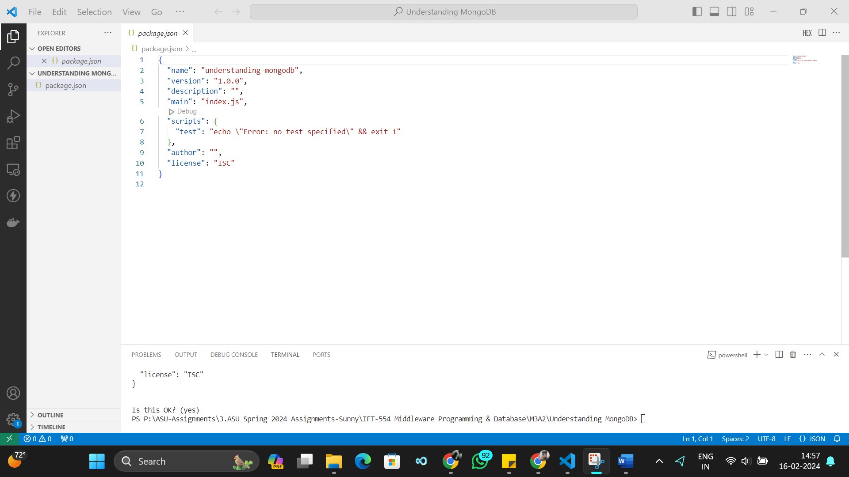

**Screenshot 2: Cluster and connection string**

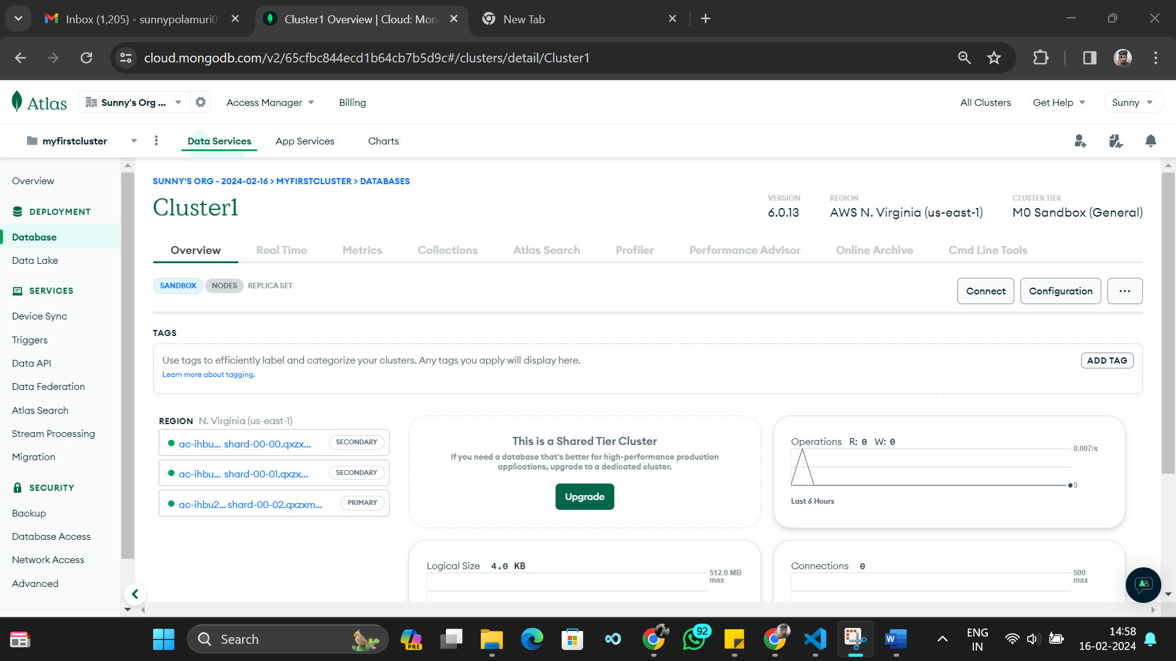

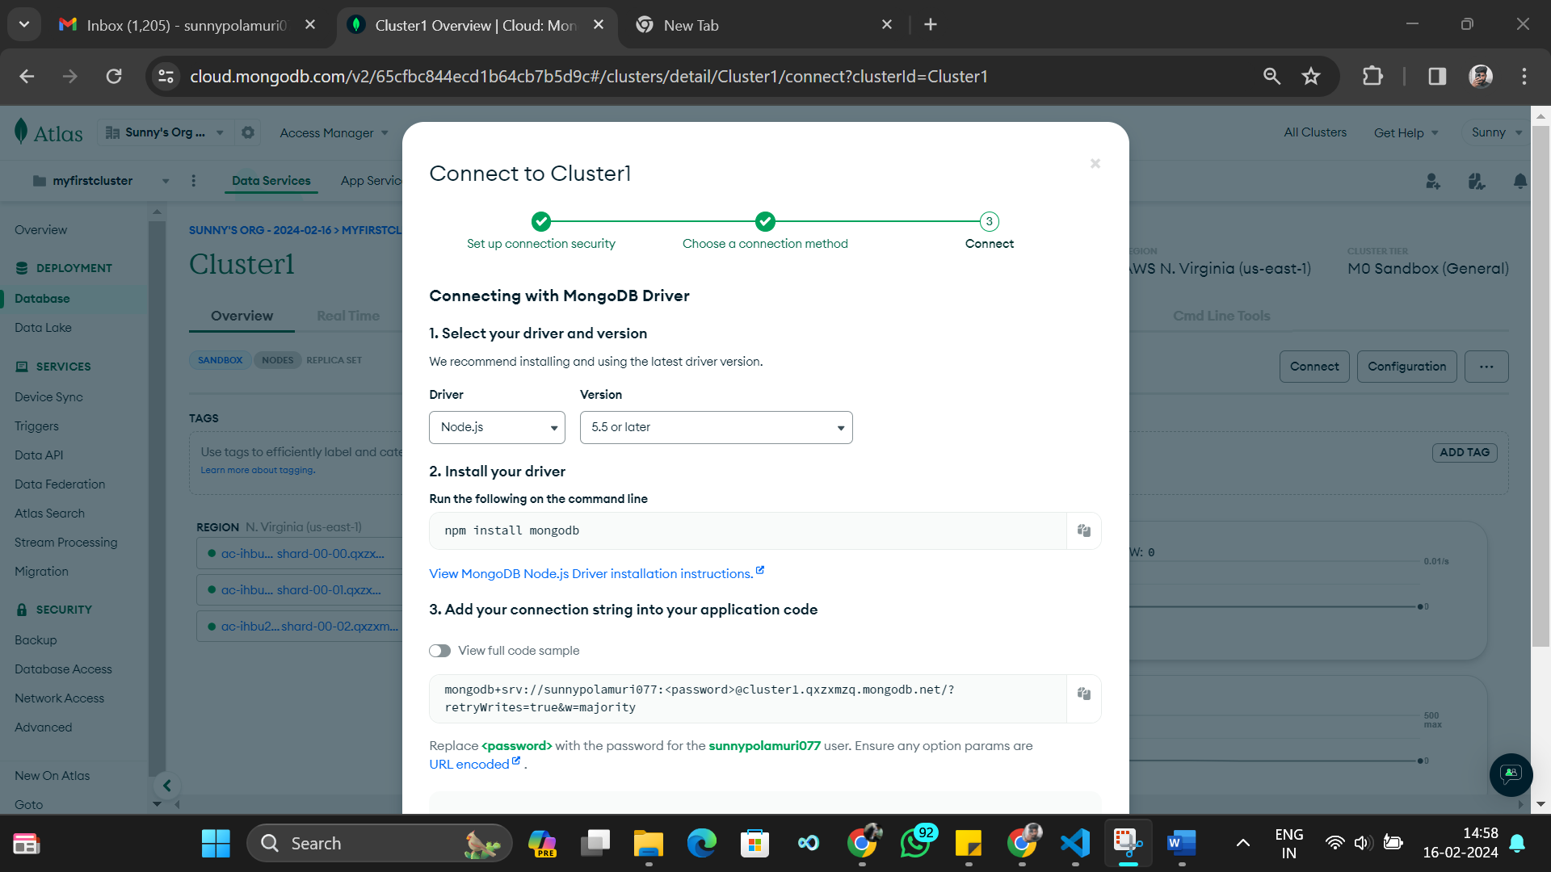

**Screenshot 3: database.js File**

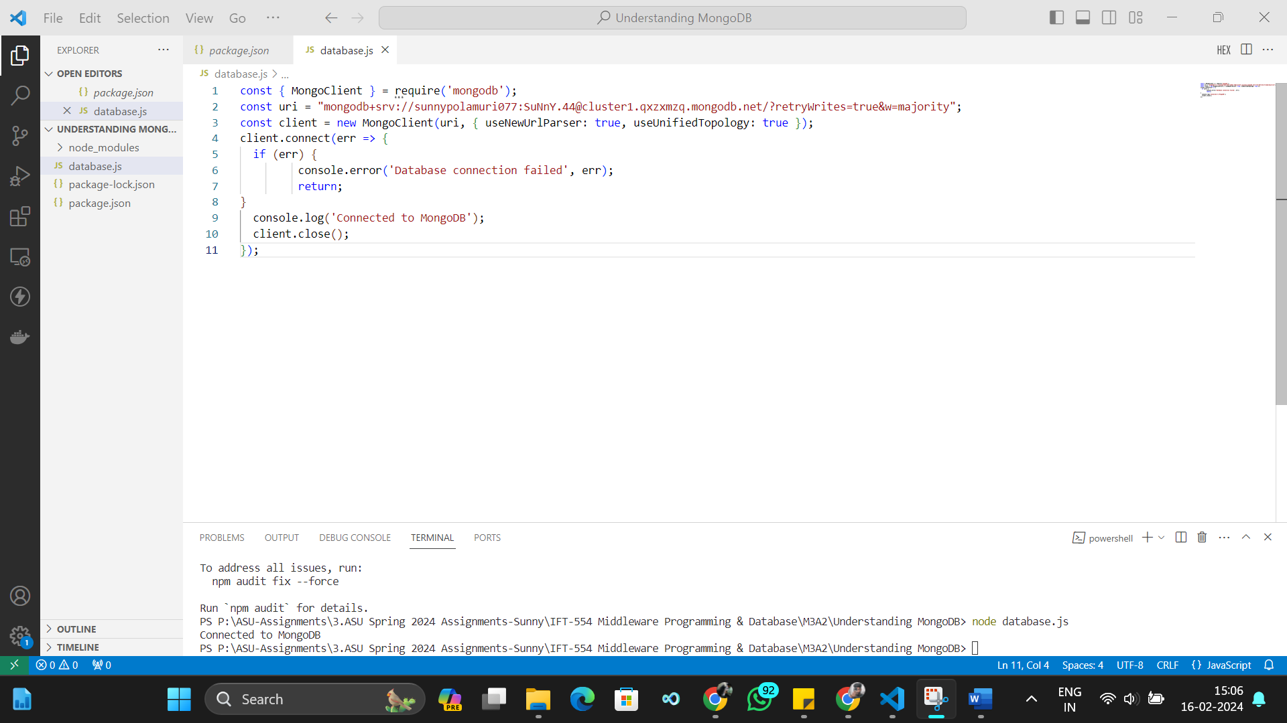

**Screenshot 4: CRUD Functions**

