**Module 3: Lab 1– Implementing MongoDB Operations in Node.js**

Sunny Polamuri

Dinesh Sthapit

February 18th, 2024

**Screenshot 1: Env Configuration** 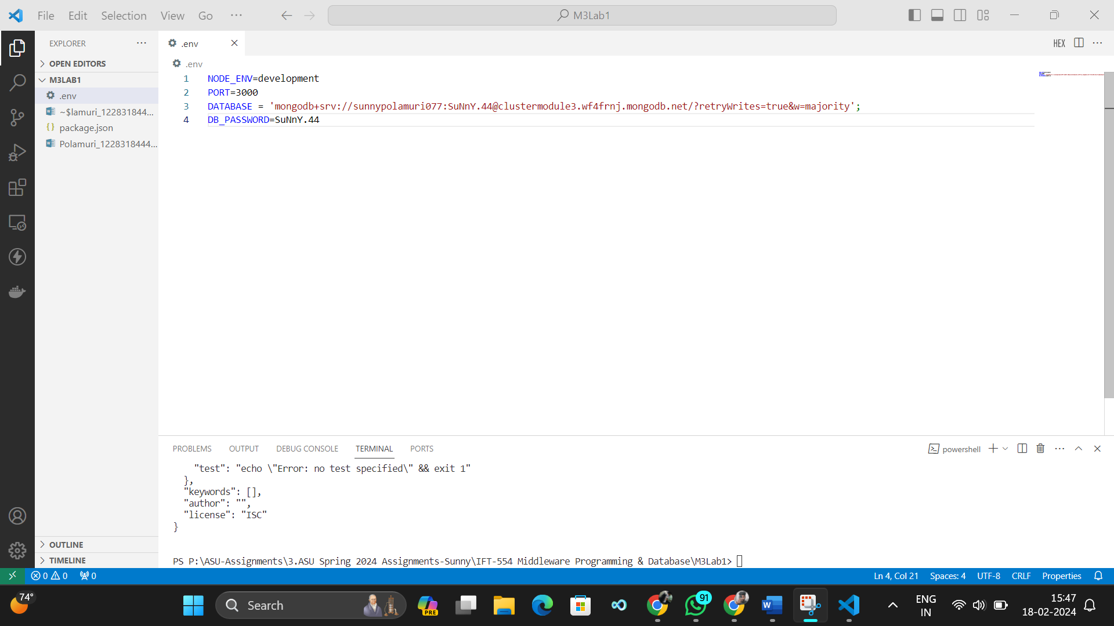

**Screenshot 2: Create Express backend and interact with MongoDB**

1. loanRoutes.js

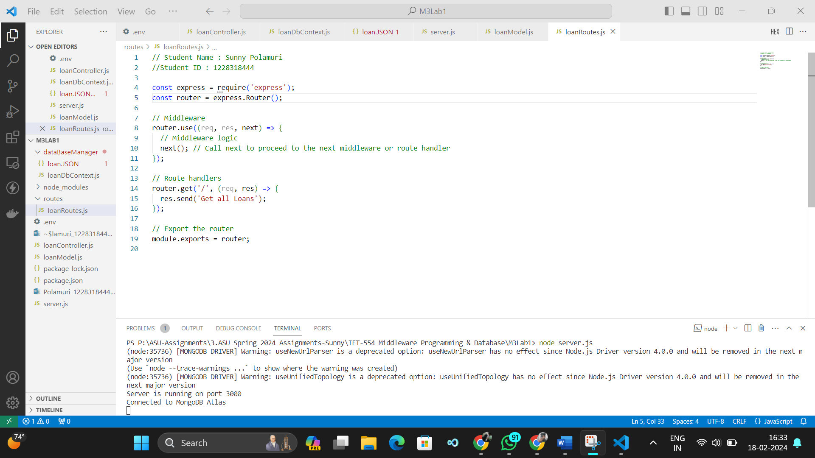

1. loanController.js

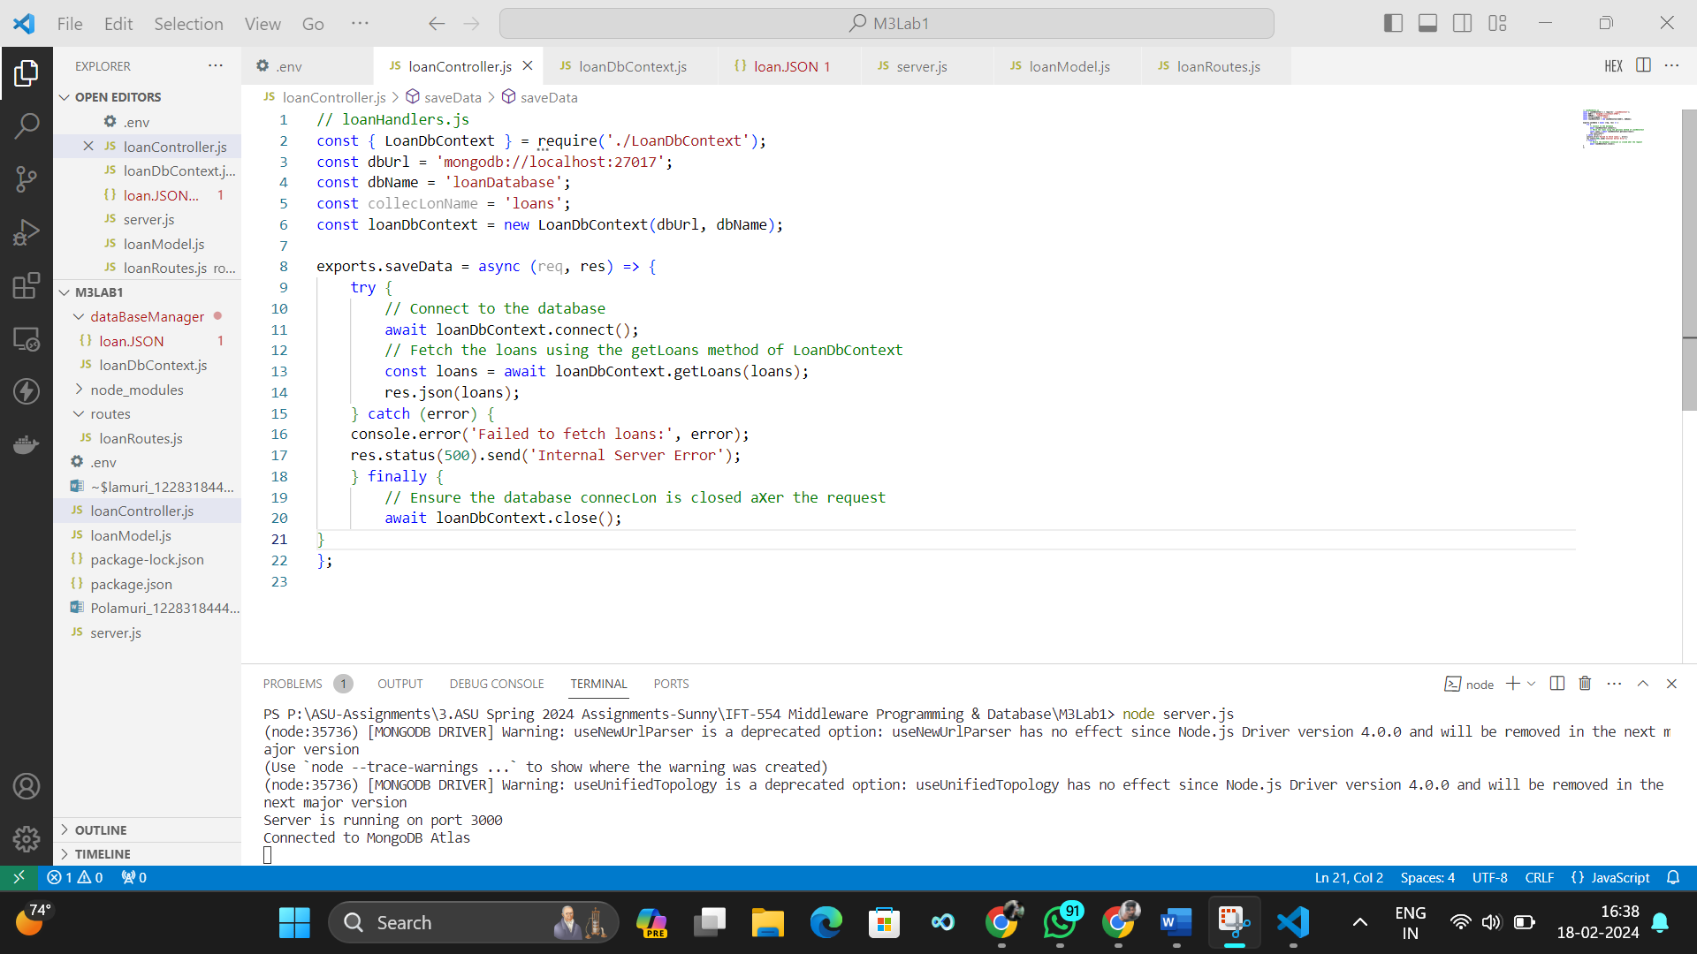

1. loanModel.js

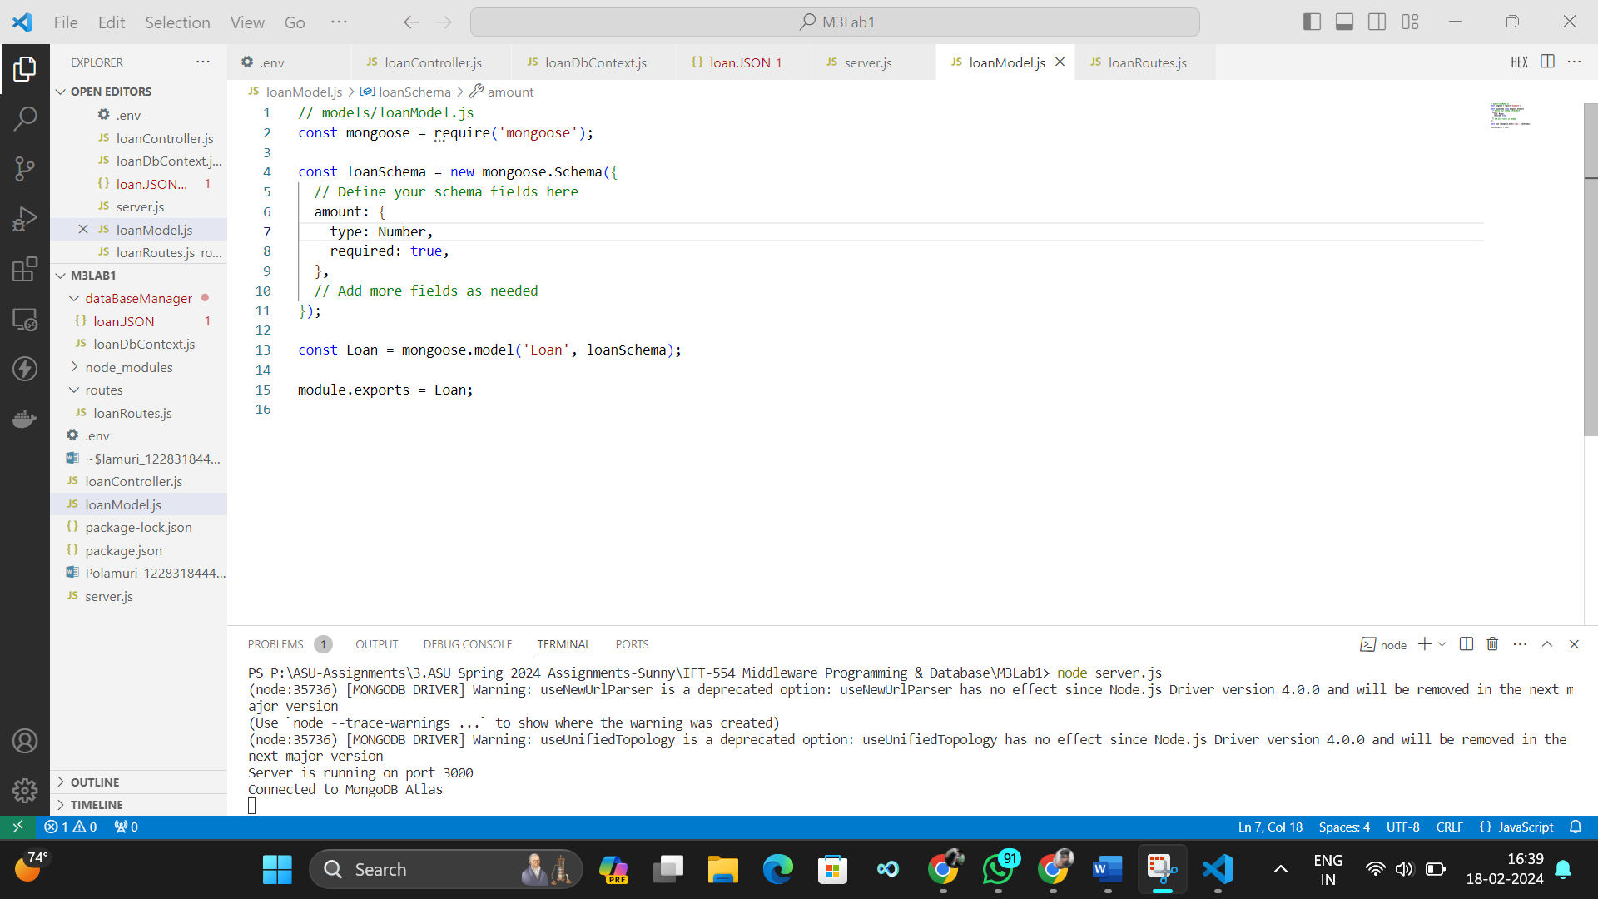

**Screenshot 3: server.js**

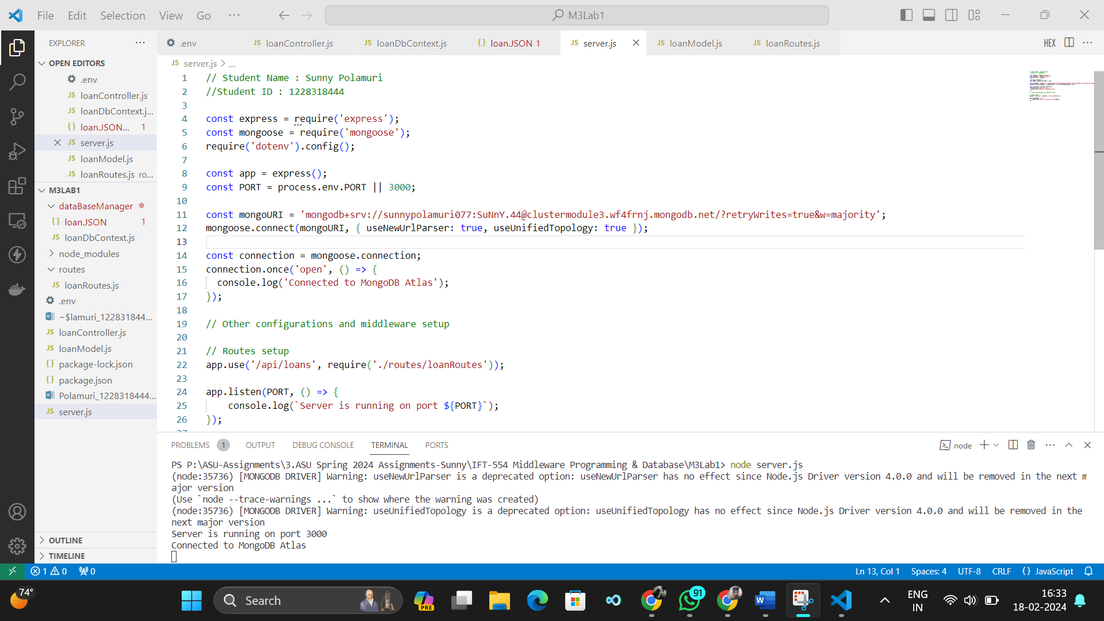

**Screenshot 4: Database Manager and loanDb Context**

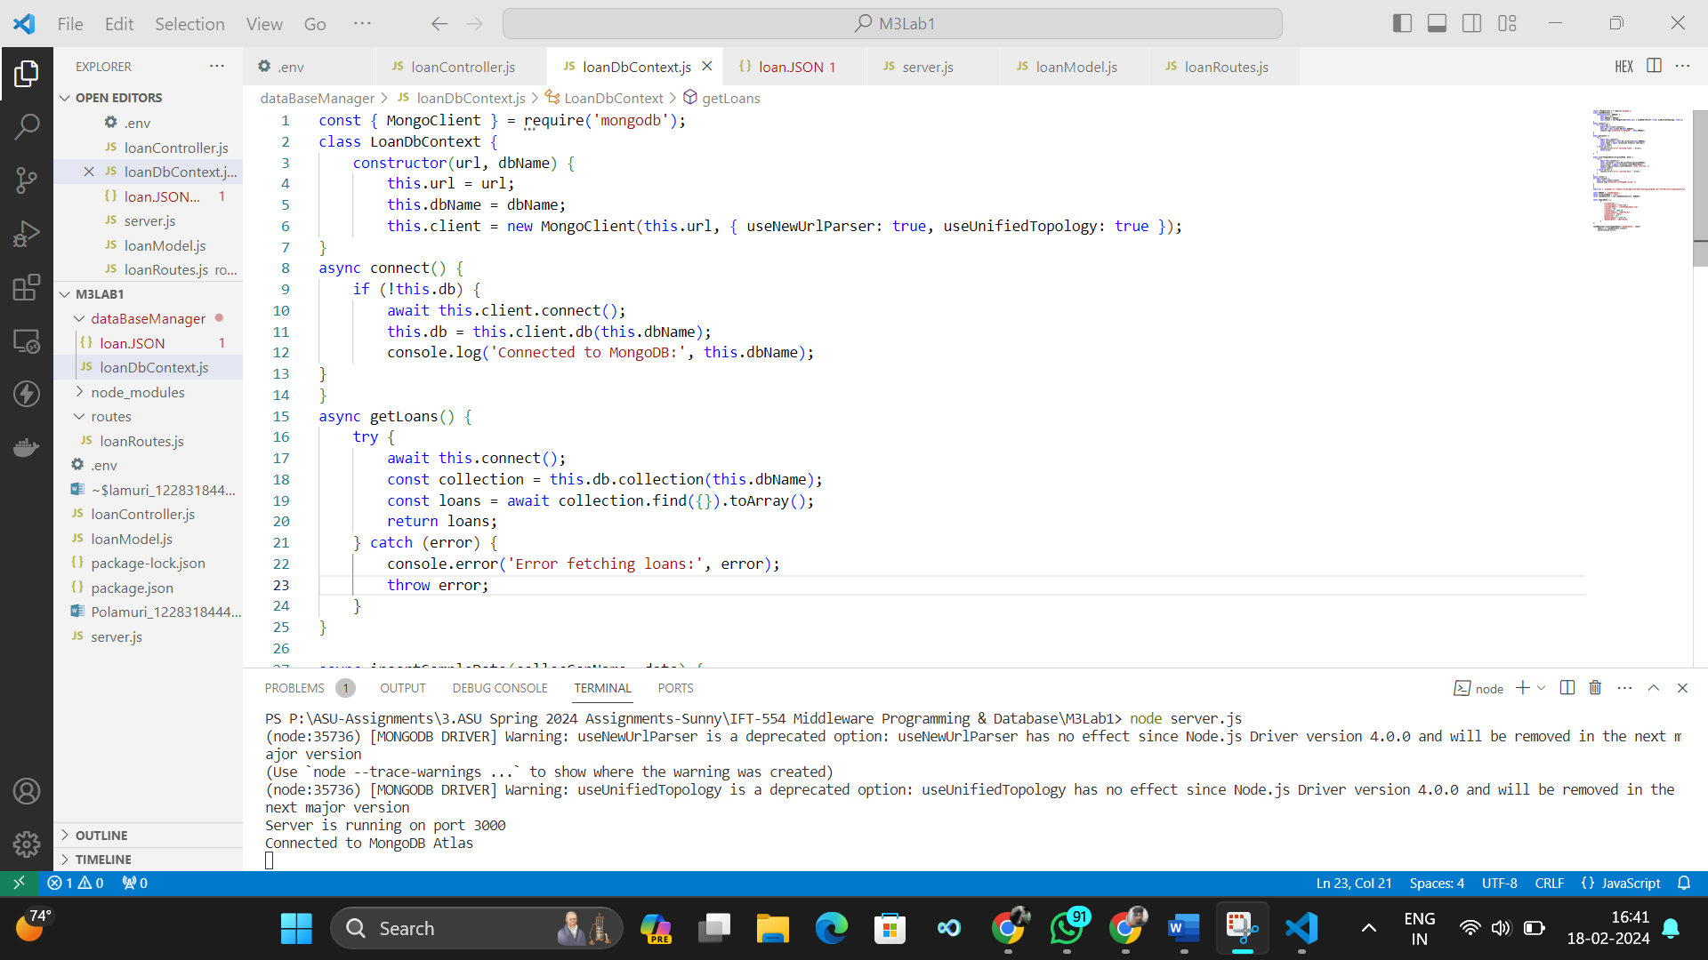

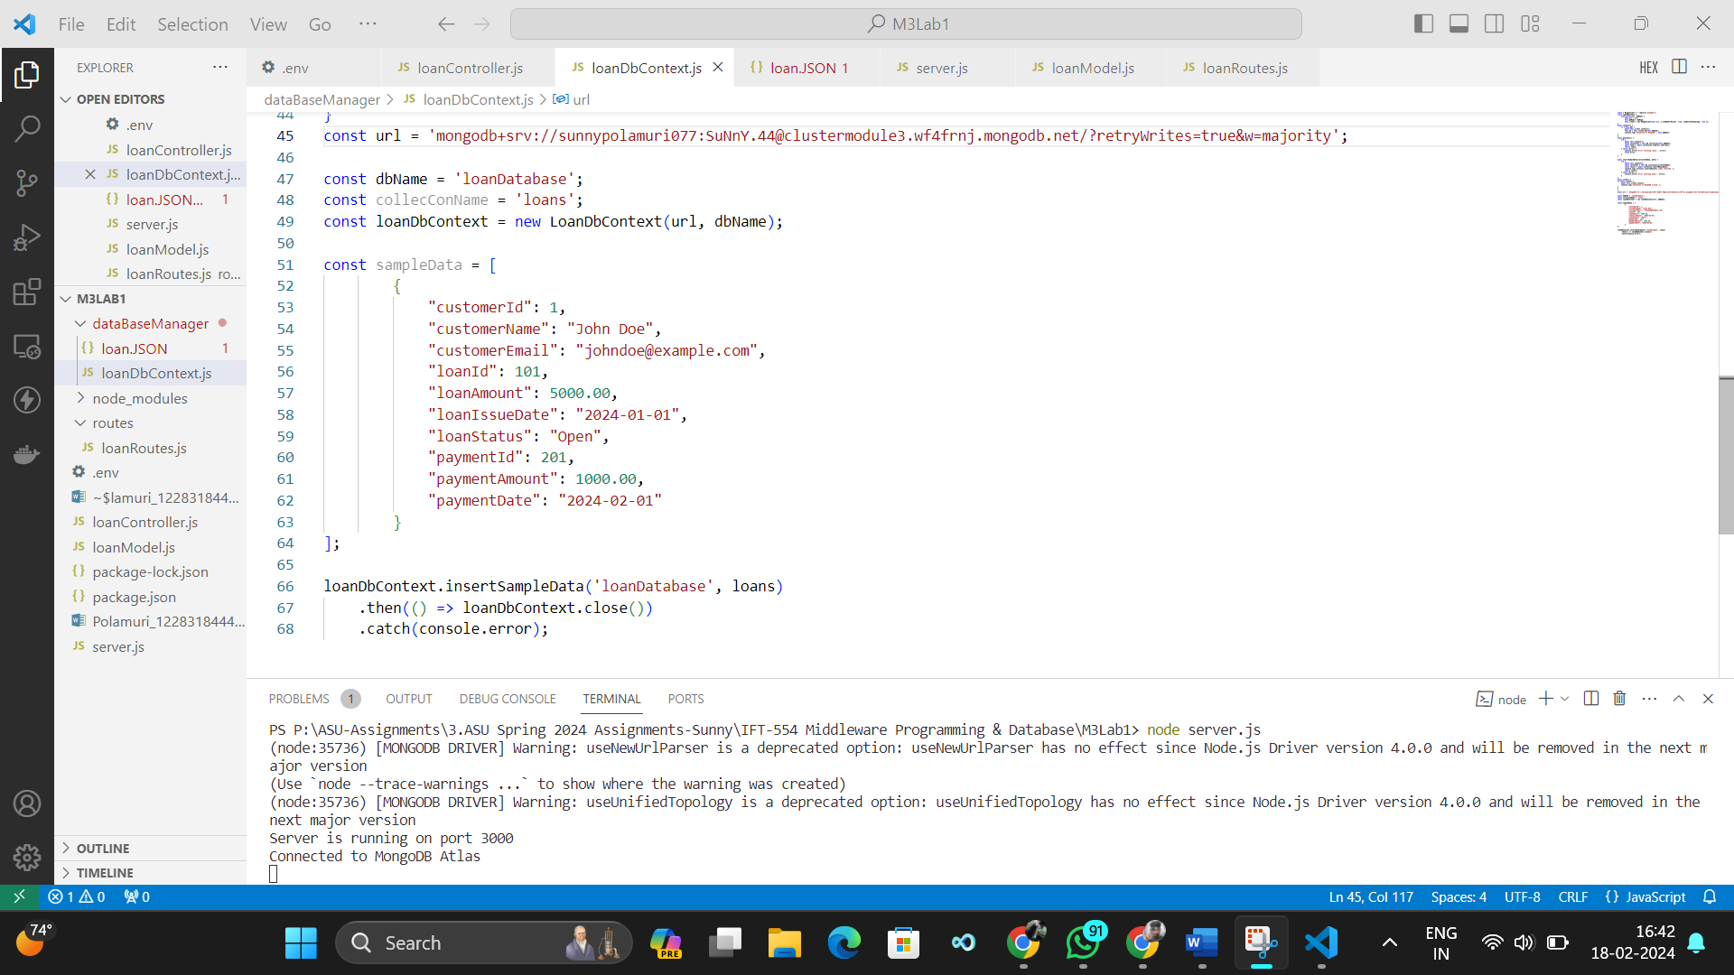

**Screenshot 5: loanController Creation and file modification**

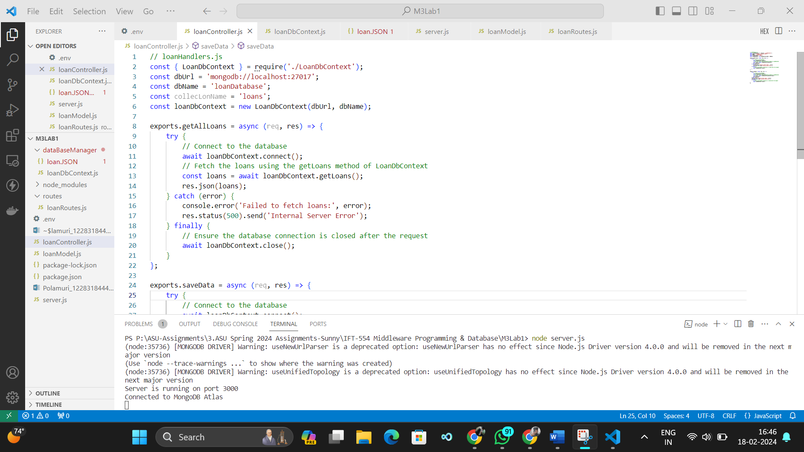

**Screenshot 6: Add routes to app.js**

