**Module 3: Lab 2 – Integrating MongoDB with Express.js**

Sunny Polamuri

Dinesh Sthapit

February 18th, 2024

**Screenshot 1: Setting Up Express.js**

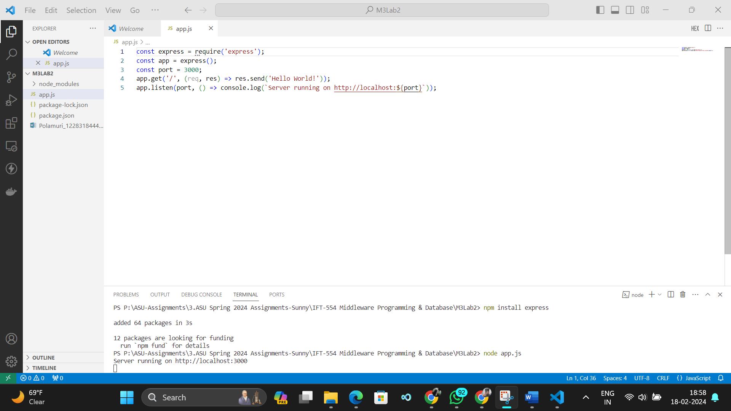

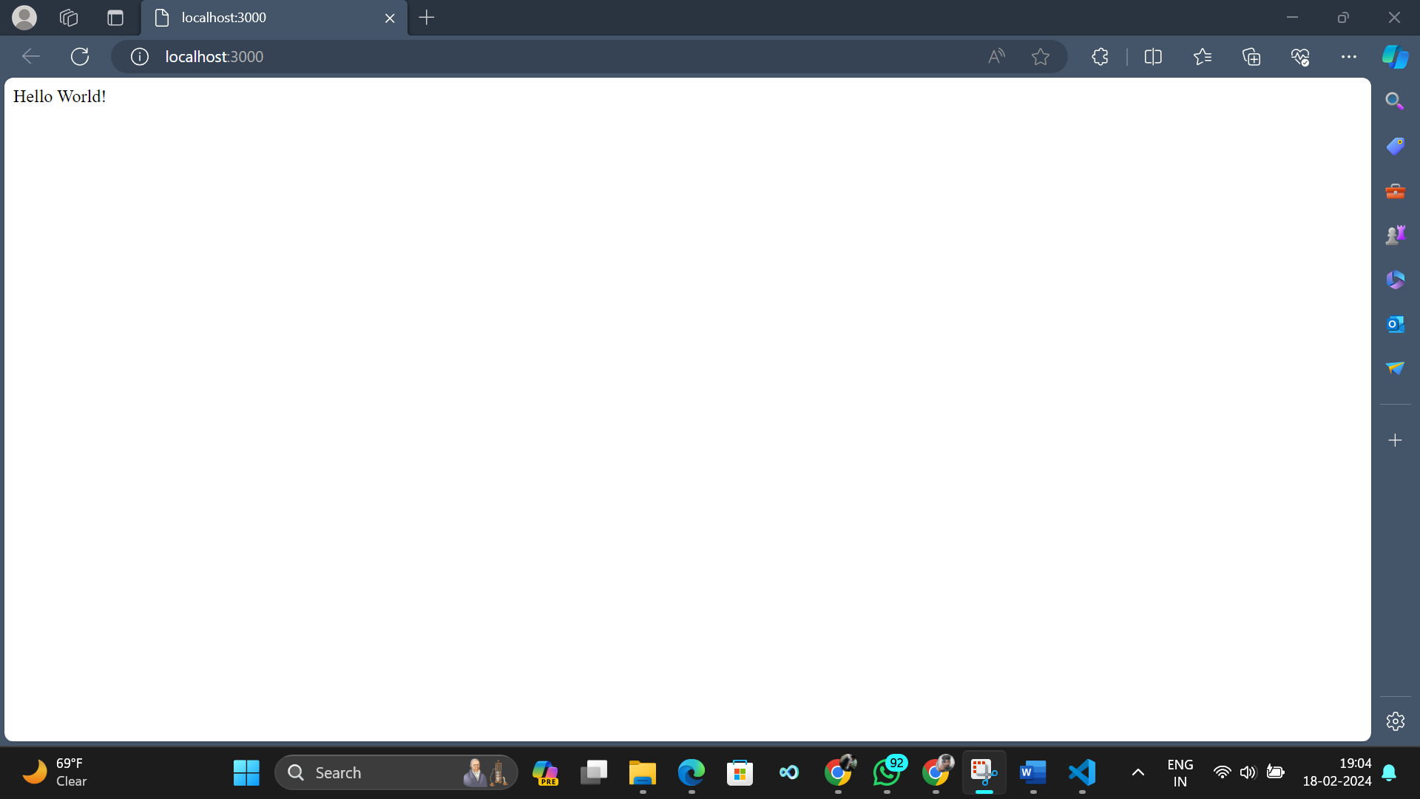

**Screenshot 2: Middleware for Database Interactions**

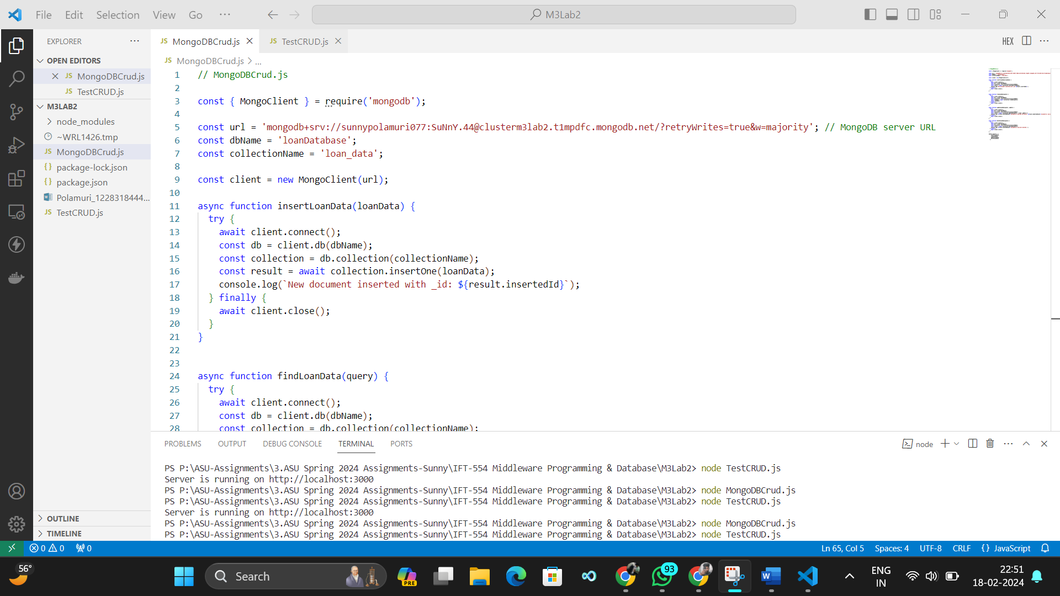

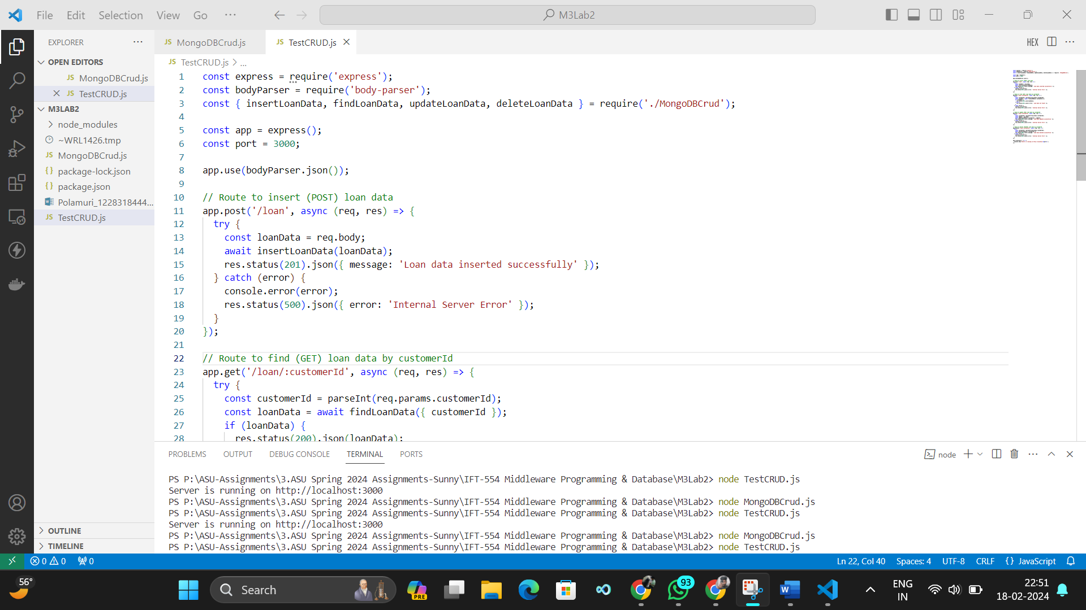

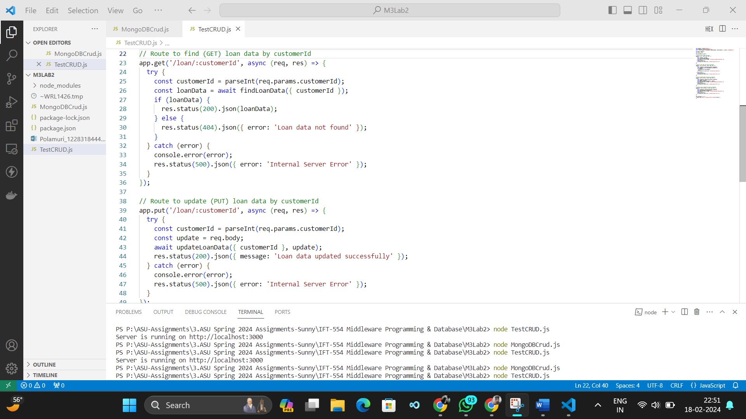

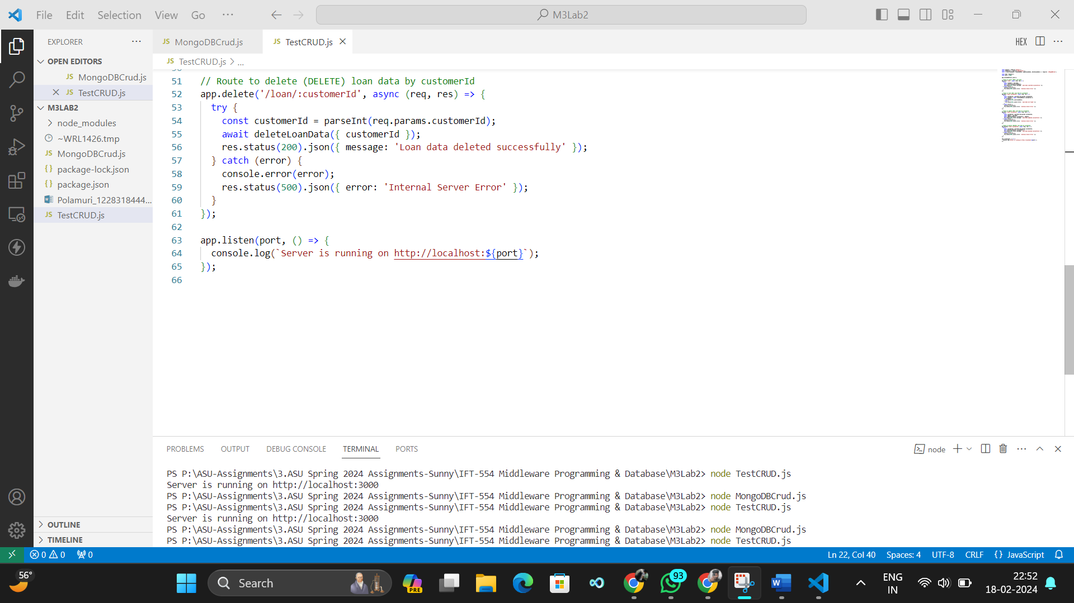

**Screenshot 3: Testing and Debugging**

**POST method in Postman:**

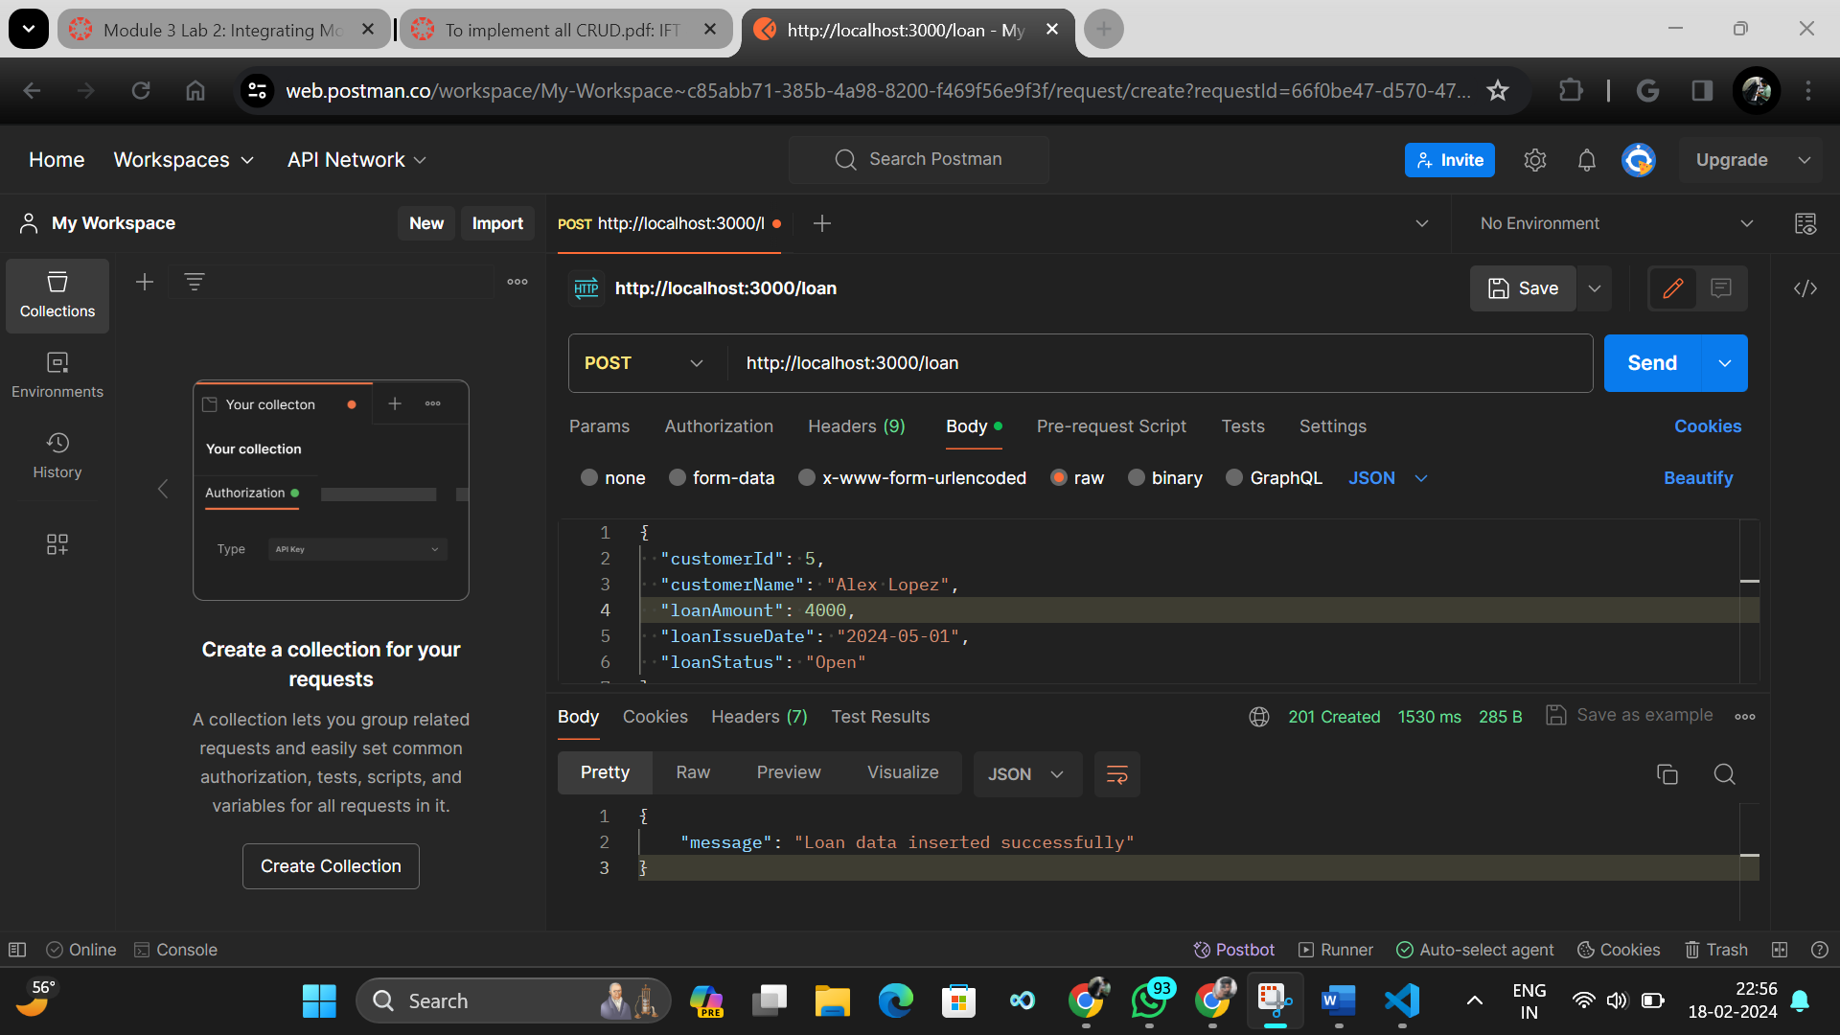

**POST method updated on MongoDB:**

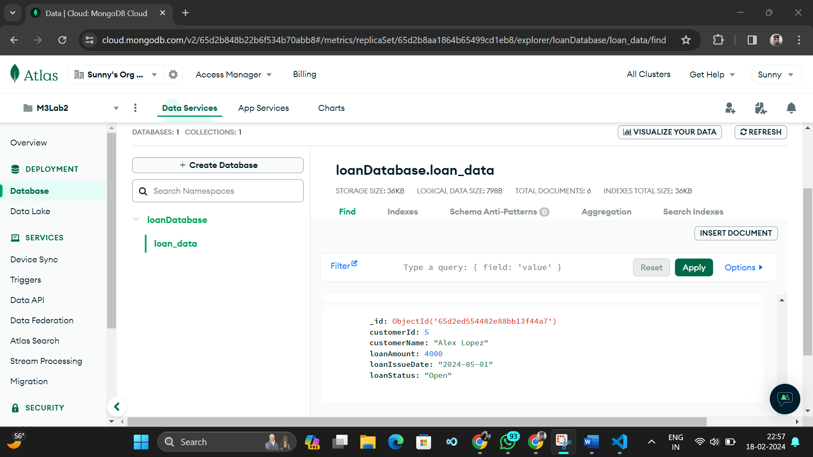

**GET method in Postman:**

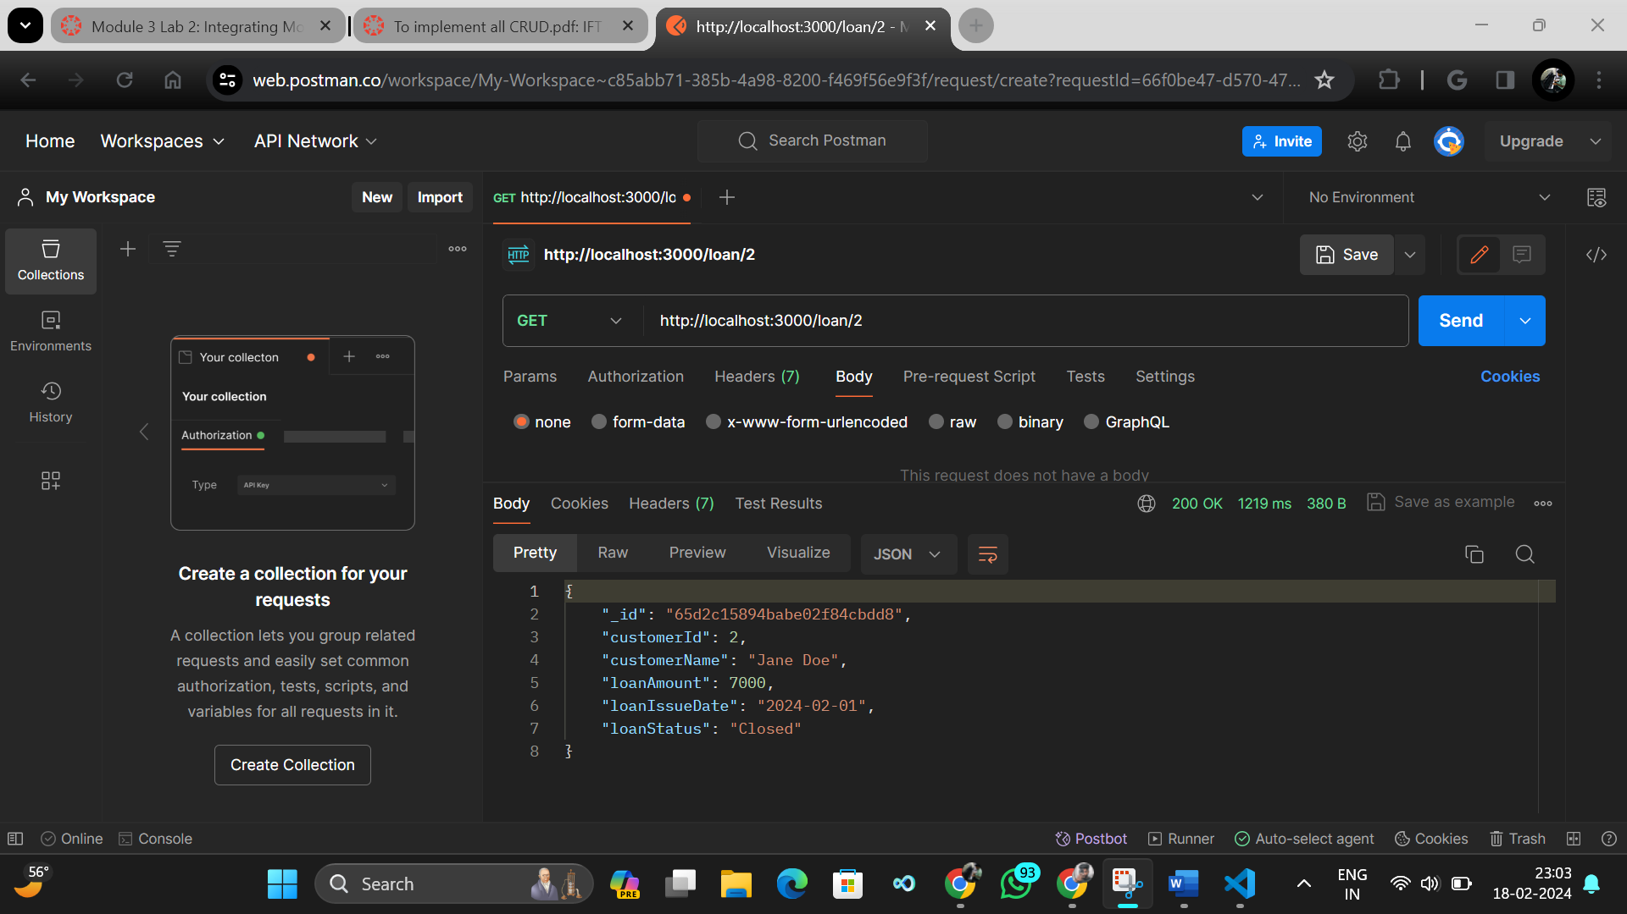

**PUT method in Postman:**

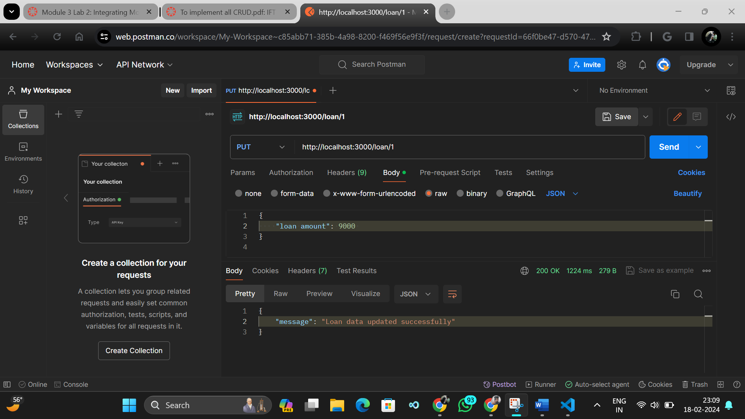

**PUT method updated on MongoDB:**

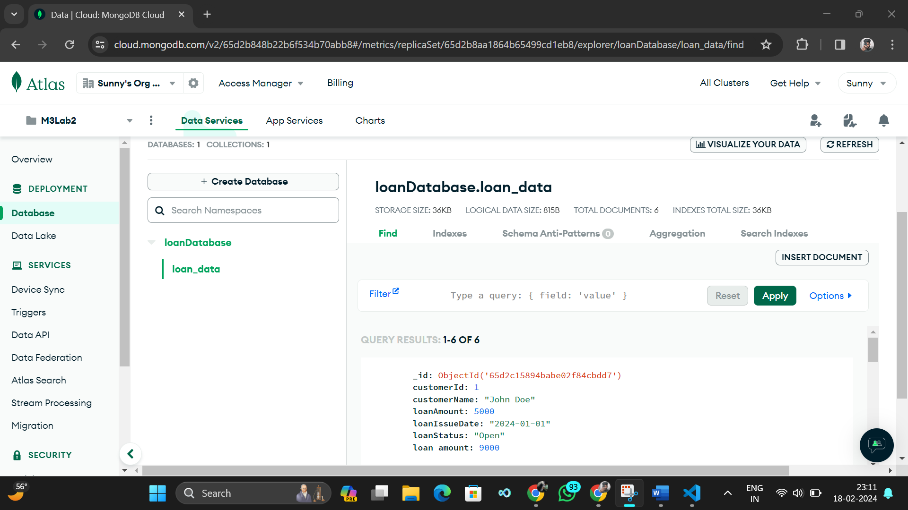

**DELETE method in Postman:**

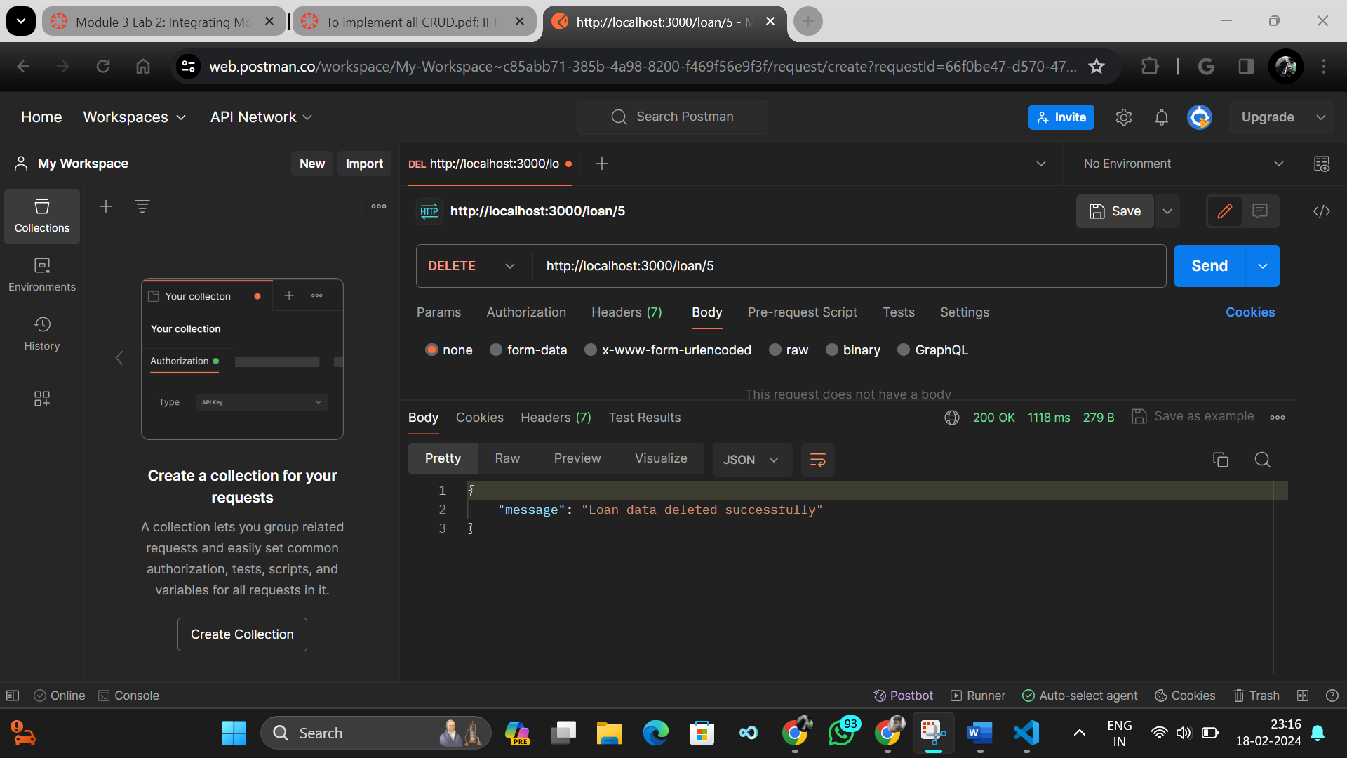

**LOGS during CRUD Operations:**

