Defect Life Cycle
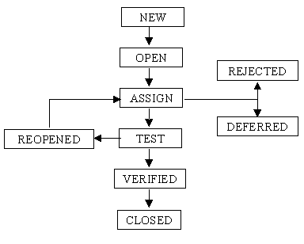
- New: When the bug is posted for the first time, its state will be “NEW”. This means that the bug is not yet approved.
- Open: After a tester has posted a bug, the lead of the tester approves that the bug is genuine and he changes the state as “OPEN”.
- Assign: Once the lead changes the state as “OPEN”, he assigns the bug to corresponding developer or developer team. The state of the bug now is changed to “ASSIGN”.
- Test: Once the developer fixes the bug, he has to assign the bug to the testing team for next round of testing. Before he releases the software with bug fixed, he changes the state of bug to “TEST”. It specifies that the bug has been fixed and is released to testing team
- Deferred: The bug, changed to deferred state means the bug is expected to be fixed in next releases. The reasons for changing the bug to this state have many factors. Some of them are priority of the bug may be low, lack of time for the release or the bug may not have major effect on the software
- Rejected: If the developer feels that the bug is not genuine, he rejects the bug. Then the state of the bug is changed to “REJECTED
- Duplicate: If the bug is repeated twice or the two bugs mention the same concept of the bug, then one bug status is changed to “DUPLICATE”.
- Verified: Once the bug is fixed and the status is changed to “TEST”, the tester tests the bug. If the bug is not present in the software, he approves that the bug is fixed and changes the status to “VERIFIED”.
- Reopened: Once the bug is fixed and the status is changed to “TEST”, the tester tests the bug. If the bug is not present in the software, he approves that the bug is fixed and changes the status to “VERIFIED”.
- Closed: Once the bug is fixed and the status is changed to “TEST”, the tester tests the bug. If the bug is not present in the software, he approves that the bug is fixed and changes the status to “VERIFIED”.
Contents of a Defect Report
Project Name: |  |  | Tester Name:
Project ModuleNumber: |  |  | Assigned to:
Open date: |  |  | Close date:
Defect ID:
Introduction
Synopsis
Description of defects
Steps to Reproduce
Priority: | 1 | Severity: |  | Mild
 | 2 |  |  | Moderate
 | 3 |  |  | Serious

Synopsis: Short meaningful description of a defect.
Detailed description: Elaboration of defect and detailed steps to reproduce.
Severity of defect: Denotes the impact of failure to customer.
Priority: Denotes the level of urgency. i.e., how fast this needs to be fixed.
Reported by: Name of person who reported this defect.
Assigned to: Name of person responsible to fix this defect.
Open date, Close date: When was this filed and when was this closed.

