Day 5 — Financial Data Confirmation Report
Palm Oil Futures Price Data · Yahoo Finance

1. Objective
This document records the Day 5 financial-data task for palm oil futures only. The goal is to confirm that the selected price dataset has a time span of at least 10 years, a missing rate no higher than 5%, and a visually continuous price trend suitable for later analysis.

2. Financial Data Confirmation Table
Required Field | Palm Oil Futures Dataset
Data source | Yahoo Finance
Fields | Date, Open, High, Low, Close, Adj Close, Volume
Span时间跨度 | 2014-01-02 to 2026-06-18 (12.5 years)
Frequency | Daily
Acquisition谈判 method | Yahoo Finance historical price download via Python yfinance
Risk points | Free continuous-futures data may have imperfect roll/stitching logic. One large gap was found from 2015-12-04 to 2016-07-08 (217 days). No zero or negative prices were found.

3. Workflow
- Step 1 — Download CPO=F daily historical prices from Yahoo Finance.
- Step 2 — Read the CSV file with pandas and inspect the first rows, columns, date span, and missing values.
- Step 3 — Check duplicated dates, large calendar gaps, and zero or negative price values.
- Step 4 — Plot the daily Close price trend using matplotlib for visual inspection.

4. Data Quality Check
Check Item | Result
Rows | 2986
Date range | 2014-01-02 to 2026-06-18
Maximum missing rate among price columns | 0.00%
Duplicated误差dates | 0
Zero / negative price cells | 0
Large calendar gap | 2015-12-04 to 2016-07-08 (217 days)
Requirement result | PASS: span >= 10 years and missing rate <= 5%

5. Price Trend Chart
The following chart plots the daily Close price. The red shaded area marks the detected large calendar gap.
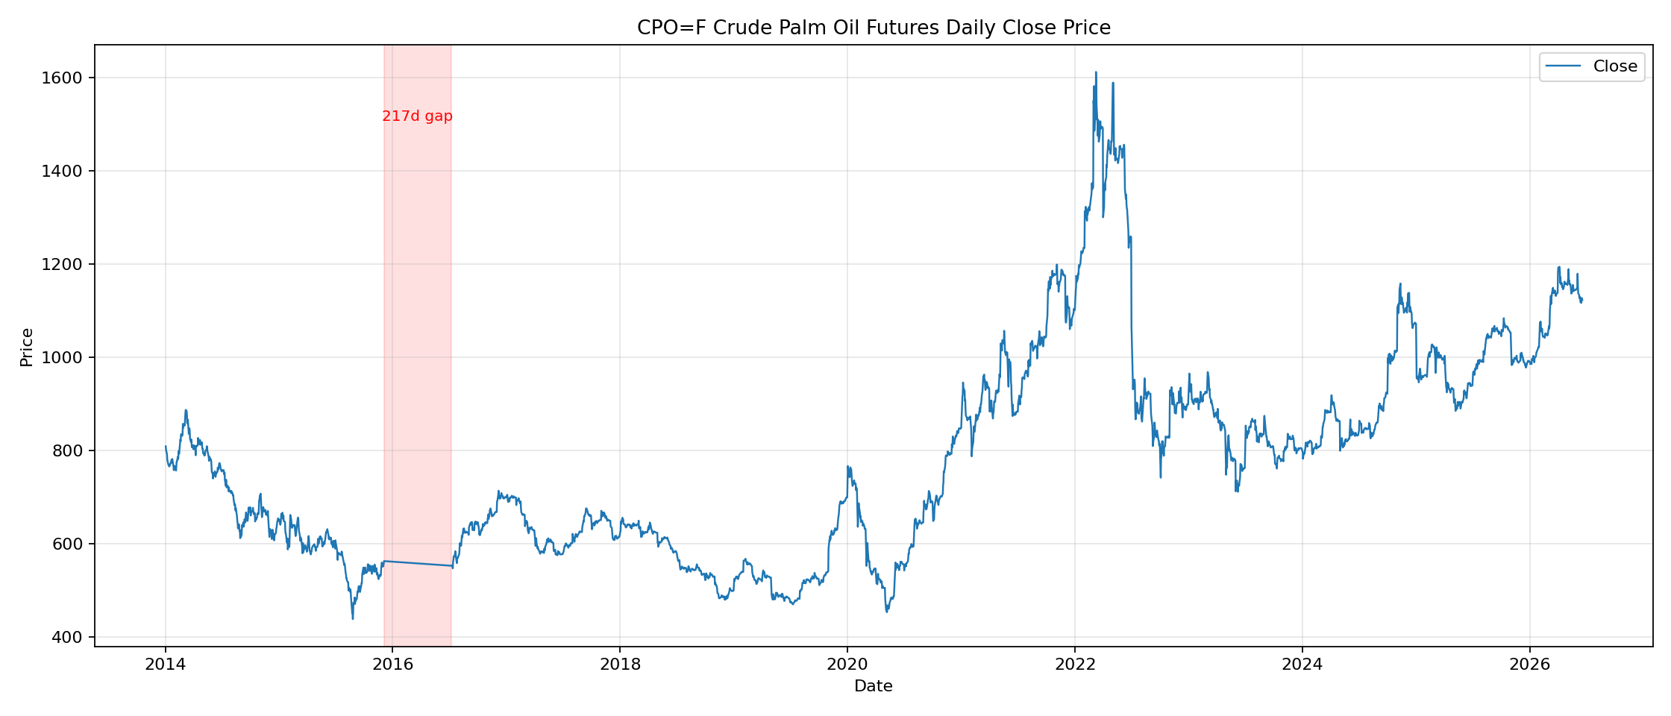
Evidence-backed gap explanation:
1. Most likely factor: Yahoo Finance continuous-futures coverage / roll-stitching issue, not a real market shutdown. Bursa Malaysia reported active FCPO trading in both 2015 and 2016, so the 217-day gap is more likely a free-data continuity problem. (Source: Bursa Malaysia 2016 Annual Report)
2. Market context: the 2015/16 strong El Niño caused drought stress and lower palm-oil production in Malaysia/Indonesia, which made prices more volatile, but this explains market stress rather than a half-year trading stop. (Source: USDA 2016 Malaysia Palm Oil Report)
3. Minor factor: Bursa/CME-type system outages can temporarily halt derivatives trading, but available evidence points to short technical interruptions, not a 217-day suspension. (Source: Reuters: Malaysia derivatives trade hit by computer glitch)
impact: A long trading/data gap breaks price continuity and can bias return, volatility, and lag-correlation estimates if treated as normal observations.

6. Files Produced
File | Meaning
data/raw/CPO_F_daily_yahoo.csv | Raw Yahoo Finance daily price data
data/processed/CPO_F_calendar_gaps.csv | Detected large calendar gaps between adjacent trading dates
data/figures/CPO_F_price_trend.png | Daily Close price trend chart
scripts/download_palm_oil_yahoo.py | Download script
scripts/explore_plot_palm_oil.py | Data check and plotting script

7. Reading Report
Source: IMF Commodity Special Feature, October 2022 — Market Developments and Food Price Inflation Drivers.

7.1 Key Takeaways
- Food prices are driven by multiple shocks at the same time: harvest/production shocks, fertilizer prices, oil prices, interest rates, exchange rates, and global demand.
- Supply-side shocks matter strongly. The IMF highlights that a 10% rise in fertilizer prices can raise cereal prices by about 7% after one quarter.
- Oil prices affect food prices with a longer lag, partly through fuel, logistics, and production costs.
- Monetary policy also matters. A 100-basis-point US monetary-policy shock can reduce cereal prices by about 13% with a one-quarter lag, partly by weakening demand and speculative inventory holding.
- The IMF explicitly flags upside risks from export restrictions, droughts, and fertilizer pass-through. Indonesia's 2022 palm-oil export ban is mentioned as an example of policy risk.

7.2 Link to My Project
This article supports the logic of my project: climate shocks do not affect futures prices directly; they first change expected supply, production costs, inventories, and trade policy, and then these channels move futures prices. For palm oil, El Niño can reduce rainfall in Malaysia and Indonesia, raising concerns about future yields. At the same time, fertilizer, oil, exchange rates, and export policies can amplify or weaken the price reaction. Therefore, my model should treat ONI and rainfall as key climate features, but not as the only drivers of palm-oil futures prices.

7.3 How the IMF Model Helps My Project
The IMF uses a dynamic shock-response framework, including local projections and impulse-response functions, to specifically estimate how food prices react over time after a shock. This is useful for my project because El Niño is also a delayed shock. I can adapt the same idea by testing whether ONI or rainfall changes lead palm-oil prices after 1, 3, 6, 9, or 12 months. In practice, this means creating lagged features such as ONI_lag_3, ONI_lag_6, and PRCP_lag_6, then checking which lag has the strongest relationship with palm-oil prices.
Also, I learnt that to predict the most relevant trends or prices, we should built various types of models and combine them into a collective whole. The more dataset and graphs we have, the more factor we can evaluate then ultimately leads to more precise forecast.

7.4 Expert View and Connection to My Project
The IMF's expert view is that food-price inflation is not caused by one single factor. It is a system of interacting shocks: weather affects harvests, energy affects transport and inputs, fertilizer affects yields, interest rates affect inventories and speculation, and trade policy can suddenly tighten supply. This is directly connected to my project. My palm-oil model should not simply ask 'Does El Niño raise prices?' Instead, it should ask 'Under which cost, policy, and macro conditions does El Niño create a stronger price response?' This expert view helps turn the project from a simple correlation exercise into a more realistic supply-shock model.
Short conclusion: the IMF article confirms that lagged climate variables should be combined with cost, policy, and macro variables when explaining agricultural futures prices.

