**Pittsburgh vs. Philadelphia Tourism**

Sunny Patel

May 2020

1. **Introduction**
   1. **Background**

Pittsburgh, Pennsylvania also known as “the Steel City” is home to many prominent leaders in a variety of categories. Pittsburgh has one of the largest medical providers in University of Pittsburgh Medical Center (UPMC). A city that was built around bridges by the steel they produced started seeing a shift in the economy. During the 1980s, Pittsburgh faced the shift due to the collapse of the steel industry. Large steel corporations began decreasing production which inevitably led to closures. The fall of the steel industry left half of the nation’s steelworkers unemployed.

Pittsburgh was able to successfully transition from an economy dominated by manufacturing to a city focusing on banking, medicine, higher education and technology. Large tech corporations such as Uber, Google, and Duolingo have opened campuses in the city. Pittsburgh is rooted with rich history, beautiful scenery and a thriving economy.

* 1. **Problem**

Even though Pittsburgh has plenty of essentials and a variety of amenities, the city still sits behind Philadelphia in tourism. Metro cities like Pittsburgh tend to garner higher tourist rates such as St. Louis and Philadelphia. According to WorldAtlas, Philadelphia ranks number eight as the most visited city in the US with 42 million visitors. The data that focuses on Philadelphia and Pittsburgh will help provide insight as to why a traveler should choose Pittsburgh as a destination compared to Philadelphia.

* 1. **Interest**

Those that want to travel to cities in the eastern region of The United States. Others who are interested in the development of tourism in Pittsburgh.

1. **Data** 
   1. **Data Sources**

There are different metrics that can be used to analyze tourism trends in a city. These include employment, attraction sites including sports, academics, cost of travel and goods. [Employment rankings](https://wallethub.com/edu/best-cities-for-jobs/2173/#methodology) for 2020 have already been figured, weighted, and ranked by WalletHub. These rankings have calculated weighted points in socio-economics and job market. Job market calculations involve metrics such as job opportunities, employment growth, monthly average starting salary among many other indicators. Attraction sites and sports datasets are from FourSquare attraction links and WalletHub’s ranking for [best sport cities](https://wallethub.com/edu/best-sports-cities/15179/#methodology). Education attainment in Allegheny County and Philadelphia County datasets are provided from [United States Census Bureau](https://data.census.gov/cedsci/table?q=education&g=0500000US42003,42101&hidePreview=true&tid=ACSST1Y2018.S1501&t=Education%3AEducational%20Attainment&vintage=2018&layer=VT_2018_050_00_PY_D1). The data will be used to compare both cities and determine the city with the most valuable travel indicator. Philadelphia and Pittsburgh will be matched up in employment, attractions with sports, and education.

1. **Methodology**
   1. **Four Square Data**

For those wanting to travel to a new city the main components involve lodging and activities. Using Four Square’s API, I was able to find the hotels close to the city and different attraction venues around the city has to offer. Pittsburgh and Philadelphia offer many different unique venue sites. The most common among them are stadium, casinos, zoos, among other sites. Sports arenas are valuable in bringing tourists from other cities. Pittsburgh has 3 football stadiums, 2 baseball stadiums, and one generic stadium

Pittsburgh Venue Summary

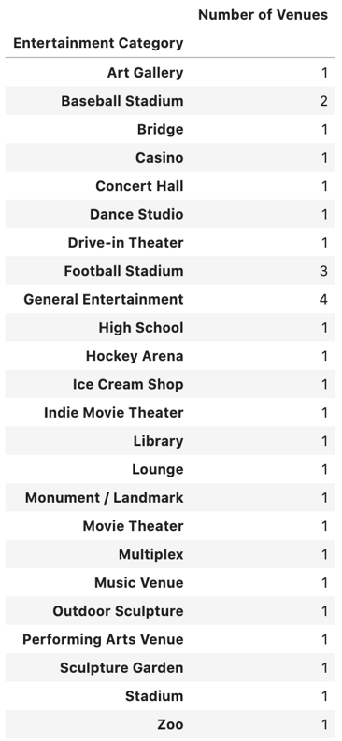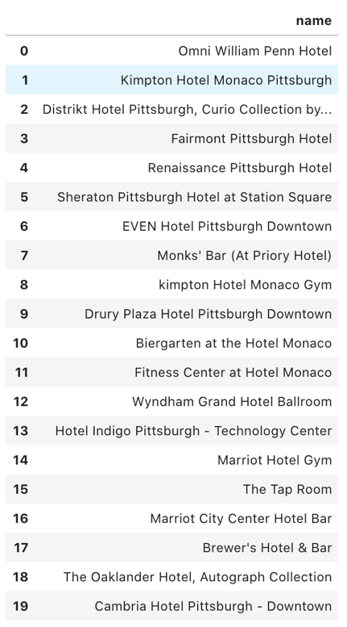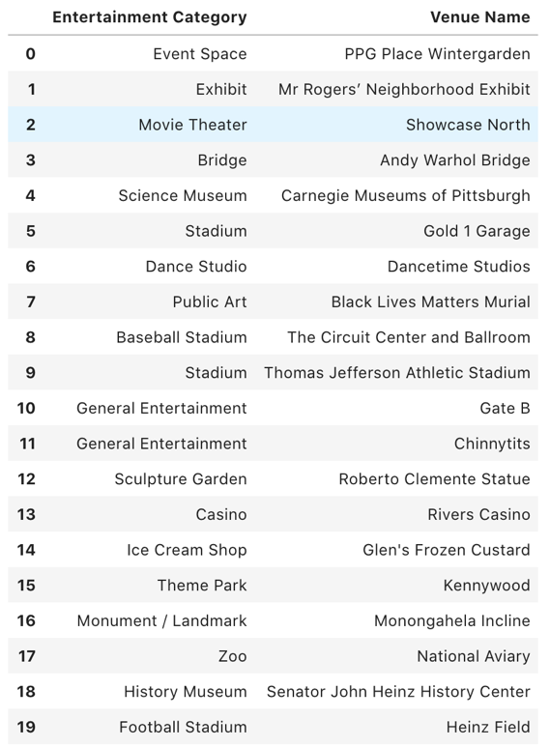

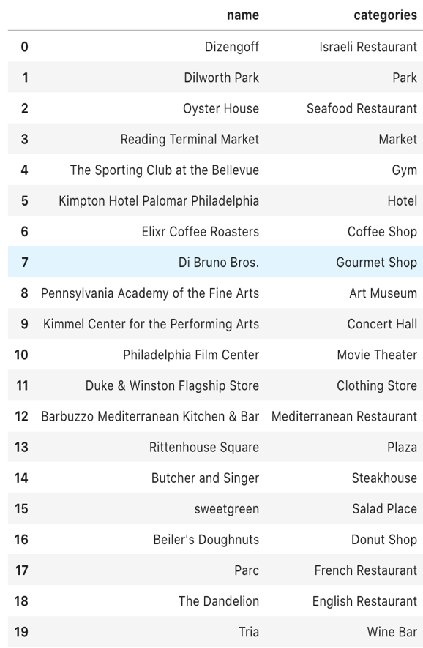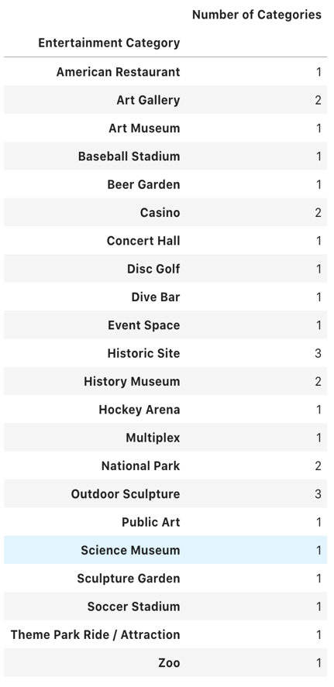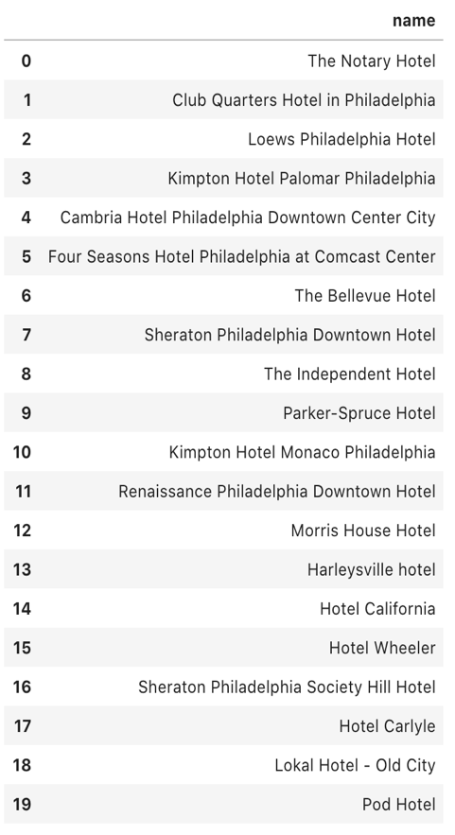Philadelphia Venue Summary

* 1. **Employment**

Employment plays a big role in the economy of a city. Employment can show how active the job and socio-economic market is. According to the data attained from WalletHub it shows that Pittsburgh ranks higher in both Job Market and Socio-Economics. Philadelphia falls much lower then Pittsburgh. The job markets in the area are categorized and weighted accordingly from employment growth, unemployment rate, automation risk, industry variety, and monthly average salary. Socio-Economic rankings are determined by categories such as transit score, housing affordability, safety, and median annual income. The real gross domestic production paints a different picture. Philadelphia has a higher GDP compared to Pittsburgh. Though Pittsburgh has either stayed the same or increased in GDP from 2015-2018 where as Philadelphia saw up and down years.

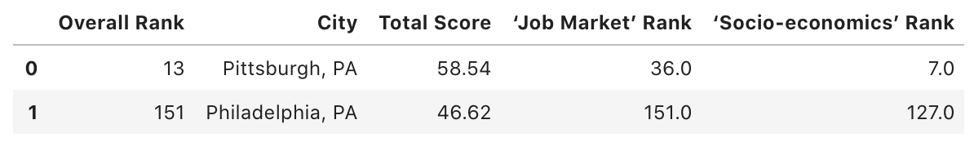

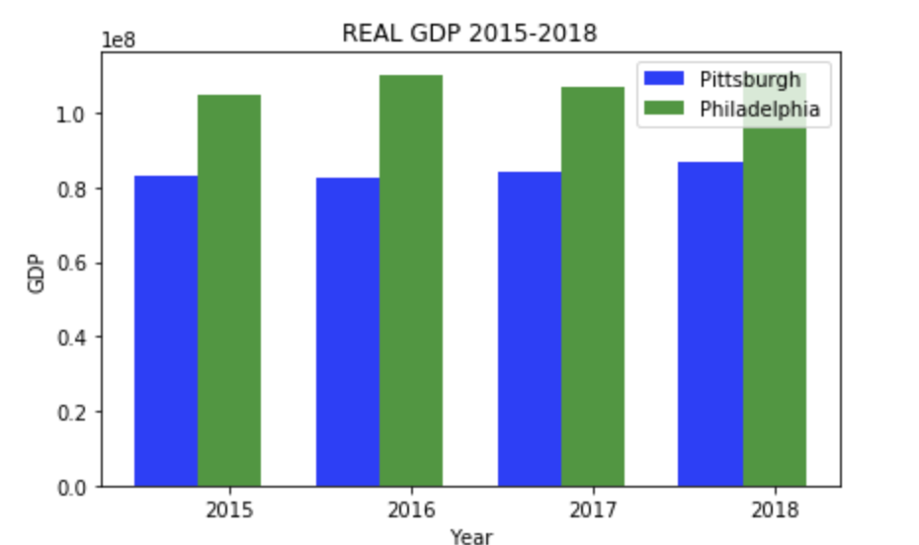

* 1. **Education**

Education levels in a city can help determine an areas city growth, which in turn can attract more tourists to the area. The data found that even though there is a higher population of 18-24-year olds in Philadelphia the educational attainment rate is higher in Pittsburgh. There are less people in Pittsburgh without a high school diploma as there is in Philadelphia. There are more professional graduates and associates in Pittsburgh then in Philadelphia. Bachelor rates are about the same in both cities.

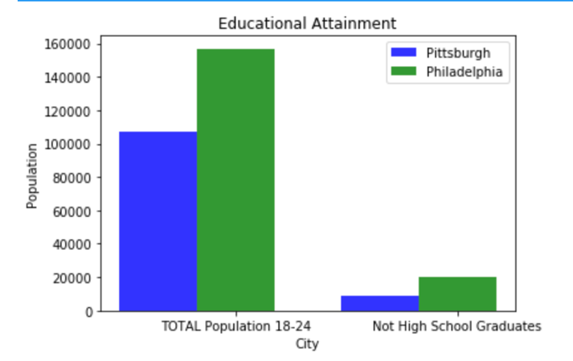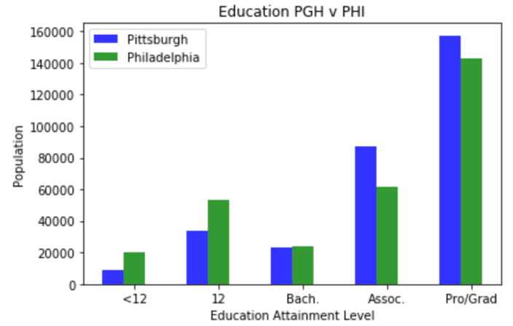

1. **Results**

Pittsburgh and Philadelphia are both great cities with driving economies and education. Both cities garner thousands of visitors yearly and are projected to continue the growth. Both cities provide varieties of entertainment, food, and housing. Entertainment venues is diverse but a commonality they both share are sport venues. Philadelphia does however have a larger selection of hotels. Economically speaking, Pittsburgh has seen steady growth for the past few years while Philadelphia has seen some stagnant years but with gradual development. Both economies are comparable but the difference and driving factor seems to be educational attainment. Pittsburgh has shown a higher level of attainment in almost all categories. There are more young teens in Philadelphia without high school diplomas and about the same in bachelor degrees.

1. **Discussion**

Recommendations that I can offer are that Pittsburgh looks into urban development allowing for more space to place hotels and other museum venues. With Pittsburgh’s rich history and diverse culture it is lacking a variety of food venues compared to Philadelphia. I suggest that Philadelphia tries to push academic achievement on to those in the area.

1. **Conclusion**

Pittsburgh and Philadelphia share the same state but the level of educational attainment helps drive Pittsburgh’s economy which was depicted with the steady growth of the economy. Both are great cities to visit but I recommend Pittsburgh over Philadelphia.